ASSESSMENT – 3 DATABASE

1. create database db; = to create database name db
show databases; = to see the databases present

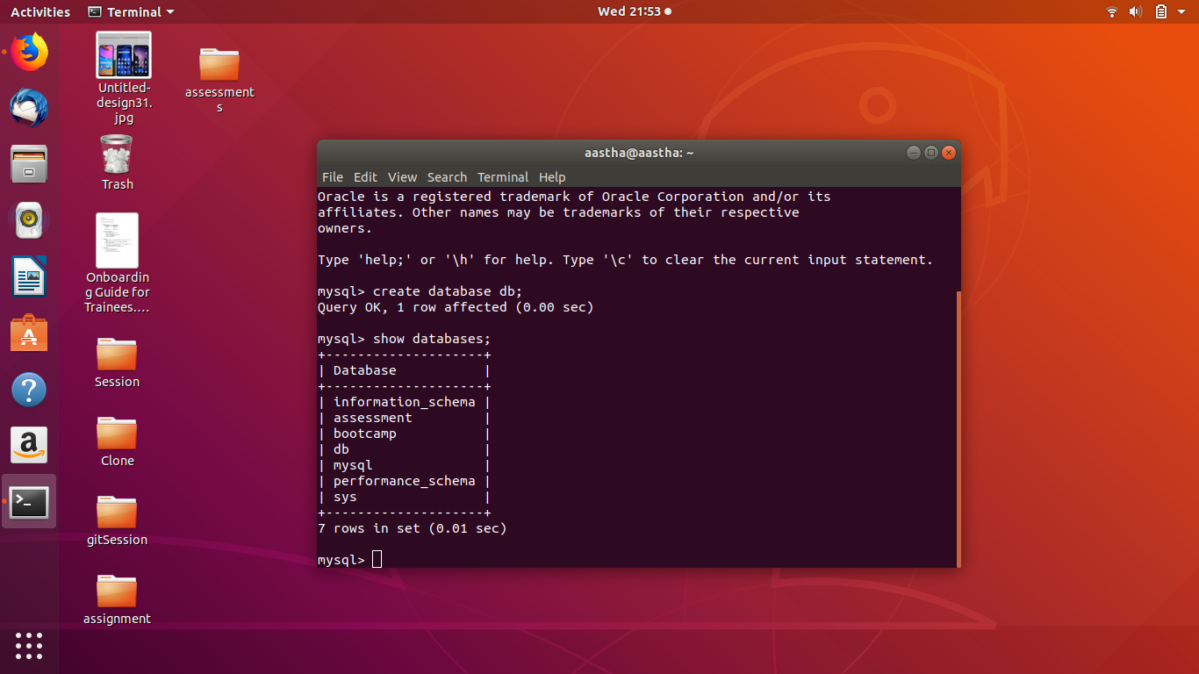
2.

customer table : it will contain the details of the customers

orders table : it will contain the details of the orders

salesperson table : it will contain the details of the salesperson

customer_order_mapping table : a map table of customer and order

customer_order_mapping
co_id int
c_id int
o_id int
n
customer
c_id int
customer_name varchar
address varchar
phone long

n
1
n
salesperson
s_id int
sales_name varchar
address varchar
phone long
n
n

orders
o_id int
desciption varchar

3. create table customer(c_id int primary key auto_increment, name varchar(20), phone int,address varchar(50)); = to make a customer table
containg all their details, in which c_id is the primary key

create table salesperson(s_id int primary key auto_increment, name varchar(20), phone int,address varchar(50)); = to make a salesperson
table containing all their details, in which s_id is the
primary key of salesperson table

create table orders(o_id int primary key auto_increment, description varchar(100), sales_id int, foreign key(sales_id) references salesperson(s_id)); = to make a order table contaning all their details, in
which o_id is the primary key of order table,
sales_id is the foreign key of salesperson table

create table customer_order_mapping(co_id int primary key auto_increment,c_id int,o_id int,foreign key(c_id) references customer(c_id),foreign key(o_id) references orders(o_id)); = a map table
of customer and user

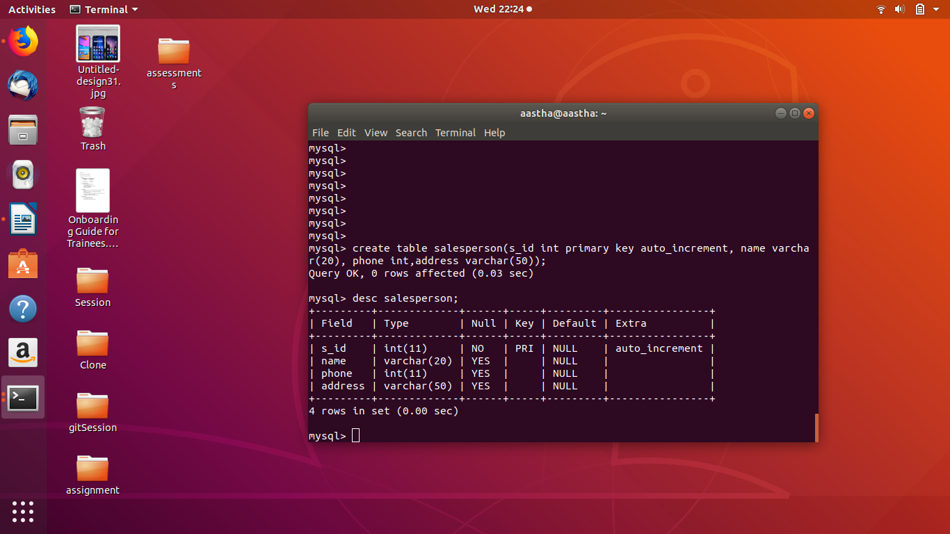

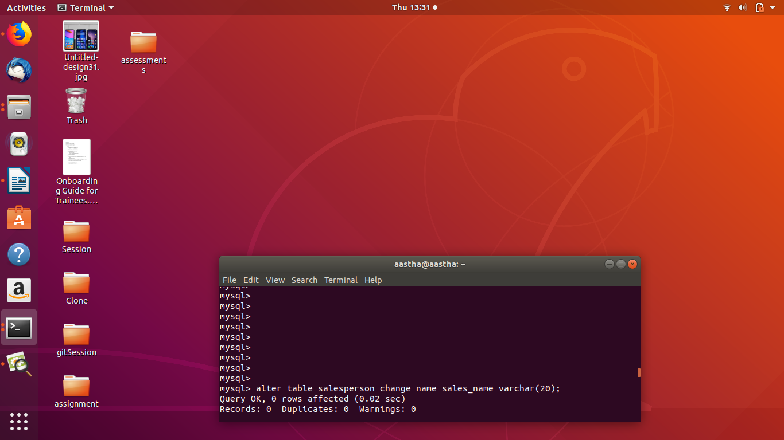

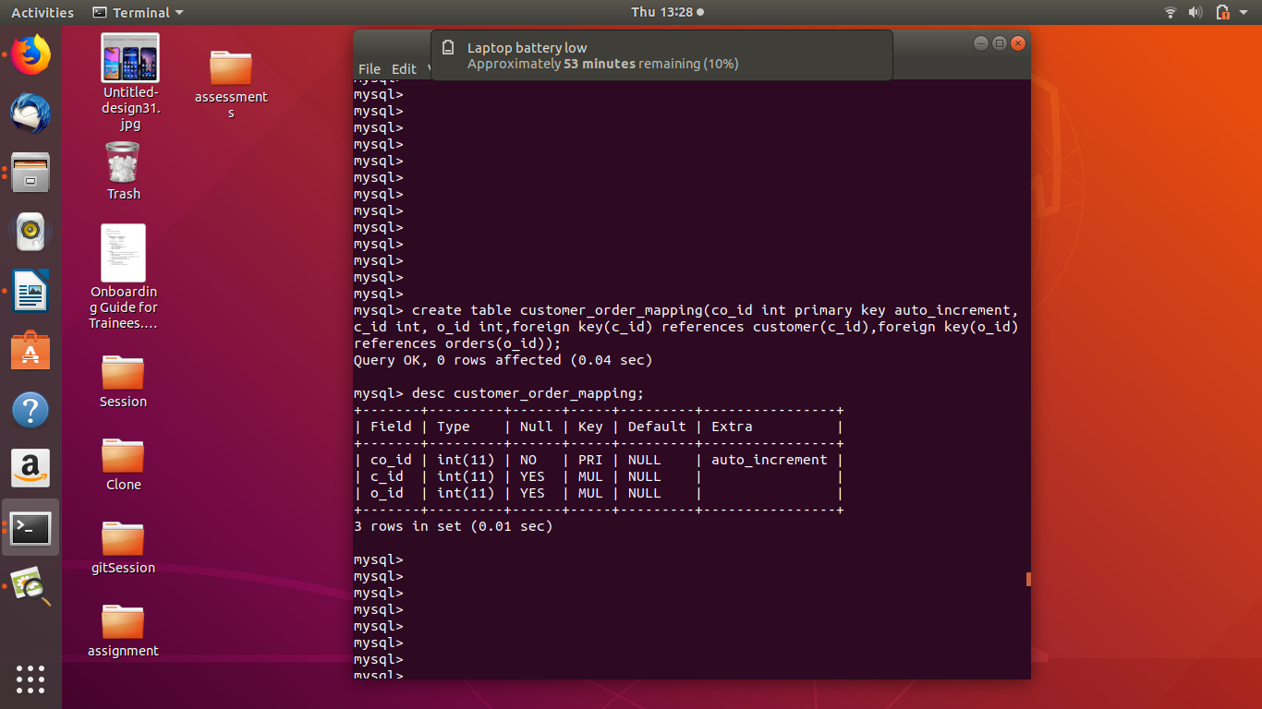

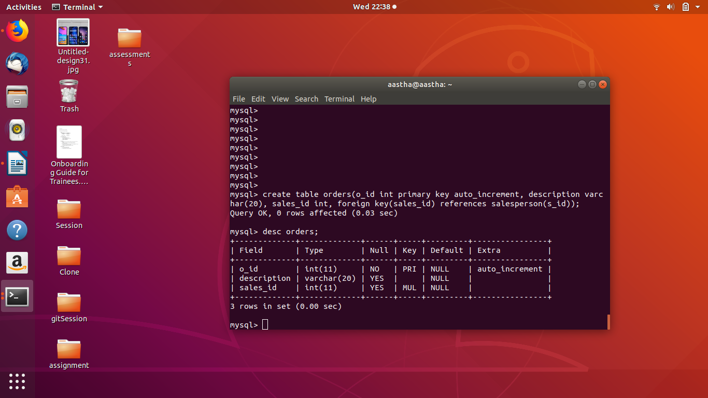
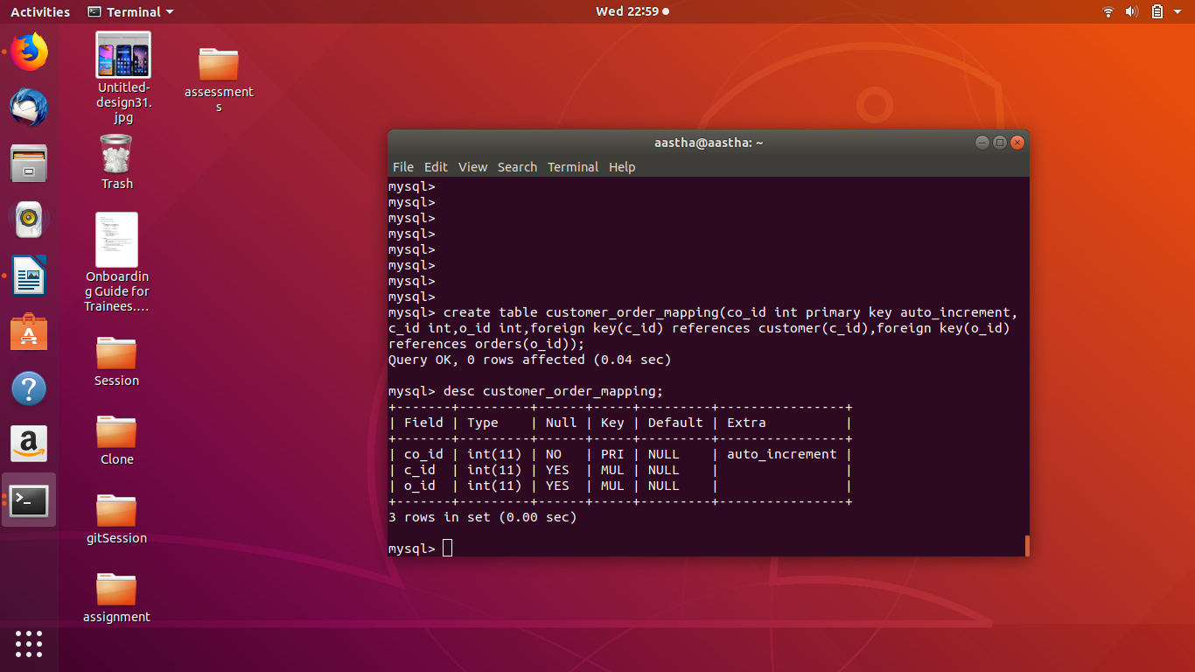

4. insert into customer(customer_name,address,phone) values(‘aastha’,’vikaspuri’,9999999999); = to insert value in table

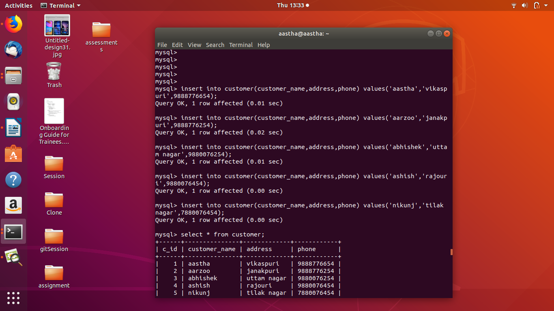

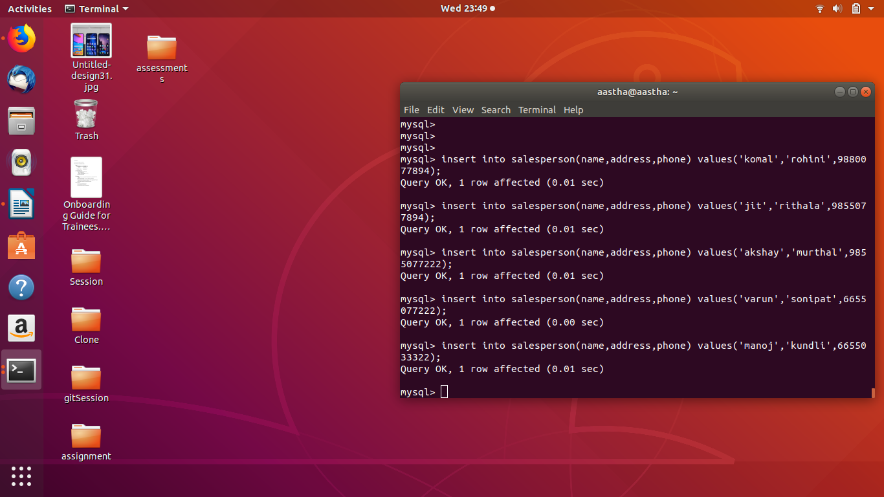
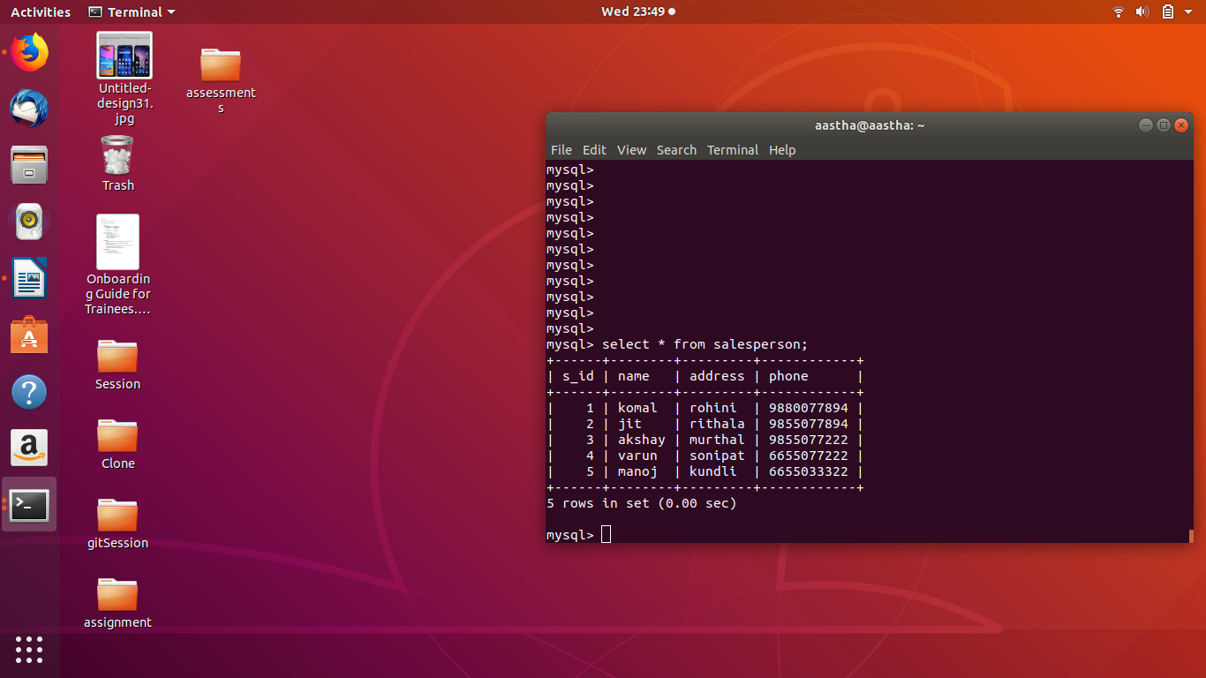

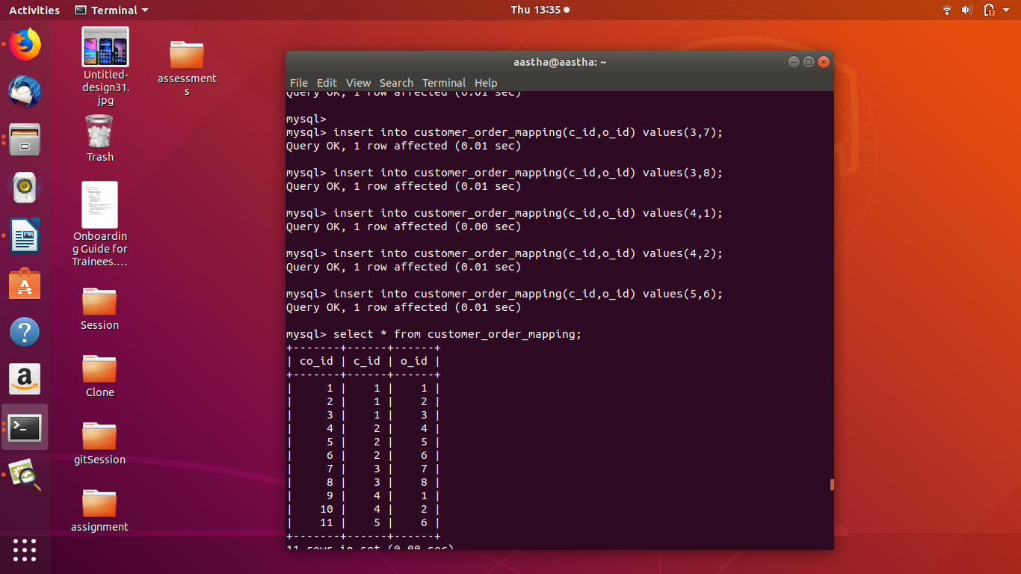


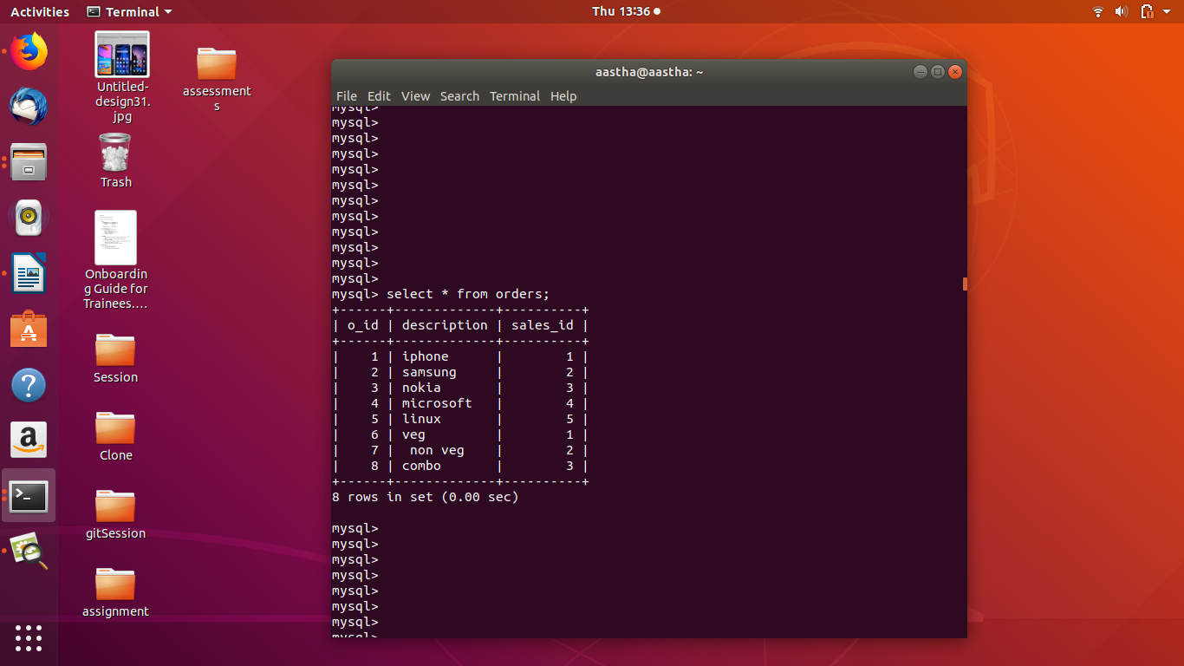
5. select sales_name,COUNT(s_id) from (select s.sales_name,ord.description,ord.o_id,s.s_id from salesperson as s join orders as ord on s.s_id=ord.sales_id) as a group by s_id having COUNT(s_id) >1;

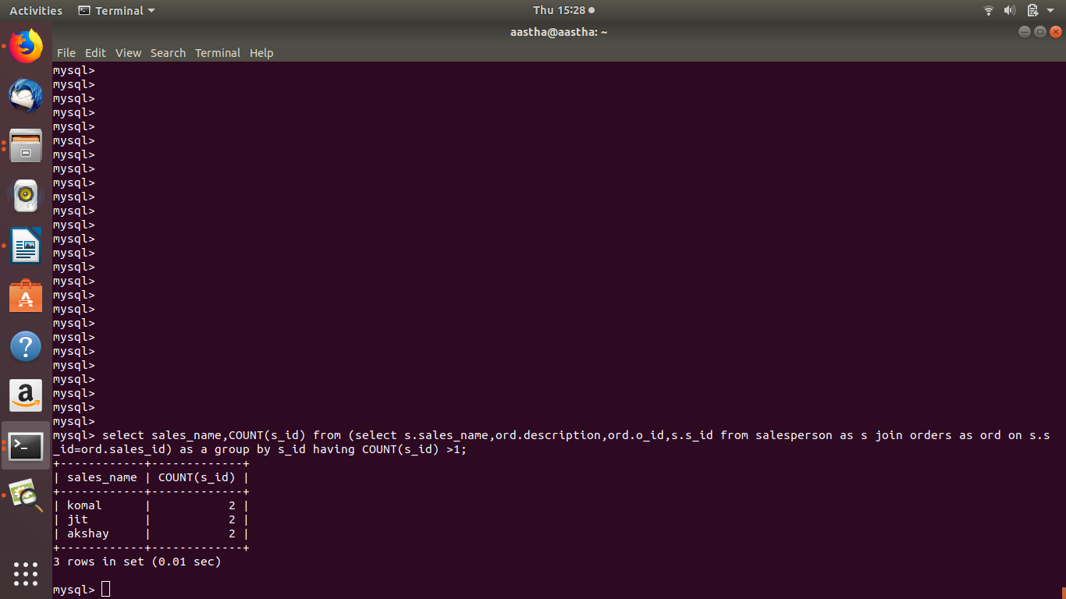

6. select salesperson.sales_name,orders.o_id,orders.description from salesperson JOIN orders on salesperson.s_id= orders.sales_id;



7. alter table customer ADD INDEX name(customer_name); = to create index on customer_name column with the name index



8. show indexes from customer; = to show index on a table



9. select s.sales_name,ord.o_id,c.customer_name from salesperson as s JOIN orders as ord on s.s_id= ord.sales_id JOIN customer_order_mapping as com on ord.o_id=com.o_id JOIN customer as c on com.c_id = c.c_id;



