ASSESSMENT - BOOTSTRAP

ANS 1.

CODE :

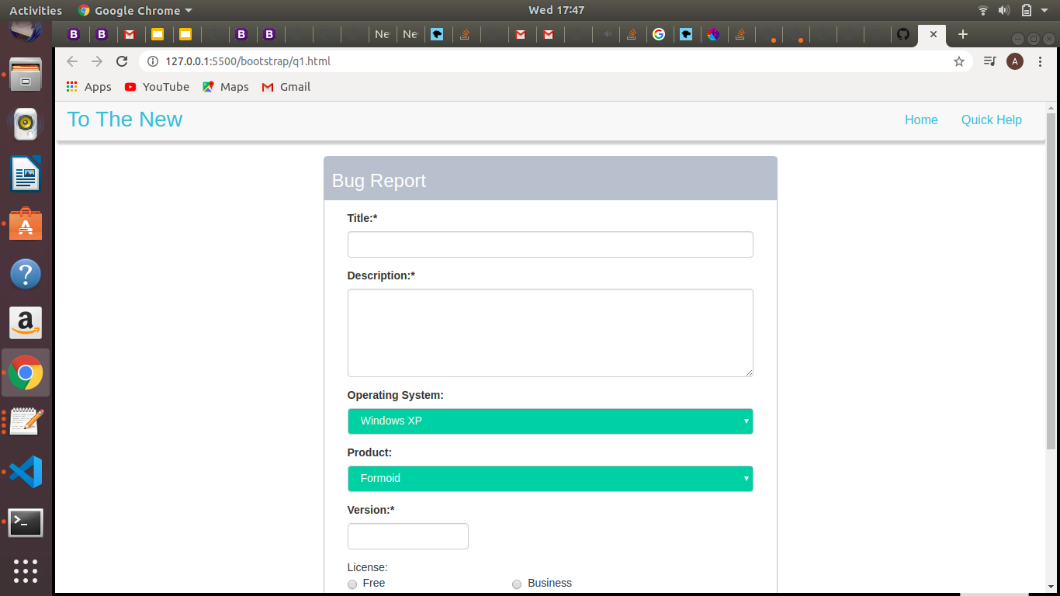
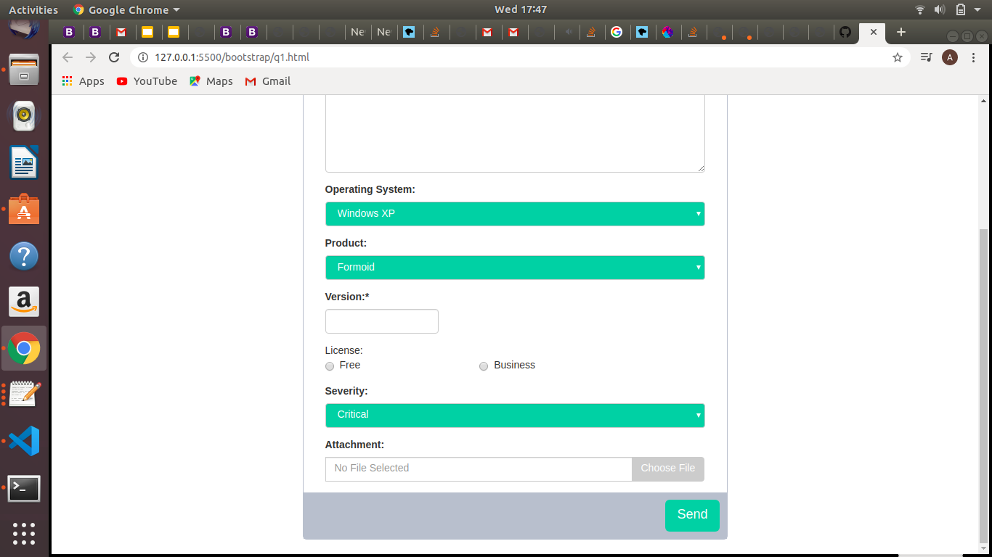

q1.html

<!DOCTYPE html>
<html lang="en">
<head>
<title>Bootstrap 3 Website Example</title>
<meta charset="utf-8">
<meta name="viewport" content="width=device-width, initial-scale=1">
<link rel="stylesheet" href="https://maxcdn.bootstrapcdn.com/bootstrap/3.4.1/css/bootstrap.min.css">
<script src="https://ajax.googleapis.com/ajax/libs/jquery/3.4.1/jquery.min.js"></script>
<script src="https://maxcdn.bootstrapcdn.com/bootstrap/3.4.1/js/bootstrap.min.js"></script>
<link href="formStyle.css" rel="stylesheet">
</head>
<body>

<header>
<nav class="navbar navbar-default">
<div class="container-fluid">
<div class="navbar-header">
<button type="button" class="navbar-toggle" data-toggle="collapse" data-target="#myNavbar">
<span class="icon-bar"></span>
<span class="icon-bar"></span>
<span class="icon-bar"></span>
</button>
<a class="navbar-brand " href="#">To The New</a>
</div>
<div class="collapse navbar-collapse" id="myNavbar">
<ul class="nav navbar-nav navbar-right">
<li><a href="#"> Home</a></li>
<li><a href="#"> Quick Help</a></li>
</ul>
</div>
</div>
</nav>

</header>
<div class="container">

<div class="row">
<div class="col-lg-3"></div>
<div class="col-lg-6 divCol6">
<div class="row report">
<h3>Bug Report</h3>
</div> <!---end of report row------>
<form>
<div class="forminput">
<div class="form-group">
<label for="title">Title:*</label>
<input type="title" class="form-control" id="title" name="title">
</div>
<div class="form-group">
<label for="desc">Description:*</label>
<textarea class="form-control" rows="5" id="desc"></textarea>
</div>
<div class="form-group">
<label for="os">Operating System:</label>
<select class="form-control" id="os">
<option>Windows XP</option>
<option>Linux</option>
<option>Mac</option>
</select>
</div>
<div class="form-group">
<label for="product">Product:</label>
<select class="form-control" id="product">
<option>Formoid</option>
<option>Formoid1</option>
<option>Formoid2</option>
</select>
</div>
<div class="form-group">
<label for="version">Version:*</label>
<input type="version" class="form-control verinput" id="version" name="version">
</div>
<div class="form-group">
<labbel for="radiobtn">License:</labbel><br>
<label class="radio-inline radiofirst">
<input type="radio" name="radiobtn">Free
</label>
<label class="radio-inline">
<input type="radio" name="radiobtn">Business
</label>
</div>
<div class="form-group">
<label for="severity">Severity:</label>
<select class="form-control" id="severity">
<option>Critical</option>
<option>Easy</option>
<option>Normal</option>
</select>
</div>
<div class="input-group">
<label for="attach">Attachment:</label>
<input type="text" class="form-control" placeholder="No File Selected" name="attach">
<div class="input-group-btn chbtndiv">
<button class="btn btn-default chfilebtn" type="submit">Choose File</button>
</div>
</div>
</div><!----end of inoutform div-------->
<div class="row rowbtn">
<div class=" pull-right">
<button type="submit" class="btn btn-lg btn-default subbtn">Send</button>
</div>
</div>
</form>

</div><!---end of col-llg-6------->
</div><!-----end of row----->
<br>
</div><!--------end of continare ----->

</body>
</html>

formStyle.css

*{
margin: 0;
padding: 0;
}
.navbar-default{
border: none;
box-shadow: 2px 5px 3px #ccc;
}
.navbar-default .navbar-brand{
color:rgb(93,188,210);
font-size: 28px;
}
.navbar-default .navbar-collapse .navbar-nav li a{
color: rgb(93,188,210);
font-size: 16px;
}
.divCol6{
border: 1px solid rgb(185,193,204);
border-radius: 5px
}
.report{
background-color: rgb(185,193,204);
color: white;
padding-left: 10px;
}
.forminput{
padding: 15px;
}
.verinput{
width: 30%;
}
.radiofirst{
margin-right: 150px;
}
.forminput select{
background-color: rgb(8,196,158);
color: white;
}
.chbtndiv{
padding-top: 25px;
}
.chfilebtn{
background-color: #ccc;
color: white;
}
.rowbtn{
background-color: rgb(185,193,204);
padding: 10px;
}
.subbtn{
background-color: rgb(8,196,158);
color: white;
border: none;;
}
@media only screen and (max-width: 600px) {
.verinput{
width: 100%;
}
.radiofirst{
margin-right: 0px;
}
}

ANS 2.

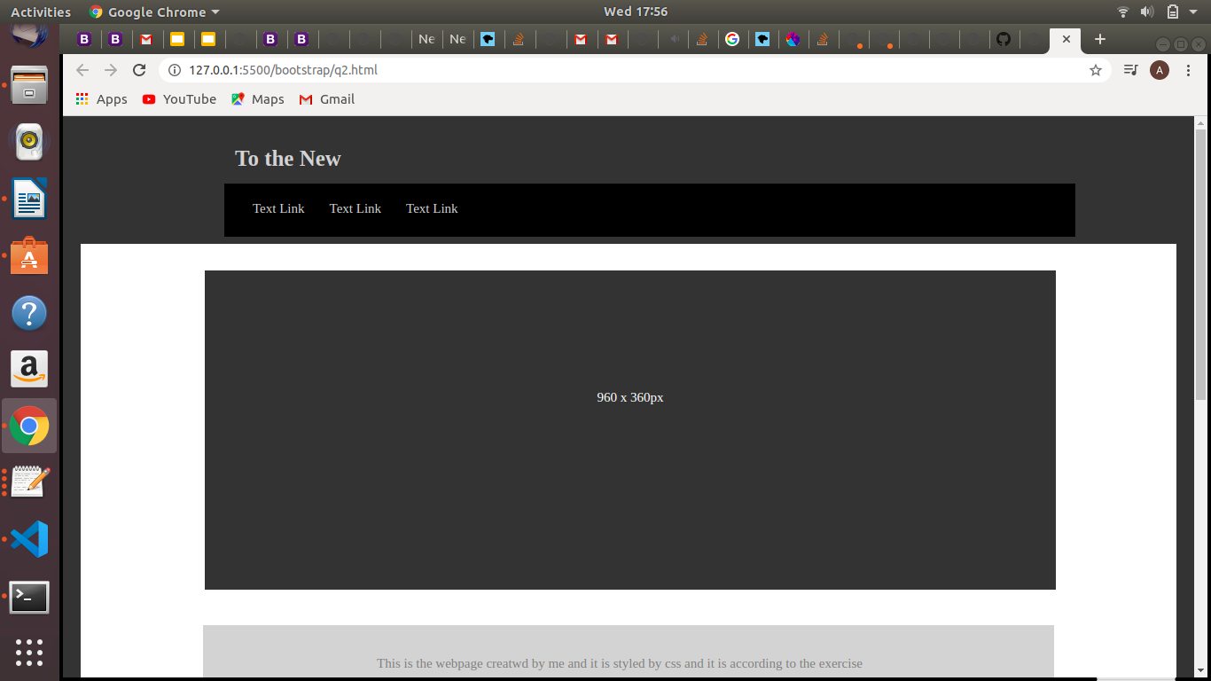
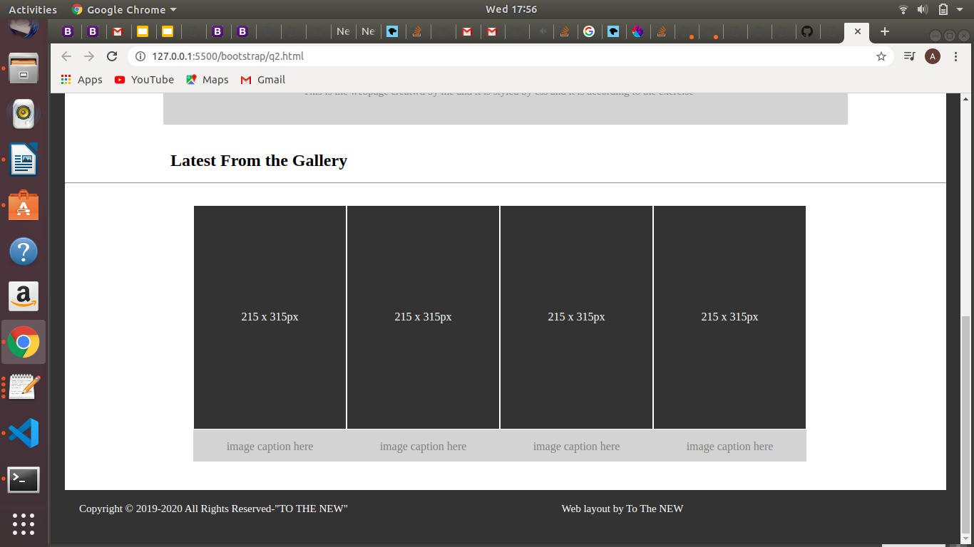

CODE :

q1.html

<!Doctype html>
<html class="border">
<head>
<meta charset="UTF-8">
<title>Gallery</title>
<link rel="stylesheet" type="text/css" href="style.css" />
</head>
<body>

<div class="header">
<a href="#default" class="logo">To the New</a><br><br><br>
<div class="header-left">
<a class="active" href="#">Text Link</a>
<a href="#">Text Link</a>
<a href="#">Text Link</a>
</div>
</div>

<div class="body">
<p>960 x 360px</p>
</div>
<div class ="text">
<p>This is the webpage creatwd by me and it is styled by css and it is according to the exercise </p>

</div>
<br><br>
<h2 class ="heading">Latest From the Gallery</h2>
<hr>
<div class="body">
<ul class="list-container">
<li class="list-item">
<span>215 x 315px</span></li>
<li class="list-item">
<span>215 x 315px</span></li>
<li class="list-item">
<span>215 x 315px</span></li>
<li class="list-item">
<span>215 x 315px</span></li>
</ul>
<ul class="list-container">
<li class="list-item1">
<span>image caption here</span></li>
<li class="list-item1">
<span>image caption here</span></li>
<li class="list-item1">
<span>image caption here</span></li>
<li class="list-item1">
<span>image caption here</span></li>
</ul>
</div>
<!-- end of body ................................................................ -->
<!-- start of footer ............................................................ -->
<div class="footer">
<p style="color: white"> Copyright &copy; 2019-2020 All Rights Reserved-"TO THE NEW"&nbsp;&nbsp;&nbsp;&nbsp;&nbsp;&nbsp;&nbsp;&nbsp;&nbsp;&nbsp;&nbsp;&nbsp;&nbsp;&nbsp;&nbsp;&nbsp;&nbsp;&nbsp;&nbsp;&nbsp;&nbsp;&nbsp;&nbsp;&nbsp;&nbsp;&nbsp;&nbsp;&nbsp;&nbsp;&nbsp;&nbsp;&nbsp;&nbsp;&nbsp;&nbsp;&nbsp;&nbsp;&nbsp;&nbsp;&nbsp;&nbsp;&nbsp;&nbsp;&nbsp;&nbsp;&nbsp;&nbsp;&nbsp;&nbsp;&nbsp;&nbsp;&nbsp;&nbsp;&nbsp;&nbsp;&nbsp;&nbsp;&nbsp;&nbsp;&nbsp;&nbsp;&nbsp;&nbsp;&nbsp;&nbsp;&nbsp;&nbsp;&nbsp;&nbsp;&nbsp;&nbsp;&nbsp;&nbsp;&nbsp;&nbsp;&nbsp;&nbsp;&nbsp;&nbsp; Web layout by To The NEW </p>

</div>
<!-- end of footer ................................................................. -->
</div>
</body>

</html>

style.css

* {box-sizing: border-box;}

body {
margin: 0;
color:grey;
}
.border{
border-style: solid;
border-color: #333333;
border-width: 20px;
}
/*..................... Header css ............*/

.header {
overflow: hidden;
background-color: #333333;
padding: 8px 10px;
width: 100%;
margin: 0 auto;
color:black;
}

/*..................... Header NavBar css ............*/

.header a {
color: lightgrey;
text-align: center;
padding: 12px;
text-decoration: none;
font-size: 15px;
line-height: 20px;
border-radius: 4px;
}
/*..................... To The New logo css ............*/

.header a.logo {
font-size: 25px;
font-weight: bold;
color:lightgrey;
float: left;
margin-left: 152px;
}
.header a.logo:hover{
background-color: #333333;
color: lightgrey;
}

.header a:hover {
background-color: #ddd;
color: black;

}

/*
.header a.active {
!* background-color: dodgerblue;*!
color: white;

}
*/

.header-left {

padding: 20px;
margin-left: 152px;
width:960px;
float: center;

background: black;
}

.body {
overflow: hidden;
background-color: #333333;
width: 960px;
height: 360px;
margin: 30px 70px 40px 140px;
color:black;

}
.body p {
color: white;
text-align: center;
padding: 12px;
text-decoration: none;
font-size: 15px;
line-height: 20px;
padding-top: 120px;
border-radius: 4px;

}
.text{
overflow: hidden;
background-color: #d3d3d3 ;
padding: 8px 10px;
width: 960px;
margin: 0 auto;
color:black;
padding-right: 30px;
}
.text p {
color: grey;
text-align: center;
padding: 12px;
text-decoration: none;
font-size: 15px;
line-height: 20px;
border-radius: 4px;
}
.heading{
overflow: hidden;
background-color: white;
padding: 8px 10px;
width: 960px;
margin: 0 auto;
color:black;
}
.heading h2 {
color: grey;
text-align: center;
padding: 12px;
text-decoration: none;
font-size: 15px;
line-height: 20px;
border-radius: 4px;
}

.list-item {
color: white;
text-align: center;
padding: 10px;
height: 315px;
width: 215px;
list-style: none;
background: #333333;
display: flex;
border: 1px solid white;

justify-content: center;

align-items: center;
}
.list-container{
display: flex;

width: 960px;

justify-content: space-evenly;
background-color: white;
margin: 0 auto;
padding-right: 60px;
}
.list-item1{
color: grey;
text-align: center;
padding: 10px;
height: 50px;
width: 215px;
list-style: none;
background: lightgrey;
display: flex;

justify-content: center;

align-items: center;
}
.footer {
overflow: hidden;
background-color: #333333;
padding: 8px 10px;
width: 960px;
margin: 0 auto;
color:black;
width: 100%;
}

.footer p {
color: black;
text-align: left;
padding: 10px;
text-decoration: none;
font-size: 15px;
line-height: 20px;
border-radius: 4px;
margin: 0 auto;

}

