ASSESSMENT -3 HTML & CSS

1.
A block-level element always starts on a new line and takes up the full width available .
e.g. <div> is block-level element

A n inline element does not start on a new line and only takes up as much width as necessary.
e.g. <span> is inline element

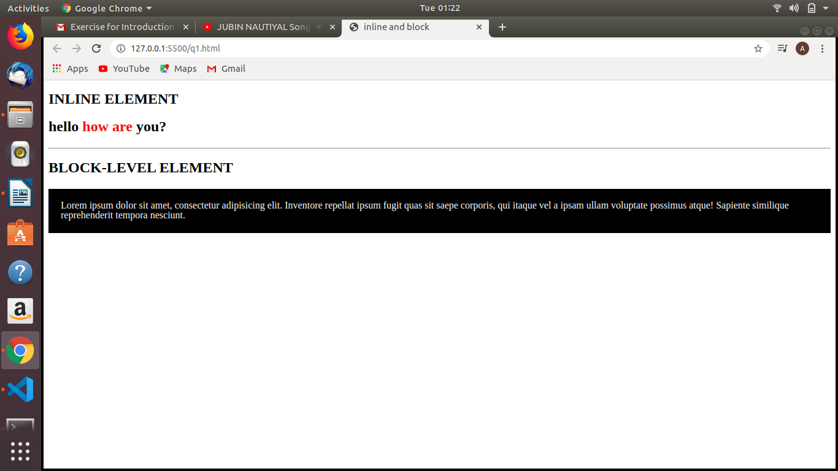
CODE :

<!DOCTYPE html>
<html lang="en">
<head>
<meta charset="UTF-8">
<meta name="viewport" content="width=device-width, initial-scale=1.0">
<title>inline and block</title>
<style>
.block{
padding:20px;
color:white;
background-color: black;
}
</style>
</head>
<body>
<h2>INLINE ELEMENT</h2>
<h2>hello <span style="color:red;">how are</span> you?</h2>
<hr>
<h2>BLOCK-LEVEL ELEMENT</h2>
<div class="block">
Lorem ipsum dolor sit amet, consectetur adipisicing elit. Inventore repellat ipsum fugit quas sit saepe corporis, qui itaque vel a ipsam ullam voluptate possimus atque! Sapiente similique reprehenderit tempora nesciunt.
</div>
</body>
</html>

2.
The display property specifies if/how an element is displayed.
Display:none ; is commonly used with Javascript to hide and show elements without deleting and recreating them.

visibility:hidden; hides an element.
The element still take up the same space as before. The element will be hidden, but still affect the layout.

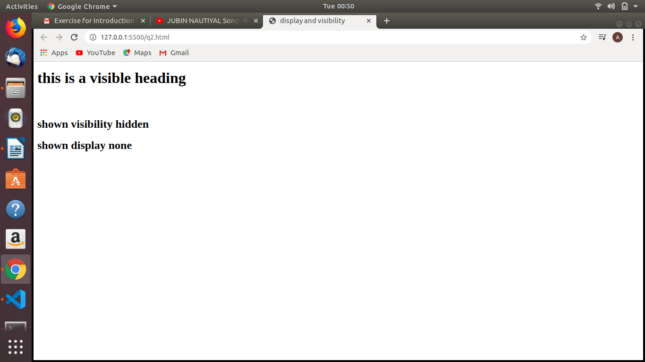

CODE :

<!DOCTYPE html>
<html lang="en">
<head>
<meta charset="UTF-8">
<meta name="viewport" content="width=device-width, initial-scale=1.0">
<title>display and visibility</title>
<style>
.hidden{
visibility:hidden;
}
.display{
display: none;
}
</style>
</head>
<body>
<h1>this is a visible heading</h1>
<h2 class="hidden">this is a visiblity hidden heading</h2>
<h2>shown visibility hidden</h2>
<h2 class="display">this is display none heading</h2>
<h2>shown display none</h2>
</body>
</html>

3.
The float CSS Property places an element on the left or right side of its container, allowing text and inline elements to wrap around it. The element is removed from the normal flow of the page, though still remaining a part of the flow. It modifies the computed value of the display values.

float:left; the element must float on the left side of its containing block

float:right; the element must float on the right side of its containing block

float:none; the element must not float

float:inline-start; the element must float on the right side of its containing block. That is left side with ltr scripts and right side with rtl scripts.

Float:inline-end; the element must float on the end side of its containing block. That is right side with ltr scripts and left side with rtl scripts.

The clear property specifies what elements can float beside the cleared element and on which side.
The clear property can have one of the following values:
- none - Allows floating elements on both sides. This is default
- left - No floating elements allowed on the left side
- right- No floating elements allowed on the right side
- both - No floating elements allowed on either the left or the right side
- inherit - The element inherits the clear value of its parent
The most common way to use the clear property is after you have used a float property on an element.

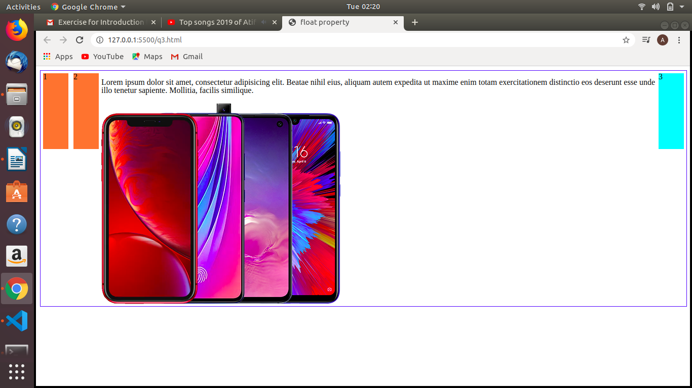
CODE :

<!DOCTYPE html>
<html lang="en">
<head>
<meta charset="UTF-8">
<meta name="viewport" content="width=device-width, initial-scale=1.0">
<title>float property</title>
<style>
.left{
float:left;
background-color: coral;
}
section{
border: 1px solid blue;
width: 100%;
float:left;
}
div{

margin: 5px;
width: 50px;
height: 150px;
}
.left{
float: left;
background-color: coral;
}
.right{
float:right;
background-color: cyan;
}
img{
float:none;
}
</style>
</head>
<body>
<section>
<div class="left">1</div>
<div class="left">2</div>
<div class="right">3</div>
<p>Lorem ipsum dolor sit amet, consectetur adipisicing elit. Beatae nihil eius, aliquam autem expedita ut maxime enim totam exercitationem distinctio eos deserunt esse unde illo tenetur sapiente. Mollitia, facilis similique.</p>
<img src="https://s3-ap-southeast-1.amazonaws.com/bsy/iportal/images/handset-offer-banner-new_31F555919982EFE18360075F1D2EC443.png" alt="">
</section>
</body>
</html>

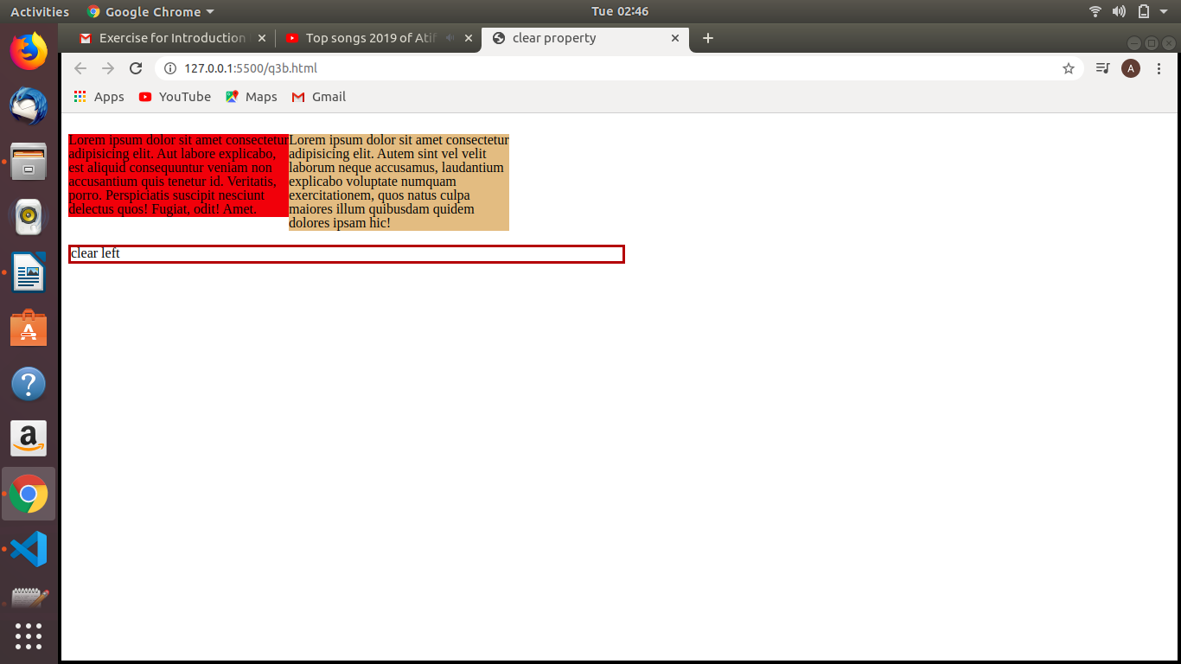

CODE :

<!DOCTYPE html>
<html lang="en">
<head>
<meta charset="UTF-8">
<meta name="viewport" content="width=device-width, initial-scale=1.0">
<title>clear property</title>
<style>
.black{
background-color: crimson;
color: black;
float: left;
width:20%;
}
.red{
background-color: burlywood;
float:left;
color:black;
width:20%;
}
.clear{
border: 3px solid brown;
clear:left;
}
p{
width:50%;
}
</style>
</head>
<body>
<div>
<p class="black">Lorem ipsum dolor sit amet consectetur adipisicing elit. Aut labore explicabo, est aliquid consequuntur veniam non accusantium quis tenetur id. Veritatis, porro. Perspiciatis suscipit nesciunt delectus quos! Fugiat, odit! Amet.</p>
<p class="red">Lorem ipsum dolor sit amet consectetur adipisicing elit. Autem sint vel velit laborum neque accusamus, laudantium explicabo voluptate numquam exercitationem, quos natus culpa maiores illum quibusdam quidem dolores ipsam hic!</p>
<p class="clear">clear left</p>
</div>
</body>
</html>

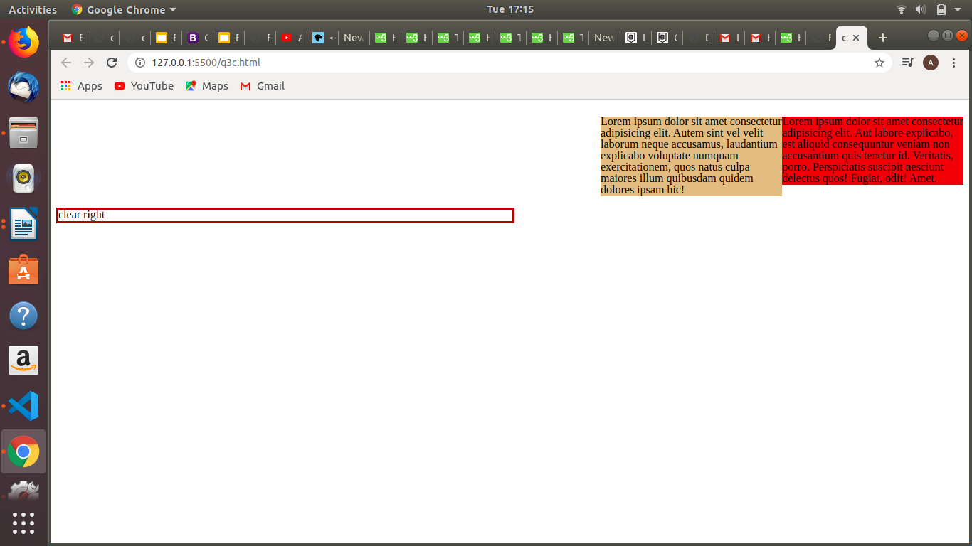

CODE :

<!DOCTYPE html>
<html lang="en">
<head>
<meta charset="UTF-8">
<meta name="viewport" content="width=device-width, initial-scale=1.0">
<title>clear property</title>
<style>
.black{
background-color: crimson;
color: black;
float: right;
width:20%;
}
.red{
background-color: burlywood;
float:right;
color:black;
width:20%;
}
.clear{
border: 3px solid brown;
clear:right;
}
p{
width:50%;
}
</style>
</head>
<body>
<div>
<p class="black">Lorem ipsum dolor sit amet consectetur adipisicing elit. Aut labore explicabo, est aliquid consequuntur veniam non accusantium quis tenetur id. Veritatis, porro. Perspiciatis suscipit nesciunt delectus quos! Fugiat, odit! Amet.</p>
<p class="red">Lorem ipsum dolor sit amet consectetur adipisicing elit. Autem sint vel velit laborum neque accusamus, laudantium explicabo voluptate numquam exercitationem, quos natus culpa maiores illum quibusdam quidem dolores ipsam hic!</p>
<p class="clear">clear right</p>
</div>
</body>
</html>

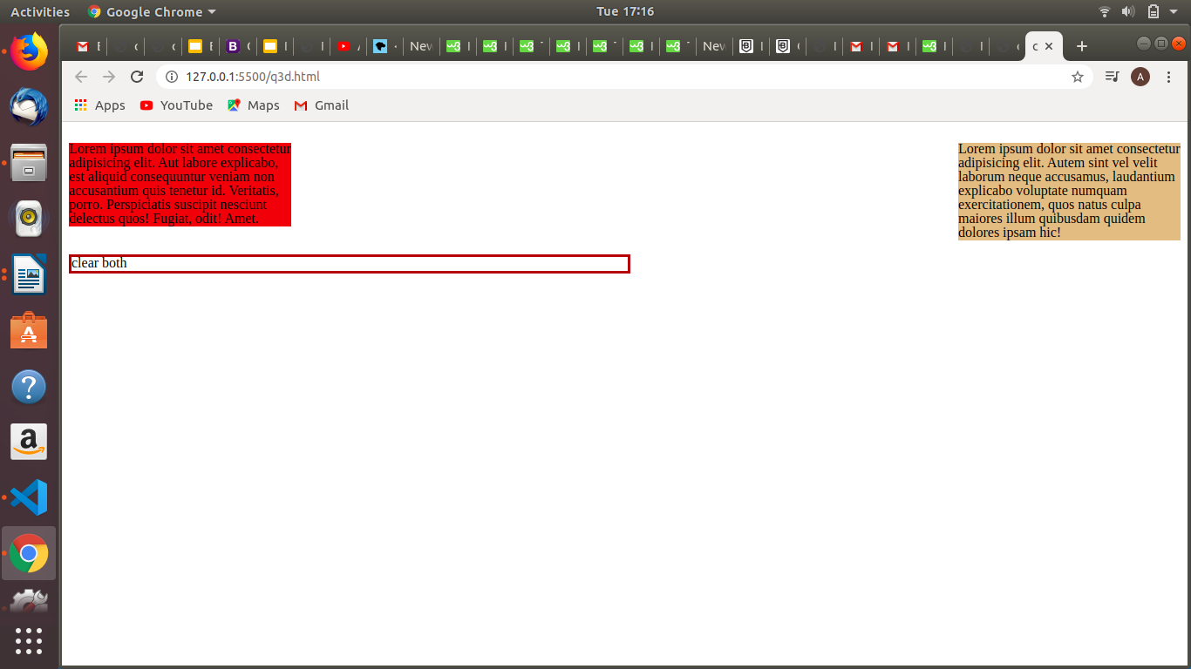

CODE :

<!DOCTYPE html>
<html lang="en">
<head>
<meta charset="UTF-8">
<meta name="viewport" content="width=device-width, initial-scale=1.0">
<title>clear property</title>
<style>
.black{
background-color: crimson;
color: black;
float: left;
width:20%;
}
.red{
background-color: burlywood;
float:right;
color:black;
width:20%;
}
.clear{
border: 3px solid brown;
clear:both;
}
p{
width:50%;
}
</style>
</head>
<body>
<div>
<p class="black">Lorem ipsum dolor sit amet consectetur adipisicing elit. Aut labore explicabo, est aliquid consequuntur veniam non accusantium quis tenetur id. Veritatis, porro. Perspiciatis suscipit nesciunt delectus quos! Fugiat, odit! Amet.</p>
<p class="red">Lorem ipsum dolor sit amet consectetur adipisicing elit. Autem sint vel velit laborum neque accusamus, laudantium explicabo voluptate numquam exercitationem, quos natus culpa maiores illum quibusdam quidem dolores ipsam hic!</p>
<p class="clear">clear both</p>
</div>
</body>
</html>

4.

The Position Property: The position property specifies the type of positioning method used for an element.
There are four different position values:
- static
- relative
- fixed
- absolute
Elements are then positioned using the top, bottom, left, and right properties. However, these properties will not work unless the position property is set first. They also work differently depending on the position value.
- position: static;
HTML elements are positioned static by default.
Static positioned elements are not affected by the top, bottom, left, and right properties.
An element with position: static; is not positioned in any special way; it is always positioned according to the normal flow of the page
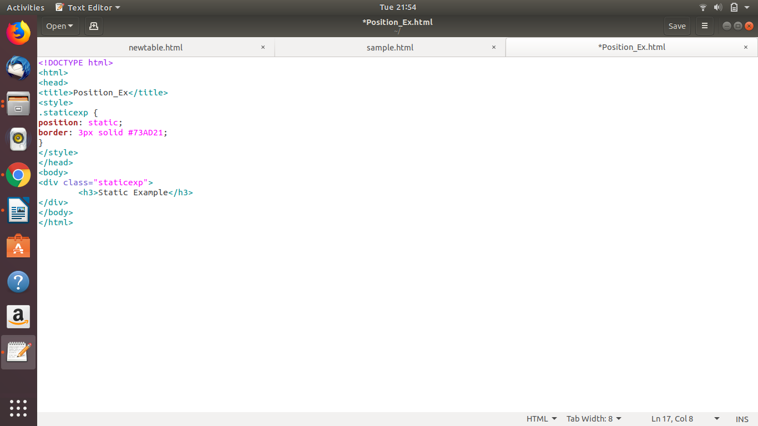
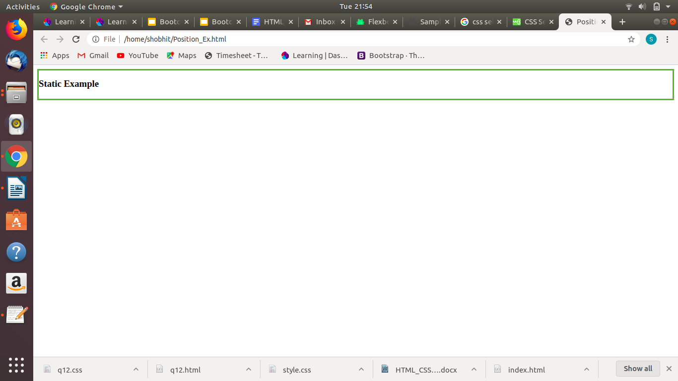
- position: relative;
An element with position: relative; is positioned relative to its normal position.
Setting the top, right, bottom, and left properties of a relatively-positioned element will cause it to be adjusted away from its normal position. Other content will not be adjusted to fit into any gap left by the element.
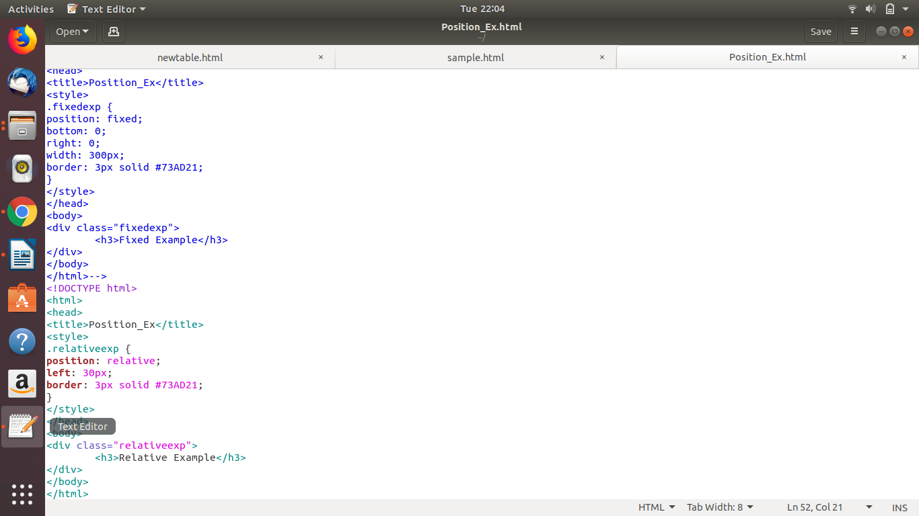
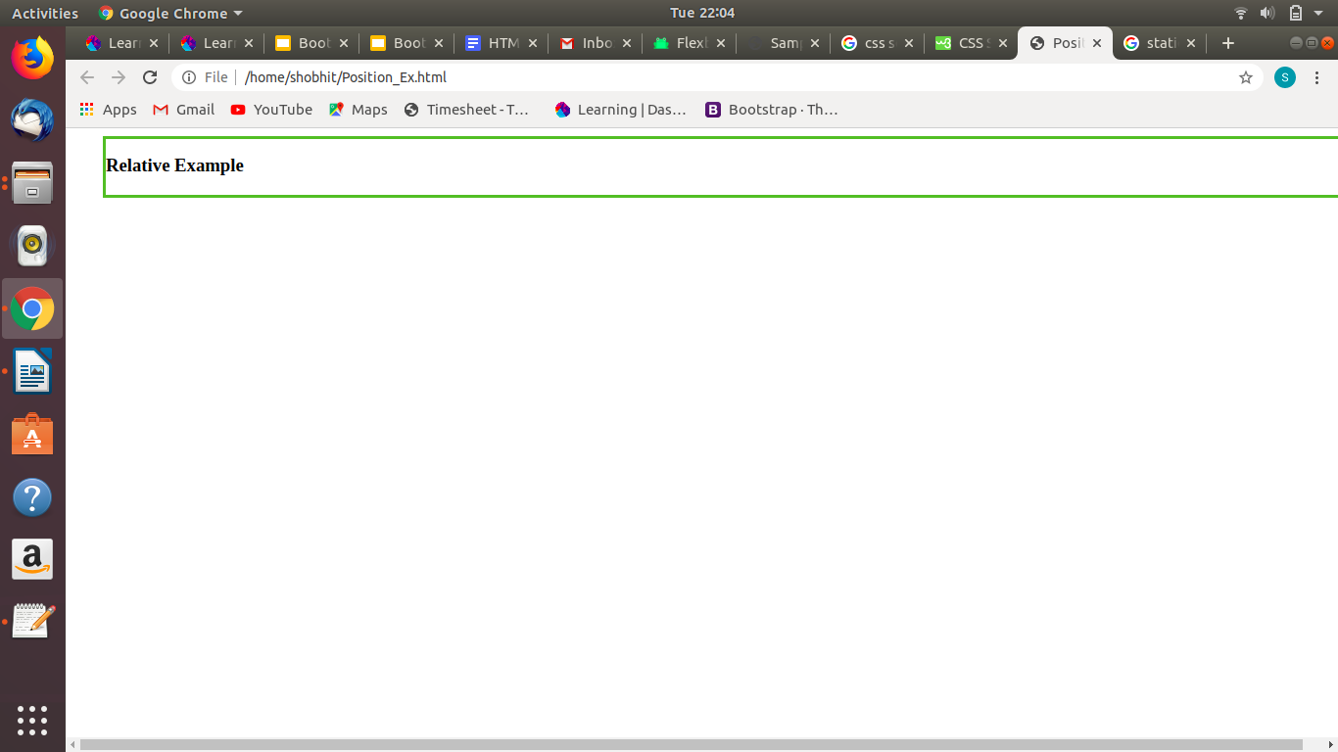
- position: fixed;
An element with position: fixed; is positioned relative to the viewport, which means it always stays in the same place even if the page is scrolled. The top, right, bottom, and left properties are used to position the element.
A fixed element does not leave a gap in the page where it would normally have been located.
Notice the fixed element in the lower-right corner of the page.
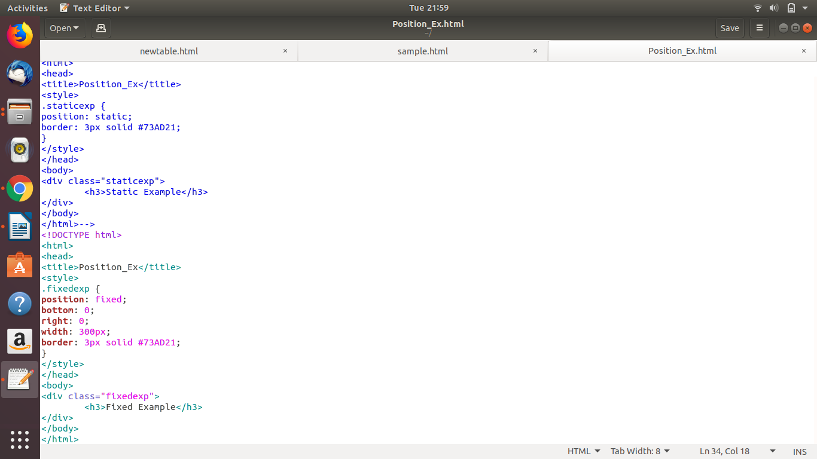
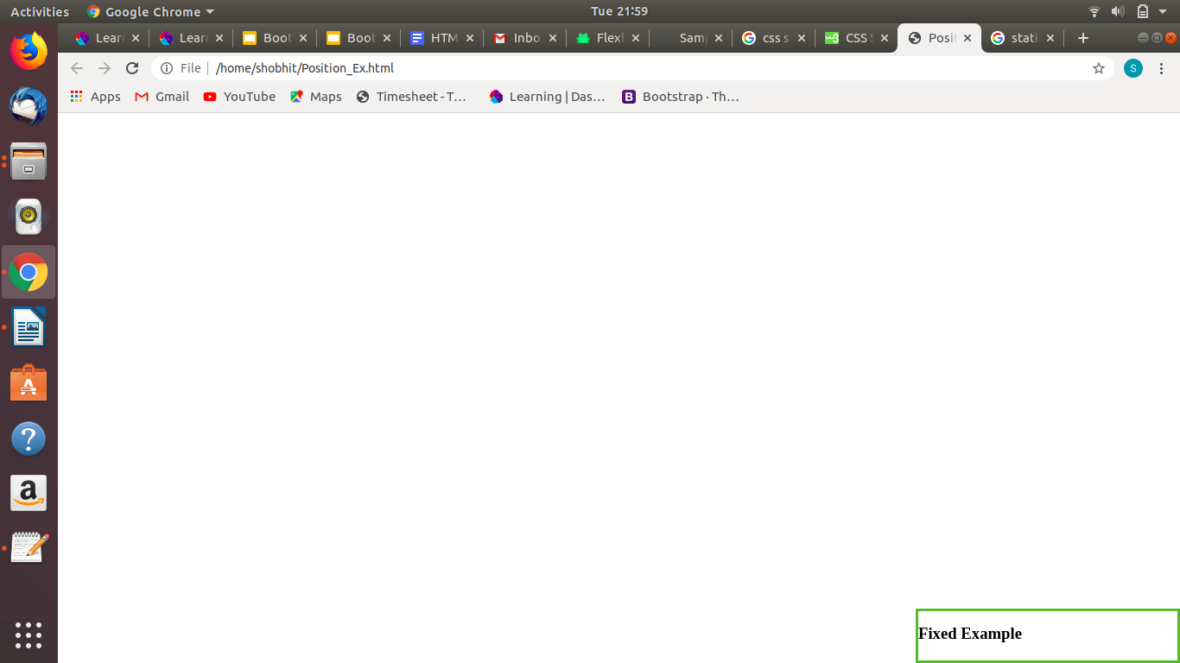
- position: absolute;
An element with position: absolute; is positioned relative to the nearest positioned ancestor (instead of positioned relative to the viewport, like fixed).However; if an absolute positioned element has no positioned ancestors, it uses the document body, and moves along with page scrolling.
Note: A "positioned" element is one whose position is anything except static.
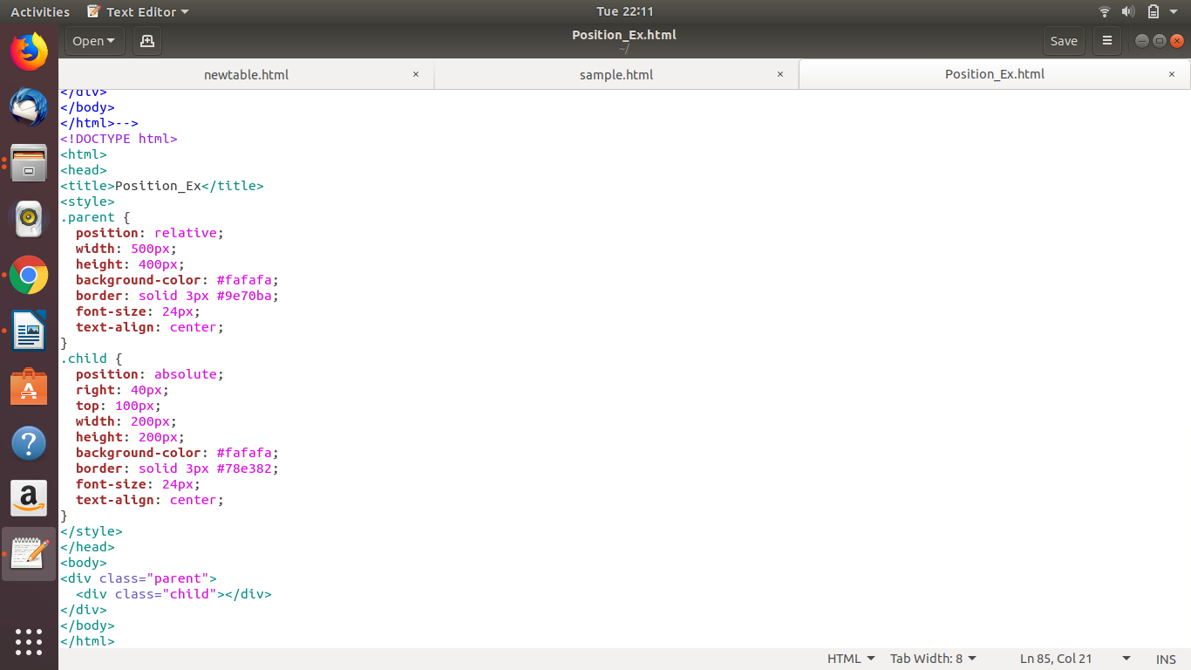
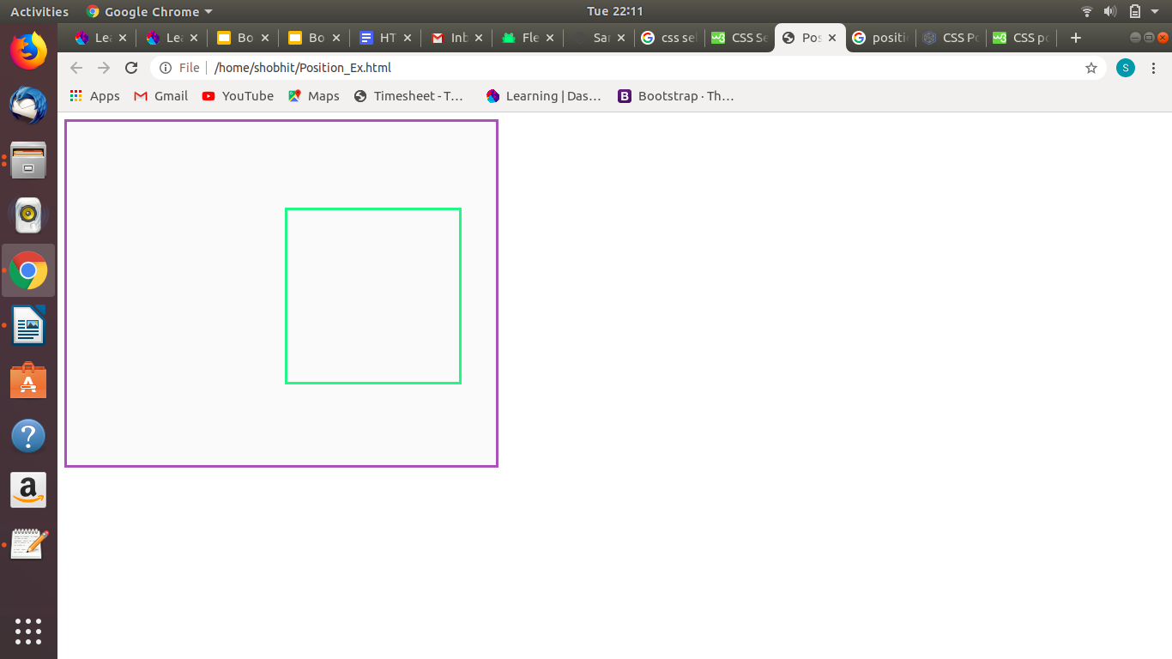

5.
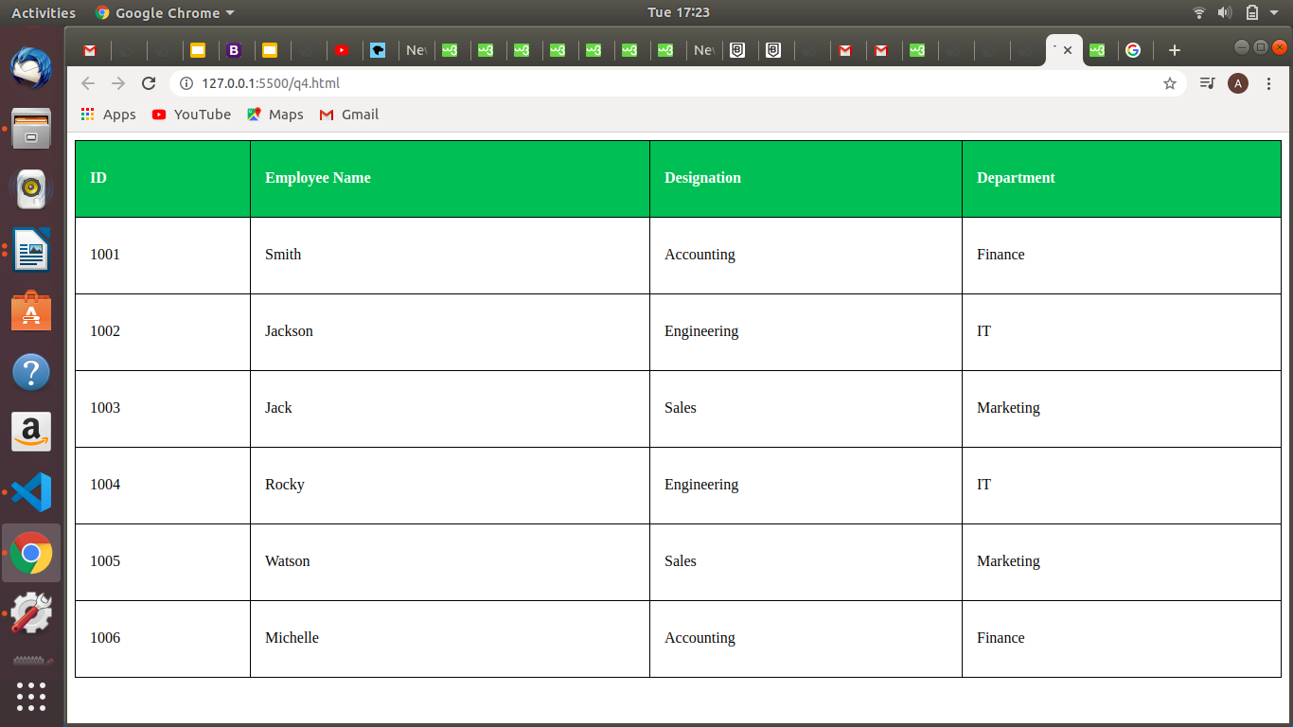

Table.html

<!doctype html>
<html lang="en">
<head>
<meta charset="UTF-8">
<meta name="viewport"
content="width=device-width, user-scalable=no, initial-scale=1.0, maximum-scale=1.0, minimum-scale=1.0">
<meta http-equiv="X-UA-Compatible" content="ie=edge">
<link rel="stylesheet" type="text/css" href="tablestyle.css">

<title>TABLE</title>
</head>
<body>
<div style="overflow-x:auto">

<table style="width:100%">
<tr>
<th>ID</th>
<th>Employee Name</th>
<th>Designation</th>
<th>Department</th>
</tr>

<tr>
<td>1001</td>
<td>Smith</td>
<td>Accounting</td>
<td>Finance</td>
</tr>
<tr>
<td>1002</td>
<td>Jackson</td>
<td>Engineering</td>
<td>IT</td>
</tr>
<tr>
<td>1003</td>
<td>Jack</td>
<td>Sales</td>
<td>Marketing</td>
</tr>
<tr>
<td>1004</td>
<td>Rocky</td>
<td>Engineering</td>
<td>IT</td>
</tr>
<tr>
<td>1005</td>
<td>Watson</td>
<td>Sales</td>
<td>Marketing</td>
</tr>
<tr>
<td>1006</td>
<td>Michelle</td>
<td>Accounting</td>
<td>Finance</td>
</tr>

</table>
</div>
</body>

</html>

tablestyle.css

table {
border-collapse: collapse; /*The border-collapse property sets whether the table borders should be collapsed into a single border: */
width: 100%;
}
table, th, td {
border: 1px solid black;
height: 50px;
text-align: left;
padding: 15px;
}
tr:hover {
background-color: #f5f5f5;
}
th {
background-color: #4CAF50;
color: white;
}

6.
- metadata is the information about the data.
- The <meta> tag provides metadata about the html document. Metadata will not be displayed on the page , but will be machine parsable.
- Meta elements are typically used to specify page description keywords,author of the document,last modified,and other metadata.
- the metadata can be used by browsers,search engines or other web services.
- In HTML 5, web designers take control over the viewport through the <meta> tag.

CODE :

<!DOCTYPE html>
<html lang="en">
<head>
<meta charset="UTF-8">
<meta name="keywords" content="samsung,iphone,nokia,redmi">
<meta name="author" content="aastha">
<meta name="viewport" content="width=device-width, initial-scale=1.0">
<title>Document</title>
</head>
<body>
</body>
</html>

7.
MARGIN

CONTENT
PADDING
BORDER

CSS Box Model is essentially a box that wraps around every HTML element. It consists of:- margins,borders,padding and the actual content.

Content : the content of the box, where text and images appear
Padding : Cllears an area around the content. The padding is transparent.
Border : A border that goes around the padding and content.
Margin : Clears an area outside the border. The margin is transparent.
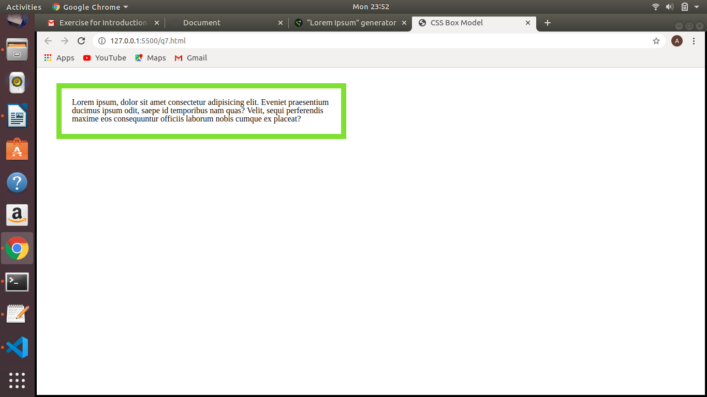
CODE :

<!DOCTYPE html>
<html lang="en">
<head>
<meta charset="UTF-8">
<meta name="viewport" content="width=device-width, initial-scale=1.0">
<title>CSS Box Model</title>
<style>
.box{
width : 500px;
padding : 20px;
border : 10px solid yellowgreen;
margin : 30px;
}
</style>
</head>
<body>
<div class="box">
Lorem ipsum, dolor sit amet consectetur adipisicing elit. Eveniet praesentium ducimus ipsum odit, saepe id temporibus nam quas? Velit, sequi perferendis maxime eos consequuntur officiis laborum nobis cumque ex placeat?
</div>
</body>
</html>

8.

CSS selectors are used to select the content you want to style. Selectors are the part of CSS rule set. CSS selectors select HTML elements according to its id, class, type, attribute etc.
There are several different types of selectors in CSS.
1.Simple Selectors
i. CSS Element Selector
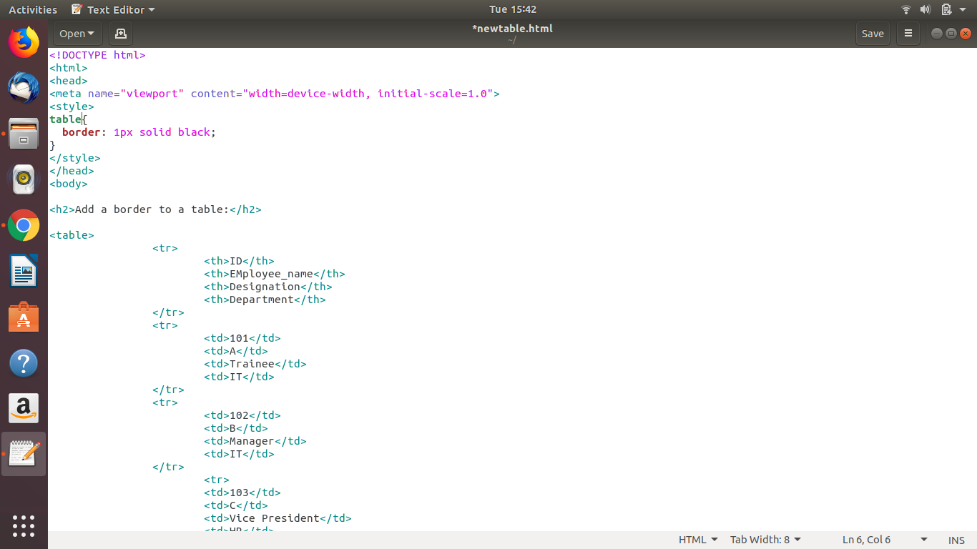
ii. CSS Id Selector
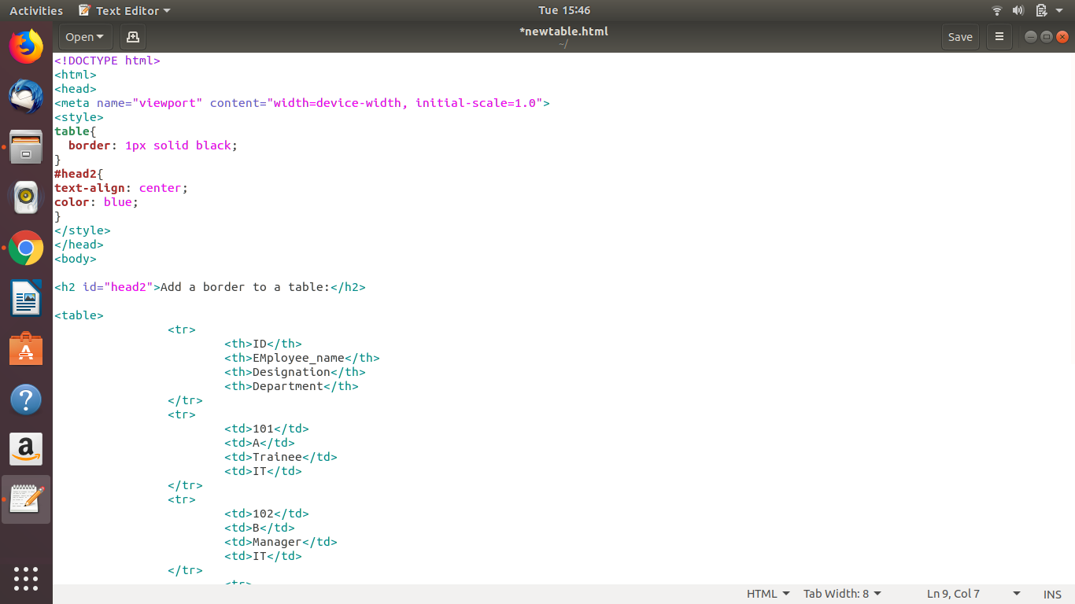
iii. CSS Class Selector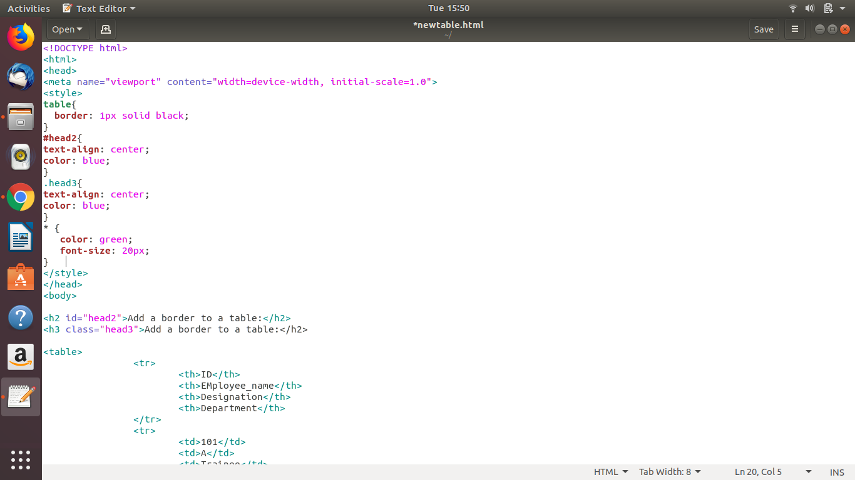
iv. CSS Universal Selector
v. CSS Group Selector
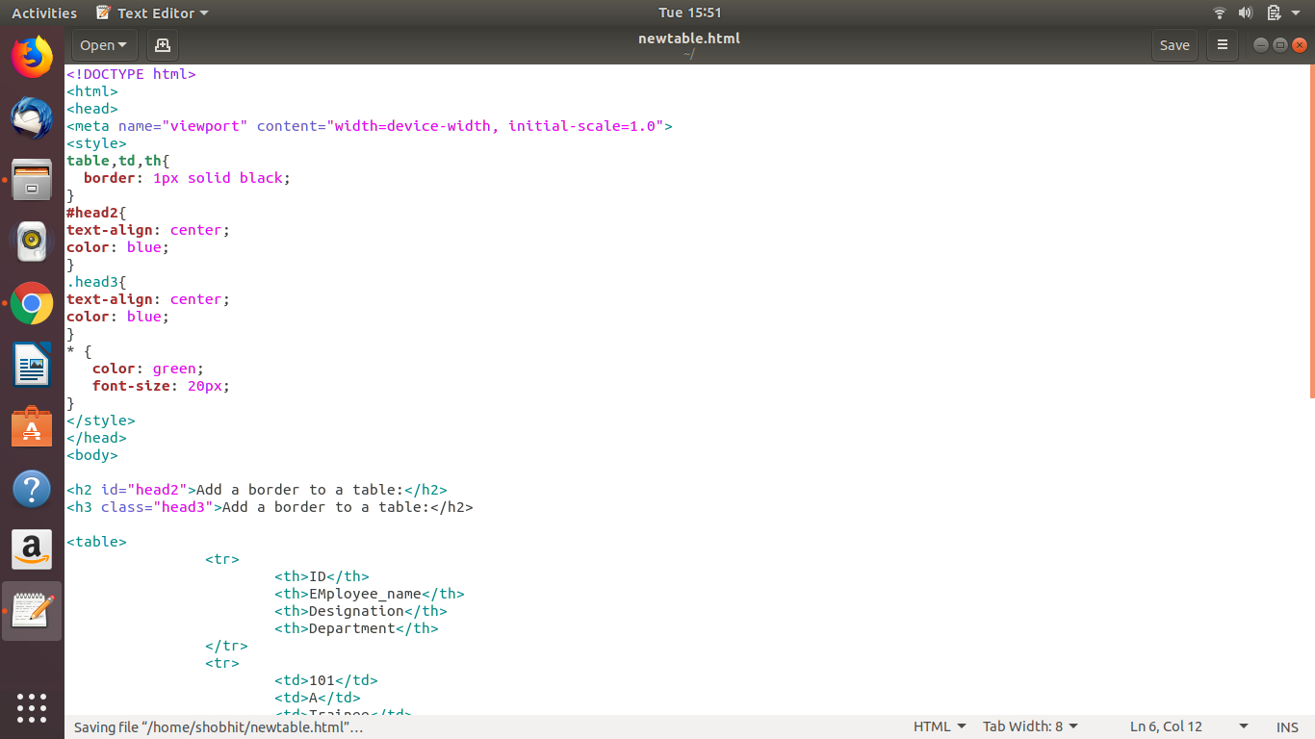
2.Combinator Selector
- descendant selector (space)
The descendant selector matches all elements that are descendants of a specified element.
The following example selects all <p> elements inside <div> elements:
div p {
background-color: yellow;
}
- child selector (>)
The child selector selects all elements that are the children of a specified element.
The following example selects all <p> elements that are children of a <div> element:
div > p {
background-color: yellow;
}
- adjacent sibling selector (+)
The adjacent sibling selector selects all elements that are the adjacent siblings of a specified element.
Sibling elements must have the same parent element, and "adjacent" means "immediately following".
The following example selects all <p> elements that are placed immediately after <div> elements:
div + p {
background-color: yellow;
}
- general sibling selector (~)
The general sibling selector selects all elements that are siblings of a specified element.
The following example selects all <p> elements that are siblings of <div> elements:
div ~ p {
background-color: yellow;
}
3.Pseudo Class Selectors
A pseudo-class is used to define a special state of an element.
For example, it can be used to:
- Style an element when a user mouses over it
- Style visited and unvisited links differently
- Style an element when it gets focus
The syntax of pseudo-classes:
selector:pseudo-class {
property:value;
}
4.Pseudo Element Selectors
A CSS pseudo-element is used to style specified parts of an element.
For example, it can be used to:
- Style the first letter, or line, of an element
- Insert content before, or after, the content of an element
The syntax of pseudo-elements:
selector::pseudo-element {
property:value;
}
5.Attribute Selectors
It is possible to style HTML elements that have specific attributes or attribute values.
The [attribute] selector is used to select elements with a specified attribute.
The following example selects all <a> elements with a target attribute:
a[target] {
background-color: yellow;
}
9.

The <!DOCTYPE> declaration is not just a html tag;; it is an instruction to the web browser about what version of HTML the page is written in.
It is the very first thing in the HTML document, before the <html> tag.

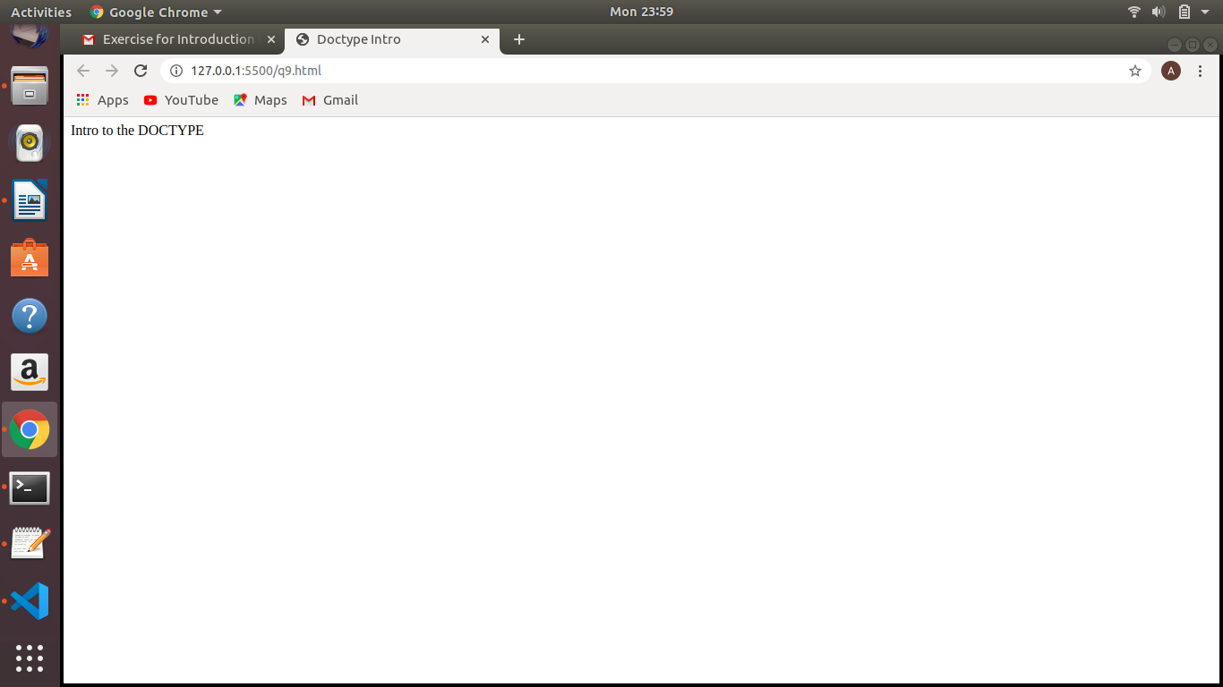
CODE :

<!DOCTYPE html>
<html lang="en">
<head>
<meta charset="UTF-8">
<meta name="viewport" content="width=device-width, initial-scale=1.0">
<title>Doctype Intro</title>
</head>
<body>
Intro to the DOCTYPE
</body>
</html>

10.
A semantic element clearly describes its meaning to both the browser and the developer.

a) <header>
- the <header> element specifies a header for a document.
- The <header> element should be used as a container for introductory content.

b) <footer>
- a <footer> element specifies a footer for a document
- a <footer> element should contain information about is containing element.
- A footer mainly contains the author of the document , copyright information, links to terms of use, contact information,etc.

c) <nav>
- the <nav> element defines a set of navigation links.

d) <aside>
- the <aside> element defines some content aside from the content it is placed in like sidebar.
- The <aside> content should be related to the surrounding content.

e) <section>
- the <section> element defines section in a document.

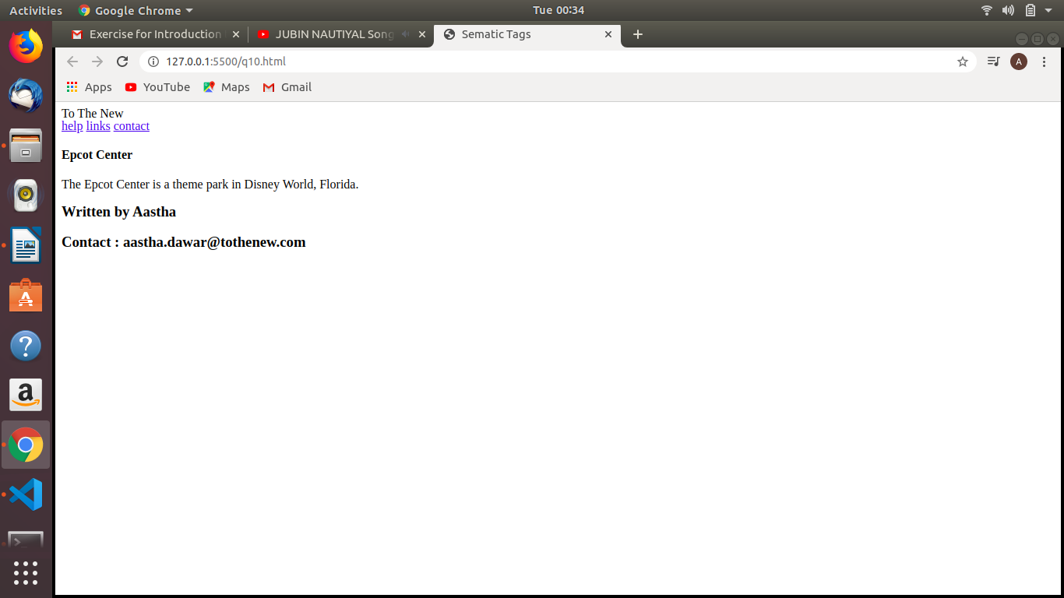

CODE :

<!DOCTYPE html>
<html lang="en">
<head>
<meta charset="UTF-8">
<meta name="viewport" content="width=device-width, initial-scale=1.0">
<title>Sematic Tags</title>
</head>
<body>
<article>
<header>
To The New
<nav>
<a href="#">help</a>
<a href="#">links</a>
<a href="#">contact</a>
</header>
</article>
<aside>
<h4>Epcot Center</h4>
<p>The Epcot Center is a theme park in Disney World, Florida.</p>
</aside>
<footer>
<h3>Written by Aastha</h3>
<h3>Contact : aastha.dawar@tothenew.com</h3>
</footer>
</body>
</html>

11.

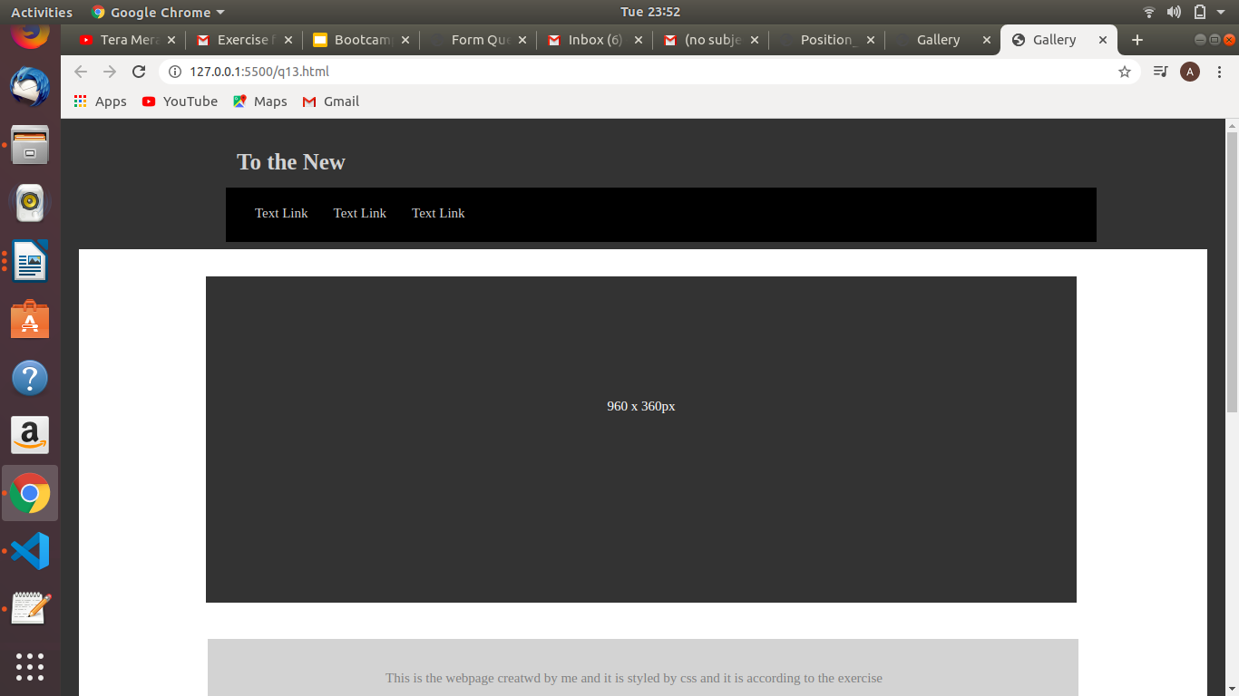
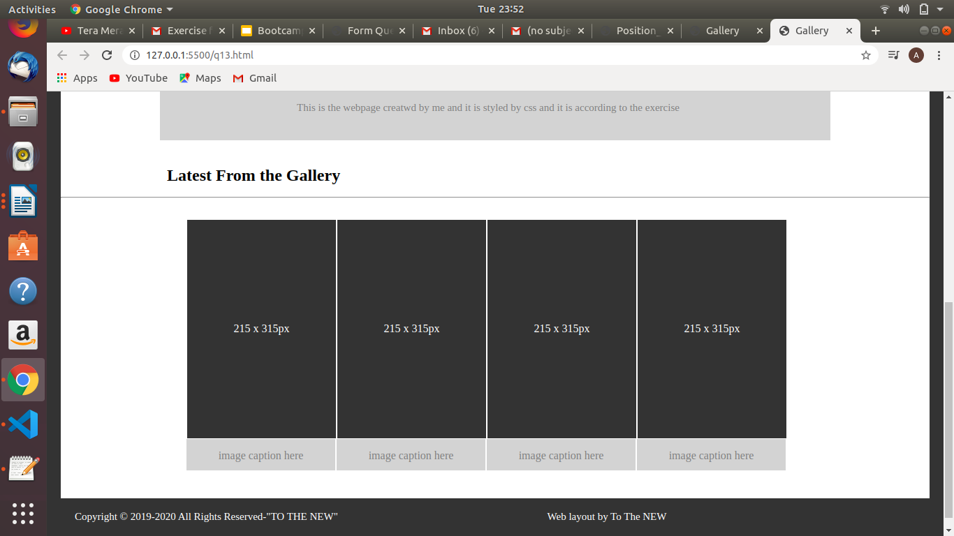

q13.html

<!Doctype html>
<html class="border">
<head>
<meta charset="UTF-8">
<title>Gallery</title>
<link rel="stylesheet" type="text/css" href="style.css" />
</head>
<body>

<div class="header">
<a href="#default" class="logo">To the New</a><br><br><br>
<div class="header-left">
<a class="active" href="#">Text Link</a>
<a href="#">Text Link</a>
<a href="#">Text Link</a>
</div>
</div>

<div class="body">
<p>960 x 360px</p>
</div>
<div class ="text">
<p>This is the webpage creatwd by me and it is styled by css and it is according to the exercise </p>

</div>
<br><br>
<h2 class ="heading">Latest From the Gallery</h2>
<hr>
<div class="body">
<ul class="list-container">
<li class="list-item">
<span>215 x 315px</span></li>
<li class="list-item">
<span>215 x 315px</span></li>
<li class="list-item">
<span>215 x 315px</span></li>
<li class="list-item">
<span>215 x 315px</span></li>
</ul>
<ul class="list-container">
<li class="list-item1 lmargin">
<span>image caption here</span></li>
<li class="list-item1 lmargin">
<span>image caption here</span></li>
<li class="list-item1 lmargin">
<span>image caption here</span></li>
<li class="list-item1 lmargin">
<span>image caption here</span></li>
</ul>
</div>
<!-- end of body ................................................................ -->
<!-- start of footer ............................................................ -->
<div class="footer">
<p style="color: white"> Copyright &copy; 2019-2020 All Rights Reserved-"TO THE NEW"&nbsp;&nbsp;&nbsp;&nbsp;&nbsp;&nbsp;&nbsp;&nbsp;&nbsp;&nbsp;&nbsp;&nbsp;&nbsp;&nbsp;&nbsp;&nbsp;&nbsp;&nbsp;&nbsp;&nbsp;&nbsp;&nbsp;&nbsp;&nbsp;&nbsp;&nbsp;&nbsp;&nbsp;&nbsp;&nbsp;&nbsp;&nbsp;&nbsp;&nbsp;&nbsp;&nbsp;&nbsp;&nbsp;&nbsp;&nbsp;&nbsp;&nbsp;&nbsp;&nbsp;&nbsp;&nbsp;&nbsp;&nbsp;&nbsp;&nbsp;&nbsp;&nbsp;&nbsp;&nbsp;&nbsp;&nbsp;&nbsp;&nbsp;&nbsp;&nbsp;&nbsp;&nbsp;&nbsp;&nbsp;&nbsp;&nbsp;&nbsp;&nbsp;&nbsp;&nbsp;&nbsp;&nbsp;&nbsp;&nbsp;&nbsp;&nbsp;&nbsp;&nbsp;&nbsp; Web layout by To The NEW </p>

</div>
<!-- end of footer ................................................................. -->
</div>
</body>

</html>

style.css
* {box-sizing: border-box;}

body {
margin: 0;
color:grey;
}
.border{
border-style: solid;
border-color: #333333;
border-width: 20px;
}
/*..................... Header css ............*/

.header {
overflow: hidden;
background-color: #333333;
padding: 8px 10px;
width: 100%;
margin: 0 auto;
color:black;
}

/*..................... Header NavBar css ............*/

.header a {
color: lightgrey;
text-align: center;
padding: 12px;
text-decoration: none;
font-size: 15px;
line-height: 20px;
border-radius: 4px;
}
/*..................... To The New logo css ............*/

.header a.logo {
font-size: 25px;
font-weight: bold;
color:lightgrey;
float: left;
margin-left: 152px;
}
.header a.logo:hover{
background-color: #333333;
color: lightgrey;
}

.header a:hover {
background-color: #ddd;
color: black;

}

/*
.header a.active {
!* background-color: dodgerblue;*!
color: white;

}
*/

.header-left {

padding: 20px;
margin-left: 152px;
width:960px;
float: center;

background: black;
}

.body {
overflow: hidden;
background-color: #333333;
width: 960px;
height: 360px;
margin: 30px 70px 40px 140px;
color:black;

}
.body p {
color: white;
text-align: center;
padding: 12px;
text-decoration: none;
font-size: 15px;
line-height: 20px;
padding-top: 120px;
border-radius: 4px;

}
.text{
overflow: hidden;
background-color: #d3d3d3 ;
padding: 8px 10px;
width: 960px;
margin: 0 auto;
color:black;
padding-right: 30px;
}
.text p {
color: grey;
text-align: center;
padding: 12px;
text-decoration: none;
font-size: 15px;
line-height: 20px;
border-radius: 4px;
}
.heading{
overflow: hidden;
background-color: white;
padding: 8px 10px;
width: 960px;
margin: 0 auto;
color:black;
}
.heading h2 {
color: grey;
text-align: center;
padding: 12px;
text-decoration: none;
font-size: 15px;
line-height: 20px;
border-radius: 4px;
}

.list-item {
color: white;
text-align: center;
padding: 10px;
height: 315px;
width: 215px;
list-style: none;
background: #333333;
display: flex;
border: 1px solid white;

justify-content: center;

align-items: center;
}
.list-container{
display: flex;

width: 960px;

justify-content: space-evenly;
background-color: white;
margin: 0 auto;
padding-right: 60px;
}
.list-item1{
color: grey;
text-align: center;
padding: 10px;
height: 50px;
width: 215px;
list-style: none;
background: lightgrey;
display: flex;

justify-content: center;

align-items: center;
}
.footer {
overflow: hidden;
background-color: #333333;
padding: 8px 10px;
width: 960px;
margin: 0 auto;
color:black;
width: 100%;
}

.footer p {
color: black;
text-align: left;
padding: 10px;
text-decoration: none;
font-size: 15px;
line-height: 20px;
border-radius: 4px;
margin: 0 auto;

}

.lmargin{
margin:0px 2px 0px 0px;
}

12.1.
A block-level element always starts on a new line and takes up the full width available .
e.g. <div> is block-level element

A n inline element does not start on a new line and only takes up as much width as necessary.
e.g. <span> is inline element

CODE :

<!DOCTYPE html>
<html lang="en">
<head>
<meta charset="UTF-8">
<meta name="viewport" content="width=device-width, initial-scale=1.0">
<title>inline and block</title>
<style>
.block{
padding:20px;
color:white;
background-color: black;
}
</style>
</head>
<body>
<h2>INLINE ELEMENT</h2>
<h2>hello <span style="color:red;">how are</span> you?</h2>
<hr>
<h2>BLOCK-LEVEL ELEMENT</h2>
<div class="block">
Lorem ipsum dolor sit amet, consectetur adipisicing elit. Inventore repellat ipsum fugit quas sit saepe corporis, qui itaque vel a ipsam ullam voluptate possimus atque! Sapiente similique reprehenderit tempora nesciunt.
</div>
</body>
</html>

2.
The display property specifies if/how an element is displayed.
Display:none ; is commonly used with Javascript to hide and show elements without deleting and recreating them.

visibility:hidden; hides an element.
The element still take up the same space as before. The element will be hidden, but still affect the layout.

CODE :

<!DOCTYPE html>
<html lang="en">
<head>
<meta charset="UTF-8">
<meta name="viewport" content="width=device-width, initial-scale=1.0">
<title>display and visibility</title>
<style>
.hidden{
visibility:hidden;
}
.display{
display: none;
}
</style>
</head>
<body>
<h1>this is a visible heading</h1>
<h2 class="hidden">this is a visiblity hidden heading</h2>
<h2>shown visibility hidden</h2>
<h2 class="display">this is display none heading</h2>
<h2>shown display none</h2>
</body>
</html>

3.
The float CSS Property places an element on the left or right side of its container, allowing text and inline elements to wrap around it. The element is removed from the normal flow of the page, though still remaining a part of the flow. It modifies the computed value of the display values.

float:left; the element must float on the left side of its containing block

float:right; the element must float on the right side of its containing block

float:none; the element must not float

float:inline-start; the element must float on the right side of its containing block. That is left side with ltr scripts and right side with rtl scripts.

Float:inline-end; the element must float on the end side of its containing block. That is right side with ltr scripts and left side with rtl scripts.

The clear property specifies what elements can float beside the cleared element and on which side.
The clear property can have one of the following values:
- none - Allows floating elements on both sides. This is default
- left - No floating elements allowed on the left side
- right- No floating elements allowed on the right side
- both - No floating elements allowed on either the left or the right side
- inherit - The element inherits the clear value of its parent
The most common way to use the clear property is after you have used a float property on an element.

CODE :

<!DOCTYPE html>
<html lang="en">
<head>
<meta charset="UTF-8">
<meta name="viewport" content="width=device-width, initial-scale=1.0">
<title>float property</title>
<style>
.left{
float:left;
background-color: coral;
}
section{
border: 1px solid blue;
width: 100%;
float:left;
}
div{

margin: 5px;
width: 50px;
height: 150px;
}
.left{
float: left;
background-color: coral;
}
.right{
float:right;
background-color: cyan;
}
img{
float:none;
}
</style>
</head>
<body>
<section>
<div class="left">1</div>
<div class="left">2</div>
<div class="right">3</div>
<p>Lorem ipsum dolor sit amet, consectetur adipisicing elit. Beatae nihil eius, aliquam autem expedita ut maxime enim totam exercitationem distinctio eos deserunt esse unde illo tenetur sapiente. Mollitia, facilis similique.</p>
<img src="https://s3-ap-southeast-1.amazonaws.com/bsy/iportal/images/handset-offer-banner-new_31F555919982EFE18360075F1D2EC443.png" alt="">
</section>
</body>
</html>

CODE :

<!DOCTYPE html>
<html lang="en">
<head>
<meta charset="UTF-8">
<meta name="viewport" content="width=device-width, initial-scale=1.0">
<title>clear property</title>
<style>
.black{
background-color: crimson;
color: black;
float: left;
width:20%;
}
.red{
background-color: burlywood;
float:left;
color:black;
width:20%;
}
.clear{
border: 3px solid brown;
clear:left;
}
p{
width:50%;
}
</style>
</head>
<body>
<div>
<p class="black">Lorem ipsum dolor sit amet consectetur adipisicing elit. Aut labore explicabo, est aliquid consequuntur veniam non accusantium quis tenetur id. Veritatis, porro. Perspiciatis suscipit nesciunt delectus quos! Fugiat, odit! Amet.</p>
<p class="red">Lorem ipsum dolor sit amet consectetur adipisicing elit. Autem sint vel velit laborum neque accusamus, laudantium explicabo voluptate numquam exercitationem, quos natus culpa maiores illum quibusdam quidem dolores ipsam hic!</p>
<p class="clear">clear left</p>
</div>
</body>
</html>

CODE :

<!DOCTYPE html>
<html lang="en">
<head>
<meta charset="UTF-8">
<meta name="viewport" content="width=device-width, initial-scale=1.0">
<title>clear property</title>
<style>
.black{
background-color: crimson;
color: black;
float: right;
width:20%;
}
.red{
background-color: burlywood;
float:right;
color:black;
width:20%;
}
.clear{
border: 3px solid brown;
clear:right;
}
p{
width:50%;
}
</style>
</head>
<body>
<div>
<p class="black">Lorem ipsum dolor sit amet consectetur adipisicing elit. Aut labore explicabo, est aliquid consequuntur veniam non accusantium quis tenetur id. Veritatis, porro. Perspiciatis suscipit nesciunt delectus quos! Fugiat, odit! Amet.</p>
<p class="red">Lorem ipsum dolor sit amet consectetur adipisicing elit. Autem sint vel velit laborum neque accusamus, laudantium explicabo voluptate numquam exercitationem, quos natus culpa maiores illum quibusdam quidem dolores ipsam hic!</p>
<p class="clear">clear right</p>
</div>
</body>
</html>

CODE :

<!DOCTYPE html>
<html lang="en">
<head>
<meta charset="UTF-8">
<meta name="viewport" content="width=device-width, initial-scale=1.0">
<title>clear property</title>
<style>
.black{
background-color: crimson;
color: black;
float: left;
width:20%;
}
.red{
background-color: burlywood;
float:right;
color:black;
width:20%;
}
.clear{
border: 3px solid brown;
clear:both;
}
p{
width:50%;
}
</style>
</head>
<body>
<div>
<p class="black">Lorem ipsum dolor sit amet consectetur adipisicing elit. Aut labore explicabo, est aliquid consequuntur veniam non accusantium quis tenetur id. Veritatis, porro. Perspiciatis suscipit nesciunt delectus quos! Fugiat, odit! Amet.</p>
<p class="red">Lorem ipsum dolor sit amet consectetur adipisicing elit. Autem sint vel velit laborum neque accusamus, laudantium explicabo voluptate numquam exercitationem, quos natus culpa maiores illum quibusdam quidem dolores ipsam hic!</p>
<p class="clear">clear both</p>
</div>
</body>
</html>

4.

The Position Property: The position property specifies the type of positioning method used for an element.
There are four different position values:
- static
- relative
- fixed
- absolute
Elements are then positioned using the top, bottom, left, and right properties. However, these properties will not work unless the position property is set first. They also work differently depending on the position value.
- position: static;
HTML elements are positioned static by default.
Static positioned elements are not affected by the top, bottom, left, and right properties.
An element with position: static; is not positioned in any special way; it is always positioned according to the normal flow of the page
- position: relative;
An element with position: relative; is positioned relative to its normal position.
Setting the top, right, bottom, and left properties of a relatively-positioned element will cause it to be adjusted away from its normal position. Other content will not be adjusted to fit into any gap left by the element.
- position: fixed;
An element with position: fixed; is positioned relative to the viewport, which means it always stays in the same place even if the page is scrolled. The top, right, bottom, and left properties are used to position the element.
A fixed element does not leave a gap in the page where it would normally have been located.
Notice the fixed element in the lower-right corner of the page.
- position: absolute;
An element with position: absolute; is positioned relative to the nearest positioned ancestor (instead of positioned relative to the viewport, like fixed).However; if an absolute positioned element has no positioned ancestors, it uses the document body, and moves along with page scrolling.
Note: A "positioned" element is one whose position is anything except static.

5.

Table.html

<!doctype html>
<html lang="en">
<head>
<meta charset="UTF-8">
<meta name="viewport"
content="width=device-width, user-scalable=no, initial-scale=1.0, maximum-scale=1.0, minimum-scale=1.0">
<meta http-equiv="X-UA-Compatible" content="ie=edge">
<link rel="stylesheet" type="text/css" href="tablestyle.css">

<title>TABLE</title>
</head>
<body>
<div style="overflow-x:auto">

<table style="width:100%">
<tr>
<th>ID</th>
<th>Employee Name</th>
<th>Designation</th>
<th>Department</th>
</tr>

<tr>
<td>1001</td>
<td>Smith</td>
<td>Accounting</td>
<td>Finance</td>
</tr>
<tr>
<td>1002</td>
<td>Jackson</td>
<td>Engineering</td>
<td>IT</td>
</tr>
<tr>
<td>1003</td>
<td>Jack</td>
<td>Sales</td>
<td>Marketing</td>
</tr>
<tr>
<td>1004</td>
<td>Rocky</td>
<td>Engineering</td>
<td>IT</td>
</tr>
<tr>
<td>1005</td>
<td>Watson</td>
<td>Sales</td>
<td>Marketing</td>
</tr>
<tr>
<td>1006</td>
<td>Michelle</td>
<td>Accounting</td>
<td>Finance</td>
</tr>

</table>
</div>
</body>

</html>

tablestyle.css

table {
border-collapse: collapse; /*The border-collapse property sets whether the table borders should be collapsed into a single border: */
width: 100%;
}
table, th, td {
border: 1px solid black;
height: 50px;
text-align: left;
padding: 15px;
}
tr:hover {
background-color: #f5f5f5;
}
th {
background-color: #4CAF50;
color: white;
}

6.
- metadata is the information about the data.
- The <meta> tag provides metadata about the html document. Metadata will not be displayed on the page , but will be machine parsable.
- Meta elements are typically used to specify page description keywords,author of the document,last modified,and other metadata.
- the metadata can be used by browsers,search engines or other web services.
- In HTML 5, web designers take control over the viewport through the <meta> tag.

CODE :

<!DOCTYPE html>
<html lang="en">
<head>
<meta charset="UTF-8">
<meta name="keywords" content="samsung,iphone,nokia,redmi">
<meta name="author" content="aastha">
<meta name="viewport" content="width=device-width, initial-scale=1.0">
<title>Document</title>
</head>
<body>
</body>
</html>

7.
MARGIN

CONTENT
PADDING
BORDER

CSS Box Model is essentially a box that wraps around every HTML element. It consists of:- margins,borders,padding and the actual content.

Content : the content of the box, where text and images appear
Padding : Cllears an area around the content. The padding is transparent.
Border : A border that goes around the padding and content.
Margin : Clears an area outside the border. The margin is transparent.
CODE :

<!DOCTYPE html>
<html lang="en">
<head>
<meta charset="UTF-8">
<meta name="viewport" content="width=device-width, initial-scale=1.0">
<title>CSS Box Model</title>
<style>
.box{
width : 500px;
padding : 20px;
border : 10px solid yellowgreen;
margin : 30px;
}
</style>
</head>
<body>
<div class="box">
Lorem ipsum, dolor sit amet consectetur adipisicing elit. Eveniet praesentium ducimus ipsum odit, saepe id temporibus nam quas? Velit, sequi perferendis maxime eos consequuntur officiis laborum nobis cumque ex placeat?
</div>
</body>
</html>

8.

CSS selectors are used to select the content you want to style. Selectors are the part of CSS rule set. CSS selectors select HTML elements according to its id, class, type, attribute etc.
There are several different types of selectors in CSS.
1.Simple Selectors
i. CSS Element Selector
ii. CSS Id Selector
iii. CSS Class Selector
iv. CSS Universal Selector
v. CSS Group Selector
2.Combinator Selector
- descendant selector (space)
The descendant selector matches all elements that are descendants of a specified element.
The following example selects all <p> elements inside <div> elements:
div p {
background-color: yellow;
}
- child selector (>)
The child selector selects all elements that are the children of a specified element.
The following example selects all <p> elements that are children of a <div> element:
div > p {
background-color: yellow;
}
- adjacent sibling selector (+)
The adjacent sibling selector selects all elements that are the adjacent siblings of a specified element.
Sibling elements must have the same parent element, and "adjacent" means "immediately following".
The following example selects all <p> elements that are placed immediately after <div> elements:
div + p {
background-color: yellow;
}
- general sibling selector (~)
The general sibling selector selects all elements that are siblings of a specified element.
The following example selects all <p> elements that are siblings of <div> elements:
div ~ p {
background-color: yellow;
}
3.Pseudo Class Selectors
A pseudo-class is used to define a special state of an element.
For example, it can be used to:
- Style an element when a user mouses over it
- Style visited and unvisited links differently
- Style an element when it gets focus
The syntax of pseudo-classes:
selector:pseudo-class {
property:value;
}
4.Pseudo Element Selectors
A CSS pseudo-element is used to style specified parts of an element.
For example, it can be used to:
- Style the first letter, or line, of an element
- Insert content before, or after, the content of an element
The syntax of pseudo-elements:
selector::pseudo-element {
property:value;
}
5.Attribute Selectors
It is possible to style HTML elements that have specific attributes or attribute values.
The [attribute] selector is used to select elements with a specified attribute.
The following example selects all <a> elements with a target attribute:
a[target] {
background-color: yellow;
}
9.

The <!DOCTYPE> declaration is not just a html tag;; it is an instruction to the web browser about what version of HTML the page is written in.
It is the very first thing in the HTML document, before the <html> tag.

CODE :

<!DOCTYPE html>
<html lang="en">
<head>
<meta charset="UTF-8">
<meta name="viewport" content="width=device-width, initial-scale=1.0">
<title>Doctype Intro</title>
</head>
<body>
Intro to the DOCTYPE
</body>
</html>

10.
A semantic element clearly describes its meaning to both the browser and the developer.

a) <header>
- the <header> element specifies a header for a document.
- The <header> element should be used as a container for introductory content.

b) <footer>
- a <footer> element specifies a footer for a document
- a <footer> element should contain information about is containing element.
- A footer mainly contains the author of the document , copyright information, links to terms of use, contact information,etc.

c) <nav>
- the <nav> element defines a set of navigation links.

d) <aside>
- the <aside> element defines some content aside from the content it is placed in like sidebar.
- The <aside> content should be related to the surrounding content.

e) <section>
- the <section> element defines section in a document.

CODE :

<!DOCTYPE html>
<html lang="en">
<head>
<meta charset="UTF-8">
<meta name="viewport" content="width=device-width, initial-scale=1.0">
<title>Sematic Tags</title>
</head>
<body>
<article>
<header>
To The New
<nav>
<a href="#">help</a>
<a href="#">links</a>
<a href="#">contact</a>
</header>
</article>
<aside>
<h4>Epcot Center</h4>
<p>The Epcot Center is a theme park in Disney World, Florida.</p>
</aside>
<footer>
<h3>Written by Aastha</h3>
<h3>Contact : aastha.dawar@tothenew.com</h3>
</footer>
</body>
</html>

11.

q13.html

<!Doctype html>
<html class="border">
<head>
<meta charset="UTF-8">
<title>Gallery</title>
<link rel="stylesheet" type="text/css" href="style.css" />
</head>
<body>

<div class="header">
<a href="#default" class="logo">To the New</a><br><br><br>
<div class="header-left">
<a class="active" href="#">Text Link</a>
<a href="#">Text Link</a>
<a href="#">Text Link</a>
</div>
</div>

<div class="body">
<p>960 x 360px</p>
</div>
<div class ="text">
<p>This is the webpage creatwd by me and it is styled by css and it is according to the exercise </p>

</div>
<br><br>
<h2 class ="heading">Latest From the Gallery</h2>
<hr>
<div class="body">
<ul class="list-container">
<li class="list-item">
<span>215 x 315px</span></li>
<li class="list-item">
<span>215 x 315px</span></li>
<li class="list-item">
<span>215 x 315px</span></li>
<li class="list-item">
<span>215 x 315px</span></li>
</ul>
<ul class="list-container">
<li class="list-item1 lmargin">
<span>image caption here</span></li>
<li class="list-item1 lmargin">
<span>image caption here</span></li>
<li class="list-item1 lmargin">
<span>image caption here</span></li>
<li class="list-item1 lmargin">
<span>image caption here</span></li>
</ul>
</div>
<!-- end of body ................................................................ -->
<!-- start of footer ............................................................ -->
<div class="footer">
<p style="color: white"> Copyright &copy; 2019-2020 All Rights Reserved-"TO THE NEW"&nbsp;&nbsp;&nbsp;&nbsp;&nbsp;&nbsp;&nbsp;&nbsp;&nbsp;&nbsp;&nbsp;&nbsp;&nbsp;&nbsp;&nbsp;&nbsp;&nbsp;&nbsp;&nbsp;&nbsp;&nbsp;&nbsp;&nbsp;&nbsp;&nbsp;&nbsp;&nbsp;&nbsp;&nbsp;&nbsp;&nbsp;&nbsp;&nbsp;&nbsp;&nbsp;&nbsp;&nbsp;&nbsp;&nbsp;&nbsp;&nbsp;&nbsp;&nbsp;&nbsp;&nbsp;&nbsp;&nbsp;&nbsp;&nbsp;&nbsp;&nbsp;&nbsp;&nbsp;&nbsp;&nbsp;&nbsp;&nbsp;&nbsp;&nbsp;&nbsp;&nbsp;&nbsp;&nbsp;&nbsp;&nbsp;&nbsp;&nbsp;&nbsp;&nbsp;&nbsp;&nbsp;&nbsp;&nbsp;&nbsp;&nbsp;&nbsp;&nbsp;&nbsp;&nbsp; Web layout by To The NEW </p>

</div>
<!-- end of footer ................................................................. -->
</div>
</body>

</html>

style.css
* {box-sizing: border-box;}

body {
margin: 0;
color:grey;
}
.border{
border-style: solid;
border-color: #333333;
border-width: 20px;
}
/*..................... Header css ............*/

.header {
overflow: hidden;
background-color: #333333;
padding: 8px 10px;
width: 100%;
margin: 0 auto;
color:black;
}

/*..................... Header NavBar css ............*/

.header a {
color: lightgrey;
text-align: center;
padding: 12px;
text-decoration: none;
font-size: 15px;
line-height: 20px;
border-radius: 4px;
}
/*..................... To The New logo css ............*/

.header a.logo {
font-size: 25px;
font-weight: bold;
color:lightgrey;
float: left;
margin-left: 152px;
}
.header a.logo:hover{
background-color: #333333;
color: lightgrey;
}

.header a:hover {
background-color: #ddd;
color: black;

}

/*
.header a.active {
!* background-color: dodgerblue;*!
color: white;

}
*/

.header-left {

padding: 20px;
margin-left: 152px;
width:960px;
float: center;

background: black;
}

.body {
overflow: hidden;
background-color: #333333;
width: 960px;
height: 360px;
margin: 30px 70px 40px 140px;
color:black;

}
.body p {
color: white;
text-align: center;
padding: 12px;
text-decoration: none;
font-size: 15px;
line-height: 20px;
padding-top: 120px;
border-radius: 4px;

}
.text{
overflow: hidden;
background-color: #d3d3d3 ;
padding: 8px 10px;
width: 960px;
margin: 0 auto;
color:black;
padding-right: 30px;
}
.text p {
color: grey;
text-align: center;
padding: 12px;
text-decoration: none;
font-size: 15px;
line-height: 20px;
border-radius: 4px;
}
.heading{
overflow: hidden;
background-color: white;
padding: 8px 10px;
width: 960px;
margin: 0 auto;
color:black;
}
.heading h2 {
color: grey;
text-align: center;
padding: 12px;
text-decoration: none;
font-size: 15px;
line-height: 20px;
border-radius: 4px;
}

.list-item {
color: white;
text-align: center;
padding: 10px;
height: 315px;
width: 215px;
list-style: none;
background: #333333;
display: flex;
border: 1px solid white;

justify-content: center;

align-items: center;
}
.list-container{
display: flex;

width: 960px;

justify-content: space-evenly;
background-color: white;
margin: 0 auto;
padding-right: 60px;
}
.list-item1{
color: grey;
text-align: center;
padding: 10px;
height: 50px;
width: 215px;
list-style: none;
background: lightgrey;
display: flex;

justify-content: center;

align-items: center;
}
.footer {
overflow: hidden;
background-color: #333333;
padding: 8px 10px;
width: 960px;
margin: 0 auto;
color:black;
width: 100%;
}

.footer p {
color: black;
text-align: left;
padding: 10px;
text-decoration: none;
font-size: 15px;
line-height: 20px;
border-radius: 4px;
margin: 0 auto;

}

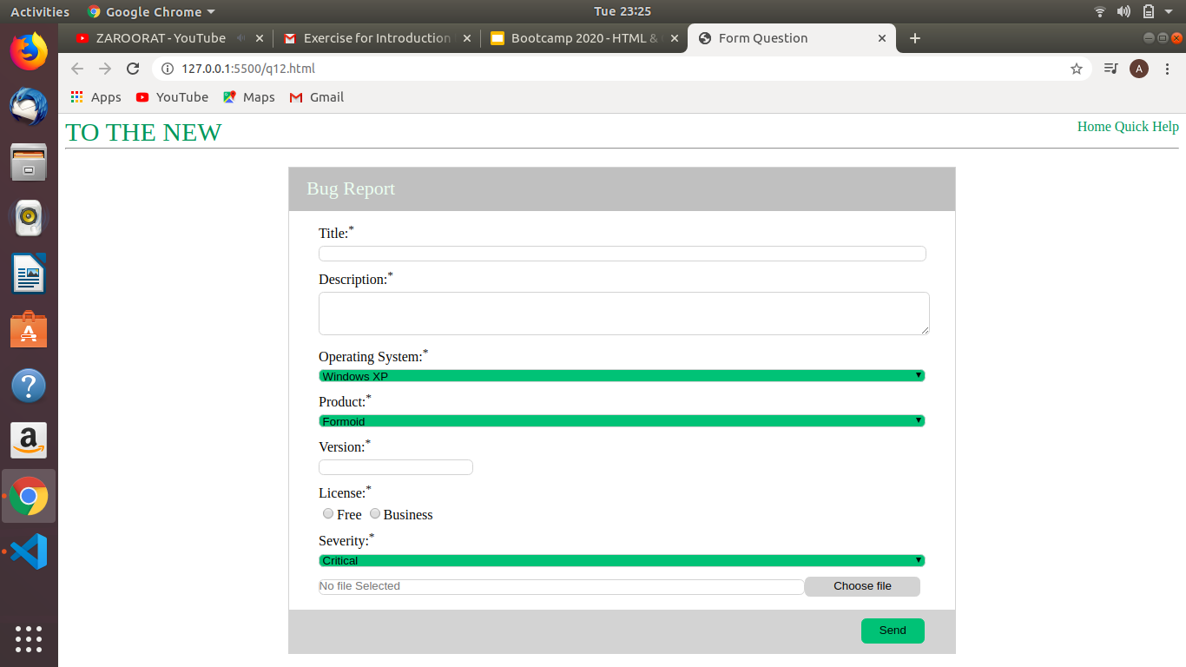
CODE :

q12.html

<!DOCTYPE html>
<html lang="en">
<head>
<meta charset="UTF-8">
<meta name="viewport" content="width=device-width, initial-scale=1.0">
<title>Form Question</title>
<link rel="stylesheet" href="q12.css">
</head>
<body>
<div class="container">
<header>
<nav>
<div class="left font">
<a href="">TO THE NEW</a>
</div>
<div class="right">
<a href="">Home</a>
<a href="">Quick Help</a>
</div>
</nav>
</header>
<hr class="clear">
<section class="clear border">
<header class="header">
<p class="content">Bug Report</p>
</header>
<form action="#" >
<table >
<div class="title padding ">
<label class="lmargin display" for="">Title:<sup>*</sup></label>
<input class="display width iborder " type="text">
</div>
<div class="desc padding">
<label class="lmargin display" for="">Description:<sup>*</sup></label>
<textarea name="" id="" cols="30" rows="3" class="display width textarea "></textarea>
</div>
<div class="os padding">
<label class="display lmargin" for="">Operating System:<sup>*</sup></label>
<select name="os" id="" class="display select width iborder ">
<option value="">Windows XP</option>
<option value="">Ubuntu</option>
<option value="">MAC</option>
<option value="">Windows 8</option>
</select>
</div>
<div class="product padding">
<label class="lmargin display" for="">Product:<sup>*</sup></label>
<select name="product" id="" class="display select width iborder ">
<option value="">Formoid</option>
<option value="">Vegetable</option>
<option value="">Mobiles</option>
<option value="">Laptop</option>
</select>
</div>
<div class="version padding">
<label class="display width lmargin" for="">Version:<sup>*</sup></label>
<input class="display version iborder " type="text">
</div>
<div class="license padding">
<label class="display width lmargin" for="">License:<sup>*</sup></label>
<div>
<input type="radio" name="license" >Free
<input type="radio" name="license" >Business
</div>
</div>
<div class="severity padding">
<label class="display lmargin" for="">Severity:<sup>*</sup></label>
<select name="severity" id="" class="display select width iborder ">
<option value="">Critical</option>
<option value="">Low</option>
<option value="">High</option>
<option value="">Medium</option>
</select>
</div>
<div class="attachment padding ">
<input type="text" class="display attach iborder" placeholder="No file Selected"><button class="abutton" type="button">Choose file</button>
</div>
<footer class="footer">
<button class="button">Send</button>
</footer>
</table>
</form>
</section>
</div>
</body>
</html>

q12.css

a{
text-decoration: none;
color:seagreen;
}
.font{
font-size: 30px;
}
.left{
float:left;
}
.right{
float:right;
}
.width{
width: 100%;
}
.clear{
clear:both;
}
.width{
widows: 100px;
}
.display{
display:inline-block;
}
.border{
border: 0.5px solid lightgray;
padding: 0px 30px 30px 30px;
margin: 20px 20% 0px 20%;
}
.header{
margin: 0px -29px 10px;
padding: 0px;
background-color:silver;
height:50px;
}
.content{
padding: 15px 20px 10px;
margin:0px;
color:honeydew;
font-size: 22px;
}
.footer{
margin: 10px -29px -30px -29px;
background-color: lightgray;
height:50px;
}
.button{
margin:10px 35px 5px 5px;
padding:6px 20px 6px 20px;
float:right;
background-color: mediumseagreen;
border: 1px solid mediumseagreen;
border-radius: 1.5mm;
}
.abutton{
margin:0px;
padding:3px 32px 3px 32px;
background-color:lightgray;
border: 1px solid lightgrey;
border-radius: 1.5mm;
}
.attach{
width: 80%;
height:20px;
}
.version{
width:50%
}
.padding{
padding:5px;
}
.iborder{
border-radius: 1.5mm;
border: 0.5px solid lightgrey;
height:15px;
}
.textarea{
border-radius: 1.5mm;
border: 0.5px solid lightgrey;
}
.margin{
margin:5px;
}
.lmargin{
margin:0px 0px 5px 0px;
}
.select{
background-color:mediumseagreen;
}
.radio{
padding:0px 40% 0px 0px;
}

