ASSESSMENT - JAVASCRIPT

ANS 1. CODE :

<!DOCTYPE html>
<html>
<head>
<title></title>
</head>
<body>
<script type="text/javascript">
window.onload = function(){ var p=prompt("Enter amount");
var r=prompt("Enter rate");
var t=prompt("Enter time");
var i=(p*r*t)/100;
alert("SIMPLE INTEREST "+i);}
</script>
</body>
</html>

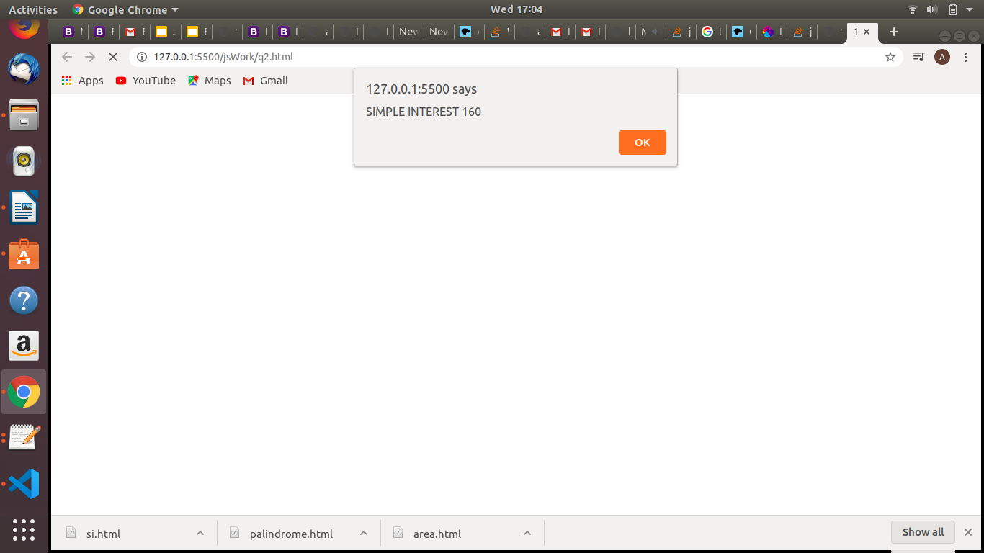
ANS 2. CODE :

<!DOCTYPE html>
<html>
<head>
<title></title>
</head>
<body>
<script type="text/javascript">
window.onload = function(){
var str=prompt("Enter the string");
var len = str.length;
var mid = Math.floor(len/2);

for ( var i = 0; i < mid; i++ ) {
if (str[i] !== str[len - 1 - i]) {
alert("String is not palindrome");
}
}
alert("String is palindrome");}
</script>
</body>
</html>

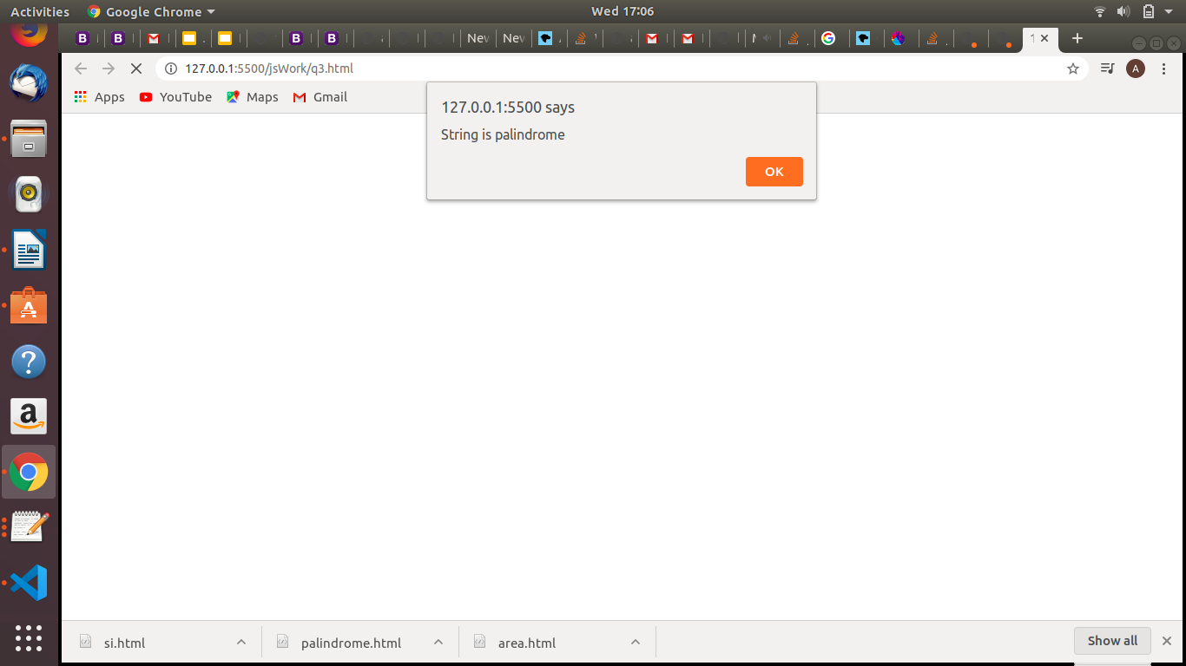

ANS 3. CODE :

<!DOCTYPE html>
<html lang="en">
<head>
<meta charset="UTF-8">
<meta name="viewport" content="width=device-width, initial-scale=1.0">
<title>Document</title>
<script>
function Calc(){
var radius = document.getElementById("radius").value;
if((typeof(radius))=="string" && radius!=null)
{
var area = 0.5*3.14*radius*radius;
document.getElementById("div").innerText = "Area of the circle is: "+area;
}
}
</script>
</head>
<body>
<input type="number" id="radius" placeholder="enter the radius" >
<button onclick="Calc()">Area</button>
<div id="div"></div>
</body>
</html>

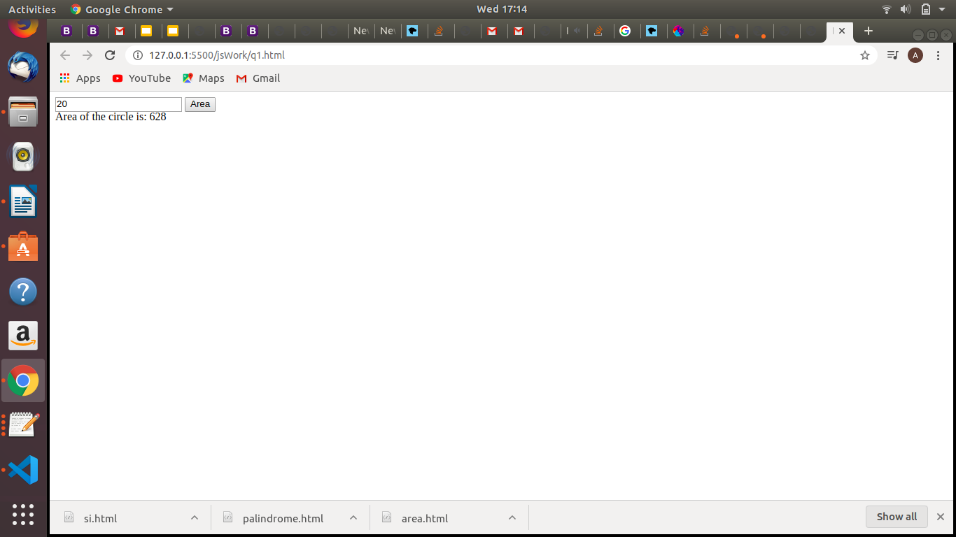

ANS 4 . Spread syntax allows an iterable such as an array expression or string to be expanded in places where zero or more arguments (for function calls) or elements (for array literals) are expected, or an object expression to be expanded in places where zero or more key-value pairs (for object literals) are expected.

CODE:
*******

var obj1 = {id:14,name:'aastha',no:999999,address:'vikaspuri'};
var obj2 = {...obj1};
console.log(obj2);
obj1.id = 15;
console.log(obj1);
console.log(obj2);

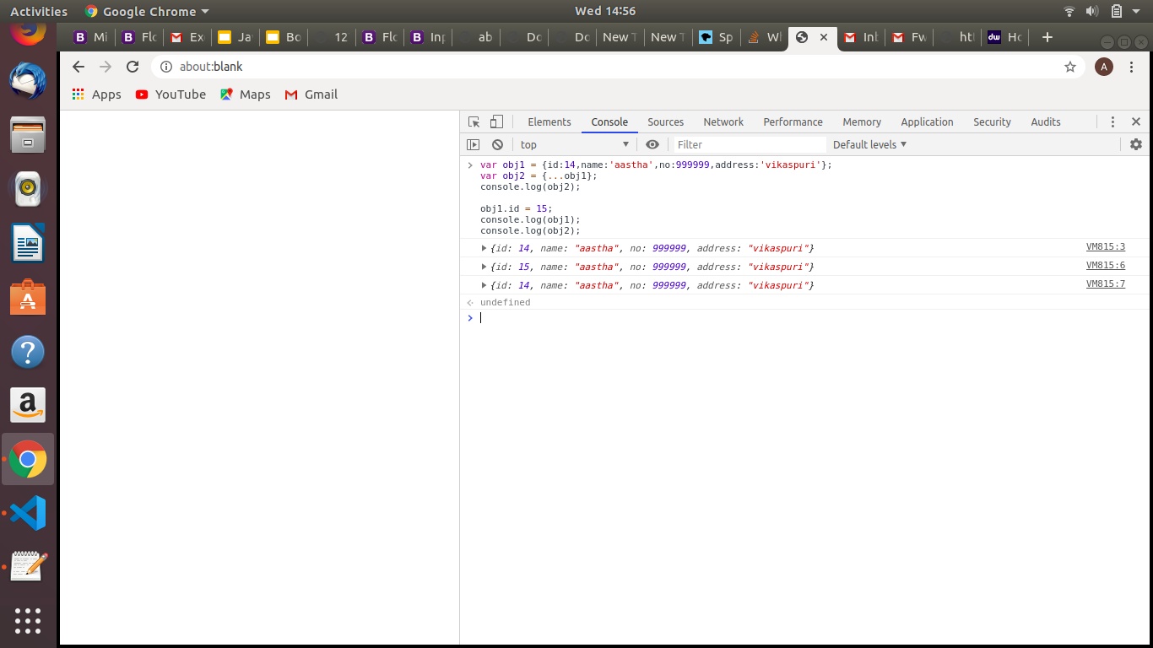

ANS 5.

a) CODE :

var arr = [{id:1,age:20,sal:2000,dob:'2-2-98'},{id:12,age:15,sal:6000,dob:'3-3-98'},{id:3,age:25,sal:8000,dob:'4-4-98'},{id:4,age:18,sal:10000,dob:'5-5-98'},{id:5,age:22,sal:4000,dob:'6-6-98'},{id:6,age:30,sal:9000,dob:'7-7-98'}];

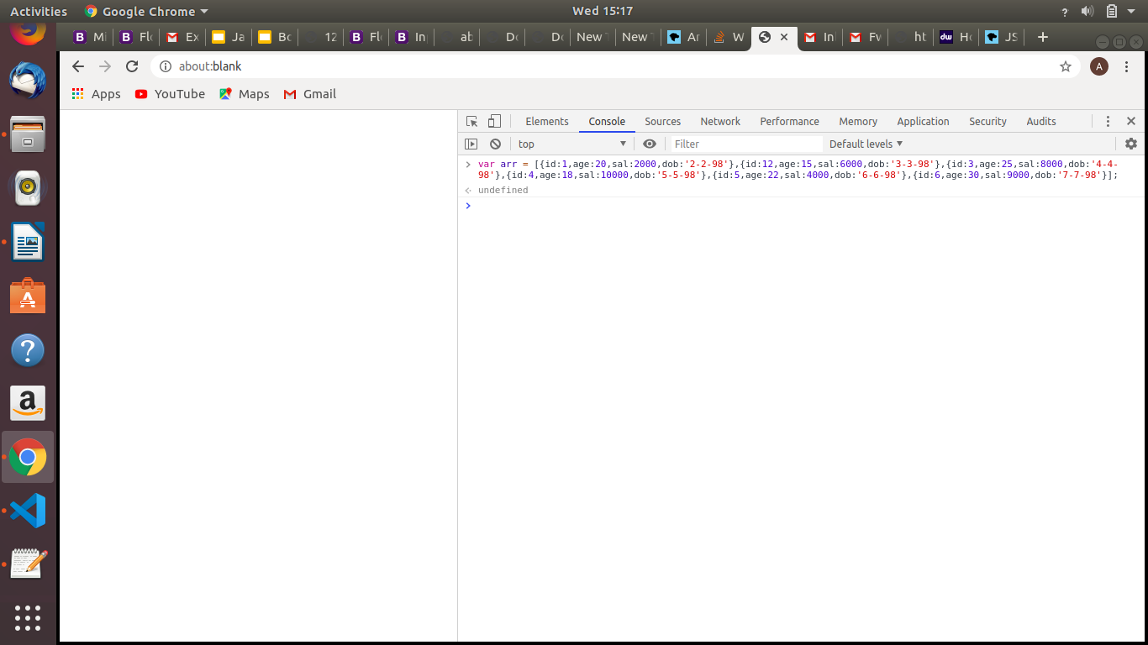
b)
CODE :

var arr = [{id:1,age:20,sal:2000,dob:'2-2-98'},{id:12,age:15,sal:6000,dob:'3-3-98'},{id:3,age:25,sal:8000,dob:'4-4-98'},{id:4,age:18,sal:10000,dob:'5-5-98'},{id:5,age:22,sal:4000,dob:'6-6-98'},{id:6,age:30,sal:9000,dob:'7-7-98'}];
var result = arr.filter(obj=>obj.sal>5000);
console.log("total no. of employees are",result.length);
for(let i=0;i<result.length;i++)
{
console.log("employee no.",i);
console.log("ID is",result[i].id,"age is",result[i].age,"sal is",result[i].sal,"dob is",result[i].dob);
}

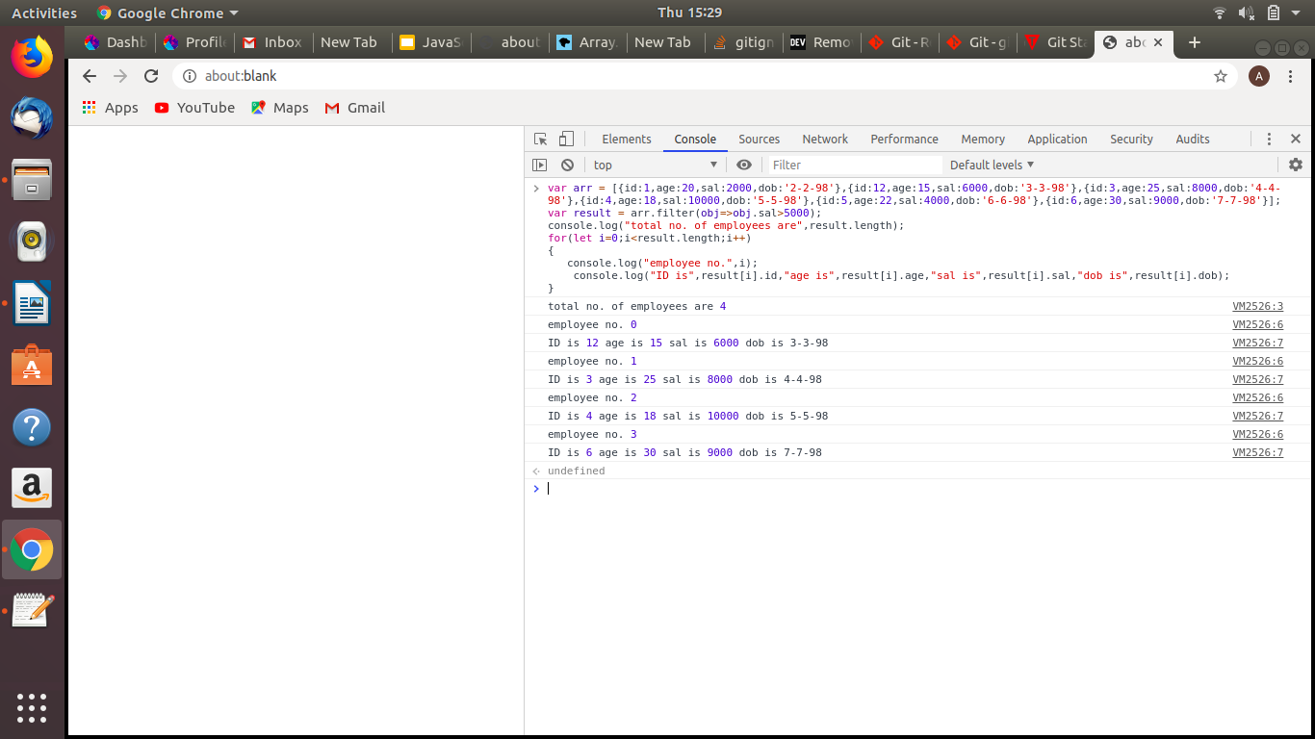
c) CODE :

var arr1 = [{id:1,age:23,sal:500,dob:'2-2-98'},{id:12,age:23,sal:6000,dob:'3-3-98'},{id:3,age:25,sal:8000,dob:'4-4-98'},{id:4,age:18,sal:10000,dob:'5-5-98'},{id:5,age:22,sal:4000,dob:'6-6-98'},{id:6,age:30,sal:9000,dob:'7-7-98'}];

const groupedData = {};

arr1.forEach((val) => {
if(groupedData[val.age]) {
groupedData[val.age].push(val);
} else {
groupedData[val.age] = [val];
}
});

groupedData;

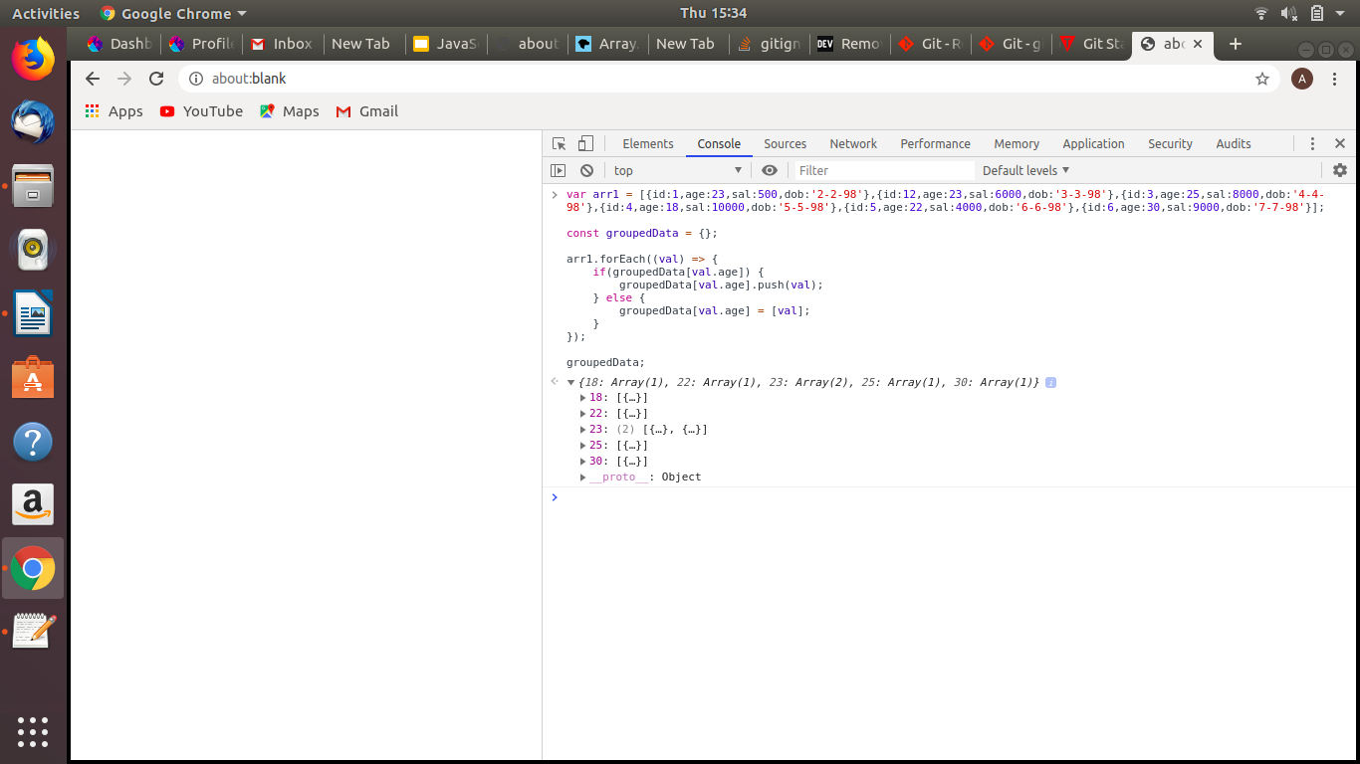

d) CODE :

var arr1 = [{id:1,age:23,sal:500,dob:'2-2-98'},{id:12,age:15,sal:6000,dob:'3-3-98'},{id:3,age:25,sal:8000,dob:'4-4-98'},{id:4,age:18,sal:10000,dob:'5-5-98'},{id:5,age:22,sal:4000,dob:'6-6-98'},{id:6,age:30,sal:9000,dob:'7-7-98'}];

var result = arr1.filter(function(obj){
if(obj.sal<1000 && obj.age>20)
{ console.log(obj);
return obj; }
});

var final = result.map(obj=> ({...obj, sal: obj.sal*5}));

final;

