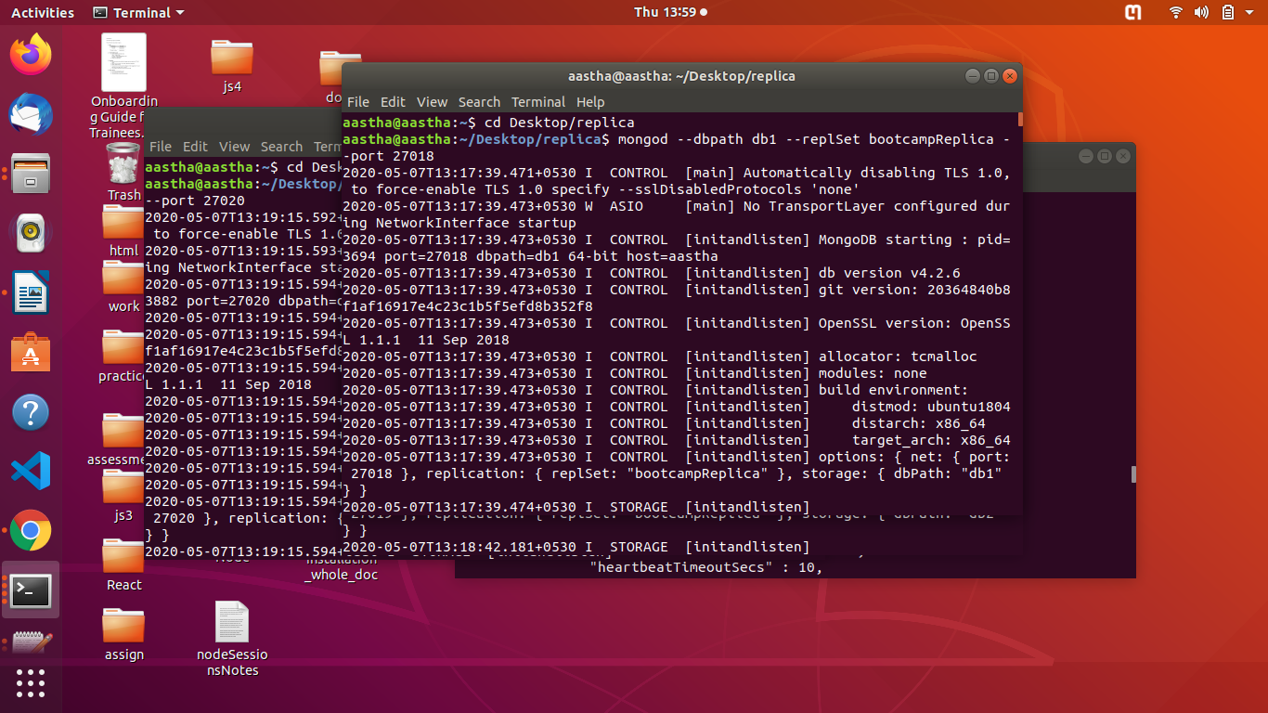
- mongod --dbpath db1 --replSet bootcampReplica --port 27018 : to start mongod without authentication means without username and password

(2) running 3 instance for 3 servers

mongod --dbpath db1 --replSet bootcampReplica --port 27018
mongod --dbpath db2 --replSet bootcampReplica --port 27019
mongod --dbpath db3 --replSet bootcampReplica --port 27020

running mongo shell on 3 instances and making port 27018 as primary

mongo –port 27018
mongo –port 27019
mongo –port 27020

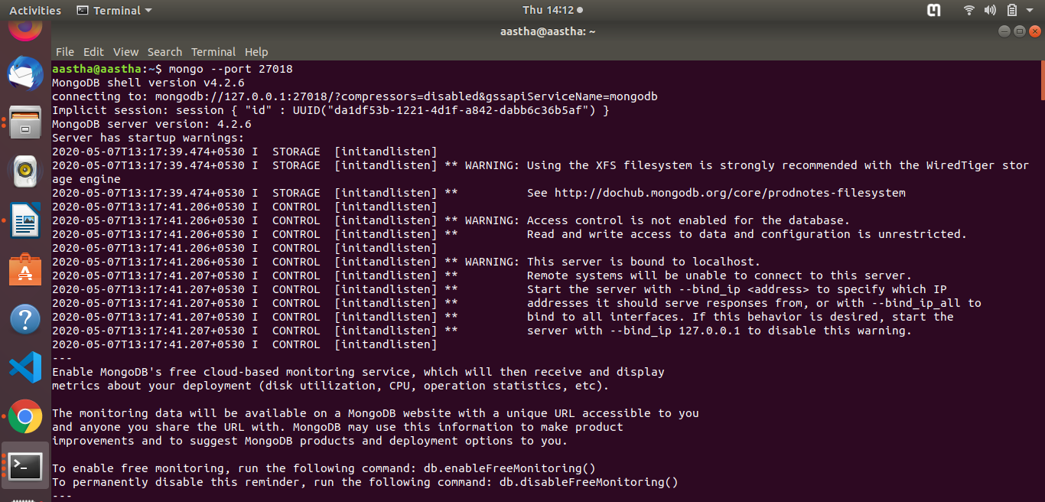
initiate the configuration in port 27018

rs.initiate(configuration)
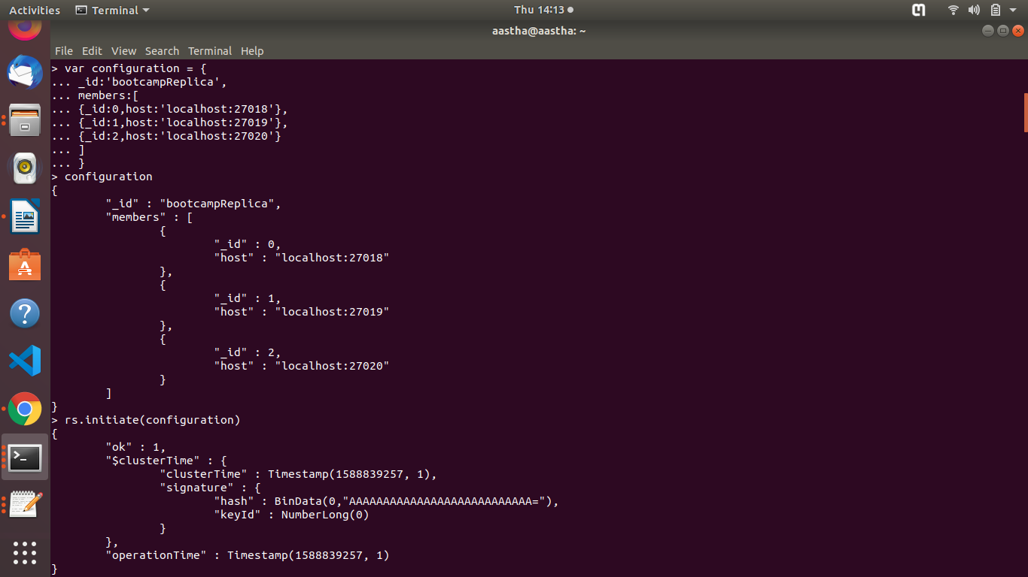
considering port 27018 as primary

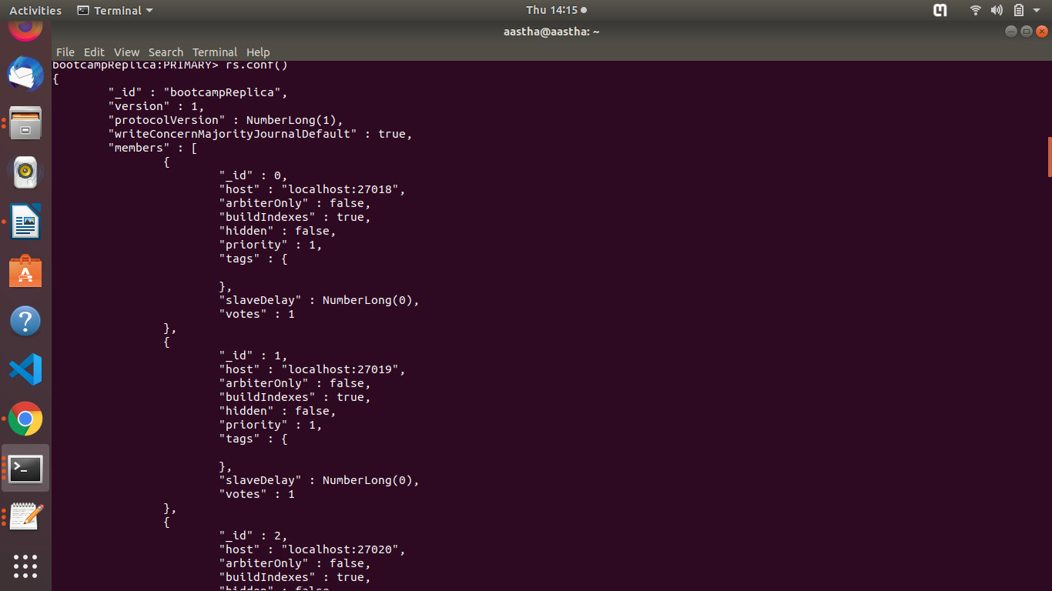

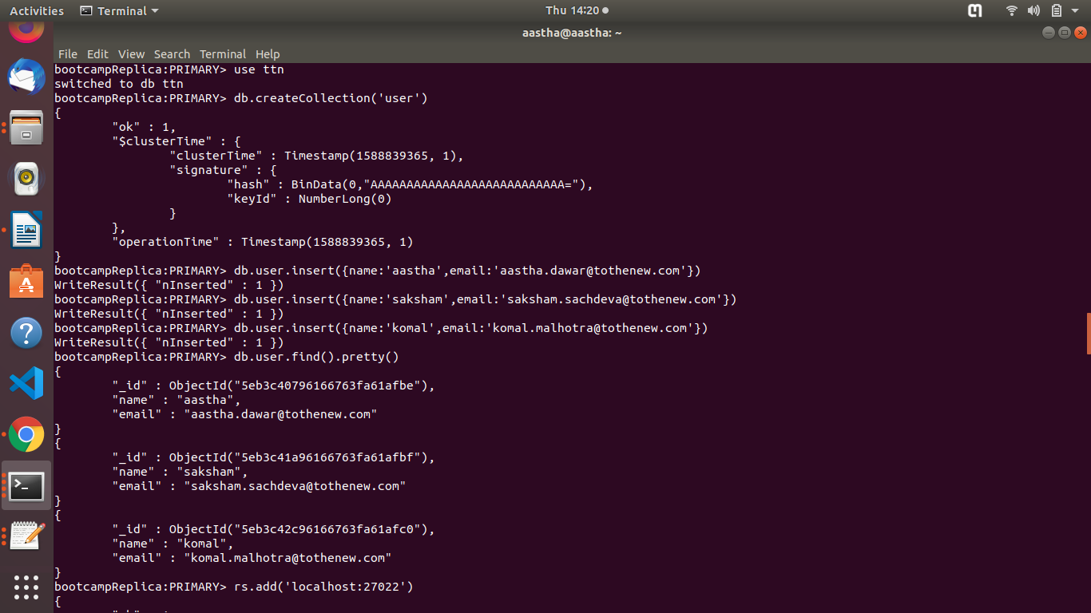
creating database ttn and user collection in primary

(3) setting up replication with arbiter

rs.addArb('localhost:27021')

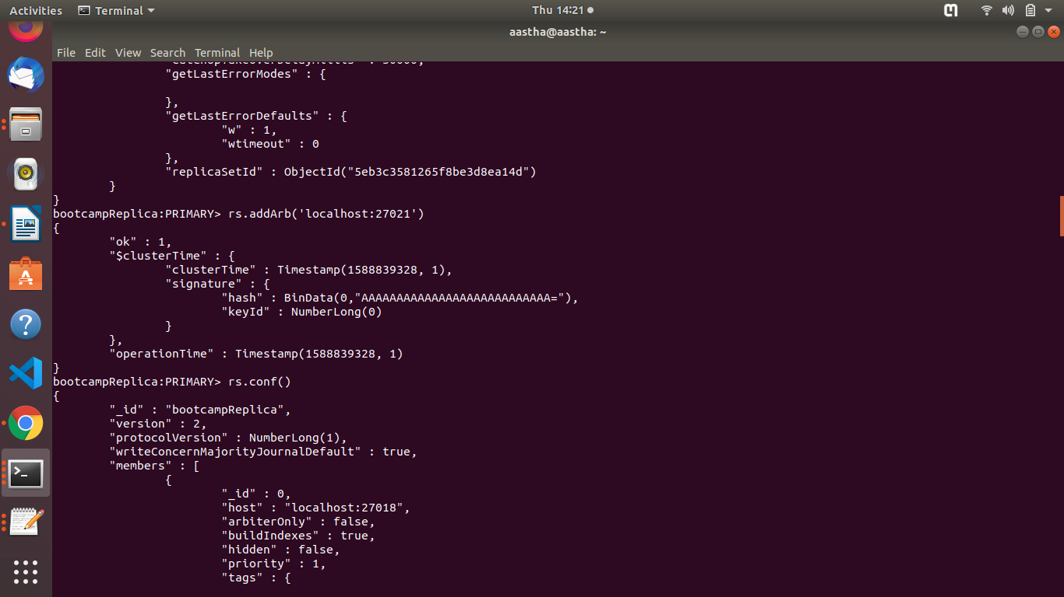

check in secondary whether replication occured or not

rs.slaveOk(true) : to allow secondary to read records
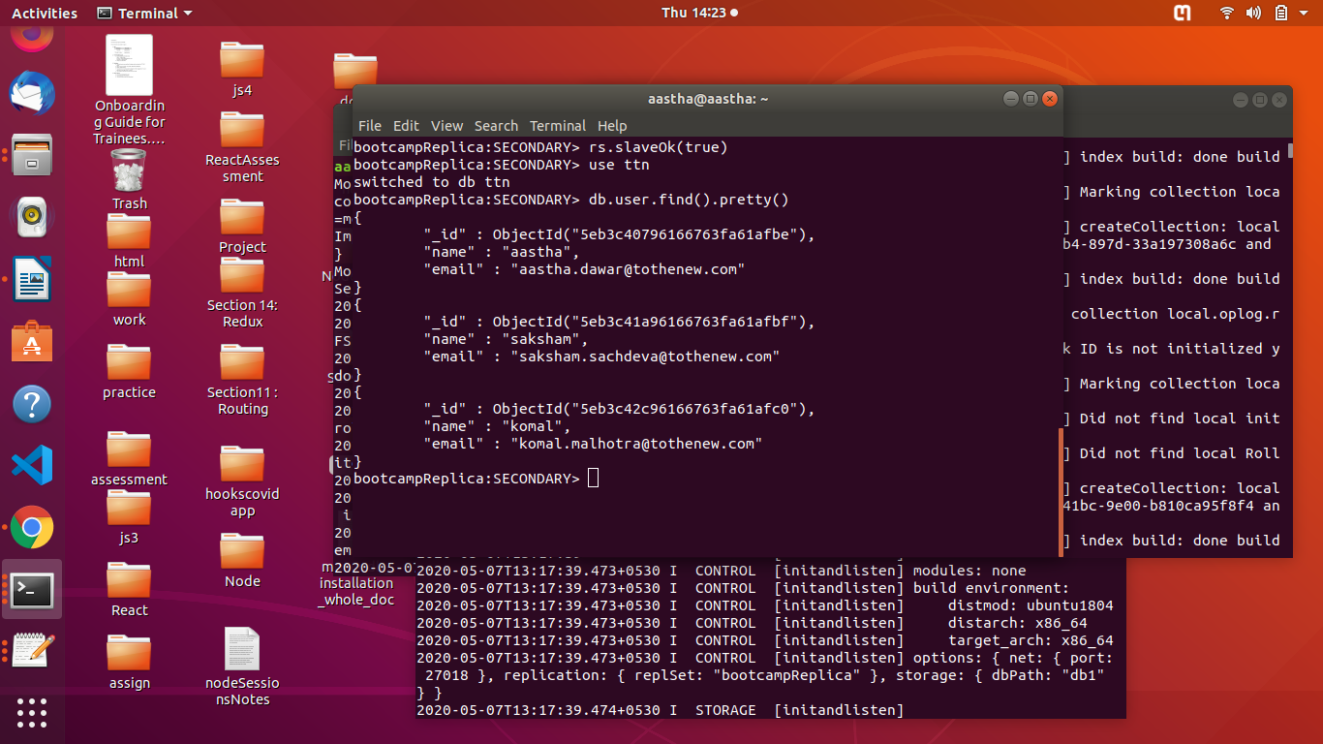

(4) adding 2 more members to replica set

rs.add('localhost:27022')
rs.add('localhost:27023')
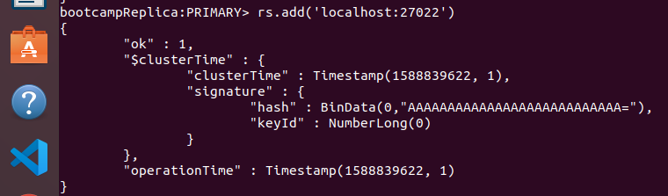

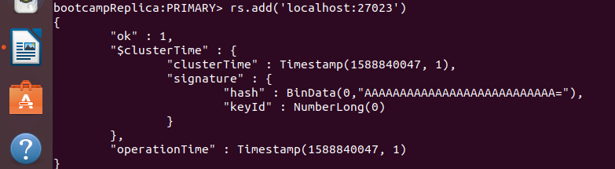

(5) made a instance on new port 27026
added a database and collection and inserted record in it

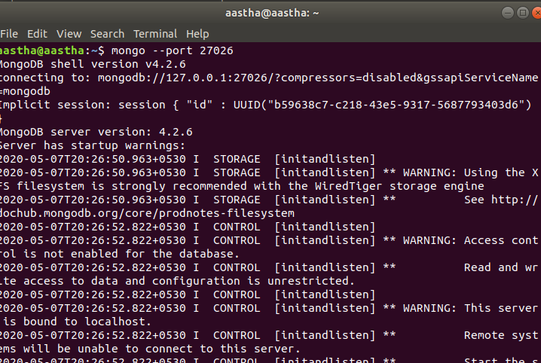

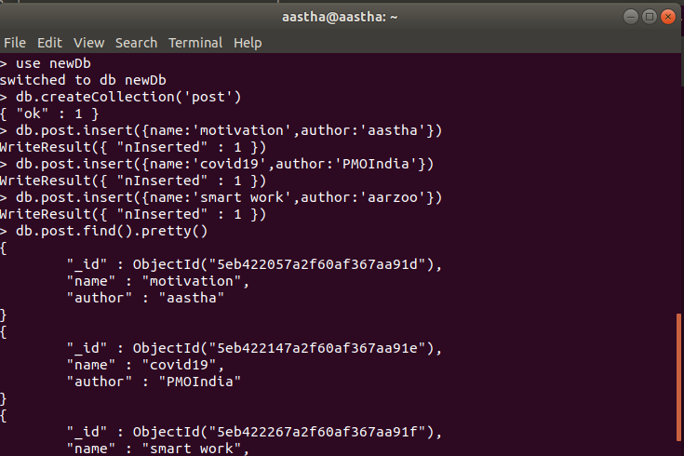

now added this new port 27026 with data as a member in primary

