- Use MYWall : to create a database name MYWall and switch to it if it is not present
else if database is present, it will switch to that database

show dbs : it will show all the databases once the collection is added to that database
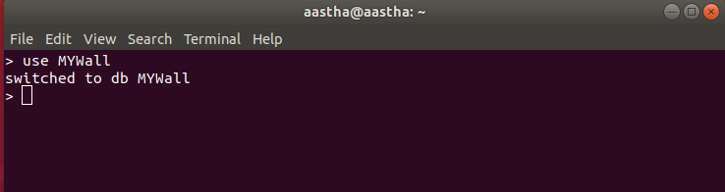
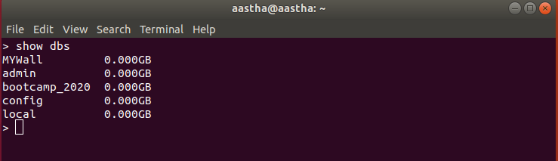
********************************************************************************
(2) db.createCollection(‘user’) : it is used to create a user collection inside the database MYWall

db.createCollection(‘post’) : it is used to create a post collection inside the database MYWall

show collections : it is used to see all the collections in MYWall database
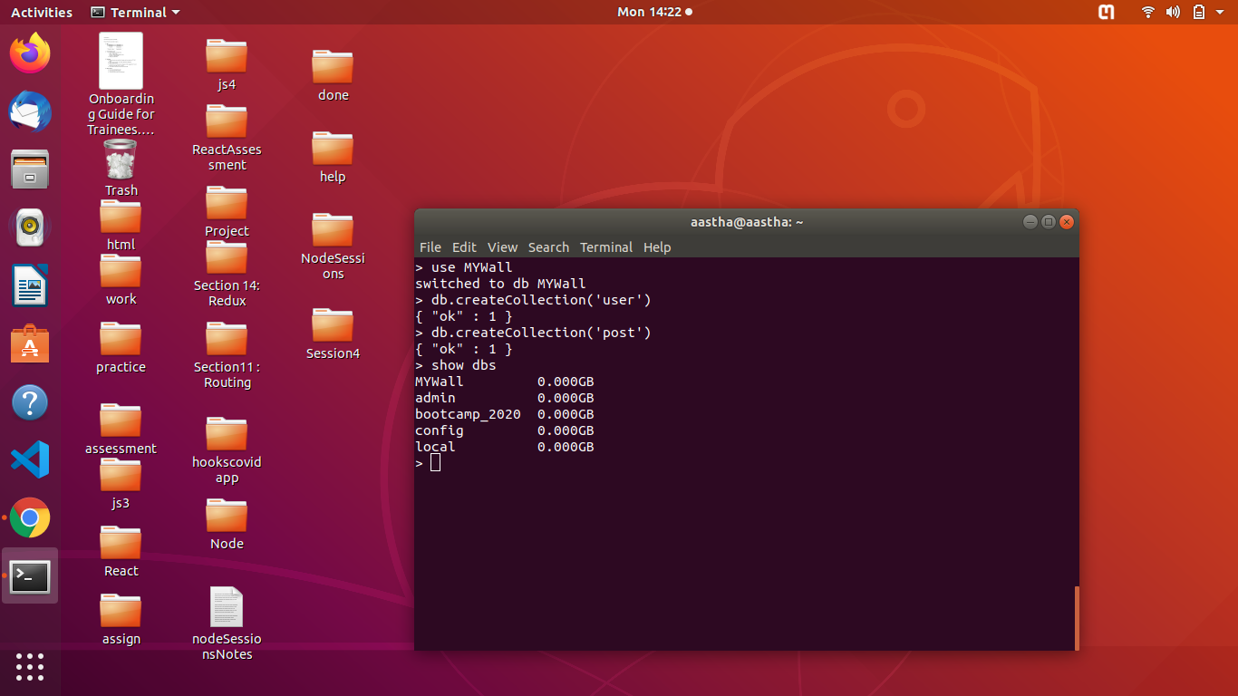

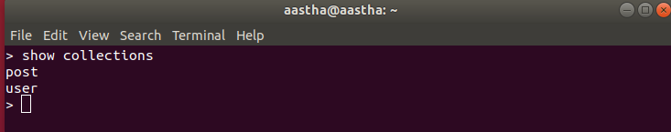
********************************************************************************
(3) db.post.insert({post_id:1,title:'creativity',description:'this is a creativity post which includes beautiful art work',posted_by:'aarzoo',comments:[{comment_id:1000,message:'nice',timestamp:new Date().toTimeString()}],created_at:Date()}) : to insert a record in post collection with the following fields

db.post.find().pretty() : to see all the records of post collection

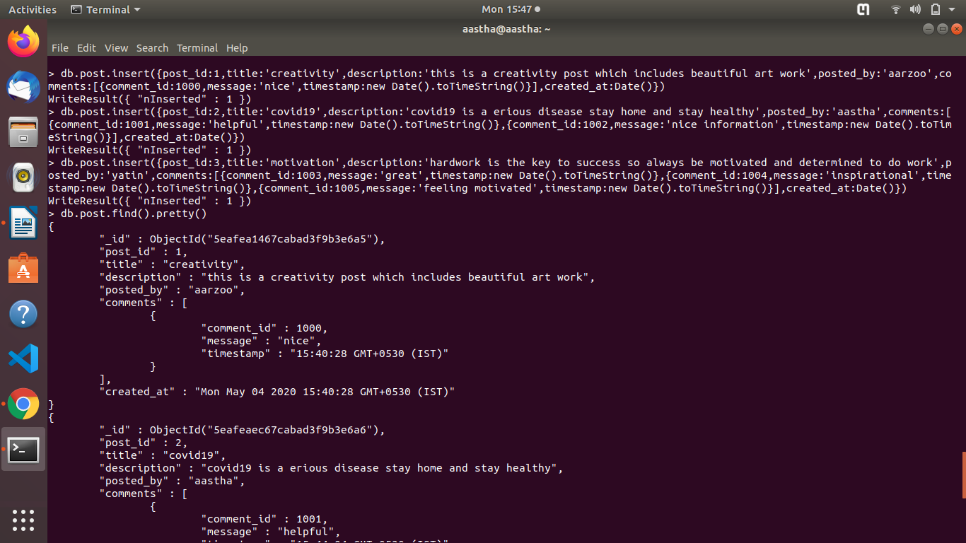

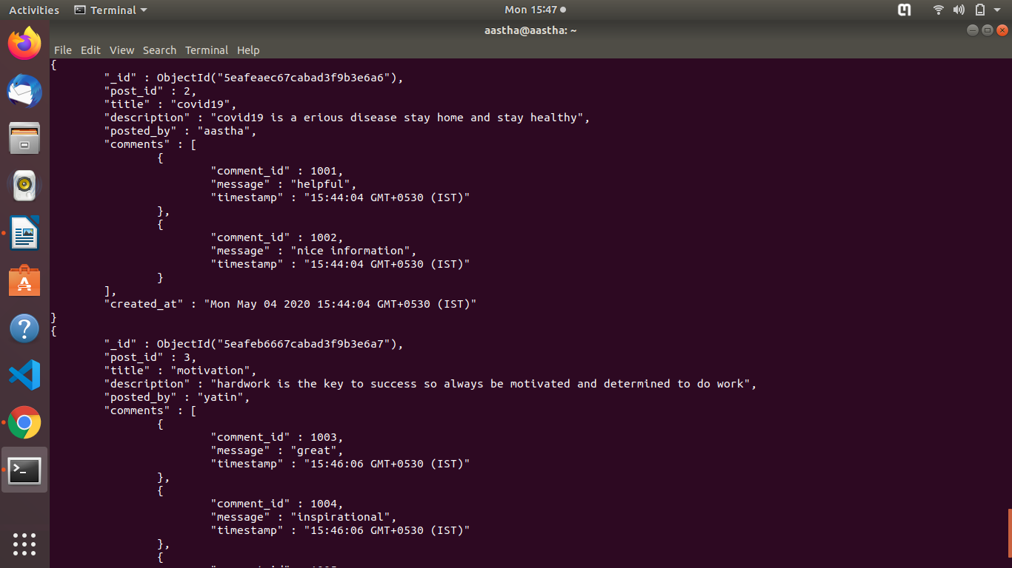

db.user.insert({name:’aastha’,email:’aastha.dawar@tothenew.com’,city:’delhi’}) : it is
used to insert a record inside collection user.

db.user.find().pretty() : it is used to find all the records of the user collection and pretty is used
to show it in easily readable form.

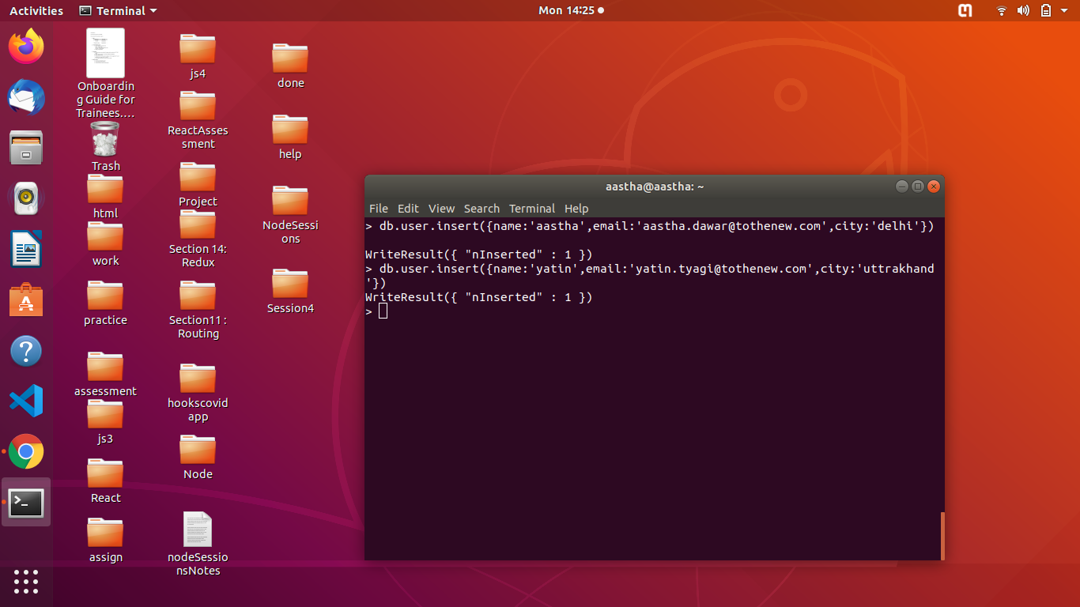
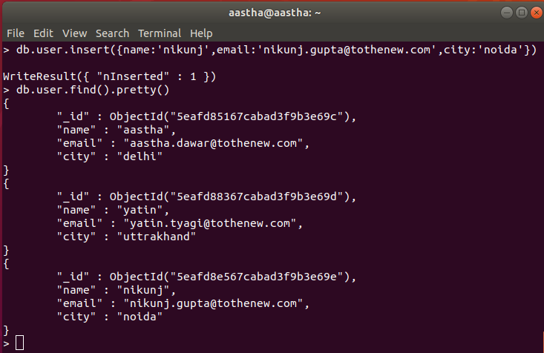

********************************************************************************
(4) db.post.insert({post_id:4,title:'machine learning',description:'machine learning is done using python which is used for analytics puropse',posted_by:'nikunj',created_at:Date()}) : created a record which is not having comments array

db.post.update({post_id:4},{$set:{comments:[{comment_id:1007,message:'knowledgable',timestamp:new Date().toTimeString()}]}}) : now added comments to this record of post_id:4 which is initially not having comments array

(also comments were added in initial 3 records)

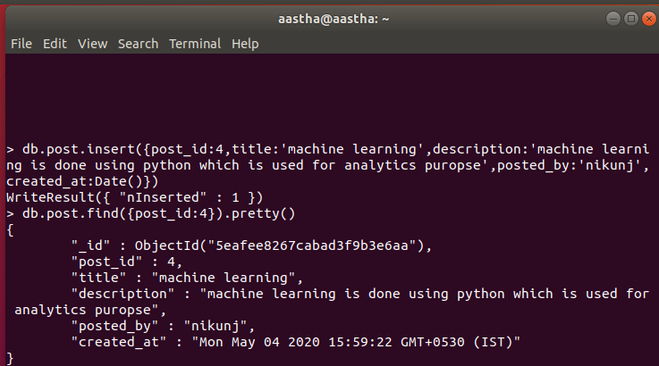

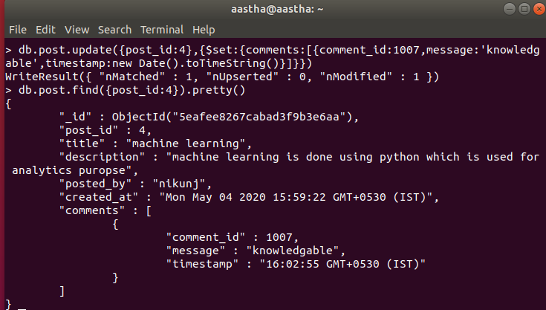

*******************************************************************************
(5) db.post.update({post_id:1},{$push:{comments:{comment_id:1006,message:'i love your work',timestamp:new Date().toTimeString()}}}) : added a new comment to a record having post_id as 1

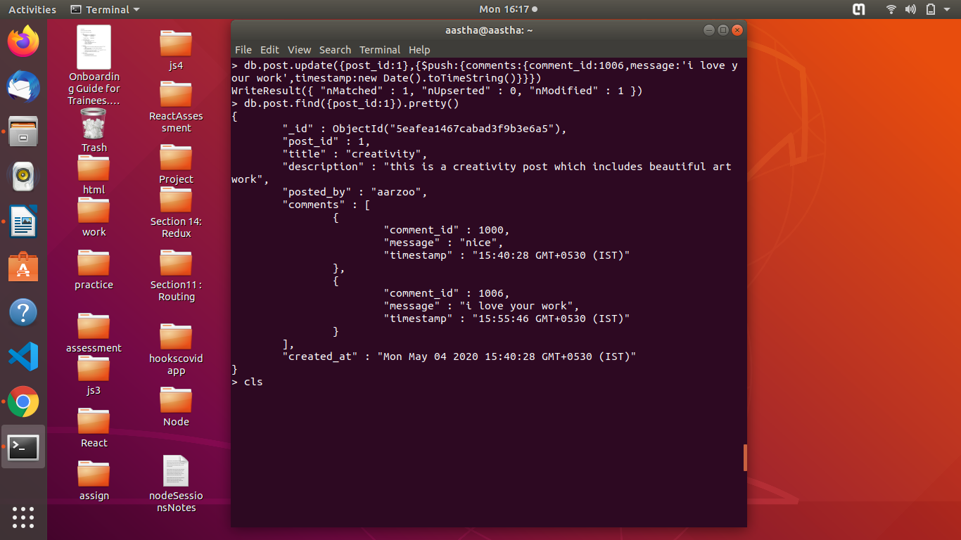
********************************************************************************
(6) db.post.update({post_id:3},{$set:{description:'smart work is very important in life'}}) : to update the description of post_id which is 3
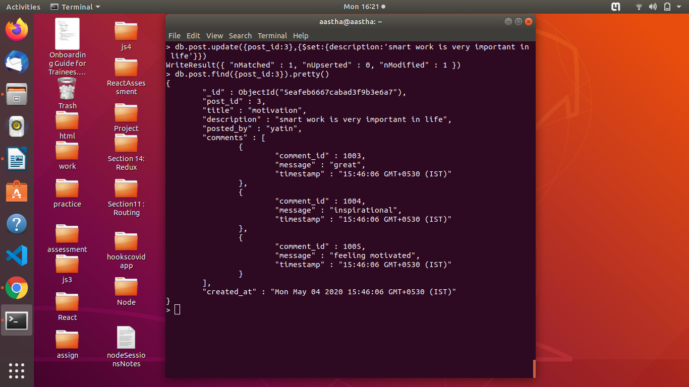

*******************************************************************************
(7) db.post.update({post_id:1,'comments.comment_id':1006},{$set:{'comments.$.message':'i found ur work fascinating'}}) : to update the comment message having comment_id as 1006 and with the post_id as 1 (used positional operator)

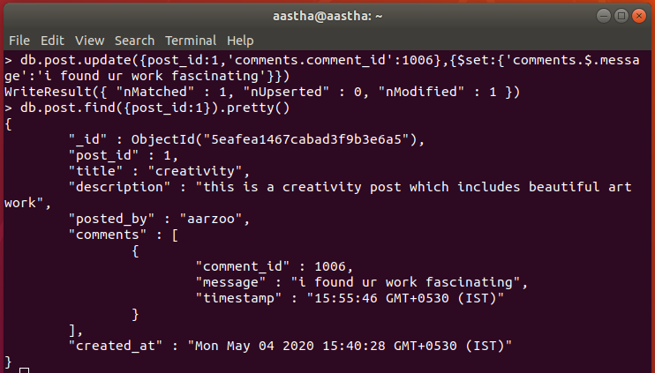

*******************************************************************************
(8) db.post.update({post_id:1},{$pull:{comments:{comment_id:1000}}}) : query to delete a comment with comment_id (1000) of post with post_id (1)

