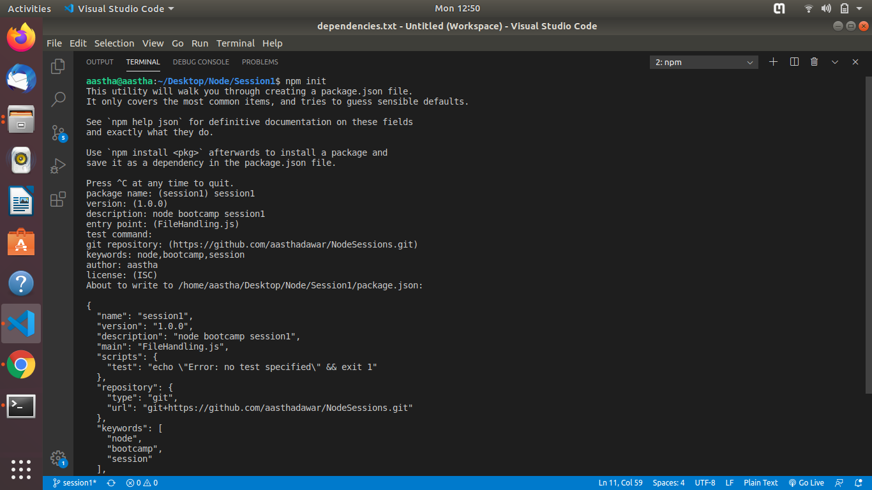
Package.json : it is a json text file which contains meta data about the application.
Syntax: npm init

