Node install :
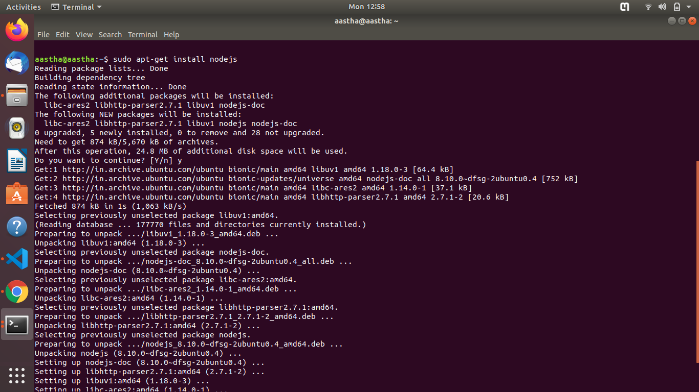
sudo apt-get install nodejs - to install nodejs

node -v - to check node version

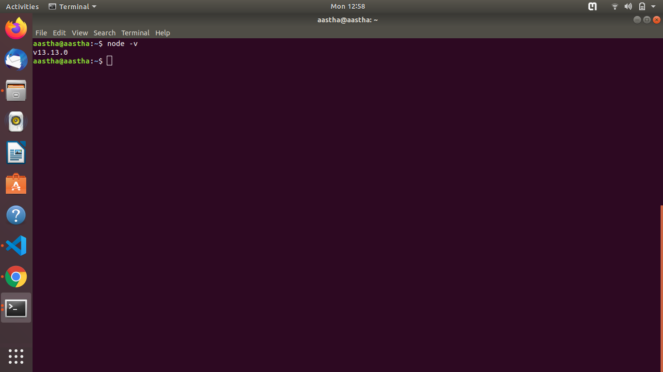

NPM install :
sudo apt-get install npm - to install npm

npm -v - to check version of npm

