

S. B. JAIN INSTITUTE OF TECHNOLOGY, MANAGEMENT & RESEARCH, NAGPUR.

Practical No. 4
Aim: Develop a webpage to display tabular data (Timetable / Student Record) using advanced table tags and attributes.

Name of Student: Aastha Kawre
Roll No.: CD25001
Semester/Year: 2nd semester/1st year
Academic Session: 2025-26
Date of Performance:
Date of Submission:

AIM: Develop a webpage to display tabular data (Timetable / Student Record) using advanced table tags and attributes.

OBJECTIVE/EXPECTED LEARNING OUTCOME:
- Design and implement complex grid layouts using the <table> tag, effectively handling irregular data structures.
- Demonstrate the ability to merge multiple rows or columns using rowspan (for breaks/long periods) and colspan (for common headings) without breaking the table structure.
- Correctly distinguish and apply <th> for header cells (bold, centered) and <td> for data cells (standard text).
- Use attributes like cellpadding and cellspacing to control the visual spacing and readability of tabular data.
- Independently code a complete Class Timetable or Student Record that is visually organized and semantically correct.

HARDWARE AND SOFTWARE REQUIRMENTS:

Hardware Requirement
- 1.6 GHz or faster processor
- .RAM: 1GB
- Hard Disk Drive: > 80 GB

Software Requirement
- Operating System – Windows 7/10.
- Editor – Notepad
THEORY:
Basic Table Structure
- <table>: The container for all table data.
- <tr> (Table Row): Defines a row of cells.
- <th> (Table Header): Defines a header cell (text is bold and centered by default).
- <td> (Table Data): Defines a standard data cell.

Advanced Semantic Structure
HTML5 introduces specific sections for tables to improve readability and printing:
- <caption>: Defines the title of the table. Must be the first tag inside <table>.
- <thead>: Groups the header content (first row).
- <tbody>: Groups the body content (data rows).
- <tfoot>: Groups the footer content (summary rows).
Cell Merging Attributes
- rowspan="n": Merges n cells vertically (downwards). Used for things like "Lunch Break" that spans multiple time slots.
- colspan="n": Merges n cells horizontally (across). Used for headings that cover multiple columns.
Formatting Attributes
- border="1": Adds a border around the table.
- cellpadding="10": Adds space inside the cell (between text and border).
- cellspacing="5": Adds space outside the cell (between two cells).

CODE:
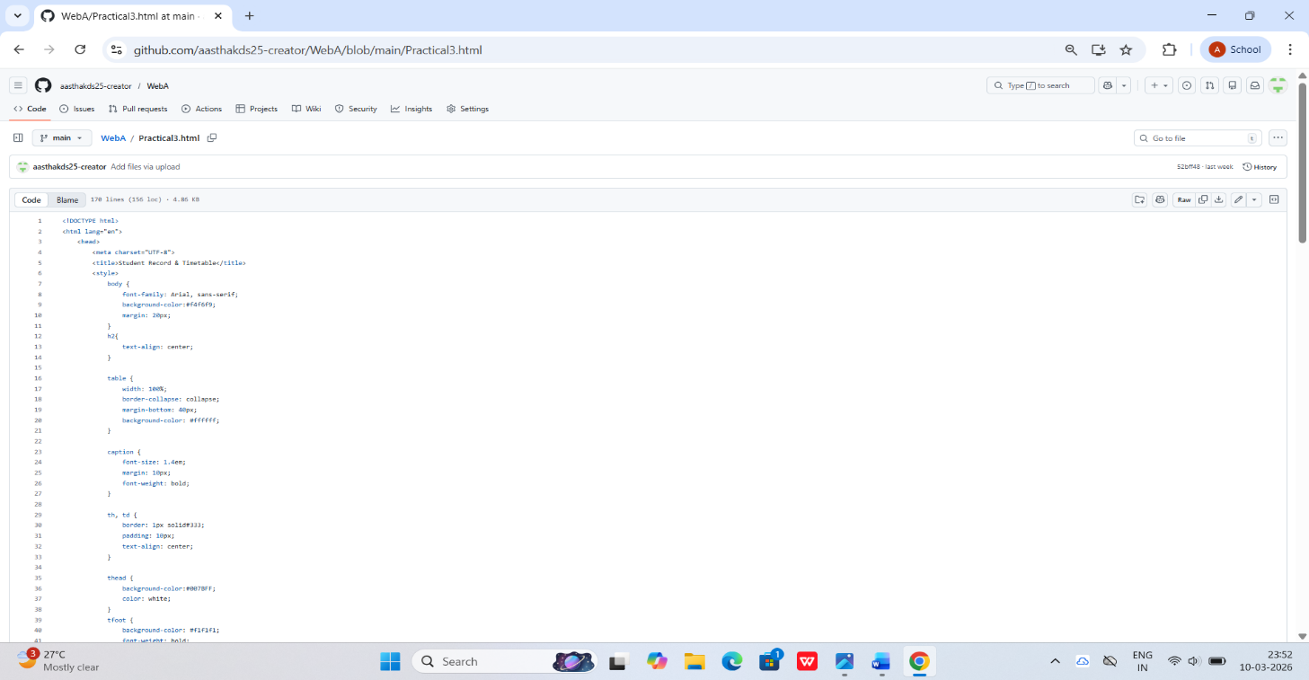
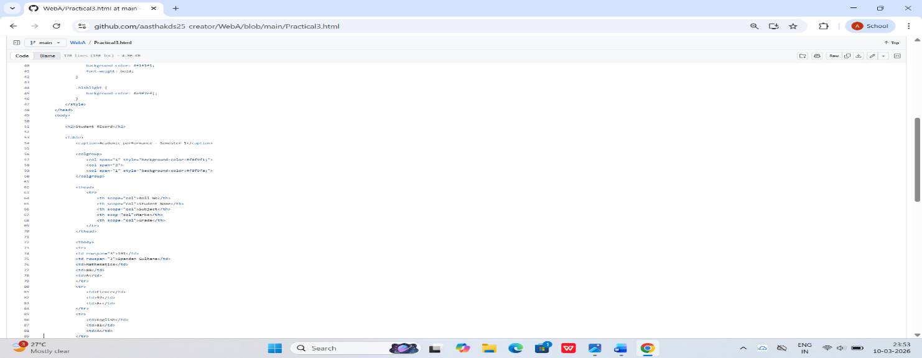
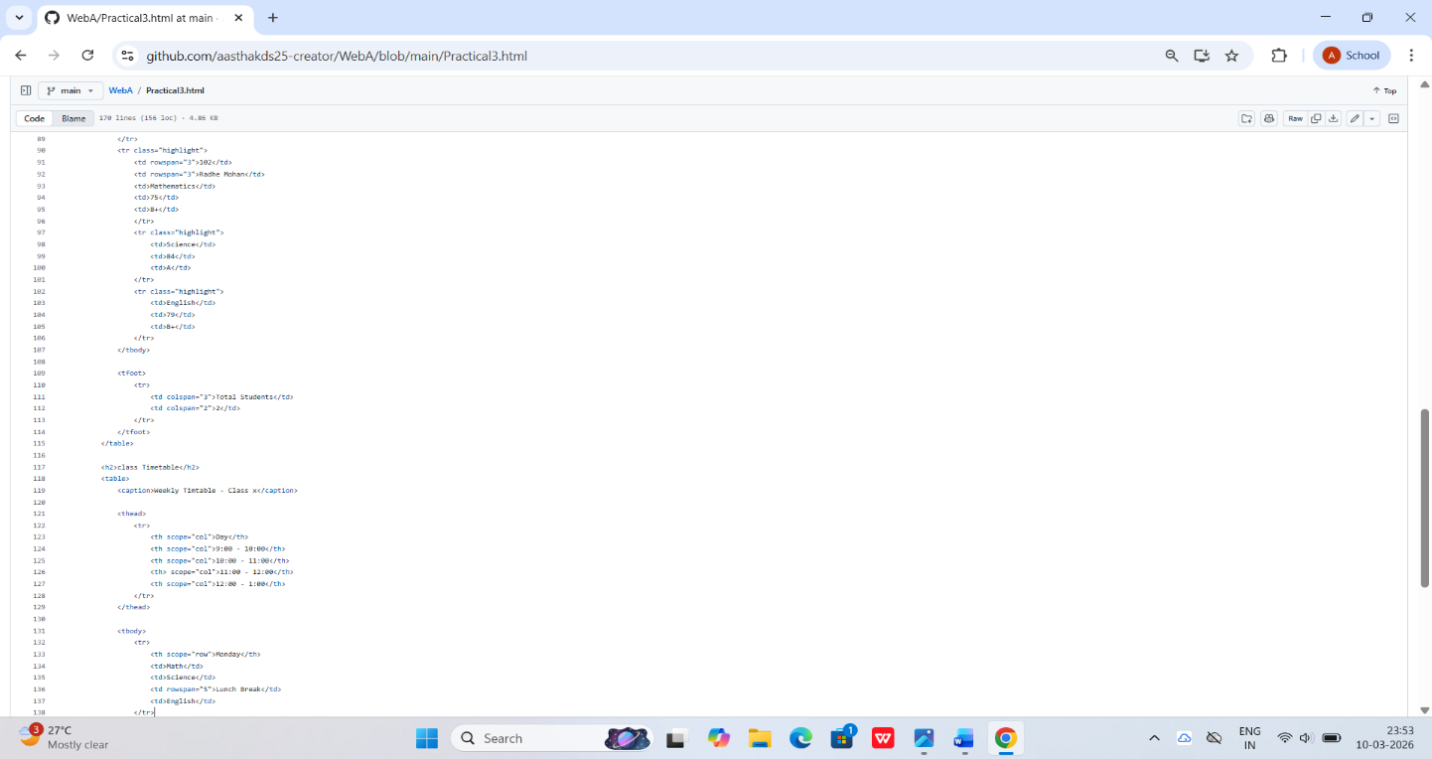
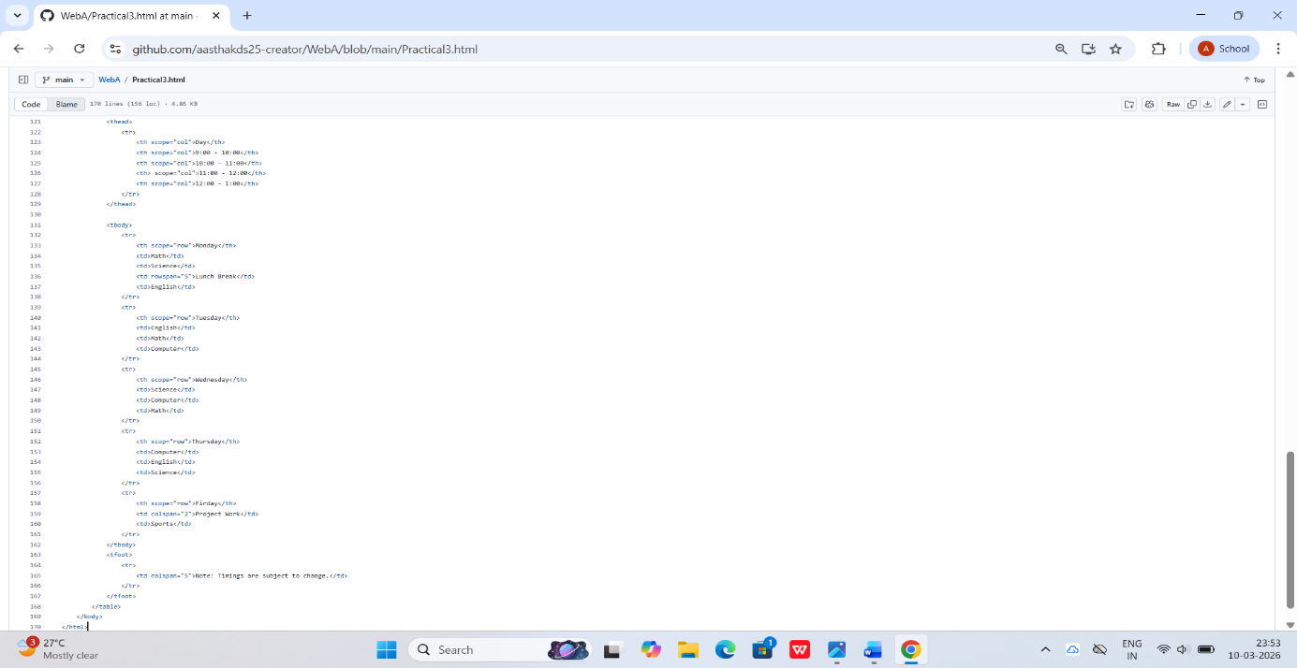
OUTPUT/SCREENSHOTS: (

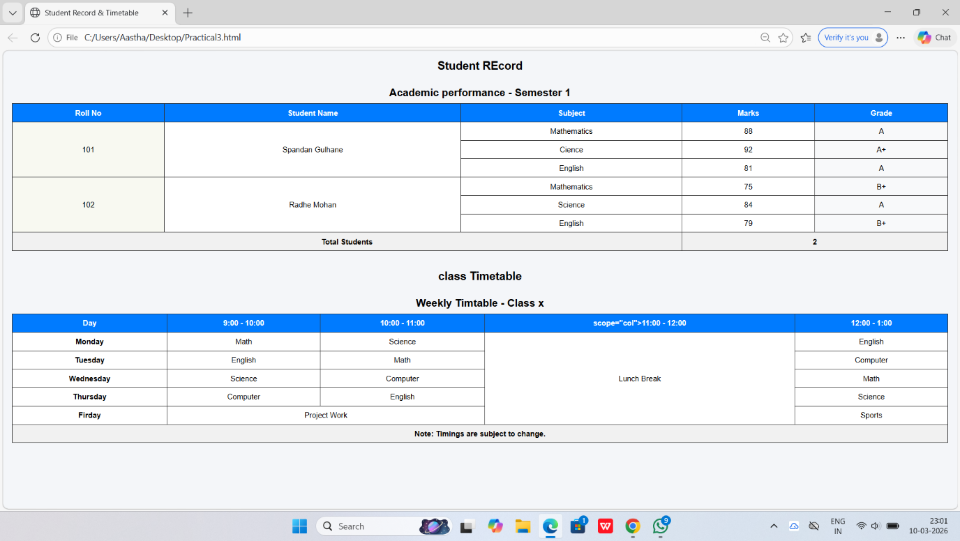

CONCLUSION: I have successfully designed a complex webpage using HTML table tags and advanced attributes like rowspan and colspan to create an organized, semantically correct timetable.

DISCUSSION QUESTIONS: (Write answers on loose practical pages)
- What is the difference between <thead> and <th>?
- Explain rowspan with an example.
- What is the difference between cellpadding and cellspacing?
- Why do we use <caption> instead of just writing a heading (<h3>) above the table?
- How do you merge two columns horizontally?
- Can a table have multiple <tbody> sections?

REFERENCE:
    - https://www.w3schools.com/TAgs/default.asp
    - https://simplycoding.in/html-tables-question-bank/
    - https://www.tutorialspoint.com/html/html_lists.html
    - https://www.tutorialspoint.com/html/html_tables.html

