1/13/2022

AASTHA NIRAULA

Level 6 GROUP C

ID: c7227225

Advanced Web Engineering

Final Submission

Contents

PROJECT BRIEF 2

Users 2

Admin 2

WEBSITE SCREENSHOT 3

# PROJECT BRIEF

The project uses Laravel as the PHP framework, tailwind and Bootstrap for CSS and MYSQL for the database.

* Views for Books, CDs and Games
* The project uses authentication using Laravel JetStream for login and register.
* Different views is designed for different users using blade
* Users are categorized as admin and users
* Only admin is capable of create/update/delete
* User can only view the products
* Admin dashboard is created
* Authorization is done using Gate for users
* Use of factories and seeders to authorize role for users
* Use of factories and seeders for products
* Responsive site

## Users

* List of products
* Pagination for the list of products displayed
* Searching and sorting of products

## Admin

* Add, update, delete CDs from the dashboard
* Add, update, delete Books from the dashboard
* Add, update, delete Games from the dashboard

# WEBSITE SCREENSHOT

Initial Page

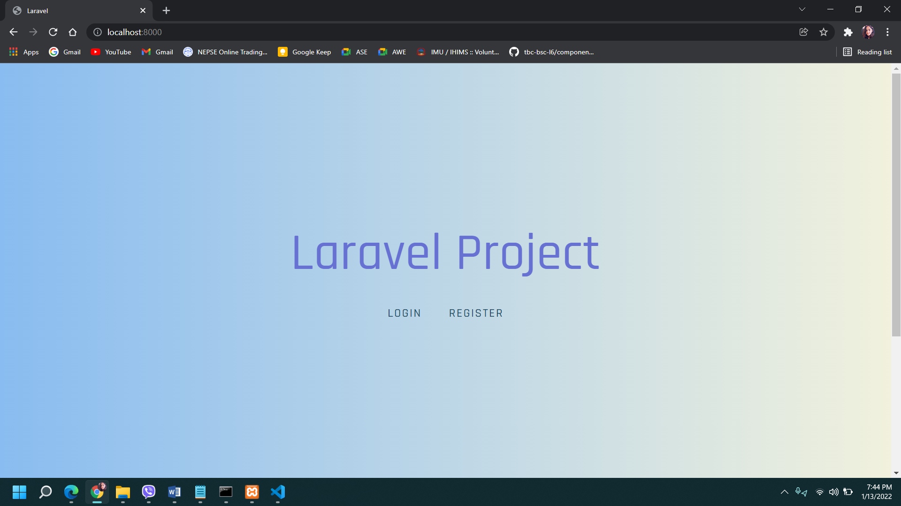

When logged in as user

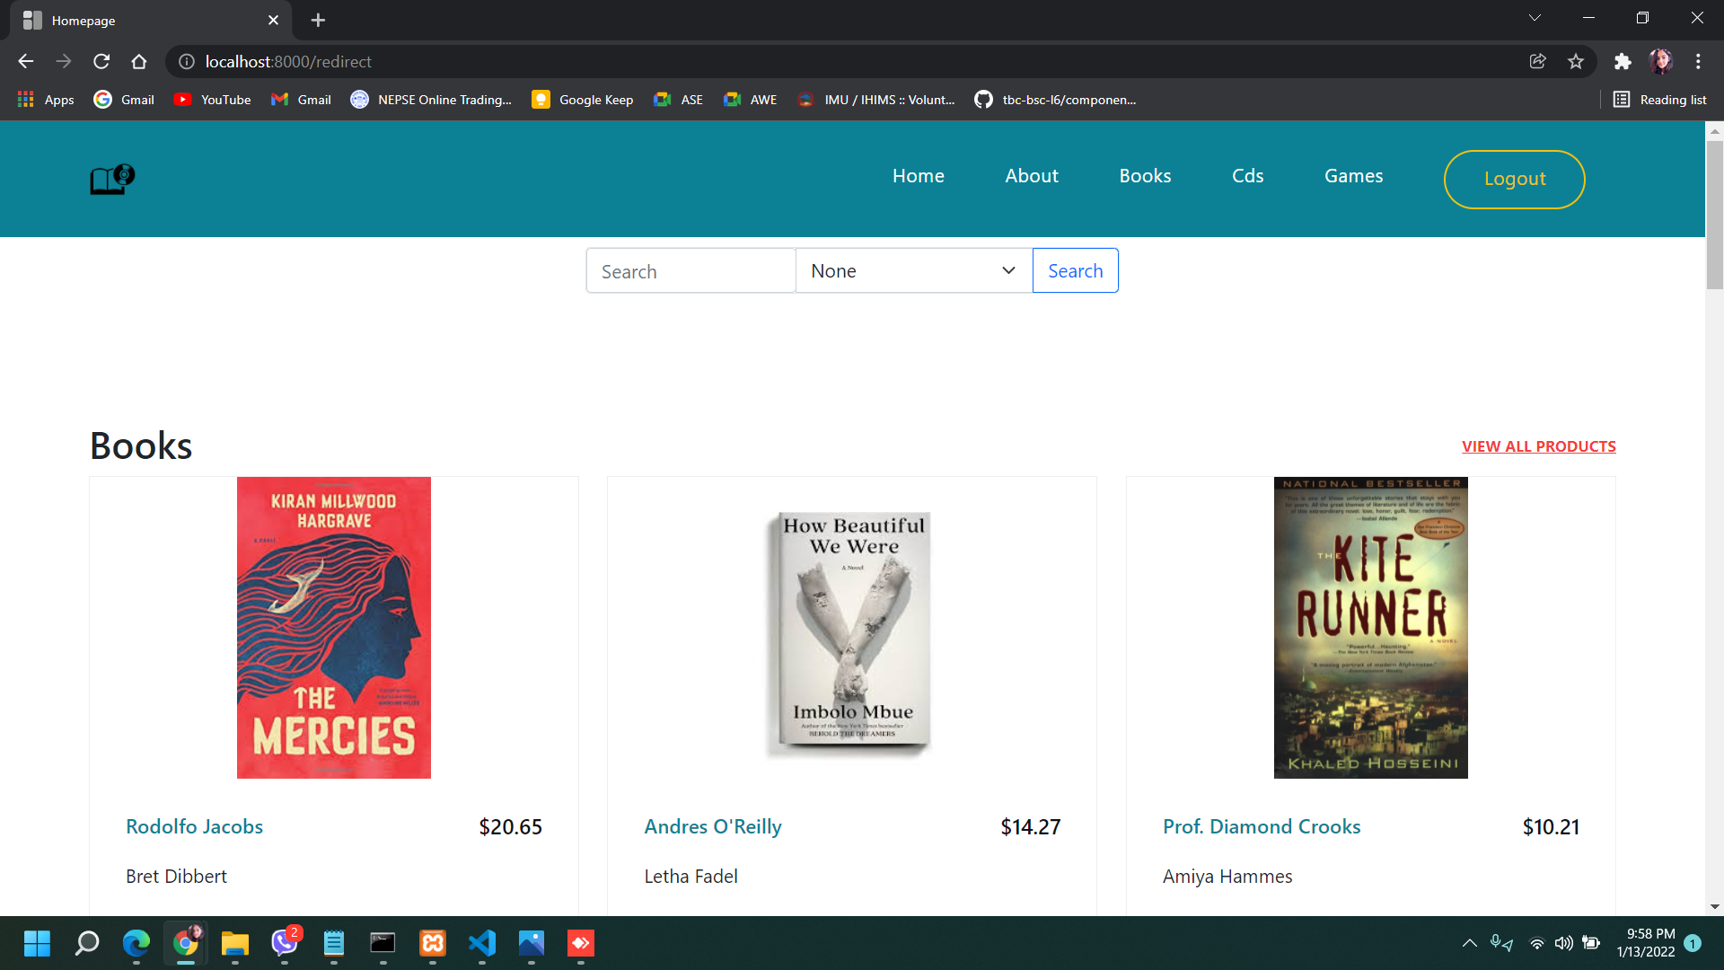

Searching and Sorting

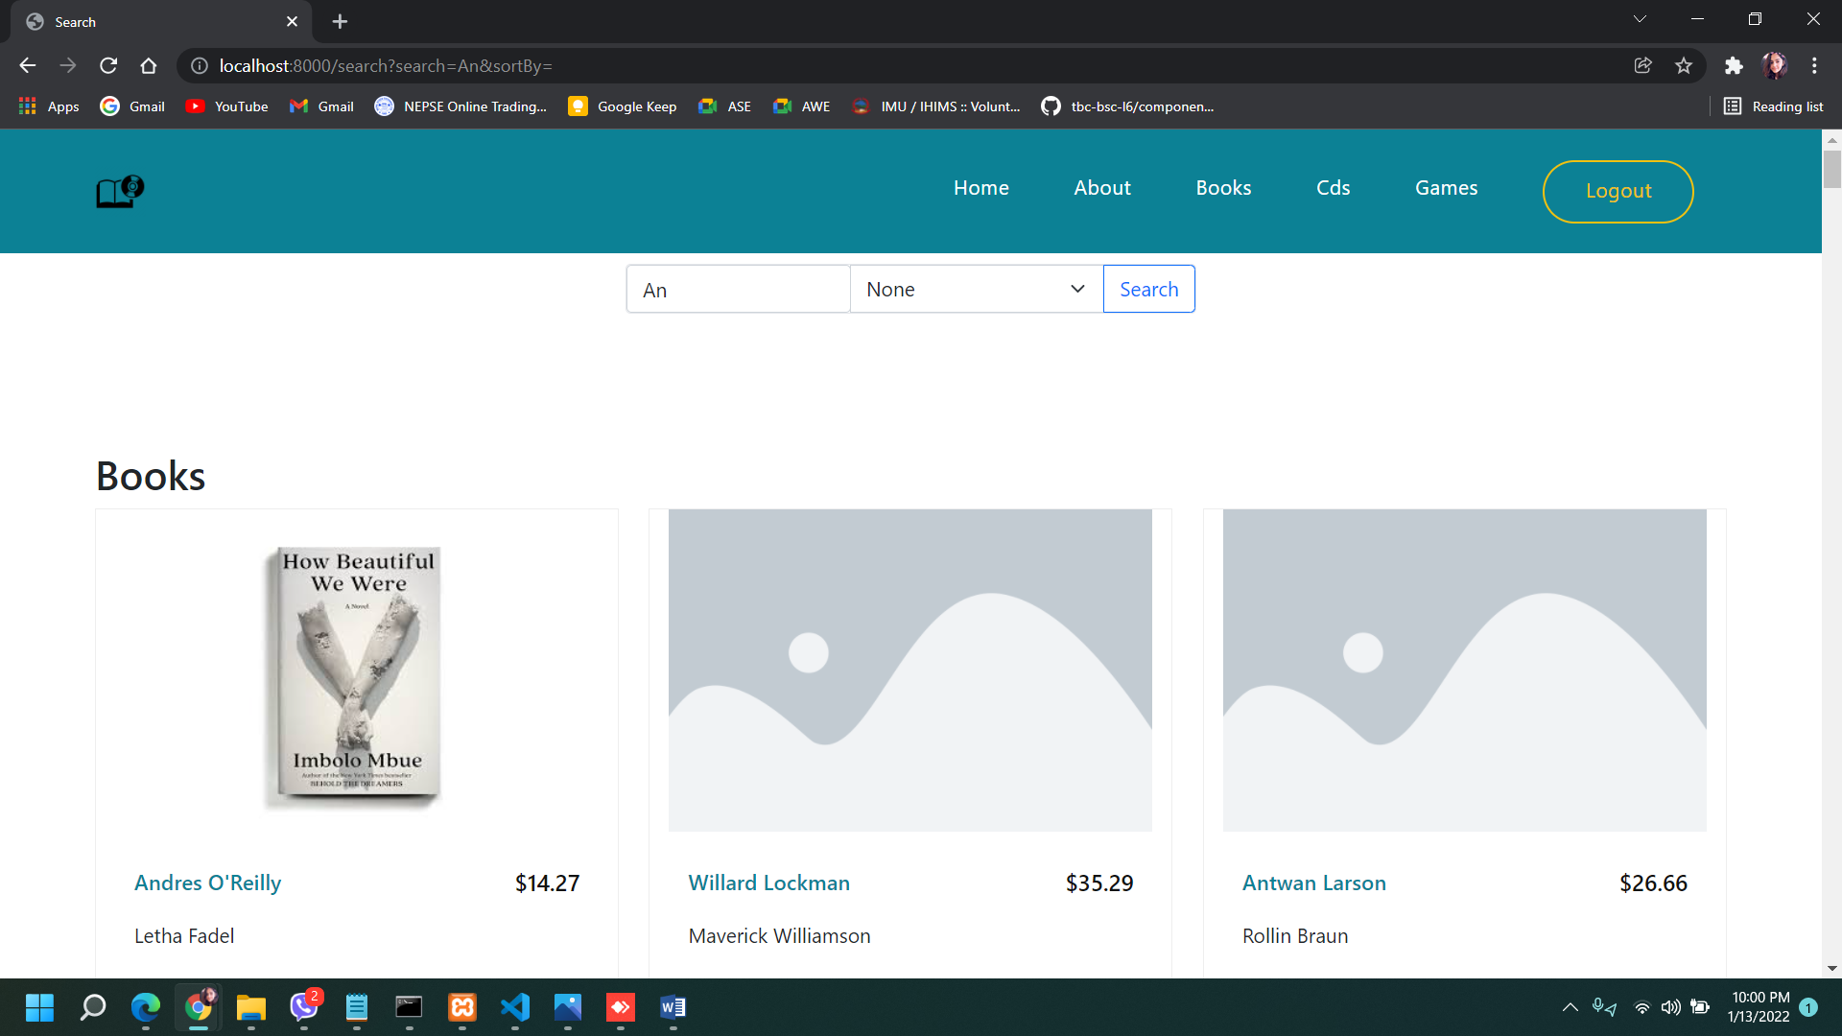

When accessing admin page from user login

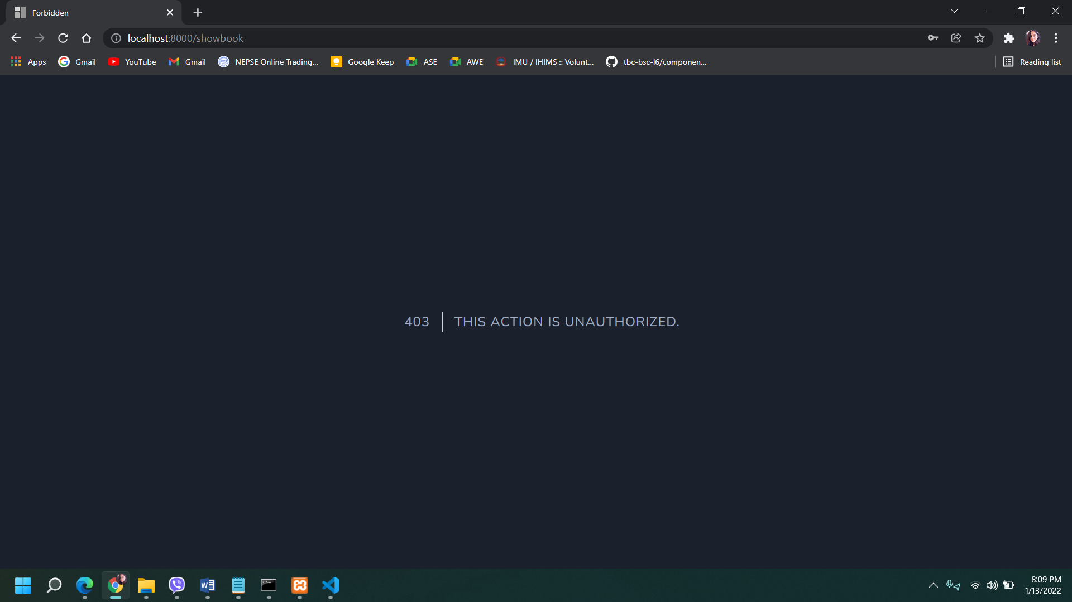

When logged in as admin

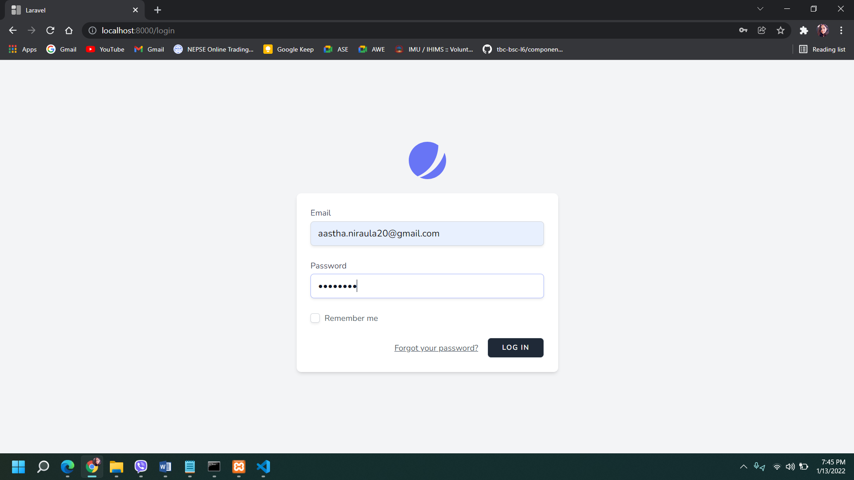

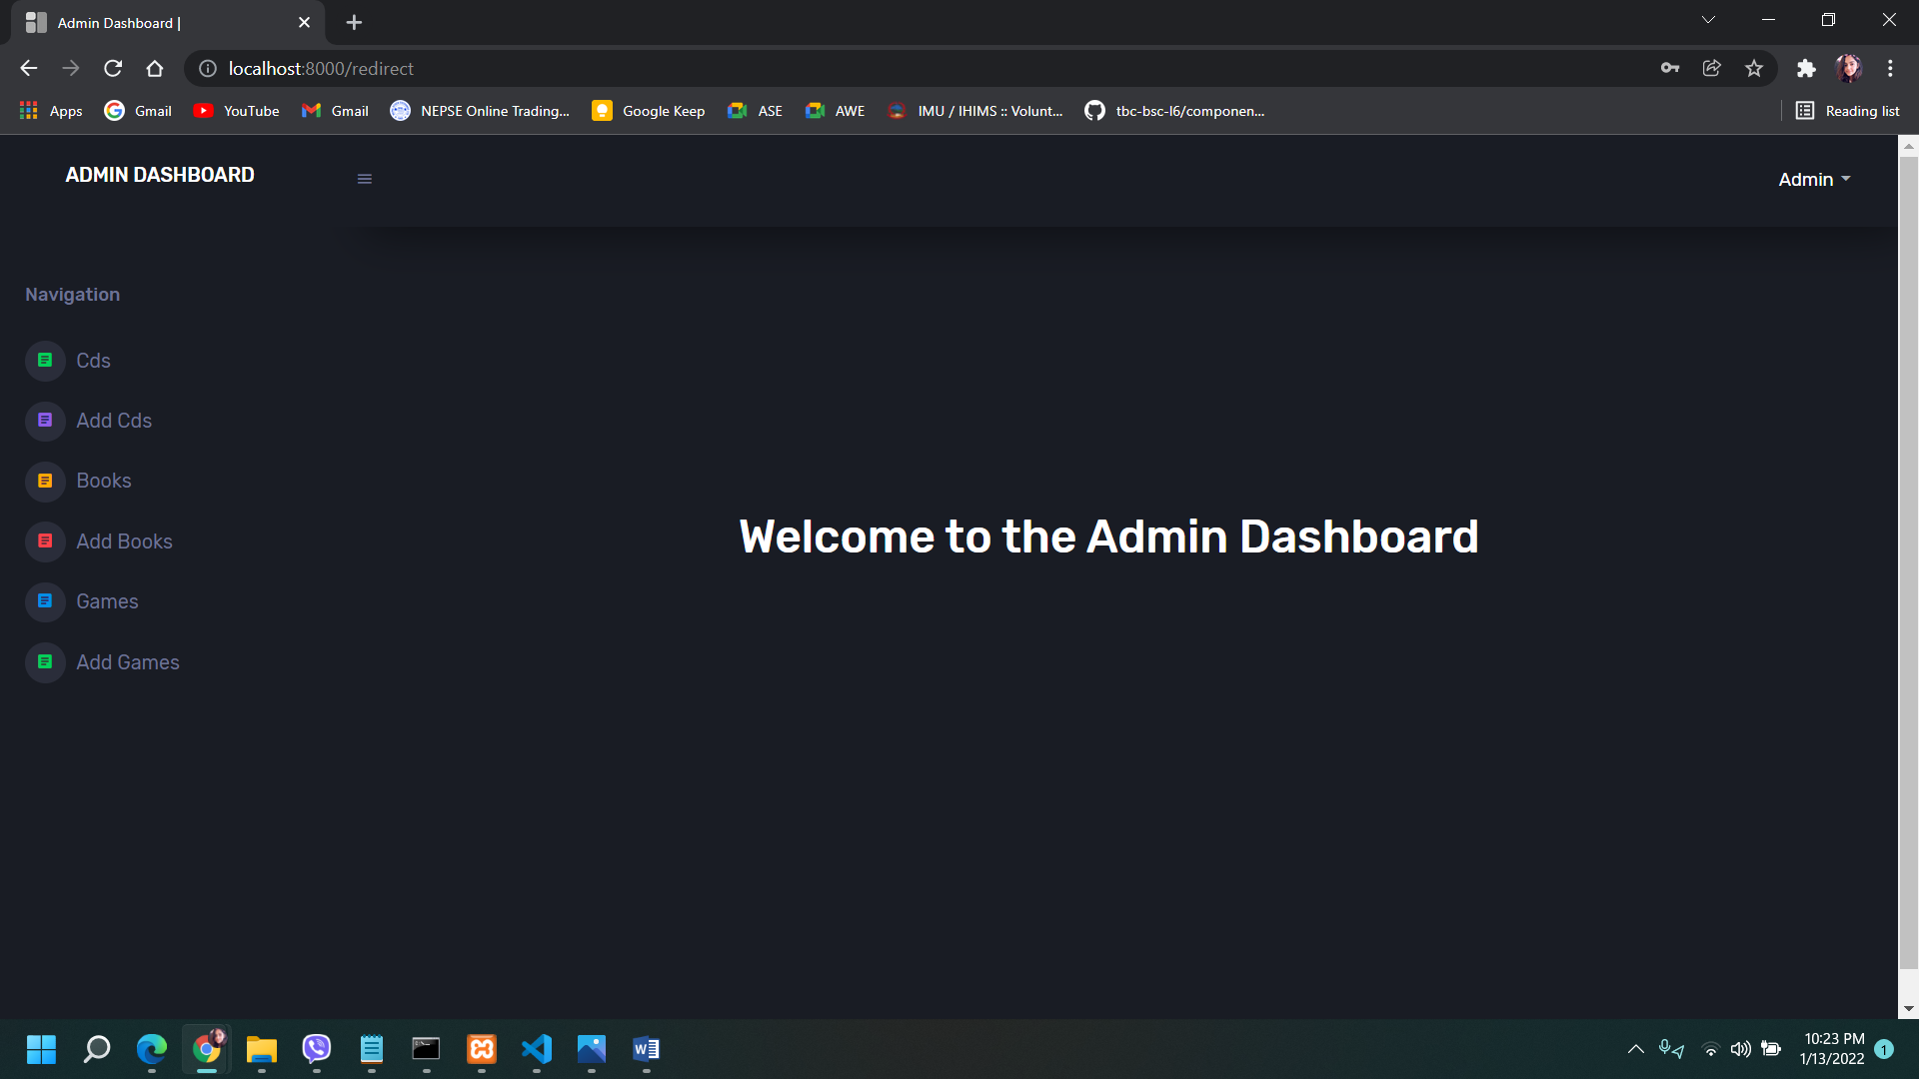

CRUD for products

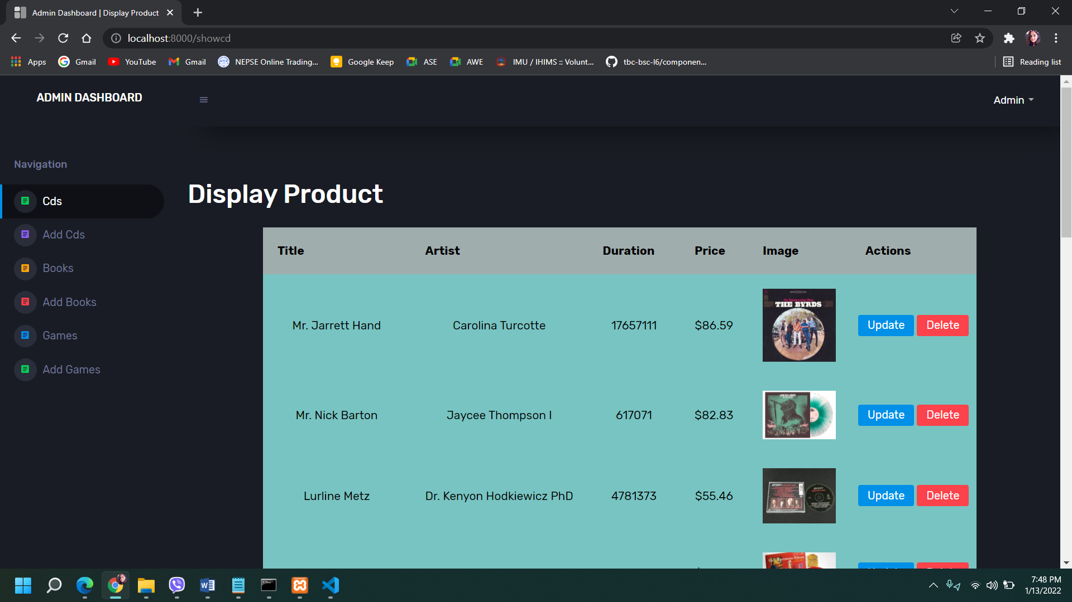

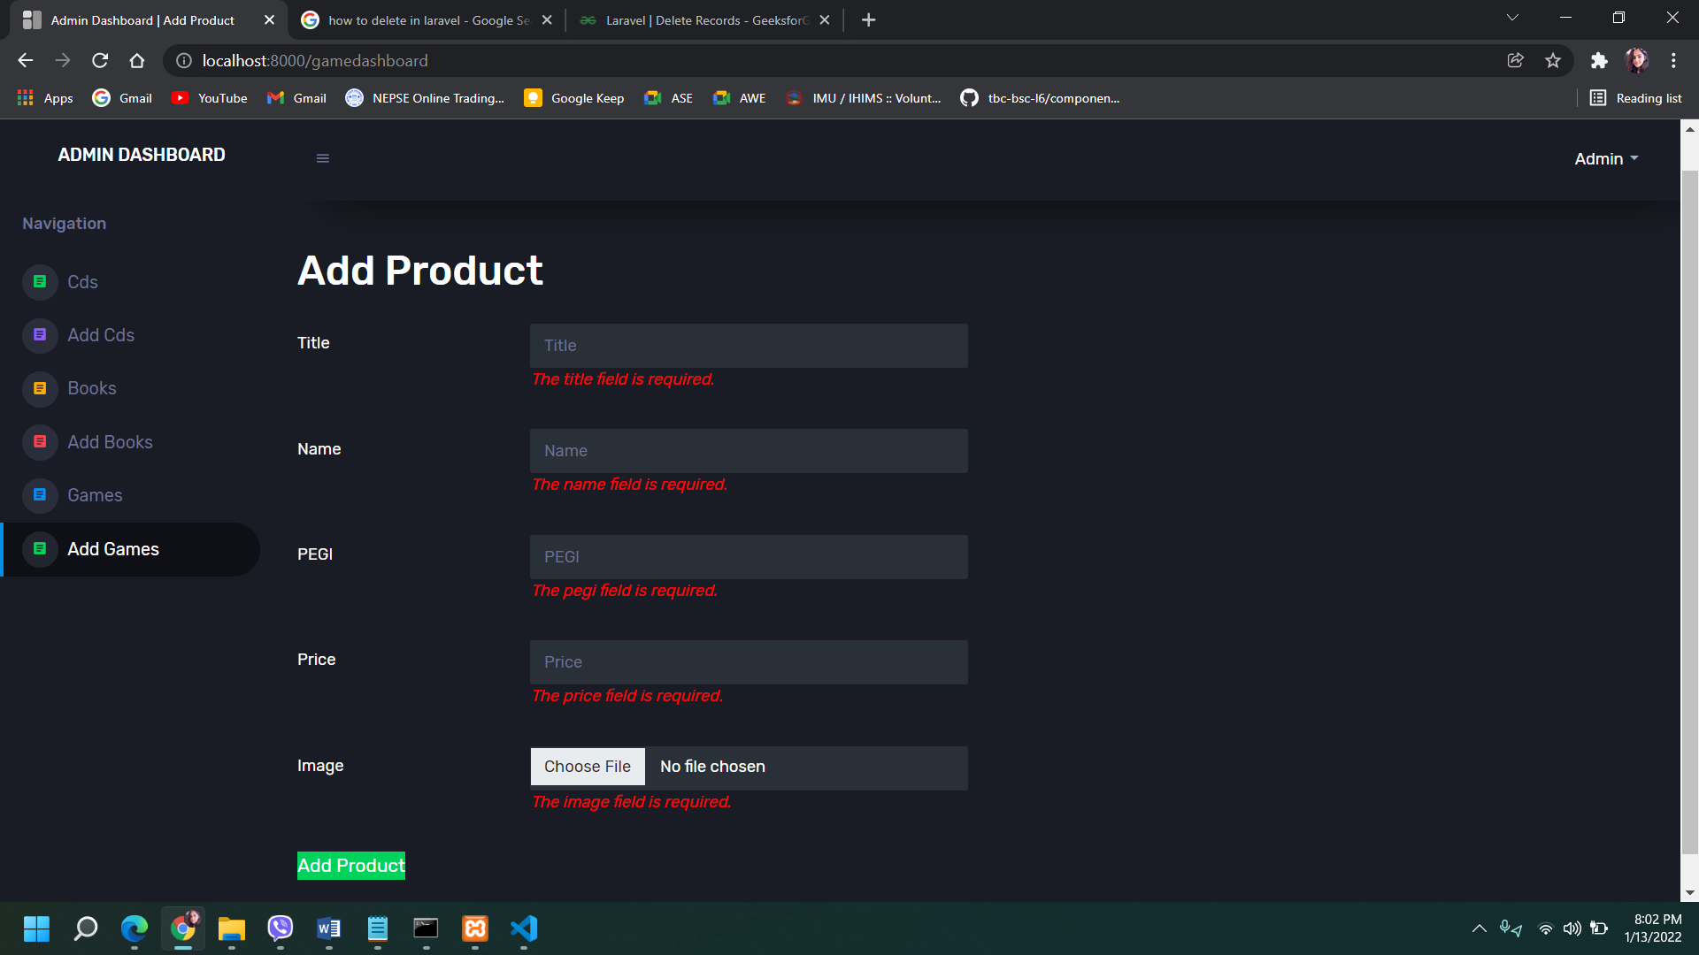

Pagination

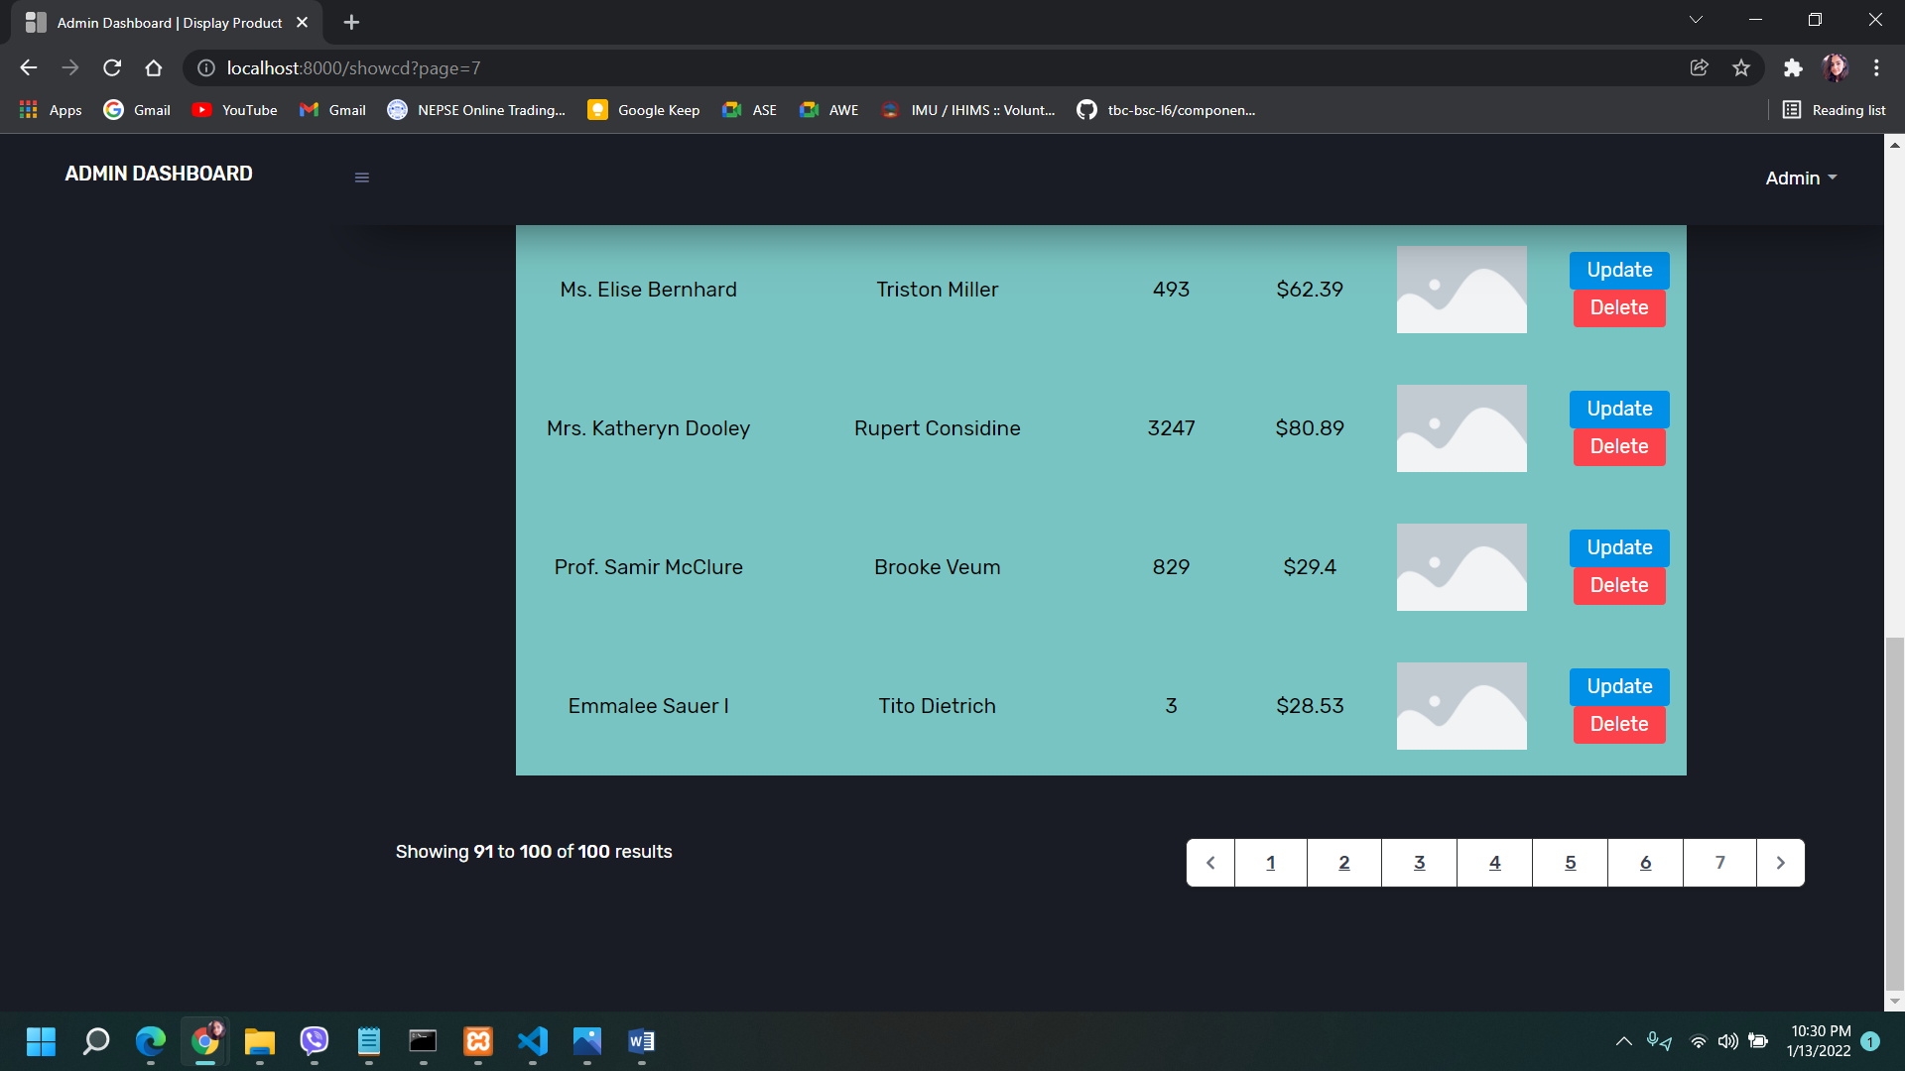

THANK

YOU