**Project: Health care Data Analysis**

**Input files in HDFS**

prescpipeline/staging/city

prescpipeline/staging/prescriber

**Data ingestion**

Step1: Creating Input directory and putting files in HDFS.

hdfs dfs -mkdir -p prescpipeline/staging/city

hdfs dfs -put us_cities_dimension.parquet prescpipeline/staging/city

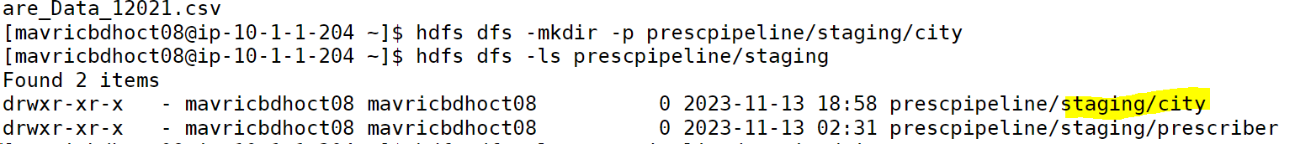



hdfs dfs -mkdir -p prescpipeline/staging/city

hdfs dfs -put us_cities_dimension.parquet prescpipeline/staging/city





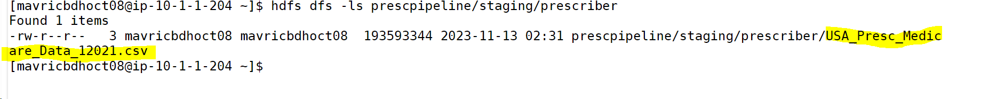

**Data Preprocessing**

**Clean City Data:**

Step1.

* 1. **Select only required Columns in city data file like city, state_id,state_name,county_name,population,zips**
  2. **Convert city, state and county fields to Upper Case**

city_df=spark.read.option("header",True).option("inferschema",True).parquet('prescpipeline/staging/city/us_cities_dimension.parquet')

>>> city_df.printSchema()

root

|-- city: string (nullable = true)

|-- city_ascii: string (nullable = true)

|-- state_id: string (nullable = true)

|-- state_name: string (nullable = true)

|-- county_fips: integer (nullable = true)

|-- county_name: string (nullable = true)

|-- lat: double (nullable = true)

|-- lng: double (nullable = true)

|-- population: integer (nullable = true)

|-- density: integer (nullable = true)

|-- timezone: string (nullable = true)

|-- zips: string (nullable = true)

city_df.count()

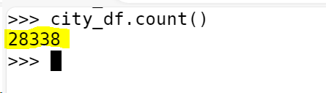

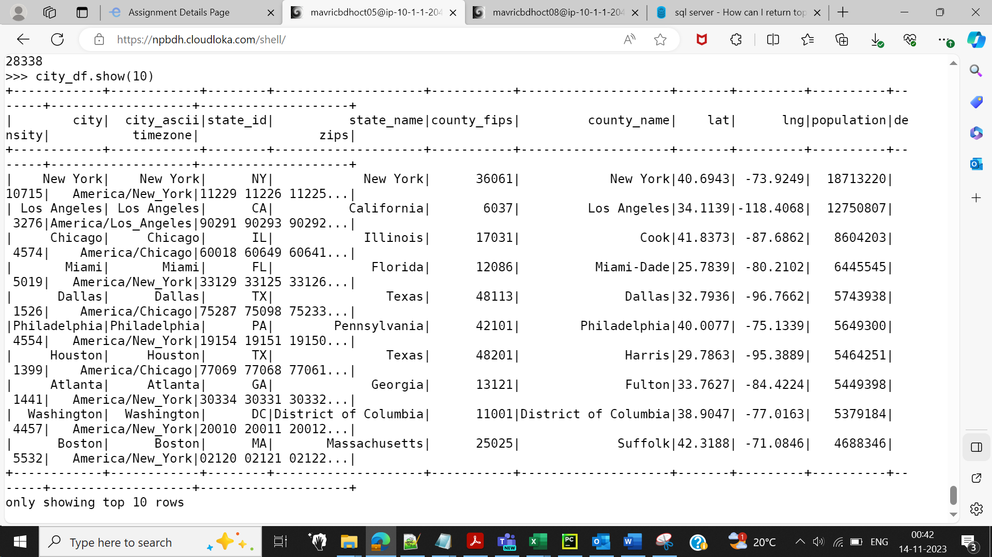

Selecting only required Columns in city data file like city, state_id,state_name,county_name,population,zips

Also converting city, state, county fields to upper case.

import pyspark.sql.functions as F

city_df_sel=city_df.select(F.upper(city_df.city).alias("city"),'state_id',F.upper(city_df.state_name).alias("state_name"),F.upper(city_df.county_name).alias("county_name"),'population','zips')

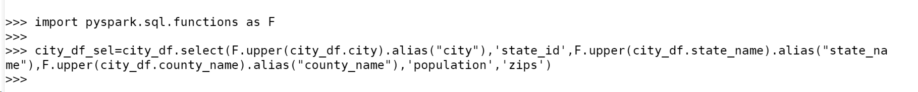

>>> city_df_sel.printSchema()

root

|-- city: string (nullable = true)

|-- state_id: string (nullable = true)

|-- state_name: string (nullable = true)

|-- county_name: string (nullable = true)

|-- population: integer (nullable = true)

|-- zips: string (nullable = true)

>>> city_df_sel.show(4)

+-----------+--------+----------+-----------+----------+--------------------+

| city|state_id|state_name|county_name|population| zips|

+-----------+--------+----------+-----------+----------+--------------------+

| NEW YORK| NY| NEW YORK| NEW YORK| 18713220|11229 11226 11225...|

|LOS ANGELES| CA|CALIFORNIA|LOS ANGELES| 12750807|90291 90293 90292...|

| CHICAGO| IL| ILLINOIS| COOK| 8604203|60018 60649 60641...|

| MIAMI| FL| FLORIDA| MIAMI-DADE| 6445545|33129 33125 33126...|

+-----------+--------+----------+-----------+----------+--------------------+

**Clean Prescriber Data:**

prescriber_df=spark.read.option("header",True).option("inferschema",True).csv("prescpipeline/staging/prescriber/USA_Presc_Medicare_Data_12021.csv")

prescriber_df.show(10)

prescriber_df.printSchema()

prescriber_df.count()

>>> prescriber_df.count()

1329329

>>>

**Step1. Selecting only required column and renaming the fields to shorter names.**

prescriber_df_sel=prescriber_df.select(prescriber_df.npi.alias("presc_id"),(prescriber_df.nppes_provider_last_org_name).alias ('presc_lname'),(prescriber_df.nppes_provider_first_name).alias ('presc_fname'),

(prescriber_df.nppes_provider_city).alias ('presc_city'),(prescriber_df.nppes_provider_state).alias ('presc_state'),(prescriber_df.specialty_description).alias ('presc_spclt'),

(prescriber_df.drug_name).alias ('drug_nm'),(prescriber_df.total_claim_count).alias ('tot_clm_count'),(prescriber_df.total_day_supply).alias ('tot_day_supp'),

(prescriber_df.total_drug_cost) .alias ('tot_drug_cst'),prescriber_df.years_of_exp)

prescriber_df_sel.printSchema()

Step2. Add a Country Field 'USA'

from pyspark.sql.functions import col, lit

prescriber_df_sel=prescriber_df_sel.withColumn("Country", lit("USA"))

prescriber_df_sel.show(10)

**Step3: Clean years_of_exp field**

import pyspark.sql.functions as F

prescriber_df_sel = prescriber_df_sel.withColumn("years_of_exp",F.regexp_extract(col("years_of_exp"),'\d+',0))

prescriber_df_sel.select("years_of_exp").s

how()

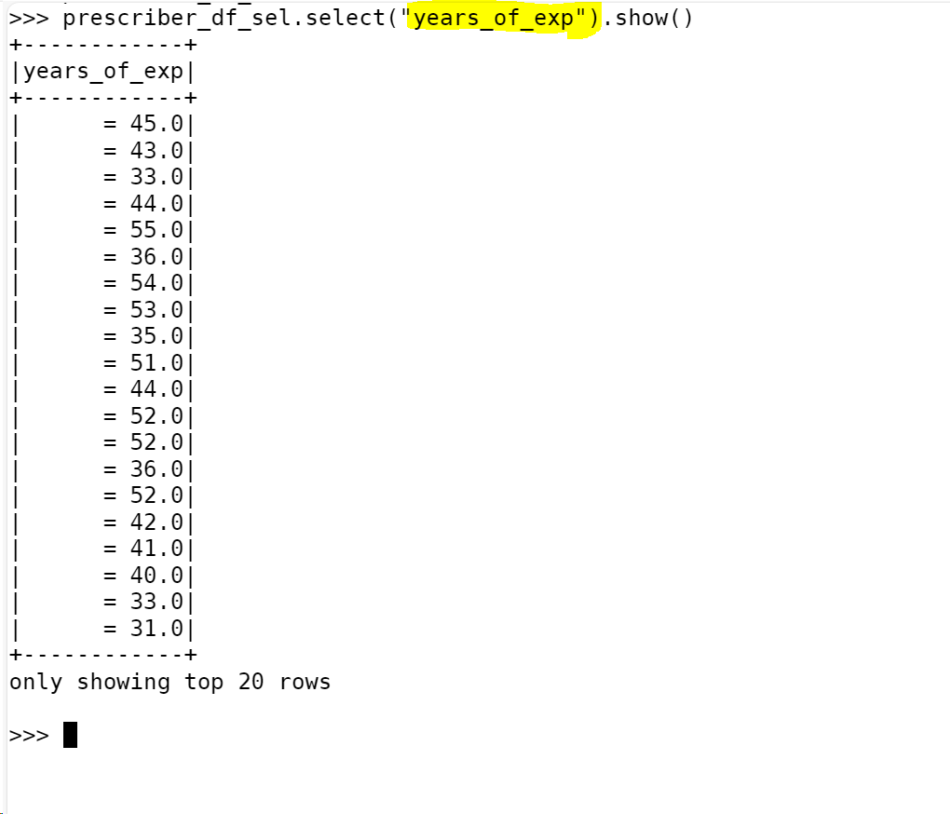

prescriber_df_sel.select("years_of_exp").show()

**Step4: Convert the years_of_exp datatype from string to Number**

from pyspark.sql.functions import concat, concat_ws,col, lit

prescriber_df_sel = prescriber_df_sel.withColumn("years_of_exp",col("years_of_exp").cast("int"))



prescriber_df_sel.printSchema()

**Step5: Combine First Name and Last Name and remove the individual column**

from pyspark.sql.functions import concat, concat_ws,col, lit

prescriber_df_sel = prescriber_df_sel.withColumn("presc_fullname",concat_ws(" ", "presc_fname", "presc_lname"))

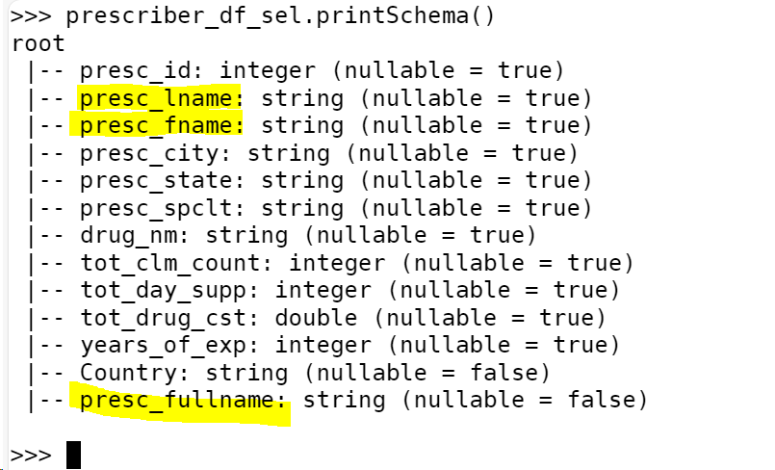

Removing presc_fname and presc_lname

prescriber_df_sel = prescriber_df_sel.drop("presc_fname", "presc_lname")

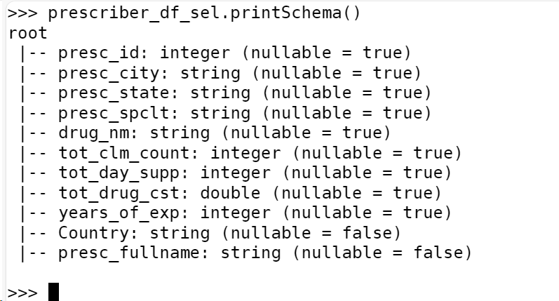

**Step6: Count the number of null values for each column**

from pyspark.sql.functions import col,isnan, when, count

prescriber_df_sel.select([count(F.when(isnan(c) | col(c).isNull(),c)).alias(c) for c in

prescriber_df_sel.columns]).show()

+--------+----------+-----------+-----------+-------+-------------+------------+------------+------------+-------+-------

-------+

|presc_id|presc_city|presc_state|presc_spclt|drug_nm|tot_clm_count|tot_day_supp|tot_drug_cst|years_of_exp|Country|presc_f

ullname|

+--------+----------+-----------+-----------+-------+-------------+------------+------------+------------+-------+-------

-------+

| 22| 1| 1| 1| 15| 3| 1| 1| 1| 0|

0|

+--------+----------+-----------+-----------+-------+-------------+------------+------------+------------+-------+-------

-------+

**Step7: clean all the Null/Nan Values where presc_id and drug_nm is null**

prescriber_df_sel = prescriber_df_sel.dropna(subset="presc_id")

prescriber_df_sel = prescriber_df_sel.dropna(subset="drug_nm")

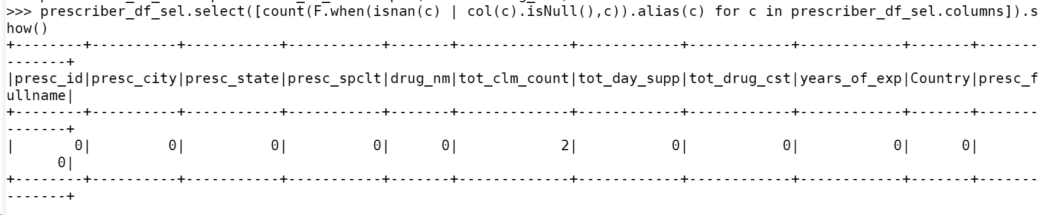

**DATA TRANSFORMATION**

Prescriber Report:

* 1. Top 5 Prescribers with highest total_claim_count per each state.
  2. Consider the prescribers only from 20 to 50 years of experience.

from pyspark.sql import Window

from pyspark.sql.functions import dense_rank

from pyspark.sql.functions import concat, concat_ws,col, lit

window = Window.partitionBy("presc_state").orderBy(col("tot_clm_count").desc())

prescriber_df_final = prescriber_df_sel.select("presc_id","presc_fullname","presc_state","Country","years_of_exp","tot_clm_count","tot_day_supp","tot_drug_cst") \

.filter((prescriber_df_sel.years_of_exp >= 20) & (prescriber_df_sel.years_of_exp <= 50) ) \

.withColumn("dense_rank",dense_rank().over(window)) \

.filter(col("dense_rank") <= 5) \

.select("presc_id","presc_fullname","presc_state","Country","years_of_exp","tot_clm_count","tot_day_supp","tot_drug_cst")

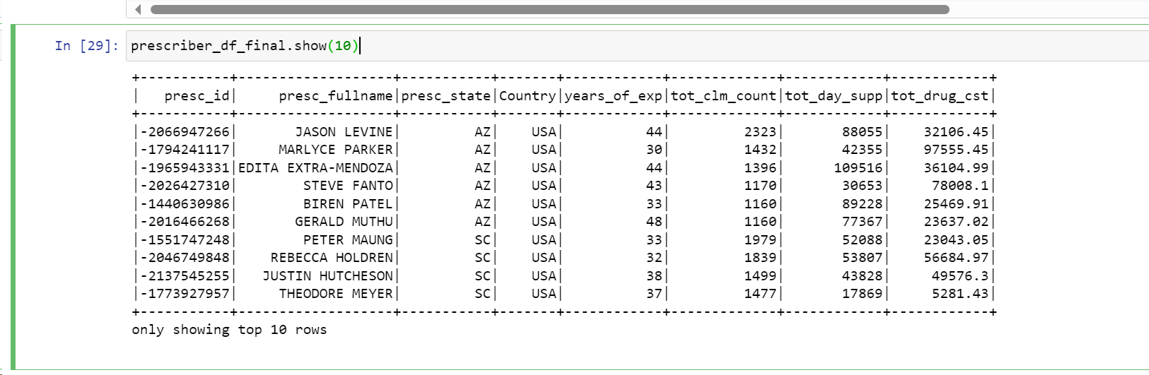

Creating Output directory :

****Run in HDFS***

hdfs dfs -mkdir -p prescpipeline/output/prescriber

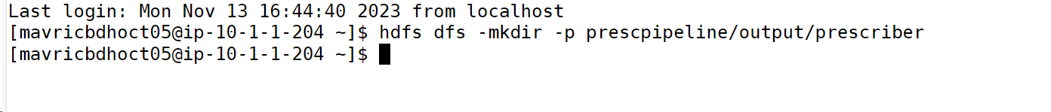

**Writing the output into HDFS in ORC format and snappy compression :**

from pyspark.sql import SparkSession

spark=SparkSession.builder.appName("SparkHive").enableHiveSupport().config("spark.sql.warehouse.dir","/user/hive/warehouse").getOrCreate()

spark.sparkContext.setLogLevel("ERROR")

**# writing the output in HDFS with split 2**

prescriber_df_final.repartition(2).write.mode("overwrite").option("compression","snappy").orc("/user/mavricbdhoct05/prescpipeline/output/prescriber/prescriber_report.orc")

**checking the output report file generated in hdfs:**

hdfs dfs -ls /user/mavericbdhoct05/prescpipeline/output/prescriber/prescriber_report.orc/

prescriber_report_DF.write.mode("overwrite").saveAsTable("aastha_lab. prescriber_report_DF ")

use aastha_lab;

show tables;

select * from prescriber_report_DF order by Total_claim_count desc ;

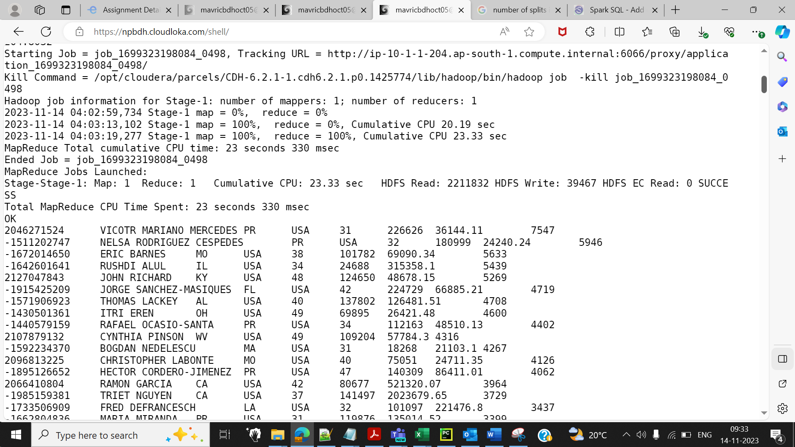

* 1. **Transform Logic: City Report**
  2. **1.Calculate the Number of zips in each city.**

from pyspark.sql.functions import split,size

df_city_split = city_df_sel.withColumn('zip_counts',size(split(city_df_sel['zips']," ")))

df_city_split.show(5)

**2.Calculate the number of distinct Prescribers assigned for each City.**

prescriber_df_sel.createOrReplaceTempView("prescriber")

prescriber1_df = spark.sql("SELECT count(distinct presc_id) as presc_counts,presc_city from prescriber group by presc_city").show()

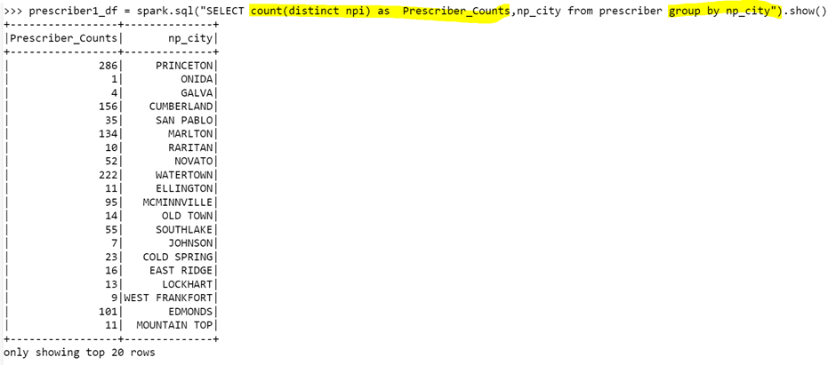

**3.Calculate total_claim_count prescribed for each city.**

prescriber1_df = spark.sql("SELECT sum(tot_clm_count) as total_claim_counts, presc_state from prescriber group by presc_state").show()

prescriber1_df.createOrReplaceTempView(“prescriber1”)

df_city_split.createOrReplaceTempView(“City_split_df”)

**Do not report a city in the final report if no prescriber is assigned to it.**

# **Joining two tables prescriber and1 and prescriber1**

spark.sql( "SELECT CITY as City_Name,STATE_NAME as State_Name,COUNTY_NAME as County_Name ,POPULATION as City_Population,zip_counts as Number_of_Zips,p.presc_counts,p.total_claim_counts FROM City_split_df c inner join prescriber1 p on upper(c.CITY) = p.presc_city and c.STATE_ID = p.presc_state where p.presc_counts != 0").show(5)

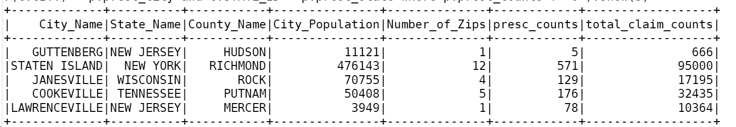

City_report_df = spark.sql( "SELECT CITY as City_Name,STATE_NAME as State_Name,COUNTY_NAME as County_Name ,POPULATION as City_Population,zip_counts as Number_of_Zips,p.presc_counts,p.total_claim_counts FROM City_split_df c inner join prescriber1 p on upper(c.CITY) = p.presc_city and c.STATE_ID = p.presc_state where p.presc_counts != 0")



from pyspark.sql import SparkSession

spark=SparkSession.builder.appName("SparkHive").enableHiveSupport().config("spark.sql.warehouse.dir","/user/hive/warehouse").getOrCreate()

spark.sparkContext.setLogLevel("ERROR")

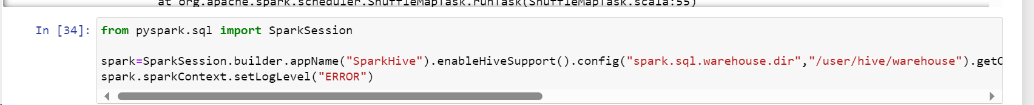

#Storing the output into HDFS

City_report_df.write. repartition(1) mode("overwrite").option("compression","bzip2").json("/user/mavricbdhoct05/prescpipeline/output/city")



City output In HDFS

hdfs dfs -ls /user/mavricbdhoct05/prescpipeline/output/city



City_report_df.write.mode("overwrite").saveAsTable("aastha_lab.City_Final_Report")

desc City_Final_Report;

select count(*) from City_Final_Report;



