**HBASE Assignment1**

TASK1

Design a Data model

create "aastha_db:stocksymbolvarioususer","info"

list_namespace_tables 'aastha_db'

Inserting data into table ‘stocksymbolvarioususer’

put "aastha_db:stocksymbolvarioususer","1","info:stock_symbol","EXC"

put "aastha_db:stocksymbolvarioususer","1","info:commentid","comment1"

put "aastha_db:stocksymbolvarioususer","1","info:userid","user1"

put "aastha_db:stocksymbolvarioususer","1","info:displayname","KingJames"

put "aastha_db:stocksymbolvarioususer","1","info:active","True"

put "aastha_db:stocksymbolvarioususer","1","info:comment","I have this one on my radar."

put "aastha_db:stocksymbolvarioususer","2","info:stock_symbol","EXC"

put "aastha_db:stocksymbolvarioususer","2","info:commentid","comment2"

put "aastha_db:stocksymbolvarioususer","2","info:userid","user1"

put "aastha_db:stocksymbolvarioususer","2","info:displayname","KingJames"

put "aastha_db:stocksymbolvarioususer","2","info:active","True"

put "aastha_db:stocksymbolvarioususer","2","info:comment","Interesting value proposition but too early to know if they will survive."

put "aastha_db:stocksymbolvarioususer","3","info:stock_symbol","INFI"

put "aastha_db:stocksymbolvarioususer","3","info:commentid","comment1"

put "aastha_db:stocksymbolvarioususer","3","info:userid","user2"

put "aastha_db:stocksymbolvarioususer","3","info:displayname","Wizard of Wall Street"

put "aastha_db:stocksymbolvarioususer","3","info:active","True"

put "aastha_db:stocksymbolvarioususer","3","info:comment","like this one but would suggest waiting a few months."

put "aastha_db:stocksymbolvarioususer","4","info:stock_symbol","INFI"

put "aastha_db:stocksymbolvarioususer","4","info:commentid","comment2"

put "aastha_db:stocksymbolvarioususer","4","info:userid","user2"

put "aastha_db:stocksymbolvarioususer","4","info:displayname","Wizard of Wall Street"

put "aastha_db:stocksymbolvarioususer","4","info:active","False"

put "aastha_db:stocksymbolvarioususer","4","info:comment","Not obvious yet but this stock is gonna be a huge winner."

put "aastha_db:stocksymbolvarioususer","5","info:stock_symbol","INFI"

put "aastha_db:stocksymbolvarioususer","5","info:commentid","comment1"

put "aastha_db:stocksymbolvarioususer","5","info:userid","user3"

put "aastha_db:stocksymbolvarioususer","5","info:displayname","Time World Series Winner"

put "aastha_db:stocksymbolvarioususer","5","info:active","False"

put "aastha_db:stocksymbolvarioususer","5","info:comment","Buy it now before the rush."

put "aastha_db:stocksymbolvarioususer","6","info:stock_symbol","INFI"

put "aastha_db:stocksymbolvarioususer","6","info:commentid","comment2"

put "aastha_db:stocksymbolvarioususer","6","info:userid","user3"

put "aastha_db:stocksymbolvarioususer","6","info:displayname","Time World Series Winner"

put "aastha_db:stocksymbolvarioususer","6","info:active","True"

put "aastha_db:stocksymbolvarioususer","6","info:comment","Dump this one fast!"

To check data in hbase table ‘stocksymbolvarioususer’

scan "aastha_db:stocksymbolvarioususer"

Queries:

What are the various comments given by all the users?

Scan 'aastha_db:stocksymbolvarioususer',{COLUMN=>['info:comment']}

What are the comments by user3?

scan 'aastha_db:stocksymbolvarioususer', { FILTER => SingleColumnValueFilter.new(Bytes.toBytes('info'), Bytes.toBytes('userid'), CompareFilter::CompareOp.valueOf('EQUAL'),BinaryComparator.new(Bytes.toBytes('user3')))}

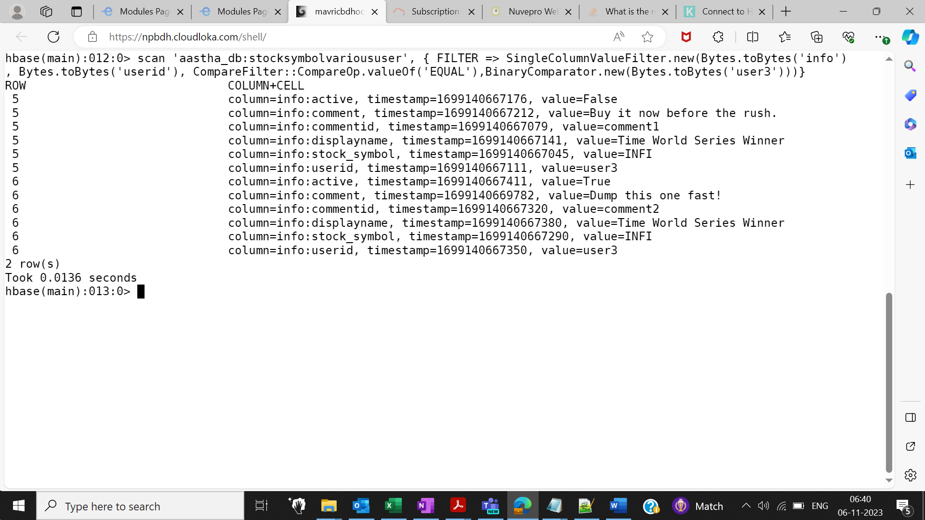

Which users have inactive comments?

import org.apache.hadoop.hbase.filter.SingleColumnValueFilter

import org.apache.hadoop.hbase.filter.CompareFilter

import org.apache.hadoop.hbase.filter.BinaryComparator

scan 'aastha_db:stocksymbolvarioususer', { FILTER => SingleColumnValueFilter.new(Bytes.toBytes('info'),Bytes.toBytes('active'), CompareFilter::CompareOp.valueOf('EQUAL'),BinaryComparator.new(Bytes.toBytes('False')))}

