**HBASE Assignment1**

**TASK3**

create table album(rowkey String, singer STRING, song STRING,duration string,music_director string)

row format delimited fields terminated by ',';

load data local inpath 'singer.csv' into table album

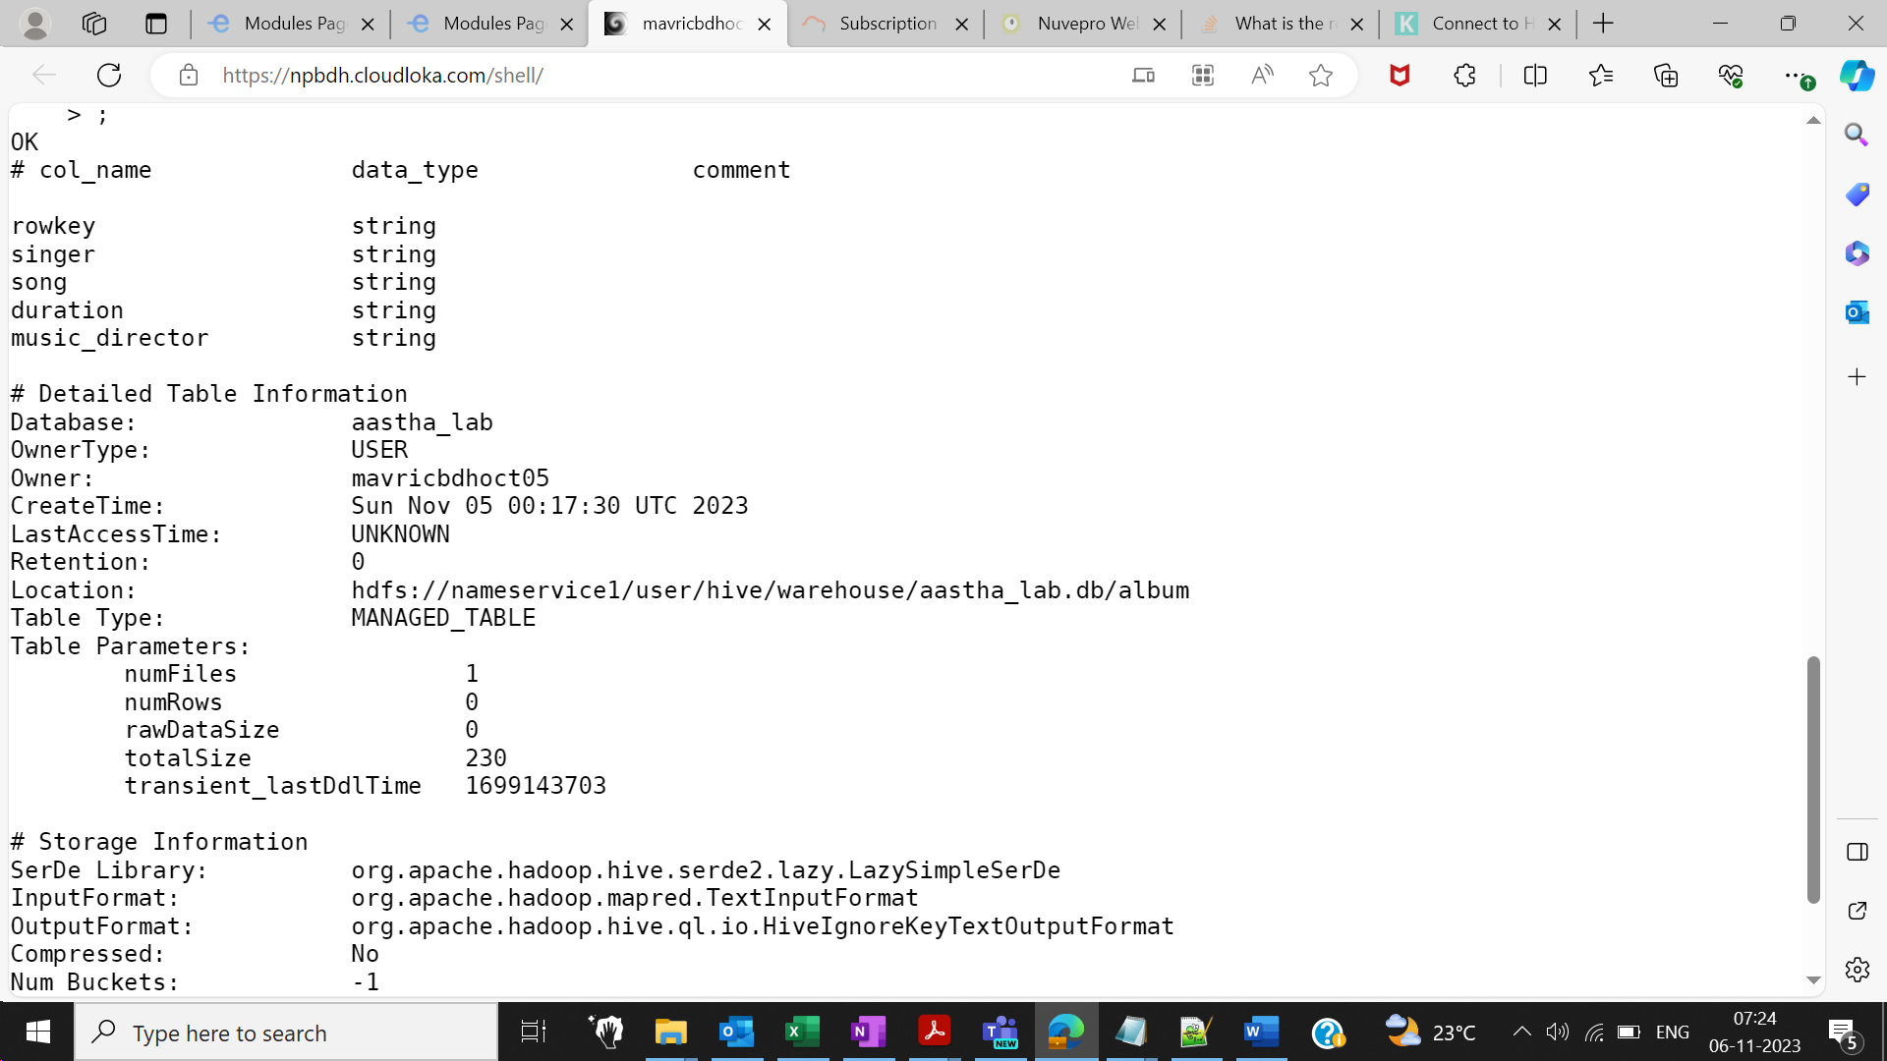

Created table in hive

CREATE TABLE albumsToHBase(rowkey String,singer STRING, song STRING,duration string,music_director string)

STORED BY 'org.apache.hadoop.hive.hbase.HBaseStorageHandler'

WITH SERDEPROPERTIES ('hbase.columns.mapping' = ':key,info:singer,info:song,info:duration,info:music_director')

TBLPROPERTIES ('hbase.table.name' = 'aastha_db:album_hbase' );

insert overwrite table albumsToHBase select * from album;

select * from albumsToHBase ;

Run queries like 1) getall songs sung by a singer 2) Which singer sung for music director AK and what were the songs

**1. getall songs sung by a singer**

1) scan 'aastha_db:album_hbase', {COLUMN=>['info:singer','info:song']}

hbase(main):001:0> scan 'aastha_db:album_hbase', {COLUMN=>['info:singer','info:song']}

**2) Which singer sung for music director AK and what were the songs**

**import org.apache.hadoop.hbase.filter.SingleColumnValueFilter**

**import org.apache.hadoop.hbase.filter.CompareFilter**

**import org.apache.hadoop.hbase.filter.BinaryComparator**

**scan 'aastha_db:album_hbase', {COLUMNS=>['info:singer','info:song','info:music_director'],FILTER => SingleColumnValueFilter.new(Bytes.toBytes('info'), Bytes.toBytes('music_director'),CompareFilter::CompareOp.valueOf('EQUAL'),BinaryComparator.new(Bytes.toBytes('AK')))}**

hbase(main):009:1* FILTER => SingleColumnValueFilter.new(Bytes.toBytes('info'), Bytes.toBytes('musicdirector'),CompareFilter::

CompareOp.valueOf('EQUAL'),BinaryComparator.new(Bytes.toBytes('AK')))}

ROW COLUMN+CELL

1 column=info:musicdirector, timestamp=1699254481745, value=AK

1 column=info:singer, timestamp=1699254481745, value=Singer1

1 column=info:song, timestamp=1699254481745, value=Song1

4 column=info:musicdirector, timestamp=1699254481745, value=AK

4 column=info:singer, timestamp=1699254481745, value=Singer2

4 column=info:song, timestamp=1699254481745, value=Song4

7 column=info:musicdirector, timestamp=1699254481745, value=AK

7 column=info:singer, timestamp=1699254481745, value=Singer3

7 column=info:song, timestamp=1699254481745, value=Song1

