**Covid 19 Data analysis**

1. Load the covid 19 data in to a spark dataframe (country_wise_latest.csv) with the correct schema definition

hdfs dfs -put country_wise_latest.csv

hdfs dfs -ls

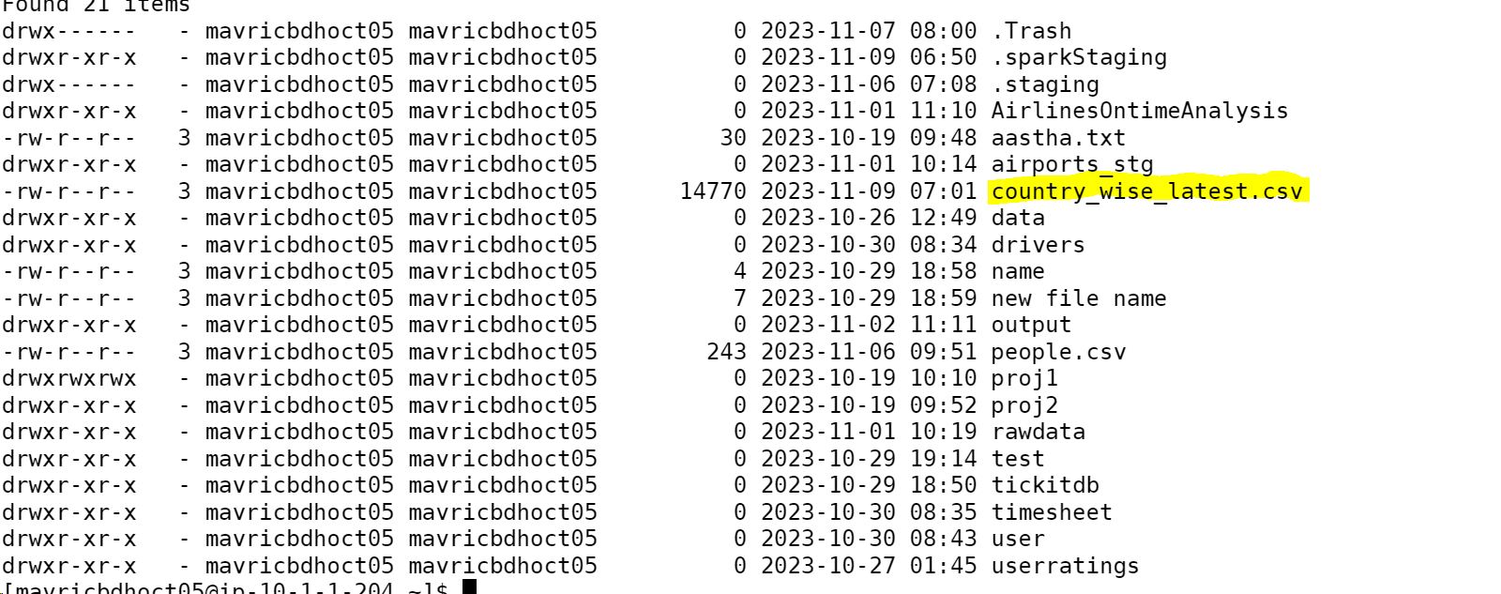

covidDF=spark.read.option("header",True).option("inferschema",True).csv("country_wise_latest.csv")

covidDF.printSchema()

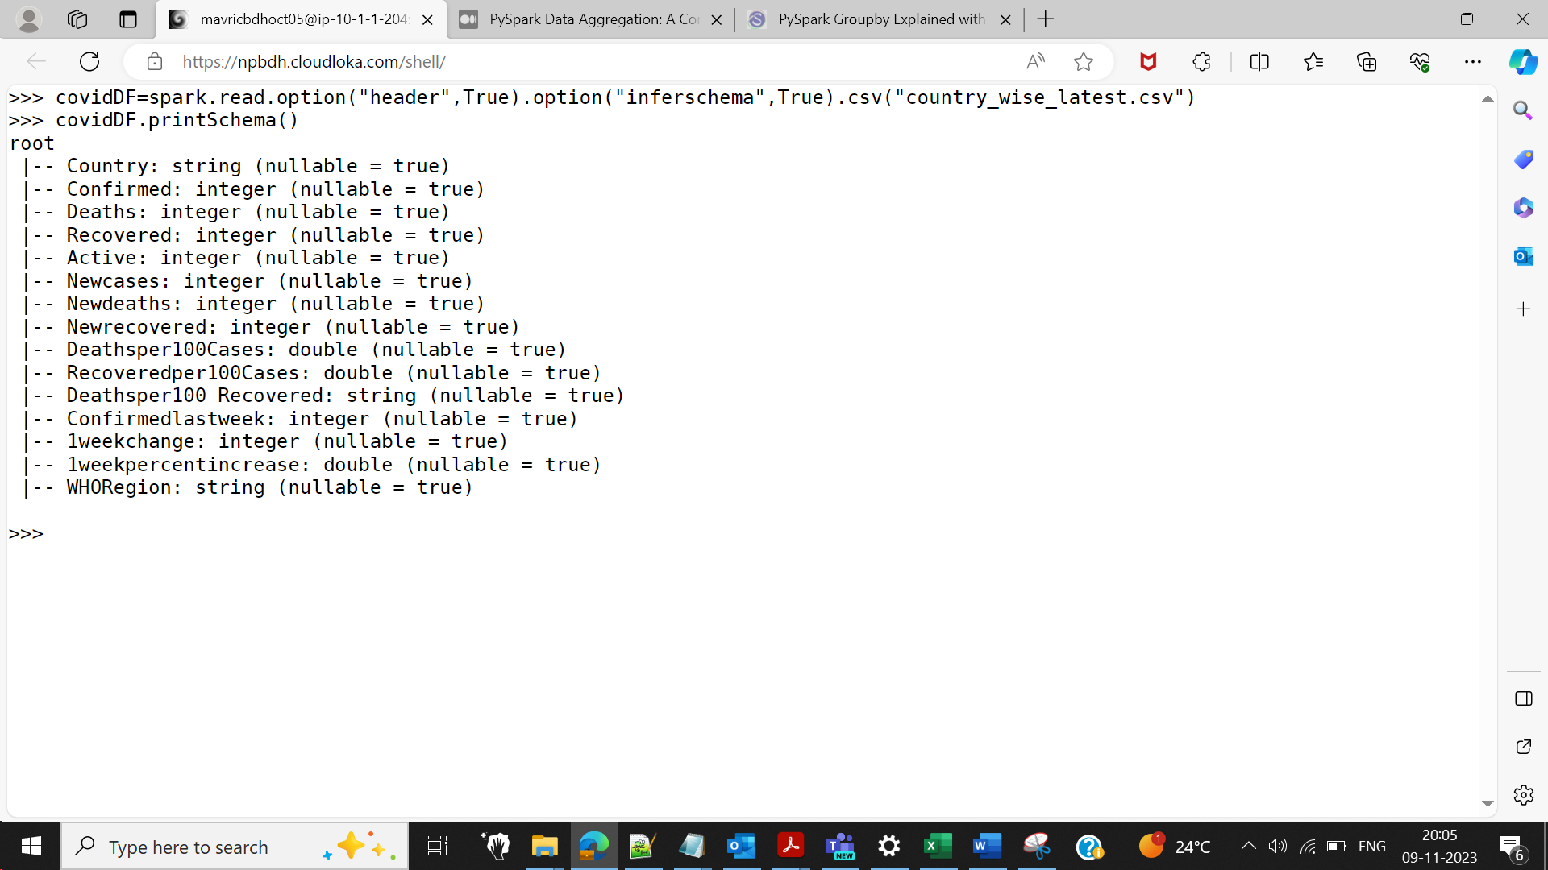

covidDF.show()

covidDF.createOrReplaceTempView("covid")

2.The are some column names which are long, contains special

characters, spaces etc. Rename all such column names accordingly.

Example Country/Region ? country New cases ? New_cases etc

covidDF.withColumnRenamed("Deathsper100 Recovered","Deathsper100_Recovered").show(truncate=False)

3.Count and check if there any null values in any of the columns

import pyspark.sql.functions as F

covidDF_agg = covidDF.agg(*[F.count(F.when(F.isnull(c), c)).alias(c) for c in covidDF.columns])

covidDF_agg.show()

4. What are the top 10 countries under the WHO region with covid 19 Confirmed cases

spark.sql( "SELECT Country,WHORegion,sum(Confirmed) FROM covid GROUP BY Country, WHORegion order by 3 desc").show(10)

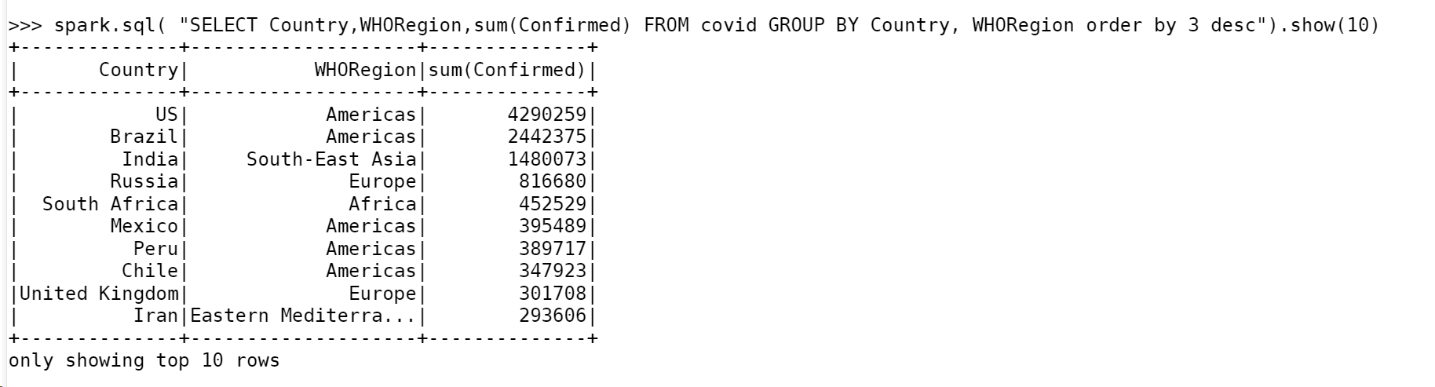

5. What are the bottom 10 countries under the WHO region with covid 19 Confirmed cases

spark.sql( "SELECT Country,WHORegion,sum(Confirmed) FROM covid GROUP BY Country, WHORegion order by 3 asc").show(10)

6. What are the total number of countries/ total no. of WHO regions and

also list the various WHO regions

spark.sql("SELECT count(distinct Country), count(distinct WHORegion) from covid").show()

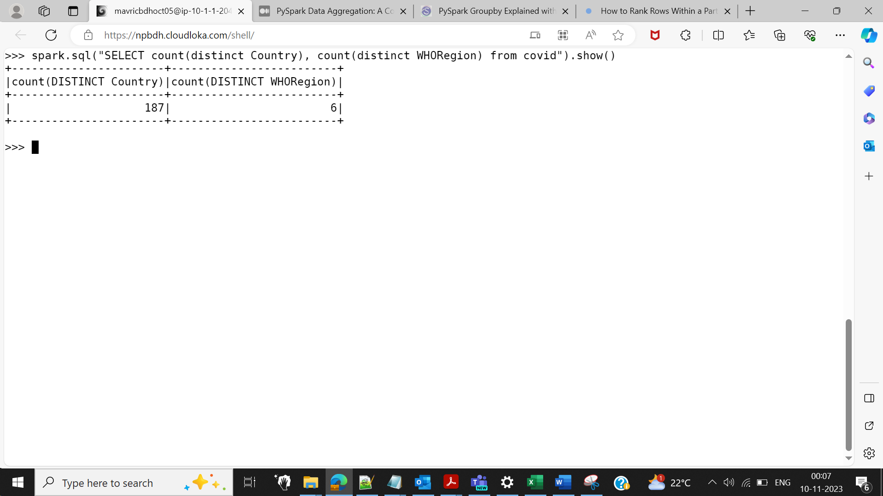

spark.sql("SELECT distinct WHORegion from covid").show()

spark.sql("SELECT count(distinct Country), count(distinct WHORegion),WHORegion from covid group by WHORegion").show()

