2.Load the required data in to DF like categories, customer,departments,order_items,orders and products

orderitemsDF=spark.read.option("header",True).option("inferschema",True).csv("order_items.csv")

orderitemsDF.createOrReplaceTempView("orderitems")

orderitemsDF.printSchema()

>>> orderitemsDF.printSchema()

root

|-- order_item_id: integer (nullable = true)

|-- order_item_order_id: integer (nullable = true)

|-- order_item_product_id: integer (nullable = true)

|-- order_item_quantity: integer (nullable = true)

|-- order_item_subtotal: double (nullable = true)

|-- order_item_product_price: double (nullable = true)

ordersDF=spark.read.option("header",True).option("inferschema",True).csv("orders.csv")

ordersDF.createOrReplaceTempView("orders")

ordersDF.printSchema()

root

|-- order_id: integer (nullable = true)

|-- order_date: string (nullable = true)

|-- order_customer_id: integer (nullable = true)

|-- order_status: string (nullable = true)

productsDF=spark.read.option("header",True).option("inferschema",True).csv("products.csv")

productsDF.createOrReplaceTempView("products")

productsDF.printSchema()

>>> productsDF.printSchema()

root

|-- product_id: integer (nullable = true)

|-- product_category_id: integer (nullable = true)

|-- product_name: string (nullable = true)

|-- product_description: string (nullable = true)

|-- product_price: double (nullable = true)

|-- product_image: string (nullable = true)

1.Problem Statement: What is the daily product revenue for CLOSED or

COMPLETE orders?

spark.sql("SELECT order_status,o.order_date, p.product_name ,sum(ot.order_item_subtotal) as revenue from orders o join orderitems ot on o.order_id = ot.order_item_order_id join products p on p.product_id = ot.order_item_product_id where o.order_status in ('CLOSED','COMPLETE') group by order_status,o.order_date, p.product_name order by order_status").show()

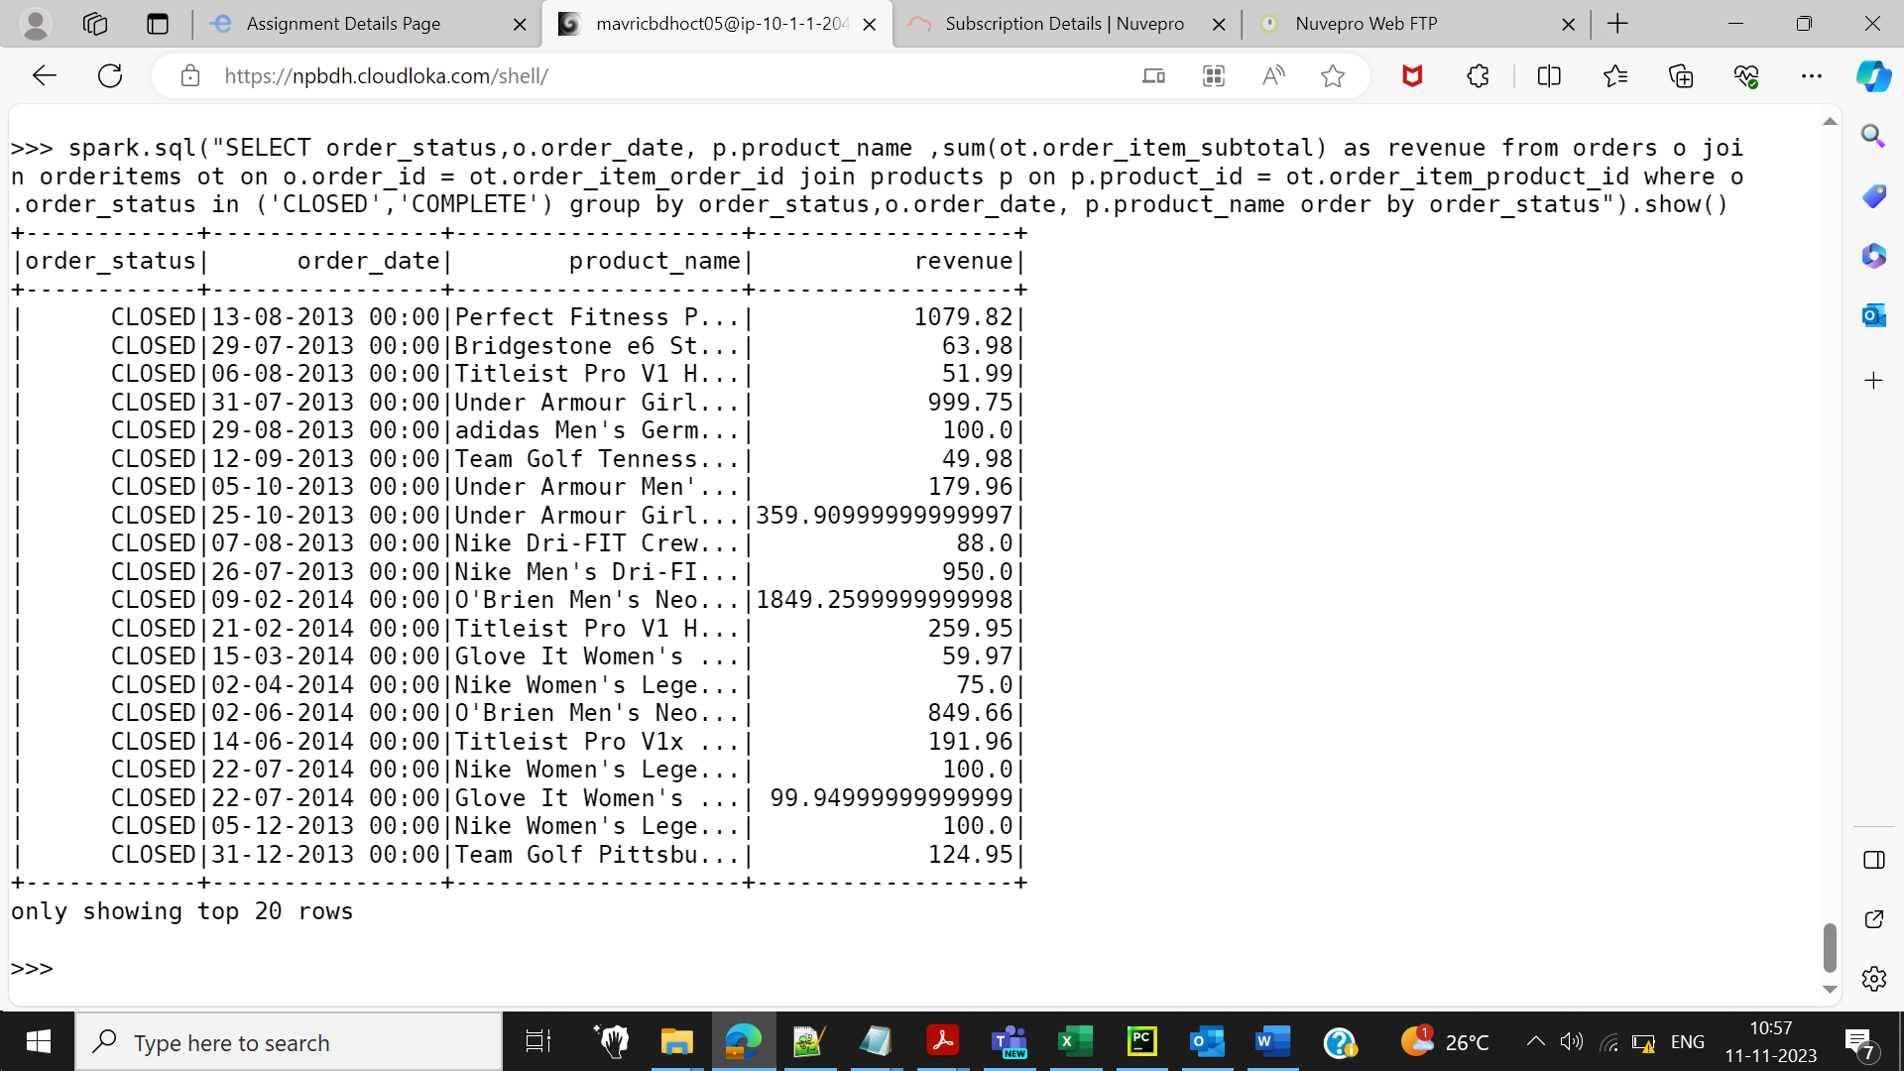

3.Get the count for each order status

spark.sql("SELECT order_status, count(order_id) from orders group by order_status").show()

+---------------+---------------+

| order_status|count(order_id)|

+---------------+---------------+

|PENDING_PAYMENT| 15030|

| COMPLETE| 22899|

| ON_HOLD| 3798|

| PAYMENT_REVIEW| 729|

| PROCESSING| 8275|

| CLOSED| 7556|

|SUSPECTED_FRAUD| 1558|

| PENDING| 7610|

| CANCELED| 1428|

4.Filter only COMPLETE or CLOSED orders

ordersDF.filter(ordersDF.order_status == 'CLOSED').show(truncate=False)

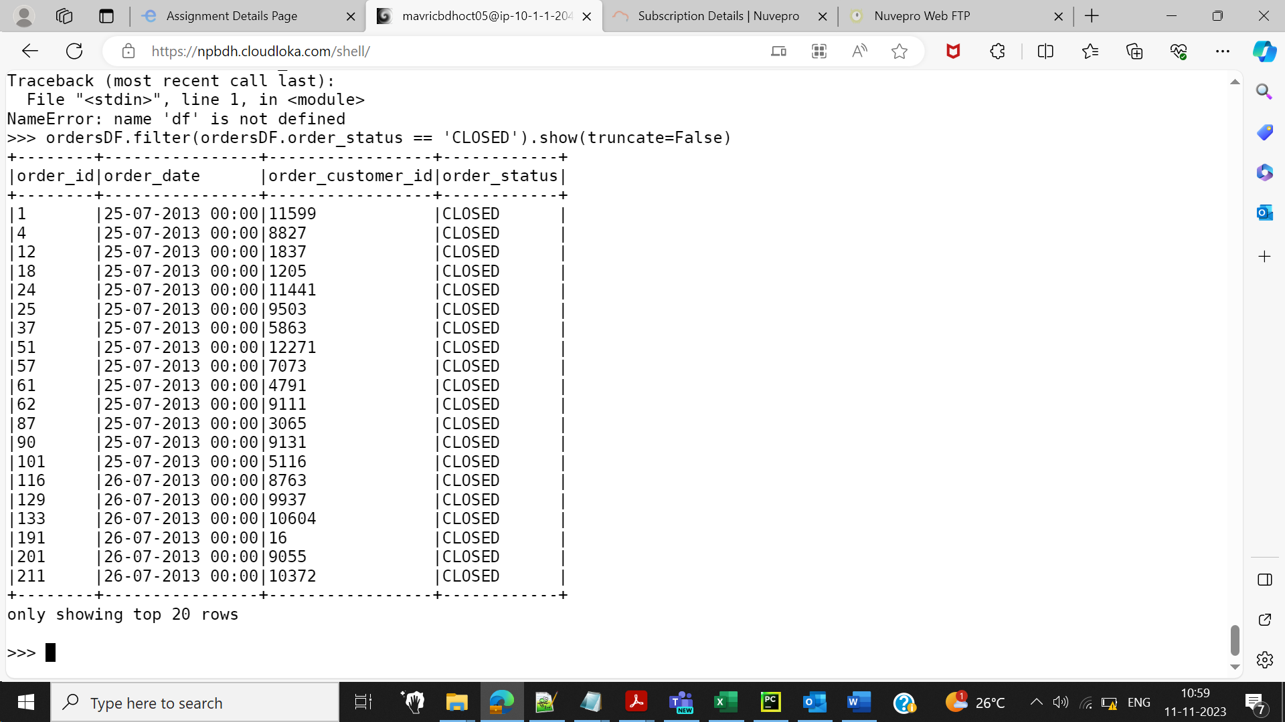

ordersDF.filter(ordersDF.order_status == 'COMPLETE').show(truncate=False)

5.Join the products,order_items and orders tables and calculate daily product revenue

spark.sql("SELECT o.order_date, p.product_name ,sum(ot.order_item_subtotal) as revenue from orders o join orderitems ot on o.order_id = ot.order_item_order_id join products p on p.product_id = ot.order_item_product_id group by o.order_date, p.product_name").show()

6.Write the data in to the table Daily product revenue in Hive

from pyspark.sql import SparkSession

spark=SparkSession.builder.appName("Spark Hive").enableHiveSupport().config("spark.sql.warehouse.dir","/user/hive/warehouse").getOrCreate()

spark.sparkContext.setLogLevel("ERROR")

df = spark.sql("SELECT o.order_date, p.product_name ,sum(ot.order_item_subtotal) as revenue from orders o join orderitems ot on o.order_id = ot.order_item_order_id join products p on p.product_id = ot.order_item_product_id group by o.order_date, p.product_name")

df.show()

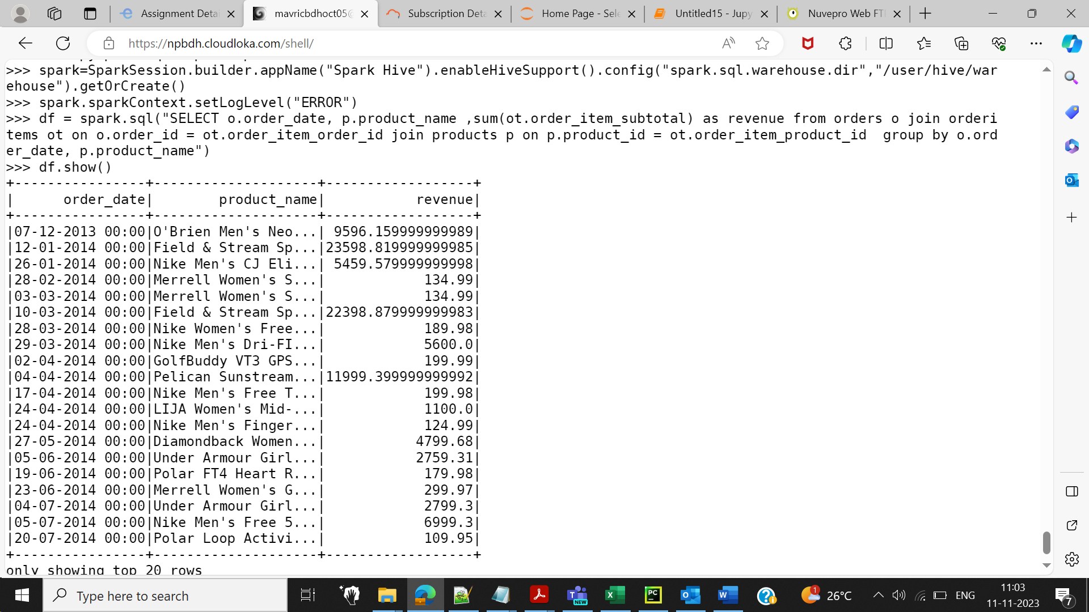

df.write.partitionBy("product_name").mode("overwrite").saveAsTable("aastha_lab.daily_revenue")

HIVE SHELL:

use aastha_lab;

show tables;

select * from daily_revenue limit 10;

