**Working of the Project**

***1. Getting the Dataset***

I downloaded the dataset from KAGGLE.

“ <https://www.kaggle.com/yuqing01/breast-cancer> “

Start in “ <https://colab.research.google.com> “

***2. Import Libraries***

Pandas, Numpy, IO and some libraries from Scikit learn.

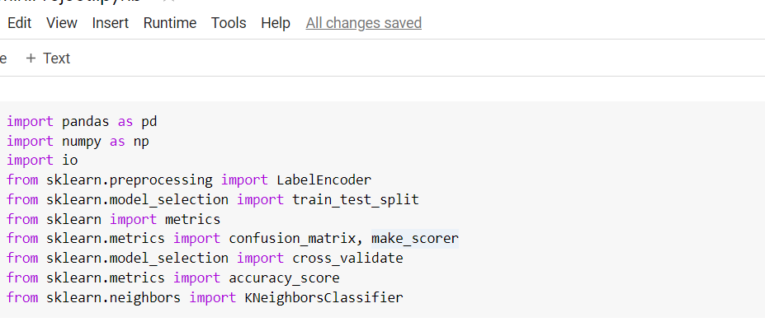

***3. Uploading the Dataset***

Upload the data set in google colab research

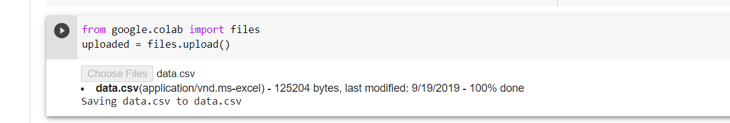

Then import it



***4. Overview***

The df.head function is used to overview the data

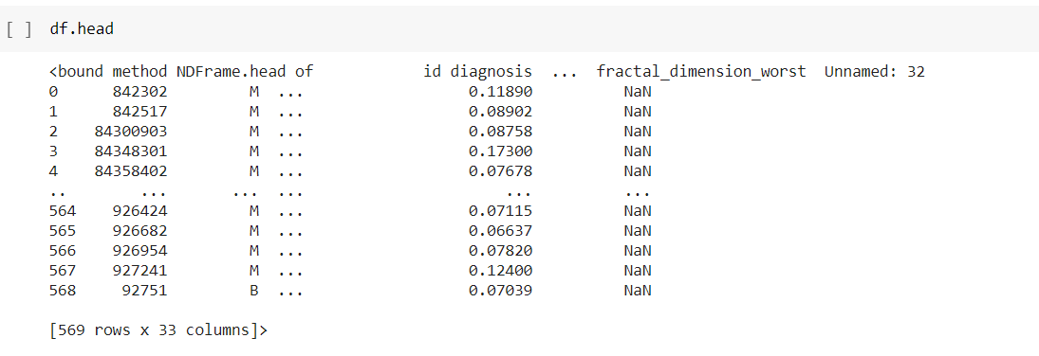

***5. Cleaning and Sampling***

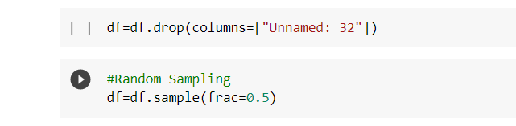

***6. Label Encoding***

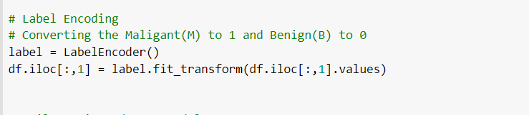

***7. Split Test & Train Model***



***8.KNN – Classification Algorithm***

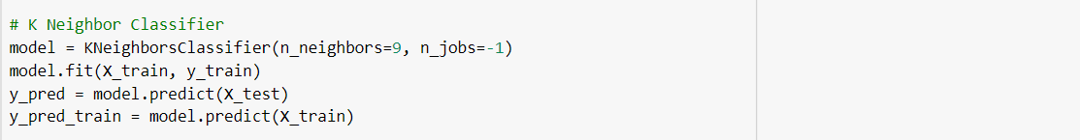

***9. Result***

