AI-Based Log Anomaly Detection using Machine Learning and Deep Learning

Dataset: HDFS Log Dataset

Training Dataset:
- File: hdfs_train.txt
- Total Logs: 5583
Testing Dataset:
- File: hdfs_test_abnormal.txt
- Total Logs: 16838
Feature Extraction:
- Technique: TF-IDF Vectorization
- Total Features Generated: 5593

Isolation Forest
- Model Type:
Unsupervised Anomaly Detection
- Training Logs:5583
- Testing Logs:16838
- Results:
Anomalies Detected: 12445
Normal Logs: 4393
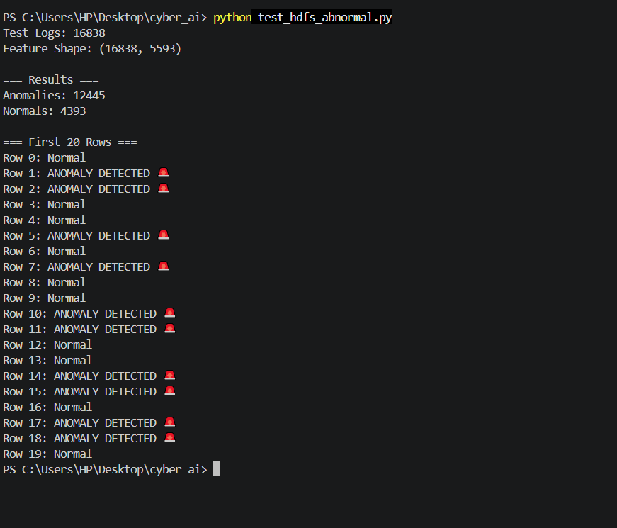
One-Class SVM
- Model Type:
Unsupervised Anomaly Detection
- Results:
Anomalies Detected: 7467
Normal Logs: 9371

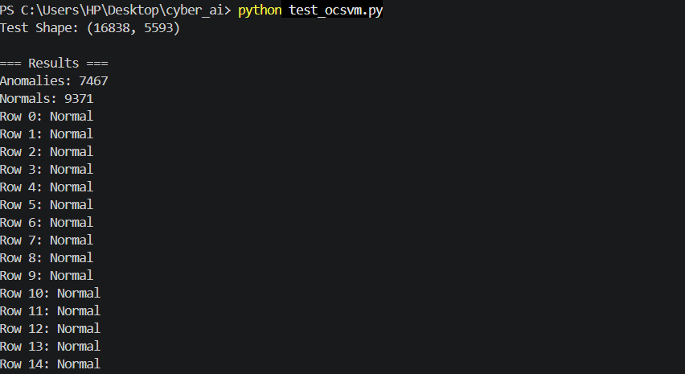
Autoencoder
- Model Type:
Deep Learning Based Anomaly Detection
- Training Epochs: 50
- Final Training Loss:0.000176
- Results: Anomalies Detected: 3029
Normal Logs: 13809
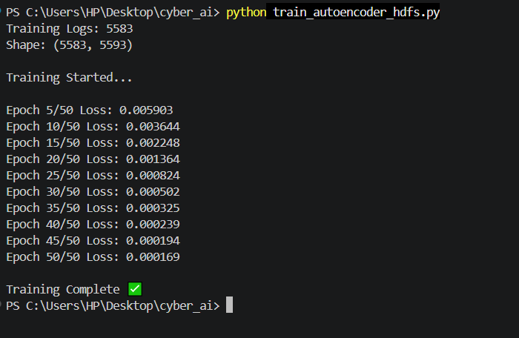
Figure 1:MODEL TRAINING
Autoencoder was trained on 5,583 normal HDFS logs after converting them into TF-IDF feature vectors of dimension 5,593. The model used an encoder–decoder neural network architecture and was trained for 50 epochs using Mean Squared Error (MSE) loss and the Adam optimizer. During training, the reconstruction loss gradually decreased and reached 0.000176, showing that the model successfully learned the normal log patterns. The trained model was then saved and used for anomaly detection on the abnormal HDFS log dataset.
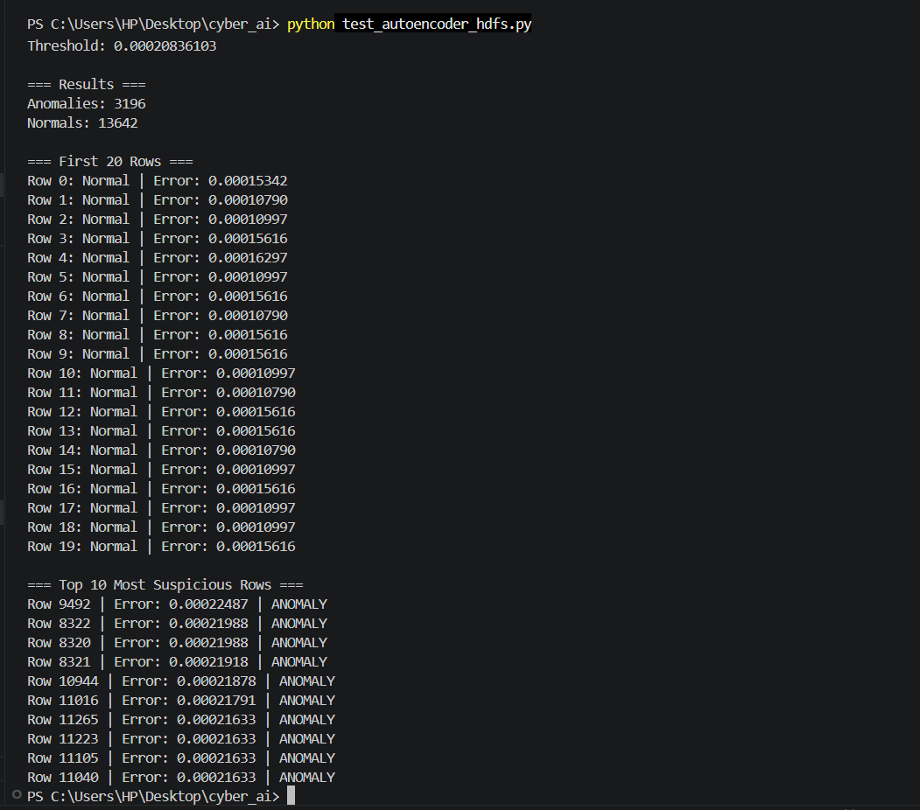
Figure 2:MODEL TESTING
The trained Autoencoder model was tested on 16,838 HDFS test logs. For each log, the reconstruction error was calculated by comparing the original TF-IDF vector with the reconstructed output. Logs with reconstruction errors above the predefined threshold (0.00020836103) were classified as anomalies, while the remaining logs were classified as normal.

XGBoost
- Model Type: Supervised Classification
- Training Logs: 5583 Normal
- Testing Logs: 16838 Abnormal
- Performance Metrics: Accuracy: 100%
Precision: 100%
Recall: 100%
F1 Score: 100%
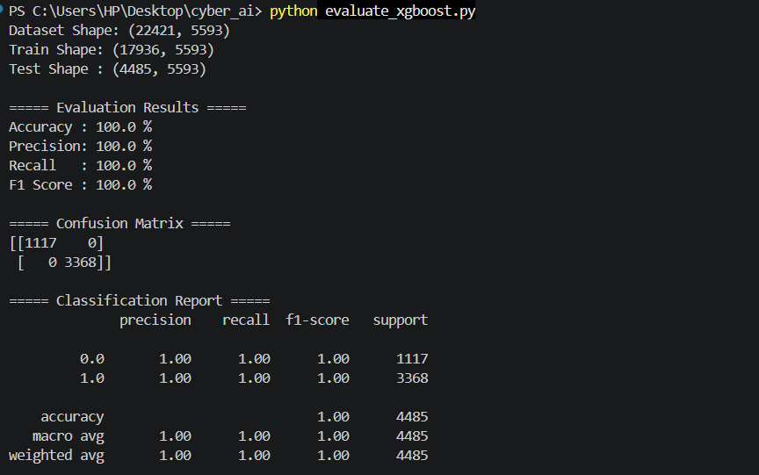

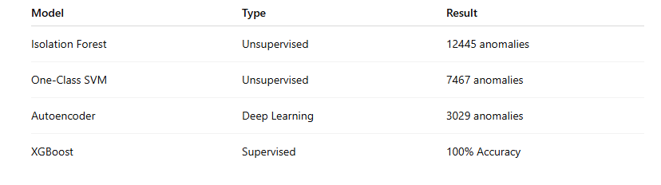

The HDFS dataset contains system-generated log messages collected from a distributed file system environment. The logs were preprocessed and converted into numerical feature vectors using TF-IDF vectorization. These feature vectors were used to train and evaluate multiple anomaly detection and classification models.

MODEL DESCRIPTION:
- Isolation Forest

Model Description
Isolation Forest is an unsupervised anomaly detection algorithm that identifies anomalies by isolating observations using randomly generated decision trees. Anomalous logs are isolated in fewer splits compared to normal logs.

Training
- Training Logs: 5583
- Features: 5593
- Trees: 100
- Algorithm: Isolation Forest
The model was trained on normal HDFS logs after TF-IDF vectorization. It learned the normal behavior patterns present in the training dataset.

Testing
The trained model was evaluated on 16838 HDFS test logs. Logs identified as unusual were classified as anomalies.

One-Class SVM

Model Description
One-Class SVM is an unsupervised learning algorithm that learns the boundary of normal data and classifies observations outside this boundary as anomalies.

Training
- Training Logs: 5583
- Features: 5593
The model learned the decision boundary representing normal HDFS log behavior.

Testing
The trained model was tested on 16838 HDFS logs. Logs falling outside the learned boundary were classified as anomalous.

Autoencoder

Model Description
Autoencoder is a deep learning-based anomaly detection model consisting of an encoder and decoder network. It learns to reconstruct normal log patterns and detects anomalies using reconstruction error.

Training
- Training Logs: 5583
- Features: 5593
- Epochs: 50
- Final Loss: 0.000176
The model was trained to reconstruct normal HDFS logs while minimizing reconstruction error.

Testing
The trained Autoencoder was evaluated on 16838 HDFS logs. Logs with reconstruction errors greater than the threshold value were classified as anomalies.

XGBoost

Model Description
XGBoost is a supervised machine learning algorithm based on gradient-boosted decision trees. It learns from labeled normal and anomalous logs to perform classification.

Training
- Normal Logs: 5583
- Abnormal Logs: 16838
- Total Samples: 22421
The model was trained using labeled HDFS logs converted into TF-IDF feature vectors.

Testing
The dataset was split into training and testing sets using an 80:20 ratio. Performance was evaluated using standard classification metrics.

