Emotional Community Detection in Social Networks
Aasthaba Zala
School of Computer Science, University of Windsor
401, Sunset Avenue, Windsor Ontario, Canada
Zala2@Uwindsor.ca

Abstract— In this paper, I address the problem of classification and detection of emotions of text in any form. I consider English text which is collected from social media like Twitter, which can provide information having utility in a variety of ways, especially opinion mining. Social media like Twitter and Facebook is full of emotions, feelings and opinions of people all over the world. However, analyzing and classifying text on the basis of emotions is a big challenge and can be considered as an advanced form of Sentiment Analysis. This paper proposes a method to classify text into six different Ekman’s Emotion-Categories: Happy, Sad, Fearful, Angry, Surprise and Anxious. In my model, I use different approaches and combine them to effectively extract these emotions from text. I have also successfully devised a method that find out tweets of a particular person. Moreover, I have managed to create a large bag of emotional words, like I collected data from live streaming. On testing, it is shown that my model provides significant result in classifying tweets taken from Twitter.

Keywords— Sentiment Analysis, Emotion Detection, Social Network, Data mining, Twitter
Introduction
Emotions are very interested topic and it is described as intense feelings that are directed at something or someone in response to internal or external events having a particular significance for the individual. And in today’s time Internet has become a key medium through which people express their point of view, feelings and emotions. Every event, news or activity around the globe, is shared, discussed, posted and commented on social networks, by millions of people. Eg. ”The three out of the three win for Team India! Super happy”, “I’m super sad because corona spoiled my birthday”, “Yayy! I got a new car”. Capturing these emotions of people in text, especially those posted on social media, can be a source of precious information, which can be used to study how different people react to different situations.
Business companies can use this information to track feelings and opinions of people to find out what people think about various products. The problem with most of the Sentiment Analysis that is done today is that the analysis only informs whether the public reaction is positive, neutral or negative but unable to describe the exact feelings of the customers. With my emotional analysis, they can have a more profound analysis of their markets than the previous Sentiment Analysis, which itself has turned their businesses more profitable. Business leaders can change their product type according to people’s response. Also, health-analysts can study the thinking of individuals or groups at different times of the day or in response to certain situations. It can also be used to formulate the mental or emotional state of an individual, studying their activity over a specific period of time, and possibly detect depression risks.
There are number of research available that have focussed on Sentiment Analysis. But few have actually focussed on proper mining emotions from text. However, it is difficult to analysis the text to classify and score it on the basis of emotions. Few challenges are listed below:
•No proper classification of emotions using Ekman’s emotions.
• Lack of manually created data to train classifiers to label data into six categories.
In order to address the aforementioned challenges, it was crucial to create a system that could generate a good and reliable data sets, and an algorithm that could not only detect the kind of emotions, but also differentiate its categories.
A lot of research has been already done on classifying tweets, opinions, reviews, ratings, comments and other forms on social media into positive or negative sentiments. Emotions have also been studied by people, but in a limited extent, such as by asking specific questions and judging on the basis of replies, or an analysis done only on short one-lined headlines.
In this paper, I proposed a new idea to classify and quantify tweets according to six standard emotions suggested by Paul Ekman. Here, I did my analysis on tweets posted on Twitter, but it can be easily extended to any kind of text whether it is one lined headlines, messages and posts on social networks.
My main contributions are listed below:
• I have developed a system that could score any piece of text, especially tweets and posts on social media according to six Emotion-Categories: Happy, Sad, Fearful, Surprise, Angry and Anxious.
• Another significant contribution is that I have devised a system that could find an efficient data set for analysis. Moreover, I created a system which can collect a data set by live streaming also.

RELATED WORK
In the recent past, with the rise of social media, interest rate has been increased for Sentiment Analysis. Lately, a lot of research has been done on classifying comments, opinions, reviews, recommendations and other forms of online expressions into positive, neutral and negative sentiments. Earlier research involved manually created corpus that has limited size to classify the emotions. Wiebe et al. worked on the manual annotation of emotions, opinions and sentiments in a sentence corpus (of size 10,000) of news articles. Segundo et al. also studies the presence of emotions in text, and is a functional theory of the language used for expressing attitudes, judgments and emotions. one research work classified text into six Emotion Categories, but that was only limited to classification of news headlines, and the training set used was created manually. On the other hand, I developed a system, which classifies text in any form, which is generated automatically. This saved a lot of effort. Another similar work was of Carlo and Rada who did a similar classification on news headlines but even they used manually annotated corpus for their classification.
DATA SETS
This section describes the various data sets used.

  - Tweets Set
I used Tweepy library to collect tweets, which is a Python library for accessing the Twitter API. It takes as input various parameters, such as coordinates, radius, etc., and after removal of duplicates, links, hashtags, and words in other languages (besides English) from these tweets, stores the tweet-ids, text and location of the most recent ones in the database. This provided me with a list of tweets from various locations across the country.

  - Live tweets set
I created another data set which is created doing live streaming. And then it will find the categories.

TABLE I: An example of EWS

Word | Category
amused | happy
disheartened | sad
bewildered | surprise
cautious | fearful
bitter | angry
distrustful | anxious

  - Emotion-Words Set (EWS)
A selection of relevant and commonly-used Emotion words is one of the most essential and indispensable aspects in the emotional quantification of a whole sentence. I have created a high-quality accurate bag of words, called Emotion-Words Set. It has been developed by manually which are the synonyms of the 6 basic Emotion-Categories (HAPPY, SAD, ANGRY, SURPRISE, FEARFUL, ANXIOUS). An example is shown in the Table 1.

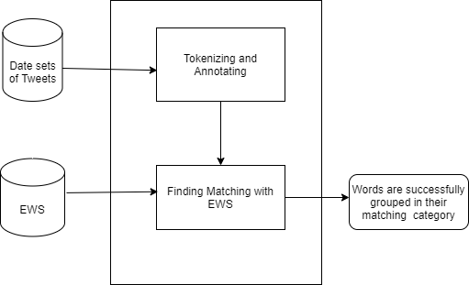
Fig. 1: An overview of the approach

EMOTION-DETECTION ALGORITHM
My model uses Natural Language Processing, Emotion-Words Set and several textual features. It attempts to classify and score text according to the emotions present in it.

Using NLP and EWS:
The first approach uses the tweets in Tweets Set, which are already free from any unwanted characters, hyperlinks or hashtags. The following steps comprise the first approach. 1) Tokenizing and Annotating: First, I tokenize the tweets into sentences, which are further tokenized into tokens. Then, I remove all the stop words from these tokens. The filtered tokens are then annotated using the following CoreNLP annotators.

Finding Hits:
In this step, the annotated tokens are matched against the words present in the EWS. But first, all the words in the EWS are lemmatized to their base form. Eg. “happiness” and “happily” are changed to “happy”. A matched token along with all its characteristics/annotations is stored as a hit.
Then I stop the word which is not useful for the detection.

Finding the Sentiment:
After matching the words, I analyse and visualize the tweets. I differentiate the tweets into three parts: Positive, Negative and Neutral. I show the graph representation which shows the number of times a single word is occurred.

Requirements:
There is specific requirements for this research work which are listed below.

• Windows 10
• Python Platform (Pycharm)
• Packages
• Twitter API
To get a Twitter API, I created developer’s account on twitter. And after that I got four key which I used as a twitter credentials. I put all keys in one python file and it is used for sentimental analysis. Without that we cannot able to get the tweets of people.

SYSTEM DESIGN

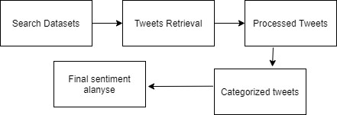

Input(Search Datasets):
Data in the form of raw tweets is acquired by using the Python library “tweepy” which provides a package for simple twitter streaming API . This API allows two modes of accessing tweets: it simply delivers a small, random sample of all the tweets streaming at a real time

Tweets Retrieval:
Since human labelling is an expensive process. I further filter out the tweets to be labelled so that we have the greatest amount of variation in tweets without the loss of generality. It filters useless words. I used few methods to stop the words.

Data Preprocessing:
It processes the tweets. In this when we got data, it will be further processed.

Classified Tweets:
I labelled the tweets in three classes according to sentiments observed in the tweets: positive, negative and neutral.
Positive: If the entire tweet has a positive/happy attitude or if something is mentioned with positive connotations. Also if more than one sentiment is expressed in the tweet but the positive sentiment is more dominant.
Negative: If the entire tweet has a negative/sad attitude or if something is mentioned with negative connotations. Also if more than one sentiment is expressed in the tweet but the negative sentiment is more dominant.
Neutral: If the creator of tweet expresses no personal opinion in the tweet and merely transmits information. Advertisements of different products would be labelled under this category.

EXPERIMENT SETUP

Implementation details:
First of all, I created twitter Developer account. And after that I got its API. Then I Chose PYCHARM as a platform, because it was feasible for me. Then imported few packages which were crucial for my analysis. For instance, I imported the following packages:1)tweepy 2)tweepy.streaming 3)textblob 4)Pandas 5)numpy 6)re 7)string 8)matplot.. Tweepy is an open source Python package that gives you a very convenient way to access the Twitter API with Python. Tweepy includes a set of classes and methods that represent Twitter's models and API endpoints, and it transparently handles various implementation details, such as: Data encoding and decoding. Pandas is mainly used for data analysis. Pandas allows importing data from various file formats such as comma-separated values, JSON, SQL, Microsoft Excel. Pandas allows various data manipulation operations such as merging, reshaping, selecting, as well as data cleaning, and data wrangling features. I used numpy because it is open source numerical python library. It contains a multi-dimensional array and matrix data structure. It is extension of Numeric and Numarray. Pandas objects rely heavily on numpy objects. The Python module re provides full support for Perl-like regular expressions in Python. The re module raises the exception re. error if an error occurs while compiling or using a regular expression. TextBlob is a Python library for processing textual data. It provides a simple API for diving into common natural language processing tasks such as part-of-speech tagging, noun phrase extraction, sentiment analysis, classification, translation, and more. It allows to generate high quality line plots, scatter plots, histograms, bar charts, and much more. Each plot presents data in a different way and it is often useful to try out different types of plots before settling on the most informative plot for your data. Python string module contains a single utility function – capwords. This function split the specified string into words using str. If it's provided then the separator is used to split and join the words. I did two kinds search to get tweets, for the first method I fetched the data by live streaming. For the second one, I got tweets of a particular person and did analysis on that. I manually prepared matching word data sets that matches the words from tweets. After getting tweets I filtered the words which were not useful. For example “ Yayyyyyy! Happy! I have two weeks of vacation.” In this tweet, there are many useless words which is not needed. So I created a method which matches the tweet and provide only useful result. After that I did sentimental analysis and showed the sentiment of the Tweet whether it is positive, Negative or Neutral. If we get 1 then the tweet is positive, if the result is 0 then it is neutral and the result is -1 then it’s negative.
Moreover, my work also shows the tweeter ID, tweeter name, location, retweets and tweets.

Testing:

I checked my result with the real result and it very much accurate. I got a proper outcome for sentimental analysis. I found out whether it is positive tweet, negative or neutral. Here are some results that I got during my search.

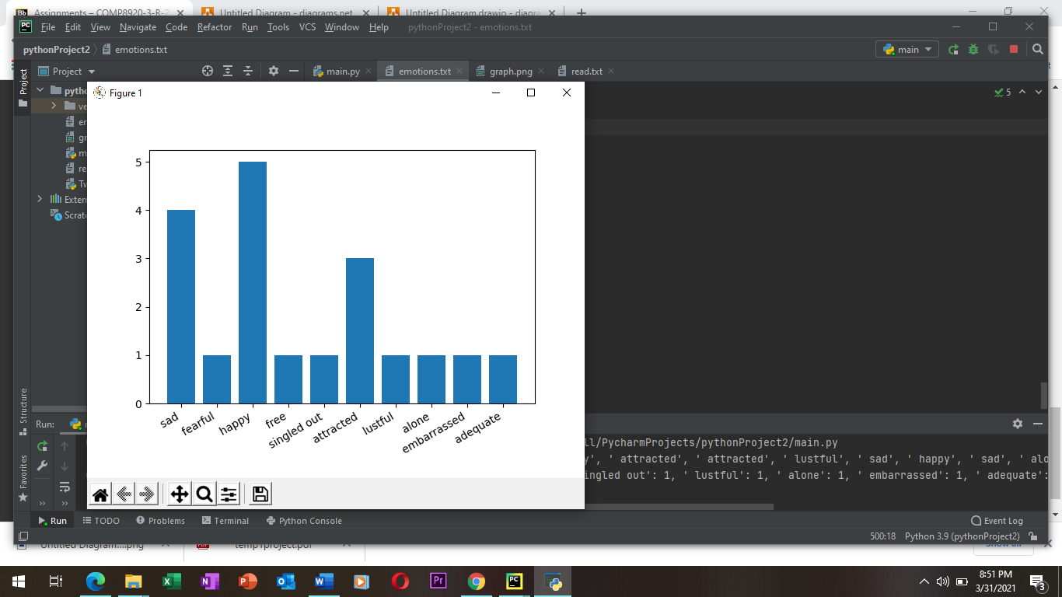

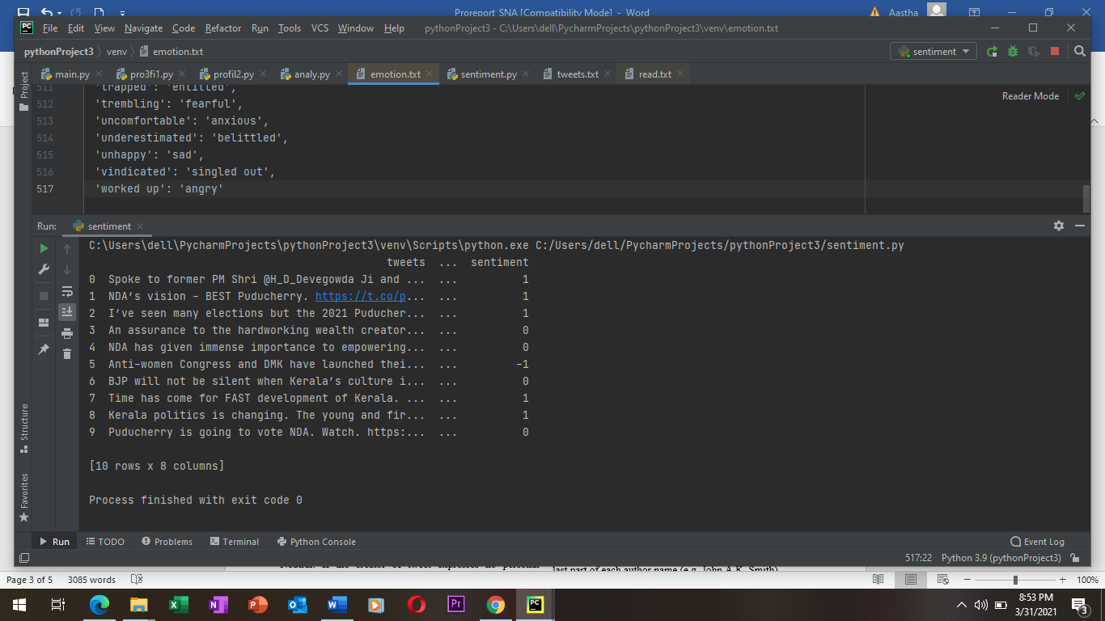

CONCLUSION
In this paper, I have addressed the problem of classifying text into the six basic Emotion-Categories, rather than just labelling them as positive or negative. Through my research reliable bag of emotional words, I can now effectively quantify many emotions in any block of text. In future, a system could be established for automatically updating the bag-of-words and automatically generate matching word sets . Using this approach, many interesting apps can be created, such as a social-networking site displaying the recent mood of your friends. Moreover, my analysis of Twitter can be extended to the development of a real-time application, analyzing mood-swings and emotions on Twitter.

REFERENCES:

[1] Rakesh C Balabantaray, Mudasir Mohammad, and Nibha Sharma. Multiclass twitter emotion classification: A new approach. International Journal of Applied Information Systems, 4(1):48–53, 2012.
[2] Cecilia Ovesdotter Alm, Dan Roth, and Richard Sproat. Emotions from text: machine learning for text-based emotion prediction. In Proceedings of the conference on human language technology and empirical methods in natural language processing, pages 579–586. Association for Computational Linguistics, 2005.
[3] Janyce Wiebe, Theresa Wilson, and Claire Cardie. Annotating expressions of opinions and emotions in language. Language resources and evaluation, 39(2-3):165–210, 2005.
[4] Paulo Roberto Gonc¸alves Segundo. The language of evaluation: Appraisal in english (martin, jr & white, rrr). Linha D’Agua ´ , (21):133–137, 2008.
[5] Carlo Strapparava and Rada Mihalcea. Learning to identify emotions in text. In Proceedings of the 2008 ACM symposium on Applied computing, pages 1556–1560. ACM, 2008.
[6] Carlo Strapparava and Rada Mihalcea. Semeval-2007 task 14: Affective text. In Proceedings of the 4th International Workshop on Semantic Evaluations, pages 70–74. Association for Computational Linguistics, 2007.
[7] Wenbo Wang, Lu Chen, Krishnaprasad Thirunarayan, and Amit P Sheth. Harnessing twitter” big data” for automatic emotion identification. In Privacy, Security, Risk and Trust (PASSAT), 2012 International Conference on and 2012 International Confernece on Social Computing (SocialCom), pages 587–592. IEEE, 2012
[8] Gaind, B., Syal, V., & Padgalwar, S. (2019). Emotion detection and analysis on social media. arXiv preprint arXiv:1901.08458.
[9] Saima Aman and Stan Szpakowicz. Identifying expressions of emotion in text. In International Conference on Text, Speech and Dialogue, pages 196–205. Springer, 2007.
[10] ”Sequential minimal optimization”. https://en.wikipedia.org/wiki/ sequential minimal optimization.
[11] Clare H Liu. Applications of twitter emotion detection for stock market prediction. PhD thesis, Massachusetts Institute of Technology, 2017.
[12] Dario Stojanovski, Gjorgji Strezoski, Gjorgji Madjarov, and Ivica Dimitrovski. Emotion identification in twitter messages for smart city applications. In Information Innovation Technology in Smart Cities, pages 139–150. Springer, 2018.
[13] ”Tweepy”. http://www.tweepy.org/.
[14] ”Thesaurus.com”. http://www.thesaurus.com/.
[15] Christopher D. Manning, Mihai Surdeanu, John Bauer, Jenny Finkel, Steven J. Bethard, and David McClosky. The Stanford CoreNLP natural language processing toolkit. In Association for Computational Linguistics (ACL) System Demonstrations, pages 55–60, 2014.

