Sentinel Automatic Antenna Tracker

LITE

User GuIDE

VirtualPilot

NOTICE

The information contained in this document is believed to be accurate in all respects but is not warranted. The information is subject to change without notice and should not be construed in any way as a commitment by the manufacturer, supplier, distributor, affiliates or subsidiaries.

The manufacturer, supplier, distributor, affiliates or subsidiaries assume no responsibility or liabilities for any errors or omissions in this document.

Revisions of this document or new editions of it may be issued to incorporate such changes.

No part of this document can be reproduced or transmitted in any form or by any means without written permission from the manufacturer.

This device is a hobby grade device intended for use by hobbyists. It is not intended or warranted for commercial or military use.

This device must only be used in compliance with applicable legislation.

This use of device can be impacted by ferromagnetic / electromagnetic and GPS interference.

**Patents**

Patents pending

**Trademarks**

Other product names mentioned in this document may be trademarks of their respective companies and are hereby acknowledged.

© Copyright 2020, VirtualPilot  
All rights reserved

Table of Contents

Introduction 4

AAT – Quick Start wiring guide 5

AAT – Quick Start configuration guide 5

AAT – Quick Start user reference 6

AAT – Configuring the AAT 7

AAT – OLED display (optional accessory) 9

AAT – Calibration for Hard / Soft iron interference 10

AAT – Manual pan adjustment calibration 10

AAT – Updating the firmware 11

AAT – Mounting the VRX / Antenna 12

AAT – Connections and interfaces 13

FC – iNAV – Configuration (mandatory) 15

FC – Betaflight – Configuration (mandatory) 15

FC – Ardupilot – Configuration (mandatory) 15

FC – MWOSD – Configuration 15

AAT – Troubleshooting 16

Specifications 17

Requirements 17

# Introduction

The AAT brings higher quality video and the ability to use lower video transmission power or increase the maximum reception distance over traditional omnidirectional antennas. The AAT provides the benefit of maintaining a more accurate direction over manually mounted antennas without the concern of the aircraft moving outside of the antenna’s dominant reception area.

The AAT is designed to work with many standard Flight Control systems such as iNAV, Ardupilot and Betaflight. The AAT is also designed to work with any systems running MWOSD on standard minim compatible OSD hardware.

This AAT uses a completely new concept for sending aircraft telemetry tracking information without the need of additional hardware on the aircraft and brings simple and easy antenna tracking capability to a wide range of Flight Control systems in use.

The AAT lite version brings a low-cost DIY option to the market using low cost and widely available components. Design files are available for those wanting to develop and improve the design or 3D print their own add-on components.

The AAT lite version provides a full 360-degree pan coverage with a fast return. This can generate a small glitch in the video signal when the AAT passes its end point however in real operation it is far less impacting than imagined and similar to a typical analog glitch for less than a second. Fixed rotation trackers are however typically much more accurate in yaw positioning than magnetic compass based trackers.

# AAT – Quick Start wiring guide

This is intended for users who just want to get going without reading the full manual:

1. **Pin connections are listed in the AAT connections section**
2. **Connect VRX Video, Audio GND and Power to “VRX in” connector on AAT PCB.**
3. **Connect YAW and TILT servos.**
4. **Take special care with connection GND and Power (choice of 5V or V battery)**

# AAT – Quick Start configuration guide

This is intended for users who just want to get going without reading the full manual:

1. **Power up the AAT and connect to AAT Wi-Fi access point**
2. **Open a web browser and connect to** [**http://192.168.4.1**](http://192.168.4.1)
3. **Using the simulator to test, configure pitch min and max for correct 0 ° and 90** **° tilt operation**
4. **Using the simulator to test, configure yaw for correct 0 ° and 180 ° pan operation**
5. **Configure voltage scale to display correct voltage value in the GUI**
6. **Adjust cell count and minimum voltage to trigger low voltage warning**
7. **Save settings**
8. **Click the calibrate button and rotate in as**
9. **FC - Install a firmware that supports the AAT** [**Click here for files**](https://github.com/aat-sentinel)
10. **FC - Install fonts that support the AAT** [**Click here for files**](https://github.com/aat-sentinel)
11. **FC - Enable AAT telemetry from within the Features menu on the OSD**
12. **Connect RX to AAT and verify telemetry is received by LED or the web browser**

# AAT – Quick Start user reference

This is intended for users who just want to get going without reading the full manual:

*Initial power up state*: the AAT will center yaw and point at an angle slightly above the horizon. The unit can be manually aimed for manual tracking if required. This state will remain until a valid telemetry signal is received.

*FC disarmed state*: when the AAT receives a valid telemetry tracking command, it will point vertically and due North to indicate to the user that the AAT is ready. This state will remain until the FC enters FC armed state.

*FC armed state*: when the aircraft is armed, once the aircraft has moved outside its activation perimeter (10 meters), it will engage and point at the aircraft.

*FC armed state*: if the aircraft moves back within the activation perimeter, the antenna will point vertically.

If enabled, the AAT will provide audible warning for loss of telemetry data or low battery.

Note: The position of the aircraft and it’s tracking is relative to the home position of the aircraft and not the AAT unit itself.

To use the AAT:

1. **Power up the aircraft**
2. **Power up the AAT**
3. **Set the AAT offset direction to best match the prime direction in which you are flying. E.g:**
   1. **If yaw offset = 0, point the AAT North**
   2. **If Yaw offset = 90, point the AAT West**
   3. **If Yaw offset = 180, point the AAT South**
   4. **If Yaw offset = 270, point the AAT East**
4. **Verify the AAT is receiving valid data (antenna points vertical and telemetry LED = ON)**
5. **Arm aircraft close to the AAT (with minimum sats needed by the FC)**
6. **Launch aircraft**
7. **Verify antenna is tracking as soon as practical after launch (visual / audible movement)**

# AAT – Configuring the AAT

The AAT contains a built in Wi-Fi access point and GUI web interface for easy configuration. The Wi-Fi can be disabled when the AAT is in use to avoid interference with any VRX.

To connect to the AAT:

1. **Power up the AAT.**
2. **Open your wireless connections and the AAT should appear shortly.**
3. **Select the AAT wireless network. Allow up to a minute to establish the connection.**
4. **Open a web browser and connect to** [**http://192.168.4.1**](http://192.168.4.1)

To configure the tilt operation (mandatory):

1. **Click on the simulator compass / tilt icon for quick setting of angles.**
2. **Adjust the “Pitch min” so that the antenna is pointing horizontally using the simulator.**
3. **Adjust the “Pitch max” so that the antenna is pointing vertically using the simulator.**
4. **Toggle “Pitch reverse” if pitch travel direction is incorrect.**
5. **Adjust the “Pitch speed” if needed. Recommend using default values to start.**

To configure the pan operation (mandatory):

1. **Click on the simulator compass / tilt icon for quick setting of angles.**
2. **Set “Yaw adjust” to 0.**
3. **Set “Yaw mid” to 1500.**
4. **Adjust the “Yaw range” so that the antenna moves full 180 degrees using the simulator.**
5. **Test Yaw range using the simulator to travel between 0 and 180 degrees.**
6. **Toggle “Yaw reverse” if pitch travel direction is incorrect.**
7. **Adjust the “Yaw speed” if needed. Recommend using default values to start.**

To configure low battery alarm (recommended):

1. **Adjust the “Voltage scale” so the GUI voltage display matches measured supply voltage.**
2. **Adjust the “Cell count” to match the battery cell count.**
3. **Enable “Low voltage alert” if you desire audible battery low warning.**

To configure loss of tracking alarm (recommended):

1. **Enable “Beeper” if you desire audible loss of tracking signal.**

To configure the AAT Wi-Fi to remove conflict with VRX (recommended):

1. **Set “Wi-Fi” mode to “Auto disable” to reduce 2.4G interference to your VRX when in flight.**

To configure the AAT to use negative elevations (not typically required):

1. **Adjust the “Min pitch constrain” if needed.**
2. **A value of 37 equates to 0° or horizon (default)**
3. **A value of 0 equates to tracking at -37° below the horizon**
4. **The AAT will need to be able to physically support this without mechanical interference**

To configure AAT Wi-Fi settings (optional)

1. **If flying with others using the same AAT, change SSID from defaults.**
2. **Enable authentication and passphrase to prevent malicious connections**
3. **Changes will require reconnection and / or a password into your connecting device**

# AAT – OLED display (optional accessory)

Normal operation showing:

* Battery voltage
* Tilt angle
* Pan angle
* Signal strength
* Uncorrected Magnetic angle

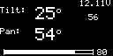

No signal and error message displays:

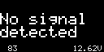







# AAT – Calibration for Hard / Soft iron interference

The AAT can be configured to use an embedded compass IC, but is not currently recommended. When using this mode, the yaw offset should be set to zero initially and then fine adjusted for the AAT to point at the plane

Calibration of the AAT is critical to gain the best tracking accuracy from the AAT.

Hard calibration is required to identify and compensate for the geomagnetic field and any localised magnetic field surrounding the AAT. A secondary Soft calibration uses a complex and powerful algorithm to generate compensation data for any localised ferromagnetic interference.

Typically, re-calibration is only required once unless you add addition items to your ground station, are situated near metal objects or travel very long distances from calibration point.

1. **Put the AAT in a level position. It must be able to turn full 360 degress.**
2. **Click the calibrate button.**
3. **Rotate the AAT through a full 360 degrees at least once during the timed period.**

# AAT – Manual pan adjustment calibration

This procedure can be used as an alternative to adjusting tracker aim when aircraft is in the air.

1. **With enough sats, arm then disarm the aircraft immediately next to the AAT.**
2. **Move aircraft at least 30m away from AAT.**
3. **Position AAT directly at aircraft.**

# AAT – Updating the firmware

1. **Download the latest AAT firmware from** [**here**](https://github.com/aat-sentinel)**.**
2. **Power up the AAT.**
3. **Open your wireless connections and the AAT should appear shortly in the networks list.**
4. **Select the AAT wireless network. Allow up to a minute to establish the connection.**
5. **Open a web browser and connect to** [**http://192.168.4.1**](http://192.168.4.1)
6. **Take note / screenshot of existing settings**
7. **Select the “Flash” icon.**
8. **Choose the TFW file**
9. **Select the appropriate variant and select OLED if you have a display**
10. **Select the red “Flash” button**
11. **When flashing completed, allow time for the AAT to restart and the GUI to connect**
12. **After re-connecting:** 
    1. **Force a browser refresh to see updated GUI (“CTRL” and “F5” simultaneously on a PC).**
    2. **verify the version number displayed is correct.**

**WARNING:** do not disconnect WiFi or Power during flashing. This may render the AAT inoperable.

**NOTE:** for some version updates, all AAT configuration information will be reset to default. The AAT will need to be re-configured and re-calibrated. This may include the Wi-Fi SSID settings which means the Wi-Fi connection may have to be re-selected.

# AAT – Mounting the VRX / Antenna

3D STL and Google Sketchup files are available for printing mounting options.

These currently include files for:

Eachine Pro 58 diversity RX,

AKK 5.8 diversity RX

RC Uno. These can be easily modified for other RX units.

The Tilt plate has mounting points 80mm apart for any user created mounting brackets.

Care should be taken to minimise stress on the AAT by reducing antenna / VRX weight and ensuring both are placed as close to the AAT mounting plate as possible.

The recommended maximum weight should not be exceeded.

[**Click here for available 3D STL files**](https://tinyurl.com/SentinelAAT)

# AAT – Connections and interfaces

### AAT – Connecting

1. **All DC sockets are joined together.**
2. **Internal VRX connector in for AV and supports 5v or V battery supplies for the RX. Choose VRX supply carefully!**
3. **Dual independent outputs - one Fatshark compatible and one standard RCA video.**
4. **Note: audio pins 1 and 2 are linked together internally**
5. **Note: external power output for RX is connected directly to battery input (V battery)**

### AAT – LED indicators

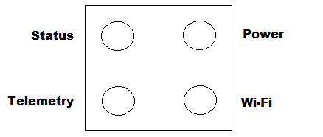

### AAT – AV connector pinout

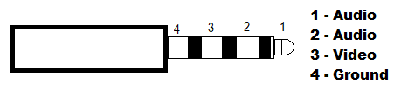

### AAT – DC Battery power connector polarity



### PCB layout and internal connections

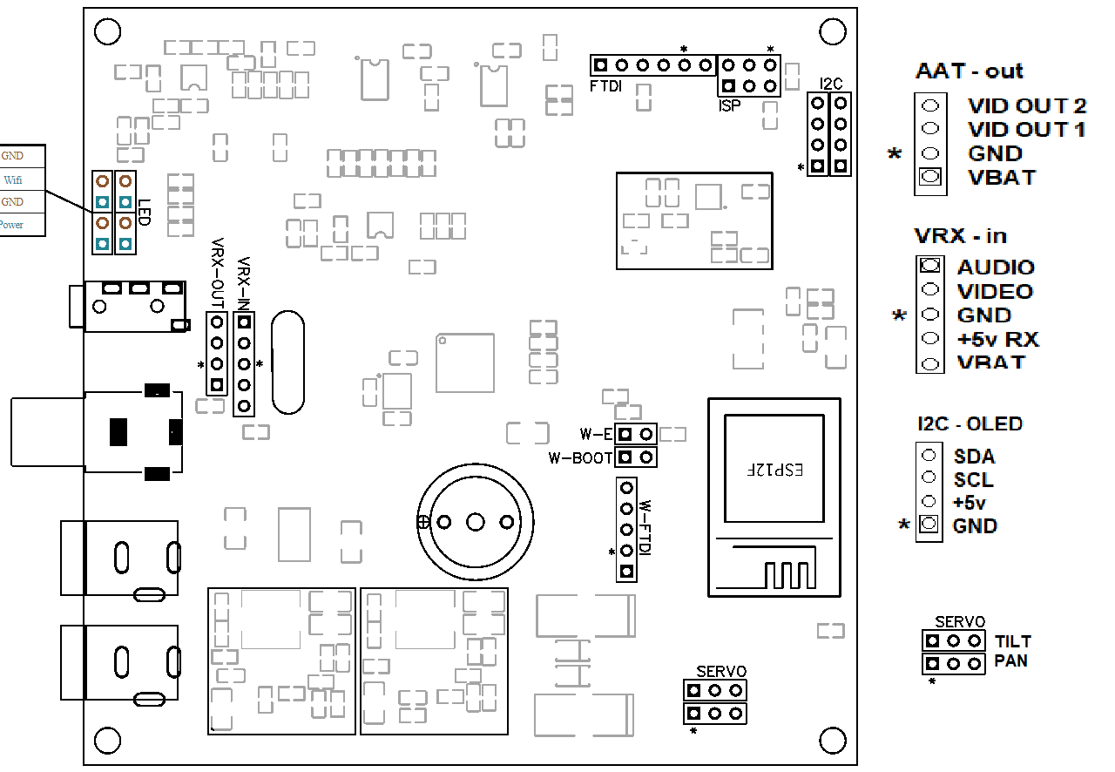

# FC – iNAV – Configuration (mandatory)

1. **Download AAT enabled firmware to your PC.**
2. **Flash iNav with AAT enabled firmware. (Firmware Flasher > Load Firmware [Local]).**
3. **Download required AAT enabled font to your PC.**
4. **Update Font (OSD tab>Font Manger>Open Font File>Open downloaded font>Upload Font**
5. **Enable AAT telemetry from within the Features menu on the OSD.**
6. **NOTE: This setting is currently not available via CLI or iNAV GUI configurator.**

# FC – Betaflight – Configuration (mandatory)

1. **Download AAT enabled firmware to your PC.**
2. **Flash Betaflight with AAT enabled firmware. (Firmware Flasher > Load Firmware [Local]).**
3. **Download required AAT enabled font to your PC.**
4. **Update Font (OSD tab>Font Manger>Open Font File>Open downloaded font>Upload Font**
5. **Enable AAT telemetry from within the Features menu on the OSD.**
6. **NOTE: This setting is currently not available via CLI or iNAV GUI configurator.**

# FC – Ardupilot – Configuration (mandatory)

1. **Requires minim compatible hardware OSD.**
2. **Install MWOSD on the OSD hardware**
3. **Follow instructions for MWOSD - configuration**

# FC – MWOSD – Configuration

1. **Flash MWOSD with AAT enabled firmware.**
2. **Flash with AAT font.**

[**AAT enabled firmware and Fonts are available by clicking HERE**](https://github.com/aat-sentinel)

# AAT – Troubleshooting

First, please read the Quick Start configuration guide steps to make sure no steps have been missed.

### AAT – Troubleshooting #1 – No tracking Telemetry

1. **Ensure the FC has AAT enabled firmware installed.**
2. **Ensure Telemetry is enabled in the OSD menu features section.**
3. **Ensure AAT enabled fonts have been uploaded to the FC.**
4. **Ensure an OSD layout is selected with Telemetry enabled**
5. **Ensure RX is powered up and connected correctly. Video visible on outputs.**
6. **Note: Telemetry will not be active in OSD menu or statistics pages**

### AAT – Troubleshooting #2 – Unable to connect to GUI

1. **Ensure the AAT is showing in the networks list and is the connected network.**
2. **Only one AAT connection at a time is permitted – verify mobile devices are not connected.**
3. **If Auto-disable is selected (default), the AAT Wi-Fi is disabled when the aircraft is armed.**

### AAT – Troubleshooting #3 – AAT not pointing directly at aircraft

1. **Ensure the aircraft is armed close to the AAT otherwise accuracy improves at range.**

# Specifications

|  |  |
| --- | --- |
| Input Voltage | Recommend 3S LiPo. Operational Voltage 8v-14v |
| Output Voltage | Same as input voltage |
| Voltage connectors | 2.1mm x 5.5mm DC barrel jack |
| Video input connectors | 0.1” PCB pin header (internal) |
| Video output connectors | 1 * 4 Pole 3.5mm Fatshark / IRC compatible pinout  1 * RCA phone. Video |
| Load Capacity | 1KG |
| Angular variance | Typically less than +/-2 degrees when calibrated |
| Antenna recommendation | Antennas with a beam-width @ -3db of > 10 degrees. |

# Requirements

|  |  |
| --- | --- |
| Configuration | A PC / mobile device with Wi-Fi connectivity and browser to access and configure the unit. Windows / IOS / Android. |