**To find name and work location of the Shift 1 Flight Director on Apollo 17:**

* **“name” indicates the individual, role mentions the job position, location indicates the location** 
  + **i.e. Flight Director Staff Support Room (SSR)**
* **Add the keyword “distinct” to eliminate duplicate individuals**

prefix rdf: <http://www.w3.org/1999/02/22-rdf-syntax-ns#>

prefix rdfs: <http://www.w3.org/2000/01/rdf-schema#>

prefix sft: <http://shiftassignment/ontology/apollo/>

prefix vcard: <http://www.w3.org/2006/vcard/ns#>

prefix xsd: <http://www.w3.org/2001/XMLSchema#>

SELECT ?name ?role ?location

WHERE {

?person sft:ShiftAssigned "1" .

?person vcard:Name ?name.

?person sft:Location "Flight Director SSR" .

?person sft:Role ?role.

?person sft:Location ?location

}

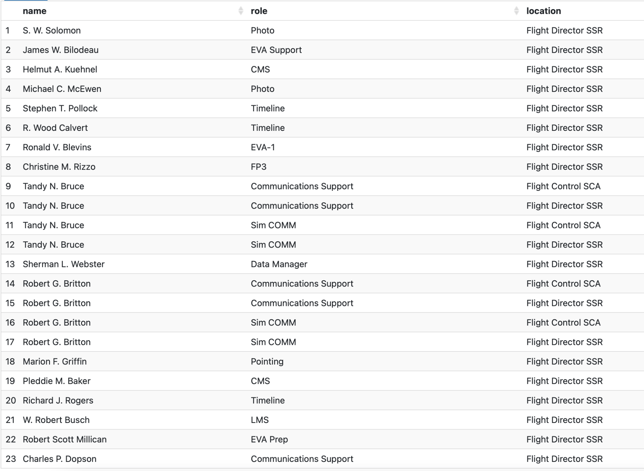

**To find people with matched Wikidata Identifiers:**

PREFIX rdfs: <http://www.w3.org/2000/01/rdf-schema#>

PREFIX rdf: <http://www.w3.org/1999/02/22-rdf-syntax-ns#>

prefix foaf: <http://xmlns.com/foaf/0.1/>

prefix owl: <http://www.w3.org/2002/07/owl#>

prefix rdf: <http://www.w3.org/1999/02/22-rdf-syntax-ns#>

prefix rdfs: <http://www.w3.org/2000/01/rdf-schema#>

prefix sft: <http://shiftassignment/ontology/apollo/>

prefix vcard: <http://www.w3.org/2006/vcard/ns#>

prefix xsd: <http://www.w3.org/2001/XMLSchema#>

SELECT ?name ?ID

WHERE {

?person vcard:ID ?ID .

?person vcard:Name ?name

}

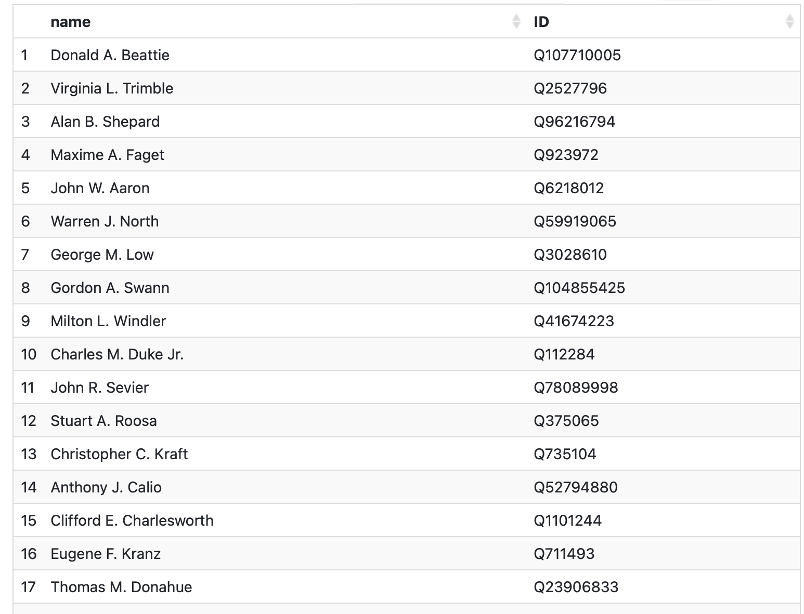

**To see how many people worked per shift:**

PREFIX rdfs: <http://www.w3.org/2000/01/rdf-schema#>

PREFIX rdf: <http://www.w3.org/1999/02/22-rdf-syntax-ns#>

prefix foaf: <http://xmlns.com/foaf/0.1/>

prefix owl: <http://www.w3.org/2002/07/owl#>

prefix rdf: <http://www.w3.org/1999/02/22-rdf-syntax-ns#>

prefix rdfs: <http://www.w3.org/2000/01/rdf-schema#>

prefix sft: <http://shiftassignment/ontology/apollo/>

prefix vcard: <http://www.w3.org/2006/vcard/ns#>

prefix xsd: <http://www.w3.org/2001/XMLSchema#>

SELECT ?shift (COUNT(?shift) AS ?shiftcount)

WHERE {

?person sft:ShiftAssigned ?shift

}

GROUP BY ?shift

ORDER BY ASC(?shift)

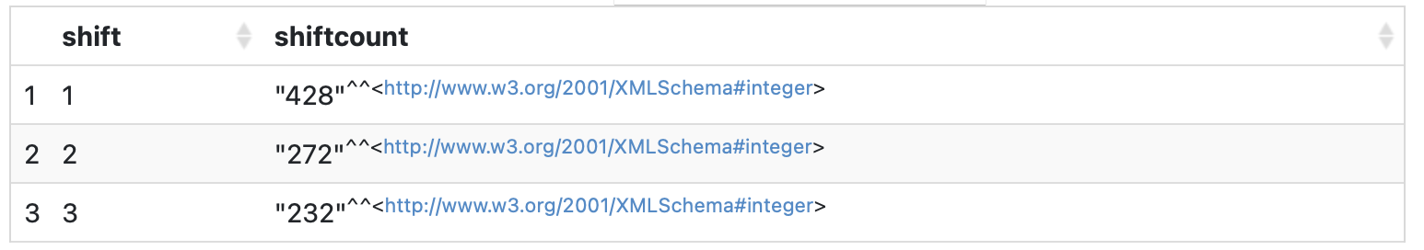

**Similarly, to view how many people worked per location:**

* **Change Order by clause to locationcount to organize by number of workers per location**

PREFIX rdfs: <http://www.w3.org/2000/01/rdf-schema#>

PREFIX rdf: <http://www.w3.org/1999/02/22-rdf-syntax-ns#>

prefix foaf: <http://xmlns.com/foaf/0.1/>

prefix owl: <http://www.w3.org/2002/07/owl#>

prefix rdf: <http://www.w3.org/1999/02/22-rdf-syntax-ns#>

prefix rdfs: <http://www.w3.org/2000/01/rdf-schema#>

prefix sft: <http://shiftassignment/ontology/apollo/>

prefix vcard: <http://www.w3.org/2006/vcard/ns#>

prefix xsd: <http://www.w3.org/2001/XMLSchema#>

SELECT ?location (COUNT(?location) AS ?locationcount)

WHERE {

?person sft:Location ?location

}

GROUP BY ?location

ORDER BY ASC(?location)

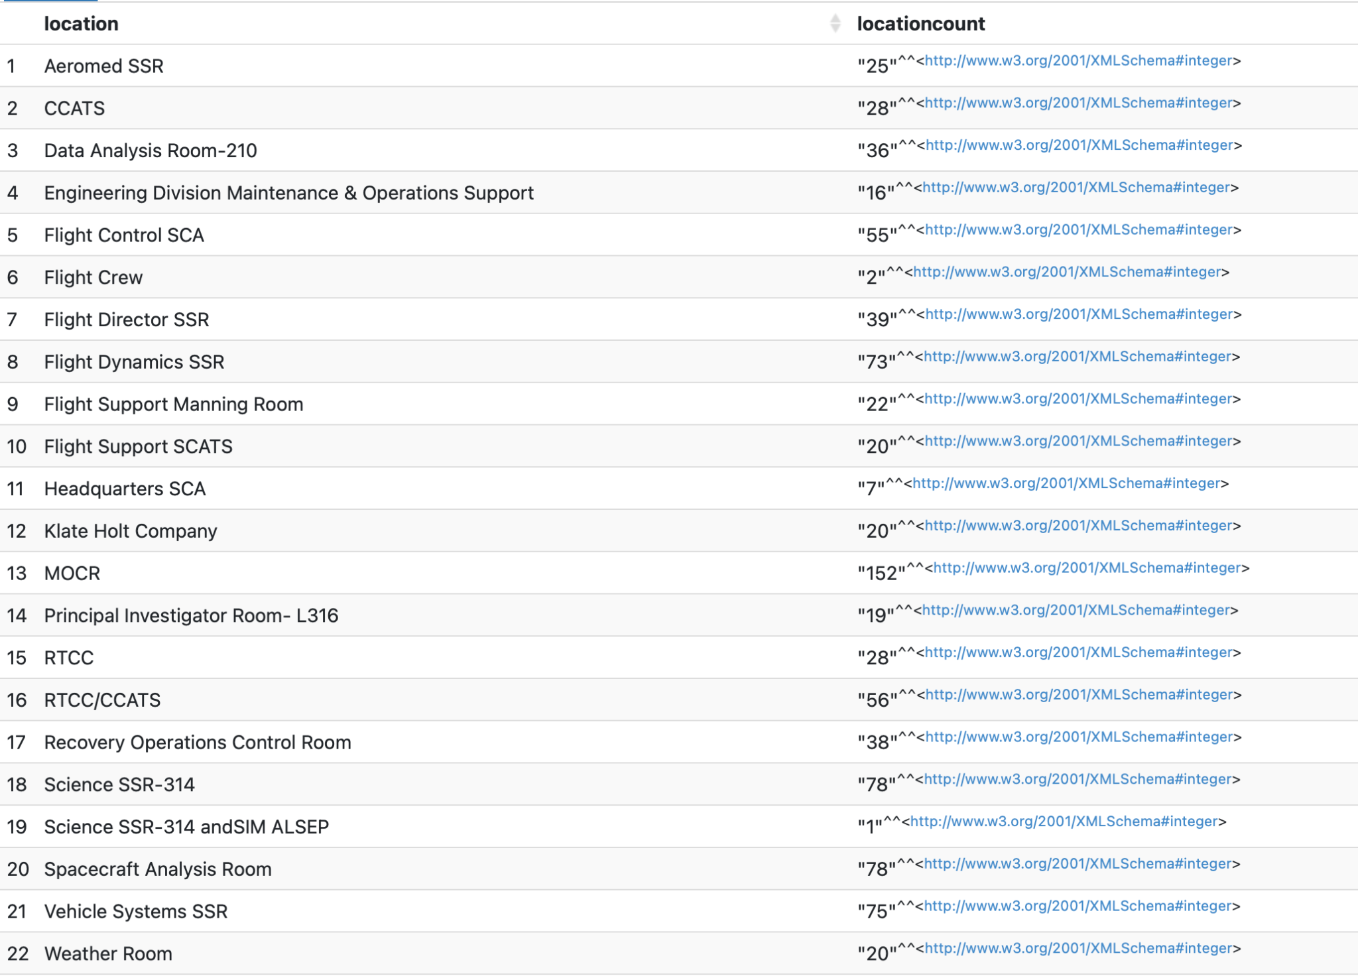

**To see which locations had more than 50 employees:**

PREFIX rdfs: <http://www.w3.org/2000/01/rdf-schema#>

PREFIX rdf: <http://www.w3.org/1999/02/22-rdf-syntax-ns#>

prefix foaf: <http://xmlns.com/foaf/0.1/>

prefix owl: <http://www.w3.org/2002/07/owl#>

prefix rdf: <http://www.w3.org/1999/02/22-rdf-syntax-ns#>

prefix rdfs: <http://www.w3.org/2000/01/rdf-schema#>

prefix sft: <http://shiftassignment/ontology/apollo/>

prefix vcard: <http://www.w3.org/2006/vcard/ns#>

prefix xsd: <http://www.w3.org/2001/XMLSchema#>

SELECT ?location (COUNT(?location) AS ?locationcount)

WHERE {

?person sft:Location ?location

}

GROUP BY ?location

HAVING (COUNT(?location) > 50)

