DFM ANALYSIS REPORT
CNC Machining Analysis

Date: | March 09, 2026
Process: | CNC Machining
Material: | Aluminum 6061
Score: | 50.0/100
Status: | NEEDS REVISION

Executive Summary
Overall Assessment: NEEDS REVISION
Manufacturability Score: 50.0/100

Critical Issues | 0
Warnings | 1
Passed Checks | 0
Optimization Opportunities | 2

Overall Assessment: NEEDS REVISION - Address critical issues
Manufacturability Score: 50.0/100
Analysis Results: 0 checks passed, 1 warnings, 0 critical issues
Key Findings:
• Wall thickness: Review required (minimum 0.8mm, recommended 1.0mm)
• Internal corners: Verify radii ≥0.5mm (sharp corners require EDM +200-400% cost)
• Hole specifications: Use standard sizes: 3, 4, 5, 6, 8, 10, 12mm
• Tolerances: Apply ±0.1mm standard, ±0.02mm only for critical features (<20%)
• Setup minimization: Design for ≤2 setups (each setup adds 30-40% cost)
• Material: Aluminum - ★★★★★ Excellent
Cost Optimization Opportunities:
1. Relax tolerances to ±0.1mm where possible (saves 40-80% per feature)
2. Add corner radii ≥1mm (saves 15-25% machining time, avoids EDM)
3. Use standard hole sizes (saves 20-40% per non-standard hole)
4. Minimize setups to 1-2 (saves 30-40% per setup eliminated)
Recommendation: Design is manufacturable with standard CNC machining.
Based on: CNC_DFM_Guidelines.md (25 sections, 200+ rules)
Standards: ISO 2768, ASME Y14.5, ISO 1302, ISO 965, ISO 286

Geometry Analysis
Dimensions: | 12.0 x 24.1 x 50.0 mm
Holes Detected: | 0
Min Thickness: | N/A
Volume: | 13334.53 mm³

Visual Analysis - Problem Areas
The following 3D renderings show the actual CAD geometry with problematic features highlighted in red. These images are generated directly from your STEP file to show exactly where design changes are needed.

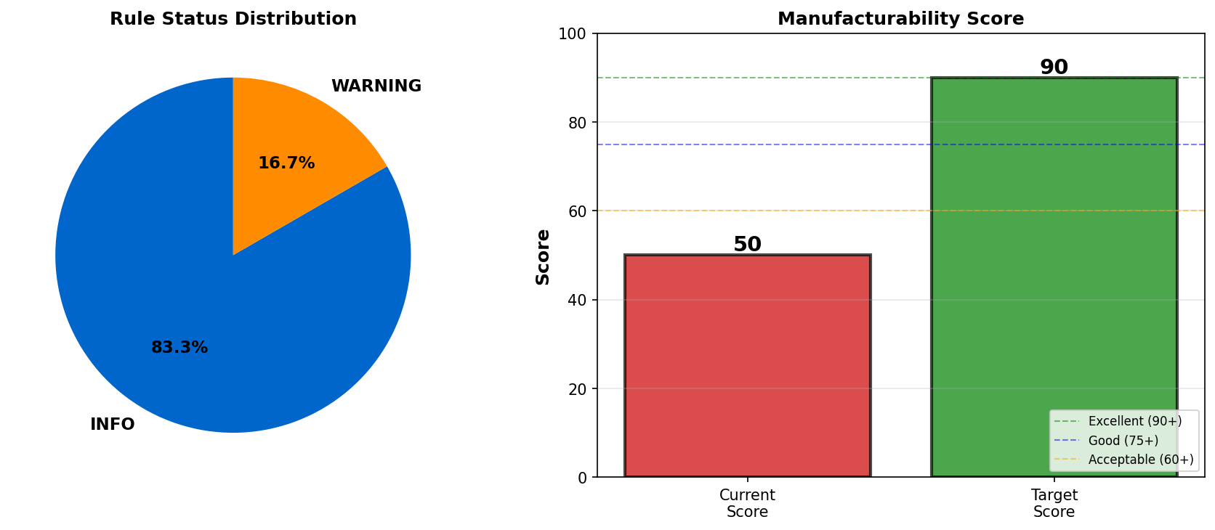
No visual annotations generated. This may be because:
• All rules passed (no failures to visualize)
• Geometry data not available for visualization
• Rule types don't support visual annotation yet

Detailed Rule-by-Rule Analysis

1. Wall Thickness
Status: INFO
Standard: Minimum: 0.8mm, Recommended: ≥1.0mm for Aluminum
Measured Value: Not measured

Evaluation:
Wall thickness could not be measured from geometry

Recommendation:
Verify wall thickness: minimum 0.8mm, recommended 1.0mm

Rationale:
Wall thickness analysis requires watertight 3D model
Cost Impact: N/A
________________________________________________________________________________

2. Internal Corner Radii
Status: WARNING
Standard: Minimum radius ≥ tool radius. Recommended: radius = 1/3 × pocket depth. Standard: 0.5mm, 1mm, 3mm, 5mm
Measured Value: Cannot detect from geometry

Evaluation:
Internal corner radii cannot be automatically verified

Recommendation:
Add radius ≥ tool radius. Use standard sizes: 0.5mm, 1mm, 3mm, 5mm

Rationale:
CNC milling tools are round - sharp 90° internal corners are physically impossible without secondary processes. Sharp corners require EDM (Electrical Discharge Machining): adds 200-400% cost, 3-5 days lead time. Minimum radius = tool radius (e.g., 3mm tool → 1.5mm radius). Recommended: radius = 1/3 × pocket depth. Larger radii: enable faster toolpaths (15-25% time savings), reduce tool wear, improve part strength.
Cost Impact: Sharp corners: require EDM (+200-400% cost). Larger radii: save 15-25% machining time
________________________________________________________________________________

3. Hole Diameter and Depth
Status: INFO
Standard: Standard sizes: 3, 4, 5, 6, 8, 10, 12mm. Maximum depth: 4× diameter. Optimal: 2-3× diameter
Measured Value: No holes detected

Evaluation:
No holes found in geometry

Recommendation:
If adding holes, use standard sizes: 3, 4, 5, 6, 8, 10, 12mm. Limit depth to 4× diameter

Rationale:
Standard hole sizes reduce cost and lead time
Cost Impact: N/A
________________________________________________________________________________

4. Tolerance Specifications
Status: INFO
Standard: Standard: ±0.1mm for non-critical features. Precision: ±0.01-0.02mm for critical only. Target: <20% tight tolerances
Measured Value: Design consideration

Evaluation:
Tolerance specification is critical for cost control

Recommendation:
Use ±0.1mm standard tolerance. Apply ±0.01-0.02mm only to critical features (<20% of part)

Rationale:
Tolerance cost impact: ±0.1mm (standard, 1.0× cost), ±0.05mm (1.3× cost), ±0.02mm (1.8× cost), ±0.01mm (2.5× cost). Over-tolerancing increases cost by 40-80% per feature. Standards: ISO 2768-mK (general tolerances), ASME Y14.5 (GD&T). Target: Only 5-10% of features should have tight tolerances. Use GD&T for critical features (position, perpendicularity, flatness).
Cost Impact: Over-tolerancing: +40-80% per feature. Proper tolerancing: standard cost
________________________________________________________________________________

5. Setup Minimization
Status: INFO
Standard: Target: ≤2 setups on 3-axis CNC. Each additional setup adds 30-40% cost
Measured Value: Design consideration

Evaluation:
Setup count directly impacts cost and accuracy

Recommendation:
Orient all critical features to be accessible from 1-2 directions. Add flat reference surfaces

Rationale:
Setup cost impact: Each setup adds 15-60 minutes (30-40% cost increase), introduces alignment error (±0.02-0.05mm cumulative), increases scrap risk. Design strategies: Orient features to 1-2 sides, add flat datum surfaces for clamping, design opposite-side features to be non-interfering, consider 5-axis machining for complex multi-sided parts (1 setup, but 1.8-2.5× machine cost).
Cost Impact: Each setup: +30-40% cost. Reducing 3 setups to 1: saves 60-80% setup cost
________________________________________________________________________________

6. Material Selection and Machinability
Status: INFO
Standard: Aluminum: ★★★★★ Excellent, Cost multiplier: 1.0×
Measured Value: Aluminum, Machinability: ★★★★★ Excellent

Evaluation:
Material machinability rating: ★★★★★ Excellent

Recommendation:
Material selection is appropriate

Rationale:
Machinability ratings: Aluminum 6061 (★★★★★, 1.0×), Brass (★★★★☆, 1.5×), Mild Steel (★★★☆☆, 1.3×), Stainless 304 (★★☆☆☆, 2.0×), Titanium (★☆☆☆☆, 4.0×). Aluminum selected: ★★★★★ Excellent, 1.0× cost multiplier. Factors: tool wear, cutting speed, surface finish, thermal expansion. Thermal expansion coefficients: Aluminum (23 µm/m·°C), Steel (12), Titanium (8.6 - excellent stability).
Cost Impact: Material cost multiplier: 1.0× vs aluminum baseline

Cost Optimization Opportunities

Opportunity 1
Opportunity: Apply tight tolerances (±0.02mm) only to critical mating surfaces
Potential Savings: 40-80% cost reduction per over-toleranced feature
Implementation Difficulty: Easy

Over-tolerancing is the #1 cost driver in CNC machining. Standard ±0.1mm is sufficient for 80-90% of features. Tight tolerances require multiple passes, inspection, and potential rework.

Opportunity 2
Opportunity: Design features accessible from 1-2 directions to minimize setups
Potential Savings: 30-40% cost reduction per setup eliminated
Implementation Difficulty: Medium

Each setup adds 15-60 minutes and introduces alignment error (±0.02-0.05mm). Orient critical features to same side. Add flat datum surfaces for stable clamping.

Recommendations

Warnings (Should Fix)
- Corner Radii: Verify all internal corners have adequate radii
- → Recommendation: Add minimum 0.5mm radius to all internal corners (1mm+ preferred)

Final Recommendation
Design needs significant revision. Address all critical issues before proceeding to manufacturing.

________________________________________________________________________________
Generated by DFM Inspector
March 09, 2026 at 10:12 AM

