PLOVER ANALYTICS · COMPANY NOTE
AMD under Lisa Su: equity repair first, margin-led growth second, Xilinx bought with shares

Advanced Micro Devices, Inc. (AMD) · Intel · NVIDIA
Asia Economics Observations · 30 September 2026
Data as of 30 September 2026: SEC filings via Plover Analytics
All company figures as filed with the SEC. Calculated ratios are marked in the text; formulas are in the appendix.

Summary
Advanced Micro Devices' recovery under Lisa Su, appointed President and CEO on 8 October 2014, was built in a particular order, and the filings make that order visible. The balance sheet was rebuilt first, in 2016, through a share issue, a revised wafer agreement with GLOBALFOUNDRIES settled partly in warrants, and the sale of 85% of its assembly and test subsidiaries. Growth followed from 2016, and it was margin-led rather than volume-led. Revenue rose 4.1× from the 2015 trough to 2021 while gross margin widened by 25.0pp. The remaining debt was retired in 2019–2021, largely through conversions and a warrant exercise, after growth was established. The 2022 acquisition of Xilinx, for $48.8bn, was paid almost entirely in shares.
The outcome is a company whose revenue rose from 9.9% of Intel's in 2014 to 65.5% in 2025, and whose gross margin (49.5%) now exceeds Intel's (34.8%). Data Center revenue, $1.7bn in 2020, was $16.6bn in 2025, close to half of the total. Two qualifications apply. NVIDIA, smaller than AMD in 2014, reported revenue more than six times AMD's in its latest fiscal year. And AMD's cumulative shareholder return, which led the S&P 500 semiconductor index through 2023, trailed it by a wide margin in 2024 and 2025.

AMD's position at the change of CEO, 2011–2015
AMD's revenue had fallen for three years when Su took over. It declined from $6,568m in 2011 to $5,506m in 2014, a fall of 16.2%. The company reported a net loss of $403m in 2014, following losses of $1,183m in 2012 and $83m in 2013. Debt stood at $2,212m against cash and short-term investments of $1,040m, and free cash flow (operating cash flow less capital expenditure) was negative at −$193m.
The first full year under the new CEO was the low point. Revenue fell a further 27.5%, to $3,991m, and the net loss widened to $660m. Stockholders' equity, $187m at the end of 2014, was −$350m at the end of 2015. The decline was concentrated in the PC and graphics business. Revenue in the Computing and Graphics segment fell 42.4%, from $3,132m to $1,805m, while the Enterprise, Embedded and Semi-Custom segment fell 7.9%, to $2,186m. For 2015 and 2016 the second segment was the larger of the two.
$m | 2011 | 2014 | 2015
Revenue | 6,568 | 5,506 | 3,991
Net income | 491 | −403 | −660
Stockholders' equity | 1,590 | 187 | −350
Debt | — | 2,212 | 2,237
Cash and short-term investments | 1,765 | 1,040 | 785
Source: AMD Forms 10-K via SEC company facts; Plover Analytics. Debt for 2011 is not shown because the tag used for the total changes in 2012.

Balance-sheet repair in 2016 and debt retirement in 2019–2021
The equity base was rebuilt in 2016, before revenue growth had become established. The 2016 Form 10-K records four transactions that together account for most of the change. AMD issued 115m new shares for proceeds of $667m. It amended its wafer supply agreement with GLOBALFOUNDRIES on 30 August 2016, issuing a warrant over 75m shares at an exercise price of $5.98 to West Coast Hitech L.P. (tagged in the filing as a Mubadala affiliate), recorded at $240m, and agreeing a limited-waiver payment of $100m, paid in quarterly instalments of $25m by the end of 2017. On 29 April 2016 it sold 85% of the equity in its Suzhou and Penang assembly and test subsidiaries to affiliates of Tongfu Microelectronics (the ATMP JV), receiving approximately $342m and recognising a gain of $146m on deconsolidation. And it issued $782m of new long-term debt while repaying $467m of its 7.75% notes due 2020. At the end of 2016 equity was $477m, debt $1,435m and cash and short-term investments $1,264m.
Revenue returned to growth in the same period, rising 8.2% in 2016 and 21.6% in 2017. The debt itself was largely retired later. In February 2019 the GLOBALFOUNDRIES-related warrant was exercised for 75m shares and proceeds of $449m. In the same year 69m shares were issued on conversion of the 2.125% convertible notes due 2026, and $403m of long-term debt was repaid. Debt fell from $1,250m at the end of 2018 to $486m at the end of 2019, $330m at the end of 2020 and $1m at the end of 2021.
The sequence therefore only partly supports the view that repair preceded growth. The equity was restored before growth began, but the debt was retired after it. Both stages were financed principally with equity rather than with cash from operations, which was modest until 2020: free cash flow was $4m in 2016, −$101m in 2017 and −$129m in 2018.
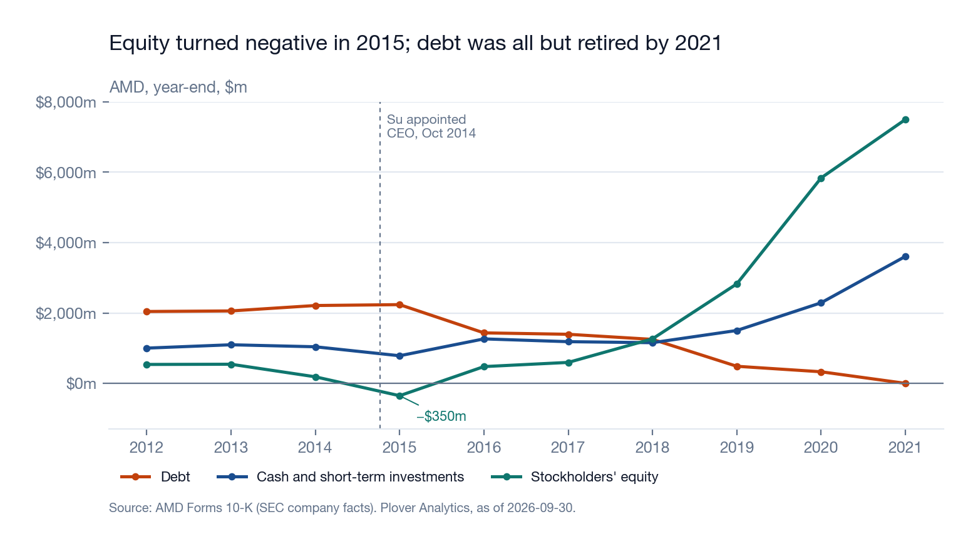

Research and development spending through the downturn
R&D was reduced during the downturn, but by less than revenue. Spending fell from $1,354m in 2012 to $947m in 2015, a reduction of 30.1%, of which the larger part, to $1,072m in 2014, predates the change of CEO. In 2015, when revenue fell 27.5%, R&D fell 11.7%, and R&D as a share of revenue (calculated) rose from 19.5% to 23.7%. From 2016 R&D increased in every year, reaching $8,091m in 2025, 8.5× the 2015 level. The evidence is consistent with R&D having been protected relative to revenue, although not in absolute terms.

Revenue growth and gross margin expansion, 2016–2021
The recovery in revenue was accompanied by a substantially higher gross margin, which suggests that it was driven by product mix and pricing and not by volume alone. Revenue rose from $3,991m in 2015 to $16,434m in 2021, 4.1×, or 26.6% a year (calculated). Gross margin (calculated) rose from 23.2% in 2016 to 34.0% in 2017, 42.6% in 2019 and 48.2% in 2021. Operating margin moved from −8.6% to 22.2% over the same five years. AMD reported its first annual operating profit since 2013 in 2017 ($127m) and its first net profit since 2011 in 2018 ($337m). By 2021 free cash flow was $3,220m.
Both reporting segments contributed. Computing and Graphics revenue rose from $1,805m in 2015 to $9,332m in 2021, 5.2×. Enterprise, Embedded and Semi-Custom revenue, which had been broadly flat at $2.0–2.4bn from 2014 to 2019, rose to $7,102m in 2021.
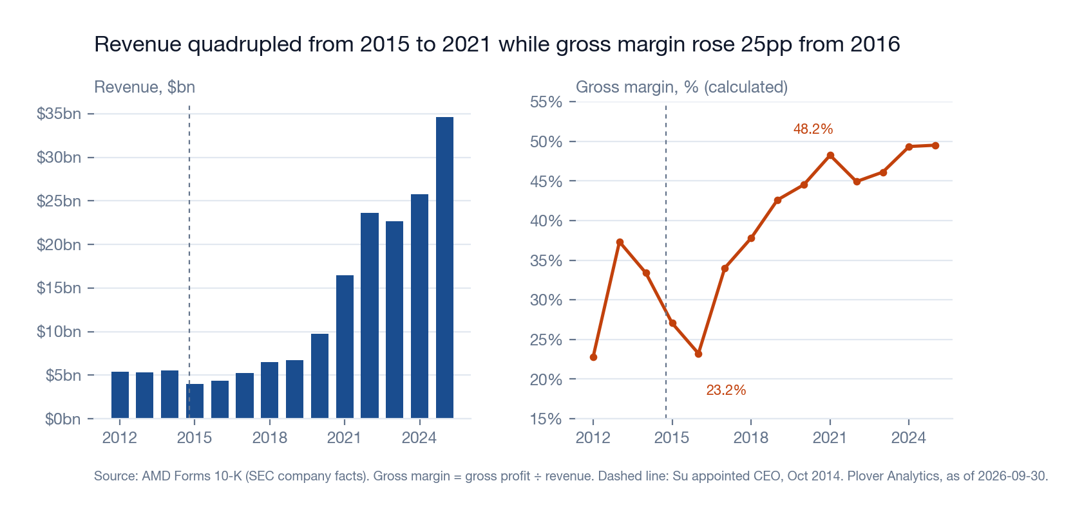

The Xilinx acquisition and its cost to reported operating profit
The acquisition of Xilinx, with an acquisition date of 14 February 2022 in the filing, was paid for almost entirely in AMD shares. The FY2022 Form 10-K records consideration of $48.8bn, of which $48.5bn was equity: 429m shares valued at $113.18 each. AMD recognised goodwill of $22,784m and intangible assets of $27,308m, and assumed $1,474m of Xilinx's long-term debt. Shares outstanding rose from 1,207m to 1,612m. Debt rose from $1m to $2,467m, compared with the $1,474m assumed from Xilinx. Smaller acquisitions followed: Pensando for $1.7bn in 2022, ZT Systems for $4.4bn on 31 March 2025 and Silo AI for $553m in 2025.
The accounting cost of the transaction is visible in operating profit. Amortisation of intangible assets was $2,800m in 2023, $2,400m in 2024 and $2,300m in 2025. In 2023 amortisation was 7.0× reported operating income of $401m. Operating margin fell from 22.2% in 2021 to 5.4% in 2022 and 1.8% in 2023, before recovering to 10.7% in 2025, while gross margin remained in a range of 44.9% to 49.5%.

Data Center as the largest segment, 2020–2025
AMD adopted four reporting segments in its FY2022 Form 10-K and restated 2020 and 2021 on that basis. Data Center revenue rose from $1,685m in 2020 to $16,635m in 2025, 9.9×. Its share of total revenue (calculated) rose from 17.3% in 2020 to 28.6% in 2023 and 48.8% in 2024, and was 48.0% in 2025. Gaming revenue moved in the opposite direction, from $6,805m in 2022 to $2,595m in 2024, before recovering to $3,910m in 2025. Embedded revenue, $246m in 2021, was $4,552m in 2022, the year of the acquisition, and $3,454m in 2025. In FY2025 AMD combined Client and Gaming into a single segment, which reported $14,550m.
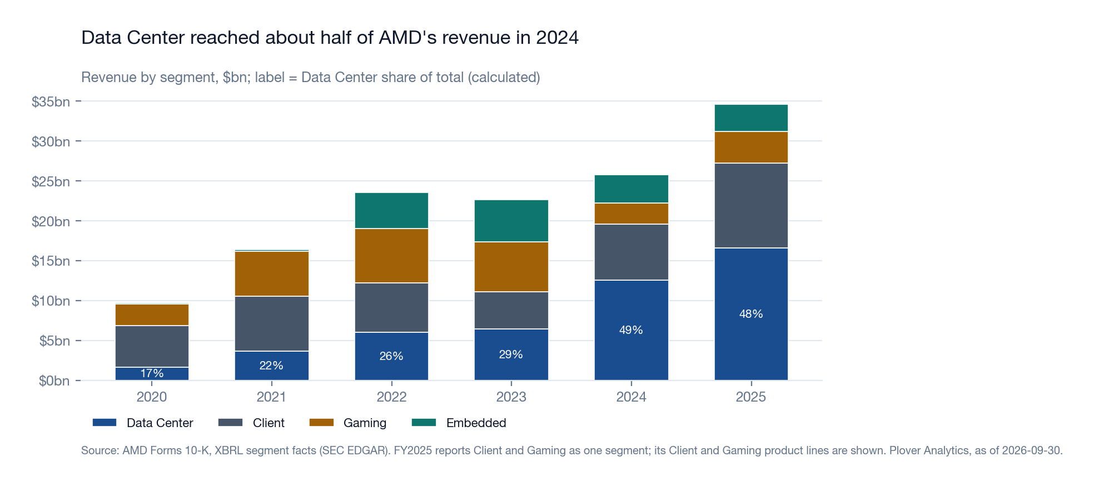

AMD relative to Intel and NVIDIA, 2014 and 2025
The comparison with Intel shows how far AMD's position has changed. AMD's revenue was 9.9% of Intel's in 2014 and 65.5% in 2025. AMD's gross margin of 49.5% in 2025 compares with Intel's 34.8%, and its operating margin of 10.7% with Intel's −4.2%. Intel reported a net loss of $18,756m in 2024. Intel still spends more on R&D, $13,774m against AMD's $8,091m.
The comparison with NVIDIA points the other way. In 2014 AMD's revenue was 117.6% of NVIDIA's; in 2025 it was 16.0%. NVIDIA's gross margin (71.1%) and operating margin (60.4%) are well above AMD's, and its R&D spending, $18,497m, is more than twice AMD's.
2014 → 2025 | AMD | Intel | NVIDIA
Revenue, $m | 5,506 → 34,639 | 55,870 → 52,853 | 4,682 → 215,938
Gross margin, % | 33.4 → 49.5 | 63.7 → 34.8 | 55.5 → 71.1
Operating margin, % | −2.8 → 10.7 | 27.5 → −4.2 | 16.2 → 60.4
R&D, $m | 1,072 → 8,091 | 11,537 → 13,774 | 1,360 → 18,497
Net income, $m | −403 → 4,335 | 11,704 → −267 | 631 → 120,067
Source: Forms 10-K via SEC company facts; Plover Analytics. NVIDIA's fiscal years end in late January and are shown against the calendar year they mostly cover (FY ending January 2015 and January 2026). Margins are calculated.

CEO compensation and shareholder return, 2020–2025
AMD's Pay versus Performance disclosures cover 2020 to 2025. Su's total compensation as reported in the Summary Compensation Table was $27.1m in 2020 and between $29.5m and $31.0m in each year from 2021 to 2024, before rising to $55.2m in 2025. Compensation actually paid, which marks equity awards to market, moved with the share price: $178.4m in 2020, $188.4m in 2021, −$160.1m in 2022, $189.8m in 2023, −$18.7m in 2024 and $146.7m in 2025.
On the cumulative basis used in the proxy statements, a $100 investment in AMD was worth $317 at the end of 2021 against $214 for the S&P 500 Semiconductors & Semiconductor Equipment Index, and $319 against $282 at the end of 2023. The position reversed in 2024: $271 against $537, and in 2025 $234 against $547. The revival documented in this note is largely complete by the start of this window, and within it AMD's share performance has trailed the index since 2024.
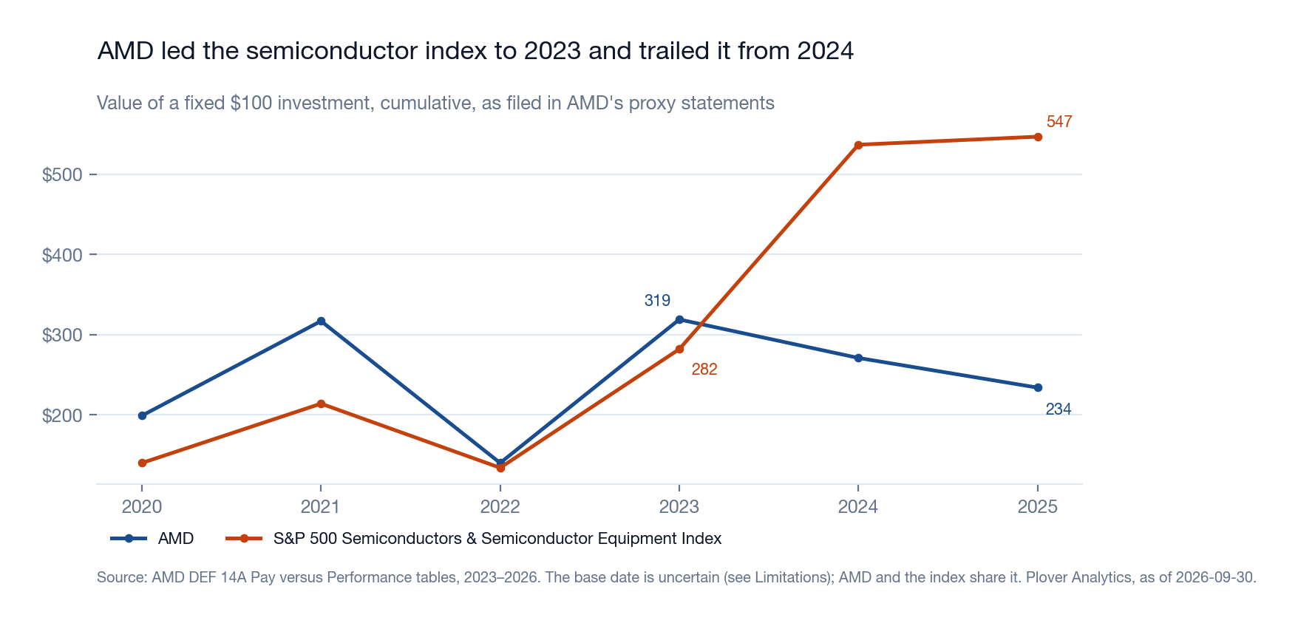

Limitations
- Segment revenue before FY2022 uses AMD's earlier two-segment structure; figures on the two structures are not comparable, and 2020–2021 appear on both.
- Share prices are not held. The note makes no valuation statement and uses total shareholder return only as filed in the proxy statements.
- The 2026 proxy statement dates the base of its $100 return series to 24 December 2020, but its FY2021 value (317) is identical to the value filed in earlier proxies whose series begin a year earlier. The base date is therefore uncertain, and only AMD-versus-index comparisons, which share a base, are used.
- Company facts carry no segment dimension; segment figures are taken from the XBRL instance documents of each Form 10-K.
- Intangible amortisation for 2022 is not tagged on the same basis as later years and is shown as missing.

Appendix: sources and method
- Company financials: SEC company facts (data.sec.gov/api/xbrl/companyfacts) for AMD (CIK 2488), Intel (CIK 50863) and NVIDIA (CIK 1045810), loaded into Plover Analytics' US deep-coverage set and served at https://ploveranalytics.com/api/v1/us/financials/deep/{ticker}/series?tag=…&as_of=2026-09-30. The value used for each period is the latest filed on or before 30 September 2026. Revenue uses SalesRevenueNet to FY2017 and RevenueFromContractWithCustomerExcludingAssessedTax from FY2016, where AMD's tagging changed. Debt is LongTermDebt where AMD tagged a total including the current portion; otherwise the noncurrent and current parts are added.
- Segments and transactions: XBRL instance documents of AMD's Forms 10-K for FY2014–FY2025, downloaded from EDGAR and archived with SHA-256. Segment revenue reconciles to reported revenue in every year.
- CEO appointment: AMD Form 8-K filed 8 October 2014, Item 5.02.
- Pay and shareholder return: AMD DEF 14A Pay versus Performance tables, 2023–2026 proxies, from Plover Analytics' proxy archive (/api/v1/us/pay/AMD).
- Calculated figures: gross margin = gross profit ÷ revenue; operating margin = operating income ÷ revenue; R&D intensity = R&D ÷ revenue; free cash flow = net cash from operating activities − payments for property, plant and equipment; growth rates = end ÷ start − 1; annual growth = (end ÷ start)^(1/years) − 1; changes in a percentage are in percentage points (pp).

