***ELEVATE LABS - TASK #1***

*Name: Mohammed Aatef*

*Gmail:* [*moatif1416@gmail.com*](mailto:moatif1416@gmail.com)

*GitHub*

Q. Create s3 bucket in AWS and understand Object storage.

1. Login into Free tier AWS Account and go to s3 from the search bar.
2. Once in the s3 page click on create bucket, you will see something like this:-

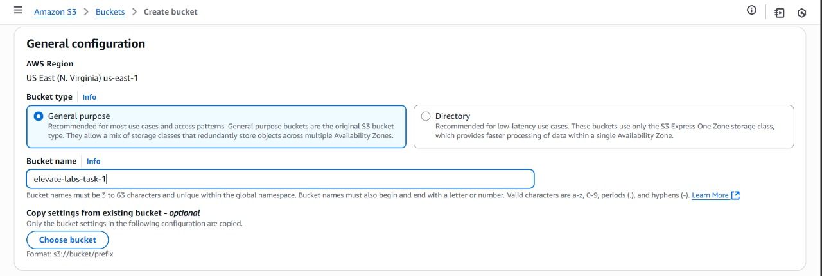

1. Once here, type unique name for the bucket eg- “elevate-labs-task-1”, name must be unique so aws will use it as subdomain.
2. Next, scroll down and untick block public access which will allow us to access the files in the bucket.

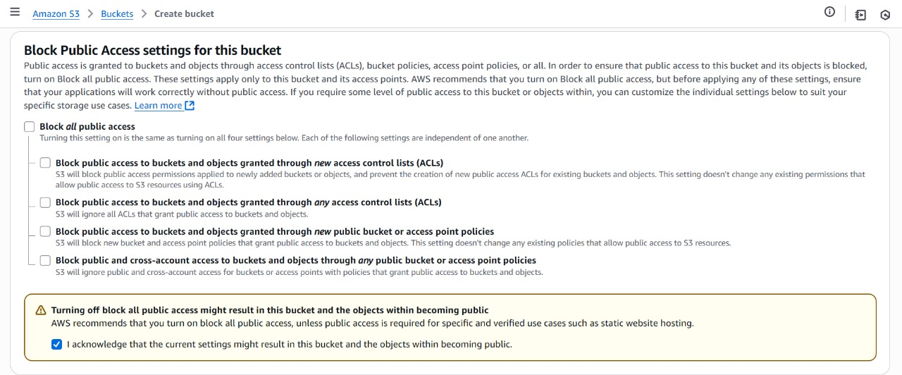

1. Make sure to accept the acknowledgement. And click submit to create the bucket.

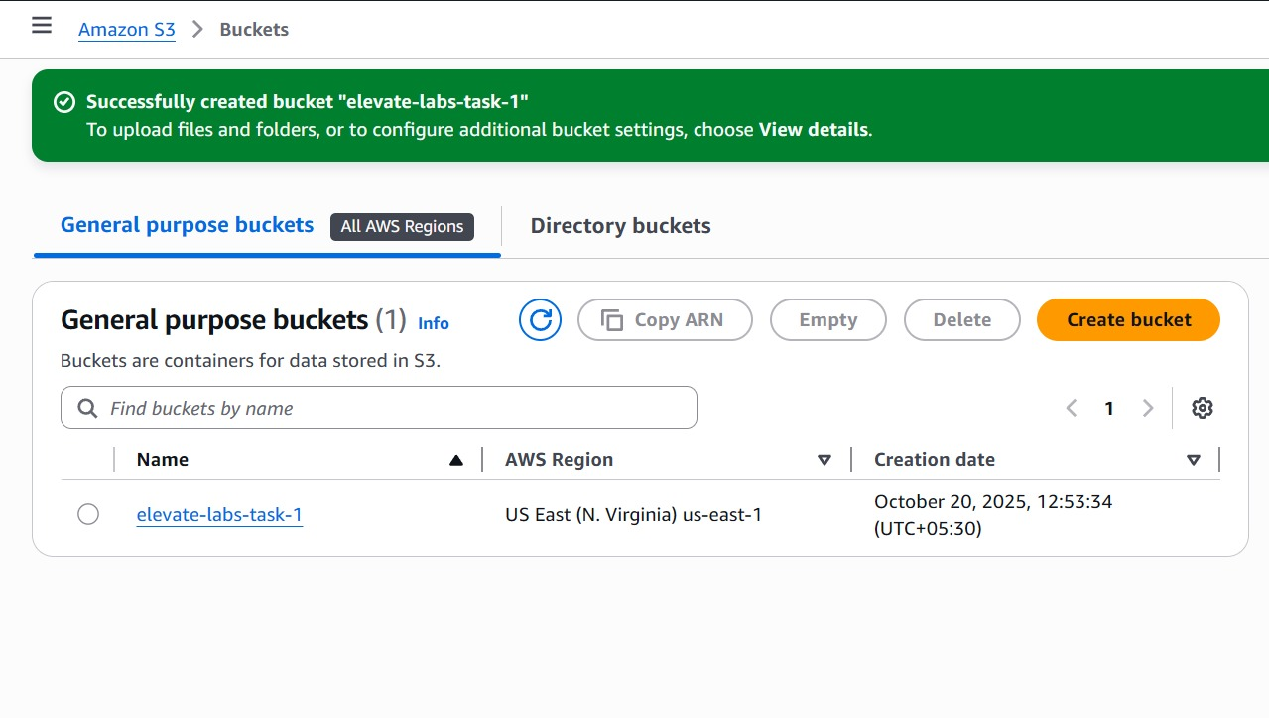

1. Bucket will be created click on it and will open a page which allows to upload files (object).

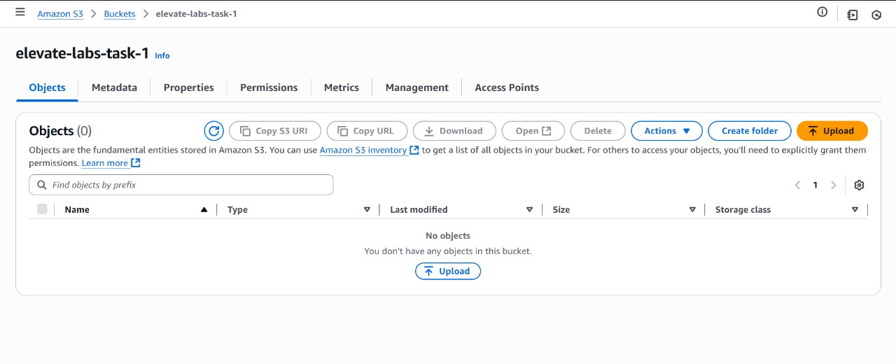

1. Click on upload and select files from your local machine.

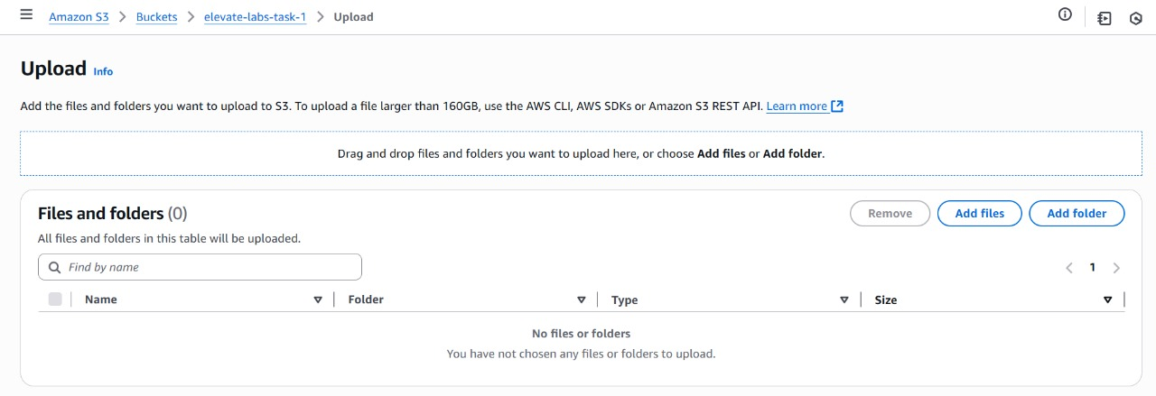

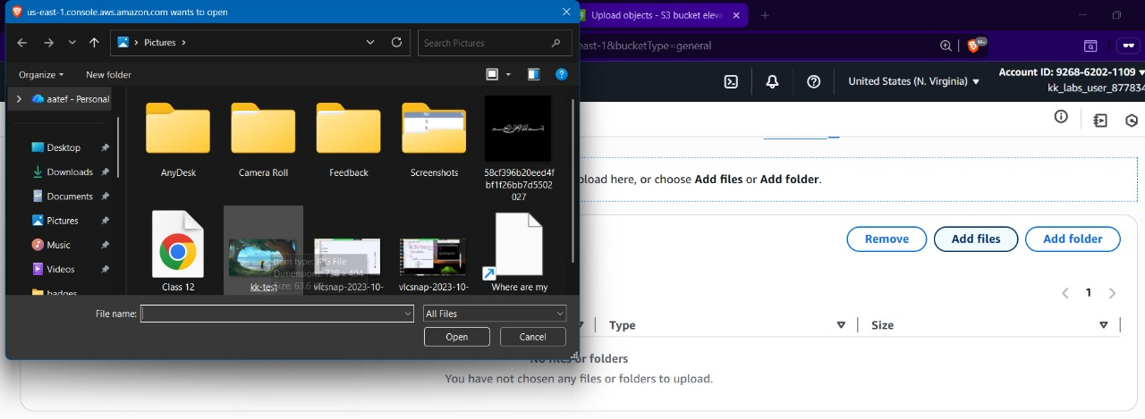

1. Once file selected click on “UPLOAD”

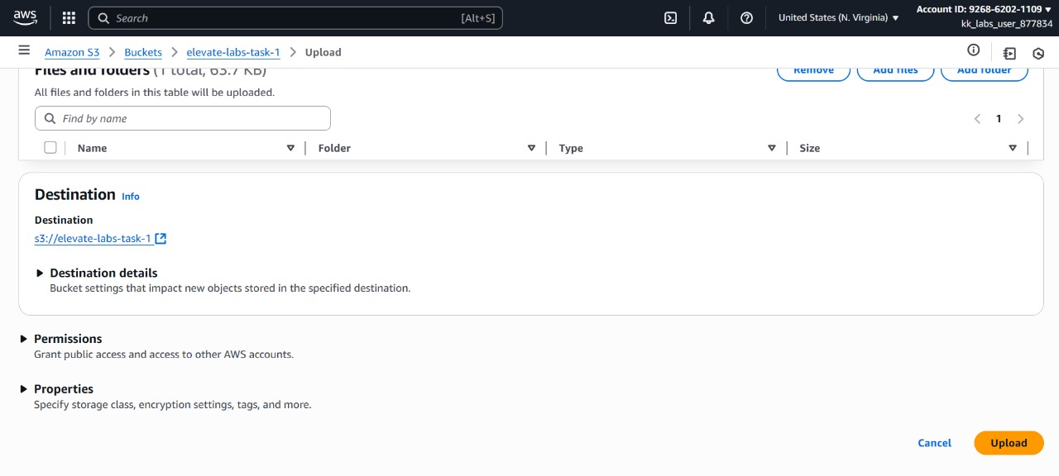

1. File will be uploaded successfully.

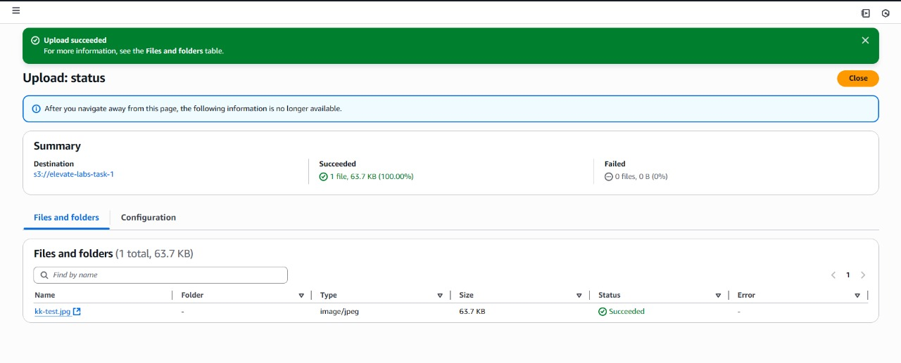

1. Go to the object file which we uploaded inside the bucket.

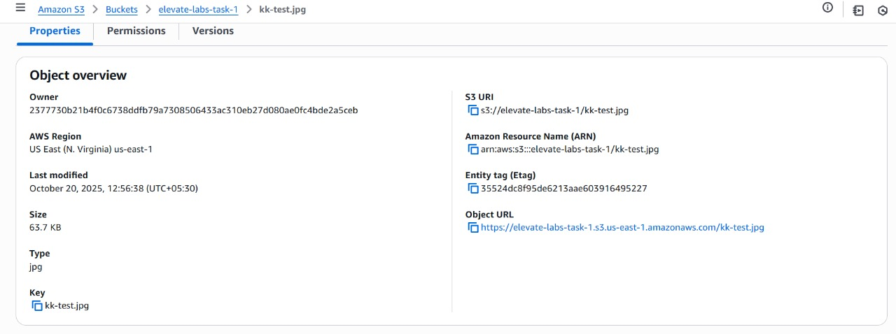

1. You will get Object URL.



1. In our example we got

<https://elevate-labs-task-1.s3.us-east-1.amazonaws.com/kk-test.jpg>

This defines bucket-name-which has to be unique to act as a subdomain.

<https://elevate-labs-task-1.s3.us-east-1.amazonaws.com/kk-test.jpg>

This define which aws service, in this case its AWS S3.

<https://elevate-labs-task-1.s3.us-east-1.amazonaws.com/kk-test.jpg>

This define location eg- us-east-1

<https://elevate-labs-task-1.s3.us-east-1.amazonaws.com/kk-test.jpg>

The main amazon AWS domain.

<https://elevate-labs-task-1.s3.us-east-1.amazonaws.com/kk-test.jpg>

The path or uri of our actual object.

Now, lets try to access the URL from a browser.

1. When truing to access the url from browser we are getting Access denied error. Even though we have allowed public access for all in set “4”.

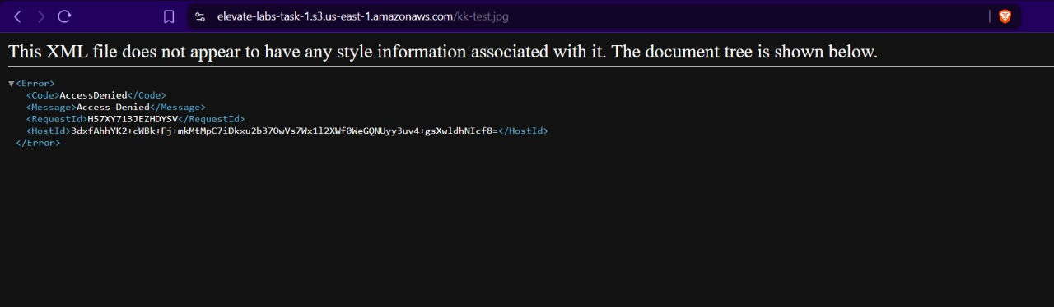



1. That’s expected because public access is enabled but to actually access the object we need “GET” api permission.
2. Go to your bucket and navigate to permission tab.

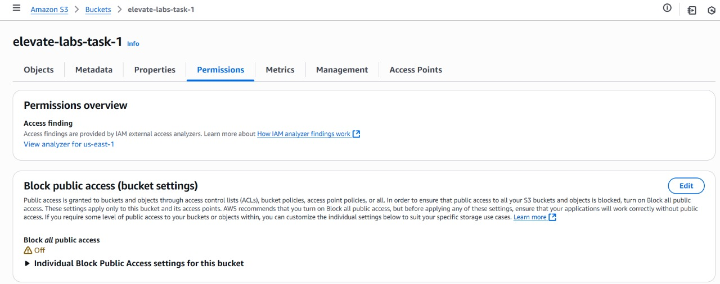



1. Scroll down till you find bucket policy and click on edit.

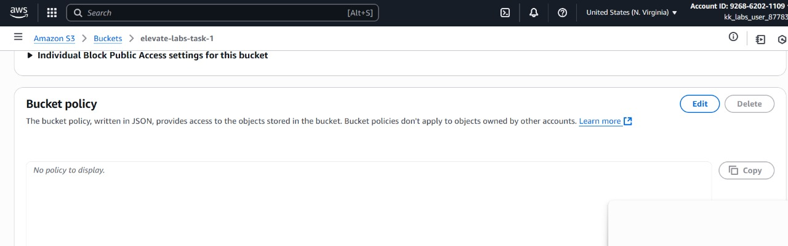

1. And paste the json policy.



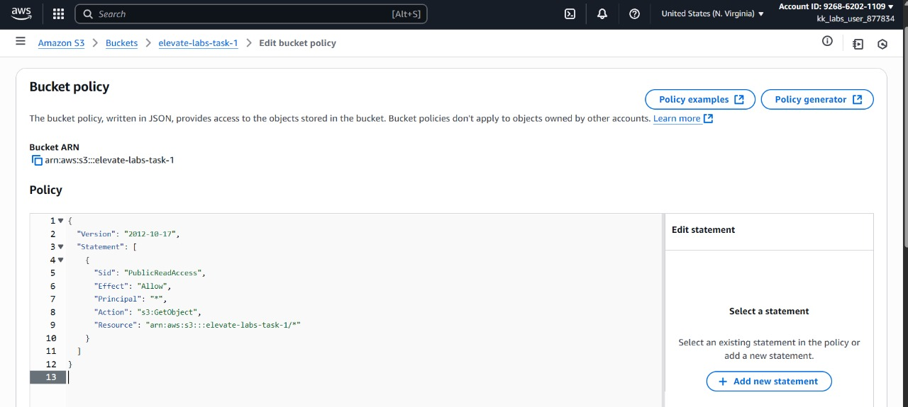



1. Now if we try to access the URL we will be able to see the contents.

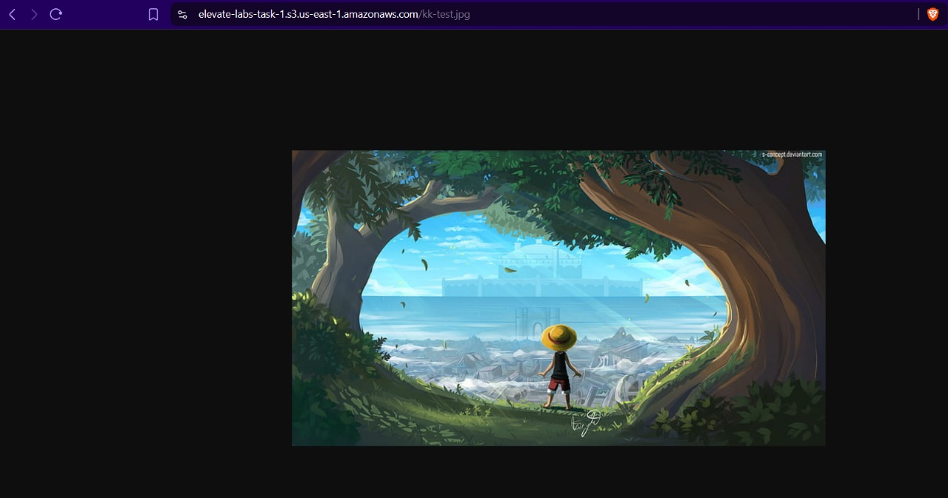

---------------------------------- END ---------------------------------------------------------