Voice Search Extension based on Speech recognition for Magento 2
Product Specification
Magento 2 Voice Search Extension is a Magento 2 extension developed by PIT solutions which helps customers to search products faster by using voice search.
Customer can search product faster by using voice search. Customers do not have to type anything for searching. Customers can just click on the microphone icon, voice out the required search term and the desired results will appear.

Features
- Customer can search product faster by using voice search.
- Mobile and desktop support.
- Enable/ Disable the extension.
- Customers do not have to type anything for searching. Customers can just click on the microphone icon, voice out the required search term and the desired results will appear.
- Voice search will recognise the voice from the following languages
Afrikaans
Amharic
Azerbaijani
Bangla
Indonesian
Malay
Catalan (Spain)
Czech
Danish
German
English
Spanish
Basque (Spain)
Filipino
French
Javanese
Galician (Spain)
Gujarati
Croatian
Zulu (South Africa)
Icelandic
Italian
Kannada
Khmer
Latvian
Lithuanian
Malayalam
Marathi
Hungarian
Lao
Dutch
Nepali
Norwegian
Polish (Poland)
Portuguese
Romanian
Sinhala (Sri Lanka)
Slovenian
Sundanese
Slovak
Finnish
Swedish
Kiswahili (Tanzania)
Georgian
Armenian
Tamil
Telugu
Vietnamese
Turkish
Urdu
Greek
Bulgarian
Russian
Serbian
Ukrainian
Korean
Chinese
Japanese
Hindi
Thai
Screenshots / Video
Home page with Voice Search


Mobile home page with Voice Search

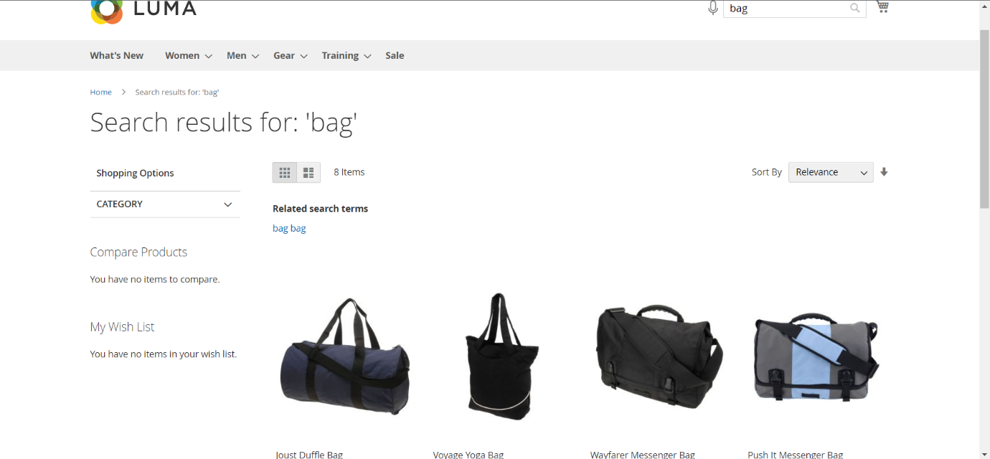
Search page with results

Technical Requirements / Compatible with:
Magento Community 2.3.x or 2.4.x.

Supported Languages
English and German language packs.

Change Log / Release Notes
Version: 1.0.0
● Customer can search using voice search.
● Added admin configuration option to enable or disable the module.

Note
Supported only in Web Speech API enabled browsers (For example Google Chrome, Safari, etc).
Most browsers allow mic permission to only https enabled sites.

Support
If you have questions use our contact form in webshopextension.com

