Voice Search Extension based on Speech recognition for Magento 2
1. Pre-requisites
Magento 2.3.x or 2.4.x.

2. Configuration
After installation, from the admin backend, go to Stores > Configuration>PITS Configuration > Voice Search

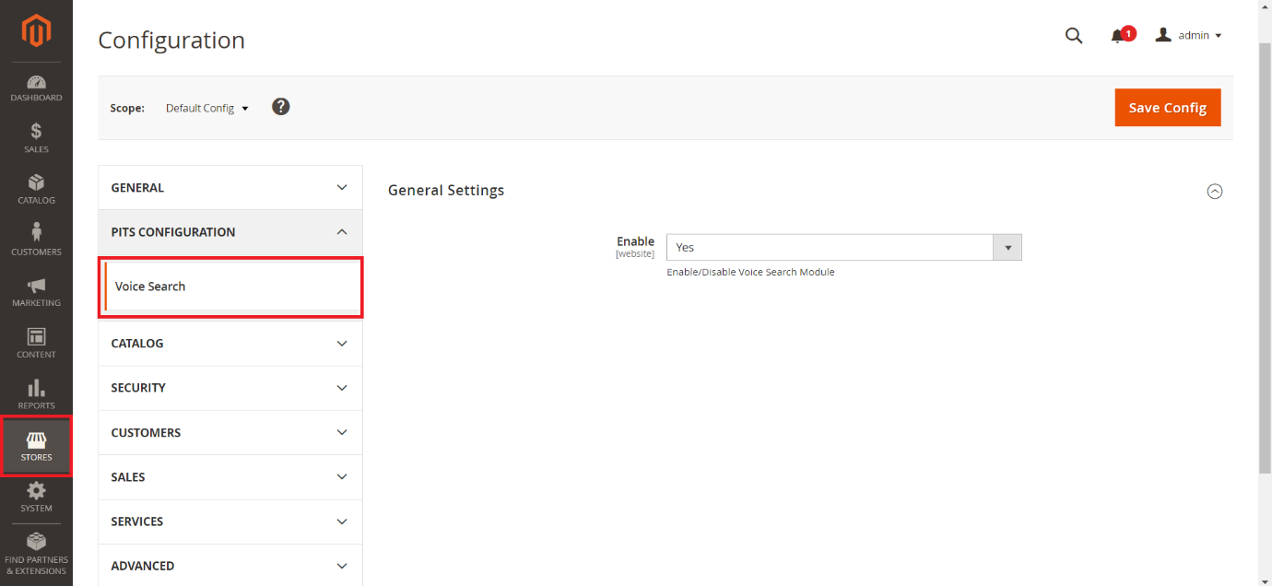

2.1 Configure Voice Search
2.1.1 General Settings
1. Select Yes in the Enable dropdown option to enable the extension.
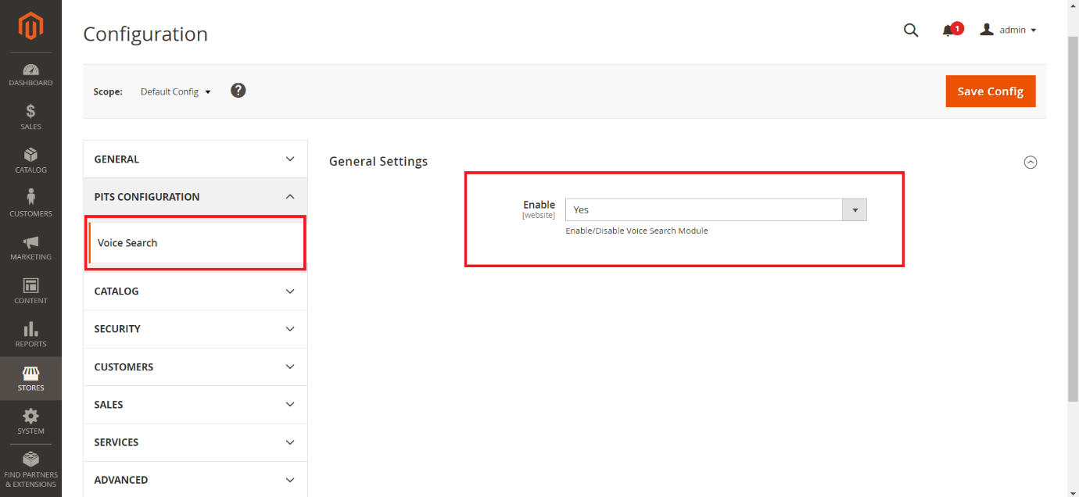

3. Voice Search
Magento 2 Voice Search Extension is a Magento 2 extension developed by PIT solutions which helps customers to search products faster by using voice search.
Voice search will recognise the voice from the following languages
Afrikaans
Amharic
Azerbaijani
Bangla
Indonesian
Malay
Catalan (Spain)
Czech
Danish
German
English
Spanish
Basque (Spain)
Filipino
French
Javanese
Galician (Spain)
Gujarati
Croatian
Zulu (South Africa)
Icelandic
Italian
Kannada
Khmer
Latvian
Lithuanian
Malayalam
Marathi
Hungarian
Lao
Dutch
Nepali
Norwegian
Polish (Poland)
Portuguese
Romanian
Sinhala (Sri Lanka)
Slovenian
Sundanese
Slovak
Finnish
Swedish
Kiswahili (Tanzania)
Georgian
Armenian
Tamil
Telugu
Vietnamese
Turkish
Urdu
Greek
Bulgarian
Russian
Serbian
Ukrainian
Korean
Chinese
Japanese
Hindi
Thai

3.1 Search using Voice Search

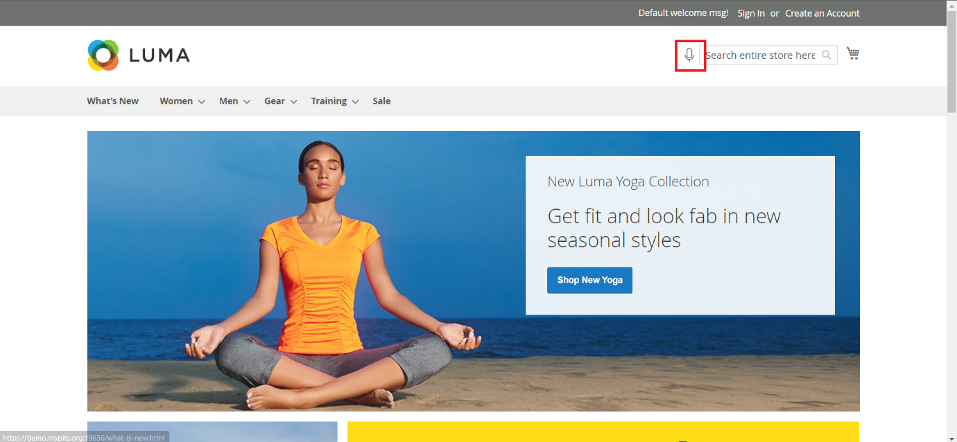
Use the mic icon near the search bar for enabling the voice search

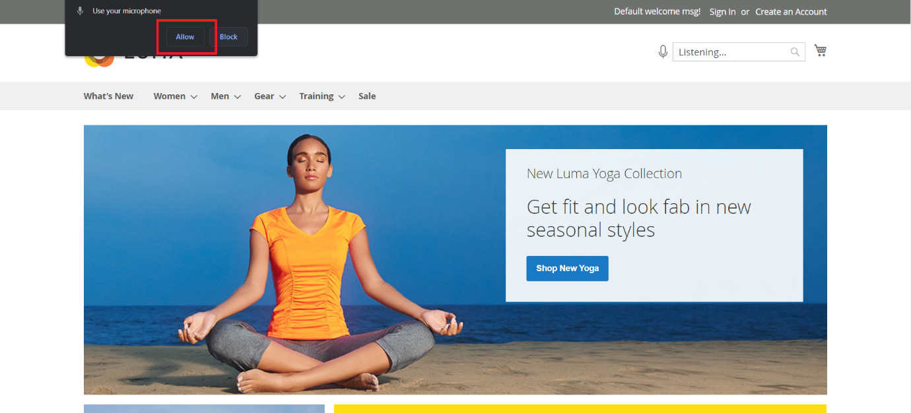
A browser popup will appear for allowing the mic access for the first-time use. Allowing the mic will enable the voice search for the browser.

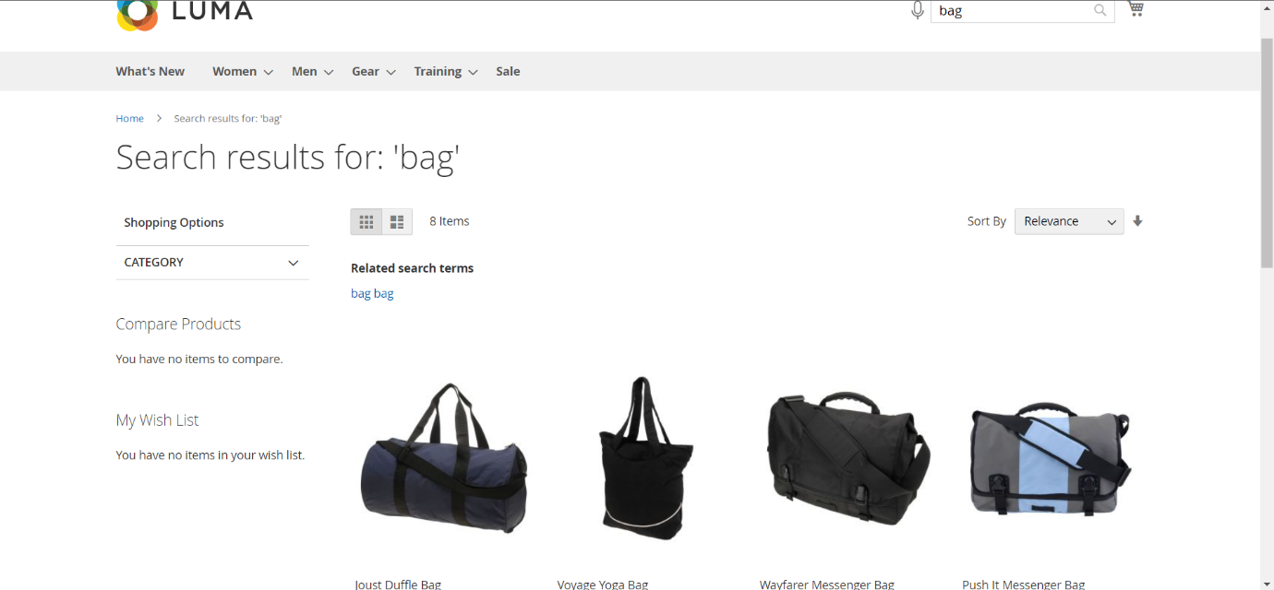
Speak through microphone and it will display the recognised word in search bar and will automatically start searching.

4. Important notice
Supported only in Web Speech API enabled browsers (For example Google Chrome, Safari, etc).
Most browsers allow mic permission to only https enabled sites.

5. Support
If you have questions use our contact form in webshopextension.com

