

**NATIONAL UNIVERSITY OF SCIENCES AND TECHNOLOGY**

School of Electrical Engineering and Computer Sciences

**ADVANCED PROGRAMMING**

**ASSIGNMENT - 01**

**Title of the assignment: Open Source Software**

**SUBMITTED TO: Dr. Sidra Sultana**

**SUBMITTED BY: (Ali Ather 211226)**

**CLASS + SECTION: BSCS – 7A**

**Date of Submission: 15th Sept ’19**

**PHPBB**

PHPBB stands for “PHP Bulletin Board”, is a free internet forum package built in PHP. It is very useful to connect with new people and stay in touch with friends from all over the world. It’s extremely efficient, user friendly, with a lot of different features.

PHPBB has a very large database, having a large number of users created extensions. It also has style database which gives the user many options to customize their board. It also supports different database engines including SQLite, MySQL, Oracle Database etc. Its basic features will be discussed below.

This free forum has two types of users:

1. Administrator
2. General User

The **Administrator** has access to a lot of other features, as he is the one maintaining the forum too. Whereas the **General User** is like a normal user using the forum, he can reply on forums, send messages etc.

**Administrator**

This user is made during the installation of the OSS. Along with having access to every feature available to the general user, **only** the administrator has access to the **ACP (Administration control panel).**

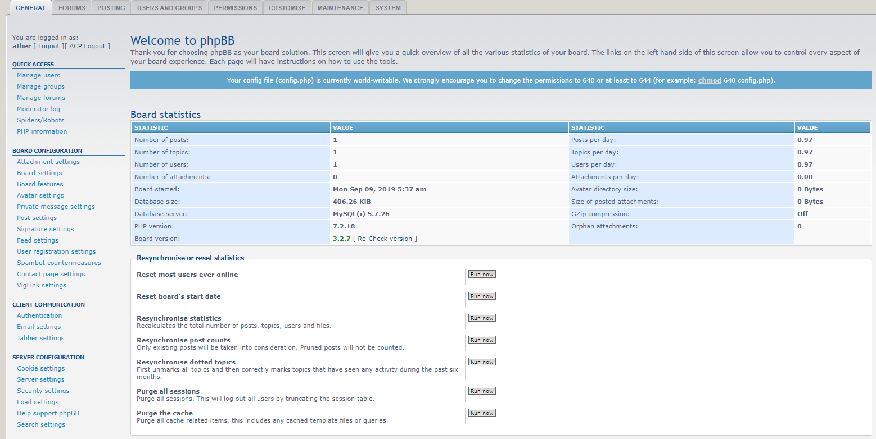

This is the ACP. As you can see in the picture, ACP shows boards statistics, which has a lot of information such as number of topics, number of posts etc. Being an administrator gives you a lot of other options as well, such as:

* Manage groups

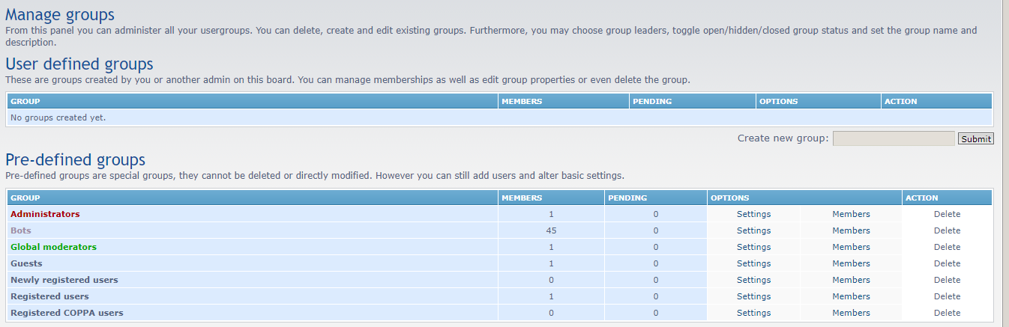

* Create and manage forums

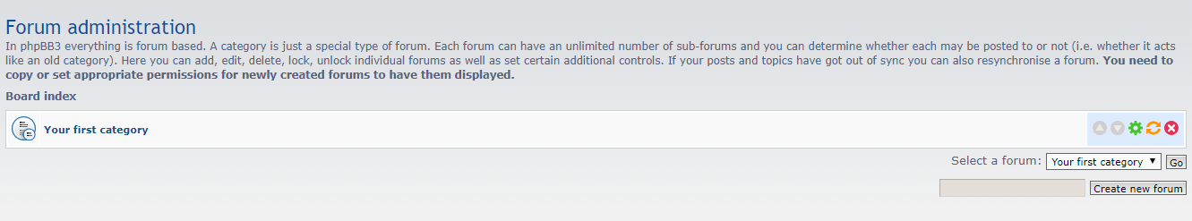

* Managing users

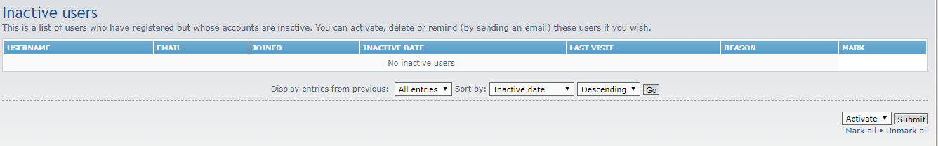

* Deals with permissions (approvals for posts etc)

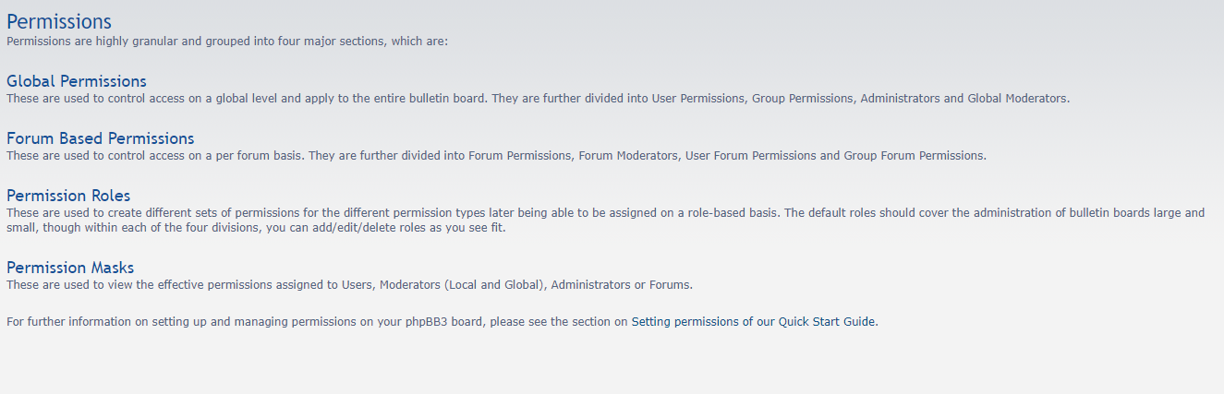

* Managing and updating system
* Manage Customizations

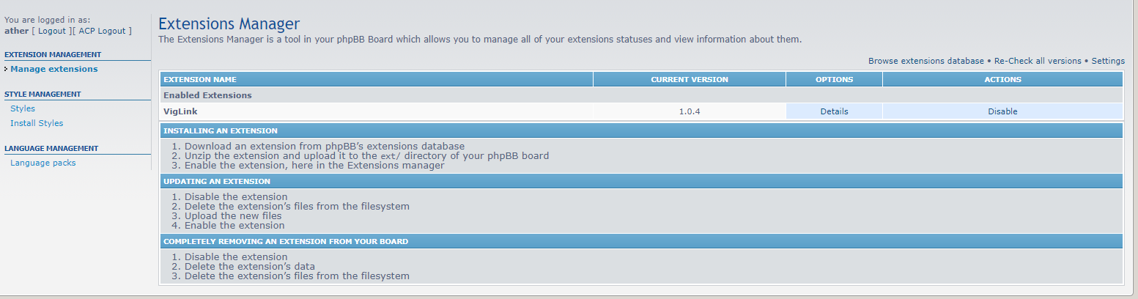

Features listed above are dedicated to an administrator account only. In addition to this, administrator has access to all the features which a **general user** has access to.

**General user**

For a **general user** account, you have to register your account. First of all, you have to accept their terms and conditions:

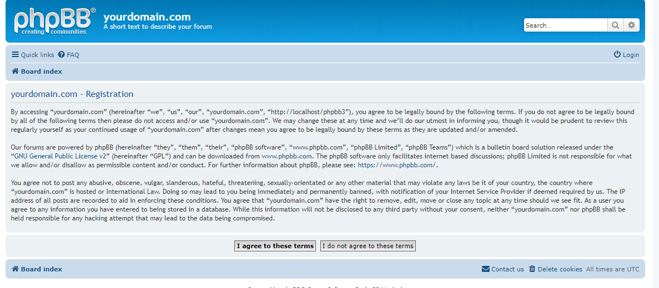

Then you have to register an account as shown in the picture below:

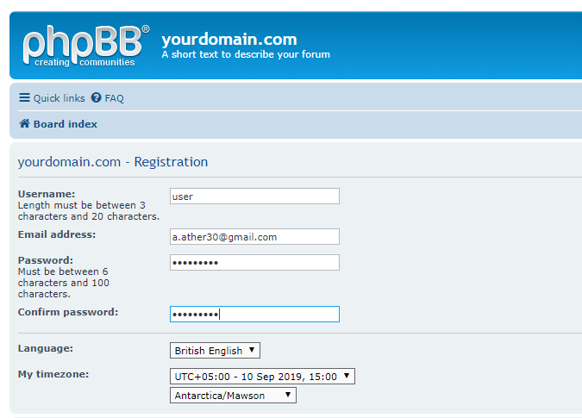

When you fill this form, you will be registered as a general user.

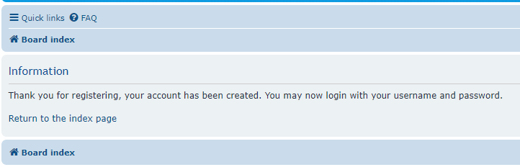

Then you will have to login with the user’s credentials, now this user will have very limited options as compared to an administrator. The screenshot below is the homepage of a general user:

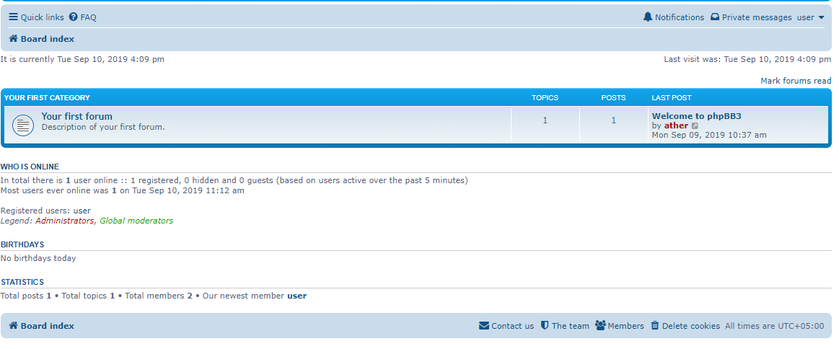

Some features accessible to the general user are:

* He can edit his profile signature

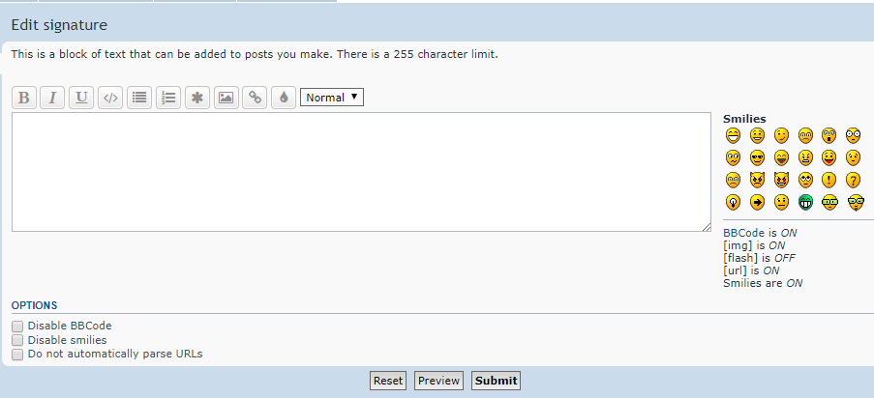

* He can edit his avatar

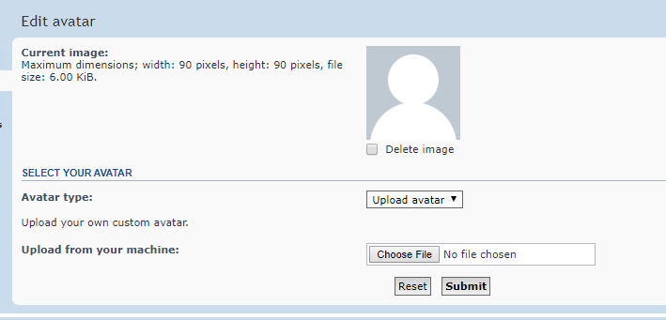

* He can also edit his account settings, such as changing his password:

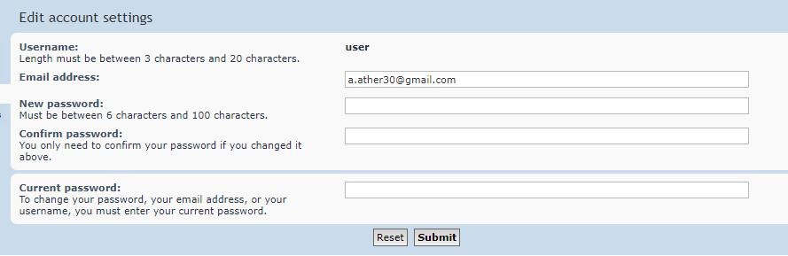

* User can compose and receive messages easily:

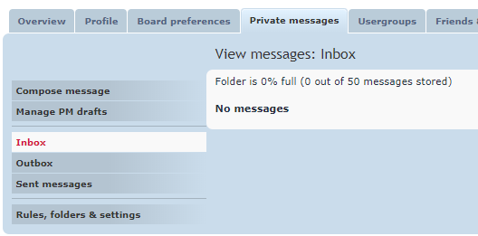

* The user can save drafts
* Create new topics and reply to different threads
* User can manage his friends too

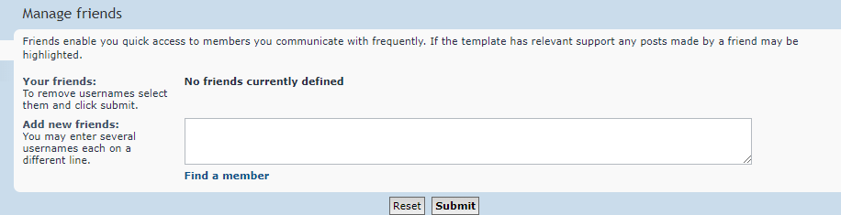

**Coding Structure**

Moving on to the coding structure of PHPBB, these are the folders and files in PHPBB folder:

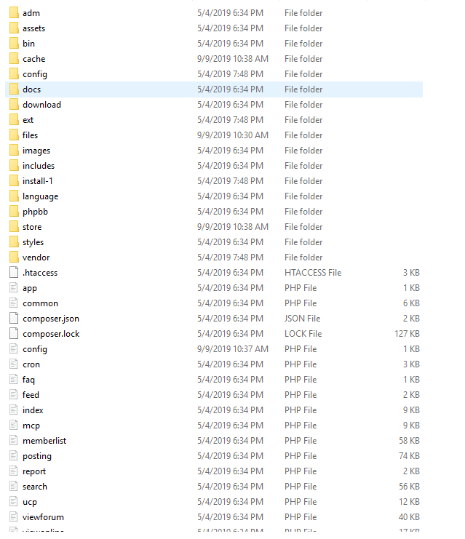

* Styles for the **ACP** are in the **adm** folder
* JavaScript files along with the CSS files are in the **assets** folder
* Files used in the installation of PHPBB are located in **config** folder
* All the extensions are located in **ext** file
* Different images are contained in the **images** folder
* The **includes** folder contains all the things that are reused again and again such as headers, menus etc
* All the sql files are located in the **install** folder
* Different languages (there is only one language by default) are located in **language** folder
* Themes are located in the **styles** folder

**Database Structure**

The database of PHPBB has 68 tables in it, some of the tables can be seen in the screenshot below:

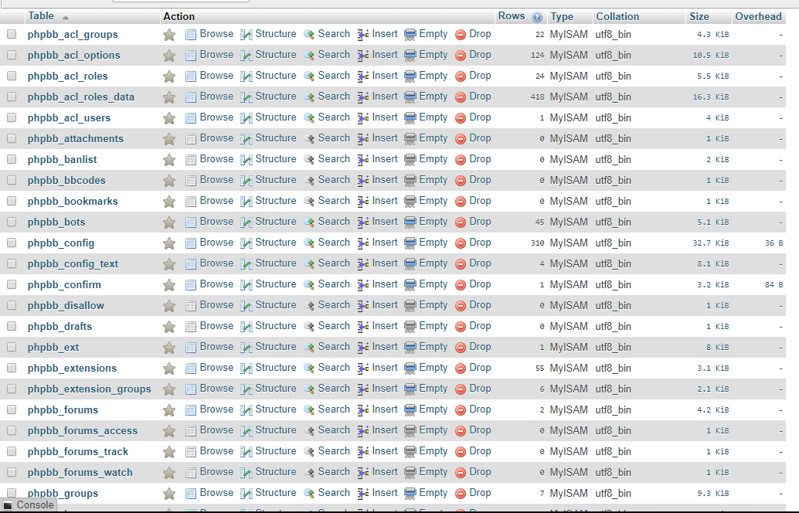

* Many of these tables are linked to each other by a **user_id**, which is assigned to every user, which helps to keep track of a specific user.
* Some of the many tables are for:
  + forums
  + Drafts
  + Languages
  + Notifications

To get an overview of the database, an ERD is shown in the picture below:

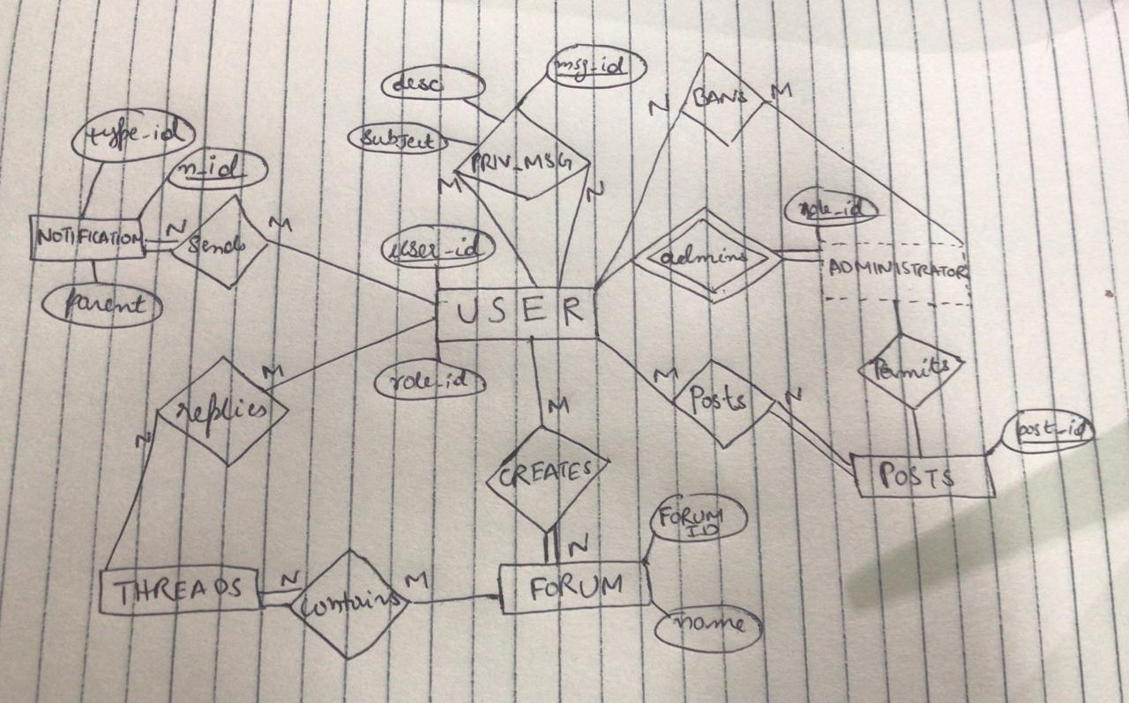

**Plugins**

1. **Database Optimize & Repair Tool**

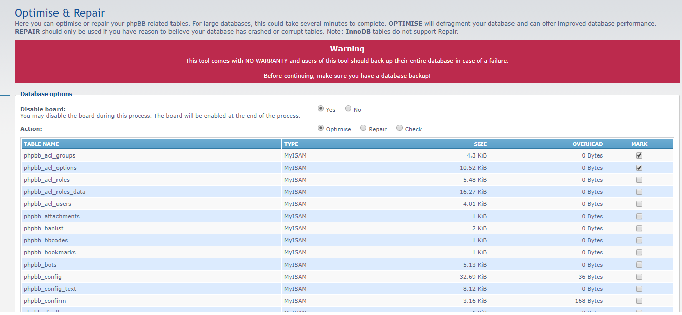

Through this extension, you can optimize your database through the Administration Control Panel (**ACP**). As you can see in the screenshot above, after enabling the extension, you can see an option under the database heading “Optimize and Repair” where you can check your database tables and repair them, if needed.

1. **Large Font**

Through this extension, you can increase the font size up to 400%, which can be seen in the screenshot below (font is highlighted in yellow):

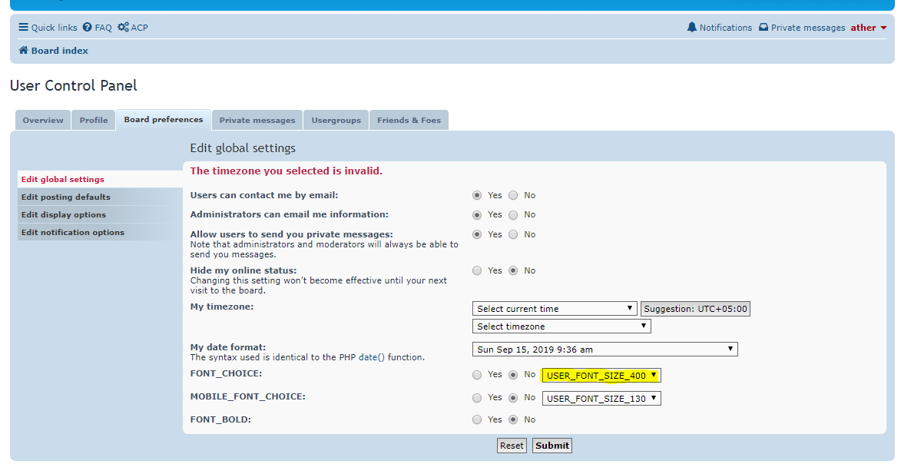

1. **Mass Notification**

This extension lets you send notifications to multiple users at a time

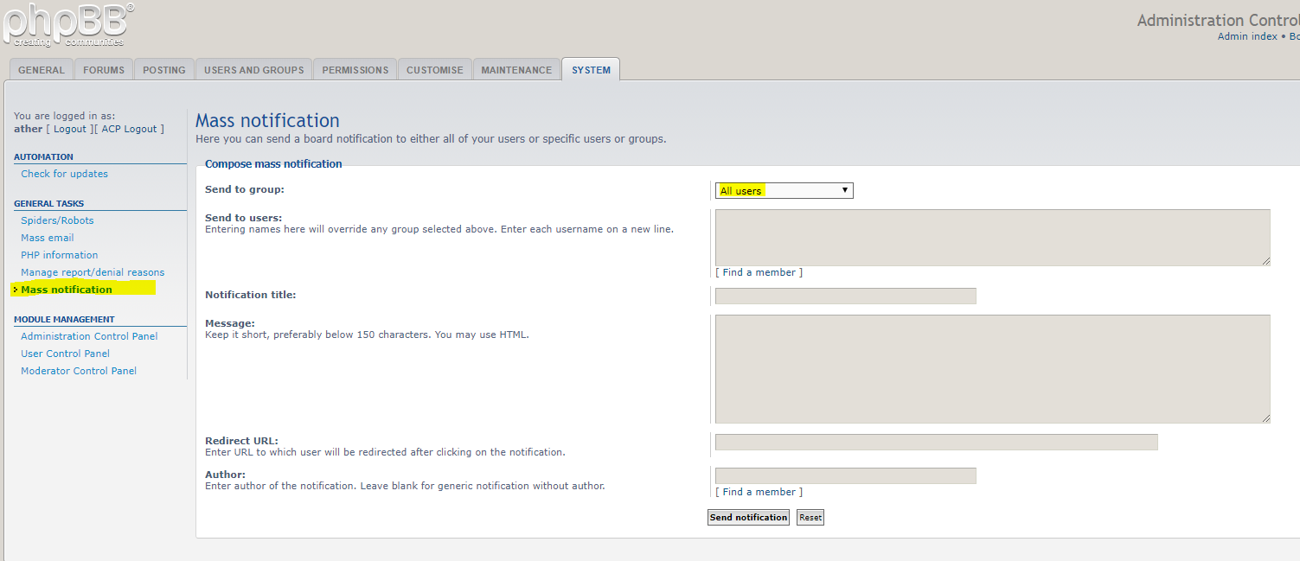

1. **Online Since**

It tells you the total time your board has been online as shown in the screenshot below:



