Department of Computing

CS-213: Advanced Programming
Class: BSCS 7AB

Lab 10: React Native Environment Setup
Date: 28 November, 2019
Time: 10:00-01:00pm & 02:00-05:00pm

Ali Ather
BSCS-7A
211226

Instructor: Dr. Sidra Sultana
Lab Engineer: Ms. Ayesha Asif

Lab 10: React Native Environment Setup
Lab Task
Open the sample project in the emulator.
Solution
Task Code:
import * as React from 'react';
import { Text, View, StyleSheet } from 'react-native';
import Constants from 'expo-constants';

// You can import from local files
import AssetExample from './components/AssetExample';

// or any pure javascript modules available in npm
import { Card } from 'react-native-paper';

export default class App extends React.Component {
render() {
return (
<View style={styles.container}>
<Text style={styles.paragraph}>
Welcome Ali Ather!
</Text>
</View>
);
}
}

const styles = StyleSheet.create({
container: {
flex: 1,
justifyContent: 'center',
paddingTop: Constants.statusBarHeight,
backgroundColor: '#ecf0f1',
padding: 8,
},
paragraph: {
margin: 24,
fontSize: 18,
fontWeight: 'bold',
textAlign: 'center',
},
});

Task Output Screenshot:
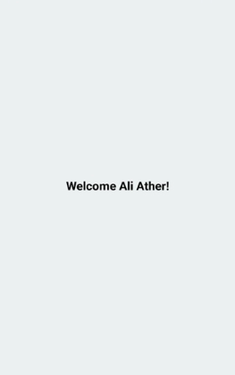

Deliverable
Compile a single word document by filling in the solution part and submit this Word file on LMS. This lab grading policy is as follows: The lab is graded between 0 to 10 marks. The submitted solution can get a maximum of 5 marks. At the end of each lab or in the next lab, there will be a viva/quiz related to the tasks. You must show the implementation of the tasks in the designing tool, along with your complete Word document to get your work graded. You must also submit this Word document on the LMS. In case of any problems with submissions on LMS, submit your Lab assignments by emailing it to Ms. Ayesha Asif: ayesha.asif@seecs.edu.pk.

