Department of Computing

CS-213: Advanced Programming
Class: BSCS 7AB

Lab 3: jQuery
Date: 19 September, 2019
Time: 10:00-01:00pm & 02:00-05:00pm

Instructor: Dr. Sidra Sultana
Lab Engineer: Ms. Ayesha Asif

Lab 3: jQuery
Ali Ather
211226
BSCS-7A

Solution
Task 1 Code:
$(document).ready(function () {

$("li").click(function () {

$("span").remove();
var cd = new Date();

var monthNames = ["January", "February", "March", "April", "May", "June",
"July", "August", "September", "October", "November", "December"];

var days = ['Sunday', 'Monday', 'Tuesday', 'Wednesday', 'Thursday', 'Friday', 'Saturday'];
var d = ("<span class = 'date'> Clicked on " + days[cd.getDay() - 1] + " " + monthNames[cd.getMonth() - 1] + " " + cd.getDate() + " " + cd.getFullYear() + " at " + cd.getHours() + ":" + cd.getMinutes() + ":" + cd.getSeconds() + "</span>");
$(this).append(d);

})
})
Task 1 Output Screenshot:
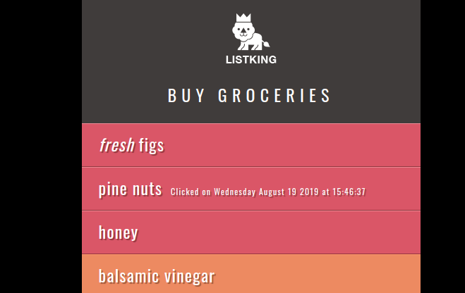
Task 2 Code:
$("li").on("click mouseover", function (event) {

var item = $(this).html();

if (item == "honey" || item == "pine nuts") {
var status = "important";
}
else {
var status = "Available";
}

var text = "Item:" + item + "<br>" + "Status:" + status + "<br>" + "Event:" + event.type;

$("p").html(text);
$("p span").remove();

})

})

Task 2 Output Screenshot:
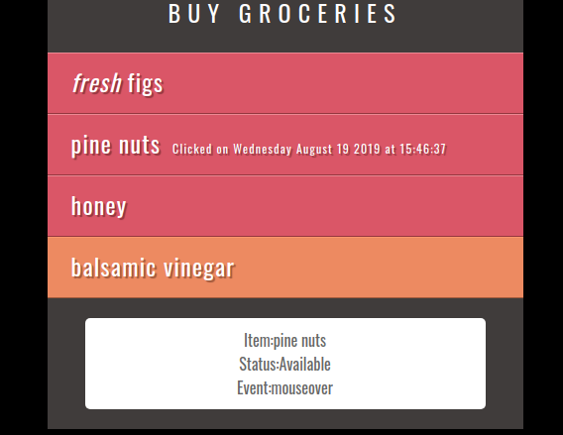

Task 3 Code:

$("ul").append("<li>extras</li><li>extras</li><li>extras</li><li>extras</li><li>extras</li><li>extras</li><li>extras</li><li>extras</li><li>extras</li><li>extras</li><li>extras</li><li>extras</li><li>extras</li><li>extras</li><li>extras</li><li>extras</li><li>extras</li><li>extras</li><li>extras</li><li>extras</li><li>extras</li><li>extras</li><li>extras</li><li>extras</li><li>extras</li><li>extras</li><li>extras</li><li>extras</li><li>extras</li><li>extras</li><li>extras</li><li>extras</li><li>extras</li><li>extras</li><li>extras</li><li>extras</li><li>extras</li><li>extras</li><li>extras</li><li>extras</li><li>extras</li><li>extras</li><li>extras</li>")

$("ul").append("<div id = 'footer'>List King</div>")

$("ul").append("<div id = 'slideAd'>Buy ListKing Pro for only $1.99</div>")
$("#slideAd").hide()

$(window).scroll(function () {

var val = $(document).height() - 1500
console.log(val + " " +$(document).scrollTop())
if ($(document).scrollTop() > val) {
$("#slideAd").show()
}
else {
$("#slideAd").hide()

}

})

Task 3 Output Screenshot:
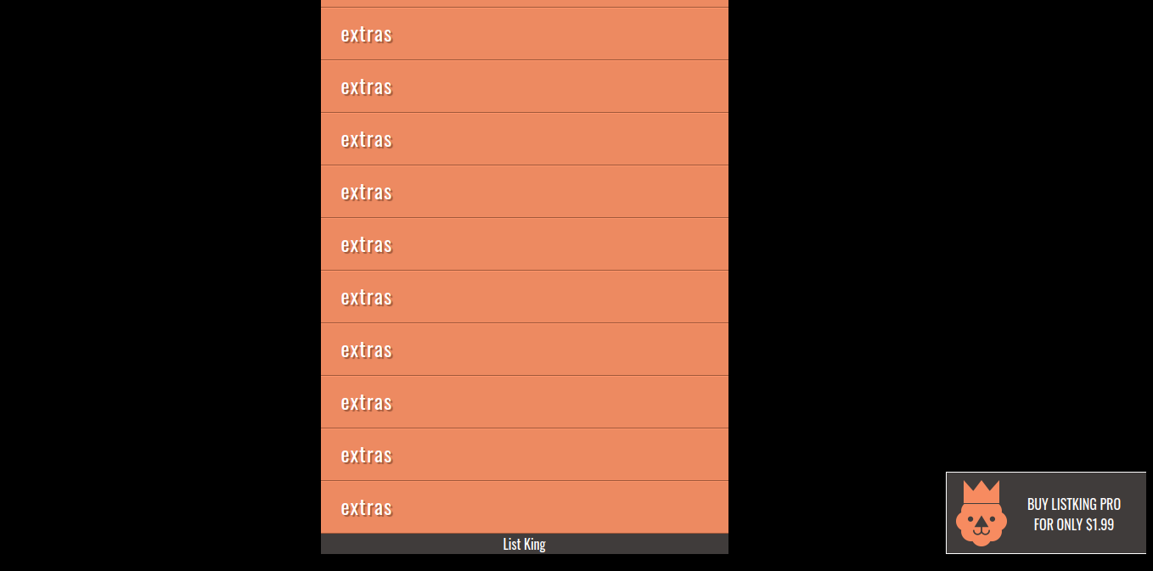

Deliverables
Compile a single word document by filling in the solution part and submit this Word file on LMS. This lab grading policy is as follows: The lab is graded between 0 to 10 marks. The submitted solution can get a maximum of 5 marks. At the end of each lab or in the next lab, there will be a viva related to the tasks. The viva has a weightage of 5 marks. Insert the solution/answer in this document. You must show the implementation of the tasks in the designing tool, along with your complete Word document to get your work graded. You must also submit this Word document on the LMS. In case of any problems with submissions on LMS, submit your Lab assignments by emailing it to Ms. Ayesha Asif: ayesha.asif@seecs.edu.pk.

