Department of Computing

CS-213: Advanced Programming
Class: BSCS 7AB

Lab 4: Introduction to Node.js
Date: 26rd September, 2019
Time: 10:00-01:00pm & 02:00-05:00pm

Instructor: Dr. Sidra Sultana
Lab Engineer: Ms. Ayesha Asif

Ali Ather
BSCS-7A
CMS: 211226

Lab 4: Introduction to Node.js

Helping Material
Slides of Lecture 4 & 5
https://www.w3schools.com/nodejs/nodejs_get_started.asp

Lab Tasks
Task 1: Download Node.js from the official Node.js web site: https://nodejs.org.
Task 2: Once you have downloaded and installed Node.js on your computer, let's try to display "Hello World" in a web browser.

Solution
Task Code:
var http = require('http');

http.createServer(function (req, res) {

res.writeHead(200, { 'COntent-type': 'text/plain' });
res.write("Hello World!");
res.end();

}).listen(1337, 'localhost');

Task Output Screenshot:
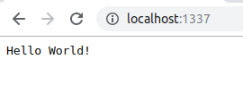

Task 3: Create a module that returns the current date and time. Save the code in a file called "myfirstmodule.js".

Solution
Task Code:
exports.Datee = function () {
return Date();
}

Task 4: Use the module "myfirstmodule" of date and time in a Node.js file.
Solution
Task Code:
var http = require('http');
var dt = require('./myfirstmodule');

http.createServer(function (req, res) {

res.writeHead(200, { 'Content-type': 'text/hmtl' });
res.write('Date:' + dt.Datee());

res.end();

}).listen(1337, 'localhost');

Task Output Screenshot:
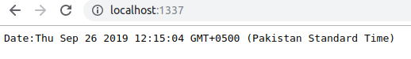

Node.js as a Web Server

Task 5: The HTTP module can create an HTTP server that listens to server ports and gives a response back to the client. Use the createServer() method to create an HTTP server.

Solution
Task Code:
var http = require('http');
var dt = require('./myfirstmodule');

http.createServer(function (req, res) {

res.writeHead(200, { 'Content-type': 'text/hmtl' });
res.write('Date:' + dt.Datee());

res.end();

}).listen(1337, 'localhost');

Task Output Screenshot:

Task 6: Add an HTTP Header

Solution
Task Code:
var http = require('http');
var dt = require('./myfirstmodule');

http.createServer(function (req, res) {

res.writeHead(200, { 'Content-type': 'text/hmtl' });
res.write('Hellooooo');

res.end();

}).listen(1337, 'localhost');

Task Output Screenshot:
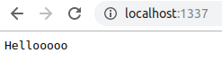

Node.js as a File Server
The Node.js file system module allows you to work with the file system on your computer. To include the File System module, use the require() method:
var fs = require('fs');
Common use for the File System module:
- Read files
- Create files
- Update files
- Delete files
- Rename files

Task 7: Create a Node.js file that reads the HTML file, and return the content.

Solution
Task Code:
var http = require('http');
var fs = require('fs');
http.createServer(function (req, res) {

res.writeHead(200, { 'Content-type': 'text/html' });

fs.readFile('add.html', function (err, data) {

if (err)
throw err;

res.write('Data from file: ' + data);
res.end();

})

}).listen(1337, 'localhost');

Task Output Screenshot:
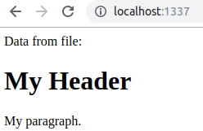

Task 8: Create a new file using
- appendFile() method
- open() method
- writeFile() method

Solution
Task Code:
var http = require('http');
var fs = require('fs');
http.createServer(function (req, res) {

res.writeHead(200, { 'Content-type': 'text/html' });

fs.appendFile('file2.txt', 'file 1', function (err) {

if (err)
throw err;

});

fs.open('file3.txt', 'w', function (err) {

if (err)
throw err;

});

fs.writeFile('file4.txt', 'file 1', function (err) {

if (err)
throw err;

});
// res.write('Data from file: ' + data);
res.end();

}).listen(1337, 'localhost');

Task Output Screenshot:
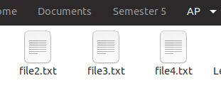

Task 9: Append "This is my text." to the end of the file "mynewfile1.txt".

Solution
Task Code:
var http = require('http');
var fs = require('fs');
http.createServer(function (req, res) {

res.writeHead(200, { 'Content-type': 'text/html' });

fs.appendFile('file2.txt', 'This is my text', function (err) {

if (err)
throw err;

});
// res.write('Data from file: ' + data);
res.end();

}).listen(1337, 'localhost');

Task Output Screenshot:
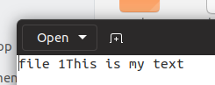

Task 10: Replace the content of the file "mynewfile3.txt".

Solution
Task Code:
var http = require('http');
var fs = require('fs');
http.createServer(function (req, res) {

res.writeHead(200, { 'Content-type': 'text/html' });

fs.writeFile('file3.txt', 'this is some more text', function (err) {

if (err)
throw err;

});
// res.write('Data from file: ' + data);
res.end();

}).listen(1337, 'localhost');

Task Output Screenshot:
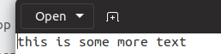

Task11: Delete "mynewfile2.txt".
Solution
Task Code:
var http = require('http');
var fs = require('fs');
http.createServer(function (req, res) {

res.writeHead(200, { 'Content-type': 'text/html' });

fs.unlink('file2.txt', function(err){
if (err)
throw err;
});
// res.write('Data from file: ' + data);
res.end();

}).listen(1337, 'localhost');

Task Output Screenshot:
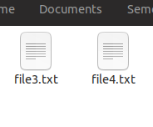

Task 12: Rename "mynewfile1.txt" to "myrenamedfile.txt".

Solution
Task Code:
var http = require('http');
var fs = require('fs');
http.createServer(function (req, res) {

res.writeHead(200, { 'Content-type': 'text/html' });

fs.rename('file3.txt', 'newname.txt', function(err){
if (err)
throw err;
});
// res.write('Data from file: ' + data);
res.end();

}).listen(1337, 'localhost');

Task Output Screenshot:
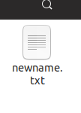

Deliverables
Compile a single word document by filling in the solution part and submit this Word file on LMS. This lab grading policy is as follows: The lab is graded between 0 to 10 marks. The submitted solution can get a maximum of 5 marks. At the end of each lab or in the next lab, there will be a viva related to the tasks. The viva has a weightage of 5 marks. Insert the solution/answer in this document. You must show the implementation of the tasks in the designing tool, along with your complete Word document to get your work graded. You must also submit this Word document on the LMS. In case of any problems with submissions on LMS, submit your Lab assignments by emailing it to Ms. Ayesha Asif: ayesha.asif@seecs.edu.pk.

