Department of Computing

CS-213: Advanced Programming
Class: BSCS 7AB

Lab 06: Node.js MongoDB
Date: 3rd October, 2019
Time: 10:00-01:00pm & 02:00-05:00pm

Instructor: Dr. Sidra Sultana
Lab Engineer: Ms. Ayesha Asif

Ali Ather
BSCS-7A
CMS:211226

Lab 06: Node.js MongoDB

Lab Tasks

Task 1: Create a database named "mydb". Save the code in a file called "demo_create_mongo_db.js" and run the file.
Code
var MongoClient = require('mongodb').MongoClient;
var url = "mongodb://localhost:27017/mydb";

MongoClient.connect(url, function(err, db) {
if (err) throw err;
console.log("Database created!");
db.close();
});

Screenshot

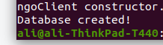

Task 2: Create a collection called "customers". Save the code in a file called "demo_mongodb_createcollection.js" and run the file.
Code
var MongoClient = require('mongodb').MongoClient;
var url = "mongodb://localhost:27017/";

MongoClient.connect(url, function (err, db) {

if (err) throw err;

var dbo = db.db("mydb")
dbo.createCollection("Customers", function (err, res) {

if (err) throw err;
console.log("Collection Created!");
db.close();
});

});
Screenshot

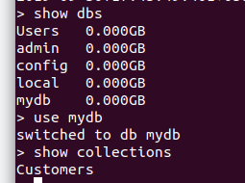

Task 3: Insert a document in the "customers" collection. Save the code in a file called "demo_mongodb_insert.js" and run the file.
Code

var MongoClient = require('mongodb').MongoClient;
var url = "mongodb://localhost:27017/";

MongoClient.connect(url, function(err, db) {
if (err) throw err;
var dbo = db.db("mydb");
var myobj = { name: "Company Inc", address: "Highway 37" };
dbo.collection("customers").insertOne(myobj, function(err, res) {
if (err) throw err;
console.log("1 document inserted");
db.close();
});
});

Screenshot

Task 4: Insert multiple documents in the "customers" collection. Save the code in a file called "demo_mongodb_insert_multiple.js" and run the file.
Code

var MongoClient = require('mongodb').MongoClient;
var url = "mongodb://localhost:27017/";

MongoClient.connect(url, function(err, db) {
if (err) throw err;
var dbo = db.db("mydb");
var myobj = [
{ name: 'John', address: 'Highway 71'},
{ name: 'Peter', address: 'Lowstreet 4'},
{ name: 'Amy', address: 'Apple st 652'},
{ name: 'Hannah', address: 'Mountain 21'},
{ name: 'Michael', address: 'Valley 345'},
{ name: 'Sandy', address: 'Ocean blvd 2'},
{ name: 'Betty', address: 'Green Grass 1'},
{ name: 'Richard', address: 'Sky st 331'},
{ name: 'Susan', address: 'One way 98'},
{ name: 'Vicky', address: 'Yellow Garden 2'},
{ name: 'Ben', address: 'Park Lane 38'},
{ name: 'William', address: 'Central st 954'},
{ name: 'Chuck', address: 'Main Road 989'},
{ name: 'Viola', address: 'Sideway 1633'}
];
dbo.collection("customers").insertMany(myobj, function(err, res) {
if (err) throw err;
console.log("Number of documents inserted: " + res.insertedCount);
db.close();
});
});

Screenshot
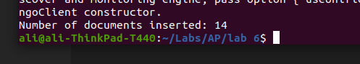

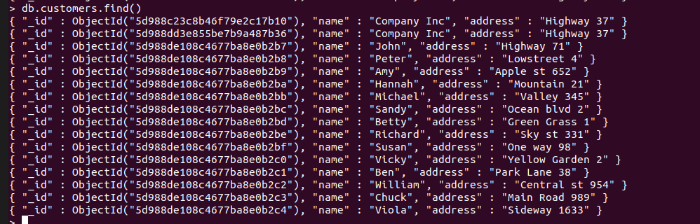

Task 5: Insert three records in a "products" table, with specified _id fields. Save the code in a file called "demo_mongodb_insert_id.js" and run the file.
Code
var MongoClient = require('mongodb').MongoClient;
var url = "mongodb://localhost:27017/";

MongoClient.connect(url, function(err, db) {
if (err) throw err;
var dbo = db.db("mydb");
var myobj = [
{ _id: 154, name: 'Chocolate Heaven'},
{ _id: 155, name: 'Tasty Lemon'},
{ _id: 156, name: 'Vanilla Dream'}
];
dbo.collection("products").insertMany(myobj, function(err, res) {
if (err) throw err;
console.log(res);
db.close();
});
});
Screenshot
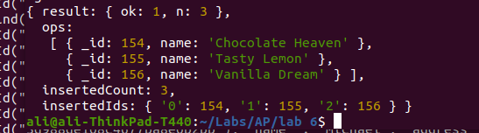

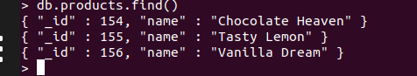

Task 6: Find the first document in the customer’s collection. Save the code in a file called "demo_mongodb_findone.js" and run the file.

Code
var MongoClient = require('mongodb').MongoClient;
var url = "mongodb://localhost:27017/";

MongoClient.connect(url, function(err, db) {
if (err) throw err;
var dbo = db.db("mydb");
dbo.collection("customers").findOne({}, function(err, result) {
if (err) throw err;
console.log(result);
db.close();
});
});

Screenshot
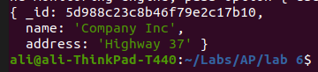

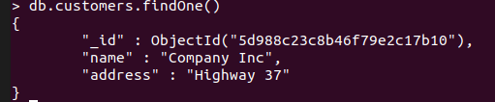

Task 7: Return the fields "name" and "address" of all documents in the customers collection
Code
var MongoClient = require('mongodb').MongoClient;
var url = "mongodb://localhost:27017/";

MongoClient.connect(url, function(err, db) {
if (err) throw err;
var dbo = db.db("mydb");
dbo.collection("customers").find({}, { projection: { _id: 0, name: 1, address: 1 } }).toArray(function(err, result) {
if (err) throw err;
console.log(result);
db.close();
});
});
Screenshot
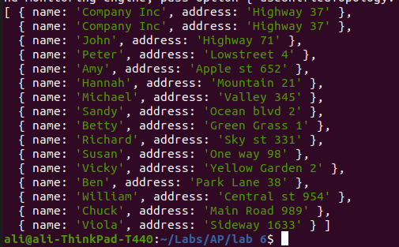

Task 8: Find documents with the address "Park Lane 38". Save the code in a file called "demo_mongodb_query.js" and run the file.
Code

var MongoClient = require('mongodb').MongoClient;
var url = "mongodb://localhost:27017/";

MongoClient.connect(url, function(err, db) {
if (err) throw err;
var dbo = db.db("mydb");
var query = {address:"Park Lane 38"}
dbo.collection("customers").find(query, { projection: { _id: 0, name: 1, address: 1 } }).toArray(function(err, result) {
if (err) throw err;
console.log(result);
db.close();
});
});

Screenshot

Task 9: Sort the result alphabetically by name. Save the code in a file called "demo_sort.js" and run the file.
Code
var MongoClient = require('mongodb').MongoClient;
var url = "mongodb://localhost:27017/";

MongoClient.connect(url, function(err, db) {
if (err) throw err;
var dbo = db.db("mydb");
var mysort = {name : 1}
dbo.collection("customers").find().sort(mysort).toArray(function(err, result) {
if (err) throw err;
console.log(result);
db.close();
});
});
Screenshot
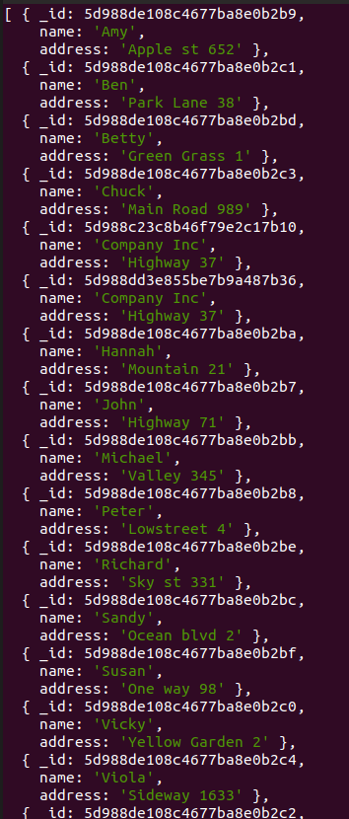

Task 10: Delete the document with the address "Mountain 21". Save the code in a file called "demo_delete.js" and run the file.
Code

var MongoClient = require('mongodb').MongoClient;
var url = "mongodb://localhost:27017/";

MongoClient.connect(url, function(err, db) {
if (err) throw err;
var dbo = db.db("mydb");
var myquery = { address: 'Mountain 21' };
dbo.collection("customers").deleteOne(myquery, function(err, obj) {
if (err) throw err;
console.log("1 document deleted");
db.close();
});
});

Screenshot
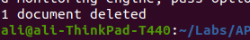

Task 11: Delete all documents were the address starts with the letter "O". Save the code in a file called "demo_delete_many.js" and run the file
Code

var MongoClient = require('mongodb').MongoClient;
var url = "mongodb://localhost:27017/";

MongoClient.connect(url, function(err, db) {
if (err) throw err;
var dbo = db.db("mydb");
var myquery = { address: /^O/ };
dbo.collection("customers").deleteMany(myquery, function(err, obj) {
if (err) throw err;
console.log(obj.result.n + " document(s) deleted");
db.close();
});
});

Screenshot
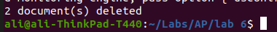

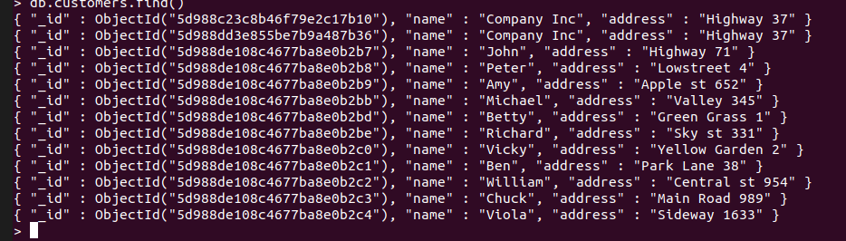
Task 12: Delete the "customers" table. Save the code in a file called "demo_drop.js" and run the file.
Code
var MongoClient = require('mongodb').MongoClient;
var url = "mongodb://localhost:27017/";

MongoClient.connect(url, function(err, db) {
if (err) throw err;
var dbo = db.db("mydb");
dbo.collection("customers").drop(function(err, delOK) {
if (err) throw err;
if (delOK) console.log("Collection deleted");
db.close();
});
});

Screenshot
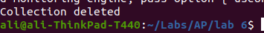

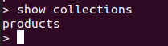

Task 13: Update the document with the address "Valley 345" to name="Mickey" and address="Canyon 123". Save the code in a file called "demo_update_one.js" and run the file
Code
var MongoClient = require('mongodb').MongoClient;
var url = "mongodb://127.0.0.1:27017/";

MongoClient.connect(url, function(err, db) {
if (err) throw err;
var dbo = db.db("mydb");
var myquery = { address: "Valley 345" };
var newvalues = { $set: {name: "Mickey", address: "Canyon 123" } };
dbo.collection("customers").updateOne(myquery, newvalues, function(err, res) {
if (err) throw err;
console.log("1 document updated");
db.close();
});
});

Screenshot
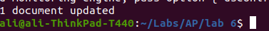

Task 14: Consider you have a "customers" collection. Limit the result to only return 5 documents. Save the code above in a file called "demo_mongodb_limit.js" and run the file.
Code

var MongoClient = require('mongodb').MongoClient;
var url = "mongodb://localhost:27017/";

MongoClient.connect(url, function(err, db) {
if (err) throw err;
var dbo = db.db("mydb");
dbo.collection("customers").find().limit(5).toArray(function(err, result) {
if (err) throw err;
console.log(result);
db.close();
});
});
Screenshot
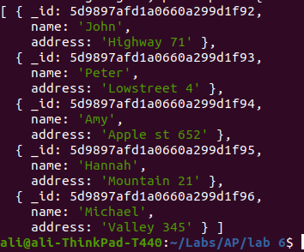

Task 15: Practice the Join operations on different tables.
Code
var MongoClient = require('mongodb').MongoClient;
var url = "mongodb://127.0.0.1:27017/";

MongoClient.connect(url, function(err, db) {
if (err) throw err;
var dbo = db.db("mydb");
dbo.collection('customers').aggregate([
{ $lookup:
{
from: 'products',
localField: 'product_id',
foreignField: '_id',
as: 'orderdetails'
}
}
]).toArray(function(err, res) {
if (err) throw err;
console.log(JSON.stringify(res));
db.close();
});
});

Screenshot
