Department of Computing

CS-213: Advanced Programming
Class: BSCS 7AB

Lab 08: React JS
Date: 07 November, 2019
Time: 10:00-01:00pm & 02:00-05:00pm

Instructor: Dr. Sidra Sultana
Lab Engineer: Ms. Ayesha Asif

Lab 08: ReactJS States

Lab Tasks
- You have to practice the states codes covered in class lecture

Welcome Program

Code

import React, {Component} from 'react';
class Welcome extends Component {
constructor(){
super();
this.state = {message: 'Welcome Visitor'};
}

changeMessage(){
this.setState({
message: 'Thank You for subscribing'
});
}

render(){
return(
<div>
<h1>{this.state.message}</h1>
<button onClick = {()=>this.changeMessage()}>Subscribe</button>
</div>
);
}
}

export default Welcome;

Screenshot
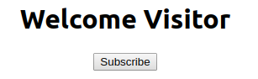

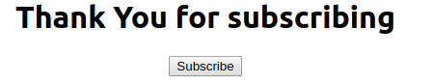

Counter Problem

Code

import React, { Component } from 'react';
class Counter extends Component {
constructor() {
super();
this.state = { count: 0 };
}

Increment() {
this.setState({
count: this.state.count + 1
});
}

render() {
return (
<div>
<h1>{this.state.count}</h1>
<button onClick={() => this.Increment()}>Increment Count</button>
</div>
);
}
}

export default Counter;

Screenshot
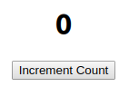

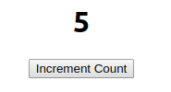

- Create a timer application which asks the user for minutes. The user then click Start button and starts the timer count down. Preview @ https://7zyz2y4p5j.csb.app/

Code

import React, { Component } from 'react';
class Timer extends Component {
constructor() {
super();
this.state = {
min: 0,
sec: 0
};

}

changeHandler = (event) => {

var time = parseInt(event.target.value);

this.setState({

min: time,
sec: 0
})
}

timerStart = (event) => {
this.update = setInterval(() => {

var sec = this.state.sec;
var min = this.state.min;

sec -= 1;

if (sec == -1) {

min = this.state.min - 1;

sec = 59;

}

if (min == -1) {
min = 0;
sec = 0;
clearInterval(this.update);
}

this.setState({

min: min,
sec: sec
})

}, 1000);
}

render() {
return (
<div>
<h2>Input your desired time</h2>
<input type='number' onChange={this.changeHandler}></input>
<h1>{this.state.min}:{this.state.sec}</h1>

<input type='button' onClick={this.timerStart} value='Start'></input>

</div>
);
}
}

export default Timer;

Screenshot
