BATCH NO:
REGISTRATION NUMBER | STUDENT NAME | SIGNATURE
61782323106001 | AATHIKESAVAA S | 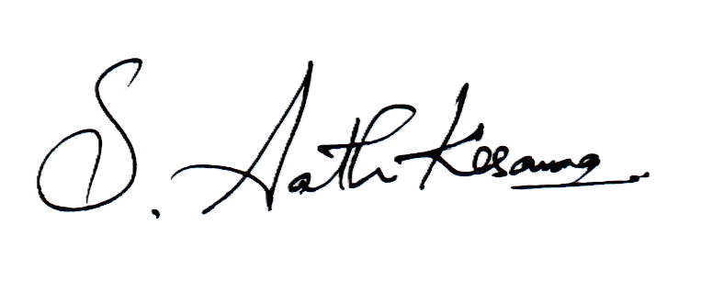
61782323106016 | BHARATH R | 
61782323106040 | HARSHINI S | 
TITLE OF THE PROJECT: | AI-POWERED SECURE CROSS-BORDER PAYMENT ROUTER
DOMAIN NAME/AREA: | CLOUD COMPUTING
Algorithm/Technique used: | Yen’s K-Shortest Path Algorithm, Dynamic Multi-Criteria Decision Analysis
REFERENCE (JOURNAL/ ON LINE RESOURCES/OTHERS) | https://networkascode.nokia.com , https://camaraproject.org
GUIDE NAME & SIGNATURE | Mr. A. Naveen Kumar, AP / IT

ABSTRACT
Cross-border payments are currently slow, expensive, and highly vulnerable to modern fraud like SIM swap attacks. Because traditional financial networks lack real-time context about the user's physical device, they often route transactions blindly. This means a compromised transaction looks identical to a legitimate one until it is too late, resulting in massive financial losses and a lack of trust in international digital payments.
Our solution is an AI-Powered Secure Payment Router that acts as an intelligent mediator before any money moves. Instead of relying on easily faked SMS codes, we use Nokia's CAMARA APIs (SIM Swap, Number Verification, Device Status) to verify the user's identity directly through the telecom network. By confirming the physical integrity of the device and SIM card in real-time, we create a "Zero-Trust" environment where only verified, uncompromised devices can initiate transactions.
Technically, we are mapping the global financial network using a Neo4j Graph Database. The AI agent acts as a dynamic brain: it takes the live security signals from the Nokia APIs and instantly translates them into risk metrics on the graph. Using Yen’s K-Shortest Path algorithm, the AI recalculates the absolute best route for the payment based on speed, cost, and the live telecom risk, ensuring the transaction is both highly efficient and mathematically secure.

PROJECT COORDINATOR

BATCH NO:
REGISTRATION NUMBER | STUDENT NAME | SIGNATURE
61782323106001 | AATHIKESAVAA S | 
61782323106016 | BHARATH R | 
61782323106040 | HARSHINI S | 
TITLE OF THE PROJECT: | ZERO-TRUST API VULNERABILITY SANDBOX
DOMAIN NAME/AREA: | CLOUD COMPUTING
Algorithm/Technique used: | Dynamic Application Security Testing, Ephemeral Container Orchestration
REFERENCE (JOURNAL/ ON LINE RESOURCES/OTHERS) | https://owasp.org/www-project-api-security , https://docs.docker.com/engine/api/
GUIDE NAME & SIGNATURE | Mr. A. Naveen Kumar, AP / IT

ABSTRACT
In modern software development, rapid CI/CD deployment cycles frequently cause backend APIs to ship with undiscovered logic flaws and zero-day vulnerabilities. Traditional security tools, such as static code analyzers, rely on predefined rules and struggle to detect complex, context-dependent edge cases like Broken Object Level Authorization (BOLA) or Mass Assignment. Consequently, these undetected logical flaws leave live production environments highly susceptible to data breaches and unauthorized access by sophisticated threat actors.
To address this critical security gap, we propose an automated, Zero-Trust API Vulnerability Sandbox designed to actively penetrate and evaluate APIs prior to production deployment. Unlike standard testing frameworks, this platform acts as an intelligent, automated red team. It utilizes Generative Adversarial Fuzzing via Large Language Models (LLMs) to dynamically construct unforeseen, malicious edge-case attacks. By actively probing the API's business logic and boundary constraints, the AI agent uncovers deep-seated vulnerabilities that human QA engineers and traditional static scanners routinely miss.
The technical architecture is built around programmatic isolation to ensure absolute testing safety. A Node.js and Express backend orchestrates the automated integration testing pipeline, coordinating with Python-based AI agents that simulate the complex network attacks. To prevent any risk to live user data, the system leverages Docker Engine APIs to instantly spin up, seed, and tear down ephemeral MongoDB database environments for every single test sequence. This self-contained evaluation pipeline guarantees a zero-contamination environment while providing developers with real-time, actionable vulnerability analytics.

PROJECT COORDINATOR

BATCH NO:
REGISTRATION NUMBER | STUDENT NAME | SIGNATURE
61782323106001 | AATHIKESAVAA S | 
61782323106016 | BHARATH R | 
61782323106040 | HARSHINI S | 
TITLE OF THE PROJECT: | AI-DRIVEN MULTIMEDIA AUTHENTICITY AND DEEPFAKE DETECTION
DOMAIN NAME/AREA: | CLOUD COMPUTING
Algorithm/Technique used: | Convolutional Neural Networks, Metadata and EXIF Analysis
REFERENCE (JOURNAL/ ON LINE RESOURCES/OTHERS) | https://arxiv.org/abs/2601.01281 , https://www.scitepress.org/Papers/2025/138757/138757.pdf
GUIDE NAME & SIGNATURE | Mr. A. Naveen Kumar, AP / IT

ABSTRACT
The rapid advancement of Generative Artificial Intelligence (AI) has made it increasingly difficult to distinguish authentic digital media from manipulated or synthetically generated content. Deepfakes and AI-generated media pose serious threats to journalism, public safety, elections, business credibility, and online trust by facilitating the spread of misinformation, identity impersonation, and digital fraud. These challenges highlight a pressing need for reliable, automated systems capable of verifying the authenticity of digital content before it causes real-world harm.
This project proposes an AI-based Deepfake and Digital Media Authenticity Verification platform that detects manipulated or AI-generated multimedia using advanced Machine Learning and Digital Forensics techniques. The system analyzes uploaded images and videos by extracting visual artifacts, metadata, frame-level inconsistencies, and compression anomalies. It employs Deep Learning models, such as Convolutional Neural Networks (CNNs) and Transformer-based architectures, alongside forensic methods like EXIF analysis, Error Level Analysis (ELA), and noise-pattern inspection, to uncover the hidden inconsistencies introduced during manipulation
Through an intuitive upload-and-analyze interface, the platform provides users with detailed forensic reporting. After analyzing a file, the system generates a confidence score indicating the likelihood that the content is authentic or AI-generated, along with an explanation of the detected anomalies. This accessible tool empowers journalists, election authorities, businesses, and everyday users to verify multimedia and make informed decisions, ultimately aiming to strengthen digital trust, reduce the spread of misinformation, and foster a safer digital ecosystem.

PROJECT COORDINATOR

