

**Method of Procedure (MOP)**

**hSenid Mobile Solutions**

320, 2nd Floor

T. B. Jayah Mawatha

Colombo 10

Sri Lanka

Tel: +94-11-2686751/2683751

Fax: +94-11-2683951

Copyright © 1997-2022 hSenid Mobile Solutions (Pvt) Ltd. All rights reserved. No part of this publication may be reproduced, transmitted, transcribed, stored in a retrieval system, or translated into any language, in any form or by any means, electronic, mechanical, photocopying, recording, or otherwise, without prior written permission from hSenid Mobile. All copyright, confidential information, patents, design rights and all other intellectual property rights of whatsoever nature in and to any source code contained herein (including any header files and demonstration code that may be included), are and shall remain the sole and exclusive property of hSenid Mobile. The information furnished herein is believed to be accurate and reliable. However, no responsibility is assumed by hSenid Mobile for its use, or for any infringements of patents or other rights of third parties resulting from its use.

Last edited: 18/08/2022

All other trademarks in this publication are the property of their respective owners.

Table of contents

**Upgrade RHEL 7.x version to RHEL 7.9 ……………………………………………5**

**Upgrade RHEL 7.9 version to RHEL 8.6 ……………………………………………5**

**Upgrade RHEL 7.x version to RHEL 7.9**

Download and install REHL 7 latest version, it’s RHEL 7.9. This is the major version in RHEL 7, and if you are using previous version you have to update it to RHEL 7.9.

To update the OS use ***yum -y upgrade***

**Upgrade RHEL 7.9 version to RHEL 8.6**

This is a common scenario for any RHEL 7.x version.

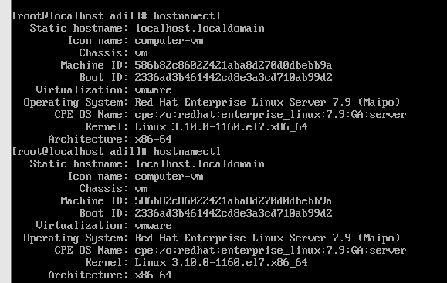

To accomplish the task RHEL 7 need to keep an active subscription.

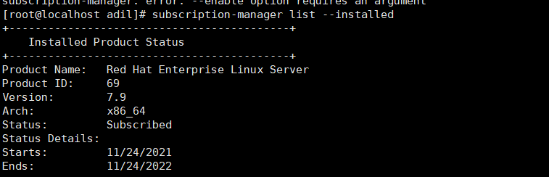

The important thing is, to upgrade the OS first we need to enable at least these two repositories.

1. rhel-7-server—rpms
2. rhe1-7-server-extras-rpms

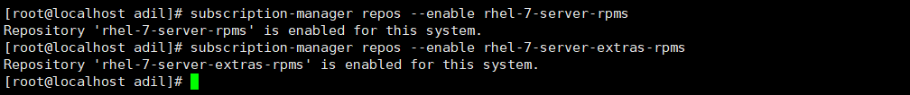

To consume latest packages from rhel 7 repo we need to unset it. So we can get latest releases.



Next, need to update yum repository to download latest version of the packages. Using ***yum update*** command. I have already updated.



After completing these steps, we need to reboot the machine using ***reboot*** command.

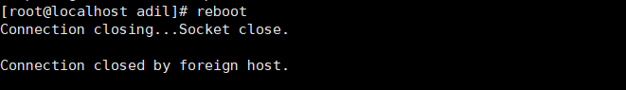

After reboot the machine, we need to install **leapp** for the upgrading process. Using ***yum install leapp***

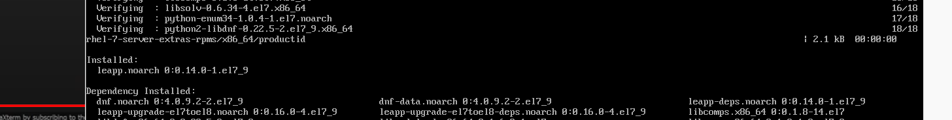

And then download the data files from redhat official web. These are additional required files. The

downloaded link from Community Linux distributions. And then extract in under the /etc/leapp/files

directory. Download the latest version.

<https://access.redhat.com/articles/3664871>

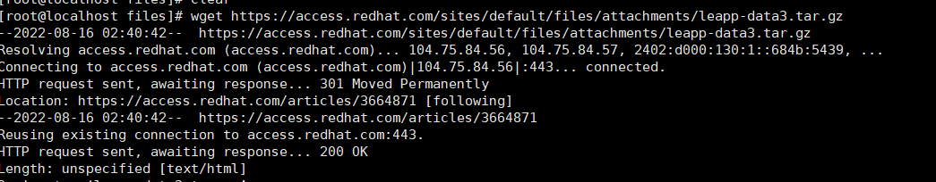

Finally, we are in the upgrade final steps, type ***leapp upgrade.***

When upgrade the rhel 7 to rhel 8 probably we will get these three issues.

1. Multiple devel kernels installed.
2. Leapp detected loaded kernel drivers which have been removed in RHEL 8. Upgrade cannot proceed.
3. Missing required answers in the answer file.

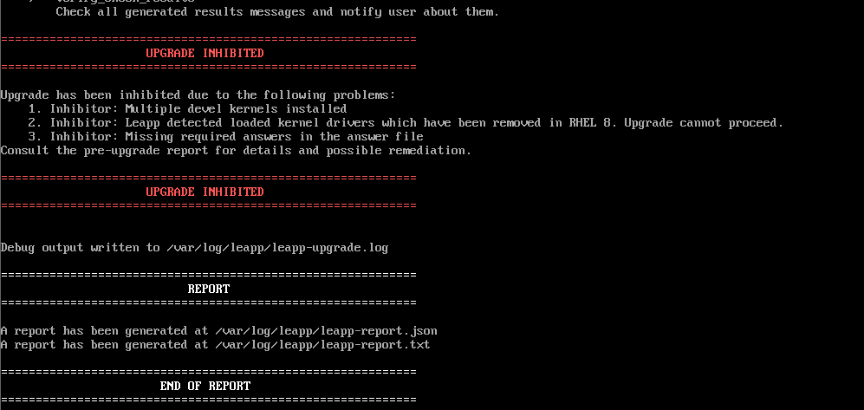

Let encounter those errors.

1. Missing required answers in the answer file.

To encounter this in the terminal,

***leapp answer --section remove_pam_pkcs11_module_check.confirm=True***

then ***leapp upgrade***

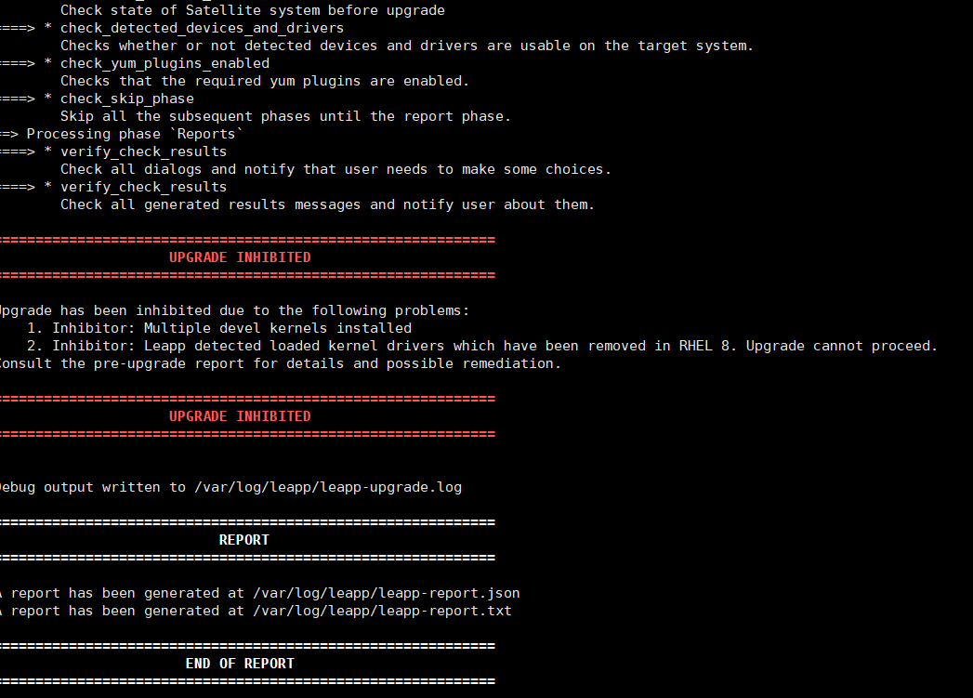

1. Multiple devel kernels installed.

This occurs we had installed multiple kernels. Delete all kernels without the latest one.

For Check the kernels.

***rpm -q kernel***

delete the oldkernels and by this and mentioned the number of kernels in count that wants to delete.

***Package-cleanup –oldkernels --count=<limit>***

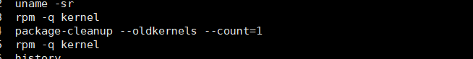

Then ***leapp upgrade***

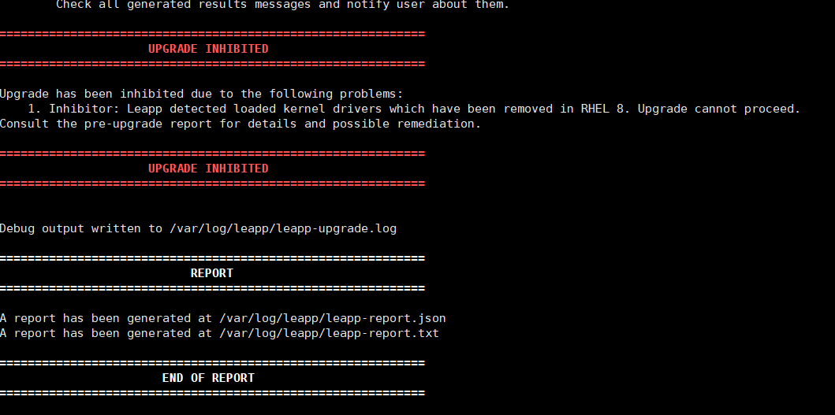

To encounter this error, we need to checkup the report file that generated by the leapp when upgrading. My report like this,

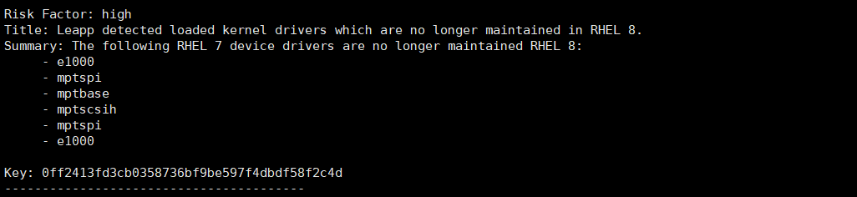

To encounter in the terminal

***rmmod pata_acpi***

then type ***leapp upgrade***

Finally,

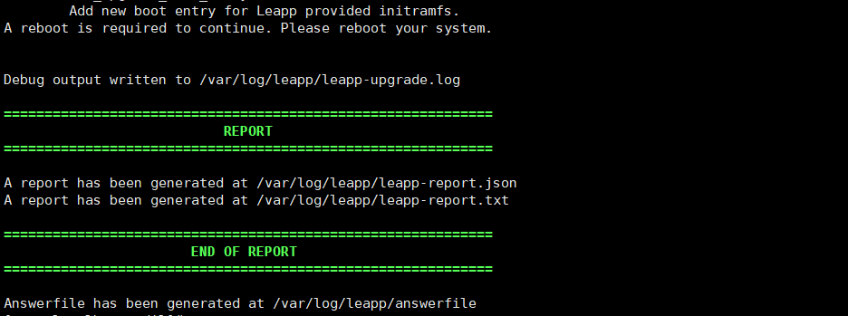

These green marks indicate our upgrade was successful and ***reboot*** the machine. **We got RHEL 8.6**

