**SABARAGAMUWA UNIVERSITY OF SRI LANKA**



**Faculty of Applied Sciences**

**Declaration by Student for Online Examination**

I do hereby undertake to submit without demur or protest to the decision of the Faculty of Applied Sciences as far as the online examination and its results are concerned. I will be strictly following the instruction listed below:

1. I will strictly follow the deadlines of the examinations including the starting date and time and ending date and time.
2. I will check the emails and/or LMS to get the necessary instructions and exam schedule from the department.
3. I will contact the department to check my eligibility to appear in the online examinations.
4. I will be responsible to ensure the availability of a suitable computer/device with stable Internet connectivity and a suitable location (a closed room with no external noise and sufficient lighting) in order to avoid any disturbance during the online examination.
5. I agree to switch on the video camera and/or microphone of my computer or any other device during the presentation and viva voce Examination and when requested to do so by the examination supervisor. I also agree to share my screen with the evaluation panel during such Examination. In the case of projects, I will also be aware of sharing relevant deliverables on the screen for discussions.
6. I will ensure the submission of answers to all attempted questions within the prescribed time in the required file format.
7. I am aware that in case of any examination misconduct, the examination supervisor has the authority to report to the relevant authorities of the Faculty/University and the prescribed procedure for examination malpractices and/or offenses will be followed.
8. I have read and understood the information in the Students’ Guide for Online Examinations, Faculty of Applied Sciences, prior to the Online Examination.
9. I will compulsorily adhere to the conditions specified in the Honour code for open book examinations as follows:

*I acknowledge the Faculty Honour Code and I hereby confirm that the submitted work is entirely my own and I have not (i) used the services of any agency or person(s) providing a specimen, model work in the preparation of the work I submit for this open book examination; (ii) given assistance in accessing this paper or in providing specimen, model to other candidates submitting for this open-book examination.*

Name of Student: A.M. Aathil Index Number: 17 APC3071

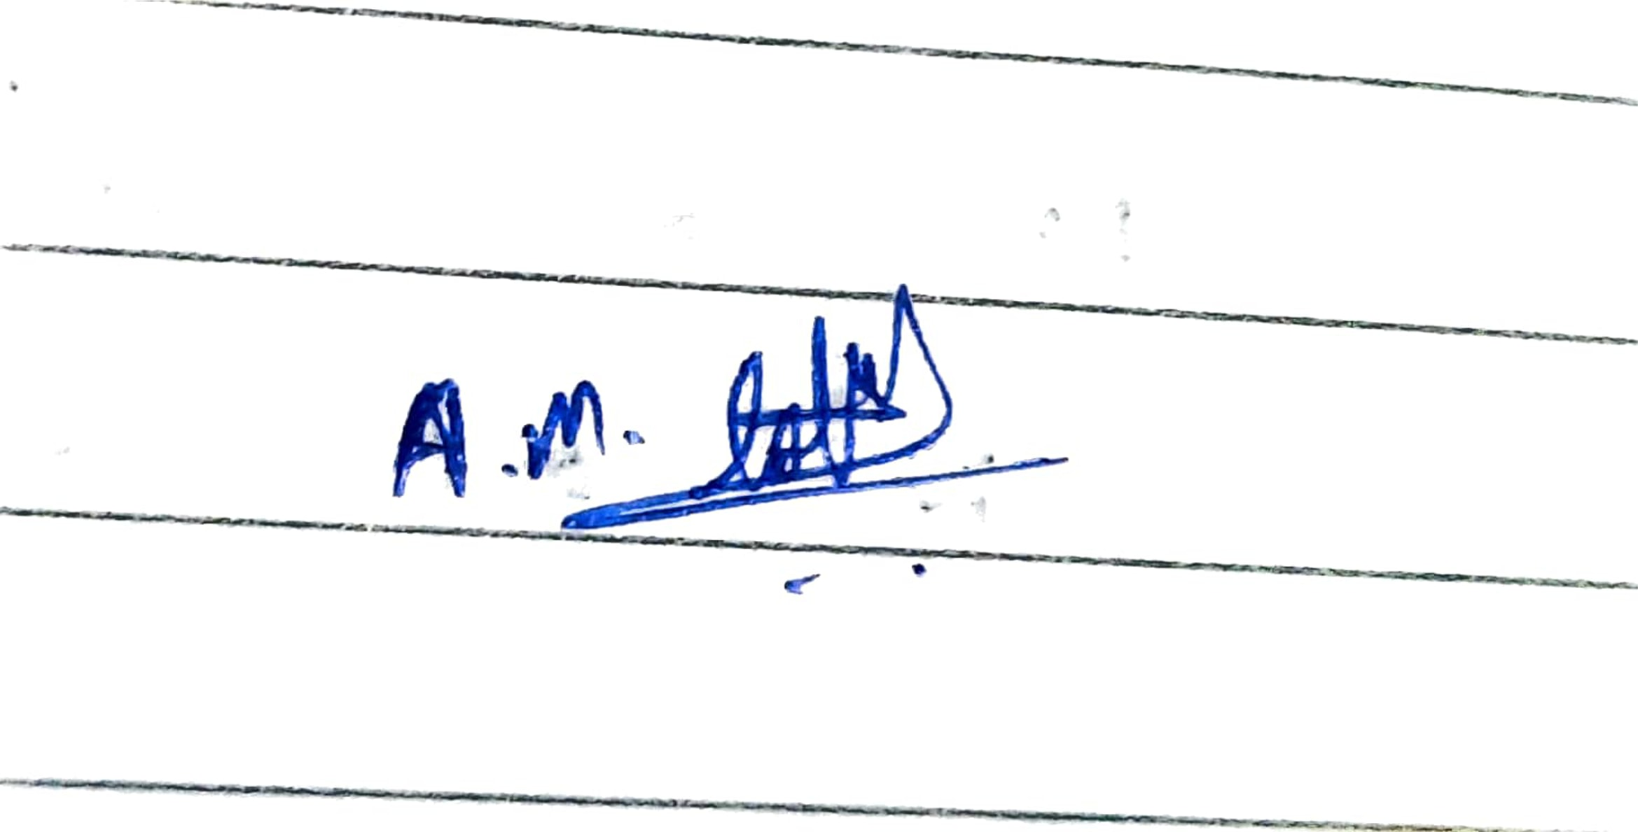

Signature: Location: Batticaloa Date: 09.10.2021

Task 1

The two papers are discussing the failures of the software projects. Robert Britchner who is the author of "Why Some Large Computer Projects Fail" has discussed one of the major software project failures in the United States history. The project is called (FAA’s AAS) Federal Aviation Administration’s Advanced Automation System. The Advanced Automation System comprises all of the automation equipment required for Air Traffic Control at the Area Control Facilities and Air Traffic Control Towers to accommodate the ATC evolution of the 1990 -2010 era.

In 1997 due to equipment failures and the unexpected rise in air travel the Federal Aviation Administration researches the new advanced sophisticated air traffic control equipment. The total budget of this major project is estimated to be $32 billion. According to the FAA contract, IBM and Hughs were qualified for the project. But unfortunately, Hughs has delayed the project. Due to that, the whole project was developed by the tech giant IBM lonely. But unfortunately, In 1990 the constant changes in the speciation for the software FAA announces a 19-month delay to the project duration. In the series of problems, the next fourteen months delay in the project completion, FAA threatened IBM to cancel the project. Finally, IBM and FAA had agreed in management shakeups. In 1993 IBM announces the project will not be completed until well after 2000.

But according to the research paper by Robert Britchner, he mentioned slightly some of the main reasons for the failures of the massive project by a tech giant. He mentioned technical and non-technical failures. The most interesting reason is Overly optimistic deadlines. In earlier of this project, IBM was protested with another tech giant Hughs. This unfounded optimism leads to worse situations that are, sometimes, impossible to recover. That’s was exactly what happen to this project.

The next interesting reason to me, unrealistic developer involvement. This caused the main damage to the project. According to the report Harmon was one of the developers involved in the IBM project. He violated the rules and regulations of the project management of IBM. Unhappily, IBM was in breach of the contract because a programmer had given voice to his code. This also leads to further delays in the project.

The third non-technical reason according to the Sunnyday article, that lead to the project failure is cumbersome government procurement. As this is a state project somehow the government involved in the project meeting, will affect the project administration and the project legal issues. This has also happened in the FAA’s ASS project.

In the report of Robert charette’s, he mentioned multiple factors for software failures. Especially in the domain of the previously explained IBM project, we can identify some of the reasons from his report. Political Exigencies affected the project management role of IBM. It impacts project schedule, cost and quality. Next, Even if a project has been done completely it never works completely. This was exactly what happen in the FAA project. After IBM completed the project in 2000, it was faced major air trafficking problems.

The lack of upper management support is one of the common failure reasons. According to the Robert Britchner report on "Why Some Large Computer Projects Fail", he mentioned on the place the management team of IBM does not attend some meetings with state officials. This lead to the project failure and extended project duration.

Task 2

1.

The triple constraint is a model that describes the three most significant restrictions on any project: scope, schedule and cost

According to the scenario, Duminda company to develop a project on Doctor-patient management system. In every development project, there are three constraints. Limited time frame, Estimated budget and the scope of the project.

If the development team want to do the project fast, it’s gonna cost the customer. especially the team not willing to bend on the scope. That’s because a short deadline requires more resources to get the work done in a limited time frame.

A detailed scope document provides the perfect foundation for understanding the project’s time constraint because the development team can use it to build out a project estimate. Be sure to bring doctors and patients to discuss with your team and look beyond task hours. Important is the time spent in meetings or holding with doctors or patients’ hand through the process counts too.

The more accurate the project estimate, the better. After all, it’s what the development team will use to schedule work and drive project decisions if tough choices need to be made to meet the project deadline. Therefore, all constraints need to be considered during the development within a limited time limit.

2.

Scope baseline “is the approved version of a scope statement, WBS, and its associated WBS dictionary”. These elements can only be modified through a formal change control process.

The following are scope baseline according to the scenario:

a. Plan scope

In the planning phase, the Dumindu Company development team gather all input data from the patients and the doctors. Because the data is the basement for any information. So, in the beginning, The team collect all the data that was needed for the system development.

b. Collect Requirements

Next, the team has to collect all the requirements according to the system they have to develop. This information can be gathered through focus groups, interviews, or surveys, and by creating prototypes. The team’s requirements management plan can help you avoid many frustrating hurdles throughout the project.

c. Define the Scope of the system

you’re ready to clearly define exactly what is in scope and what is out of scope for your project. A project scope statement will serve as a guide throughout the project. Team members should be able to refer to it and easily be reminded of what is and is not involved in that specific job.

d. Create a Work Breakdown Structure (WBS)

Based on the project scope statement and the documents created during requirements collection, the team want to build a Work Breakdown Structure, to break the task into separately. This will lead to finish the work quickly.

e. Validate the system Scope

This is where the team’s deliverables are reviewed by the hospital or authorized party. It’s important to have a plan in place for exactly how project deliverables will be accepted as complete.

f. Control Your Scope

The project’s status should be monitored from start to finish to ensure that it is being executed according to the doctor-patient management system scope.

3.

Scheduling is one of the most important ones during system development. The main determination of project scheduling is to characterize the plan to deliver the project scope over time. A project schedule could be a chart of work elements with allied schedule dates of when work elements and milestones (usually the completion of a deliverable) are planned to happen. In addition to controlling the work, the project schedule is used to communicate to all parties in this scenario doctors, patients and the development teams when convinced work elements and project events are predictable to be proficient. The project schedule is also the tool that links the project elements of work to the properties needed to complete that work.

4.

1. Lack of scheduling knowledge

Project managers classically have roughly level of knowledge concerning how to use a scheduling software package, whichever from a training course, mentoring from colleagues, or self-learning. Maximum scheduling software training courses do not train attendees on scheduling basics, possibly assuming they already preserve this knowledge.

2. Inappropriate Level of Detail

Formulating a schedule with a suitable level of detail is tough. The key is that the schedule has to effort for the project team. One recurrent mistake made when making a schedule is creating also many tasks, which can make the schedule incontrollable.

3. Incorrect Schedule Logic

The Gantt view is not useful for inspecting the schedule logic, since it's problematic to follow the task relationships. The network diagram view is similarly not very useful, since you need to scroll up and down, left and right to see the entire network diagram. A good practice is to scheme the complete schedule and swing it on the wall. Certainly, when this is done, the project team finds logic faults and multiple occasions to progress the network logic.

3.

1.

According to the scenario, the project team is going to develop a medical health application to provide medical records. A medical health application should have come with new modern security specifications. That’s how a development team has to be motivated in the specified field.

1. First, the data breach is one of the potential major risks. Due to the software developers doesn’t acquire well knowledge in security concepts, it can be the root cause of the risk.
2. Next, errors and bugs are very common problems in applications. According to the report The team of five software developers is new and they have not worked together before. So the lack of programming knowledge can be a potential risk.
3. Database collapsed – This is one of the major threats to an organization. If they cannot handle the database administration carefully, all records of the patient will breach. And It has a chance to data staling. This will include the following, Database may not be in SQL standard format, Database vernacular not understood correctly by software engineer, Database may not have direct symptom/diagnosis/treatment linkage
4. Data theft – due to a nil knowledge of the project manager in the iPad application, this will lead to false leadership and false decisions. The false decisions are reached out to us in a delay of project completion. According to the scenario, the project team has to be paid a penalty of $10, 000 per week, if they delay.
5. Over-optimism – This is one of the main risks in project development. A team need to complete the task within a limited time frame. If they want to get the bonus increasingly, sometimes it leads to a wrong way to the project. So, it is also a risk to that team.

2.

|  |  |  |  |  |
| --- | --- | --- | --- | --- |
| Risk | Description | Probability of occurrence | Impact | Risk value |
| Database backup Exposure | plentiful security breaches are happening over database backup outflows. | 12% | 4 | 0.48 |
| SQL Injections. | This is a type of attack when a malicious code is rooted in frontend (web) applications and then passed to the backend database. As the result of SQL injections, cybercriminals get boundless entrees to any data being kept in a database. | 15% | 4 | 0.6 |
| Unmanaged Sensitive Data. | Many companies store a lot of penetrating information and fail to keep an exact inventory of it. Elapsed and unattended data may fall prey to hackers. | 17% | 4 | 0.68 |
| Excessive Database Privileges | genuine privileges mishandling and unused privilege abuse. Unwarranted privileges always create needless risks | 20% | 4 | 0.8 |
| Operational Risk | Operational risk such as a late product unveiling due to production matters. | 25% | 3 | 0.75 |
| Quality Risk | Underprivileged quality. This can arise due to requirements, non-functional requirements, design, testing or quality control failures. | 28% | 3 | 0.84 |
| Credit Risk | The risk that customers and partners will fail to pay you. | 30% | 3 | 0.9 |
| Inventory Risk | Problems with an account such as shortages in one channel and additional inventory issues in alternative. | 32% | 2 | 0.64 |
| Schedule risk  realistic, “expected case” | The plan is optimistic, “best case,” rather than | 35% | 2 | 0.7 |
| Legal and Compliance | The risk of legal or compliance costs. | 35% | 2 | 0.7 |
| Training | Part of giving your personnel the tackles they need to succeed is proper and reliable, training.  Without the right exercise, your customer service reps are ineffective at helping your customers. | 40% | 2 | 0.8 |
| Disgruntled Customers | If society is unable to meet customers’ expectations, the client service team may have to deal with unhappy customers and find ways to mend probable damage to the relationship. | 43% | 1 | 0.43 |

References

Britchner, R. (2002, May 4). *Why some large computer projects fail*? Exam LMS. <https://exam.appsc.sab.ac.lk/pluginfile.php/14760/mod_resource/content/3/Case%20Study%20Articles/LargeCompProjFail.pdf>

Charette, R. (2008, February 3). *Software project failures*. Exam LMS. <https://exam.appsc.sab.ac.lk/pluginfile.php/14817/mod_resource/content/2/WhySWFails-Charette.pdf>

FAA, U. S. D. T. (1983, April 4). *Advanced automation System (AAS)Transition strategy*. Department of Transportation. <http://www.tc.faa.gov/its/worldpac/techrpt/ap83-1.pdf>

J. (2021, April 22). *Database Security Threats And Countermeasures*. DataSunrise Data & Database Security. <https://www.datasunrise.com/blog/potential-db-threats/database-security-threats-and-countermeasures/>

Joseph A., L. (2007, February 1). *Is your schedule correct? Common scheduling mistakes and how to avoid them.* PMI. <https://www.pmi.org/learning/library/common-scheduling-mistakes-avoid-7221>

Lewyn, M. (1993, April 26). *FLYING IN PLACE: The FAA’s Air Control FIASCO*. SunnyDay. <http://sunnyday.mit.edu/16.355/faa-aas.pdf>

Prad, L. L. (2018, December 17). *The Triple Constraints of Project Management*. TeamGantt. <https://www.teamgantt.com/blog/triple-constraint-project-management>

*Project Scope Management | Adobe Workfront*. (n.d.). Adobe Experience Cloud.Com. Retrieved October 8, 2021, from <https://www.workfront.com/project-management/knowledge-areas/scope-management>

Spacey, J. (2019, June 16). *5 Examples of Performance Risk*. Simplicable. <https://simplicable.com/new/performance-risk>

Westland, J. (2018, March 22). *The Triple Constraint in Project Management: Time, Scope & Cost*. ProjectManager.Com. <https://www.projectmanager.com/blog/triple-constraint-project-management-time-scope-cost>