

**SABARAGAMUWA UNIVERSITY OF SRI LANKA**

**Faculty of Applied Sciences**

**Declaration by Student for Online Examination**

I do hereby undertake to submit without demur or protest to the decision of the Faculty of Applied Sciences as far as the online examination and its results are concerned. I will be strictly following the instruction listed below:

1. I will strictly follow the deadlines of the examinations including the starting date and time and ending date and time.
2. I will check the emails and/or LMS to get the necessary instructions and exam schedule from the department.
3. I will contact the department to check my eligibility to appear in the online examinations.
4. I will be responsible to ensure the availability of a suitable computer/device with stable Internet connectivity and a suitable location (a closed room with no external noise and sufficient lighting) in order to avoid any disturbance during the online examination.
5. I agree to switch on the video camera and/or microphone of my computer or any other device during the presentation and viva voce Examination and when requested to do so by the examination supervisor. I also agree to share my screen with the evaluation panel during such Examination. In the case of projects, I will also be aware of sharing relevant deliverables on the screen for discussions.
6. I will ensure the submission of answers to all attempted questions within the prescribed time in the required file format.
7. I am aware that in case of any examination misconduct, the examination supervisor has the authority to report to the relevant authorities of the Faculty/University and the prescribed procedure for examination malpractices and/or offenses will be followed.
8. I have read and understood the information in the Students’ Guide for Online Examinations, Faculty of Applied Sciences, prior to the Online Examination.
9. I will compulsorily adhere to the conditions specified in the Honour code for open book examinations as follows:

*I acknowledge the Faculty Honour Code and I hereby confirm that the submitted work is entirely my own and I have not (i) used the services of any agency or person(s) providing a specimen, model work in the preparation of the work I submit for this open book examination; (ii) given assistance in accessing this paper or in providing specimen, model to other candidates submitting for this open-book examination.*

Name of Student: A.M. Aathil Index Number: 17APC3071

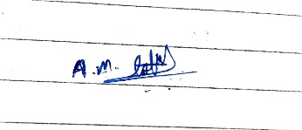

Signature: Location: Batticaloa Date: 16.10.2021

Task 1

The inherent complexity of software is derived from four elements: the complexity of

the problem domain, the difficulty of managing the development process, the flexibility

possible through software, and the problems of characterizing the behaviour of discrete

systems. According to the scenario given, now we will discuss each of the elements.

1. The complexity of the problem domain

Complexity Domain mentions the situation in which the team is constructing their product. In this scenario, pharmaceutical corporations have developed vaccines to guard human beings from the deadly virus. This is the main and also the initial task of this vaccination scenario.

The problems we try to solve in software often comprise elements of inevitable complexity, in which we find innumerable competing, perhaps even inconsistent, necessities. If we reflect the requirements for these manufacturing vaccines, The underdone functionality of such systems is difficult enough to understand. When The time covid arrived, the lockdown also arrived. Therefore the whole transportation was disrupted. Due to that pandemic has

put the transport and logistics world under the attention. This is the primarily administered problem in the initial vaccination process.

1. Difficulty managing the development process

During a software development process, the supervision of struggle and problem management is one of the main parts. No one person can ever comprehend a system entirely. Even if we decay our implementation in expressive ways, we still end up with hundreds and sometimes thousands of separate units. This quantity of work demands that we use a team of developers, and ideally we use as small a team as possible. In the scenario, we can identify the difficulties of managing the whole vaccination process.

Each vaccine has different profiles base on its RNA formula. Especially the mRNA vaccines developed by the manufacturers are extremely temperature-sensitive and place extraordinary demands on transport, handling, storage, and distribution. Furthermore, vaccines need to be store in a low-temperature zone like 2 to 8°C.

When the middle of the vaccination process, a development team has to organize the vaccine operation centers are very difficult to control the people when they are coming to get the vaccines. In this time, a new problem will arise. A full vaccine usually requires two inoculations within 3-4 weeks to deliver full protection. So these are some examples of managing difficulties in a software development process, particularly in the vaccination.

1. the flexibility possible through software

Software proposals the eventual flexibility, so a developer can express almost

any kind of abstraction. This flexibility turns out to be an extremely seductive asset,

nevertheless, because it also forces the developer to craft virtually all the primitive vaccination processes upon which these higher-level abstractions stand.

As a simple example, Under the fully IT infrastructure the government can purchase the vaccine from pharma companies. The remaining work is responsible for the subdistrict, district, state, or regional warehouse. So the top-level government flexibly watch all the progesses through an IT related system.

1. the problems of characterizing the behaviors of discrete systems

a discrete system is a system with an enumerable number of circumstances. Discrete systems may be compared with continuous systems, which may also be called analogue systems. In software development, we can decide in two states. they are Numerous possible states, Difficult to express all states.

In a continuous system, one state may not alter the extra state/behaviour change would be unlikely, but indiscrete systems all external actions can disturb any part of the system's internal state. This is the primary motivation for vigorous testing of our systems, but for all except the most trivial systems, comprehensive testing is unbearable.

References

*1.2 The Inherent Complexity of Software | Software Complexity: How Do We Bring Order to Chaos? | InformIT*. (2007, November 30). Informit. Retrieved October 16, 2021, from <https://www.informit.com/articles/article.aspx?p=726130&seqNum=2>

Dai, D. (2021, January 9). *Complexity analysis of cold chain transportation in a vaccine supply chain considering activity inspection and time-delay*. Advances in Difference Equations. Retrieved October 16, 2021, from <https://advancesindifferenceequations.springeropen.com/articles/10.1186/s13662-020-03173-z>

Kim, J. (2020, June 27). *How Complexity Domain Impacts Software Development Process*. GAMEMAKERS. Retrieved October 16, 2021, from <https://gamemakers.com/how-complexity-domain-impacts-software-development-process/>

Lowery, J. (2019, November 2). *Why is Software Development Difficult? - Level Up Coding*. Medium. Retrieved October 16, 2021, from <https://levelup.gitconnected.com/why-is-software-development-difficult-81a2a041d35e>

Task 2

|  |  |  |
| --- | --- | --- |
| Use Case ID | | UC 01 |
| Actor | | Port Authority |
| Use case name | | Check the Container |
| Scope | Pre-condition | Conversation with the manufacturer |
| Post-condition | Give to the Health Authorities |

|  |  |  |
| --- | --- | --- |
| Use Case ID | | UC 02 |
| Actor | | Port Authority |
| Use case name | | Clear the Container |
| Scope | Pre-condition | Conversation with the manufacturer |
| Post-condition | Give to the Health Authorities |

|  |  |  |
| --- | --- | --- |
| Use Case ID | | UC 03 |
| Actor | | Quality Regulator |
| Use case name | | Store Vaccine |
| Scope | Pre-condition | Conversation with the port Authority |
| Post-condition | Check the health condition of the vaccine |

|  |  |  |
| --- | --- | --- |
| Use Case ID | | UC 05 |
| Actor | | Truck Driver |
| Use case name | | Take Away |
| Scope | Pre-condition | Organize with the health officials |
| Post-condition | Store in ware houses |

|  |  |  |
| --- | --- | --- |
| Use Case ID | | UC 06 |
| Actor | | Logistician |
| Use case name | | Break Bulk |
| Scope | Pre-condition | Store the all vaccines in a ware house |
| Post-condition | Split the vaccines to the regional offices |

|  |  |  |
| --- | --- | --- |
| Use Case ID | | UC 07 |
| Actor | | Reginal Hospital Medical Staff |
| Use case name | | Give to People |
| Scope | Pre-condition | Arrange the hospitals |
| Post-condition | Take care people |

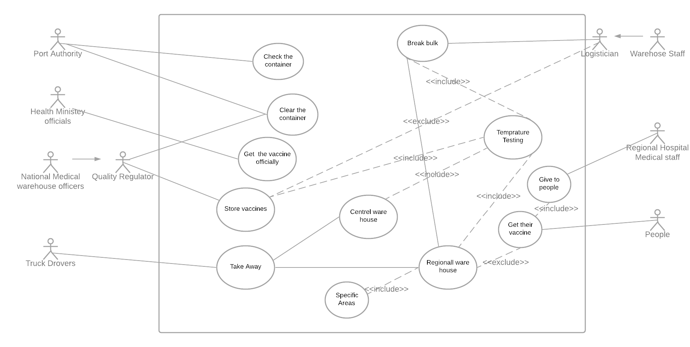Task 3

Task 4

In this scenario, I have mentioned how a vaccination process going on through using a simple use case diagram. But there are many irrelevant and ambiguities practices in the scenario. However, I have mentioned enough actors to their appropriate use cases.

According to my assumption there is no need of quality regulators. Because the profession of the national medical warehouse officers can do the storing and the safety check use case activity. According to the WHO, it says Once a vaccine has reached pre-approval stage following clinical trials, it is assessed by the relevant regulatory body for compliance with quality, safety and efficacy criteria. Following regulatory approval, manufacturers can submit a vaccine to WHO for prequalification (PQ), an assessment process that ensures quality, safety and efficacy and helps the UN and other international procurement organizations determine the programmatic suitability of a vaccine.

Therefore, a national medical doctor can do that part. The important drop down part is, a there is no involvement of Physical Health Inspectors in the scenario. They must be included in the process. According to the UNICEF report PHIs are more important in the vaccination processes. It says, One challenge is attaining compliance for school immunizations from private schools. To overcome this, the PHI ensures all children in their area - whether they are at public or private school – fully receive timely vaccinations. The role of community engagement and health promotion is important

And also, we have to check PCR or Antiget Rapid test before the vaccination. It is also important. PCR tests are considered the best and most effective method for identifying many infectious diseases, including COVID-19 and Ebola. And because they are often able to make diagnoses before symptoms of infection occur, PCR tests play a crucial role in preventing the spread of diseases.

Those are my assumption and justifications.

References

*PCR Tests*. (n.d.). PCR. Retrieved October 16, 2021, from <https://medlineplus.gov/lab-tests/pcr-tests/>