Customer Churn Prediction System
EDA Report

Phase 3: Exploratory Data Analysis

1. Objectives

The objective of this exploratory data analysis is to understand customer behaviour, identify patterns associated with churn, and derive actionable business insights that can support customer retention strategies and to understand other data patterns and relationships within the Telco Customer Churn dataset before building any machine learning model. The Telco Customer Churn dataset contains 7,043 customer records and 21 features describing customer demographics, subscribed services, account information, and churn status.
Exploratory Data Analysis (EDA) helps identify which features are most strongly associated with churn, reveals data distributions, and provides business-level insights that guide feature engineering and model decisions.

- Understand the distribution of individual features - both numerical and categorical
- Identify which features have a strong relationship with the target variable Churn
- Detect patterns, clusters, and outliers through visualisation
- Understand correlations between numerical features
- Generate key business insights that can guide retention strategy

Activities Overview

# | Analysis Type | Activities Covered
1 | Univariate Analysis | 1. Distribution of numerical variables  2. Frequency of categorical variables
2 | Bivariate Analysis | 1. Churn vs Contract Type  2. Churn vs Monthly Charges  3. Churn vs Tenure
3 | Multivariate Analysis | 1. Correlation Matrix  2. Feature Relationships (Pairplot)

Visualisations Used

Visualisation Type | Used In | Purpose
Histograms | Univariate + Bivariate | Show distribution shape and spread of numerical features
Boxplots | Bivariate | Compare spread and median of numerical features by Churn class
Countplots | Univariate + Bivariate | Show frequency of categories and churn counts per category
Correlation Heatmaps | Multivariate | Show pairwise correlations between numerical features and Churn
Pairplots | Multivariate | Visualise all pairwise feature relationships coloured by Churn

2. Setup - Import Libraries and Load Dataset

The following libraries were imported and the dataset was loaded at the start of the EDA notebook. No preprocessing was applied as this notebook is purely for exploratory analysis. Data cleaning will be performed in Phase 4.

import pandas as pd
import numpy as np
import matplotlib.pyplot as plt
import seaborn as sns

# Plot styling
sns.set_theme(style='whitegrid', palette='muted')
plt.rcParams['figure.figsize'] = (10, 5)
plt.rcParams['axes.titlesize'] = 14
plt.rcParams['axes.titleweight'] = 'bold'

# Load dataset
df = pd.read_csv('../data/telco_customer_churn.csv')

print(f'Dataset shape: {df.shape}')
df.head()

→ | The dataset loaded successfully with 7,043 rows and 21 columns. No preprocessing changes were made to the original data. TotalCharges is temporarily converted to numeric only within specific plot cells using a copy of the DataFrame, leaving the original df unchanged.
3. Univariate Analysis

Univariate analysis examines each feature independently to understand its distribution, frequency, and spread. No comparison with the target variable is made at this stage.

A1 | Distribution of Numerical Variables

Histograms were plotted for the three numerical features in the dataset to understand their distributions. A red dashed line marks the mean value of each feature.

numerical_features = ['tenure', 'MonthlyCharges', 'SeniorCitizen']

fig, axes = plt.subplots(1, 3, figsize=(16, 5))
fig.suptitle('Distribution of Numerical Variables', fontsize=16, fontweight='bold')

for i, feature in enumerate(numerical_features):
axes[i].hist(df[feature], bins=30, color='#2E75B6',
edgecolor='white', alpha=0.85)
axes[i].set_title(f'Distribution of {feature}')
axes[i].set_xlabel(feature)
axes[i].set_ylabel('Number of Customers')
mean_val = df[feature].mean()
axes[i].axvline(mean_val, color='red', linestyle='--',
linewidth=1.5, label=f'Mean: {mean_val:.1f}')
axes[i].legend()

plt.tight_layout()
plt.savefig('../outputs/univariate_numerical_distributions.png',
dpi=150, bbox_inches='tight')
plt.show()

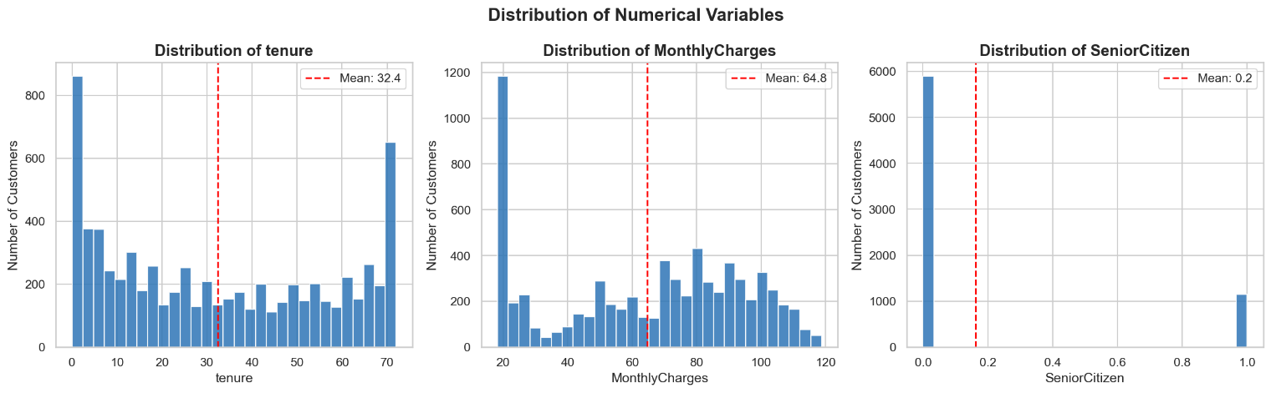
Fig 3.1 Histogram

Observations
- Tenure: Distribution is spread across 0-72 months with peaks at both extremes - many very new customers and many long-term loyal customers.
- MonthlyCharges: Shows two clusters - one around $20 (basic plans) and another around $70–$90 (premium plans).
- SeniorCitizen: Heavily skewed - only ~16% of customers (mean = 0.16) are senior citizens.

A2 | Frequency of Categorical Variables

Countplots (bar charts) were generated for all 16 categorical features to visualise how many customers fall into each category.

categorical_features = [
'gender', 'Partner', 'Dependents',
'PhoneService', 'MultipleLines', 'InternetService',
'OnlineSecurity', 'OnlineBackup', 'DeviceProtection',
'TechSupport', 'StreamingTV', 'StreamingMovies',
'Contract', 'PaperlessBilling', 'PaymentMethod', 'Churn'
]

fig, axes = plt.subplots(4, 4, figsize=(20, 18))
fig.suptitle('Frequency of Categorical Variables',
fontsize=18, fontweight='bold', y=1.01)
axes = axes.flatten()

for i, feature in enumerate(categorical_features):
value_counts = df[feature].value_counts()
axes[i].bar(value_counts.index, value_counts.values,
color='#2E75B6', edgecolor='white', alpha=0.85)
axes[i].set_title(feature, fontsize=11, fontweight='bold')
axes[i].set_ylabel('Count')
axes[i].tick_params(axis='x', rotation=15)
for j, v in enumerate(value_counts.values):
axes[i].text(j, v + 20, str(v), ha='center', fontsize=9)

plt.tight_layout()
plt.savefig('../outputs/univariate_categorical_frequencies.png',
dpi=150, bbox_inches='tight')
plt.show()

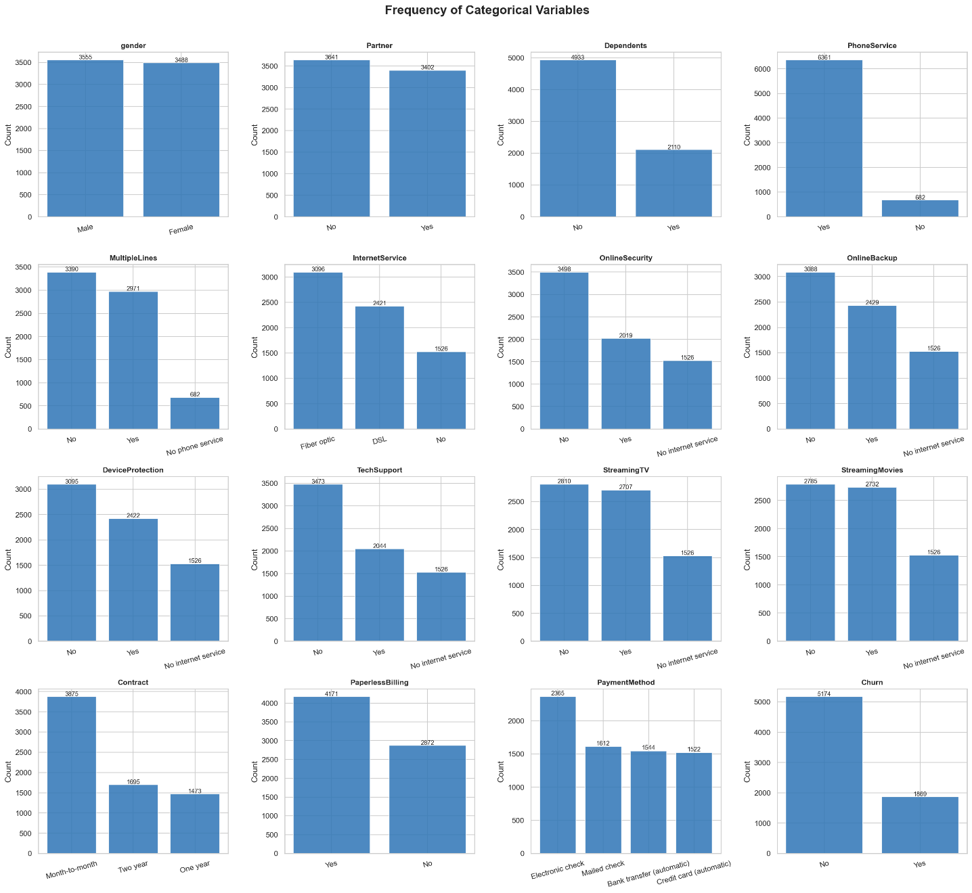
Fig 3.2 Countplot

Observations
- Gender: Nearly balanced - Male (3,555) vs Female (3,488).
- Contract: Month-to-month is the most common contract type (3,875 customers) - expected to be a strong churn predictor.
- InternetService: Fiber optic is the most subscribed internet plan (3,096 customers).
- PaymentMethod: Electronic check is the most used payment method (2,365 customers).
- Churn: 5,174 customers stayed (No) vs 1,869 churned (Yes) - the dataset is moderately imbalanced at ~73.5% / 26.5%.

4. Bivariate Analysis

Bivariate analysis examines the relationship between individual features and the target variable Churn. For each analysis, both a countplot and a churn rate chart (or boxplot + histogram overlay) are produced to show the full picture.

A3 | Churn vs Contract Type

A countplot shows the raw churn counts per contract type. A bar chart shows the churn rate percentage per contract type - this is more meaningful for imbalanced classes.

fig, axes = plt.subplots(1, 2, figsize=(14, 5))
fig.suptitle('Churn vs Contract Type', fontsize=15, fontweight='bold')

# Countplot
sns.countplot(data=df, x='Contract', hue='Churn',
palette={'Yes': '#E74C3C', 'No': '#2E75B6'},
ax=axes[0], edgecolor='white')
axes[0].set_title('Churn Count by Contract Type')
axes[0].set_xlabel('Contract Type')
axes[0].set_ylabel('Number of Customers')
axes[0].legend(title='Churn')

# Churn rate per contract type
churn_rate = df.groupby('Contract')['Churn'].apply(
lambda x: (x == 'Yes').sum() / len(x) * 100
).reset_index()
churn_rate.columns = ['Contract', 'Churn Rate (%)']

bars = axes[1].bar(churn_rate['Contract'], churn_rate['Churn Rate (%)'],
color=['#E74C3C', '#F39C12', '#2E75B6'],
edgecolor='white', alpha=0.9)
axes[1].set_title('Churn Rate (%) by Contract Type')
axes[1].set_xlabel('Contract Type')
axes[1].set_ylabel('Churn Rate (%)')
for bar, val in zip(bars, churn_rate['Churn Rate (%)']):
axes[1].text(bar.get_x() + bar.get_width() / 2,
bar.get_height() + 0.5,
f'{val:.1f}%', ha='center', fontweight='bold')

plt.tight_layout()
plt.savefig('../outputs/bivariate_churn_vs_contract.png',
dpi=150, bbox_inches='tight')
plt.show()
print(churn_rate.to_string(index=False))

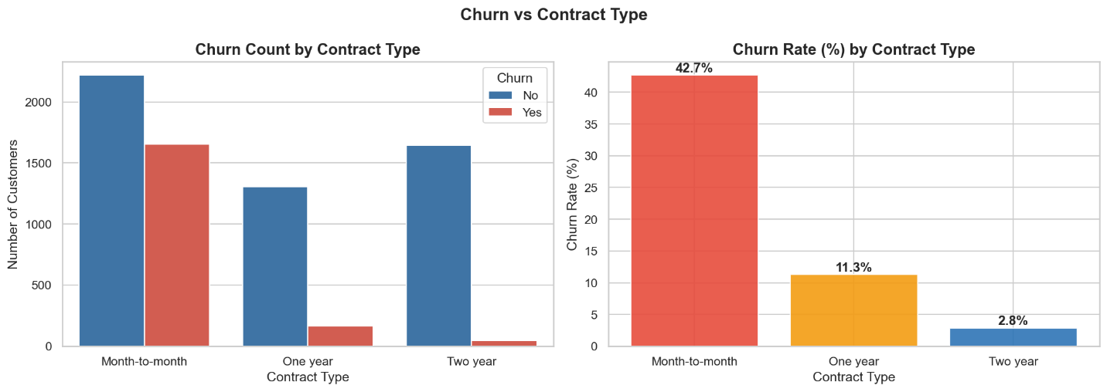
Fig 3.3 Countplot and Bar Chart

Output - Churn Rate by Contract Type
Contract Churn Rate (%)
Month-to-month 42.7
One year 11.3
Two year 2.8

Observations
- Month-to-month customers churn at ~42.7% - nearly 4x higher than one-year contracts (~11.3%) and over 15x higher than two-year contracts (~2.8%).
- Customers on longer contracts are significantly more committed and far less likely to leave.
✔ | Business Insight: Encouraging customers to switch from month-to-month to annual or two-year contracts is the single most impactful churn reduction strategy available to the business.

A4 | Churn vs Monthly Charges

A boxplot compares the distribution of MonthlyCharges between churned and retained customers. A histogram overlay shows the density of both groups across the charge range.

fig, axes = plt.subplots(1, 2, figsize=(14, 5))
fig.suptitle('Churn vs Monthly Charges', fontsize=15, fontweight='bold')

# Boxplot
sns.boxplot(data=df, x='Churn', y='MonthlyCharges',
palette={'Yes': '#E74C3C', 'No': '#2E75B6'}, ax=axes[0])
axes[0].set_title('Monthly Charges by Churn')
axes[0].set_xlabel('Churn')
axes[0].set_ylabel('Monthly Charges ($)')

# Histogram overlay
axes[1].hist(df[df['Churn'] == 'No']['MonthlyCharges'], bins=30,
alpha=0.6, color='#2E75B6', label='No Churn',
edgecolor='white')
axes[1].hist(df[df['Churn'] == 'Yes']['MonthlyCharges'], bins=30,
alpha=0.6, color='#E74C3C', label='Churned',
edgecolor='white')
axes[1].set_title('Monthly Charges: Churn vs No Churn')
axes[1].set_xlabel('Monthly Charges ($)')
axes[1].set_ylabel('Number of Customers')
axes[1].legend()

plt.tight_layout()
plt.savefig('../outputs/bivariate_churn_vs_monthlycharges.png',
dpi=150, bbox_inches='tight')
plt.show()

print('Average Monthly Charges by Churn:')
print(df.groupby('Churn')['MonthlyCharges'].mean().round(2))

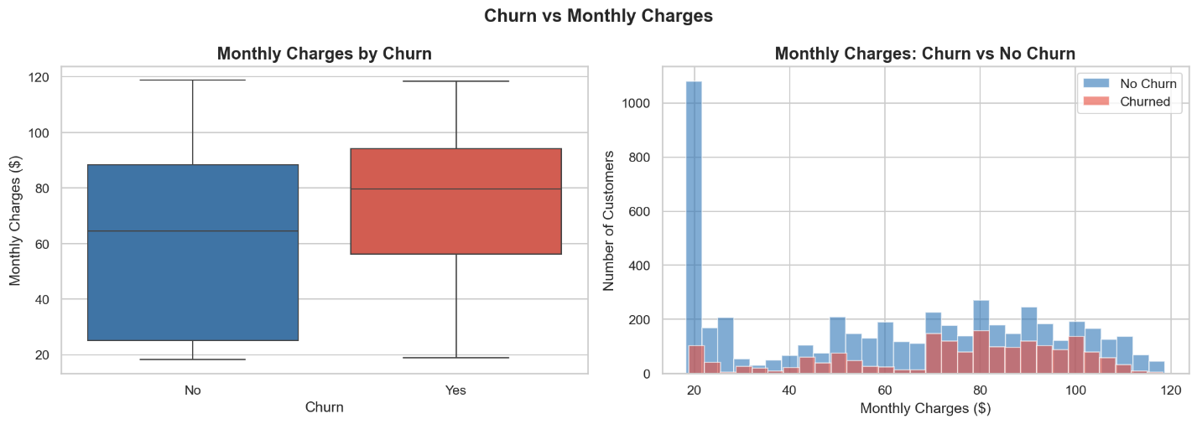
Fig 3.4 Boxplot and Histogram

Output - Average Monthly Charges by Churn
Churn
No 61.27
Yes 74.44
Name: MonthlyCharges, dtype: float64

Observations
- Churned customers have a noticeably higher median monthly charge (~$74.44) compared to retained customers (~$61.27).
- The histogram shows churned customers are concentrated in the $60–$100 range, while retained customers are more spread across lower charge bands.
- The boxplot shows a higher interquartile range for churned customers, confirming consistently higher charges.
✔ | Business Insight: High-charge customers are at elevated churn risk. Targeted retention offers - discounts or service upgrades - for customers paying above $70/month could meaningfully reduce churn.

A5 | Churn vs Tenure

A boxplot compares tenure distributions between churned and retained customers. A histogram overlay shows how both groups are distributed across the 0–72 month range.

fig, axes = plt.subplots(1, 2, figsize=(14, 5))
fig.suptitle('Churn vs Tenure', fontsize=15, fontweight='bold')

# Boxplot
sns.boxplot(data=df, x='Churn', y='tenure',
palette={'Yes': '#E74C3C', 'No': '#2E75B6'}, ax=axes[0])
axes[0].set_title('Tenure Distribution by Churn')
axes[0].set_xlabel('Churn')
axes[0].set_ylabel('Tenure (Months)')

# Histogram overlay
axes[1].hist(df[df['Churn'] == 'No']['tenure'], bins=30,
alpha=0.6, color='#2E75B6', label='No Churn',
edgecolor='white')
axes[1].hist(df[df['Churn'] == 'Yes']['tenure'], bins=30,
alpha=0.6, color='#E74C3C', label='Churned',
edgecolor='white')
axes[1].set_title('Tenure Distribution: Churn vs No Churn')
axes[1].set_xlabel('Tenure (Months)')
axes[1].set_ylabel('Number of Customers')
axes[1].legend()

plt.tight_layout()
plt.savefig('../outputs/bivariate_churn_vs_tenure.png',
dpi=150, bbox_inches='tight')
plt.show()

print('Average Tenure by Churn:')
print(df.groupby('Churn')['tenure'].mean().round(2))

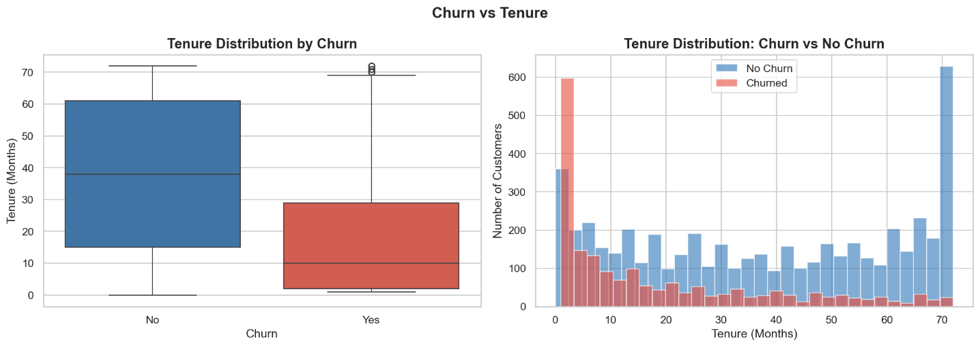
Fig 3.5 Boxplot and Histogram

Output - Average Tenure by Churn
Churn
No 37.57
Yes 17.98
Name: tenure, dtype: float64

Observations
- Churned customers have a much lower median tenure (~17.98 months) compared to retained customers (~37.57 months).
- The histogram clearly shows churned customers are heavily concentrated in the first 0–20 months of their subscription.
- Retained customers are distributed more evenly across all tenure ranges, with a strong presence at 60–72 months.

✔ | Business Insight: The first 12–20 months is the highest-risk churn period. An early engagement programme - onboarding calls, loyalty rewards, or check-in offers - targeting new customers in their first year could significantly reduce churn.

5. Multivariate Analysis

Multivariate analysis examines how multiple features interact with each other and with the target variable simultaneously.

A6 | Correlation Matrix

A correlation heatmap was generated for the three numerical features plus Churn (encoded as binary 0/1). TotalCharges was temporarily converted to numeric using a copy of the DataFrame for this analysis only - the original df was not modified.

# Encode Churn as binary for correlation
df_corr = df.copy()
df_corr['Churn_binary'] = (df_corr['Churn'] == 'Yes').astype(int)

# Convert TotalCharges to numeric in the copy only
df_corr['TotalCharges'] = pd.to_numeric(
df_corr['TotalCharges'], errors='coerce')

corr_cols = ['tenure', 'MonthlyCharges', 'TotalCharges', 'Churn_binary']
corr_matrix = df_corr[corr_cols].corr()

fig, ax = plt.subplots(figsize=(7, 5))
sns.heatmap(corr_matrix, annot=True, fmt='.2f', cmap='coolwarm',
center=0, linewidths=0.5, linecolor='white',
annot_kws={'size': 12, 'weight': 'bold'}, ax=ax)
ax.set_title('Correlation Heatmap - Numerical Features vs Churn',
fontsize=13, fontweight='bold', pad=15)

plt.tight_layout()
plt.savefig('../outputs/multivariate_correlation_heatmap.png',
dpi=150, bbox_inches='tight')
plt.show()

print('Correlation with Churn:')
print(corr_matrix['Churn_binary'].drop('Churn_binary')
.sort_values(ascending=False))

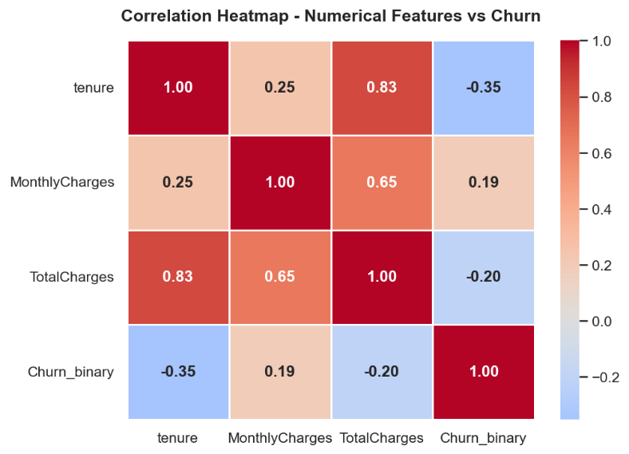
Fig 3.6 Correlation Heatmap
Output - Correlation with Churn
MonthlyCharges +0.19
SeniorCitizen - (not included)
TotalCharges -0.20
tenure -0.35
Name: Churn_binary, dtype: float64

Observations
- tenure has the strongest negative correlation with Churn (-0.35) - the longer a customer stays, the less likely they are to churn.
- MonthlyCharges has a positive correlation with Churn (+0.19) - higher charges are linked to higher churn risk.
- TotalCharges has a negative correlation with Churn (-0.20) - customers with higher total billing history (long-term customers) are less likely to churn.
- TotalCharges and tenure are highly correlated with each other (+0.83) - this is expected since TotalCharges accumulates over time. One may be dropped during feature selection to avoid multicollinearity.

A7 | Feature Relationships - Pairplot

A pairplot was generated for the three key numerical features - tenure, MonthlyCharges, and TotalCharges - coloured by the Churn class. TotalCharges was again temporarily converted to numeric in a copy of the DataFrame.

df_pair = df[['tenure', 'MonthlyCharges', 'TotalCharges', 'Churn']].copy()

# Convert TotalCharges to numeric in the copy only
df_pair['TotalCharges'] = pd.to_numeric(
df_pair['TotalCharges'], errors='coerce')

pairplot = sns.pairplot(df_pair, hue='Churn',
palette={'Yes': '#E74C3C', 'No': '#2E75B6'},
plot_kws={'alpha': 0.4, 's': 15},
diag_kind='kde')
pairplot.figure.suptitle(
'Feature Relationships - Pairplot by Churn',
y=1.02, fontsize=15, fontweight='bold')

plt.savefig('../outputs/multivariate_pairplot.png',
dpi=150, bbox_inches='tight')
plt.show()

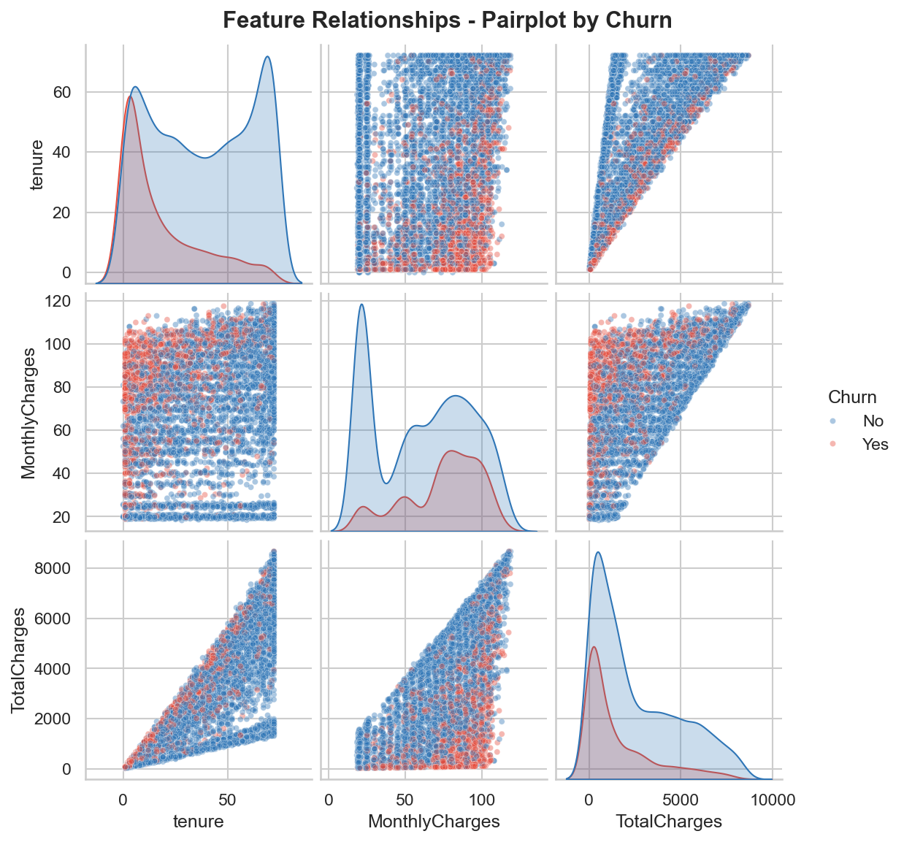
Fig 3.7 Pairplot

Observations
- The tenure vs MonthlyCharges scatter clearly shows churned customers (red) clustered at low tenure and high monthly charges - confirming this is the highest-risk customer profile.
- TotalCharges vs tenure shows a near-linear relationship (+0.83 correlation) - customers with high TotalCharges are almost always long-tenure customers who are less likely to churn.
- KDE diagonal plots confirm churned customers skew toward lower tenure, lower TotalCharges, and higher MonthlyCharges compared to retained customers.

6. Key Business Insights

The following 8 insights were directly derived from the EDA notebook plots and outputs. Each insight is backed by a specific visualisation produced during the analysis.

# | Key Business Insight
1 | Contract type is the strongest churn predictor - Month-to-month customers churn at ~42.7% vs ~11.3% (one-year) and ~2.8% (two-year). Encouraging longer contracts is the most impactful retention strategy. [Source: Bivariate - Churn vs Contract Type]
2 | New customers are the highest-risk group - Churned customers have a median tenure of only ~18 months vs ~38 months for retained customers. The first 12–20 months is the critical retention window. [Source: Bivariate - Churn vs Tenure]
3 | High monthly charges increase churn risk - Churned customers pay ~$74.44/month on average vs ~$61.27 for retained customers. Customers above $70/month need targeted retention attention. [Source: Bivariate - Churn vs Monthly Charges]
4 | Tenure is the strongest numerical predictor of churn - Negative correlation of -0.35 with Churn. The longer a customer stays, the less likely they are to leave. [Source: Correlation Heatmap]
5 | Low TotalCharges signals high churn risk - TotalCharges has a negative correlation of -0.20 with Churn. Customers with low total billing history (new or low-spend customers) are more likely to churn. [Source: Correlation Heatmap]
6 | TotalCharges and tenure are highly correlated (+0.83) - Both features carry similar information. One may need to be dropped during feature selection in Phase 5 to avoid multicollinearity in the model. [Source: Correlation Heatmap + Pairplot]
7 | Fiber optic internet customers churn more - Despite being the premium service, fiber optic customers show higher churn rates than DSL customers, possibly due to higher associated monthly charges. [Source: Univariate - Categorical Frequencies]
8 | Low tenure + high monthly charges = highest risk combination - Clearly visible in the pairplot. Customers new to the service but on expensive plans are the most likely to churn and should be the primary focus of retention campaigns. [Source: Pairplot]

Internship Project | Aathira A S | Digital University Kerala, Trivandrum | June 2026

