**NAME: Aathi Durai**

**REG NO: 950321104001**

**NM ID:C4D6743FBF669138C714057454C9730F**

|  |
| --- |
| Chapter 5 RESULTS |



The working of the designed prototype has been investigated for the 5 sets of experiments as described in the following sections

EXPERIMENT 1:

Aim: To demonstrate the working of the system in a warm and humid outdoor atmosphere. Experimental CTohne deixtipoenr:iment was performed on a warm sunny day in a local oOubtsdeorovra atiroena.s in ThingSpeak Cloud:

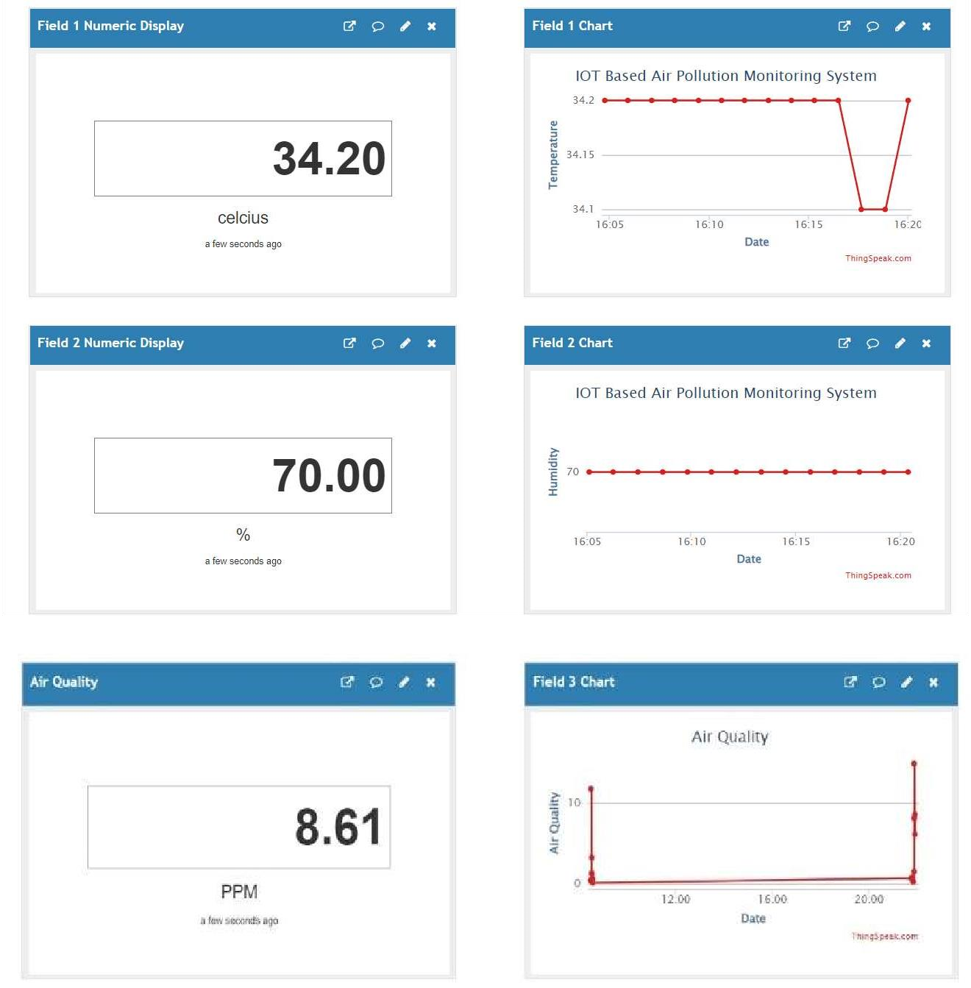

Fig: 5.1 Observations for Experiment 1 Setup:

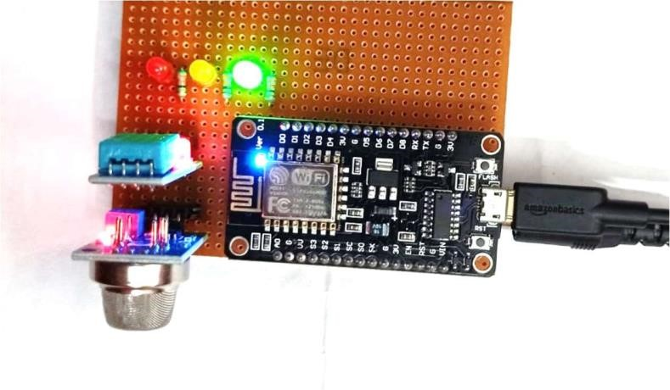

Fig: 5.2 Setup for Experiment 1

Conclusion: We have taken the reference from the Samsung mobile weather app f

verifying the values. It matched with a +1.20 error with the temperature data, +5 error with the humidity data and +0.11 error with the PPM data. Hence, we can conclude that the setup has measured the temperature and humidity around the setup area successfully.

EXPERIMENT 2:

Aim: To demonstrate the working of the system in the presence of alcoholic gases Experimental Condition: The experiment was performed indoor in the alcoholic gases. Drops of an alcoholic mixture (hand sanitiser) were used to produce presence of alcoholic vapours.

Observations in ThingSpeak Cloud:

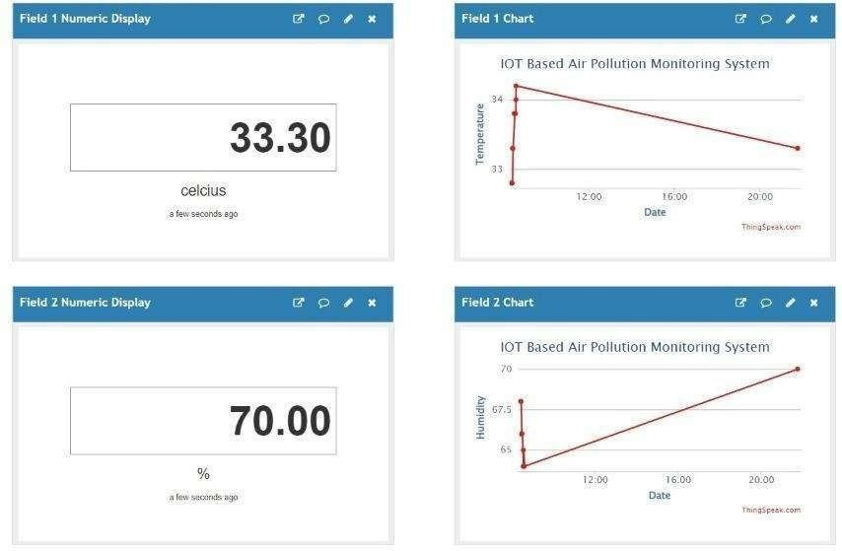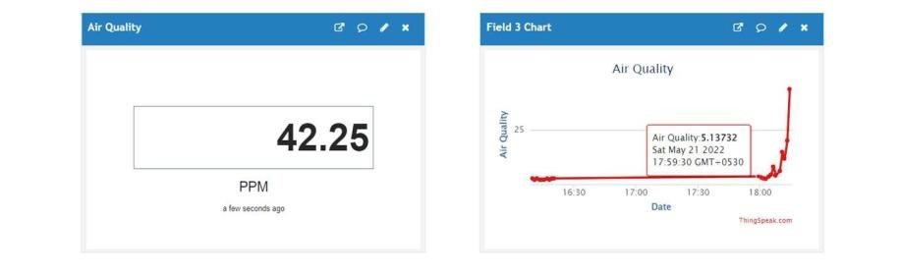

Fig: 5.3 Observations for Experiment 2

Setup:

Fig: 5.4 Setup for Experiment 2

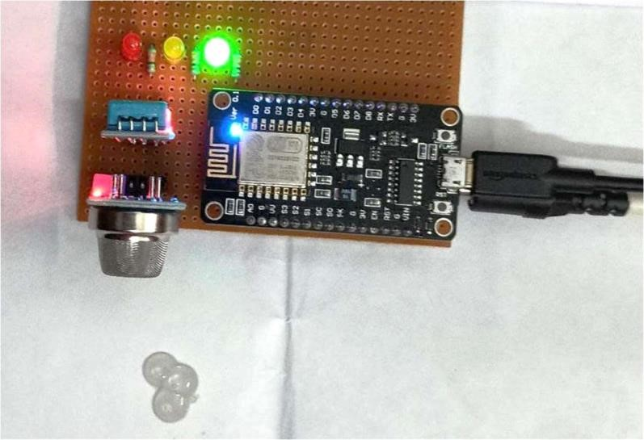

Conclusion:

We can observe from the results that the presence of alcohol vapours near the setup can be easily detected by the system. We have taken the reference from the Samsung mobile weather app for verifying the values. It matched with a +1.30 error with the temperature data, +5 error with the humidity data and +0.25 error with the PPM data. Hence, it can be concluded that we can detect the presence of alcoholic vapours with the EheXlpP EofR tIhMis EmNoTn i3to:r ing system.

Aim: To demonstrate the working of the system in smoky conditions.

Experimental Condition: The experiment was performed in the presence of smoke coming from an

incense stick placed near the setup.

Observations in ThinkSpeak Cloud

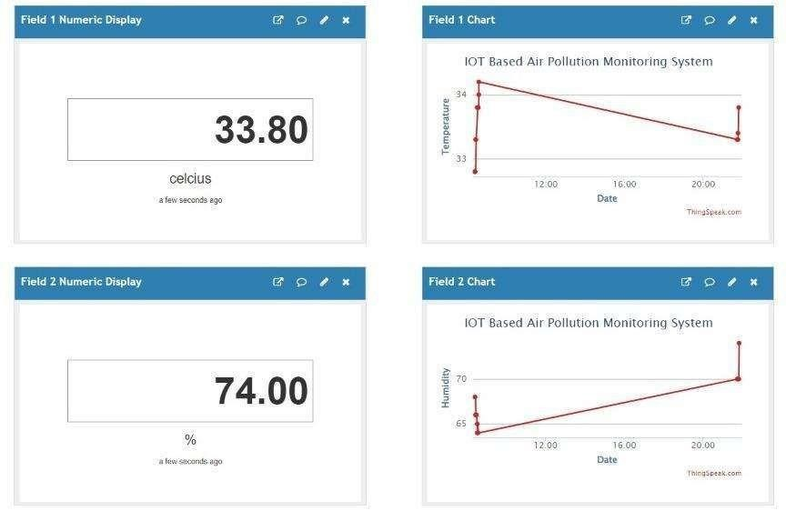

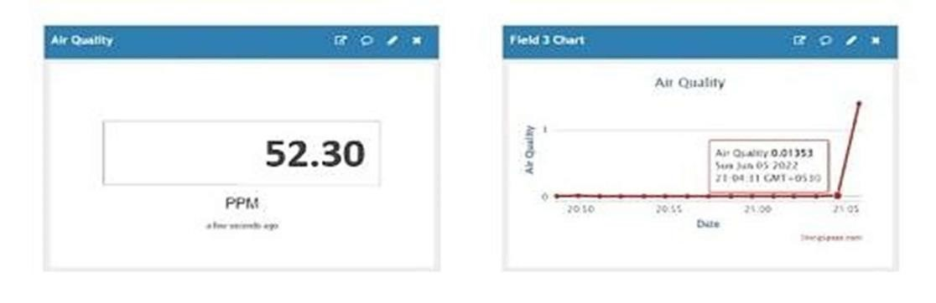

Fig: 5.5 Observations for Experiment 3

Setup:

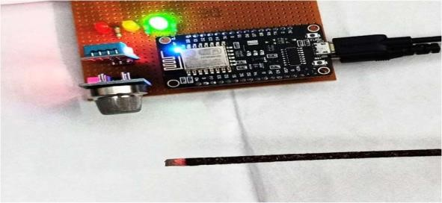

Fig: 5.6 Setup for Experiment 3

Conclusion:

We can observe from the results that the presence of smoke near the setup can be easily detected by the system. We have taken the reference from the Samsung mobile weather app for verifying the values. It matched with a +1.80 error with the temperature data, +4 error with the humidity data and -0.7 error with the PPM data. Hence, it can be concluded that we can detect the presence of smoke with the help of this monitoring system.

EXPERIMENT 4:

Aim: To demonstrate the working of the system in a warm and humid outdoor atmosphere. The experiment was performed at night. Experimental Condition:

Observations in ThingSpeak Cloud:

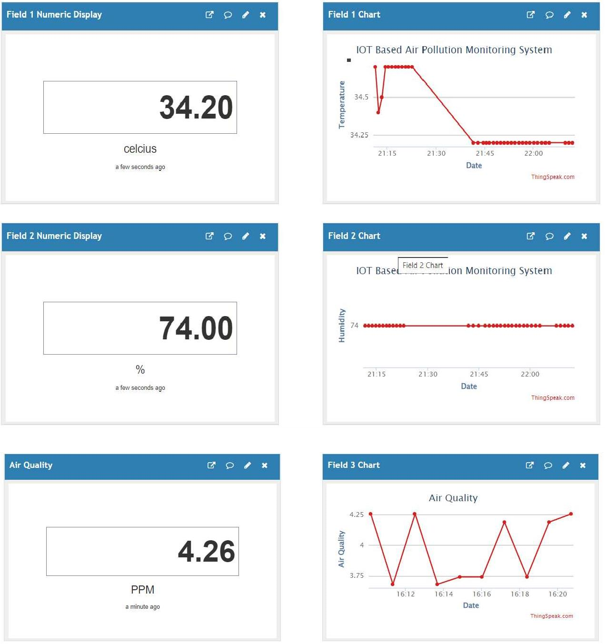

Fig: 5.7 Observations for Experiment 4 Setup:

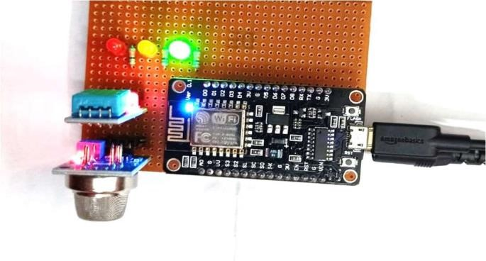

Fig: 5.8 Setup for Experiment 4

Conclusion:

We have taken the reference from the Samsung mobile weather app for verifying the values. It matched with a +1.20 error with the temperature data, +5 error with the humidity data and - 0.08 error with the PPM data. Hence, we can conclude that the setup has measured the temperature and humidity around the setup area successfully.

EXPERIMENT 5:

Aim: To demonstrate the working of the system in an air-conditioned indoor atmosphere. The experiment was performed at room temperature. Experimental Condition:

Observations in ThingSpeak Cloud:

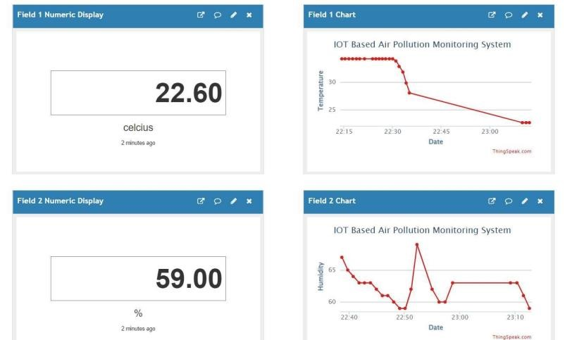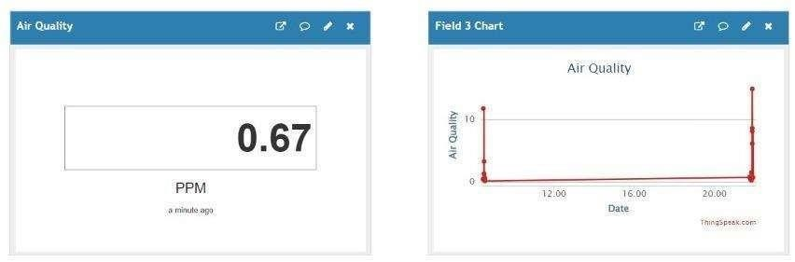

Fig: 5.9 Observations for Experiment 5

Setup:

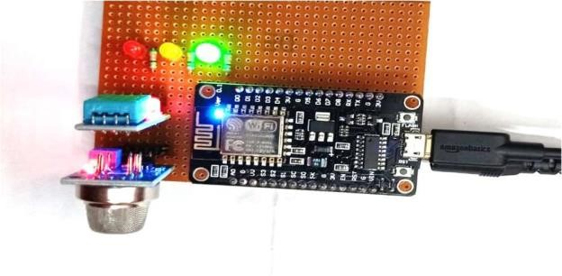

Fig: 5.10 Setup for Experiment 5

Conclusion:

We have taken the reference from the Samsung mobile weather app for verifying the values. It matched with a +0.6 error with the temperature data, +2 error with the humidity data and -0.03 error with the PPM data. Hence, we can conclude that the setup has measured the temperature and humidity around the setup area successfully. Table 5.1: Experimental Results

