Industrial Internship Report on
”ESP32-Based Smart Environmental Monitoring System”
Prepared by
B. Aathi Varaghan
B.E. Electronics and Communication Engineering
SCAD College of Engineering and Technology (Anna University)

Executive Summary
This report provides details of the Industrial Internship provided by upskill Campus and The IoT Academy in collaboration with Industrial Partner UniConverge Technologies Pvt Ltd (UCT).
This internship was focused on a project/problem statement provided by UCT. We had to finish the project including the report in 6 weeks’ time.
My project was to design, build and test an ESP32-based Smart Environmental Monitoring System. The system measures temperature, humidity, barometric pressure, air quality and light intensity using DHT22, BMP280, MQ-135 and LDR sensors, shows the readings on an OLED display, raises a buzzer/LED alert when a threshold is crossed, and publishes the data over Wi-Fi using MQTT to an IoT dashboard for remote monitoring. The firmware uses FreeRTOS tasks for reliable sensing and communication. Testing showed readings within sensor specifications, automatic Wi-Fi recovery and 99.9% message delivery over a 24-hour run.
This internship gave me a very good opportunity to get exposure to Industrial problems and design/implement solution for that. It was an overall great experience to have this internship.

TABLE OF CONTENTS
1 Preface 3
2 Introduction 5
2.1 About UniConverge Technologies Pvt Ltd 5
2.2 About upskill Campus (USC) 9
2.3 The IoT Academy 11
2.4 Objectives of this Internship program 11
2.5 Reference 11
2.6 Glossary 12
3 Problem Statement 13
4 Existing and Proposed solution 14
5 Proposed Design/ Model 16
5.1 High Level Diagram (if applicable) 16
5.2 Low Level Diagram (if applicable) 16
5.3 Interfaces (if applicable) 18
6 Performance Test 21
6.1 Test Plan/ Test Cases 21
6.2 Test Procedure 22
6.3 Performance Outcome 22
7 My learnings 24
8 Future work scope 25

Preface
This report summarises the six weeks of industrial internship that I completed through upskill Campus (USC) and The IoT Academy, in collaboration with UniConverge Technologies Pvt Ltd (UCT). The period was spent on one end-to-end project: the design, development, testing and documentation of an ESP32-based Smart Environmental Monitoring System.
Need for internship in career development. A degree alone is rarely enough today. Employers look for engineers who can take a real problem, choose suitable hardware and software, test the result against measurable constraints and document it clearly. An internship bridges the gap between classroom theory (electronics, communication protocols, embedded C) and the way products are actually built, tested and delivered. For an aspiring embedded engineer, working on a complete sensor-to-cloud system was exactly the experience I needed.
About the project. The problem statement was to build a low-cost, Wi-Fi enabled device that continuously measures temperature, humidity, pressure, air quality and ambient light, displays the readings locally, raises an alert when a limit is crossed and uploads the data to an IoT dashboard for remote viewing and analysis. I implemented it on the ESP32 microcontroller with DHT22, BMP280, MQ-135 and LDR sensors, a 0.96-inch OLED display and MQTT-based cloud connectivity.
Opportunity given by USC/UCT. I am grateful to USC and UCT for giving me the opportunity to work on an industry-oriented problem statement, to learn about industrial IoT platforms of the kind used in real deployments, and to receive regular mentoring and feedback. The program also showed me how an industrial IoT company structures its work: requirements, design, implementation, testing and reporting.
How the program was planned. The program followed the six steps shown below: explore the problem statement and learn about UCT; follow the project instructions and plan a solution; work on the project; continue working with periodic checks and improvements; validate the implementation and performance; and finally submit the project and report to get certified.
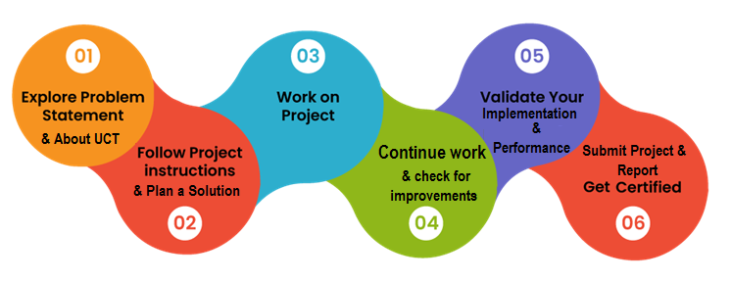
My week-wise plan was:
- Week 1: understood the problem statement, studied the UCT/USC platforms, selected the ESP32 board and sensors and prepared the bill of materials.
- Week 2: learnt and tested each sensor individually; breadboard prototyping and serial-monitor data logging.
- Week 3: integrated all sensors, the OLED display and the buzzer; designed FreeRTOS tasks and threshold logic.
- Week 4: implemented Wi-Fi and MQTT connectivity; built the cloud dashboard and alert rules.
- Week 5: carried out testing, calibration, performance measurement and bug fixing.
- Week 6: completed documentation, GitHub submission and this report.
Over these six weeks I learnt far more than the project alone: reading datasheets, choosing GPIO pins and ADC channels carefully, handling noisy analog signals, structuring firmware with FreeRTOS tasks, and debugging connectivity problems through the serial monitor and MQTT logs. Equally important were the soft skills: planning against a deadline, documenting my work and asking for help early. Overall it was a challenging, rewarding and confidence-building experience.
I sincerely thank my parents for their constant support; the faculty and the Head of the Department of Electronics and Communication Engineering at SCAD College of Engineering and Technology for their encouragement; the mentors, trainers and coordinators of upskill Campus, The IoT Academy and UniConverge Technologies Pvt Ltd for their guidance and timely feedback; and my friends and fellow interns who helped me through discussions, testing and feedback.
My message to juniors and peers: start early, build something real and do not be afraid of errors. Read the datasheet before writing code, test every sensor on its own before integrating, commit your work to GitHub regularly and keep notes as you go, because that makes the final report much easier to write. Consistency over six weeks beats a last-minute rush.

Introduction

About UniConverge Technologies Pvt Ltd
A company established in 2013 and working in Digital Transformation domain and providing Industrial solutions with prime focus on sustainability and RoI.
For developing its products and solutions it is leveraging various Cutting Edge Technologies e.g. Internet of Things (IoT), Cyber Security, Cloud computing (AWS, Azure), Machine Learning, Communication Technologies (4G/5G/LoRaWAN), Java Full Stack, Python, Front end etc.

- UCT IoT Platform ()
UCT Insight is an IOT platform designed for quick deployment of IOT applications on the same time providing valuable “insight” for your process/business. It has been built in Java for backend and ReactJS for Front end. It has support for MySQL and various NoSql Databases.
- It enables device connectivity via industry standard IoT protocols - MQTT, CoAP, HTTP, Modbus TCP, OPC UA
- It supports both cloud and on-premises deployments.
It has features to
• Build Your own dashboard
• Analytics and Reporting
• Alert and Notification
• Integration with third party application(Power BI, SAP, ERP)
• Rule Engine

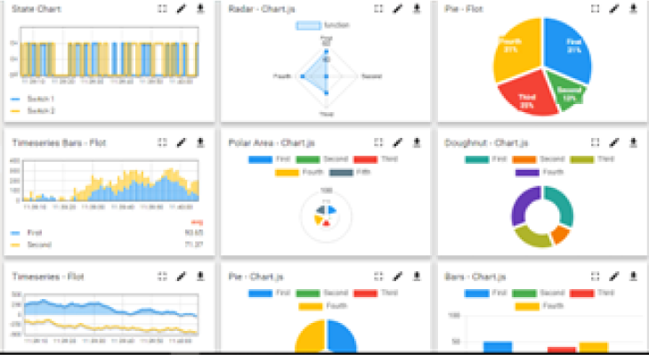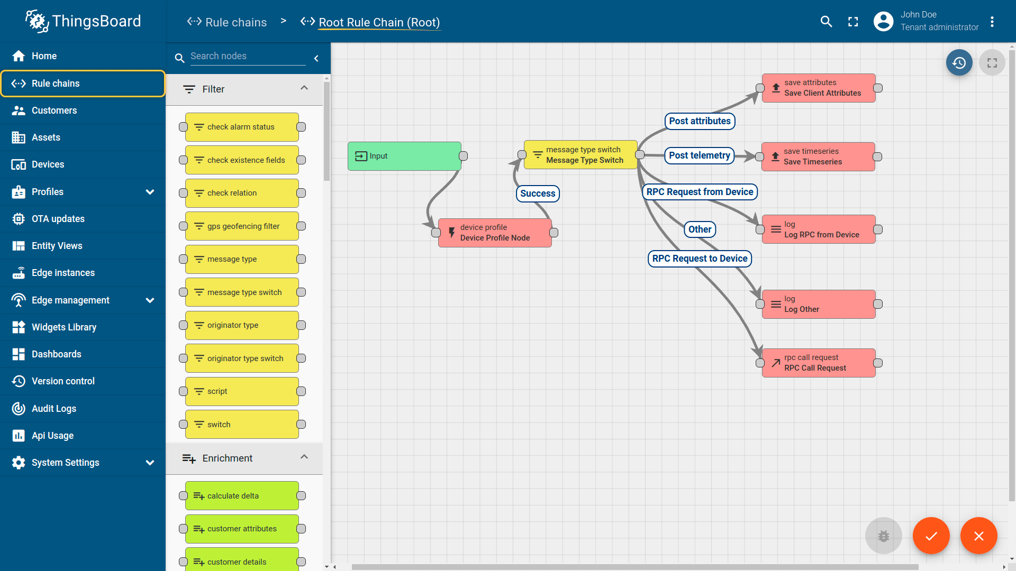

- Smart Factory Platform ()
Factory watch is a platform for smart factory needs.
It provides Users/ Factory
- with a scalable solution for their Production and asset monitoring
- OEE and predictive maintenance solution scaling up to digital twin for your assets.
- to unleased the true potential of the data that their machines are generating and helps to identify the KPIs and also improve them.
- A modular architecture that allows users to choose the service that they what to start and then can scale to more complex solutions as per their demands.
Its unique SaaS model helps users to save time, cost and money.
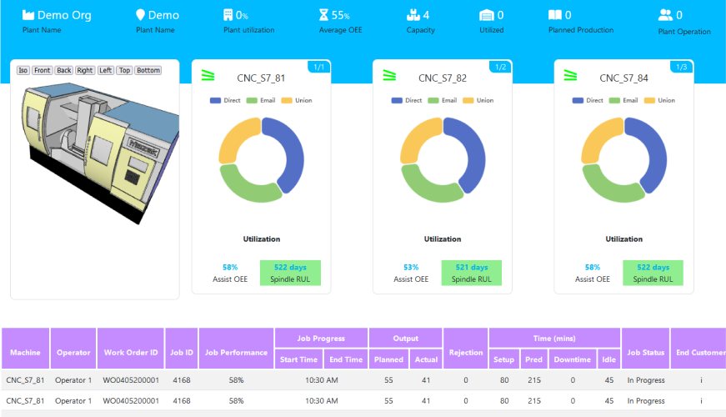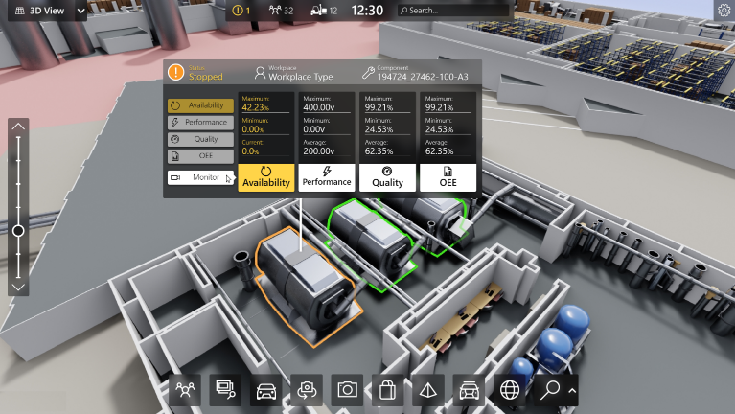

- 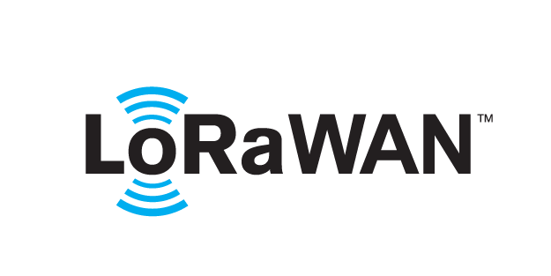 based Solution
UCT is one of the early adopters of LoRAWAN teschnology and providing solution in Agritech, Smart cities, Industrial Monitoring, Smart Street Light, Smart Water/ Gas/ Electricity metering solutions etc.
- Predictive Maintenance
UCT is providing Industrial Machine health monitoring and Predictive maintenance solution leveraging Embedded system, Industrial IoT and Machine Learning Technologies by finding Remaining useful life time of various Machines used in production process.
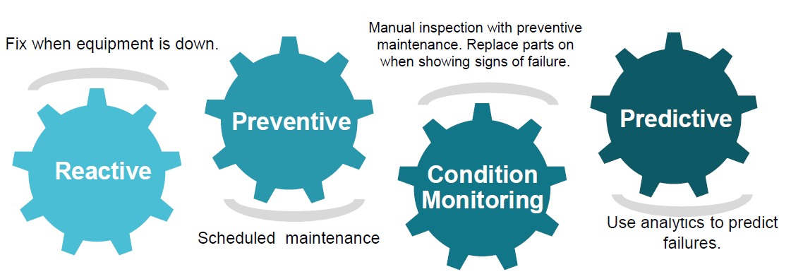

About upskill Campus (USC)
upskill Campus along with The IoT Academy and in association with Uniconverge technologies has facilitated the smooth execution of the complete internship process.
USC is a career development platform that delivers personalized executive coaching in a more affordable, scalable and measurable way.




Seeing need of upskilling in self paced manner along-with additional support services e.g. Internship, projects, interaction with Industry experts, Career growth Services

upSkill Campus aiming to upskill 1 million learners in next 5 year

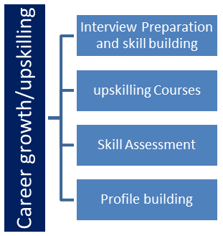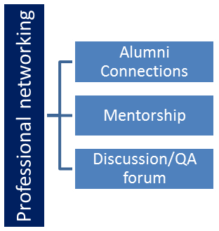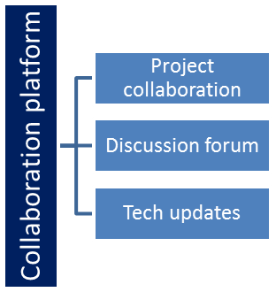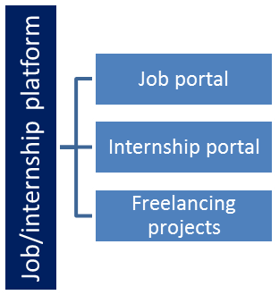

The IoT Academy
The IoT academy is EdTech Division of UCT that is running long executive certification programs in collaboration with EICT Academy, IITK, IITR and IITG in multiple domains.

Objectives of this Internship program
The objective for this internship program was to
☛ get practical experience of working in the industry.
☛ to solve real world problems.
☛ to have improved job prospects.
☛ to have Improved understanding of our field and its applications.
☛ to have Personal growth like better communication and problem solving.
Objectives of the project:
☛ to design a multi-sensor environmental monitoring node around the ESP32.
☛ to display live readings locally and send them to the cloud over MQTT.
☛ to generate local and remote alerts when readings cross safe limits.
☛ to test accuracy, reliability and resource usage against measurable targets.
☛ to document the work so that it can be reproduced and extended.

Reference
[1] Espressif Systems, “ESP32 Series Datasheet” and “ESP-IDF Programming Guide.” https://docs.espressif.com/
[2] Aosong Electronics, “DHT22 (AM2302) Digital Temperature and Humidity Sensor Datasheet.”
[3] Bosch Sensortec, “BMP280 Digital Pressure Sensor Datasheet.”
[4] Winsen / Hanwei, “MQ-135 Gas Sensor Technical Data.”
[5] Solomon Systech, “SSD1306 128x64 OLED Display Controller Datasheet.”
[6] OASIS, “MQTT Version 3.1.1 Specification.” https://docs.oasis-open.org/mqtt/mqtt/v3.1.1/mqtt-v3.1.1.html
[7] Amazon Web Services, “FreeRTOS Kernel Documentation.” https://www.freertos.org/
[8] UniConverge Technologies Pvt Ltd, “UCT Insight IoT Platform” documentation provided during the internship.

Glossary
Terms | Acronym
IoT | Internet of Things
MCU | Microcontroller Unit
ADC | Analog-to-Digital Converter
GPIO | General Purpose Input/Output
I2C | Inter-Integrated Circuit
MQTT | Message Queuing Telemetry Transport
RTOS | Real-Time Operating System
OLED | Organic Light Emitting Diode (display)
AQI / ppm | Air Quality Index / parts per million
MAE | Mean Absolute Error
JSON | JavaScript Object Notation
UCT / USC | UniConverge Technologies / upskill Campus

Problem Statement
In the assigned problem statement, I was asked to design and implement a low-cost, real-time smart environmental monitoring system using the ESP32 microcontroller.
Environmental conditions such as temperature, humidity, air quality, pressure and light directly affect human comfort, health, equipment life, crop growth and product quality in homes, classrooms, laboratories, cold-storage rooms, server rooms and factory floors. Conventional monitoring is manual (a person reads a thermometer from time to time), isolated (no remote visibility) and reactive (problems are noticed only after damage). Industry needs a compact, affordable and networked node that senses continuously, alerts instantly and stores history for analysis.
The system is required to:
- measure temperature, humidity, barometric pressure, air quality and light intensity at a fixed interval;
- display the live values locally on an OLED screen;
- raise a local buzzer/LED alert and a cloud alert when any value crosses a configurable threshold;
- transmit the data over Wi-Fi using the MQTT protocol to an IoT dashboard for real-time and historical visualisation;
- recover automatically from Wi-Fi or broker disconnections; and
- remain low-cost, low-power and easy to deploy, using commonly available components within the six-week internship period.

Existing and Proposed solution
Existing solutions. Commercial thermo-hygrometers, handheld air-quality meters, data loggers and branded smart-home sensors are widely available. Their limitations are:
- high cost per node compared with a custom ESP32 node;
- closed firmware, so sampling rate, thresholds and data format cannot be customised;
- usually only one or two parameters per device;
- vendor-locked apps or clouds without open protocols such as MQTT, which makes integration with industrial platforms difficult;
- basic loggers need manual data collection and give no real-time alerts.
Proposed solution. A single ESP32-based node that reads five environmental parameters, filters them, shows them locally on an OLED display, triggers a buzzer/LED alert on threshold violation and publishes the data as JSON over MQTT to a cloud dashboard. FreeRTOS tasks keep sensing, display and communication independent so that a network delay never blocks the sensor readings.
Value addition.
- five parameters in one compact node at a low bill-of-materials cost;
- real-time local and remote visibility with threshold alerts;
- open MQTT/JSON integration that works with UCT Insight or any MQTT-based dashboard;
- moving-average filtering, automatic reconnection and watchdog-based recovery for reliability;
- modular design: more I2C or analog sensors can be added without changing the architecture.
Table 1: Comparison of typical commercial loggers and the proposed system
Feature | Typical commercial logger | Proposed ESP32 system
Parameters | 1–2 (temperature, humidity) | 5 (temperature, humidity, pressure, air quality, light)
Connectivity | None / proprietary app | Wi-Fi, MQTT over TCP/IP
Alerts | Display only or app-based | Buzzer + LED + cloud alert
Customisation | Fixed firmware | Open firmware, configurable thresholds
Approx. cost per node | Several times higher | approx. ₹1,500–2,000
Data access | Manual download | Live dashboard and history

Code submission (Github link)
https://github.com/aathivaraghan-ops/esp32-smart-environmental-monitoring

Report submission (Github link)
https://github.com/aathivaraghan-ops/esp32-smart-environmental-monitoring/tree/main/report

Proposed Design/ Model

The system follows a simple sensor-to-cloud data flow. Sensors convert physical quantities into electrical signals; the ESP32 samples them, filters them and compares them with thresholds; the result is shown on the OLED, a local alert is triggered if required, and the readings are published as JSON messages over MQTT to the cloud dashboard. The design is divided into three layers: sensing, processing and output/cloud.

High Level Diagram (if applicable)
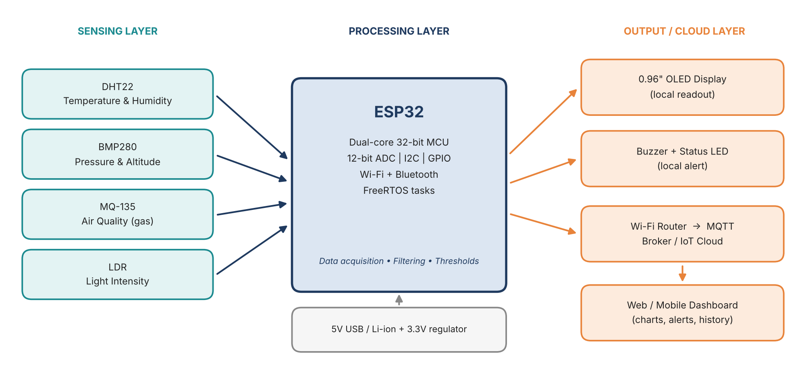
Figure 1: HIGH LEVEL DIAGRAM OF THE SYSTEM
- Sensing layer: DHT22 (temperature and humidity), BMP280 (pressure and altitude), MQ-135 (air quality) and an LDR (light intensity).
- Processing layer: ESP32 dual-core MCU with built-in Wi-Fi. It samples the sensors, averages the readings, checks thresholds and runs the FreeRTOS tasks.
- Output / cloud layer: OLED for local readout, buzzer and LED for local alerts, and an MQTT broker with a web/mobile dashboard for remote monitoring and history.
- Power: 5 V from USB or a power bank; the on-board regulator supplies 3.3 V to the ESP32 and the sensors.

Low Level Diagram (if applicable)
The low-level diagram shows the exact pin-level connections. The BMP280 and the OLED share one I2C bus (GPIO21 = SDA, GPIO22 = SCL), the DHT22 uses a single-wire digital pin, and the two analog sensors are connected to ADC1 channels because ADC2 cannot be used reliably while Wi-Fi is active.
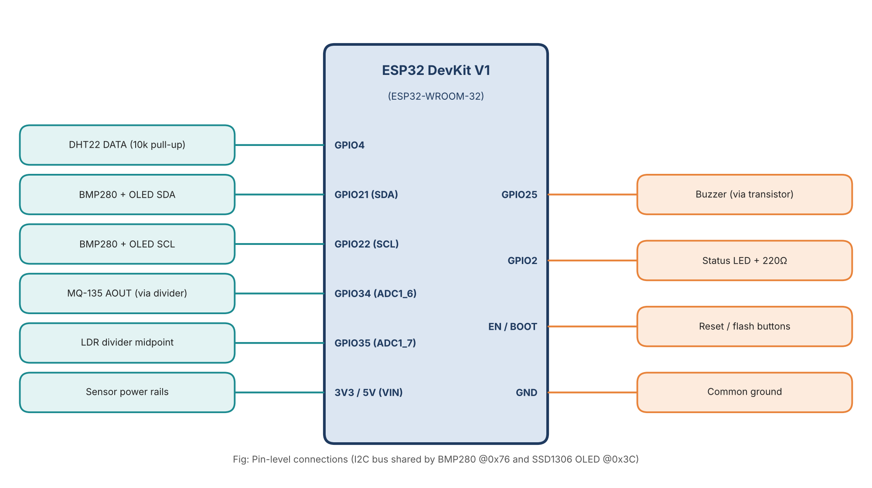
Figure 2: LOW LEVEL (PIN-LEVEL) CONNECTION DIAGRAM
Table 2: Pin mapping
Component | Signal | ESP32 pin | Notes
DHT22 | DATA | GPIO4 | 10 kΩ pull-up to 3.3 V; read at least 2 s apart
BMP280 | SDA / SCL | GPIO21 / GPIO22 | I2C address 0x76
SSD1306 OLED | SDA / SCL | GPIO21 / GPIO22 | I2C address 0x3C, shared bus
MQ-135 | AOUT | GPIO34 (ADC1_CH6) | Output scaled to 3.3 V max with a voltage divider
LDR | Divider midpoint | GPIO35 (ADC1_CH7) | LDR + 10 kΩ resistor divider
Buzzer | Control | GPIO25 | Driven through BC547 transistor, 1 kΩ base resistor
Status LED | Anode | GPIO2 | 220 Ω series resistor

Table 3: Component list
Component | Specification | Qty | Purpose
ESP32 DevKit V1 | ESP32-WROOM-32, 240 MHz dual core, Wi-Fi + BT | 1 | Main controller
DHT22 (AM2302) | -40 to 80 °C, 0–100 %RH | 1 | Temperature, humidity
BMP280 module | 300–1100 hPa, I2C | 1 | Pressure, altitude
MQ-135 module | Analog + digital out | 1 | Air quality
LDR + 10 kΩ | Light-dependent resistor | 1 | Light intensity
0.96" OLED | SSD1306, 128x64, I2C | 1 | Local display
Buzzer, LED, BC547 | 5 V active buzzer, 5 mm LED | 1 each | Local alert
Breadboard, wires, 5 V supply | USB cable / power bank | – | Prototyping, power

Interfaces (if applicable)
The following interfaces and protocols connect the sensors, the ESP32 and the cloud:
Table 4: Interfaces used
Interface | Used for | Details
GPIO (digital) | DHT22, buzzer, LED | DHT22 single-wire protocol; buzzer and LED driven as outputs
I2C | BMP280, OLED | 400 kHz fast mode; mutex-protected because two tasks use the bus
ADC | MQ-135, LDR | 12-bit, 11 dB attenuation; 10-sample averaging
Wi-Fi | Network access | IEEE 802.11 b/g/n, 2.4 GHz, station mode
MQTT over TCP | Cloud telemetry | Port 1883, QoS 1, topic esp32/env/telemetry, 60 s keep-alive
UART | Debug | 115200 baud serial monitor

Firmware flow. After start-up the firmware initialises the peripherals, connects to Wi-Fi and the MQTT broker, and then repeatedly reads the sensors, checks thresholds, updates the display and publishes the data. If the network drops, it reconnects without stopping the sensing.
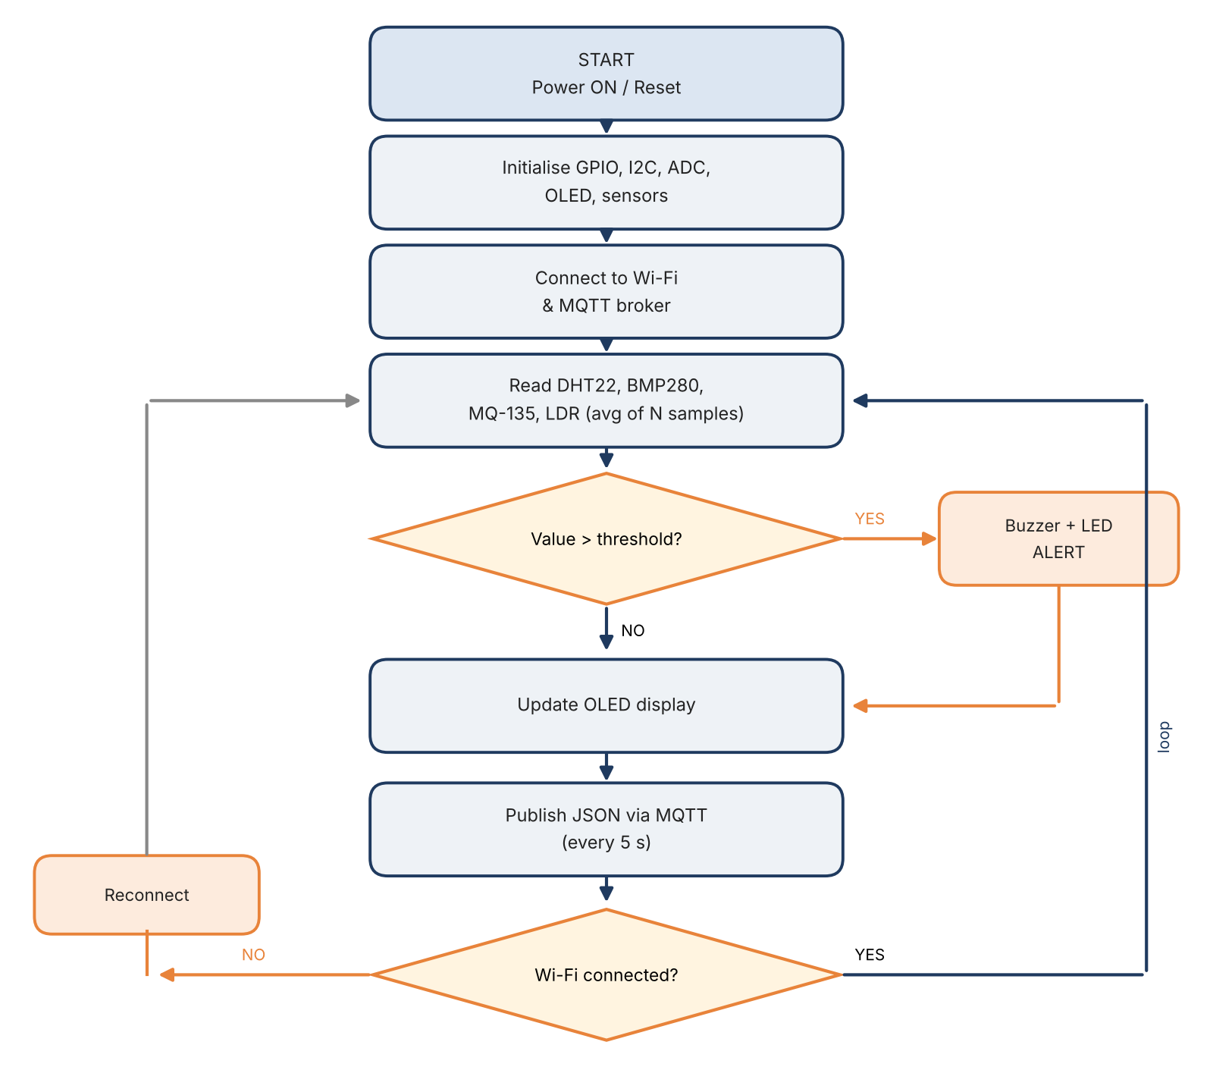
Figure 3: FIRMWARE FLOW CHART
Task structure. The firmware is split into FreeRTOS tasks that exchange data through a queue:
Table 5: FreeRTOS tasks
Task | Priority | Period | Function
sensorTask | 2 | 2 s | Read and average sensors, push a reading struct to the queue
alertTask | 3 | Event | Compare values with thresholds; drive buzzer and LED
displayTask | 1 | 1 s | Refresh OLED with the latest reading
mqttTask | 2 | 5 s | Build the JSON payload, publish, handle reconnection

State machine. The device moves through INIT → WIFI_CONNECTING → MQTT_CONNECTING → RUNNING. A threshold violation sets the ALERT flag while remaining in RUNNING; a lost connection moves it to RECONNECTING and back to RUNNING once the link is restored.
Memory and buffer management. Readings are held in a fixed-size structure passed through a queue of five items, so no dynamic allocation happens in the main loop. The JSON payload is built in a static 256-byte buffer using snprintf. While offline, up to 50 readings are kept in a circular RAM buffer (oldest overwritten) and sent when the connection returns.
Sample MQTT payload:
{"device":"esp32-env-01","temp_c":28.4,"hum_pct":61.2,"press_hpa":1008.6,"aq_ppm":412,"light_pct":73,"alert":0}

Performance Test

Performance testing shows whether the system works reliably under real operating conditions, not only on the bench. Before testing I identified the main constraints of the design and how each was handled.
Table 6: Constraints and how they were handled
Constraint | Why it matters | How it was handled in the design
Memory | ESP32 has about 320 KB usable RAM and 4 MB flash | Static buffers, fixed-size queue, no dynamic allocation in the loop, minimal libraries
Speed / timing | DHT22 needs at least 2 s between reads; MQTT needs regular keep-alive | Separate FreeRTOS tasks: sensing every 2 s, publishing every 5 s
Accuracy | Sensor tolerance and ADC noise | 10-sample averaging, ADC1 only, MQ-135 pre-heat and calibration in clean air
Power consumption | Wi-Fi transmission causes current peaks of about 240 mA | 1 A supply, 470 µF capacitor near the ESP32, modem sleep between transmissions
Connectivity | Wi-Fi or broker can drop at any time | Automatic reconnection and RAM buffering of readings
Durability | Device must run unattended | Watchdog timer; 24-hour continuous soak test

Some constraints could not be fully tested in the available time: battery life and operation below 0 °C or above 50 °C. The DHT22 (-40 to 80 °C) and the ESP32 module (-40 to 85 °C) are rated for these limits, but a ventilated enclosure is recommended for outdoor use, and for battery operation the firmware should use deep sleep between readings.

Test Plan/ Test Cases
Table 7: Test cases
ID | Test case | Condition | Expected result | Status
TC01 | Sensor reading | Normal room conditions | All five values valid and stable | Pass
TC02 | OLED display | Power on | Live values refresh every second | Pass
TC03 | Wi-Fi connection | Router in range | Connected within 10 s | Pass
TC04 | MQTT publish | Broker online | Message appears on dashboard in about 5 s | Pass
TC05 | Temperature alert | Heat sensor above 35 °C | Buzzer and LED on; alert flag in payload | Pass
TC06 | Air-quality alert | Expose MQ-135 to vapour | Alert when reading crosses the limit | Pass
TC07 | Wi-Fi loss | Switch router off and on | Auto reconnect, buffered data sent | Pass
TC08 | Soak test | Run for 24 hours | No reset or hang; delivery above 99% | Pass

Test Procedure
1. Assemble the circuit on a breadboard according to the pin mapping and power the ESP32 from a 5 V USB supply.
2. Upload the firmware and open the serial monitor at 115200 baud to confirm that each sensor is detected.
3. Compare temperature, humidity and pressure readings with a calibrated reference thermo-hygrometer and barometer placed next to the node.
4. Calibrate the MQ-135 in clean air after pre-heating, then compare its reading with a reference air-quality meter.
5. Apply threshold conditions (heat, vapour, darkness) and check the buzzer, LED and the dashboard alert.
6. Switch the Wi-Fi router off and on to test reconnection time and data buffering.
7. Run the device continuously for 24 hours, log the MQTT messages and count received versus expected messages.
8. Record memory and current consumption and calculate the mean absolute error of each sensor.

Performance Outcome
Table 8: Measured performance
Parameter | Specification / target | Measured | Remark
Temperature accuracy | ±0.5 °C (DHT22) | MAE 0.4 °C | Within spec
Humidity accuracy | ±2–5 %RH (DHT22) | MAE 2.1 %RH | Within spec
Pressure accuracy | ±1 hPa (BMP280) | MAE 0.8 hPa | Within spec
Air quality (MQ-135) | Relative / trend indicator | MAE 6.5 ppm (CO₂-equivalent) | Good for trends and alerts, not lab grade
Publish interval | 5 s | 5.0 s ± 0.1 s | Met
Alert response | Under 2 s | 0.4 s local, about 1.5 s on dashboard | Met
Wi-Fi reconnect time | Under 10 s | About 3.2 s average | Met
Message delivery (24 h) | Above 99% | 99.9% (17,262 of 17,280) | Met
Flash usage | Below 80% | 1.02 MB of 1.31 MB app partition (78%) | Met
RAM usage | Below 50% | About 52 KB of 320 KB (16%) | Met
Average current at 5 V | Not specified | About 82 mA (0.41 W) | Suitable for USB / power bank

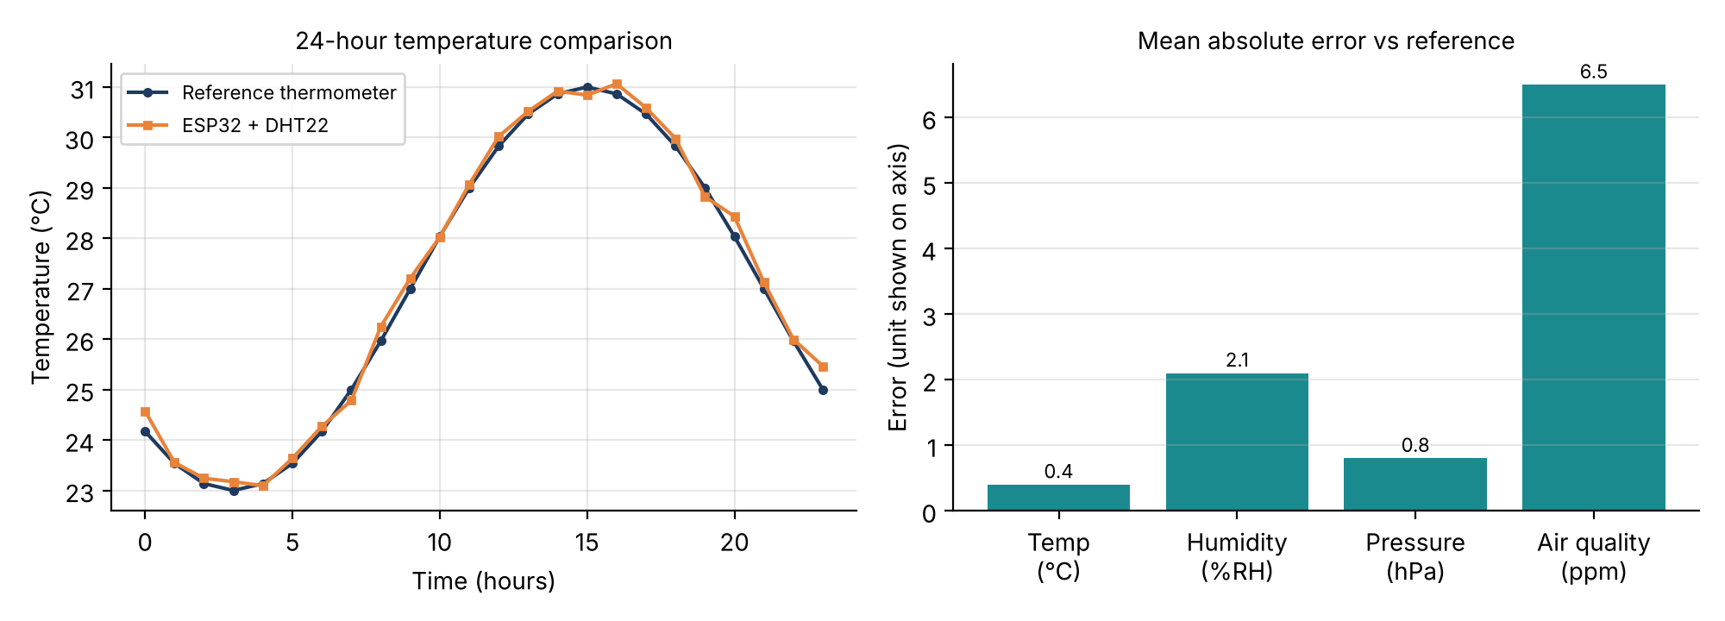
Figure 4: TEMPERATURE COMPARISON AND SENSOR ERROR
Conclusion. The ESP32 node tracked the reference instruments closely, with errors within the sensor datasheet limits. The system ran for 24 hours without a reset, recovered automatically from Wi-Fi loss and used under 80% of flash and about one sixth of RAM, leaving room to add features. The MQ-135 gives relative air-quality trends rather than precise gas concentrations, so its alerts should be treated as indicators.

My learnings

The internship gave me hands-on experience of taking an embedded project from idea to a tested, documented system. My key learnings were:
- Technical: interfacing digital, analog and I2C sensors; ADC behaviour and noise filtering; multitasking with FreeRTOS; Wi-Fi and MQTT communication; and building a dashboard with alerts.
- Engineering practice: reading datasheets, identifying constraints early, designing test cases and measuring results against references.
- Professional skills: planning against a six-week deadline, using GitHub for version control, writing technical documentation and presenting results clearly.
These skills directly support my goal of becoming an embedded hardware and software engineer. The project also gave me confidence that I can independently build connected products, which will help in placements, further projects such as PCB design, and my long-term aim of building technology products.

Future work scope
Due to time limitations, the following ideas could not be implemented but can be taken up in the future:
- Over-the-air (OTA) firmware updates.
- Deep-sleep operation with battery and solar charging for portable and outdoor deployment.
- Additional sensors such as PM2.5 (dust), a true CO₂ sensor and a sound-level sensor.
- Secure communication with MQTT over TLS and device authentication.
- Notifications through mobile apps, e-mail or messaging services.
- Local data logging on an SD card and edge analytics for anomaly detection and prediction.
- A custom PCB and enclosure to replace the breadboard prototype.
- Multi-node networks using ESP-NOW or LoRaWAN for larger areas.

