SIADS 696 Milestone II Project Report - Team 06

Project name: Do Tumor-infiltrating Immune Cell Proportions Improve Three-year Overall Survival Prediction Beyond Clinical Variables in Kidney Renal Clear Cell Carcinoma (KIRC)?
Team member: Qunshan Jia, Fang Yuan, Affan Atif

1. Introduction:
Kidney Renal Clear Cell Carcinoma (KIRC) is a common type of kidney cancer. Clinical variables such as age, pathologic stages, and histological grade are commonly used to estimate patient prognosis. However, patients with similar clinical characteristics may still have different survival outcomes. This suggests that biological information from the tumor microenvironment may provide additional information about patient risk.
Tumor-infiltrating immune cells are an important part of the tumor microenvironment. Some immune cells may support an antitumor response, while others may contribute to immune suppression and tumor progression. Previous studies have used CIBERSORT to estimate immune cell proportions from tumor gene-expression data and have reported relationships between several immune cell types and survival in renal cell carcinoma (Zhang et al., 2019; Pan et al., 2020). However, an immune feature associated with survival may not necessarily improve patient-level prediction after established clinical variables are considered.
The main question of this project is whether tumor-infiltrating immune cell proportions improve the prediction of three-year overall survival in KIRC beyond established clinical variables. Answering this question may help evaluate whether transcriptome-based immune estimates provide useful information for patient risk assessment. Even if immune features do not improve prediction, this result can still help explain the practical value and limitations of transcriptome-based immune estimates.
We combined The Cancer Genome Atlas (TCGA) clinical and survival information with CIBERSORT estimates of 22 immune cell populations. The supervised learning analysis compared four feature representations: clinical only, immune only, clinical plus immune, and clinical plus PCA-transformed immune features. Logistic Regression, Support Vector Machine, and Random Forest represented three different model families. Five-fold nested stratified cross-validation was used for evaluation, with three-fold inner cross-validation for hyperparameter tuning. The same patients and outer folds were used for all feature representations. All imputation, scaling, categorical encoding, and PCA steps were fitted only within the training folds. In the unsupervised analysis, immune cell proportions were used to identify major immune patterns and possible patient subgroups. Clinical variables and survival outcomes were not used to create or select the clusters, but were used later to describe the identified groups.
Compared with earlier studies, we focused on the direct evaluation of whether CIBERSORT immune cell proportions provide predictive information beyond routine clinical variables. The clinical-only and clinical-plus-immune models used the same patients and cross-validation folds, allowing a direct comparison between the two feature sets. The unsupervised analysis provided a second view of the data by examining whether patients could be separated into stable immune subgroups.
The supervised analysis showed that the clinical-only Random Forest achieved the highest mean ROC-AUC of 0.805 ± 0.048. Adding the original immune features reduced the mean ROC-AUC for all three model families. PCA improved some models compared with the original immune representation, but it did not outperform the clinical-only models. Therefore, the CIBERSORT immune-cell proportions did not provide consistent additional predictive value beyond the selected clinical variables. The unsupervised analysis identified two overlapping immune groups rather than tight subgroups. One group had higher CD8 T-cell proportions and more advanced stage and grade, and the other had higher M2 macrophage proportions and more stage I tumors. The groups did not differ in overall survival.

2. Related Work:
Zhang et al. (2019) used TCGA gene expression data and CIBERSORT to estimate the proportions of 22 tumor-infiltrating immune cell types in 891 renal cell carcinoma tumors. They examined the relationships between individual immune cell proportions and overall survival using Cox regression. Our project uses similar TCGA and CIBERSORT data, but we focus on patient-level prediction rather than mainly testing individual immune-survival associations. We directly compare clinical-only and clinical-plus-immune models to determine whether immune features provide additional value for predicting three-year survival.
Pan et al. (2020) used TCGA and GEO data to compare immune cell infiltration between KIRC and normal kidney tissues. They examined the associations among immune cells, clinical characteristics, and survival outcomes, but none of the immune cell types remained an independent prognostic factor after established clinical variables were considered. Our project directly compares the predictive performance of four feature sets using the same patients and outer cross-validation folds instead of mainly testing statistical associations.
Zheng et al. (2021) used CIBERSORT and consensus clustering to identify four immune infiltration clusters in KIRC and examined their relationships with patient prognosis. Their study provided a broad description of the immune microenvironment. Our study has a narrower prediction question: whether CIBERSORT immune proportions provide additional predictive value beyond age, sex, stage, and grade for three-year survival.

3. Data Sources:
This project used two publicly available datasets from The Cancer Genome Atlas (TCGA). The TCGA Clinical Data Resource was downloaded from the NCI Genomic Data Commons Pan-Cancer Clinical Data Resource page: https://gdc.cancer.gov/about-data/publications/PanCan-Clinical-2018. It was provided as an Excel workbook (TCGA-CDR-SupplementalTableS1.xlsx). It contains standardized clinical and survival information for more than 11,000 patients across 33 TCGA cancer types (Liu et al., 2018). After selecting records with a cancer type of KIRC, 537 clinical patients remained. Important clinical variables included age, sex, pathologic stage, histological grade, overall survival status, and survival time. Survival time was measured in days.The immune data were downloaded from the NCI Genomic Data Commons PanImmune page: https://gdc.cancer.gov/about-data/publications/panimmune. It was provided as a tab-separated file (TCGA.Kallisto.fullIDs.cibersort.relative.tsv). The PanImmune project analyzed immune characteristics across 33 TCGA cancer types (Thorsson et al., 2018) and contained 11,373 samples and 27 variables. The CIBERSORT file used in this project contained relative proportions for 22 immune cell populations and three quality measures: P-value, correlation, and root mean squared error (RMSE). After selecting KIRC records, 618 immune samples remained.
The two datasets were matched by TCGA patient ID. After the patient- and sample-level processing described in the next section, 533 patients had matched clinical and immune information. Among these patients, 404 had a known three-year survival outcome and were used for supervised learning. The supervised cohort included 111 patients who died within three years and 293 patients who survived for at least three years.

4. Feature Engineering:
The clinical and immune datasets were first limited to KIRC records. The TCGA sample barcode was standardized by replacing periods with hyphens. The first three barcode sections were used to create the patient ID, and the sample-type code was extracted from the barcode. Only samples with code 01, which represents primary tumor tissue, were retained. This step produced 545 primary tumor samples from 533 unique patients.
For patients who had more than one primary tumor sample, only one sample was selected without using clinical outcomes. Samples were ranked by lower CIBERSORT p-value, lower RMSE, and higher correlation. Sample ID was used as a final tie-breaker. Survival information was not used during this selection process.
The clinical and immune datasets were then joined by patient ID using an inner merge. The merge was validated as a one-to-one match. The resulting dataset contained 533 unique patients, and no patient appeared more than once.
The clinical variables were examined for actual missing values and text values that represented unavailable information. The values “Not Available”, “Discrepancy”, and “GX” were converted to missing values. Age, overall survival status, and overall survival time were converted to numeric variables, with invalid entries converted to missing values. In the final supervised cohort, age , sex and 22 immune cell proportions had no missing values. The pathologic stage had 1 missing value, and the histological grade had 5 missing values. Missing values were not filled before cross-validation. Within each training fold, numerical variables were imputed using the median, while categorical variables were imputed using the most frequent value.
A three-year cutoff was defined as 1,095 days. Patients with OS = 1 and OS.time less than or equal to 1,095 days were labeled as dying within three years (survival_3y = 0). Patients whose observed survival or follow-up time equaled or extended beyond 1,095 days were labeled as surviving for at least three years (survival_3y = 1). Patients who did not meet either rule were excluded from supervised learning because their three-year status could not be determined without making assumptions about their later outcome. This process resulted in 404 patients with a valid binary outcome. The OS and OS.time variables were used only to construct the outcome and were not included as prediction features.
Patient ID, sample ID, cancer type, sample type, overall survival status, overall survival time, and the CIBERSORT quality measures were not used as prediction features. This prevented the models from using patient identifiers, sample metadata, or variables that directly defined the outcome.
Four feature representations were evaluated. The clinical-only representation contained four original variables: age, sex, pathologic stage, and histological grade. The immune-only representation contained the 22 CIBERSORT immune-cell proportions. The clinical-plus-immune representation contained all 26 original variables. The PCA representation retained the clinical variables and replaced the 22 immune variables with principal components explaining 90% of the immune-feature variance.
All preprocessing was included inside the modeling pipelines. Categorical variables were one-hot encoded, and numerical variables were standardized. When PCA was used, scaling and PCA were fitted only on the training data. Therefore, information from the outer test folds was not used during preprocessing or model training.
Figure 1 shows that the survival outcomes were imbalanced. The proportion of patients who died within three years generally increased at higher pathologic stages and histologic grades.
Figure 2 shows that several immune cell proportions were moderately or strongly correlated. This correlation suggests that some immune variables may contain overlapping information. The clinical-plus-immune set contained all 32 predictors.

Figure 1: Distribution of clinical characteristics and three-year survival outcomes
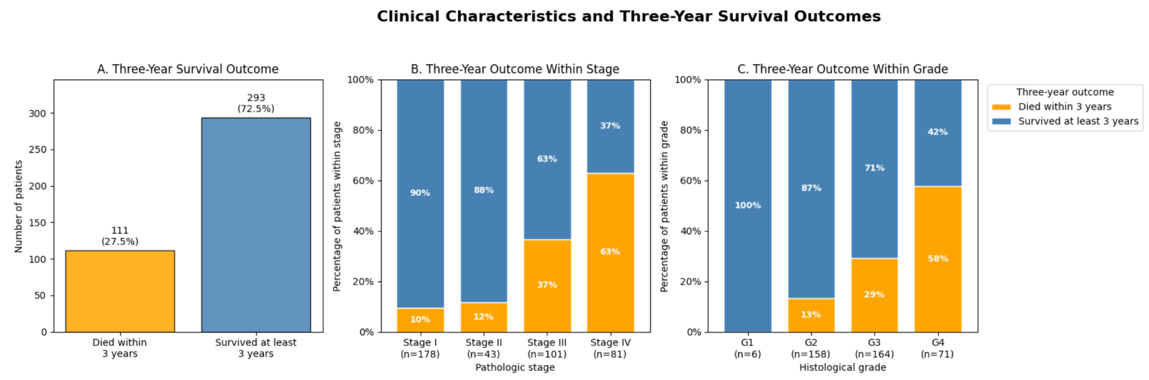

Figure 2: Spearman correlation among the 22 CIBERSORT immune cell proportions
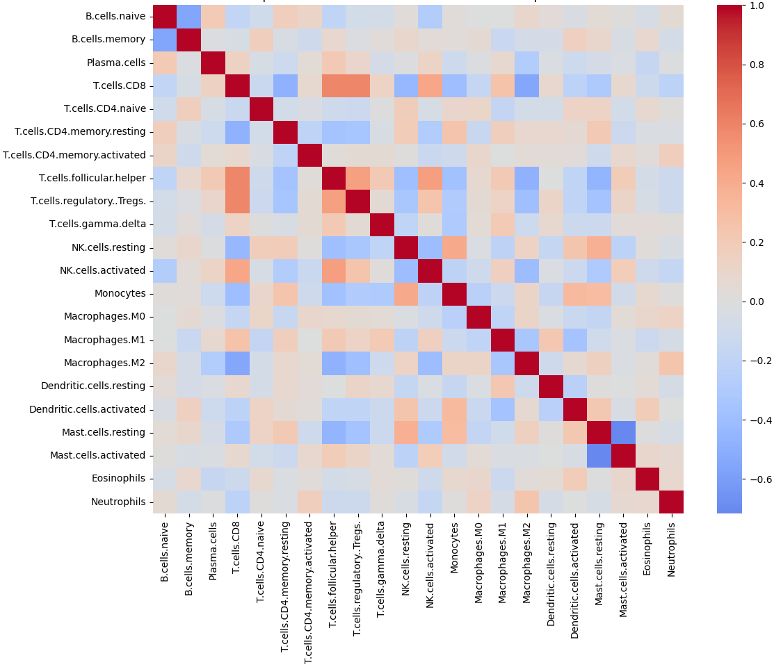
5. Part A: Supervised Learning:
5.1 Methods:
We evaluated three different model families. Logistic Regression was used as a simple and interpretable linear baseline. SVM was selected as a margin-based method that can model linear or nonlinear decision boundaries. Random Forest was selected as a tree-based method that can capture nonlinear relationships and feature interactions.
We used five-fold nested stratified cross-validation. The outer folds were used for evaluation, while three-fold inner cross-validation and GridSearchCV were used for hyperparameter selection. Logistic Regression tested C values of 0.1, 1, and 10. SVM tested the same C values with linear and radial basis function kernels. Random Forest used 300 trees and tested maximum depths of None, 5, and 10 and minimum leaf sizes of 1 and 5. Both no class weighting and balanced class weighting were considered. Hyperparameters were selected using ROC-AUC.

6. Part B: Unsupervised Learning:
6.1 Methods:
The unsupervised analysis used all 533 patients with a matched KIRC primary-tumor immune profile, including patients whose three-year outcome was unknown. Age, sex, stage, grade, and survival were not used to create the features or to choose the number of groups. Three of the 22 CIBERSORT cell types were zero in at least 90% of patients and were removed before clustering: naive CD4 T cells, activated memory CD4 T cells, and eosinophils. The remaining 19 proportions were rescaled so that each patient summed to 1. Remaining zeros were replaced with a small positive value, a centered log-ratio transformation was applied, and the features were standardized. K-means and hierarchical clustering with Ward linkage were fit to these 19 features using Euclidean distance. Each method was run for 2 through 8 groups. The selected solution was the one with the highest silhouette score in which every group contained at least 5% of the patients, or 27 patients. Silhouette, Calinski-Harabasz, and Davies-Bouldin scores were recorded with the group sizes. Stability of the selected k-means solution was assessed with 50 samples of 80% of the patients. In each sample the transformation and k-means fit were repeated, and agreement with the full-data labels was measured by the Adjusted Rand Index. After the groups were fixed, their immune composition, stage, grade, and Kaplan-Meier survival curves were compared. A log-rank test was used for the survival comparison. As specified in the proposal, principal component analysis was also applied to the same 19 standardized features. The smallest number of components explaining at least 80% of the variance was retained, and both clustering methods were repeated on those scores.
6.2 Results:
Both methods selected two groups, but the separation was weak. K-means assigned 301 patients to one group and 232 to the other. The silhouette score was 0.127, the Calinski-Harabasz score was 75.8, and the Davies-Bouldin score was 2.56. Solutions with four or more groups left at least one group below the 5% size rule. Hierarchical clustering assigned 313 and 220 patients to the two groups and had a silhouette score of 0.113. Its three-group solution had a silhouette score of 0.121, but one group contained only 14 patients and was rejected. The Adjusted Rand Index between k-means and hierarchical clustering was 0.64, and 54 patients were assigned to different groups. The 50 repeated samples agreed with the full k-means labels at a mean Adjusted Rand Index of 0.93 (minimum 0.75). The two-group division was reproducible, but the patients overlapped rather than forming two tight groups.
The two methods described the same immune pattern. One group was higher in CD8 T cells, and the other was higher in M2 macrophages. In the k-means solution, the larger group was 6.0 percentage points above the cohort mean for CD8 T cells and 3.5 points below the mean for M2 macrophages. The smaller group was 7.8 points below the mean for CD8 T cells and 4.5 points above the mean for M2 macrophages. The CD8-higher group contained more stage IV tumors (60 of 301, 19.9%) and more grade 4 tumors (57 of 301, 18.9%). The macrophage-higher group contained more stage I tumors (138 of 232, 59.5%) and fewer grade 4 tumors (19 of 232, 8.2%). Stage and grade differed between the k-means groups (chi-square p = 0.0004 for stage and p < 0.001 for grade). Overall survival did not differ. The k-means log-rank p-value was 0.34, and the median survival times were 7.7 and 7.5 years. The hierarchical log-rank p-value was 0.31. One hierarchical group had a median survival of 7.6 years, and the median was not reached in the other group.
The PCA check kept 10 components, which explained 80.4% of the variance. K-means on the PCA scores again selected two groups, with 298 and 235 patients and a silhouette score of 0.151. Five patients changed groups relative to k-means on the original 19 features (Adjusted Rand Index 0.96). Hierarchical clustering on the PCA scores also selected two groups, with 305 and 228 patients, and 42 patients changed groups (Adjusted Rand Index 0.71). The proposal's PCA step did not change the main finding. The immune profiles form a weak gradient that tracks tumor stage and grade. They do not identify survival-defined subgroups.
Figure 3 shows the k-means silhouette score for 2 through 8 groups. The score is highest at 2 groups and then falls. Gray points are solutions in which one group had fewer than 5% of patients.
Figure 3: K-means silhouette scores on the 19 immune features
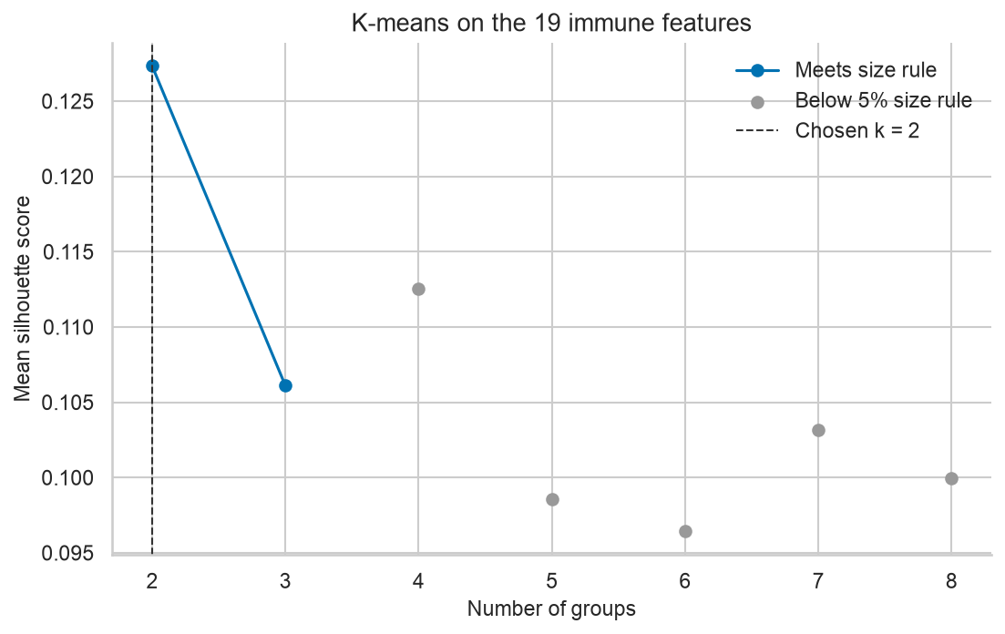
Figure 4 shows how each k-means group differs from the average immune profile. Group 1 is higher in CD8 T cells. Group 2 is higher in M2 macrophages.
Figure 4: K-means difference from the average immune profile
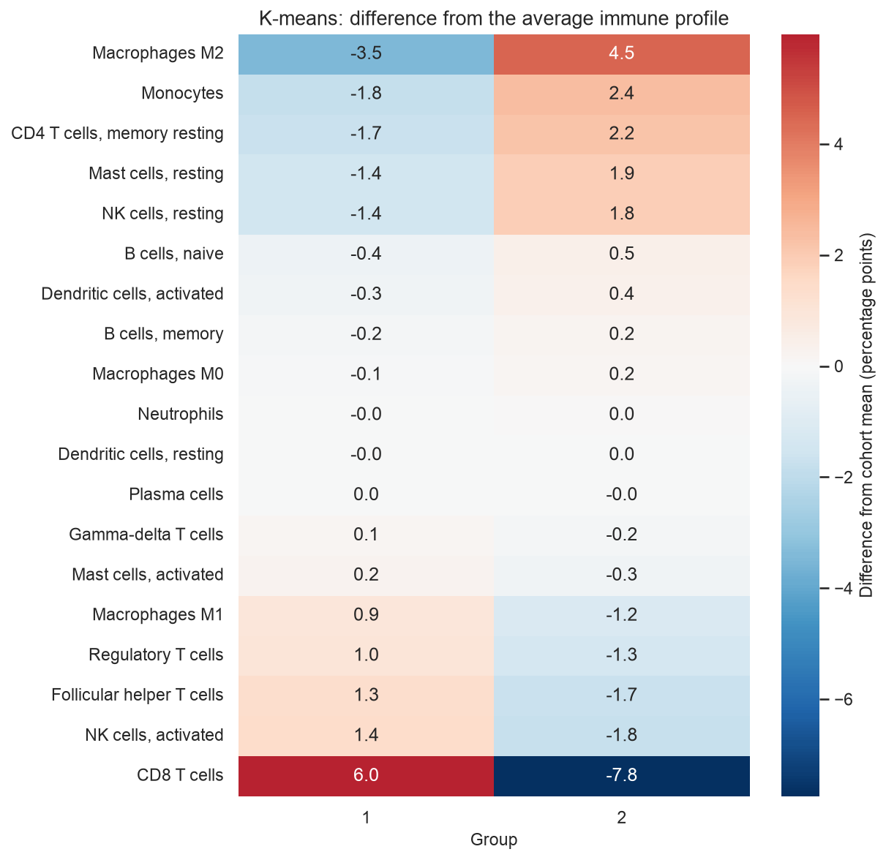
Figure 5 shows the Kaplan-Meier curves for the k-means groups. The curves stay close. The log-rank p-value is 0.343.
Figure 5: Kaplan-Meier overall survival for the k-means groups
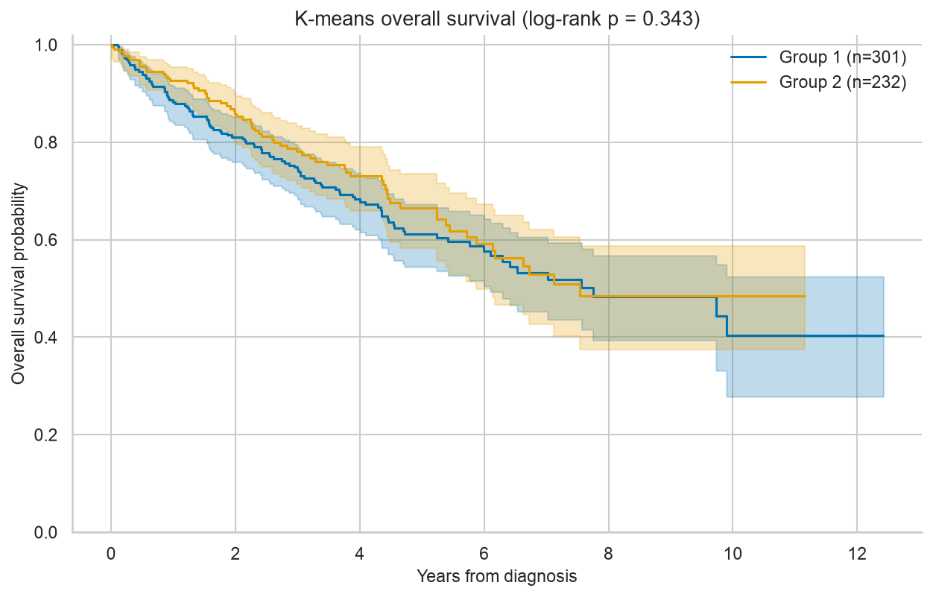
7. Discussion:

8. Ethical Consideration:

9. Statement of Work:
Qunshan Jia:
Fang Yuan:
Affan Atif:

10. References:
1, Zhang, S., Zhang, E., Long, J., Hu, Z., Peng, J., Liu, L., Tang, F., Li, L., Ouyang, Y., & Zeng, Z. (2019). Immune infiltration in renal cell carcinoma. Cancer Science, 110(5), 1564–1572.

2, Pan, Q., Wang, L., Chai, S., Zhang, H., & Li, B. (2020). The immune infiltration in clear cell renal cell carcinoma and their clinical implications: A study based on TCGA and GEO databases. Journal of Cancer, 11(11), 3207–3215.

3, Zheng, Y., Wen, Y., Cao, H., Gu, Y., Yan, L., Wang, Y., Wang, L., Zhang, L., & Shao, F. (2021). Global characterization of immune infiltration in clear cell renal cell carcinoma. OncoTargets and Therapy, 14, 2085–2100.

4, Liu, J., Lichtenberg, T., Hoadley, KA., Poisson, LM., Lazar, AJ., Cherniack, AD., Kovatich, AJ., Benz, CC., Levine, DA., Lee, AV., Omberg, L., Wolf, DM., Shriver, CD., Thorsson, V., Cancer Genome Atlas Research Network, & Hu, H. (2018). An integrated TCGA Pan-Cancer Clinical Data Resource to drive high-quality survival outcome analytics. Cell, 173(2), 400–416.e11.

5, Thorsson, V., Gibbs, DL., Brown, SD., Wolf, D., Bortone, DS., Ou Yang, T.-H., Porta-Pardo, E., Gao, GF., Plaisier, CL., Eddy, JA., Ziv, E., Culhane, AC., Paull, EO., Sivakumar, IKA., Gentles, AJ., Malhotra, R., Farshidfar, F., Colaprico, A., Parker, JS., Mose, LE., Vo, NS., Liu, J., Liu, Y., Rader, J., Dhankani, V., Reynolds, SM., Bowlby, R., Califano, A., Cherniack, AD., Anastassiou, D., Bedognetti, D., Mokrab, Y., Newman, AM., Rao, A., Chen K., Krasnitz, A., Hu, H., Malta, TM., kNoushmehr, H., Pedamallu, CS., Bullman, S., Ojesina, AI., Lamb, A., Zhou, W., Shen, H., Choueiri, TK., Weinstein, JN., Guinney, J., Saltz, J., Holt, RA., Rabkin, CS., The Cancer Genome Atlas Resarch Network, Lazar, AJ., Serody, JS., Gemicco, EG., Disis, ML., Vincent, BG., & Shmulevich, I. (2018). The immune landscape of cancer. Immunity, 48(4), 812–830.e14.

Failure Analysis of the Logistic Regression Model
To better understand the limitations of our machine learning model, we conducted a failure analysis by examining incorrectly classified samples and identifying the features that contributed most strongly to these predictions. False positive and false negative cases were analyzed separately, and feature contributions were compared between correctly and incorrectly classified samples to identify potential patterns associated with prediction errors.
The Logistic Regression model was evaluated using a held-out test dataset consisting of 80 patient samples. A total of 14 samples were incorrectly classified, including 4 patients who were incorrectly predicted to die within three years (false negatives) and 11 patients who were incorrectly predicted to survive (false positives). The classification results are summarized in Table 1.

Table 1 Total failure cases for failure analysis

Attachement1

Priority Analysis
To estimate the potential impact of future improvements on model performance, the held-out test dataset was divided into four patient subgroups based on clinical characteristics and feature distributions. Group 1 included patients aged 70 years or older, while Group 2 consisted of patients diagnosed with AJCC Stage IV cancer. Group 3 included patients with unusual immunological measurements, defined as having at least one immune-cell feature outside the 10th–90th percentile range of the training data. Group 4 consisted of patients with extreme feature values, defined as having at least three numerical features outside the 1st–99th percentile range of the training data.
For each subgroup, the number of incorrectly classified patients was calculated, along with the percentage of the entire test dataset represented by these errors, using the following formula:

$PercentofTestData=\frac{IncorrectPatientsinGroup}{AllTestPatients}×100$

The subgroup failure analysis revealed that patients with unusual immune-cell measurements accounted for the largest proportion of incorrect predictions, representing 13.58% of the entire test dataset. Patients aged 70 years or older accounted for an additional 8.64% of the test dataset through incorrect predictions. Interestingly, no patients met the predefined criteria for extreme feature values, suggesting that this category did not contribute to the observed prediction errors under the current definition.
These findings highlight several potential directions for improving model performance. One possible improvement is to enhance the accuracy, completeness, and representation of immunological measurements. Although immune-cell parameters are biologically relevant to cancer progression and survival, the current dataset may not fully capture the complexity of immune responses within the tumor microenvironment. Obtaining more comprehensive immunological data could potentially improve predictive performance; however, collecting additional biological measurements is beyond the scope of the present study. Furthermore, because patients with unusual immune-cell measurements represented a large proportion of the test dataset, additional analysis is needed to determine whether these measurements are specifically associated with increased prediction errors.
Another potential area for improvement involves the relationship between patient age and immune-system function. Aging is generally associated with changes in immune regulation, including immunosenescence and chronic low-grade inflammation. These changes may influence tumor progression and patient survival in complex ways. For example, excessive or dysregulated inflammatory responses may contribute to unfavorable clinical outcomes, while insufficient antitumor immune activity may reduce the body's ability to control tumor progression. Importantly, these processes are not exclusive to older patients, as variations in immune function among younger individuals may also influence cancer prognosis.
Therefore, the interaction between age, immunological characteristics, and cancer prognosis warrants further investigation. Future studies could examine age-dependent immune-cell patterns and incorporate interaction terms between age and immunological parameters into predictive models. Such analyses may help determine whether these relationships contribute to prediction errors and whether improved feature representation could enhance the model's ability to predict three-year survival outcomes.
Table The grouped features impact on model failure

index | Grouped Features | Affected Patients | % of Test Data | Priority
1 | Group with unusual immune-cell values | 11 | 13.58 | High
2 | Group with age > 70 + | 7 | 8.64 | Medium
0 | Group with Stage IV patients | 5 | 6.17 | Medium
3 | Group with unusual records | 0 | 0.0 | Low

Feature selection and model performance
Next step we want to understand which specific feature will contribute more to the model failure in prediction. Logistic Regression coefficients indicate the direction and strength of each feature's association with the predicted outcome. For individual patients, feature contributions can be calculated by multiplying the standardized feature values by their corresponding model coefficients.
Although feature contributions do not directly establish the underlying causes of prediction errors, analyzing these contributions in misclassified samples can provide valuable insights into potential sources of model failure. By identifying features that strongly influence incorrect predictions, this analysis can help reveal patterns associated with misclassification, guide further investigation into possible root causes, and identify opportunities for improving feature representation and model performance.

Figure 2 Top five features push your Logistic Regression model toward predicting death in failure cases . 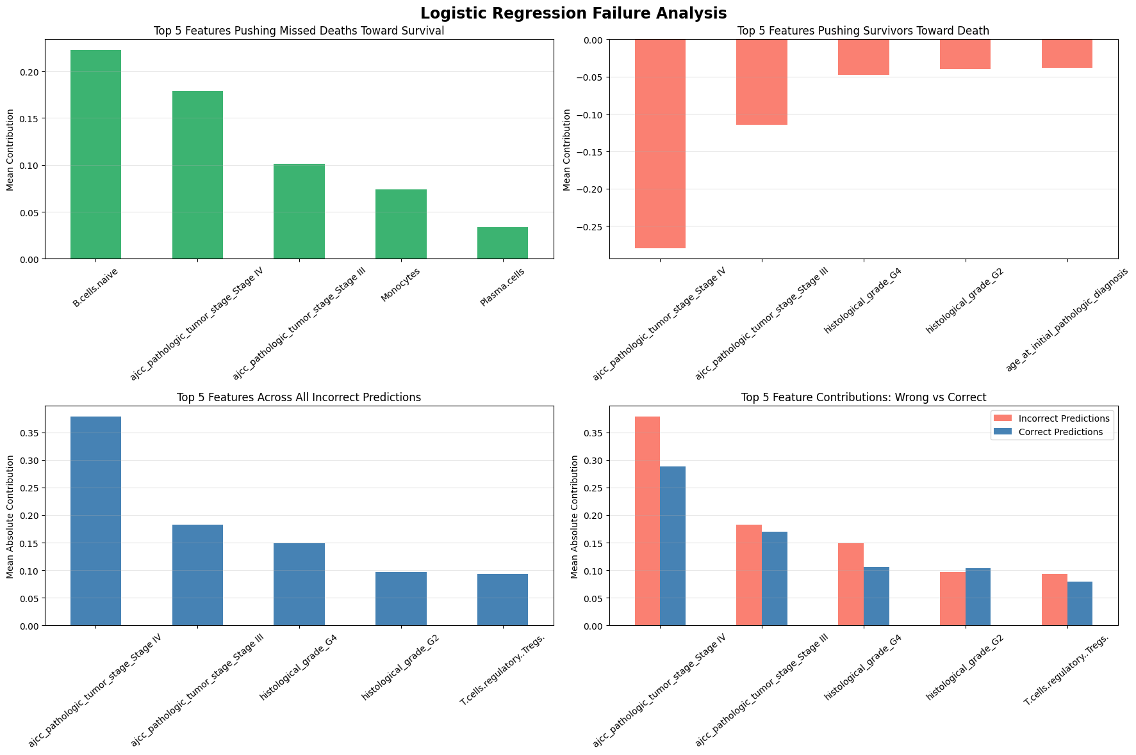

Our analysis revealed different patterns of feature contributions between false positive and false negative predictions.

In false positive cases, B-cell features, AJCC pathological tumor stage, monocytes, and plasma cells were among the strongest contributors to the model's predictions. These findings suggest that the model relies substantially on both clinical staging information and immune-cell characteristics when making predictions for these patients.
B cells, monocytes, and plasma cells are components of the immune system and may reflect different aspects of the tumor immune microenvironment. Their prominent contributions suggest that immune-related features play an important role in the model's decision-making process. However, their influence may not always correspond to the patient's actual survival outcome. This could reflect complex biological relationships, interactions among immune-cell populations, or limitations in the model's ability to capture these relationships.
In false negative cases, AJCC pathological tumor stage, histological grade, and other pathological features were the most influential predictors. AJCC stage describes the anatomical extent of cancer, while histological grade reflects the degree of cellular abnormality and can provide information about tumor aggressiveness.
The strong contributions of these features indicate that the model relies heavily on established clinical indicators when predicting survival outcomes. However, the presence of incorrect predictions suggests that these features alone may not fully capture differences in individual patient outcomes. Patients with similar tumor stages or histological grades may experience different survival outcomes due to additional biological, clinical, or treatment-related factors.

Comparison Between Incorrect and Correct Predictions
An important observation from our failure analysis was that AJCC pathological tumor stage, histological grade, and T-cell-related features exhibited larger contributions in incorrectly classified samples than in correctly classified samples.
This suggests that these features have a particularly strong influence on the model's decisions in cases where its predictions are unsuccessful.
One possible explanation is that the model may place substantial weight on certain clinical and immune-related characteristics while failing to adequately account for other relevant factors. For example, although advanced tumor stage is generally associated with poorer prognosis, survival outcomes can vary among patients within the same stage. Similarly, immune-cell characteristics may have different prognostic implications depending on the broader tumor microenvironment.
Another possible explanation is that the relationships between these features and survival outcomes are nonlinear or involve interactions. Logistic Regression models the log-odds of survival as an additive function of the input features unless nonlinear terms or interactions are explicitly included. Consequently, the model may have difficulty representing complex relationships between tumor stage, histological grade, and immune-cell composition.
The larger feature contributions observed in incorrect predictions do not necessarily mean these features are unreliable or directly responsible for the errors. Rather, they indicate that the model's decisions are strongly influenced by these features in certain challenging cases. Further analysis is needed to determine whether these patterns are associated with specific patient subgroups, feature interactions, or differences in data distribution.

Implications for Model Improvement
The findings from this failure analysis suggest several potential directions for improving model performance.
First, additional investigation of AJCC stage and histological grade may help determine whether prediction errors are concentrated in particular disease stages or tumor grades. Evaluating model sensitivity, specificity, and error rates within these subgroups could reveal whether the model performs less reliably for certain patient populations.
Second, the contributions of B cells, monocytes, plasma cells, and T cells suggest that immune-related features deserve further investigation. Because these immune-cell populations may interact with one another and with tumor characteristics, evaluating nonlinear models or incorporating clinically meaningful interaction terms may improve the model's ability to represent these relationships.

Overall, our failure analysis indicates that both clinical pathological characteristics and immune-cell-related features play important roles in the model's incorrect predictions. B cells, monocytes, plasma cells, and AJCC stage were prominent contributors in false positive cases, while AJCC stage, histological grade, and other pathological features were particularly influential in false negative cases.

Based on the current data and failure analysis, it is challenging to attribute prediction errors to a specific category, such as limitations in feature representation or model performance. As an exploratory study, our work investigates the potential relationship between immunological parameters and patient survival outcomes. Although these immune-related features are biologically relevant and may provide valuable prognostic information, it remains unclear whether they are sufficient to capture the complex factors influencing survival. In addition, the relatively small sample size and potentially suboptimal feature selection and representation may limit the model's ability to identify meaningful patterns and interactions among variables. These limitations may also affect model training and predictive performance, making it difficult to distinguish between errors arising from insufficient feature information and those resulting from the model itself. Future work should focus on expanding the dataset, incorporating additional clinically relevant variables, refining feature engineering, and systematically evaluating different modeling approaches to better understand the sources of prediction errors and improve model reliability.

The observation that AJCC stage, histological grade, and T-cell-related features have greater contributions in incorrectly classified samples than in correctly classified samples suggests that the model may struggle to capture the complex relationships among tumor characteristics, immune responses, and patient survival outcomes. These prediction errors may be attributed to several factors, including the relatively small sample size, the limited availability of clinically relevant features associated with survival outcomes, and potentially suboptimal feature selection and grouping. In particular, the current feature representation may not adequately capture interactions among clinical and immune-related variables. Together, these limitations may reduce the model's ability to generalize to unseen patients and contribute to misclassification. Further improvements in data availability, feature engineering, and model optimization may help improve predictive performance and reliability.

