Set boundary conditions 1
Create matrix of boundary conditions 1
Create and fill solution matrix 2
Introduce boundary conditions to matrix 3
Solve matrix 3
Update initial table using solved values 4
Plot surface 4
clc;

Set boundary conditions
% Create nxn 2-D surface
size = 5;
a = zeros(size,size);
% Set temperature of sides
a(1,:) = 100.*ones(size, 1);
a(:,1) = 100.*ones(size, 1);
a(:,size) = 150.*ones(size, 1);
a(size,:) = -150*ones(size, 1);

Create matrix of boundary conditions
% Constants that will be used throughout
c1 = (length(a)-2)^2; % number of nodes
c2 = length(a)-2; % n of nxn solution matrix
c3 = length(a)-3; % Honestly don't need this but it's legacy at this point
% Create and fill boundary matrix using boundary conditions
% See external documentation for justification
boundaries = zeros(c1,4);
% Top
for i = 1:c2
boundaries(i,1) = -a(1, i+1);
end
count = 2;
% Left
for i = (c1-2):c1
boundaries(i,4) = -a(size, count);
count = count + 1;
end
count = 2;
% Right
for i = 1:c3+1:c1
boundaries(i,2) = -a(count, 1);
count = 1+count;
end
count = 2;
% Bottom
for i = 3:c3+1:c1
boundaries(i,3) = -a(count, size);
count = 1+count;
end

Create and fill solution matrix
% Create an nxn solution space
b = zeros(c1, c1);
% Fill in solution matrix. See external documentation for justification
% Repeated throughout
repeat = [1 -4 1];
fillin = [1, zeros(1, c3-1) , repeat, zeros(1, c3-1), 1];
% Fill in top
count1 = round(length(fillin)/2);
count2 = 1;
for j = length(fillin)/2:-1:0
b(count2,:) = b(count2,:) + [fillin(j:length(fillin)), zeros(1, length(b)-count1)];
count2 = count2 + 1;
count1 = count1 + 1;
end
% Fill in middle
count3 = 1;
while count1 < c1
fillin(1:j);
[zeros(1,count3), fillin, zeros(1,length(b)-count1+count3)];
j =length(fillin);
b(count2,:) = b(count2,:) + [zeros(1,count3), fillin, zeros(1,length(b)-count1)];
count2 = count2 + 1;
count1 = count1 +1;
count3 = count3 + 1;
end
% Fill in bottom
for j = length(fillin):-1:length(fillin)/2
fillin(1:j);
b(count2,:) = b(count2,:) + [zeros(1,count3), fillin(1:j)];
count2 = count2 + 1;
count3 = count3 + 1;
end
% Insert zeros to account for sides of surface
for i = c2:c2:length(b)-1
b(i,i+1) = 0;
end
for i = c2+1:c2:length(b)
b(i,i-1) = 0;
end
Warning: Integer operands
are required for colon
operator when used as
index.
Warning: Integer operands
are required for colon
operator when used as
index.
Warning: Integer operands
are required for colon
operator when used as
index.
Warning: Integer operands
are required for colon
operator when used as
index.
Warning: Integer operands
are required for colon
operator when used as
index.

Introduce boundary conditions to matrix
b = [b, ones(c1, 1)];
for i = 1:length(b)-1
b(i,length(b)) = sum(boundaries(i,:));
end

Solve matrix
b
% boundaries
b = rref(b);
b =
-4 1 0 1 0 0 0 0 0 -200
1 -4 1 0 1 0 0 0 0 -100
0 1 -4 0 0 1 0 0 0 -250
1 0 0 -4 1 0 1 0 0 -100
0 1 0 1 -4 1 0 1 0 0
0 0 1 0 1 -4 0 0 1 -150
0 0 0 1 0 0 -4 1 0 50
0 0 0 0 1 0 1 -4 1 150
0 0 0 0 0 1 0 1 -4 0

Update initial table using solved values
c = a;
count = 1;
for i = 1:length(c)-2
for j = 1:length(c)-2
c(i+1,j+1) = b(count, length(b));
count = count + 1;
end
end

Plot surface
c;
s = surf(c)
zlabel('Temperature, Degrees Celsius')
s =
Surface with properties:
EdgeColor: [0 0 0]
LineStyle: '-'
FaceColor: 'flat'
FaceLighting: 'flat'
FaceAlpha: 1
XData: [1 2 3 4 5]
YData: [5×1 double]
ZData: [5×5 double]
CData: [5×5 double]
Use GET to show all properties
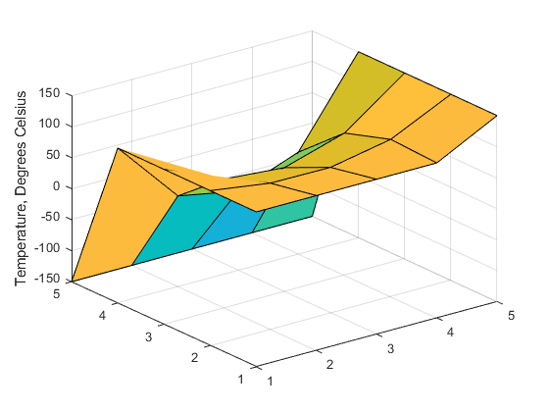
Published with MATLAB® R2020a

