Why Google cloud?
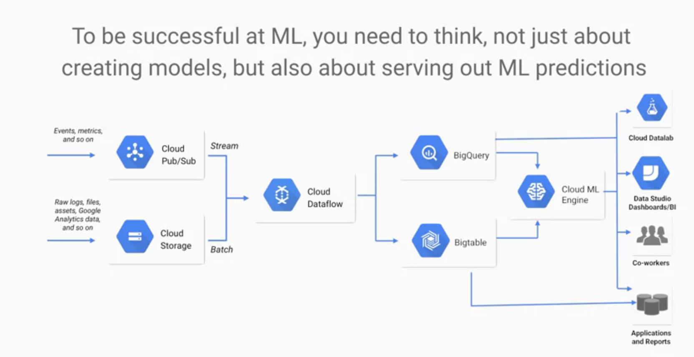
People think that ML is all about training the model but not it is about machine prediction .we serve prediction using dashboards ,application , reports.that is called operationlaizing a machine learning model and it is very hard .google learned that in order to reduce the chances of failure we needed to make sure that we could process batch data and data streaming data the same way. Google use cloud dataoverflow for this purpose .
To be good at ML you should be good at DATA ENGINEERING
IN THIS COURSE WE WILL LEARN ABOUT STREAM AND BATCH PIPELINES
FOLLOW THESE PAGES
https://cloud.google.com/blog/products/ai-machine-learning/who-street-artist-building-graffiti-artist-classifier-using-automl

https://www.blog.google/technology/ai/move-mirror-you-move-and-80000-images-move-you/’

https://cloud.google.com/blog/products/ai-machine-learning

what it means to be AI

the basic difference between AI And machine learning is that AI is a discipline like physics and contain theory and methods on the other hand the machine learning is a toolset like newton law of physics.

Two stages of ML
trained the model with dataset
inference from the model
ML IN GOOGLE PRODUCTS
NEURAL Network consist of hidden layer and each layer is mathmathical function
1n 70 we have neural network with only one layer the reason behind this are
1.computational power deep learning require more power
2.Avalablity of data; more layer more weights to adjust so we require more data
3.computational tricks : deep learning require more time , as they have more layers to train, and it become NAN or zero which blows up the model .now we have tricks and technique to deal with this

in this course we will do recommend problems , sequence problems and image problems
each layer in neural network require more then dozen models
in forcast problem we require many model and even it is different for each product
DEMOS
1.GOOGLE PHOTOS: IMAGE SEARCHING BASED ON CITY
2.Google translate : Contain sequence models

Replacing Heuristic rules:
mchine learining is not about only data , it is about logic.
In past we make rules and do heuristic search on that.now machine learning do that for us.
We just need data and other benfit is it can change rules according to data
its all about data
if you want some coffee and you search . We can give output shops with neraest distance
or we can make graph of distance vs user reviews ,service time vs user reviews,and other factor and build optimized algo.

Use Case 1: _____________
If the use case was an ML problem....
1) What is being predicted?
2) What data is needed?
Now imagine the ML problem is a question of software:
3) What is the API for the problem during prediction?
For API WILL WILL BE THINK IN TERMS OF END USER
4) Who will use this service? How are they doing it today?
GSM ARENA OR T
Lastly, cast it in the framework of a data problem. What are some key actions to collect, analyze, predict, and react to the data/predictions (different input features might require different actions)
5) What data are we analyzing?
END USER DATA + DATA WE NEED TO CLLOECT OURSELES
6) What data are we predicting?

7) What data are we reacting to?

PreTrained Model
Vision API: to find text in memes
Speech API :
JOBS API
TRANSLATION API
NLP API: We can use it for chat bot to route
VIDEO INTELIGENCE API
.In this specilization we build custom machine learning model
A Data strategy
data always wins,
means if you have option complex model vs data choose data
for model is just logic which would give better result if we have more data.
How to get started machine learining?
Select the use case for which you are doing manual analysis today then implement mahine learnig on that analysis.Reasons behind this are:
Number one .if you have the data already means you dont need to collect data , because that is most difficult part.
Number two:manual analysis helps you fall fast ,try new ideas.so don’t skip analysis part’
Number three:To build the machine learining model , you need to know your data.
Number four:For
training-serving skew : unless the data is not same as during traning the model will be fall eg you are using batch data to train and then using that model for streaming data.for this cloud Data Overflow used.
Traning should scale to handle a lot of data.
Predication should scale to handle large no of queries per second.
ML Strategy
1.if you are building new model .you will fail fast.
2.most of the data are unstructured . So use ML API to convert it to standard form ,then use it to create custom data model.

ML surpise:
defining KPI
COLLECTING DATA
Building Infrastructure
Optimizing ML algorithm require very much efforr but actually right data take much time
Integration

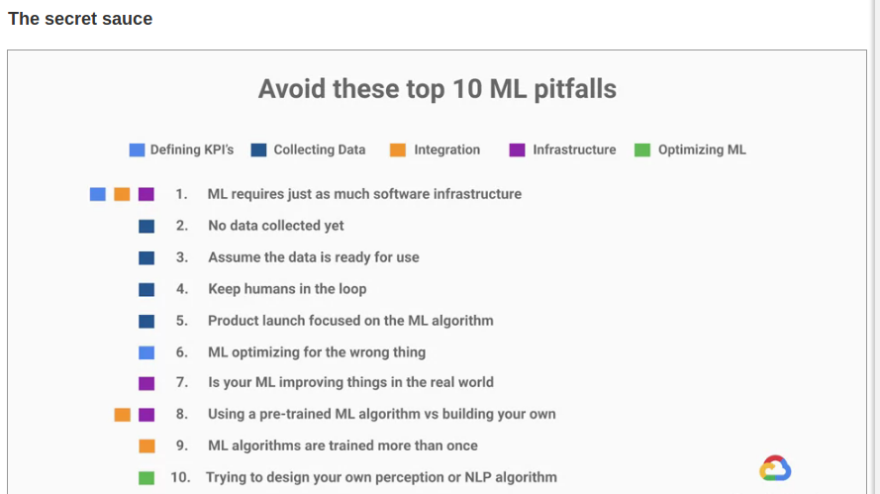
ML BUSINESS PROCESS:

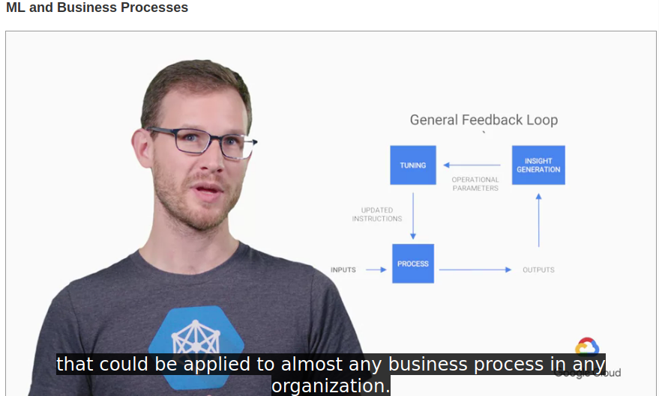

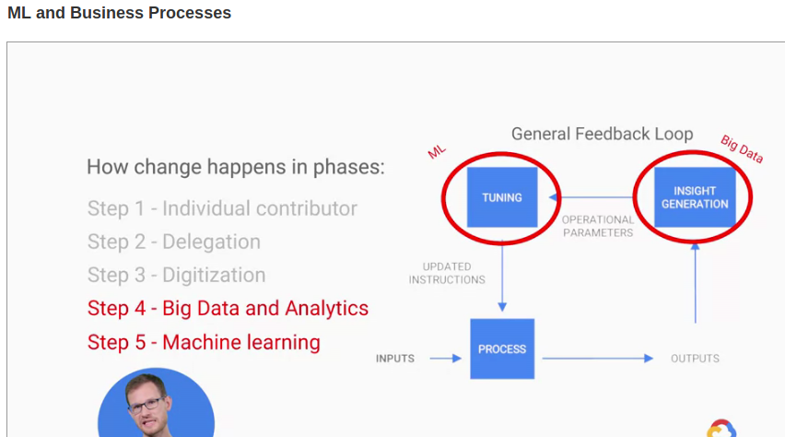
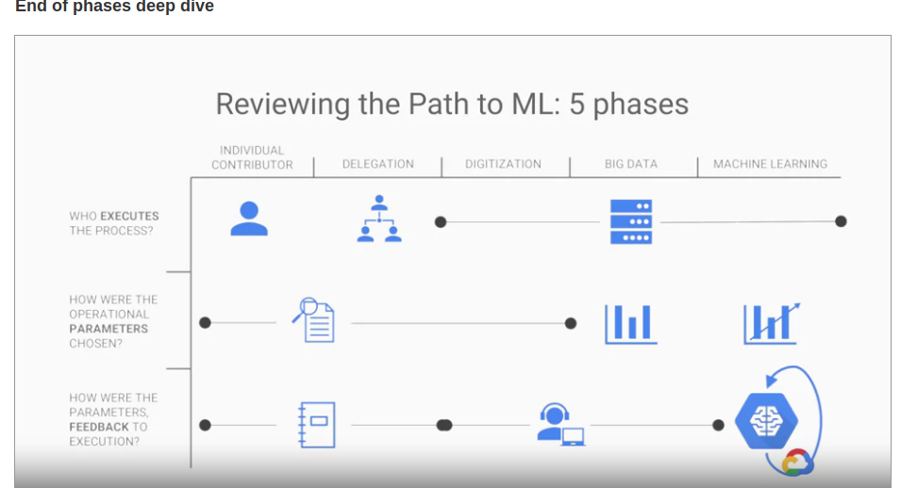
USING SOFTWARE

MARKET RESARCH

EMPLOYEE HANDBOOK

SERVERS OR MAIINLY CLOUD GRAPH GOOGLE
CLOUD
These are the path which should be perform when we are implemented in organisation .which should be perform sequentially .

Key aspect of machine learning strategy is how to build machine learning in an inclusive way means how fair and inclusive your model treated your users
machine learning and human bias
sometimes machine become bias due to data eg if we give data of physicsis and all physicsts are men then it become bias towards data . So for this google take suggestion of inapproiatiate
Evaluating metrics for inclusion
It's important to understand what these errors look like and how they might
affect the user experience that's driven by the output of your machine learning model.
But with respect to making machine learning more inclusive, we tend to really
focus on the false positive rates as well as the false negative rates in order to
get a sense of how adversely affected a subgroup might be performing.

So we use confusion metrics which determine error with different subgroups
eg four category are true predict true label ,
false predict true label, true false , false false
suppose label is face detection

evaluation metrics can help highlights areas where machine learning could be more inclusive
eg spam detection . And it is also depend what is more acceptable to us
False positive rate (α) = type I error = 1 − specificity = FP / (FP + TN) = 180 / (180 + 1820) = 9%
- False negative rate (β) = type II error = 1 − sensitivity = FN / (TP + FN) = 10 / (20 + 10) = 33%
- True positive rate (TPR), Recall, Sensitivity, probability of detection = Σ True positive/Σ Condition positive
- Accuracy (ACC) = Σ True positive + Σ True negative/Σ Total population
- Precision = Σ True positive/Σ Predicted condition positive
For more details, read under Confusion Matrix: https://en.wikipedia.org/wiki/Sensitivity_and_specificity
equality of oppurtunity

we know how to calculate evaluation metrics of a model's predictions across subgroups,
let's talk about an approach that builds on top of these metrics, in order to achieve a better performance across subgroups
equality of approach strives to give indiual an equal chances of disired outcome
eg in bank all users who qualify for a loan have an equal chance
amongst all users of being correctly classified for that loan approval.
Once we find oppurtunity of improvement we can make adjustment
eg credit card good credit score does not mean that they will repay the loan . So there can be thresold of credit score in which maximum accuracy comes
cloud Datalab
when you run the notebook it run on VM . Then you save it in cloud.
Benefit of AI platform notebook:
you edit your computiing instance
easily sharable
Computation and storage:

for persistant data you use Google Cloud storage
compute engine is like GLOBAL CPU
The purpose of Cloud Storage is to give you a durable global file system,
but how is it organized? A typical Cloud Storage URL might
look like gs:acme-sales/data/sales003.csv.The acme-sales, that's called a bucket. The name of the bucket is globally unique.
Gsutil is a sdk tool which hepl to communnicate google cloud

lab : Rent-a-VM to process earthquake data MLGCP
Step1 : create compute engine instance with necessary api access
step2 : install software using ssh
step3: install usgs data
step4 transform data to png
create bucket and store data

In this lab, you will learn how to do the following:
- Create a Compute Engine instance with specific security permissions.
- SSH into the instance.
- Install the software package Git (for source code version control).
- Ingest data into the Compute Engine instance.
- Transform data on the Compute Engine instance.
- Store the transformed data on Cloud Storage.
- Publish Cloud Storage data to the web.
In this specilization we did not create compute engine instead we use managed services file which will take code which have to run and provide compute engine ourselves and install necessary software itself
CloudShell : it is very small compute engine ,we can run few scripts there ,problem it is reclycled very frequently
third way of cloud : eg big data query example in ehcich we just run the query and it automatically managed the infrastructure

Third Wave of Cloud: BigQuery and Cloud Datalab
Bigquery offerss:
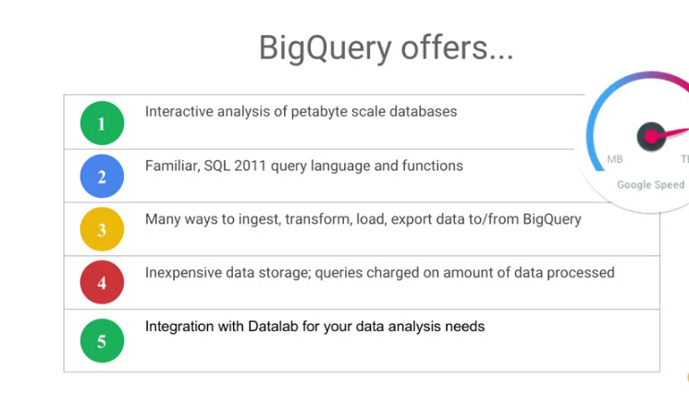

Big query lab:
In this lab, you learned how to carry out data exploration of large datasets using BigQuery, Pandas, and Jupyter. The "trick" is to do the first part of your aggregation in BigQuery, get back a Pandas dataset and then work with the smaller Pandas dataset locally. AI Platform Notebooks provides a managed Jupyter experience, so that you don't need to run notebook servers yourself.

Pre trained API:
Vision API:THIS API allows complex image detection with a single REST API request.across the web and share them on various social channel.gifs use the vision API OCR to extract text from gifs and surface
it allow label detection which will tell you what is this a picture of
allow to serch simmilar image in web
logo detetion ,landmark detection
cloud.google.com/vision/
VIDEO INTELLIGENCE
is an api which lets you understand your video entities at shot frameor video level.
Explict exploit content
or if you search anything anything in group of videos it will show where it is in video.
Cloud speech API
THIS HELP in translation test over 100 lnaguage and finding timestamp where it is present .eg in coursera
if you search anything in some folder it will show in which timestamp this word present in which video

cloud.google.com/speech
cloud.google.com/translation for translation

cloud natural langguage API
understand text .it lets u extract entities from your text ,it can tell whether sentence is positive or negative.
It can detect whether paragarph is about particular topic or not.

