s

SOLUTION MANUALS

Chapter 14

End-of-Chapter Questions
  - Regression Analysis in Finance

Multiple Choice Questions
- Two correlation coefficients are compared: Correlation Coefficient A is 0.83. Correlation Coefficient B is -0.91. Which correlation coefficient represents the stronger linear relationship?
- Correlation Coefficient A
- Correlation Coefficient B
- equal strength
- not enough information to determine
Solution: B
Section 14.1 LO 1 Moderate
- A data set containing 10 pairs of (x, y) data points is analyzed, and the correlation coefficient is calculated to be 0.58. Does this value of $r = 0.58$ indicate a significant or nonsignificant correlation?
- significant
- nonsignificant
- neither significant nor nonsignificant
- not enough information to determine
Solution: B
Section 14.1 LO3 Difficult
- A linear regression model is developed, and for$x = 10$, the corresponding predicted y-value is 22.7. The actual observed value for $x = 10$ is $y = 31.3$. Is the residual for this data point positive, negative, or zero?
- positive
- negative
- zero
- not enough information to determine
Solution: A
Section 14.2 LO 1 Moderate
- A linear model is developed for the relationship between salary of finance professionals and years of experience. The data was collected based on years of experience ranging from 1 to 15. Assuming the correlation is significant, should the linear model be used to predict the salary for a person with 25 years of experience?
- It is acceptable to predict the salary for a person with 25 years of experience.
- A linear model cannot be created for these two variables.
- It is not recommended to predict the salary for a person with 25 years of experience.
- There is not enough information to determine the answer.
Solution: C
Section 14.2 LO 2 Moderate
- Which of the following is the best interpretation for the slope of the linear regression model?
- The slope is the expected mean value of y when the x-variable is equal to zero.
- The slope indicates the change in y for every unit increase in x.
- The slope indicates the strength of the linear relationship between x and y.
- The slope indicates the direction of the linear relationship between x and y.
Solution: B
Section 14.3 LO 2 Moderate
- A linear model is developed for the relationship between the annual salary of finance professionals and years of experience, and the following is the linear model: $\hat{y}=55,000+1,000x$. Which is the correct interpretation of this linear model?
- $slope = 55,000$, $y-intercept = 1,000$
- $slope = 55$, $y-intercept = 1,000$
- s$lope = 1,000$, $y-intercept = 55$
- s$lope = 1,000$, $y-intercept = 55,000$
Solution: D
Section 14.3 LO 2 Easy
- Which of the following is the correct sequence of steps needed to create a linear regression model?
- create scatter plot, calculate correlation coefficient, check for significance, create linear model
- create linear model, calculate correlation coefficient, check for significance, create scatter plot
- check for significance, create linear model, calculate correlation coefficient, create scatter plot
- create scatter plot, check for significance, create linear model, calculate correlation coefficient
Solution: A
Section 14.4 LO 1 Easy
- A linear model is developed for the relationship between the annual salary of finance professionals and years of experience, and the linear model is: $\hat{y}=55,000+1,000x$. The correlation is determined to be significant. Predict the salary for a finance professional with 7 years of experience.
- $55,010
- $60,000
- $62,000
- $125,000
Solution: C
Section 14.5 LO 1 Easy
- As predictions are made for x-values that are further and further away from the mean of x, which is true about the prediction intervals for these x-values?
- The prediction intervals will become smaller.
- The prediction intervals will become larger.
- The prediction intervals will remain the same.
- There is not enough information to determine the answer.
Solution: B
Section 14.5 LO 2 Difficult
- Which of the following is the R command to calculate the correlation coefficient r?
- correl
- cor
- slope
- lm
Solution: B
Section 14.6 LO 1 Easy
- Which of the following is the R command to calculate the slope and y-intercept for a linear regression model?
- cor
- slope
- lm
- intercept
Solution C
Section 14.6 LO 2 Easy

Review Questions
- A correlation coefficient is calculated as -0.92. Provide an interpretation for this correlation coefficient.
Solution: A negative correlation coefficient indicates that when x increases, y tends to decrease and when x decreases, y tends to increase (negative correlation). A correlation coefficient close to -1 indicates a strong negative correlation.
Section 14.1 LO 2 Moderate
- Explain what a residual is and how this relates to the best-fit regression model.
Solution: A residual is the difference between an observed y-value and the predicted y-value obtained from the linear regression equation. When formulating the linear regression line of best fit to the points on the scatter plot, the mathematical analysis generates a linear equation where the sum of the squared residuals is minimized.
Section 14.2 LO 1 Moderate
- Explain how to interpret the slope of the best-fit line.
Solution: The slope of the best-fit line tells us how the dependent variable (y) changes for every one unit increase in the independent (x) variable, on average.
Section 14.3 LO 2 Moderate
- Explain how to generate a prediction using a linear regression model.
Solution: To generate predictions or forecasts using the linear regression model, substitute the value of the independent variable (x) in the regression equation and solve the equation for the dependent variable (y).
Section 14.5 LO 1 Easy
- Will the sign of the correlation coefficient always be the same as the sign of the slope of the best-fit linear regression model?
Solution: Yes. If the correlation is positive, then the slope of the regression line will be positive,
and if the correlation is negative, then the slope of the regression line will be negative.
Section 14.5 LO 2 Moderate

Problems
- A Fortune 500 company is tracking revenues versus cash flow for recent years, and the data is shown in the table below. Consider cash flow to be the dependent variable. Create a scatter plot of the data set, comment on the correlation between these two variables, and comment on the correlation for this data (all dollar amounts are in thousands).
Revenues ($000s) | Cash Flow ($000s)
237 | 82
241 | 86
229 | 77
284 | 94
307 | 93
Table 14.9
Solution: The scatter plot can be created using Excel or R, and the scatter plot is shown below:
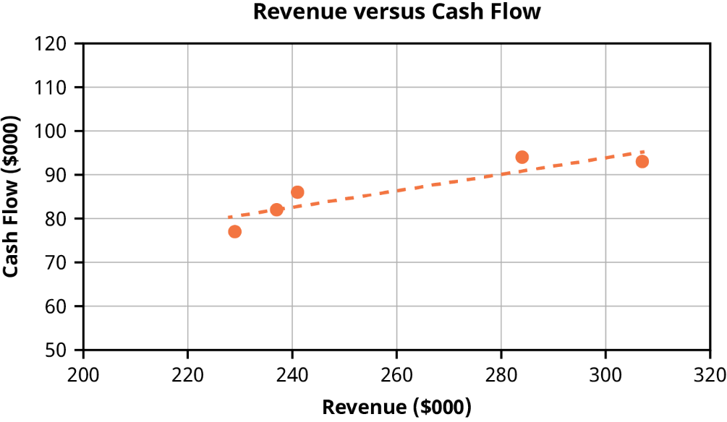
From the scatter plot, the correlation is categorized as strong positive linear correlation.
Section 14.1 LO 1 Moderate
- A Fortune 500 company is tracking revenues versus cash flow for recent years, and the data is shown in the table below. Consider cash flow to be the dependent variable. Calculate the correlation coefficient for this data (all dollar amounts are in thousands).
Revenues ($000s) | Cash Flow ($000s)
237 | 82
241 | 86
229 | 77
284 | 94
307 | 93
Table 14.10
Solution: Using the CORREL command in Excel, the cor command in R, or a calculator, the correlation coefficient is 0.907. This correlation coefficient indicates strong positive correlation.
Section 14.1 LO 1 Moderate
- A chief financial officer calculates the correlation coefficient for bond prices versus interest rate as -0.71. The data set contained nine (x, y) data points. Determine if the correlation is significant or not significant at the 0.05 level of significance.
Solution:
Using the guideline$\left| r \right|≥ \frac{2}{\sqrt{n}}$ , the absolute value of r is 0.71 and the calculation for $\frac{2}{\sqrt{n}} r$esults in 0.667. Since the absolute value of r is greater than the value of $\frac{2}{\sqrt{n}}$, the conclusion is that the correlation is significant.
Section 14.1 LO 3 Difficult
- A Fortune 500 company is tracking revenues versus cash flow for recent years, and the data is shown in the table below. Consider cash flow to be the dependent variable. Determine the best-fit linear regression equation for this data set (all dollar amounts are in thousands).
Revenues ($000s) | Cash Flow ($000s)
237 | 82
241 | 86
229 | 77
284 | 94
307 | 93
Table 14.11
Solution: Using the SLOPE command in Excel, the lm command in R, or a calculator, the slope of the best-fit line is calculated as 0.193. Using the INTERCEPT command in Excel, the lm command in R, or a calculator, the y-intercept of the best-fit line is calculated as 36.400. The equation of the best-fit line is as follows:
$$\hat{y}=a+bx$$
$$\hat{y}=36.400+0193x$$
Section 14.3 LO 1 Moderate
- A Fortune 500 company is tracking revenues versus cash flow for recent years, and the data is shown in the table below. Consider cash flow to be the dependent variable. Assume the correlation is significant. Predict the cash flow for company revenues of $250,000 (all dollar amounts are in thousands).
Revenues ($000s) | Cash Flow ($000s)
237 | 82
241 | 86
229 | 77
284 | 94
307 | 93
Table 14.12
Solution: The equation of the best-fit line is as follows:
$$\hat{y}=a+bx$$
$$\hat{y}=36.340+0193x$$
To predict cash flow for revenues of $250,000 replace “x” with 250 in the best-fit linear equation and solve for $\hat{y}.$
$$\hat{y}=36.340+0193(250)$$
$$\hat{y}=84.65$$
This indicates that the predicted cash flow is $84,650 for revenues of $250,000.
Section 14.5 LO 1 Moderate
- A Fortune 500 company is tracking revenues versus cash flow for recent years, and the data is shown in the table below. Consider cash flow to be the dependent variable. Assume the correlation is significant. Predict the cash flow for company revenues of $750,000 (all dollar amounts are in thousands).
Revenues ($000s) | Cash Flow ($000s)
237 | 82
241 | 86
229 | 77
284 | 94
307 | 93
Table 14.13
Solution: The original data set used revenues between $229,000 and $307,000 to develop the regression model. It is not recommended to use the regression model for predictions for x-values outside of the initial data collection. Since $750,000 is significantly outside of the interval for the original x-values, a prediction is not recommended.
Section 14.5 LO 1 Difficult
- A Fortune 500 company is tracking revenues versus cash flow for recent years, and the data is shown in the table below. Consider cash flow to be the dependent variable. Calculate the residual for the revenue value of $284,000 (all dollar amounts are in thousands):
Revenues ($000s) | Cash Flow ($000s)
237 | 82
241 | 86
229 | 77
284 | 94
307 | 93
Table 14.14
Solution: Using the SLOPE command in Excel, the lm command in R, or a calculator, the slope of the best-fit line is calculated as 0.193. Using the INTERCEPT command in Excel, the lm command in R, or a calculator, the y-intercept of the best-fit line is calculated as 36.400. The equation of the best-fit line is as follows:
$$\hat{y}=a+bx$$
$$\hat{y}=36.400+0.193x$$
Predict the cash flow for revenues of $284,000:
$$\hat{y}=36.400+0.193(284)$$
$$\hat{y}=91.212$$
The residual is the difference between an observed y-value and the predicted y-value obtained from the linear regression equation.
$$residual=\left(observed y value\right)-\left(predicted y value\right) \\ residual=y-\hat{y} \\ residual=94-91.212=-2.788$$
Section 14.1 LO 1 Moderate

Chapter 14

Test Bank
  - Regression Analysis in Finance

True or False Questions
- The numerical value of a correlation coefficient must always fall in the interval from 0 to 1 inclusive.
- True
- False
Solution: B. False
Section 14.1 LO 1 Easy
- The residual of a linear regression equation is calculated by subtracting the predicted y value from the observed y value, which can only produce a positive result.
- True
- False
Solution: B. False
Section 14.2 LO 1 Moderate
- The slope of a linear regression line and its correlation coefficient will always have the same sign. Either both will be positive or both will be negative.
- True
- False
Solution: A. True
Section 14.3 LO 2 Moderate

Multiple Choice Questions
- Three correlation coefficients are compared. Correlation coefficient A is 0.13, correlation coefficient B is -0.22, and correlation coefficient C is 0.45. Which correlation coefficient represents the weakest linear relationship?
- A
- B
- C
- Not enough information to determine
Solution: A. The closer the absolute value of the correlation coefficient is to zero, the weaker the correlation. Because the absolute value of 0.13 is 0.13 and this is the value closest to zero, coefficient A represents the weakest linear relationship.
Section 14.1 LO 1 Moderate
- A financial analyst calculates the correlation between two quantities as zero. Which of the following statements is valid?
- There is no relationship between x and y.
- There is no linear relationship between x and y.
- There is perfect linear correlation between x and y.
- The standard deviations for x and y are the same.
Solution: B. The correlation coefficient measures the linear relationship between two variables. If the correlation coefficient is zero, this indicates that there is no linear relationship between x and y.
Section 14.1 LO 2 Moderate
- A human resource analyst is investigating the correlation between salary and years of experience. Which of the following is a likely correlation coefficient for this relationship?
- Approximately -0.86
- Approximately 0
- Approximately 0.21
- Approximately 0.86
Solution: D. For the relationship between salary and years of experience, moderate to strong positive correlation is expected. This corresponds to a correlation coefficient of approximately 0.86.
Section 14.1 LO 2 Moderate
- Which correlation coefficient most likely corresponds to the scatter plot below?
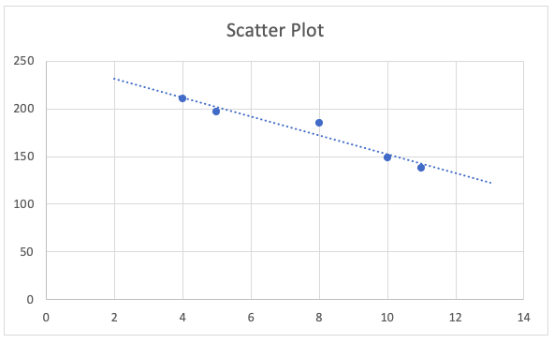
- -0.28
- -0.97
- 0.28
- 0.97
Section 14.1 LO 2 Moderate
Solution: B. The scatter plot shows a strong negative correlation, which indicates that the correlation coefficient should be a value close to -1. The only answer choice close to -1 is -0.97.
- The chief financial officer of a company determines that there is a strong positive correlation between the company’s stock price and the Russell 2000 index. Which of the following is a valid interpretation of this correlation?
- An increase in the Russell 2000 index will cause a decrease in the stock price.
- An increase in the Russell 2000 index will cause an increase in the stock price.
- As the Russell 2000 index increases, the stock price tends to decrease.
- As the Russell 2000 index increases, the stock price tends to increase.
Solution: D. A strong positive correlation indicates that as the Russell 2000 index increases, the stock price tends to increase as well. It is not correct to conclude that an increase in the Russell 2000 index will cause an increase in the stock price.
Section 14.1 LO 2 Moderate
- A stock market analyst investigating the correlation between Apple stock (y) and the Russell 2000 index (x) calculates the correlation coefficient as 0.625. The data set consists of 10 (x, y) data points. Determine if the correlation is significant at the 0.05 level of significance.
- The correlation is significant.
- The correlation is not significant.
- Because there are only 10 data points, the correlation cannot be determined.
- Because different units are used for the x-value and the y-value, the correlation cannot be calculated.
Solution: B. Using the guideline$\left|r\right|≥\frac{2}{\sqrt{n}}$ for a significant correlation, the absolute value of r is 0.625, and the calculation for $\frac{2}{\sqrt{n}} r$esults in 0.632. Because the absolute value of r is less than the value of $\frac{2}{\sqrt{n}}$, the conclusion is that the correlation is not significant.
Section 14.1 LO 3 Difficult
- The relationship between the salaries of finance professionals (y) and their corresponding years of experience (x) is modeled by the linear regression equation $\hat{y}=72,000+850x$. During data collection, it was observed that a finance professional with eight years of experience had a corresponding salary of $75,800. Calculate the residual for this data point, assuming that the correlation is significant.
- -$3,000
- $0
- $3,000
- $75,600
Solution: A. Substitute x = 8 in the regression equation and solve for $\hat{y}$:
$$\hat{y}=72,000+850x \\ \hat{y}=72,000+850(8) \\ \hat{y}=78,800$$
$$Residual=\left(Observed y\text{-}Value\right)-\left(Predicted y\text{-}Value\right) \\ Residual=y-\hat{y} \\ Residual=75,800-78,800=-3,000$$
Section 14.2 LO 1 Moderate
- A linear regression model is developed with x-values ranging from 10 to 50, and the predicted y-value for x = 25 is ŷ = 118.3. The actual observed y-value for x = 25 is y = 108.3. Is the residual for this data point positive, negative, or zero?
- Positive
- Negative
- Zero
- Not enough information to determine
Solution: A. The residual is calculated as the observed y-value minus the predicted y-value. In this example, the residual is calculated as 108.3 – 118.3 = -10. Thus, the residual is negative.
Section 14.2 LO 1 Moderate
- Which linear regression equation corresponds to the scatter plot below?
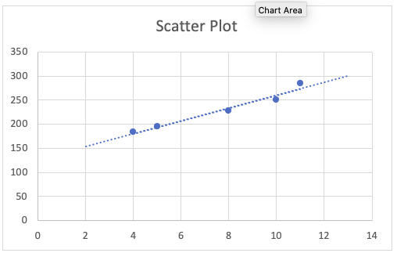
- $\hat{y}=-127.3+13.3x$
- $\hat{y}=127.3+13.3x$
- $\hat{y}=-127.3-13.3x$
- $\hat{y}=150.3+13.3x$
Section 14.2 LO 1 Moderate
Solution: B. The scatter plot shows a positive slope and a y-intercept somewhere between y = 100 and y = 150. Thus, the only possible correct answer choice is $\hat{y}=127.3+13.3x$.
- A financial analyst investigates the relationship between net sales (x) and operating expenses (y) for a company. For an observed y-value of 23.7, the analyst calculates a residual of 3.2. Determine the corresponding predicted value of y.
- -20.5
- 0
- 20.5
- 26.9
Solution: C. The residual is 3.2, and the observed y-value is 23.7. Substitute these values in the following equation:
$$Residual=\left(Observed y\text{-}Value\right)-\left(Predicted y\text{-}Value\right) \\ Residual=y-\hat{y} \\ 3.2=23.7-\hat{y} \\ \hat{y}=20.5$$
Section 14.2 LO 1 Moderate
- The relationship between the revenue of a company (y) and the amount the company spends on advertising (x) is modeled by the linear regression equation $\hat{y}=8,500+71x$. Assuming the correlation is significant, what is the predicted revenue if the amount spent on advertising is $75?
- $5,325
- $8,500
- $8,571
- $13,825
Solution: D. Substitute x = 75 in the regression equation and solve for $\hat{y}$:
$$\hat{y}=8,500+71x$$
$$\hat{y}=8,500+71(75)$$
$$\hat{y}=13,825$$
Section 14.3 LO 2 Easy
- A chief financial officer collects (x, y) data and uses technology to generate the slope and y-intercept of a regression model. The slope is -15.9, and the y-intercept is -13.1. What is the correct best-fit linear regression model?
- $\hat{y}=-13.1+15.9x$
- $\hat{y}=-15.9-13.1x$
- $\hat{y}=13.1-15.9x$
- $\hat{y}=-13.1-15.9x$
Solution: D. The linear regression model is written in the form $\hat{y}=a+bx$, where $a$ is the y-intercept and $b$ is the slope of the regression equation. Thus, in this example, the linear regression model is written as $\hat{y}=-13.1-15.9x$.
Section 14.3 LO 2 Easy
- A linear model is developed for the relationship between the monthly amount a restaurant spends on advertising (x) and the restaurant’s monthly revenue (y). The equation of the best-fit linear model is determined to be $\hat{y}=9,200+68x$. The correlation is determined to be significant. Which of the following statements is valid?
- For every additional dollar spent on advertising, the restaurant can expect an average decrease in revenue of $68.
- For every additional dollar spent on advertising, the restaurant can expect an average increase in revenue of $68.
- For every additional dollar spent on advertising, the restaurant can expect an average increase in revenue of $9,200.
- For every additional dollar spent on advertising, the restaurant can expect an average increase in revenue of $9,268.
Solution: B. The slope of the regression line is 68. This slope is interpreted to mean that for every dollar spent on advertising, on average, the restaurant can expect a $68 increase in revenue.
Section 14.3 LO 2 Moderate
- The relationship between the salaries of finance professionals (y) and their corresponding years of experience (x) is modeled by the equation $\hat{y}=68,000+950x$. Assuming the correlation is significant, how many years of experience would a finance professional be expected have if their earnings were $78,925?
- 10.75
- 11
- 11.5
- 13.5
Solution: C. Substitute $\hat{y}$ = 78,925 in the regression equation and solve for x:
$$78,925=68,000+950x \\ 10,925=950x \\ 11.5=x$$
Section 14.3 LO 2 Moderate
- 15. The Gamma Manufacturing Company is tracking revenues (y) versus number of employees (x) for recent years, and the corresponding linear regression equation is $\hat{y}=135+14.1x$.
Which of the following is the correct interpretation of the y-intercept?
- For each new employee, the company will realize an average increase in revenue of $135.
- For each new employee, the company will realize an average increase in revenue of $14.10.
- The company will maximize revenue when there are 135 employees.
- The y-intercept does not have any meaning in this context.
Solution: D. The y-intercept would represent the expected mean value of y when the x-value is zero. In the context of this regression equation, an x-value of zero would imply no employees, which is not realistic. Because an x-value of zero is not realistic, the y-intercept does not have any meaning in this context.
Section 14.3 LO 2 Moderate
- A finance professional has modeled the relationship between the Russell 2000 index (y) and the Dow Jones Industrial Average (x) with the linear regression equation $\hat{y}=-1,500+0.17x$. Assume the correlation is significant. If the Dow Jones Industrial Average were to change by 100 points from one week to the next, what would be the corresponding predicted change in the Russell 2000 index?
- -1483 points
- 0 points
- 17 points
- 170 points
Solution: C. The predicted change in the Russell 2000 index can be determined using the slope of the regression line, which is 0.17. Substituting 100 for x produces 0.17(100), or 17, so there is a corresponding change of 17 points in the Russell 2000 index.
Section 14.3 LO 2 Difficult
- A financial analyst is interested in creating a linear regression model to track the relationship between returns for stocks and returns for bonds. The analyst is planning to conduct the following steps as part of the analysis: calculating the correlation coefficient, determining if the correlation is significant, creating a scatter plot, and creating the linear regression model. Which of these steps should be done first?
- Calculating the correlation coefficient
- Determining if the correlation is significant
- Creating a scatter plot
- Creating the linear regression model
Solution: C. The scatter plot should be created first to provide a visual representation of the relationship between the two quantities, which will help the analyst determine if a linear model is appropriate.
Section 14.4 LO 1 Easy
- As predictions are made for x-values that are closer and closer to the mean value of x, what will happen to the prediction intervals for these x-values?
- They will become smaller.
- They will become larger.
- They will remain the same.
- There is not enough information to determine the answer.
Solution: A. As predictions are made for x-values closer to the mean of x, the prediction interval around the point estimate decreases.
Section 14.5 LO 2 Difficult

Problems
- The Acme Manufacturing Company is tracking revenues versus advertising spend for the past five quarters, and the data is shown in the table below. Consider revenues to be the dependent variable. Calculate the correlation coefficient for this data. Round your answer to three decimal places.
Quarter | Revenues ($000s) | Advertising Spend  ($000s)
1 | 823 | 91
2 | 855 | 96
3 | 734 | 85
4 | 771 | 88
5 | 819 | 90
Solution: Using a financial calculator, enter the revenue data in one column, enter the advertising spend data in another column, and execute the steps needed to find the correlation coefficient. The correlation coefficient is 0.956, which indicates strong positive correlation.
Section 14.1 LO 1 Moderate
- The Omega Manufacturing Company is tracking profits versus sales for the past five years, and the data is shown in the table below. Consider profits to be the dependent variable, and assume the correlation is significant. Calculate the equation of the best-fit linear regression model for this data. Round your answers to three decimal places.
Year | Profit  ($000s) | Sales  ($000s)
1 | 823 | 91
2 | 855 | 96
3 | 734 | 85
4 | 771 | 88
5 | 819 | 90
Solution: Using the TI BA II Plus calculator or similar technology, enter the profit data in one column, enter the sales data in another column, and execute the steps needed to find the slope and y-intercept for the linear regression model. The slope is 0.420, and the y-intercept is -7.270. Thus, the linear regression model is $\hat{y}=-7.270+0.420x$.
Section 14.3 LO 1 Moderate
- The Alpha Manufacturing Company is tracking sales versus hours of training for salespeople for the past five months, and the data is shown in the table below. Consider sales to be the dependent variable, and assume the correlation is significant. Predict the sales for the company if salespeople complete 25 hours of training in a particular month. Round intermediate calculations to three decimal places, and round your final answer to the nearest whole number.
Month | Sales  ($000s) | Hours of Training
1 | 410 | 21
2 | 386 | 19
3 | 315 | 15
4 | 490 | 28
5 | 512 | 31
Solution: Using the TI BA II Plus calculator or similar technology, enter the sales data in one column, enter the hours of training data in another column, and execute the steps needed to find the slope and y-intercept for the linear regression model. The slope is 12.064, and the y-intercept is 147.549. Thus, the linear regression model is $\hat{y}=147.549+12.064x$. Then, to find the predicted sales for 25 hours of training, substitute x = 25 in the best-fit linear equation and solve for $\hat{y}$:
$$\hat{y}=147.549+12.064x=147.549+12.064\left(25\right)=449$$
The predicted sales are 449 thousands of dollars (rounded to nearest whole number), or $449,000.
Section 14.5 LO 1 Moderate
- The Gamma Manufacturing Company is tracking revenues versus number of employees for recent years, and the data is shown in the table below. Consider revenues to be the dependent variable, and assume the correlation is significant. Can this data be used to predict revenue when the number of employees is 65? Explain.
Year | Revenues ($000s) | Number of Employees
1 | 183 | 4
2 | 195 | 5
3 | 227 | 8
4 | 251 | 10
5 | 284 | 11
Solution: The original data set is based on numbers of employees between 4 and 11. It is not appropriate to use the regression model for predictions for x-values outside of the initial data collection. Because 65 employees is significantly outside of the interval for the original x-values, a prediction is not appropriate and should not be calculated.
Section 14.5 LO 1 Difficult
- A financial analyst wants to calculate the value of beta as a measure of the volatility of returns for Walmart stock prices compared to the returns for the S&P 500 benchmark. The table below shows monthly returns for Walmart stock versus monthly returns for the S&P 500. Consider Walmart stock returns to be the dependent variable. Determine the value of beta, and round your answer to three decimal places.
Month | S&P 500 Returns | Walmart Stock Returns
1 | 0.05 | 0.07
2 | 0.02 | 0.04
3 | 0.06 | 0.09
4 | 0.07 | 0.11
5 | -0.04 | 0.01
Solution: Using the TI BA II Plus calculator or similar technology, enter the S&P 500 returns data in one column, enter the Walmart stock returns data in another column, and execute the steps needed to find the slope of the linear regression model. If a manual calculation for the slope is performed, then, using the given (x, y) data, the slope b can be calculated using the following formula:
$$b=\frac{n\sum{xy-(\sum{x)(\sum{y)}}}}{n\sum{x^{2}-}{(\sum{x)}}^{2}}$$
The slope is 0.858. The value of beta is equal to the slope of the regression line, so the value of beta is 0.858. This indicates that Walmart stock has lower volatility than the S&P 500 for this time period.
Section 14.4 LO 2 Moderate

This file is copyright 2022, Rice University. All Rights Reserved.

