s

SOLUTION MANUALS

Chapter 12

End-of-Chapter Questions
  - Historical Performance of US Markets

Multiple Choice Questions
- Which of the following statements about Treasury bills is false?
- T-bills sell at a discount from face value and pay the face value at maturity.
- T-bills have maturities of 2, 3, 5, 7, or 10 years.
- T-bill auctions take place weekly.
- T-bill denominations are relatively small compared to other money market instruments, with initial auction sizes of as little as $10,000 per T-bill.
Solution: B. T-bills come in maturities of 4, 8, 13, 26, and 52 weeks.
Section 12.1 LO 1 Easy
- If an investor wishes to simply execute a stock trade at the current market price, they should issue a ________.
- limit order
- stop loss order
- market order
- hedge order
Solution: C
Section 12.1 LO 3 Easy
- Based on nominal average annual returns over the period 1980–2020, list the order of returns by asset class from highest to lowest.
- large company stocks, Baa bonds, small company stocks, T-bills
- small company stocks, large company stocks, Baa bonds, T-bills
- T-bills, Baa bonds, small company stocks, large company stocks
- small company stocks, large company stocks, T-bills, Baa bonds
Solution: B
Section 12.4 LO 1 Moderate
- A $1 investment in a portfolio of small company stocks in 1928 would have grown to over ________ by mid-2019.
- $35,000
- $8,000
- $800
- $80
Solution: A. $35,000. According to data collected by Ibbotson and Associates, the $1 investment would have grown to $36,747.10.
Section 12.4 LO 1 Moderate
- Since 1980, the compound average annual growth rate for large company stocks has been ________.
- greater than Baa bonds but less than small company stocks
- greater than small company stocks but less than Baa bonds
- greater than Baa bonds and small company stocks
- less than Baa bonds and small company stocks
Solution: A
Section 12.4 LO 1 Easy

Review Questions
- Define the competitive and noncompetitive bid process for US Treasury bills.
Solution: With a competitive bid, potential investors bid for a specific number of T-bills at a specific price. Their bids may or may not be successful depending on what other bidders are willing to pay. A noncompetitive bid is always successful and pays the average successful competitive bid rate. Noncompetitive bids are limited in size, and the total sums to less than 20% of the total accepted bids.
Section 12.1 LO 1 Difficult
- How does a negotiable certificate of deposit (NCD) differ from the typical certificate of deposit you may see advertised by your local bank?
Solution: NCDs are much larger, $100,000 or more, and they have an active secondary market where they are tradable prior to maturity. Regular CDs are smaller, are FDIC insured, have no secondary market, and realize an interest penalty if redeemed before maturity. Financial institutions also have smaller reserve requirements with NCDs and can offer higher rates.
Section 12.1 LO 1 Moderate
- If you are an investor concerned about unexpected inflation in the coming years which of the following investments offers the greatest protection against inflation, and why: T-notes, T-bonds, or TIPS?
Solution: TIPS are Treasury-Inflation Protected Securities with maturities of 5, 10, or 30 years. They offer protection against inflation for the investor because the semiannual coupon payments adjust to changes in the CPI. T-notes and T-bonds have fixed payments that do not adjust to changes in the rate of inflation.
Section 12.1 LO 2 Easy
- Debentures are more common than mortgage bonds issued by corporations. Why do you think debentures are more popular with investors? Be sure to define each bond contract in your discussion.
Solution: Specific real assets guarantee mortgage bonds, whereas the ability of the corporation to generate sufficient cash flows to pay back the bonds support debentures. Because specific real assets collateralize mortgage bonds, investors view them as having less risk and therefore require lower rates of return. Debentures reflect the overall risk of a company and provide higher returns because a specific asset does not collateralize them. Debentures are more prevalent because of limited real assets available to back mortgage bonds and because investors prefer the premium of return offered by the debentures.
Section 12.1 LO 2 Difficult
- Market capitalization is a common way to rank firm size. Search the internet to identify and define at least two other ways to rank firms based on size. Identify at least one reason you prefer market capitalization as the method of choice to rank firm size.
Solution: Total annual revenue (sales) and the number of employees are two other ways to rank firms based on size. It is logical to identify the firm with the most revenue as the largest. Similarly, the firm with the most employees is also the largest. However, each measure represents a point in time or at best a short period. Market capitalization is based on the perceived value today of all future cash flows discounted for timing and risk. The measure goes beyond simply what exists at the moment or a summation of revenues for the past 12 months. Further, sales do not directly translate to increased value for the firm’s owners. Managers incur a responsibility to stockholders, or owners of a firm, and market capitalization is the best reflection of how they have affected shareholder wealth.
Note: Students may find several other techniques to rank firm size. Sales and the number of employees simply represent two examples of what they might find.
Section 12.1 LO 3 Difficult
- Compare and contrast an SEO, IPO, and SPAC. If Ford Motor Company wished to raise new equity capital, which of these vehicles would they use?
Solution: An SEO, or seasoned equity offering, occurs when a publicly traded company issues additional new shares to the market. Ford would use an SEO to raise new equity capital. An IPO is an initial public offering. This is the first time a private company issues shares to the public. A special purpose acquisition company, or SPAC, is a special form of IPO in that the only asset held by the newly formed company is cash. The SPAC uses the cash to later purchase or merge with a privately held firm.
Section 12.1 LO 3 Difficult
- Compared to a “best efforts” form of underwriting, how does “firm commitment” underwriting transfer risk from the issuing firm to the underwriter?
Solution: With a best efforts underwriting agreement, the underwriters simply pledge to sell as much of a new issue as possible. The underwriting firm is not financially responsible for any unsold shares of an IPO. However, with a firm commitment underwriting agreement, the underwriter guarantees a specific dollar amount to the issuer of the IPO. The underwriter bears the risk and responsibility if the guaranteed amount of the IPO is not realized.
Section 12.1 LO 2 Difficult
- How would a decrease in inflation affect the interest rate on an adjustable-rate debenture?
Solution: Interest rates and thus the coupon payments would become smaller.
Section 12.2 LO 2 Easy
- If inflation unexpectedly rises by 3%, would a corporation that had recently borrowed money by issuing fixed-rate bonds to pay for a new investment benefit or lose?
Solution: The corporation would win by locking in a lower rate and repaying the interest and principal with inflated and less-valuable dollars.
Section 12.2 LO 2 Moderate
- If wages on average rise at least as fast as inflation, why do people worry about how inflation affects incomes?
Solution: As we discussed, inflation represents the change in price of a market basket of goods. However, not every item experiences the same price change, and not everyone consumes the same basket of goods or continues to consume goods at the same rate. Therefore, while the average change in prices may match the change in wages, not every consumer bears the changes the same way. Further, financial products with fixed rates always have those who benefit and those who suffer from changes in interest rates brought about by changes in inflation.
Section 12.2 LO 2 Moderate
- Identify at least one item that you use regularly whose price has changed significantly.
Solution: College students might identify electronics such as a big-screen TV or laptops where the size or power has increased and the price has decreased. Gasoline prices have risen and fallen. Tuition and rent in college towns could be common answers for prices that have increased.
Section 12.2 LO 1 Easy
- What has been the average annual rate of inflation between 1985 and 2020? What is the long-run average annual rate of inflation over the last century?
Solution: The average annual rate of inflation from 1985 to 2020 was 2.55% and was lower than the long-run average inflation rate of approximately 3.00%.
Section 12.2 LO 4 Moderate
- Between 1985 and 2020, what year had the lowest realized annual rate of inflation in the United States? Why do you think inflation was so low in this particular year?
Solution: 2009. In the year following the Great Recession of 2008, the demand for funds was low and most price changes were small or even negative.
Section 12.2 LO 4 Moderate
- Go to https://www.usinflationcalculator.com/. How much money would it take today to purchase what one dollar would have bought in 1950, in 1975, and in your birth year?
Solution: $1.00 in 1950 requires $10.74 in 2021, and $1.00 in 1975 requires $4.81 in 2021.
Section 12.2 LO 4 Easy
- Are US Treasury bonds truly risk free?
Solution: We can consider Treasury bonds default-risk free. However, Treasuries still suffer from interest rate risk. Annual rates of return fluctuate significantly from year to year due to changes in price caused by changes in interest rates. Longer-term bonds and lower coupon rate bonds experience larger price swings with changes in market interest rates. Thus, investors are not concerned about receiving cash flows from Treasury bonds, but they are concerned about changes in the price of bonds from period to period.
Section 12.3 LO 1 Moderate
- At the end of 2020 and the beginning of 2021, coupon rates on long-term T-notes and T-bonds were near historic lows. Further, the federal government was running a historically large budget deficit in an effort to stimulate an economy battered by COVID-19 and to support millions of unemployed workers. Some investment advisers warned that this could be a particularly bad time to invest in government bonds or bonds in general. Why?
Solution: Some economists acknowledged that these actions were important for economic recovery, but they were concerned about two important market conditions—first, that the deficit spending would lead to inflation and higher interest rates, and second, that the extra government borrowing today would lead to higher interest rates in the future. Both inflation and the government’s need to borrow are likely to drive up interest rates and lower the prices of existing bonds and notes. Thus, investors who purchase bonds today may suffer losses. First, they receive low coupon payments today, and second, they lose value on their bond portfolios as prices fall due to rising interest rates brought on by inflation and the oversupply of bonds.
Section 12.3 LO 1 Difficult
- Which group of securities earned a higher average annual return from 2000 to 2020, T-bonds or Baa bonds? Why do think this was so?
Solution: From 2000 to 2020, Baa bonds earned an average annual rate of return of 8.04% versus the 5.77% realized by T-bonds. The 2.27% annual premium is primarily due to the default risk investors bear with the Baa bonds. Some of the additional return is a liquidity premium because the T-bonds secondary market is more active. Finally, a part of the additional return is due to the lower taxes associated with the T-bonds.
Section 12.3 LO 3 Easy
- Which earned a higher average annual return, a portfolio of T-bonds from 1980 to 2000 or from 2000 to 2020? Why do think this was so?
Solution: The earlier period had higher average annual returns of 10.21% compared to 5.77%. The rate of inflation in the earlier period was also greater and accounts for much of the difference in average returns.
Section 12.3 LO 1 Moderate
- Why is standard deviation of returns a reasonable measure of risk for a portfolio of equity securities?
Solution: Portfolios of stocks tend to follow a normal distribution of returns, as illustrated by the “pyramid of equity returns” found at the start of section 12.4 in the text. Standard deviation is a good measure of variability and uncertainty for assets with a normal, or “bell-shaped,” distribution of outcomes.
Section 12.4 LO 3 Moderate
- Many popular-press articles claim that growth investing is “clearly better” than value investing or that value investing is “dead.” How would you respond to proponents of growth investing after observing Figure 12.15?
Solution: The graph shows that for small companies, value investing has easily outperformed growth strategies for the entire 41 years reported by a nearly 2:1 margin. While growth strategies have been better under some market conditions, on average that has not proven true for several decades for small company stocks.
Section 12.4 LO 2 Moderate
- Over the last 120 years, few countries have achieved the realized rate of returns enjoyed by US equity markets. Does this mean investors should ignore international investments and focus only on domestic markets in an effort to maximize returns?
Solution: Probably not. International or global investing adds additional layers of risk in the form of exchange rates, government interference, differences in customs, and language. However, international diversification can lower overall risk and perhaps increase risk-adjusted returns. Investors who avoid international diversification also miss out on 50% of the world’s equity opportunities.
Section 12.4 LO 2 Moderate

Chapter 12

Test Bank
  - Chapter 12: Historical Performance of U.S. Markets

True or False Questions
- Capital market instruments are all equity securities.
- True
- False
Solution: B. Capital market instrument are medium to long term in nature and include debt instruments such as bonds.
Section 12.1 LO 1 Moderate
- The New York Stock Exchange (NYSE) is an example of an over-the-counter exchange.
- True
- False
Solution: B. The NYSE is a physical exchange where you can see the actual trading floor and its many floor traders.
Section 12.1 LO 3 Easy
- Inflation is a general rise in market prices that affects all goods equally.
- True
- False
Solution: B. Prices rise unevenly in an inflationary environment, so some sectors are impacted more than others.
Section 12.2 LO 3 Moderate
- It is conceivable for a stock investor to gain as much as 50% in one year or lose 50% in one year.
- True
- False
Solution: A. Average annual returns and equity gains will not always be consistent year over year. They are indicative of market and economic forces that will cause fluctuations in equity prices and/or gains.
Section 12.4 LO 3 Moderate

Multiple Choice Questions
- Which of the following is a characteristic of a money market financial instrument?
- High risk
- Low risk
- Low credit quality
- Equity instrument
Solution: B. Money market instruments are safe, short-term debt instruments
Section 12.1 LO 1 Easy
- Commercial paper performs the same basic function as T-bills for their respective issuers. How are these two instruments similar?
- Both provide short-term liquidity for the issuer.
- Both provide long-term liquidity for the issuer.
- Both provide permanent capital.
- Both are issued by the US government.
Solution: A. Commercial paper and T-bills both provide short-term liquidity for the issuer.
Section 12.1 LO 1 Moderate
- A money market mutual fund or exchange-traded fund pools money from investors and purchases various money market instruments using those funds. Which of the following would be an appropriate instrument for such a fund that would offer the lowest risk for investors?
- Preferred stock
- T-notes
- Common stock
- High-yield bonds
Solution: B. Treasury notes, or T-notes, are considered risk-free assets, meaning there is no risk that the investor will lose their principal. In other words, investors that hold the note until maturity are guaranteed repayment of their principal, or initial investment.
Section 12.1 LO 1 Moderate
- Why would a company typically choose to source external financing by issuing bonds rather than stock?
- Bonds are simpler to issue.
- Bonds have longer maturity dates than stock.
- Companies pay taxes on the proceeds from stock issues.
- Bonds are a cheaper funding source.
Solution: D. Bond interest is an expense recognized on income statements before taxable income is determined. Hence, it is effectively tax deductible, meaning it lowers the cost to the company.
Section 12.1 LO 2 Difficult
- Which of the following cannot issue bonds to the public?
- US government
- Municipalities
- Consumers
- Corporations
Solution: C. Consumers have access to borrowed money, mostly in the form of bank loans. Governments and corporations may access the public debt market by issuing bonds, but the average consumer cannot issue bonds to the public.
Section 12.1 LO 2 Moderate
- The US Treasury issues many debt instruments, including bills, notes and bonds. The 10-year Treasury note is an especially important security in the financial market. Why is the 10-year T-note so important?
- Interest on the note is not federally taxed.
- Interest on the note is adjusted for inflation.
- It is a benchmark rate for many other financial instruments.
- It has no default risk.
Solution: C. The 10-year T-note is used extensively as a funding tool of the US government. It also serves an important role as a benchmark or reference rate for other interest rates, such as residential mortgages.
Section 12.1 LO 2 Moderate
- Corporate bonds can be an attractive investment because they offer what to the investor?
- Semiannual interest payments
- Annual dividends
- Protection against inflation
- Default-free returns
Solution: A. Normally, corporate bonds pay their annual coupon interest rates in the form of two semiannual payments.
Section 12.1 LO 2 Easy
- When a company goes public through an IPO, the proceeds of the stock sale go to whom?
- The shareholders
- The issuing company
- The stockbrokers
- The public
Solution: B. Although share brokers will earn commissions from selling the shares, the funds raised in an IPO go from the investor to the issuing company.
Section 12.1 LO 3 Moderate
- Once a company’s shares are trading in the market, if Investor 1 sells shares to Investor 2, the proceeds from the sale go to whom?
- Investor 1
- Investor 2
- The issuing company
- The stockbroker
Solution: A. In the secondary market, when Investor 1 sells shares to Investor 2, the money flows from the buyer (Investor 2) to the seller (Investor 1).
Section 12.1 LO 3 Moderate
- What is an alternative financial process to an initial public offering (IPO) for a private company that wants to go public?
- Shelf registration
- Syndication
- SPAC merger
- Reverse mortgage
Solution: C. Merging with special purpose acquisition companies, or SPACs, has emerged recently as a new and popular way for a company to go public.
Section 12.1 LO 3 Moderate
- Which of the following is a characteristic of inflation?
- Economic contraction
- General decline in prices
- Shrinking money supply
- General rise in prices
Solution: D. Inflation is a period of rising prices overall. The other choices are characteristics of deflation.
Section 12.2 LO 1 Easy
- According to this table, which of the following would suffer more from inflation as measured by the CPI?
Year | 1980 | 2000 | 2020 | Annual  Change
College tuition and fees | 70.8 | 331.9 | 877.3 | 6.49%
Rent | 80.9 | 183.9 | 341.5 | 3.67%
Used cars and trucks | 62.3 | 155.8 | 144.2 | 2.12%
Ground beef | 104.6 | 125.2 | 296.2 | 2.64%
Butter | 89.4 | 135.9 | 248.7 | 2.59%
CPI (1982 to 1984 = 100) | 82.4 | 172.2 | 258.8 | 2.90%
Table 12.3 Changing Consumer Price Levels—Selected Goods (data source: US Bureau of Labor Statistics, Consumer Price Index)
- A pastry shop
- A college student
- An apartment renter
- A used car buyer
Solution: B. Of the listed components of the CPI, college tuition has risen by the greatest amount.
Section 12.2 LO 2 Moderate
- A consequence of inflation is that the purchasing power of money ________.
- decreases
- increases
- does not change
- Inflation and purchasing power are unrelated.
Solution: A. Inflation raises the overall price level compared with a base, such a salary, causing purchases to seem more expensive and thus decreasing the value of money.
Section 12.2 LO 2 Moderate
- Why would a securities issuer choose to use the shelf registration process?
- It takes less time to complete an issuance than with the standard process.
- Its disclosure requirements are less extensive.
- It does not require the securities’ interest payments to be reported to the IRS.
- It makes taxes on the issue more favorable.
Solution: A. A key benefit of a shelf registration is that it provides flexibility to the issuer, enabling them to issue an offering more quickly once market conditions are favorable because the document filings have been done in advance.
Section 12.2 LO 2 Moderate
- Inflation is commonly thought to be a negative aspect of the economy because it causes prices to rise in general. What is one positive aspect of inflation in an economy?
- It increases purchasing power.
- It improves the country’s currency value.
- It allows borrowers to repay loans with less valuable dollars.
- it decreases prevailing interest rates.
Solution: C. If the actual rate of inflation exceeds the estimated rate factored in to the loan, then the dollars used to repay the loan carry less purchasing power.
Section 12.2 LO 2 Difficult
- If actual inflation is greater than expected for a given period, which party benefits most?
- Lenders
- Borrowers
- Board members
- Consumers
Solution: B. Borrowers repay loans with less-valuable dollars and benefit from the increased inflation rate.
Section 12.2 LO 3 Difficult
- Because a majority of bonds pay a fixed rate of interest, the overall return on owning a bond ________.
- never changes
- changes in the same direction as inflation
- mirrors changes in the stock market
- changes due to market conditions
Solution: D. The coupon interest rate on a fixed rate bond does not change, but due to market conditions, the market price may change, yielding a gain or loss on the bond principal.
Section 12.3 LO 3 Difficult
- This graph shows how much an investor of $100 would have after a 40-year period. The investor in Baa corporate bonds would earn more than double the amount earned by the investor in 10-year T-bonds.
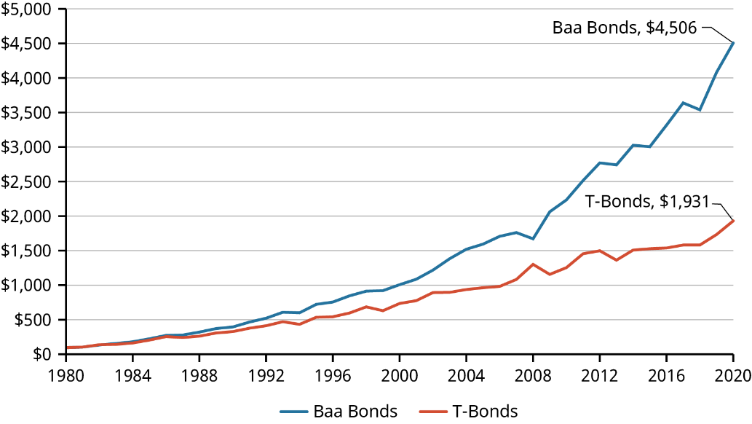
Table 12.12 Baa Bonds versus T-Bonds Performance, 1980–2020 (data source: Aswath Damodaran Online)
Why is this the case?
- The corporate bonds are riskier and would therefore pay higher returns.
- The T-bonds is riskier and would therefore pay higher returns.
- The corporate bonds would be more impacted by inflation.
- The corporate bonds would also pay dividends to their holders.
Solution: A. Baa corporate bonds are riskier than equivalent-term T-bonds. The additional risk premium means that corporate bonds must pay higher return.
Section 12.3 LO 3 Moderate
- There are thousands of publicly traded stocks trading on exchanges. Indexes are measurement tools used to determine how the market performs during a particular period. Which of the following indexes would be the best measure of the total stock market?
- Dow Jones Industrial Average
- NASDAQ Composite
- Wilshire US Small Cap
- S&P 500
Solution: D. The S&P 500 is the most diverse index. The other three indexes measure narrower portions of the market.
Section 12.4 LO 1 Moderate
- Which of the following correctly orders the financial instruments from the lowest returns to the highest?
- Large company stocks, Baa bonds, 10-year T-bonds, T-bills
- T-bills, 10-year T-bonds, Baa bonds, large company stocks
- 10-year T-bonds, Baa bonds, T-bills, large company stocks
- Baa bonds, large company stocks, T-bills, 10-year T-bonds
Solution: B. The correct order is T-bills, 10-year T-bonds, Baa bonds, large company stocks. Returns are a function of the instrument’s risk, and T-bills have the lowest risk, while large company stocks have the highest risk.
Section 12.4 LO 3 Difficult
- The Pyramid of Equity Returns displays annual stock returns over a long period.
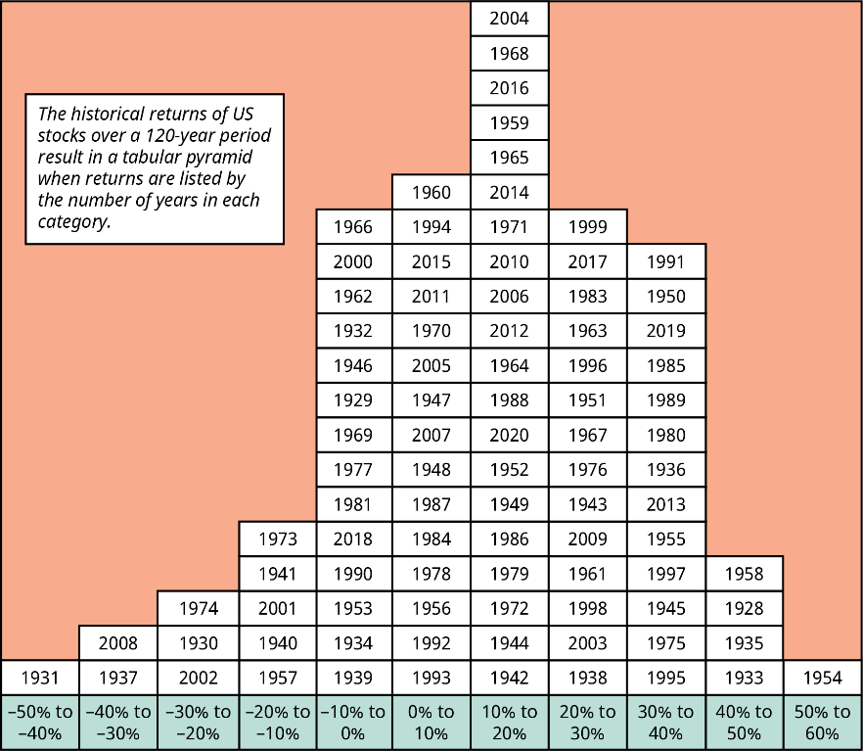
Figure 12.13 The Pyramid of Equity Returns: Distribution of Annual Returns for the S&P 500 Index, 1928–2020 (data source: Aswath Damodaran Online)
What observation can you make about these returns?
- Returns have been consistently positive over the period.
- Returns have been positive more often than they were negative.
- Losses have rarely occurred except during the Great Depression.
- The magnitude of losses has never equaled the magnitude of gains.
Solution: B. In most of the observed years, returns were positive, but a significant minority of years saw losses.
Section 12.4 LO 4 Moderate
- If an investor simply sought the highest return, they would invest only in stocks. Why might an investor diversify away from stocks only?
- Bonds offer equal return to stocks but with lower risk.
- Stocks are not always available to purchase.
- A mix of bonds and stocks normally provides the highest return.
- Investing in stocks only is the highest-risk strategy.
Solution: D. Investing in stocks only is the highest-risk strategy. By diversifying into several asset classes, an investor may have less potential for return, but they will also have a less risky portfolio.
Section 12.4 LO 4 Moderate

This file is copyright 2022, Rice University. All Rights Reserved.

