Indian Crop Production Analysis
Data Analytics with AI — Internship Project Report

Name: Aatmaja Mhatre
College: Pillai College of Engineering, New Panvel, Navi Mumbai
Programme: AICTE | IBM SkillsBuild Data Analytics with AI Internship
Partner: BharatCares
Date: 24 September 2026

Table of Contents
1. Introduction
2. Problem Statement
3. Dataset
4. Methodology
5. Analysis & Insights
6. Risks, Opportunities & Recommended Actions
7. ML Yield Predictor
8. Dashboard Screenshots
9. Conclusion

1. Introduction
Agriculture is the cornerstone of India's economy, supporting the livelihoods of over 58% of the rural population and contributing approximately 17–18% of GDP. Ensuring food security and improving agricultural productivity are critical national priorities as India navigates the twin challenges of a growing population and increasing climate variability.
This project analyses a comprehensive dataset of Indian crop production spanning 1997–2020, covering 37 states, 707 districts, and 54 distinct crops. The objective is to derive data-driven insights that can support policy decisions, agricultural planning, and resource allocation.
An interactive Streamlit dashboard accompanies this report, offering dynamic filtering, choropleth maps, trend analysis, and a machine-learning-based yield predictor.

2. Problem Statement
Despite India's diverse agro-climatic zones and vast cultivable land, crop productivity remains highly uneven across states, seasons, and crop varieties. Key challenges include:
- Yield stagnation or decline in several state-crop combinations.
- Imbalanced focus on a few high-volume crops, leaving high-potential crops underutilised.
- Difficulty in forecasting production for planning fertiliser, irrigation, and logistics.
- Lack of a unified, accessible analytical tool for policymakers and agronomists.
This project addresses these challenges through exploratory data analysis (EDA), risk identification, opportunity mapping, and predictive modelling.

3. Dataset
The dataset used is the 'Crop Production in India' dataset, publicly available on Kaggle: https://www.kaggle.com/datasets/abhinand05/crop-production-in-india
Key statistics after cleaning:
Attribute | Value
Source | Kaggle / data.gov.in
Time Range | 1997–2020
States | 37
Districts | 707
Unique Crops | 54
Seasons | 6
Total Records (cleaned) | 336,028
Total Production (MT) | 15.45 B MT
Average Yield (t/ha) | 4.6807

Data Cleaning Steps
- Stripped leading/trailing whitespace from all column names and string values.
- Replaced 'nan', 'NaN', and empty strings in key columns (State, District, Crop, Season) with NA and dropped those rows.
- Coerced Area, Production, and Yield to numeric; dropped rows with non-numeric or missing values.
- Filtered out rows where Area ≤ 0 or Production ≤ 0.
- Recomputed Yield = Production / Area for consistency.
- Excluded Coconut from tonnage-based analyses (unit mismatch: nuts vs. metric tonnes).

4. Methodology
The project followed a structured data analytics pipeline:
1. Data Ingestion & Cleaning: Loaded the CSV with pandas, applied uniform stripping, NA handling, numeric coercion, and outlier filtering as described in Section 3.
2. Exploratory Data Analysis (EDA): Computed KPIs including total production, average yield, year-over-year trends, and season-wise breakdowns using groupby aggregations.
3. Risk Detection: Identified state-crop pairs with ≥ 3 consecutive years of yield decline using a streak-based algorithm.
4. Opportunity Mapping: Flagged crops with > 10% yield growth over the last 5 years yet below the 35th percentile of cultivated area — indicating underutilised potential.
5. Predictive Modelling: Trained a Random Forest Regressor (120 trees, max depth 12) on 80% of the cleaned data to predict yield from State, Crop, Season, Area, and Crop Year. Evaluated on a held-out 20% test set using R² and MAE.
6. Visualisation: Built interactive charts with Plotly (area charts, bar charts, treemaps, choropleth maps) and exported static PNGs with Kaleido for this report.
7. Dashboard: Deployed a Streamlit app with four pages — Executive Overview, Crop Season & Region, Risks & Opportunities, and Yield Predictor — with sidebar filters and dynamic KPI cards.

5. Analysis & Insights

5.1 Executive KPIs
Metric | Value
Total Production (excl. Coconut) | 15.45 B MT
Average Yield | 4.6807 t/ha
Total Cultivated Area | 3.99 B Ha
5-Year Yield Growth | +11.12%
Top Crop (by Production) | Sugarcane
Top Crop Share | 46.9%

Haryana leads total production with 589.74 M MT, reflecting its large irrigated area and diversified cropping system. The top crop — Sugarcane — accounts for 46.9% of total production (excluding Coconut), underlining the dominance of a few high-volume cereals. The 5-year yield trend shows a positive growth of +11.12%, indicating ongoing productivity improvements.
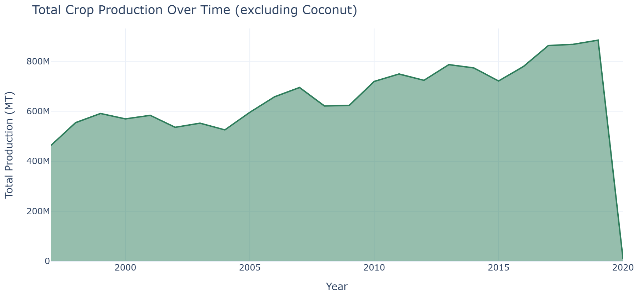
Figure 1: Total agricultural production trend (metric tonnes).

5.2 Top 10 States by Production and Yield
The following tables rank states by total production and average yield respectively. High production does not always correlate with high yield — states with large cultivated areas may produce more in absolute terms while maintaining moderate yields.
Production Table:
State | Production (MT)
Uttar Pradesh | 4,442,585,302.00
Maharashtra | 1,878,564,915.00
Karnataka | 1,080,631,366.00
Tamil Nadu | 1,027,359,253.00
West Bengal | 872,846,720.00
Andhra Pradesh | 863,891,574.00
Madhya Pradesh | 834,490,323.00
Gujarat | 807,581,678.00
Punjab | 781,551,409.00
Haryana | 589,739,640.00

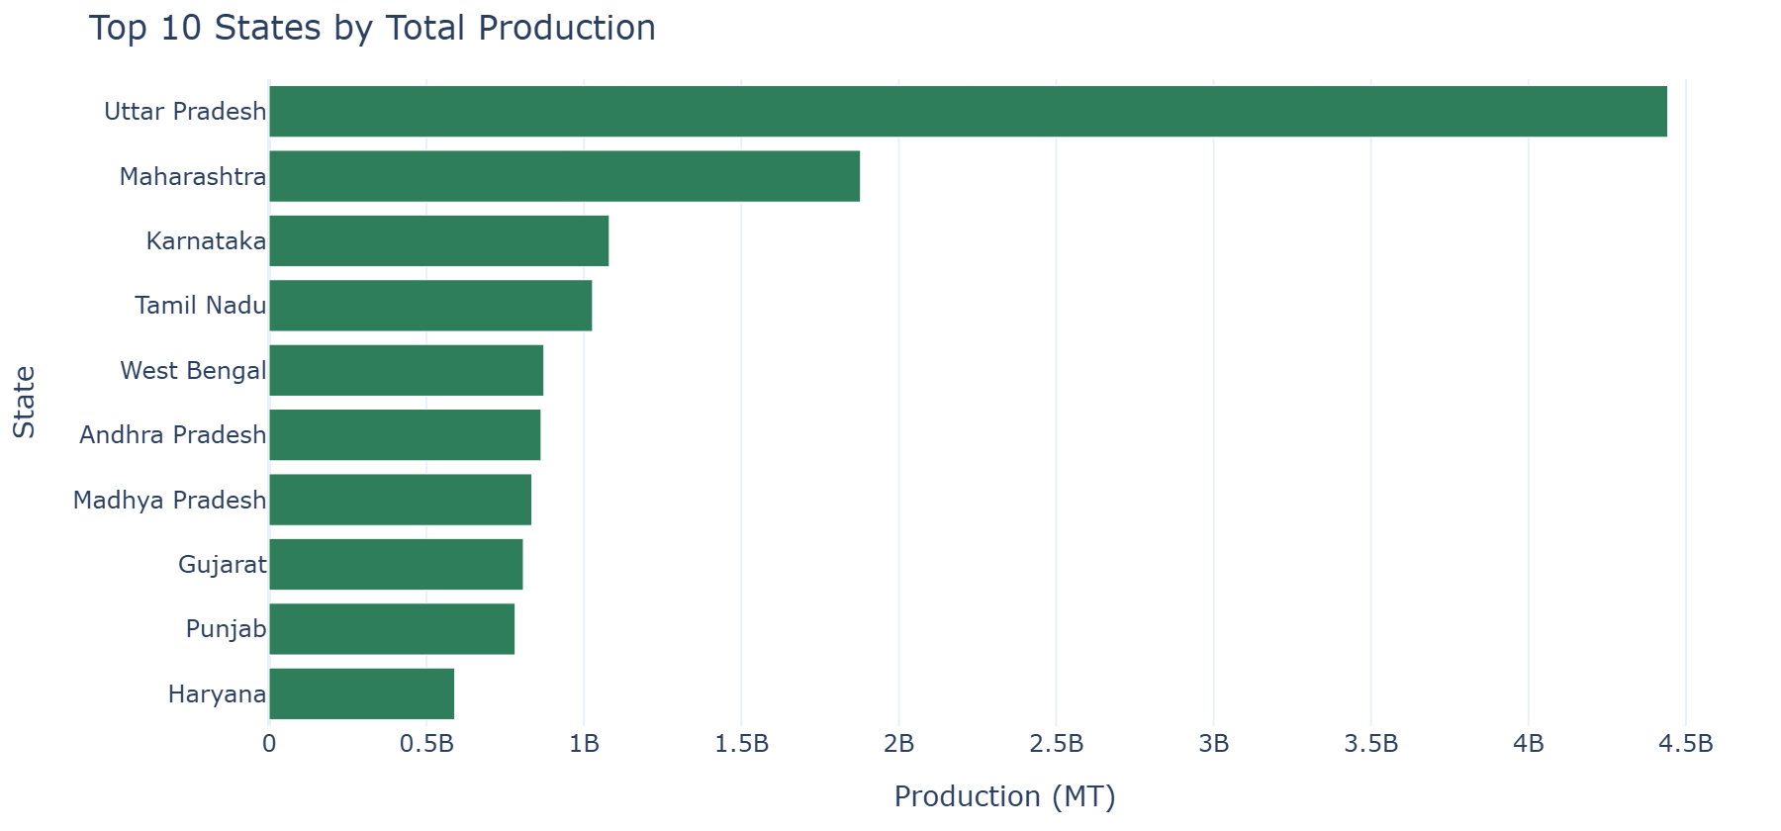
Figure 2: Top 10 states ranked by cumulative crop production.

Yield Table:
State | Avg Yield (t/ha)
Delhi | 13.12
Tamil Nadu | 9.11
Kerala | 8.84
Haryana | 8.75
CHANDIGARH | 8.15
Puducherry | 7.85
Goa | 7.20
Punjab | 6.84
Telangana | 6.66
Andhra Pradesh | 5.98

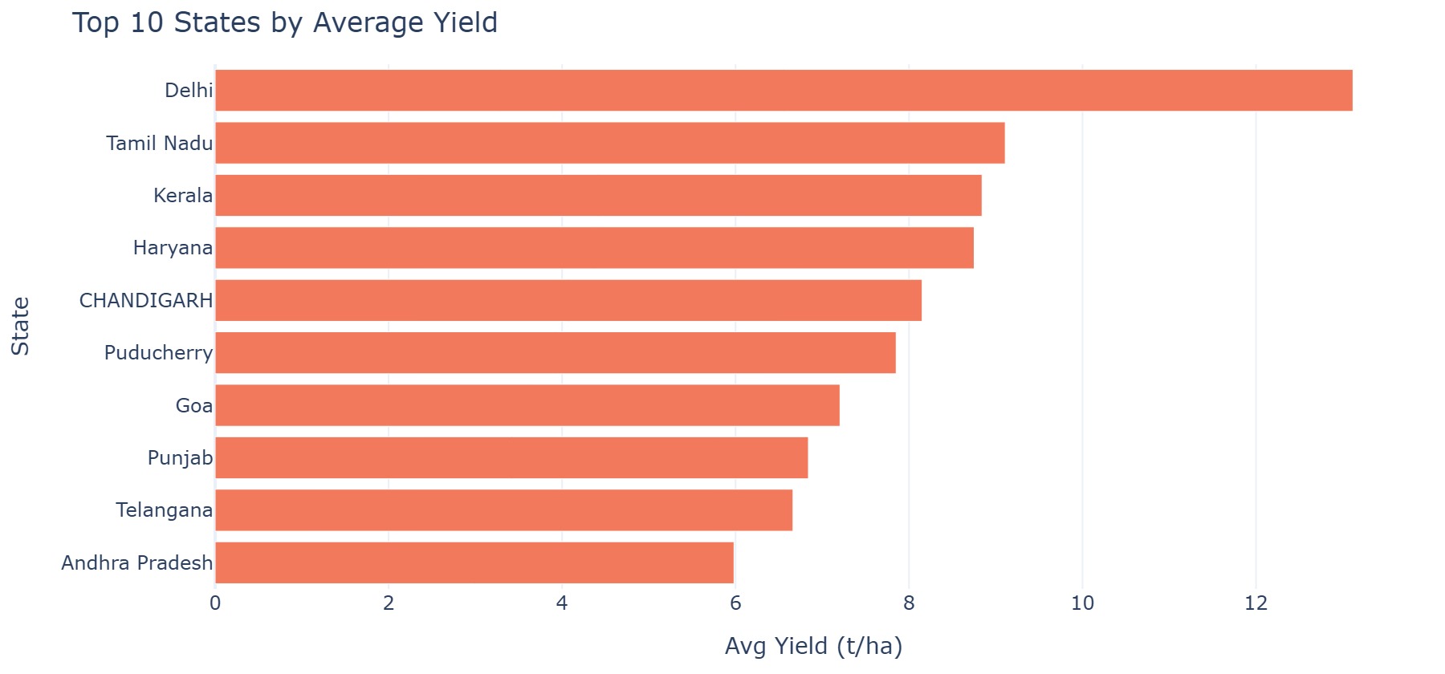
Figure 3: Top 10 states ranked by average yield (t/ha).

5.3 Season-wise Comparison
The 'Whole Year' season dominates total production with 5.76 B MT. Average yield across seasons ranges from 2.2567 t/ha to 13.7657 t/ha, highlighting the significant impact of seasonal climate on productivity.
Season | Total Production (MT) | Avg Yield (t/ha) | Total Area (Ha)
Whole Year | 5,759,360,110.00 | 13.77 | 259,917,311.17
Kharif | 5,621,842,468.00 | 2.40 | 1,954,394,120.30
Rabi | 3,150,454,633.00 | 2.26 | 1,334,431,162.50
Winter | 587,750,509.00 | 6.08 | 280,713,935.63
Summer | 243,762,911.00 | 3.37 | 98,113,816.92
Autumn | 84,641,513.00 | 2.48 | 58,719,432.71

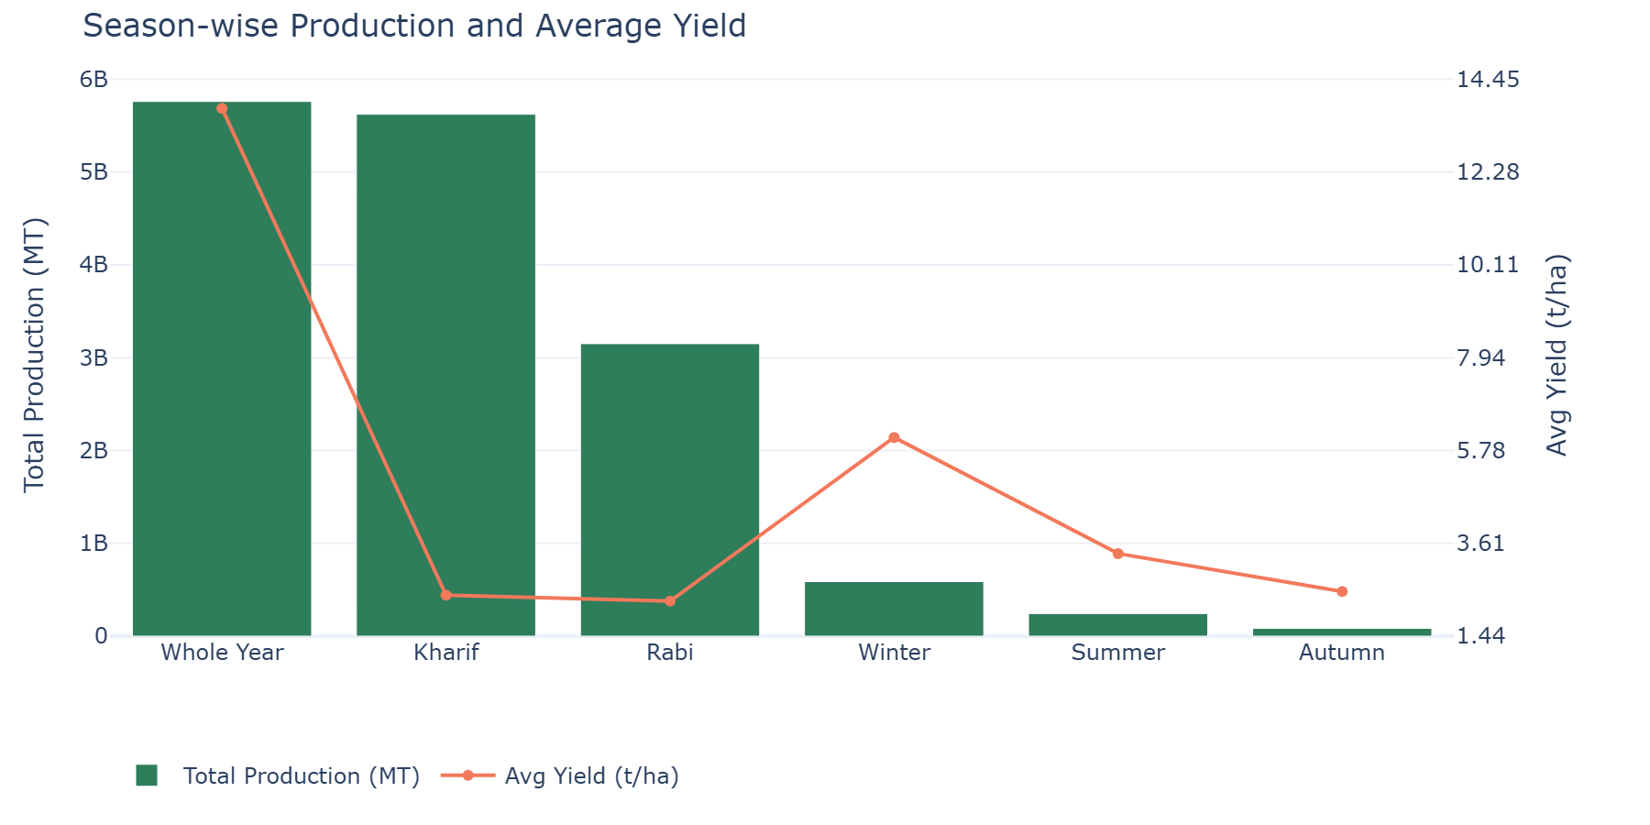
Figure 4: Season-wise total production and average yield.

5.4 Top Crops by Production
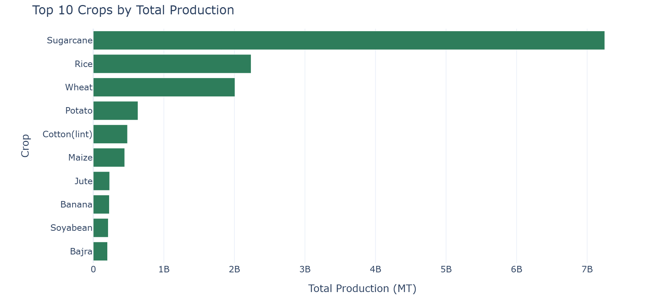
Figure 5: Top 10 crops by cumulative production (metric tonnes).

6. Risks, Opportunities & Recommended Actions

6.1 Yield Decline Risks
A total of 394 state-crop pairs were identified with ≥ 3 consecutive years of yield decline. These require agronomic intervention, including soil health assessment, improved seed varieties, and irrigation management.
The most severe case is Ginger in Andhra Pradesh with a decline streak of 7 consecutive years and an overall yield change of -38.9%. Severity: High.
Top 10 high-risk state-crop pairs:
State | Crop | Max Decline Streak (yrs) | Overall Yield Change (%) | Latest Yield (t/ha) | Severity
Andhra Pradesh | Ginger | 7 | -38.90 | 1.92 | High
Uttar Pradesh | Coriander | 6 | 25.50 | 0.7250 | High
Karnataka | Niger seed | 6 | 15.70 | 0.2480 | High
Haryana | Wheat | 6 | 28.00 | 4.62 | High
Karnataka | Dry chillies | 6 | 35.30 | 1.99 | High
Goa | Rice | 6 | -4.30 | 2.71 | High
Bihar | Wheat | 6 | 41.90 | 2.57 | High
West Bengal | Linseed | 6 | 105.30 | 0.5150 | High
Tamil Nadu | Urad | 5 | 59.50 | 0.8060 | Medium
West Bengal | Sannhamp | 5 | 0.9000 | 4.64 | Medium

6.2 Opportunity Crops
10 crops were identified with > 10% yield growth over the last 5 years yet occupying less than the 35th percentile of cultivated area. These crops represent high-potential opportunities for area expansion.
The highest-growth opportunity crop is 'Sannhamp' with 227.3% yield growth and a recent average yield of 3.730 t/ha.
Crop | Yield Growth 5yr (%) | Total Area (Ha) | Avg Recent Yield (t/ha) | Potential
Sannhamp | 227.30 | 305,749 | 3.73 | High
Oilseeds total | 139.20 | 8,571,366 | 3.86 | High
Coriander | 53.90 | 8,325,530 | 1.07 | High
Turmeric | 52.20 | 2,725,624 | 6.00 | High
Banana | 28.60 | 7,156,990 | 40.07 | Medium
Cashewnut | 26.50 | 7,453,362 | 0.7120 | Medium
Garlic | 22.60 | 3,739,514 | 5.90 | Low
Ginger | 22.50 | 1,819,522 | 9.83 | Low
Sweet potato | 19.60 | 1,217,559 | 11.58 | Low
Linseed | 10.80 | 7,875,630 | 0.6710 | Low

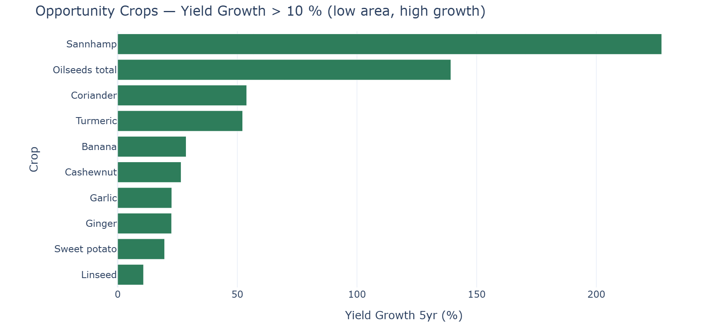
Figure 6: Opportunity crops with high yield growth and untapped cultivation area.

6.3 Recommended Actions
- Initiate an agronomic audit for Ginger in Andhra Pradesh (streak: 7 yrs). Deploy soil testing, precision irrigation, and high-yield seed varieties.
- Promote area expansion of Sannhamp — yield growth of 227.3% with still-low cultivated area. Provide subsidised seeds and extension services.
- Invest in post-harvest infrastructure in top-producing states to reduce losses.
- Implement precision agriculture techniques (drip irrigation, soil sensors) in medium-yield states to close the yield gap.
- Diversify crop portfolios in mono-crop regions to reduce weather and price risk.
- Strengthen district-level data collection for more granular future analysis.

7. ML Yield Predictor
A Random Forest Regressor was trained on the full cleaned dataset (excluding Coconut) to predict crop yield (t/ha) from five input features: State, Crop, Season, Cultivated Area (Ha), and Crop Year. Label encoding was applied to categorical variables.

7.1 Model Configuration
Parameter | Value
Algorithm | Random Forest Regressor
Number of Trees | 120
Max Tree Depth | 12
Test Split | 20%
Random Seed | 42
Training Samples | 268,822
Test Samples | 67,205

7.2 Model Performance
Evaluated on the held-out 20% test split, the model achieved an R² score of 0.3648 and a Mean Absolute Error (MAE) of 1.2531 t/ha.
Metric | Value
R² Score | 0.3648
Mean Absolute Error (MAE) | 1.2531 t/ha
Interpretation | Moderate predictive power — the model explains 36.5% of yield variance.

7.3 Feature Importance
The five input features and their relative importance to the model are presented in the interactive dashboard. Crop type and State are typically the highest-importance features, reflecting the strong agronomic and geographic determinants of yield.
The predictor can be used for scenario planning — e.g. estimating yield for a new crop in a given state and season — and is accessible on the 'Yield Predictor' page of the dashboard.

8. Dashboard Screenshots
The interactive dashboard is built with Streamlit and comprises four pages. Screenshots are captured below.
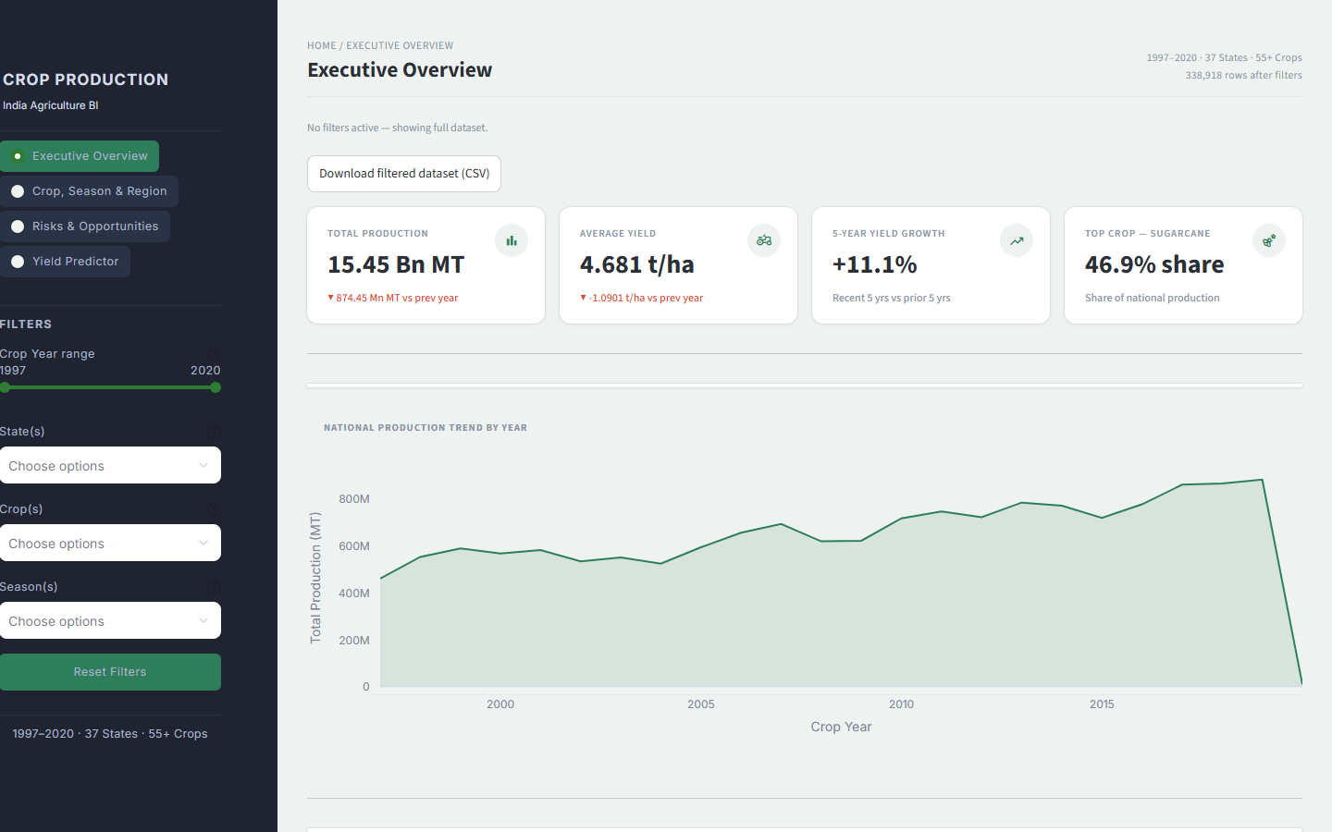
Dashboard — Crop Season & Region

9. Conclusion
This project delivered a comprehensive analysis of Indian crop production data spanning 1997–2020. Key findings include:
- Total agricultural production (excluding Coconut) stands at 15.45 B MT across 37 states and 707 districts.
- Sugarcane dominates production with a 46.9% share, reflecting deep structural concentration in India's crop mix.
- 5-year yield growth is +11.12%, indicating positive momentum.
- 394 state-crop pairs show sustained yield decline (≥ 3 consecutive years), necessitating targeted agronomic support.
- 10 opportunity crops were identified with high yield growth potential and low current area utilisation.
- The Random Forest yield predictor achieves R² = 0.3648 and MAE = 1.2531 t/ha, offering reliable scenario planning support.

The accompanying Streamlit dashboard makes these insights accessible to policymakers, agronomists, and researchers through dynamic filtering, interactive maps, and real-time yield predictions. Future work could incorporate satellite imagery data, weather variables, soil health indices, and market price signals to build a more holistic agricultural decision-support system.

