Imperial Horizons Management System

Module Specification Documentation  
2014 Phase 3 Part 2 - Miscellaneous functions inc Ghost classes

|  |  |
| --- | --- |
| Created For: | Department of Co-curricular Studies  Imperial College London |
| Created By: | Terrabase Ltd |
| Author: | Tony Harris |
| Version: | 1.0.0 |
| Publish Date: | 04/07/2014 |
| Number of pages: |  |

Introduction 4

Fonts 4

Colours 4

Pre-course withdrawal handling 5

Updated Withdraw Student Dialogue 5

Pre-course Withdrawal Notes Label 6

Withdrawal/Non-completer Radio Buttons 7

Permissions 7

Student Screen Changes 8

Withdraw 'Undo' Handling 8

Undo (reinstate) Link 9

Permissions 9

Post-grad and Staff Handling 10

Post-grad Checkbox 10

Staff Checkbox 10

Permissions 10

Search within results 11

Within results checkbox 12

Filter Textarea 12

Permissions 12

Searching for archived students 13

Permissions 13

Import Students 14

Student Upload Data Selection Dialogue 14

Main Title Label 15

File to be uploaded label and link 15

Cancel and Upload links 16

Uploading Student Data Dialogue 17

Main title label 18

File being uploaded label 18

Uploading and importing label 19

Student Data Uploaded Dialogue 20

Title and information labels 21

Feedback textbox 21

Close link 22

Students Data Import File Format 22

Permissions 25

Import Library Barcodes 26

Library Barcode Update Data Selection Dialogue 26

Uploading Library Barcode Data Dialogue 26

Library Barcode Data Uploaded Dialogue 26

Library Barcode Data Import File Format 27

Permissions 27

Course Screen Changes 28

Search within results 28

Within results checkbox 29

Filter Textarea 29

Searching for archived courses 30

Permissions 30

Per User Usage Log 31

Select User Log Details Dialogue 32

User dropdown 33

Select from date date-picker 33

Select until date date-picker 34

Cancel link 34

Show link 35

Permissions 35

'Ghost' Class Handling 36

Type dropdown 38

Permissions 38

Email Students Enhancement 39

# Introduction

Phase 3 of the Imperial Horizons Management System (IHMS) has been split into two parts due to the amount of documentation involved. The first part covers the Generic Report Creator system, the updated lecturer registers and emailing facility, and the Year End Posting facility.

Covered in this part 2 are the updated student management functions including Pre-course withdrawal handling, a withdraw undo facility, the student and library code import functions, post-grad and staff fields and the facility to mark students as non-completers. Part 2 also covers other miscellaneous items such as the inclusion of previous courses in the search parameter, a per user usage log, search within results feature on courses and students and the facility to create 'Ghost' classes.

## Fonts

The system uses Arial throughout, of various styles (Bold and non-bold in this document) and sizes.

## Colours

|  |  |  |
| --- | --- | --- |
| **Colour** | **RGB Value** | **Sample** |
| Black | 0, 0, 0 (#000000) |  |
| Grey | 154, 154, 154 (#9a9a9a) |  |
| Imperial Dark Blue | 0, 71, 127 (#00477f) |  |
| Imperial Orange | 250, 167, 39 (#faa727) |  |
| Imperial Turquoise | 0, 162, 138 (#00a28a) |  |
| Red | 255, 0, 0 (#ff0000) |  |
| White | 255, 255, 255 (#ffffff) |  |

# Pre-course withdrawal handling

## Updated Withdraw Student Dialogue

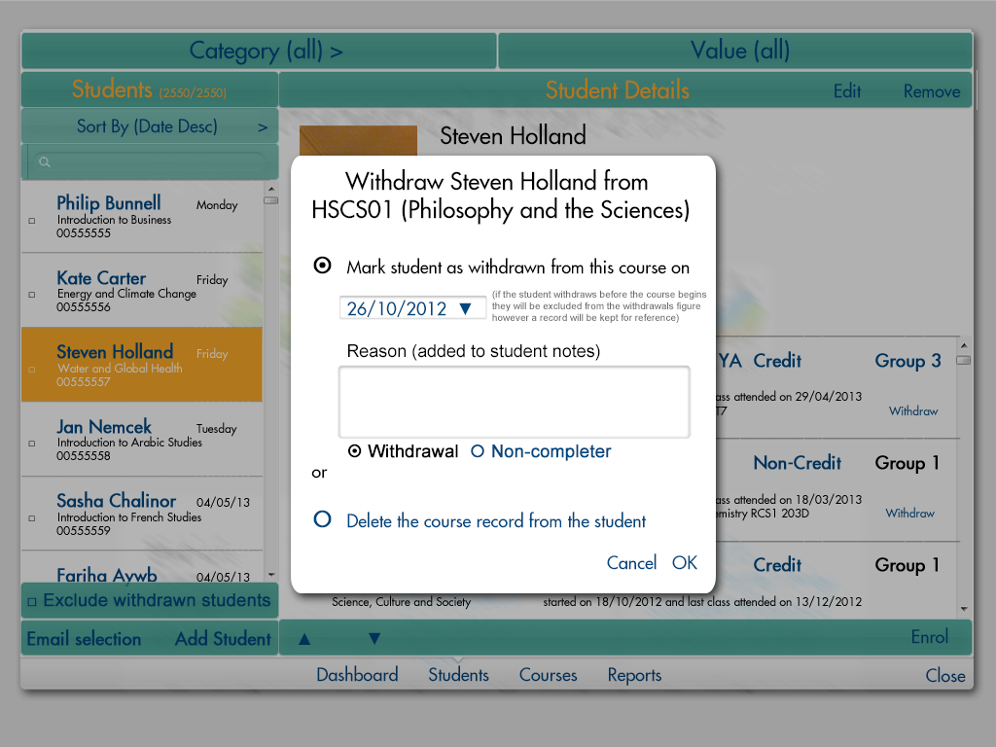

The dialogue now has notes next to the withdraw date to explain to the user that if the date is before the start of the course the student will not be included in the withdraw figures for that course and will not be regarded as withdrawn for the purposes of the register (i.e. they will not appear). The user can also let the system know if the student's withdrawal should be counted as an actual 'Withdrawal' or as a 'Non-completer'.

The interaction of this screen should be slightly changed. The reason textbox, date picker and radio buttons should be always enabled. When the user clicks on any of them the Mark students as withdrawn radio button should be selected automatically.

If a course has no classes then the student will be treated as a standard withdrawal until classes are assigned, at which the start date of the first class will determine the type of withdrawal.

The Export All export will show 'Non-completer' as well as 'Active' and 'Withdrawn' in the Active/Withdrawn column.

In the student enrolment list on the students screen Non-completers will be marked as 'Non-completer' rather than Withdrawn. The Undo withdrawal facility will still be available.

Pre-course withdrawals will show on the student enrolment list in the usual way except (Pre-course) will be shown after the word Withdrawn. Again the Undo facility will be available in the usual way.

### Pre-course Withdrawal Notes Label

**Type** Label

**Text** As per screen-shot

**Fonts** Arial around 12 in a style and relative size as per screen-shot.

**Colours** Grey as per screen-shot.

**Position** As per screen-shot.

**Alignment** As per screen-shot.

**Limits** N/A

**Default value** N/A

**Items** N/A

**Tool-tips** N/A

**Interactions** N/A

**Calculations** N/A

**Validation** N/A

### Withdrawal/Non-completer Radio Buttons

**Type** Radio buttons

**Text** As per screen-shot

**Fonts** Arial around 18pt in a style and relative size as per screen-shot.

**Colours** Black as per screen-shot for the selected item and Imperial Dark Blue for the unselected one

**Position** As per screen-shot.

**Alignment** As per screen-shot.

**Limits** N/A

**Default value** 'Withdrawal'

**Items** 'Withdrawal', 'Non-completer'

**Tool-tips** 'Select whether this student counts as a withdrawal from the course, or if there just did not take the exam (Non-completer)'

**Interactions** Standard behaviour

**Calculations** N/A

**Validation** N/A

### Permissions

The Withdraw dialogue is only available to admins.

# Student Screen Changes

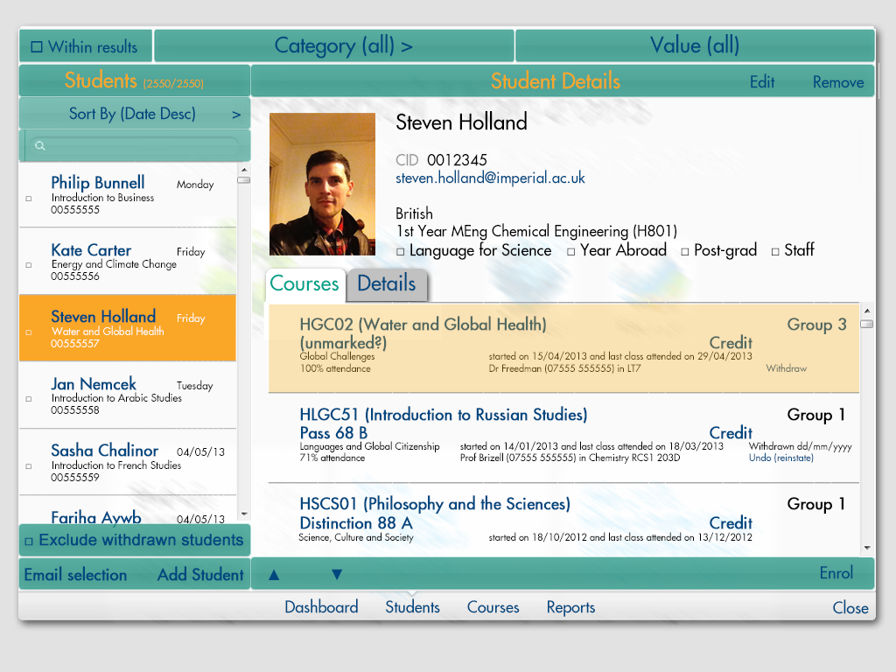

## Withdraw 'Undo' Handling

A new link has been added underneath the Withdrawn dd/mm/yyyy label which the user can click to reinstate the student onto the course. If the student is 'Withdrawn' over the period of any classes and then reinstated the missed classes will be marked as absent. The register can be amended manually if required and the student goes back to be recognised as an active member of the course. The undo link is only visible once a student has been marked as withdrawn from a particular course. A note will be put on the student notes to say they were reinstated with the corresponding date.

### Undo (reinstate) Link

**Type** Link

**Text** As per screen-shot

**Fonts** Arial around 11pt in a style and relative size as per screen-shot.

**Colours** Imperial Dark Blue

**Position** As per screen-shot.

**Alignment** As per screen-shot.

**Limits** N/A

**Default value** N/A

**Items** N/A

**Tool-tips** 'Click to mark this student as not withdrawn and as an active member of the course for the register etc'

**Interactions** Standard behaviour

**Calculations** N/A

**Validation** N/A

### Permissions

The Undo link is only visible to admins.

## Post-grad and Staff Handling

Check boxes have been added to the main section of the student information so the student can be marked as Post-grad and/or Staff which allows that information to be taken into account in reports, exports and calculations.

### Post-grad Checkbox

**Type** Checkbox

**Text** As per screen-shot

**Fonts** Arial around 18pt in a style and relative size as per screen-shot.

**Colours** Black

**Position** As per screen-shot.

**Alignment** As per screen-shot.

**Limits** N/A

**Default value** N/A

**Items** N/A

**Tool-tips** 'Click to mark this student as a Post-grad'

**Interactions** Standard behaviour

**Calculations** N/A

**Validation** N/A

### Staff Checkbox

**Type** Checkbox

**Text** As per screen-shot

**Fonts** Arial around 18pt in a style and relative size as per screen-shot.

**Colours** Black

**Position** As per screen-shot.

**Alignment** As per screen-shot.

**Limits** N/A

**Default value** N/A

**Items** N/A

**Tool-tips** 'Click to mark this student as Staff'

**Interactions** Standard behaviour

**Calculations** N/A

**Validation** N/A

### Permissions

Available to view for all users.

## Search within results

When the user selects the 'Within results' checkbox a space slides out underneath the filter to show the filters currently in place. When a filter is created (by selecting a category and value) the filter appears in text in the white space and the filter is applied. If another filter is created this is added to the list of filters and the next filter is applied in addition to the existing filter. If the 'Within results' checkbox is unchecked the white area slides away and the filters un-applied. Re-checking the checkbox will re-apply the last set of filters created. If a new filter is created while the 'Within results' checkbox is unchecked any existing filters will be cleared.

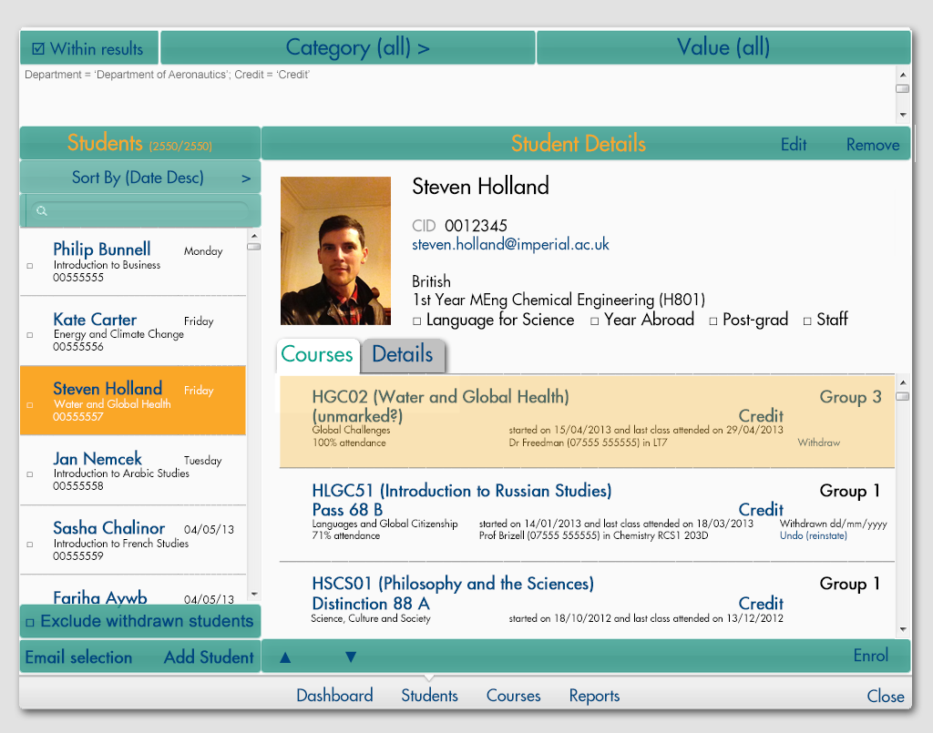

### Within results checkbox

**Type** Checkbox

**Text** As per screen-shot

**Fonts** Arial around 18pt in a style and relative size as per screen-shot.

**Colours** Imperial Dark Blue

**Position** As per screen-shot.

**Alignment** As per screen-shot.

**Limits** N/A

**Default value** N/A

**Items** N/A

**Tool-tips** 'Click to toggle searching within results'

**Interactions** Standard behaviour. Checking the box will slide open the filter textarea where filters are written and apply any existing filters. Clearing the checkbox will slide the filter textarea back and un-apply any filters. When a filter is created with the checkbox cleared any existing filters will also be cleared.

**Calculations** N/A

**Validation** N/A

### Filter Textarea

**Type** Textarea

**Text** As per screen-shot

**Fonts** Arial around 12pt in a style and relative size as per screen-shot.

**Colours** White background and grey text

**Position** As per screen-shot.

**Alignment** As per screen-shot.

**Limits** N/A

**Default value** N/A

**Items** N/A

**Tool-tips** N/A

**Interactions** Scrollbar will appear when necessary on some browsers, or be there permanently on others. Scrolling shows standard behaviour. Filters are shown here, there is no further interaction, users cannot type here.

**Calculations** N/A

**Validation** N/A

### Permissions

Available to all users

## Searching for archived students

The filters will normally only show students which have not been archived.

A new category will be added to the students filter 'Year' and the data dropdown will contain all the years for which there are students in the format yyyy-yy+1. A student is regarded as being associated with a particular year if they were in a group associated with that year. The filter will then ignore the archive flag and the user can search within results to pick out particular ranges of students.

Another category will be added called 'Archive' and the data dropdown will contain the items 'Archived', 'Not archived' and 'All'. If the user selects 'Archived' then only archived students will be returned by the filter. If they select 'Not archived' then only non-archived students will be returned, and if they select 'All' then all students will be returned regardless of their archive status. The user can search within results to further refine the range.

Searching for a student n the search box will show the matching student regardless of their archive status.

### Permissions

Available to all users.

# Import Students

## Student Upload Data Selection Dialogue

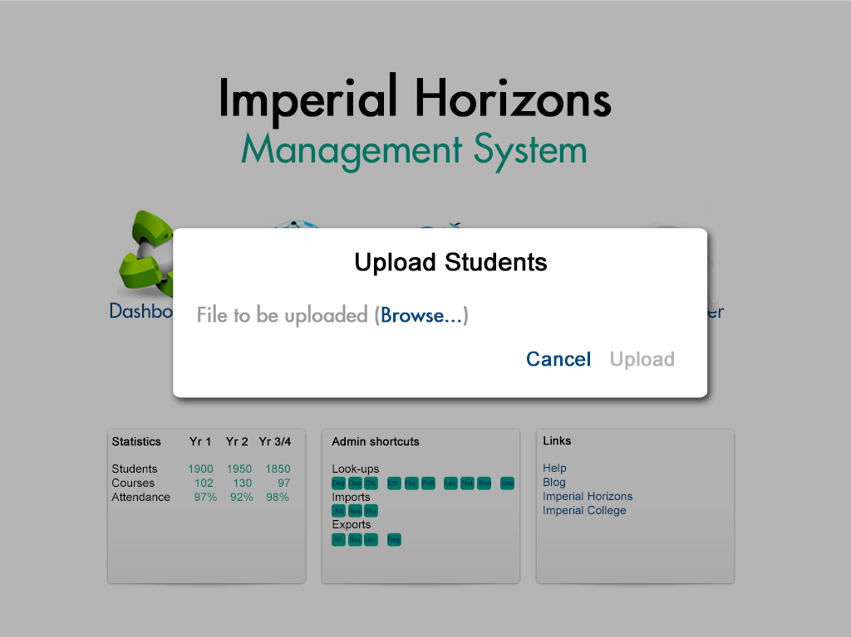

This screen allows the user to select the student data file from the local network and upload it to the system where it will be processed and the system updated.

### Main Title Label

**Type** Label

**Text** As per screen-shot.

**Fonts** Bold Arial around 30pt.

**Colours** Black

**Position** As per screen-shot.

**Alignment** Centre

**Limits** N/A

**Default value** N/A

**Items** N/A

**Tool-tips** N/A

**Interactions** N/A

**Calculations** N/A

### File to be uploaded label and link

**Type** Label and link.

**Text** As per screen-shot.

**Fonts** Bold Arial around 24pt.

**Colours** Grey for the label and Imperial Dark Blue for the link

**Position** As per screen-shot.

**Alignment** Left

**Limits** N/A

**Default value** N/A

**Items** N/A

**Tool-tips** N/A

**Interactions** When the link is clicked on the name of the file is put alongside the Browse link and the Upload link is enabled and turned Imperial Dark Blue. Standard mouseover behaviour.

**Calculations** N/A

### Cancel and Upload links

**Type** Links

**Text** As per screen-shot.

**Fonts** Bold Arial around 24pt.

**Colours** Imperial Dark Blue. The Upload link is Grey when disabled. It is initially disabled and turns Imperial Dark Blue when enabled.

**Position** As per screen-shot.

**Alignment** Right

**Limits** N/A

**Default value** N/A

**Items** N/A

**Tool-tips** N/A

**Interactions** Mouseovers on both links will result in standard behaviour. Clicking on the Cancel link will close the screen. Clicking on the Upload link will disable the screen and show the Uploading and importing label as per the screen-shot below.

**Calculations** N/A

## Uploading Student Data Dialogue

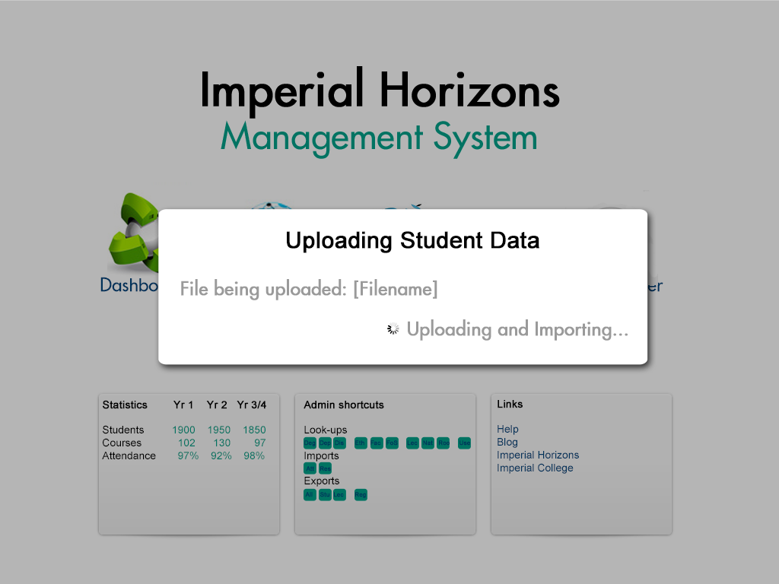

This screen is shown while the file is being uploaded and imported. Once complete the dialogue will change to the Student Data Imported Dialogue.

### Main title label

**Type** Label

**Text** As per screen-shot.

**Fonts** Bold Arial around 30pt.

**Colours** Black

**Position** As per screen-shot.

**Alignment** Centre

**Limits** N/A

**Default value** N/A

**Items** N/A

**Tool-tips** N/A

**Interactions** N/A

**Calculations** N/A

### File being uploaded label

**Type** Label

**Text** As per screen-shot except the [Filename] is replaced with the name of the actual file being uploaded.

**Fonts** Bold Arial around 24pt.

**Colours** Grey

**Position** As per screen-shot.

**Alignment** Left

**Limits** N/A

**Default value** N/A

**Items** N/A

**Tool-tips** N/A

**Interactions** N/A

**Calculations** N/A

### Uploading and importing label

**Type** Label

**Text** As per screen-shot.

**Fonts** Bold Arial around 24pt.

**Colours** Grey

**Position** As per screen-shot.

**Alignment** Right

**Limits** N/A

**Default value** N/A

**Items** N/A

**Tool-tips** N/A

**Interactions** N/A

**Calculations** N/A

## Student Data Uploaded Dialogue

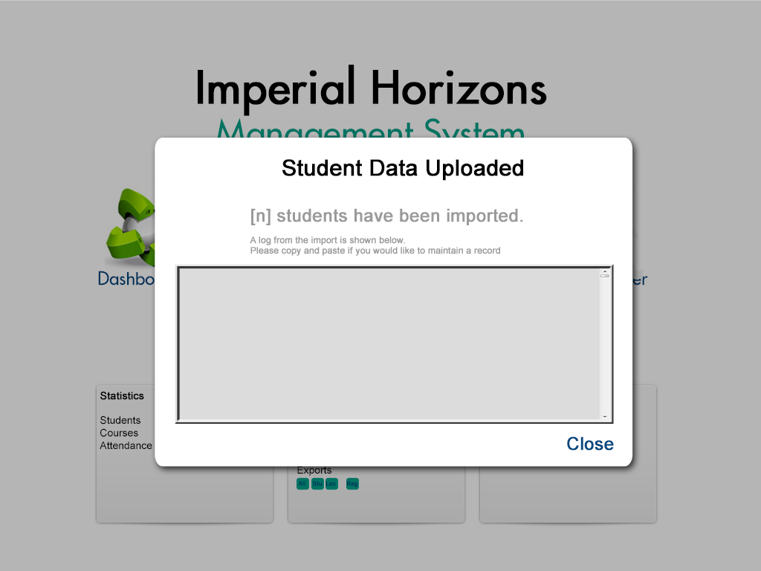

This screen-shot shows the results of the import.

### Title and information labels

**Type** Labels

**Text** As per screen-shot.

**Fonts** Bold Arial around 30pt for the title, Bold Arial around 24pt for the results information and Arial around 12pt for the information label.

**Colours** Black and Grey.

**Position** As per screen-shot.

**Alignment** Title is centre-aligned. Results information is left-aligned as is the information text. The Results and information are centrally positioned as per the screen-shot in order to maintain layout balance.

**Limits** N/A

**Default value** N/A

**Items** N/A

**Tool-tips** N/A

**Interactions** N/A

**Calculations** N/A

### Feedback textbox

**Type** Textbox

**Text** N/A

**Fonts** Arial around 12pt.

**Colours** Light Grey background. Black text.

**Position** As per screen-shot.

**Alignment** Left

**Limits** N/A

**Default value** N/A

**Items**

'n' students have been added

'm' existing students have been updated

'o' fields of study have been added

'p' groups have been added

'q' lecturers have been added

'r' rooms have been added

Student [Forename] [Surname] ([CID]) - Row 'a' - could not be imported because [Reason]

**Tool-tips** N/A

**Interactions** The text in the textbox is read-only, however the scrollbar can be used and the cursor can be positioned and text selected etc.

**Calculations** N/A

### Close link

**Type** Link

**Text** As per screen-shot.

**Fonts** Bold Arial around 24pt.

**Colours** Imperial Dark Blue.

**Position** As per screen-shot.

**Alignment** Right

**Limits** N/A

**Default value** N/A

**Items** N/A

**Tool-tips** N/A

**Interactions** Mouseovers will result in standard behaviour. Clicking on the link will close the screen.

**Calculations** N/A

## Students Data Import File Format

The import file is an Excel spreadsheet in xls format. The first row contains field titles.

|  |  |  |
| --- | --- | --- |
| **Column Position** | **Column Name** | **Expected data** |
| A(1) | CID | Text (normally in the format '00######') - *Are they unique? What to do if already in database?* |
| B(2) | Course Code Autumn Term | Text (normally between 4 and 6 characters but allow up to 50). May be blank if the course is not run on that term. |
| C(3) | Course Code Spring Term | Text. May be blank if the course is not run on that term. *Does blank ever mean the course is over 2 terms?* |
| D(4) | Course Name Autumn Term | Text. May be blank if the course is not run on that term. *What do we do with existing values (i.e. if new value is different from old one and old one is not blank)?* |
| E(5) | Course Name Spring Term | Text. May be blank if the course is not run on that term. *What do we do with existing values (i.e. if new value is different from old one and old one is not blank)?* |
| F(6) | Title | Text. *What do we do with existing values (i.e. if new value is different from old one and old one is not blank)?* |
| G(7) | Forename | Text. *What do we do with existing values (i.e. if new value is different from old one and old one is not blank)?* |
| H(8) | Surname | Text. *What do we do with existing values (i.e. if new value is different from old one and old one is not blank)?* |
| I(9) | Faculty | Text. *How to deal with unmatched faculties? What do we do with existing values (i.e. if new value is different from old one and old one is not blank)?* |
| J(10) | Department | Text. *How to deal with unmatched departments? What do we do with existing values (i.e. if new value is different from old one and old one is not blank)?* |
| K(11) | Degree Code | Text. *How to deal with unmatched degrees? What do we do with existing values (i.e. if new value is different from old one and old one is not blank)?* |
| L(12) | Email | Text. *What do we do with existing values (i.e. if new value is different from old one and old one is not blank)?* |
| M(13) | Username | Text. *What do we do with existing values (i.e. if new value is different from old one and old one is not blank)?* |
| N(14) | Phone 1 (Primary) | Text. *What do we do with existing values (i.e. if new value is different from old one and old one is not blank)?* |
| O(15) | Phone 1 Type | Text. *Do we ignore this?* |
| P(16) | Phone 1 Created On | Text. *Do we ignore this?* |
| Q(17) | Phone 2 | Text. *Do we ignore this?* |
| R(18) | Phone 2 Type | Text. *Do we ignore this?* |
| S(19) | Phone 2 Created On | Text. *Do we ignore this?* |
| T(20) | Phone 3 | Text. *Do we ignore this?* |
| U(21) | Phone 3 Type | Text. *Do we ignore this?* |
| V(22) | Phone 3 Created On | Text. *Do we ignore this?* |
| W(23) | Gender | Text. 'Male' or 'Female' maps to values in database. *What happens if unmatched? What do we do with existing values (i.e. if new value is different from old one and old one is not blank)?* |
| X(24) | Domicile | Text. 'Home', 'Overseas' or 'European Union'. *What is 'ZELQ-Home' and 'Channel Islands and Isle of Man' etc? What happens if unmatched? What do we do with existing values (i.e. if new value is different from old one and old one is not blank)?* |
| Y(25) | Ethnicity | Text. *What happens if unmatched? What do we do with existing values (i.e. if new value is different from old one and old one is not blank)?* |
| Z(26) | Nationality | Text. *What happens if unmatched? What do we do with existing values (i.e. if new value is different from old one and old one is not blank)?* |
| AA(27) | Disability | Text. *What happens if unmatched? What do we do with existing values (i.e. if new value is different from old one and old one is not blank)?* |
| AB(28) | YIE | Text. *No data in example spreadsheet. How should it appear? What do we do with existing values (i.e. if new value is different from old one and old one is not blank)?* |
| AC(29) | Combined Degree | Text. *No data in example spreadsheet. How should it appear? What do we do with existing values (i.e. if new value is different from old one and old one is not blank)?* |
| AD(30) | Year of study | Numeric. If greater than 4 then put in year 3/4. If unmatched then leave blank. *What do we do with existing values (i.e. if new value is different from old one and old one is not blank)?* |
| AE (31) | Credit/Non-credit | Text. Either 'C' or 'NC' mapping to Credit/Non-credit in the database respectively. *How should we deal with unmatched ones?* |
| AF (32) | Field of study  (Autumn Term/Full Year) | Text. Maybe blank if course is for the spring term only. *How do with deal with unmatched? What do we do with existing values (i.e. if new value is different from old one and old one is not blank)?* |
| AG(33) | Group  (Autumn Term/Full Year) | Text. Maybe blank if course is for the spring term only. *How do with deal with unmatched?* |
| AH (34) | Lecturer  (Autumn Term/Full Year) | Text. Maybe blank if course is for the spring term only. *How do with deal with unmatched? What do we do with existing values (i.e. if new value is different from old one and old one is not blank)?* |
| AI (35) | Room  (Autumn Term/Full Year) | Text. Maybe blank if course is for the spring term only. *How do with deal with unmatched? What do we do with existing values (i.e. if new value is different from old one and old one is not blank)?* |
| AJ (36) | Field of Study  (Spring Term only) | Text. Maybe blank if course is for the autumn term only. *Will it be blank if course is for 2 terms? How do with deal with unmatched? What do we do with existing values (i.e. if new value is different from old one and old one is not blank)?* |
| AK (37) | Group  (Spring Term only) | Text. Maybe blank if course is for the autumn term only. *Will it be blank if course is for 2 terms? How do with deal with unmatched?* |
| AL (38) | Lecturer  (Spring Term only) | Text. Maybe blank if course is for the autumn term only. *Will it be blank if course is for 2 terms? How do with deal with unmatched? What do we do with existing values (i.e. if new value is different from old one and old one is not blank)?* |
| AM (39) | Room  (Spring Term only) | Text. Maybe blank if course is for the autumn term only. *Will it be blank if course is for 2 terms? How do with deal with unmatched? What do we do with existing values (i.e. if new value is different from old one and old one is not blank)?* |
| AN (40) | Library Code | Text. *What do we do with existing values (i.e. if new value is different from old one and old one is not blank)?* |
| AO (41) | Other | (ignore) |

Any additional fields in the file will be ignored if they appear after these first 41 columns. The data will be determined by column position as opposed to column name.

The result will be mapped against students using the CID field. A new import button will be added to the switchboard with the letters 'Stu' and the tooltip "Import student data".

*The import file will be validated prior to import (slight change to screens required). Should courses be created as Credit/Non-credit etc?*

## Permissions

Importing is only available to admins.

# Import Library Barcodes

## Library Barcode Update Data Selection Dialogue

This will be essentially the same as the Student Upload Data Selection Dialogue (see page ) except instead of saying Upload Students in the title it will say 'Upload Library Barcodes'.

The rest of the behaviour and appearance of the dialogue will be essentially the same.

## Uploading Library Barcode Data Dialogue

This will be essentially the same as the Uploading Student Data Selection Dialogue (see page ) except instead of saying Uploading Student Data in the title it will say 'Uploading Library Barcode Data'.

The rest of the behaviour and appearance of the dialogue will be essentially the same.

## Library Barcode Data Uploaded Dialogue

This will be essentially the same as the Student Data Uploaded Dialogue (see page ) except:

i. Instead of saying Student Data Uploaded in the title it will say Library Barcode Data Uploaded'.

ii. Instead of saying [n] students have been imported it will say '[n] library barcodes have been imported.'

ii. The log will have the following feedback:

For students with unmatched CIDs:

"Student with CID: [" & [CID] & "] - Row (" & [row] & ") could not be found in the system."

For students with a barcode in an invalid format (including nulls - write nulls as '(null)')

"Student with CID: [" & [CID] & "] - Row (" & [row] & ") has a library barcode in an invalid format '[LibraryBarcode]' and could not be entered into the system."

For students with a barcode in a non-unique barcode:

"Student with CID: [" & [CID] & "] - Row (" & [row] & ") has a library barcode which has been assigned to another student [[MatchingStudentCID]] and could not be entered into the system."

For invalid file formats:

"File [Filename] is in an invalid format and could not be imported"

The rest of the behaviour and appearance of the dialogue will be essentially the same.

A new import button will be added to the Switchboard labelled 'Lib' with the tooltip "Import library barcodes".

## Library Barcode Data Import File Format

The import file is an Excel spreadsheet in xls format. The first row contains field titles.

|  |  |  |
| --- | --- | --- |
| **Column Position** | **Column Name** | **Expected data** |
| A(1) | CID | Text (normally in the format '00######') - *Are they unique? What to do if already in database?* |
| B(2) | Library barcode | Text (normally 10 characters) |

## Permissions

Importing is only available to admins.

# Course Screen Changes

## Search within results

When the user selects the 'Within results' checkbox a space slides out underneath the filter to show the filters currently in place. When a filter is created (by selecting a category and value) the filter appears in text in the white space and the filter is applied. If another filter is created this is added to the list of filters and the next filter is applied in addition to the existing filter. If the 'Within results' checkbox is unchecked the white area slides away and the filters un-applied. Re-checking the checkbox will re-apply the last set of filters created. If a new filter is created while the 'Within results' checkbox is unchecked any existing filters will be cleared.

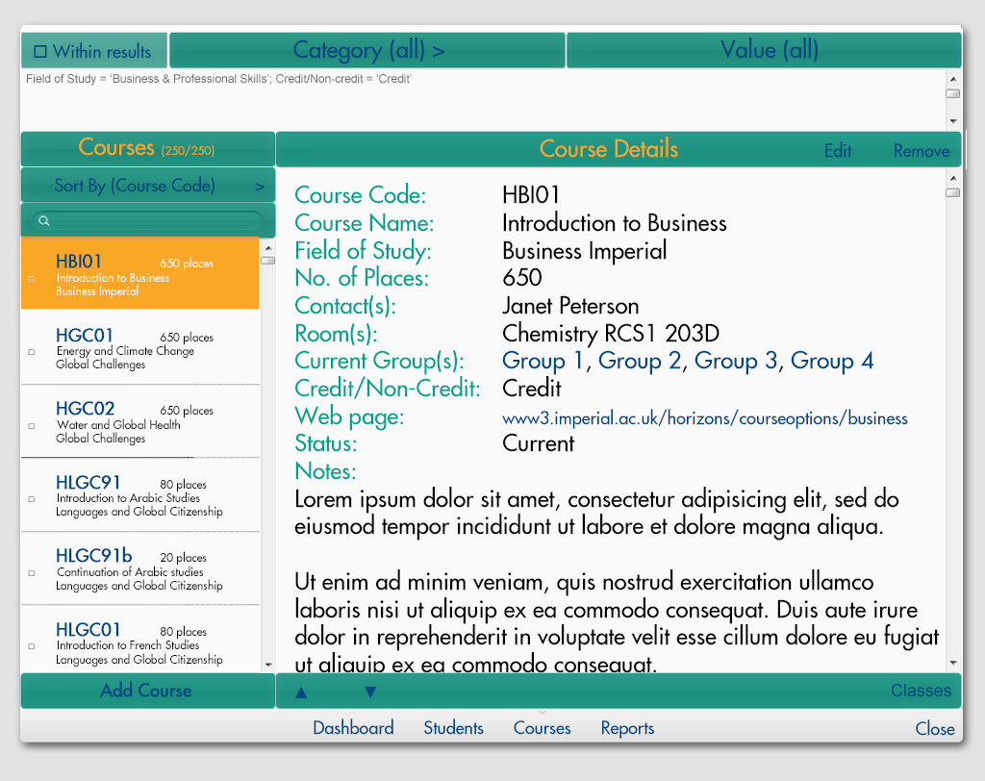

### Within results checkbox

**Type** Checkbox

**Text** As per screen-shot

**Fonts** Arial around 18pt in a style and relative size as per screen-shot.

**Colours** Imperial Dark Blue

**Position** As per screen-shot.

**Alignment** As per screen-shot.

**Limits** N/A

**Default value** N/A

**Items** N/A

**Tool-tips** 'Click to toggle searching within results'

**Interactions** Standard behaviour. Checking the box will slide open the filter textarea where filters are written and apply any existing filters. Clearing the checkbox will slide the filter textarea back and un-apply any filters. When a filter is created with the checkbox cleared any existing filters will also be cleared.

**Calculations** N/A

**Validation** N/A

### Filter Textarea

**Type** Textarea

**Text** As per screen-shot

**Fonts** Arial around 12pt in a style and relative size as per screen-shot.

**Colours** White background and grey text

**Position** As per screen-shot.

**Alignment** As per screen-shot.

**Limits** N/A

**Default value** N/A

**Items** N/A

**Tool-tips** N/A

**Interactions** Scrollbar will appear when necessary on some browsers, or be there permanently on others. Scrolling shows standard behaviour. Filters are shown here, there is no further interaction, users cannot type here.

**Calculations** N/A

**Validation** N/A

## Searching for archived courses

The filters will normally only show courses which have not been archived.

A new category will be added to the courses filter 'Year' and the data dropdown will contain all the years for which there are courses in the format yyyy-yy+1. A course is regarded as being associated with a particular year if it has groups associated with it that belong to that year. The filter will then ignore the archive flag and the user can search within results to pick out particular ranges of courses.

Another category will be added called 'Archive' and the data dropdown will contain the items 'Archived', 'Not archived' and 'All'. If the user selects 'Archived' then only archived courses will be returned by the filter. If they select 'Not archived' then only non-archived courses will be returned, and if they select 'All' then all courses will be returned regardless of their archive status. The user can search within results to further refine the range.

Searching for a course in the search box will show the matching course regardless of its archive status.

## Permissions

Available to all users.

# Per User Usage Log

The usage log appears in the format shown below. The main title is not repeated for multiple pages though the grid title is. It shows, with the most recent first, all the logins of the selected user between the selected dates.

**Logins by [Username] between [StartDate] and [EndDate]**

Most recent login shown first

|  |  |
| --- | --- |
| **Login** | **Login date and time** |
| 1 | dddd ddss mmmm yyyy at hh:mm |
| 2 | dddd ddss mmmm yyyy at hh:mm |
| 3 | dddd ddss mmmm yyyy at hh:mm |
| 4 | dddd ddss mmmm yyyy at hh:mm |
| 5 | dddd ddss mmmm yyyy at hh:mm |
| 6 | dddd ddss mmmm yyyy at hh:mm |
| 7 | dddd ddss mmmm yyyy at hh:mm |
| 8 | dddd ddss mmmm yyyy at hh:mm |
| 9 | dddd ddss mmmm yyyy at hh:mm |
| 10 | dddd ddss mmmm yyyy at hh:mm |
| 11 | dddd ddss mmmm yyyy at hh:mm |
| 12 | dddd ddss mmmm yyyy at hh:mm |
| 13 | dddd ddss mmmm yyyy at hh:mm |
| 14 | dddd ddss mmmm yyyy at hh:mm |
| 15 | dddd ddss mmmm yyyy at hh:mm |
| 16 | dddd ddss mmmm yyyy at hh:mm |
| 17 | dddd ddss mmmm yyyy at hh:mm |
| 18 | dddd ddss mmmm yyyy at hh:mm |
| 19 | dddd ddss mmmm yyyy at hh:mm |

**Total number of logins over time period: 19**

[PageNumber]

## Select User Log Details Dialogue

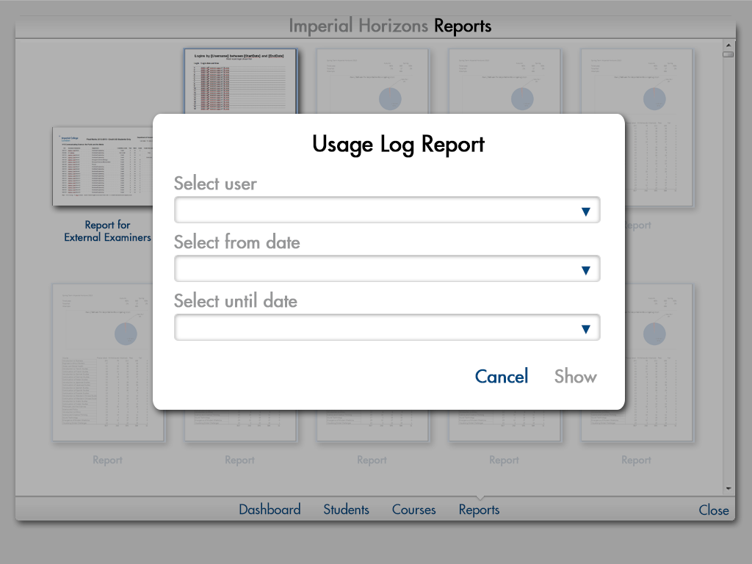

From this dialogue the user can select the date range and user to view the log for. The 'from' and 'until' dates will default to the last month, but these can be changed as necessary.

The report is accessed from the standard reports selection screen.

### User dropdown

**Type** Label and dropdown

**Text** As per screen-shot

**Fonts** Arial around 24pt in a style and relative size as per screen-shot.

**Colours** Grey label text and black dropdown text

**Position** As per screen-shot.

**Alignment** As per screen-shot.

**Limits** N/A

**Default value** (blank)

**Items** All users in the system ordered alphabetically by user name.

**Tool-tips** N/A

**Interactions** Standard behaviour

**Calculations** N/A

**Validation** A user must be selected or the Show link will remain disabled.

### Select from date date-picker

**Type** Label and date-picker

**Text** As per screen-shot

**Fonts** Arial around 24pt in a style and relative size as per screen-shot.

**Colours** Grey label text and black date-picker text

**Position** As per screen-shot.

**Alignment** As per screen-shot.

**Limits** N/A

**Default value** [Today's date minus 1 month]

**Items** N/A

**Tool-tips** Select the beginning date for the log you would like to view (i.e. this is the oldest date).

**Interactions** Standard behaviour

**Calculations** N/A

**Validation** Must be older than the until date or the Show link will be disabled.

### Select until date date-picker

**Type** Label and date-picker

**Text** As per screen-shot

**Fonts** Arial around 24pt in a style and relative size as per screen-shot.

**Colours** Grey label text and black date-picker text

**Position** As per screen-shot.

**Alignment** As per screen-shot.

**Limits** N/A

**Default value** [Today's date]

**Items** N/A

**Tool-tips** Select the end date for the log you would like to view (i.e. this is the most recent date).

**Interactions** Standard behaviour

**Calculations** N/A

**Validation** Must be more recent than the from date or the Show link will be disabled.

### Cancel link

**Type** Link

**Text** As per screen-shot

**Fonts** Arial around 24pt in a style and relative size as per screen-shot.

**Colours** Imperial Dark Blue

**Position** As per screen-shot.

**Alignment** As per screen-shot.

**Limits** N/A

**Default value** N/A

**Items** N/A

**Tool-tips** N/A

**Interactions** Closes the dialogue and reveals the reports screen shown beneath.

**Calculations** N/A

**Validation** N/A

### Show link

**Type** Link

**Text** As per screen-shot

**Fonts** Arial around 24pt in a style and relative size as per screen-shot.

**Colours** Grey when disabled and Imperial Dark Blue when enabled

**Position** As per screen-shot.

**Alignment** As per screen-shot.

**Limits** N/A

**Default value** Disabled

**Items** N/A

**Tool-tips** When enabled 'Click to show the report'. When disabled 'Please select a valid user and date range'.

**Interactions** When enabled it shows the usage log report as a pdf.

**Calculations** N/A

**Validation** N/A

## Permissions

The per user usage log report is only available to admins.

# 'Ghost' Class Handling

Ghost classes are not included in official attendance figures though it is possible to view attendance by going to the register for that group. Groups are created as Ghost groups and all classes within them are regarded as 'ghost' classes. A student may be on an official course assigned to a particular group and also be in a ghost group for that course too. When results are imported no marks are assigned to ghost groups and they are ignored for the purposes of results. They are not regarded as a student's current course but they do count as belonging to a course.

Ghost groups will be shown in the list of a students enrolments except it is marked as '(Ghost)' after the course name. The Withdraw link is changed to 'Remove' and will put a note on the student's record saying "Removed from course [CourseName: GroupName] on [Date]". The student will be completely removed from the course/group.

There is no mark text for Ghost groups.

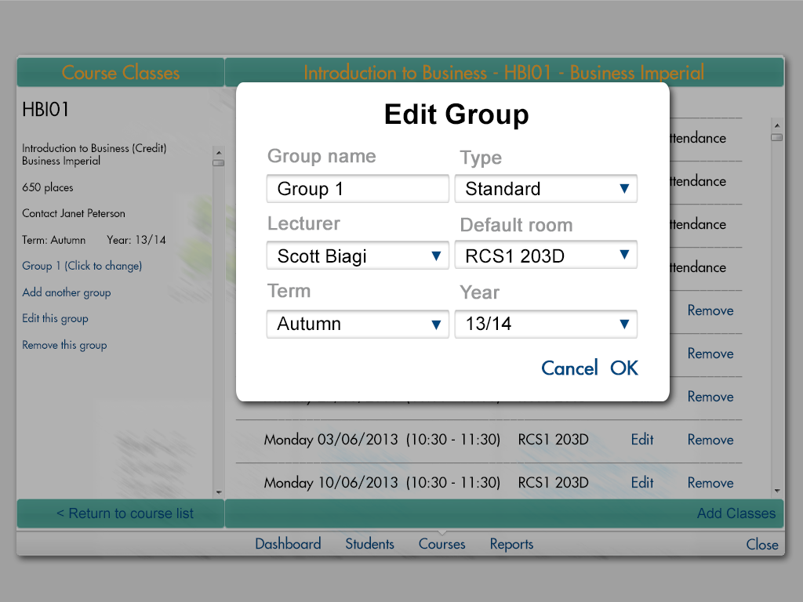

### Type dropdown

**Type** Dropdown and label

**Text** As per screen-shot

**Fonts** Arial around 24pt in a style and relative size as per screen-shot.

**Colours** Grey label and Black text in dropdown

**Position** As per screen-shot.

**Alignment** As per screen-shot.

**Limits** N/A

**Default value** 'Standard'

**Items** 'Standard', 'Ghost'

**Tool-tips** Select Ghost if you do not want classes from this group to be included for attendance and results calculations and reports.

**Interactions** Standard behaviour

**Calculations** N/A

**Validation** N/A

## Permissions

Available to all users who have access to the group/class editing facilities.

# Email Students Enhancement

This screen operates in the same way as the email all students from the register screen. The list is populated from the selected filter on the students screen, but new students can be added by typing their names into the add box at the bottom of the list of names.

