Single-Mode Kerr Inference Bias in the Early Ringdown of GW250114: Magnitude and Origin
Attia A. Gadallah¹ and Zi-Kui Liu²
¹Independent Researcher, State College, Pennsylvania 16801, USA
²Department of Materials Science and Engineering, The Pennsylvania State University, University Park, Pennsylvania 16802, USA
ORCID: A. A. Gadallah, https://orcid.org/0009-0006-3460-5819
Abstract
A numerical-relativity injection whose remnant mass is known and constant, analysed through the pipeline used here, reproduces the apparent decay of the inferred remnant mass that GW250114 shows: the trajectory is a property of the model fitted, not of the source. An unconstrained fit to the event's own data recovers the remnant's fundamental frequency at the first start time, so the departure measures the cost of describing the signal with a mass and a spin alone rather than a loss of information. We invert the (l,m,n) = (2,2,0) quasi-normal-mode frequency and damping time at 21 successive ringdown start times, spaced by one geometric mass unit M of the remnant; masses and areas are quoted in the source frame throughout. The inferred mass falls steadily from 75.3 (+3.6/−4.5) M⊙ at the earliest start time (81.8 M⊙ in the detector frame) to a late-time mean of 57.93 M⊙, crossing the global posterior anchor of 62.71 M⊙ at t0 = 14.2 M. At the earliest it exceeds not only that anchor but the entire pre-merger mass budget, by 3.87 σ with the two marginal posteriors treated as independent — an excess that holds in either frame, and the sharpest evidence that the quantity recovered there is an effective parameter. A multi-mode (2,2,0)+(2,2,1)+(2,2,2) fit removes 62% of the departure, as expected if unmodelled overtone content is its origin; significance is assessed with block-permutation and phase-randomization surrogates accounting for the overlap between neighbouring analyses. The departure decays with a timescale of 11.2 M against a Kerr (2,2,0) damping time of 12.1 M, a ratio of 0.92 in either frame — a consistency rather than a measurement, since a linear decline describes the fitted interval equally well and the timescale is determined only to about a factor of two. The inferred horizon area exceeds the pre-merger total at every start time, ending 36.5% above it; the area theorem is tested against the late-time inferred area in the Supplementary Material (S5), at 4.2 σ.
Keywords: gravitational waves, quasi-normal modes, black hole ringdown, Kerr geometry, GW250114

Introduction

Gravitational-wave (GW) astronomy has enabled direct measurements of binary black hole coalescence parameters through templated Bayesian inference [1], [2]. These analyses typically yield static posterior summaries for source properties such as component masses, final remnant mass, and final remnant spin. While this framework is indispensable, it does not by itself provide a time-resolved description of how the inferred Kerr parameters obtained from localized ringdown fits evolve as the signal transitions from a multi-mode regime to a single-mode regime.

The post-merger signal of a binary black hole coalescence is typically described by the quasi-normal modes (QNMs) of a perturbed Kerr black hole [3], [4]. Fitting the dominant $(2,2,0)$ mode within localized temporal windows tracks the single-mode inferred mass and spin, $M_{f}(t)$ and $χ_{f}(t)$, as transient contributions decay and the fundamental comes to dominate. Previous work on QNM spectroscopy [5], [6], [7] has established the feasibility of extracting single-mode inferred parameters from gravitational-wave signals, while studies of the ringdown start time [8], [9] have clarified the regime in which a linear QNM description is most applicable. Giesler et al. [10] established, on a numerical-relativity waveform consistent with GW150914, that the post-merger signal admits a linear description from the peak of the strain onward once overtones of the fundamental mode are included, and that the start-time dependence of a single-mode fit is the observational signature of that overtone content; the same model applied to the event’s own data gave evidence for that overtone [5], whose statistical significance was subsequently disputed by Cotesta et al. [11], who attributed much of it to noise. The present analysis does not revisit that detection question. It takes the start-time dependence as the observable and asks instead how large the resulting bias in the inferred Kerr parameters is, how it decays, how much of it a multi-mode model removes, and whether the information the single-mode fit appears to lose is present in the data at all.

Ringdown analyses do not directly measure the physical remnant mass of a newly formed black hole; they infer the Kerr parameters of the model that best reproduces the post-merger signal. When the signal contains transient contributions not represented in the adopted model, the inferred Kerr parameters become effective quantities that depend on the model completeness. Three quantities are therefore kept distinct throughout: the inspiral-merger-ringdown remnant mass, obtained from the complete waveform and taken here as the best available estimate of the physical remnant; the ringdown Kerr mass, obtained by inverting a measured quasi-normal-mode frequency and damping time; and the effective Kerr mass, which is what that inversion returns when an incomplete model is fitted to a signal containing more than the model describes. The trajectory presented below tracks the third of these, and the distance between it and the first is the bias this work quantifies.

Existing studies typically explore this dependence through discrete start-time analyses. Here a sequential QNM inversion of GW250114 at 21 successive ringdown start times yields a continuous time-resolved trajectory of the single-mode inferred mass and spin, and with it the breakdown and recovery of the single-mode approximation.
Relative to the earlier overtone analyses [10], [11], which addressed whether overtone content is present in a ringdown and whether its evidence is statistically significant, the contribution here is quantitative and time-resolved: a continuous bias trajectory with a measured decay timescale, an attribution budget stating what fraction of the bias a three-mode model removes and how the remainder behaves, a numerical-relativity injection of matched configuration that reproduces the same biased signature while recovering its injected truth, and a comparison against an unconstrained fit to the event's own data, which recovers the remnant's fundamental frequency at the first start time. Three further analyses of this event approach the same window dependence by other routes: an orthonormalised quasinormal-mode basis, which removes the correlation between non-orthogonal modes and raises the first overtone's significance from 82.5% to 99.9% [12]; a deterministic frequency-extraction bound that identifies which finite windows support spectroscopy at all [13]; and a linear-signal treatment of the bias unmodelled overtones induce, validated against Bayesian sampling [14]. None measures the time-resolved trajectory reported here. The wider literature brackets the same problem from three other directions: the quasi-normal mode content of numerical-relativity ringdowns has been catalogued across a wide range of start times [15]; the parameter bias that mode truncation induces has been quantified for space-based sources, where three to six modes are needed to avoid it [16]; and the practical utility of each additional overtone has been shown to decrease rather than to reach a maximum [17]. The same single-mode difficulty has since been reported on another loud event: two-mode fits to GW231123 return remnant parameters consistent with its full-signal analysis where one-mode fits do not [18]. Two analyses released with the event and not produced here — a rational-filter mode detection and an inspiral-merger-ringdown consistency test — are used as external checks on the attribution, and the collaboration's released posteriors as a direct check on the trajectory; in this sense the analysis is complementary to the LIGO-Virgo-KAGRA collaboration’s companion study of GW250114 [8].

Data and Methodology

Source Parameters and Posterior Anchors
The analysis is based on the GW250114 strain time series $h(t)$ and posterior samples obtained from a Bilby [2] analysis using the NRSur7dq4 surrogate waveform family [19]. The strain data are conditioned using standard LIGO-Virgo-KAGRA procedures, and the power spectral density (PSD) of the detector noise is estimated with the BayesWave algorithm. Calibration uncertainties are marginalised in the full-signal analysis; the ringdown fits use a fixed noise model derived from it and do not marginalise calibration. Table 1 summarizes the global source-frame parameters that serve as reference anchors throughout this work. Unless stated otherwise, all masses and areas are quoted in the source frame; the corresponding detector-frame quantities are larger by the redshift factor (1+z) and are given explicitly where they appear (e.g., the early-time effective mass in Sec. IV.D). We adopt z = 0.0856, the median of the Bilby redshift posterior, i.e. 1 + z = 1.0856.

Table 1: Global source-frame parameters for GW250114 from the Bilby NRSur7dq4 posterior analysis.
Parameter | Median | 90% CI
$$m_{1} [M_{⊙}]$$ | 33.58 | $$[32.73, 34.79]$$
$$m_{2} [M_{⊙}]$$ | 32.24 | $$[30.97, 33.08]$$
$$a_{1}$$ | 0.092 | $$[0.009, 0.300]$$
$$a_{2}$$ | 0.100 | $$[0.010, 0.336]$$
$$M_{f} [M_{⊙}]$$ | 62.71 | $$[61.65, 63.68]$$
$$χ_{f}$$ | 0.676 | $$[0.665, 0.686]$$
$$E_{rad} [M_{⊙}c^{2}]$$ | 3.11 | —

The mass-energy budget of the coalescence is summarized by $M_{f}=m_{1}+m_{2}-E_{rad}/c^{2}≃62.7 M_{⊙}$, confirming that the true physical remnant mass is less than the total pre-merger mass ($m_{1}+m_{2}≃65.8 M_{⊙}$) by the energy radiated in gravitational waves. As shown in Sec. III, the effective mass obtained from a single-mode $(2,2,0)$ QNM fit in the earliest post-merger windows exceeds this budget. This apparent excess is a well-understood consequence of attributing the combined spectral content of multiple quasi-normal modes to a single Kerr solution [5, 8, 20]: the unmodeled overtone energy is absorbed into effective model parameters, which are not the physical remnant mass and spin.

Time-Domain Ringdown Extraction
To track the evolution of single-mode inferred Kerr parameters under localized fits, the post-merger signal is analysed at 21 successive ringdown start times extending from the merger reference time $t_{merger}$(defined by the peak strain amplitude) to approximately $6.74$ms afterward. Every start time is analysed over the same segment of data, 2458 samples at 4096 Hz spanning 0.6 s, so what advances from one fit to the next is the start time of the template and not the data it is fitted to.
Because the template is damped, the interval over which it carries signal is set instead by the damping time, whose median across the 21 start times is $4.59$ms. Successive start times advance by $≈0.337$ms, so adjacent fits share $∼92.7\%$of that interval. Measured in raw samples the segments are very nearly the same data, sharing 99.94%; the damping-time figure is the operative one, and every statement below about correlation between start times refers to it.
The start times lie on a geometric grid: the ringdown analysis steps in units of the remnant mass, M ≡ GMf/c³, one step per start time, so that the 21 start times span 0–20 M. For the remnant inferred here 1 M = 0.335 ms, and the 0.337 ms step quoted above is 1.005 M; the 0.5% difference reflects the reference mass of 68.41 M⊙ with which the run was configured, not any ambiguity in the grid. We quote t0 in units of M throughout. This is the unit in which the analysis was performed, and it makes the comparison against the Kerr damping time independent of frame: τ220 = 12.1 M in the source and detector frames alike. The overlap described above renders the inferred parameters a strongly correlated time series representing a continuous projection of the signal onto the chosen model family, rather than statistically independent measurements.

At each start time, the time-domain strain data are analyzed using the pyRing inference framework [21]. For the primary analysis the sampled template comprises the fundamental $(2,2,0)$ harmonic together with the (4,4,0) harmonic, and we report the (2,2,0) frequency and damping time from that fit; the (4,4,0) component is retained because it is part of the released configuration, and removing it would require re-running the inference rather than re-analysing it. The (4,4,0) is fixed by the same mass and spin and contains no overtone, so the template's only free spectral content is the fundamental, and Sec. IV.E shows that it does not move the recovered frequency; every quantity described below as single-mode refers to the (2,2,0) parameters so obtained. A strictly single-mode run of the same data is also available and is compared with the run used here in the Supplementary Information. The two differ by 1.09 M⊙ on average over the 21 start times they share, and by +2.71 M⊙ at the first start time, where the central claim of this work is made — a displacement of +0.83 σ of the combined 90% uncertainty, with the pure single-mode template returning the larger mass. No conclusion drawn below changes under the template choice. The analysis configuration is set out in Sec. S9 of the Supplementary Material.

The extrinsic parameters are not sampled here: the reference peak time, the mass scale and the sky location are those of the released configuration [9], which adopts them in turn from the full-signal analysis [8]. The per-start-time uncertainties quoted throughout are marginal posterior widths. Any fit performed across start times using them therefore treats the windows as independent, which they are not; Sec. IV.A quantifies what that assumption costs.

Kerr QNM Inversion
For each ringdown start time, the quality factor is computed as $Q=πf_{220}τ_{220}$. $χ_{f}$ is then obtained by numerically inverting the Berti fitting relation [3]. This inversion of the measured (f220, τ220) posteriors, retaining only samples that admit a physical Kerr solution, is the estimator used throughout the paper, including the appendix diagnostics. The retained fraction is 100% at the first start time and at least 98% at 18 of the 21, falling to 56% at 9 M and to about 77% at 10 M and 12 M, where the recovered quality factor pushes against the Kerr bound. Because nothing is discarded at the first start time, every quantity built on it is unaffected by the choice: clipping the failing samples to the Kerr boundary instead of discarding them leaves the first-start-time mass and the total excess unchanged to four decimal places, moves the mean of the last five start times by 0.06 M⊙ and the final point by 0.19 M⊙, and leaves the monotonic decline significant under either treatment.
Because the relations inverted are fitting formulae rather than exact quasi-normal-mode solutions, the inversion carries its own accuracy budget: compared start time by start time against the mass and spin this chain samples directly, it closes to 0.53% on average and 0.88% at worst, or 0.33 M⊙ and 0.52 M⊙ at the masses reported here, and to 0.25% at the first start time. These are measured after the physical-Kerr selection just described; retaining every sample instead, by clipping the quality factor to the Kerr bound, loosens the budget to 0.54% and 1.35%. The Supplementary Information quotes 0.50% and 1.05% for the strictly single-mode run, which is the same statement for the other template. The residual is a smooth function of spin rather than scatter, so it displaces the trajectory almost uniformly and does not bias its shape; the numerical inversion itself is exact to machine precision.
$$Q(χ_{f})=β_{1}+β_{2}(1-χ_{f})^{β_{3}},$$
with $(β_{1},β_{2},β_{3})=(0.7000, 1.4187, -0.4990)$. $M_{f}$ follows from
$$f_{220}M_{f}=\frac{1}{2π}\left[α_{1}+α_{2}(1-χ_{f})^{α_{3}}\right],$$
with $(α_{1},α_{2},α_{3})=(1.5251, -1.1568, 0.1292)$. This inversion is carried out at the sample level at each start time, preserving the full posterior structure. The Kerr parameter $A_{f}$ is then derived as
$$A_{f}(t)=8πM_{f}(t)^{2}\left[1+\sqrt{1-χ_{f}(t)^{2}}\right],$$
where all quantities are expressed in geometric units ($G=c=1$), such that areas carry dimensions of $M_{⊙}^{2}≡(GM_{⊙}/c^{2})^{2}$.

Start-Time Diagnostics and Overtone Content
Figure 1 presents the start-time diagnostics, computed from the nested-sampling evidences. The pyRing start-time scan compares the single-mode Kerr $(220)$ signal model with the noise-only model and favours the former across the full surveyed interval, with the Bayes factor decreasing from $lnB≈484.7$ at $0M$ to $lnB≈25.8$ at $20M$ as progressively later start times discard more of the post-merger signal. That comparison establishes that signal is present, not that the Kerr description is adequate: at the first start time the Bayes factor is within five per cent of half the squared matched-filter signal-to-noise ratio, and it falls with that ratio. The overtone-sensitive evidence difference $ΔlnB=lnB_{221}-lnB_{220}$ is strongly positive only at early times ($+20.8$ at $0M$, $+10.1$ at $1M$, $+5.7$ at $2M$), becoming negative by $5M$: the earliest start times carry overtone content, while later start times are well described by the fundamental mode alone.

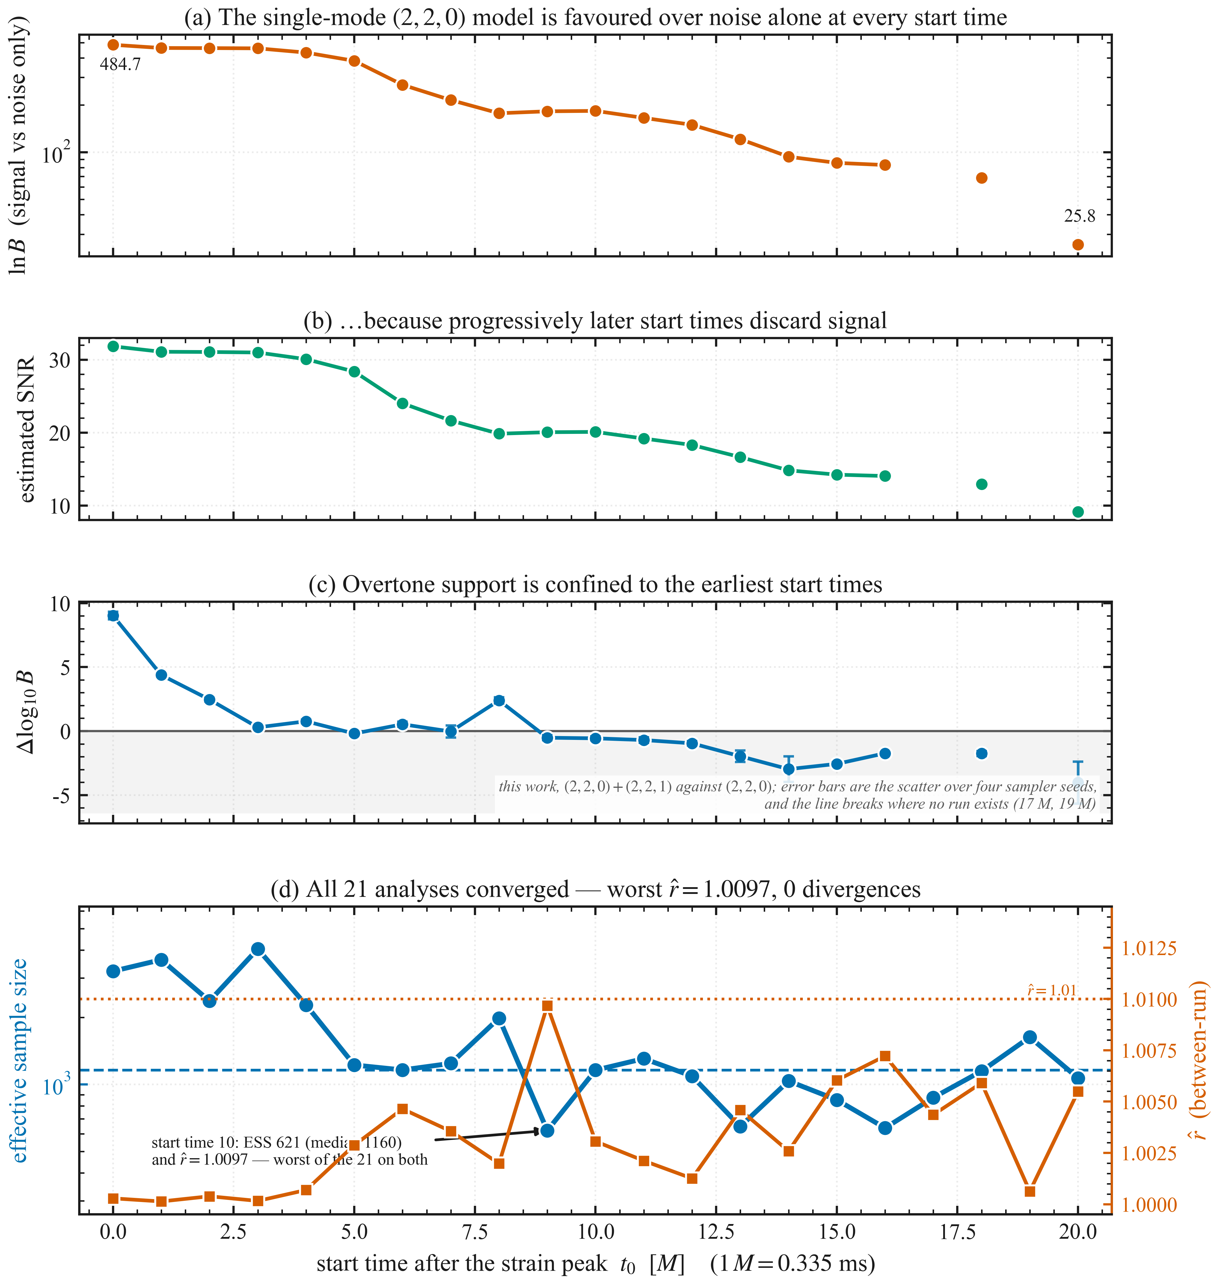
Figure 1: Start-time diagnostics and analysis quality. Panels (a)–(c) are computed from the released pyRing evidence runs, whose grid steps by one geometric mass unit to 16 M and by two beyond it; the line is broken rather than bridged at 17 M and 19 M, where no run exists. (a) the Bayes factor of the single-mode (2,2,0) signal model against the noise-only model, on a logarithmic axis, falling from 484.7 at t0 = 0 to 25.8 at 20 M. (b) the corresponding matched-filter signal-to-noise ratio, 31.8 falling to 9.2, which drives the decline in (a). (c) the overtone-sensitive evidence ratio of this work, Δlog10 B between the (2,2,0)+(2,2,1) and (2,2,0) templates, with error bars giving the scatter over four sampler seeds. (d) convergence diagnostics for all 21 analyses: the effective sample size (left axis) and the between-run r̂ (right axis). Every run converged, with a worst r̂ of 1.0097 and no divergences, and start time 10 is the least converged of the set on both statistics — which is why its credible interval is anomalously wide in Fig. 2. These are nested-sampling diagnostics, namely between-run reproducibility across the four stored runs and an effective distinct-sample count, not MCMC mixing statistics.

Time-Resolved Single-Mode Kerr Parameter Trajectories

Evolution of the Single-Mode Inferred Kerr Parameters
The regime in which a single-mode description of the ringdown fails is the subject of this work. Fits to numerical-relativity waveforms have long shown that a truncated quasi-normal-mode model recovers biased remnant parameters close to the peak [10], [22], and the companion analysis of this event [9] converts that into an interval: a (2,2,0) template is taken to be reliable from 11 tMf after the strain peak, a (2,2,0)+(2,2,1) template from 6 tMf, and a (2,2,0)+(2,2,1)+(2,2,2) template from 3 tMf, where tMf is the remnant's geometric mass unit and equals the M used here to within half a percent. Eleven of the twenty-one start times below, counted in M, lie inside the interval that criterion excludes for the template used, and the first start time — where the central measurement of this work is made — lies furthest inside it; the three-mode attribution of Sec. IV.D is quoted at that same start time, below the third of those edges. The published interval is derived from a noiseless waveform, and within the range it certifies for this template, 11 to 20 M, the inferred mass of this event still falls by 10.4 M⊙ in the source frame — a sixth of the remnant — with a rank correlation of −0.939 against start time.
The inferred Kerr mass parameter falls steadily from the strain peak onward. Figure 2 gives the trajectory of the effective single-mode inferred mass $M_{f}(t)$ across the 21 ringdown start times. The earliest start time yields $M_{f}=75.3 M_{⊙}$ (81.8 M⊙ in the detector frame), which exceeds both the global posterior anchor ($62.71 M_{⊙}$, 68.1 M⊙ in the detector frame) and the total pre-merger mass budget ($m_{1}+m_{2}≃65.8 M_{⊙}$). The single-mode value exceeds that budget by 9.5 M⊙, a 3.87 σ deviation with the two marginal posteriors treated as independent, since no joint posterior of the ringdown and full-signal analyses is available (Sec. III.B); the excess itself is frame-invariant.
The excess over the pre-merger budget is the signature this work attributes to model truncation, an interpretation tested in Secs. IV.C–IV.E. As overtone content decays on timescales shorter than the fundamental $τ_{220}$, the single-mode inferred mass decreases monotonically over the subsequent $∼7$ ms, reaching $56.2 M_{⊙}$ (61.0 M⊙ in the detector frame) by the final start time, below the anchor (Sec. III.C), while the 90% credible intervals widen as the signal-to-noise ratio falls (Fig. 2d).

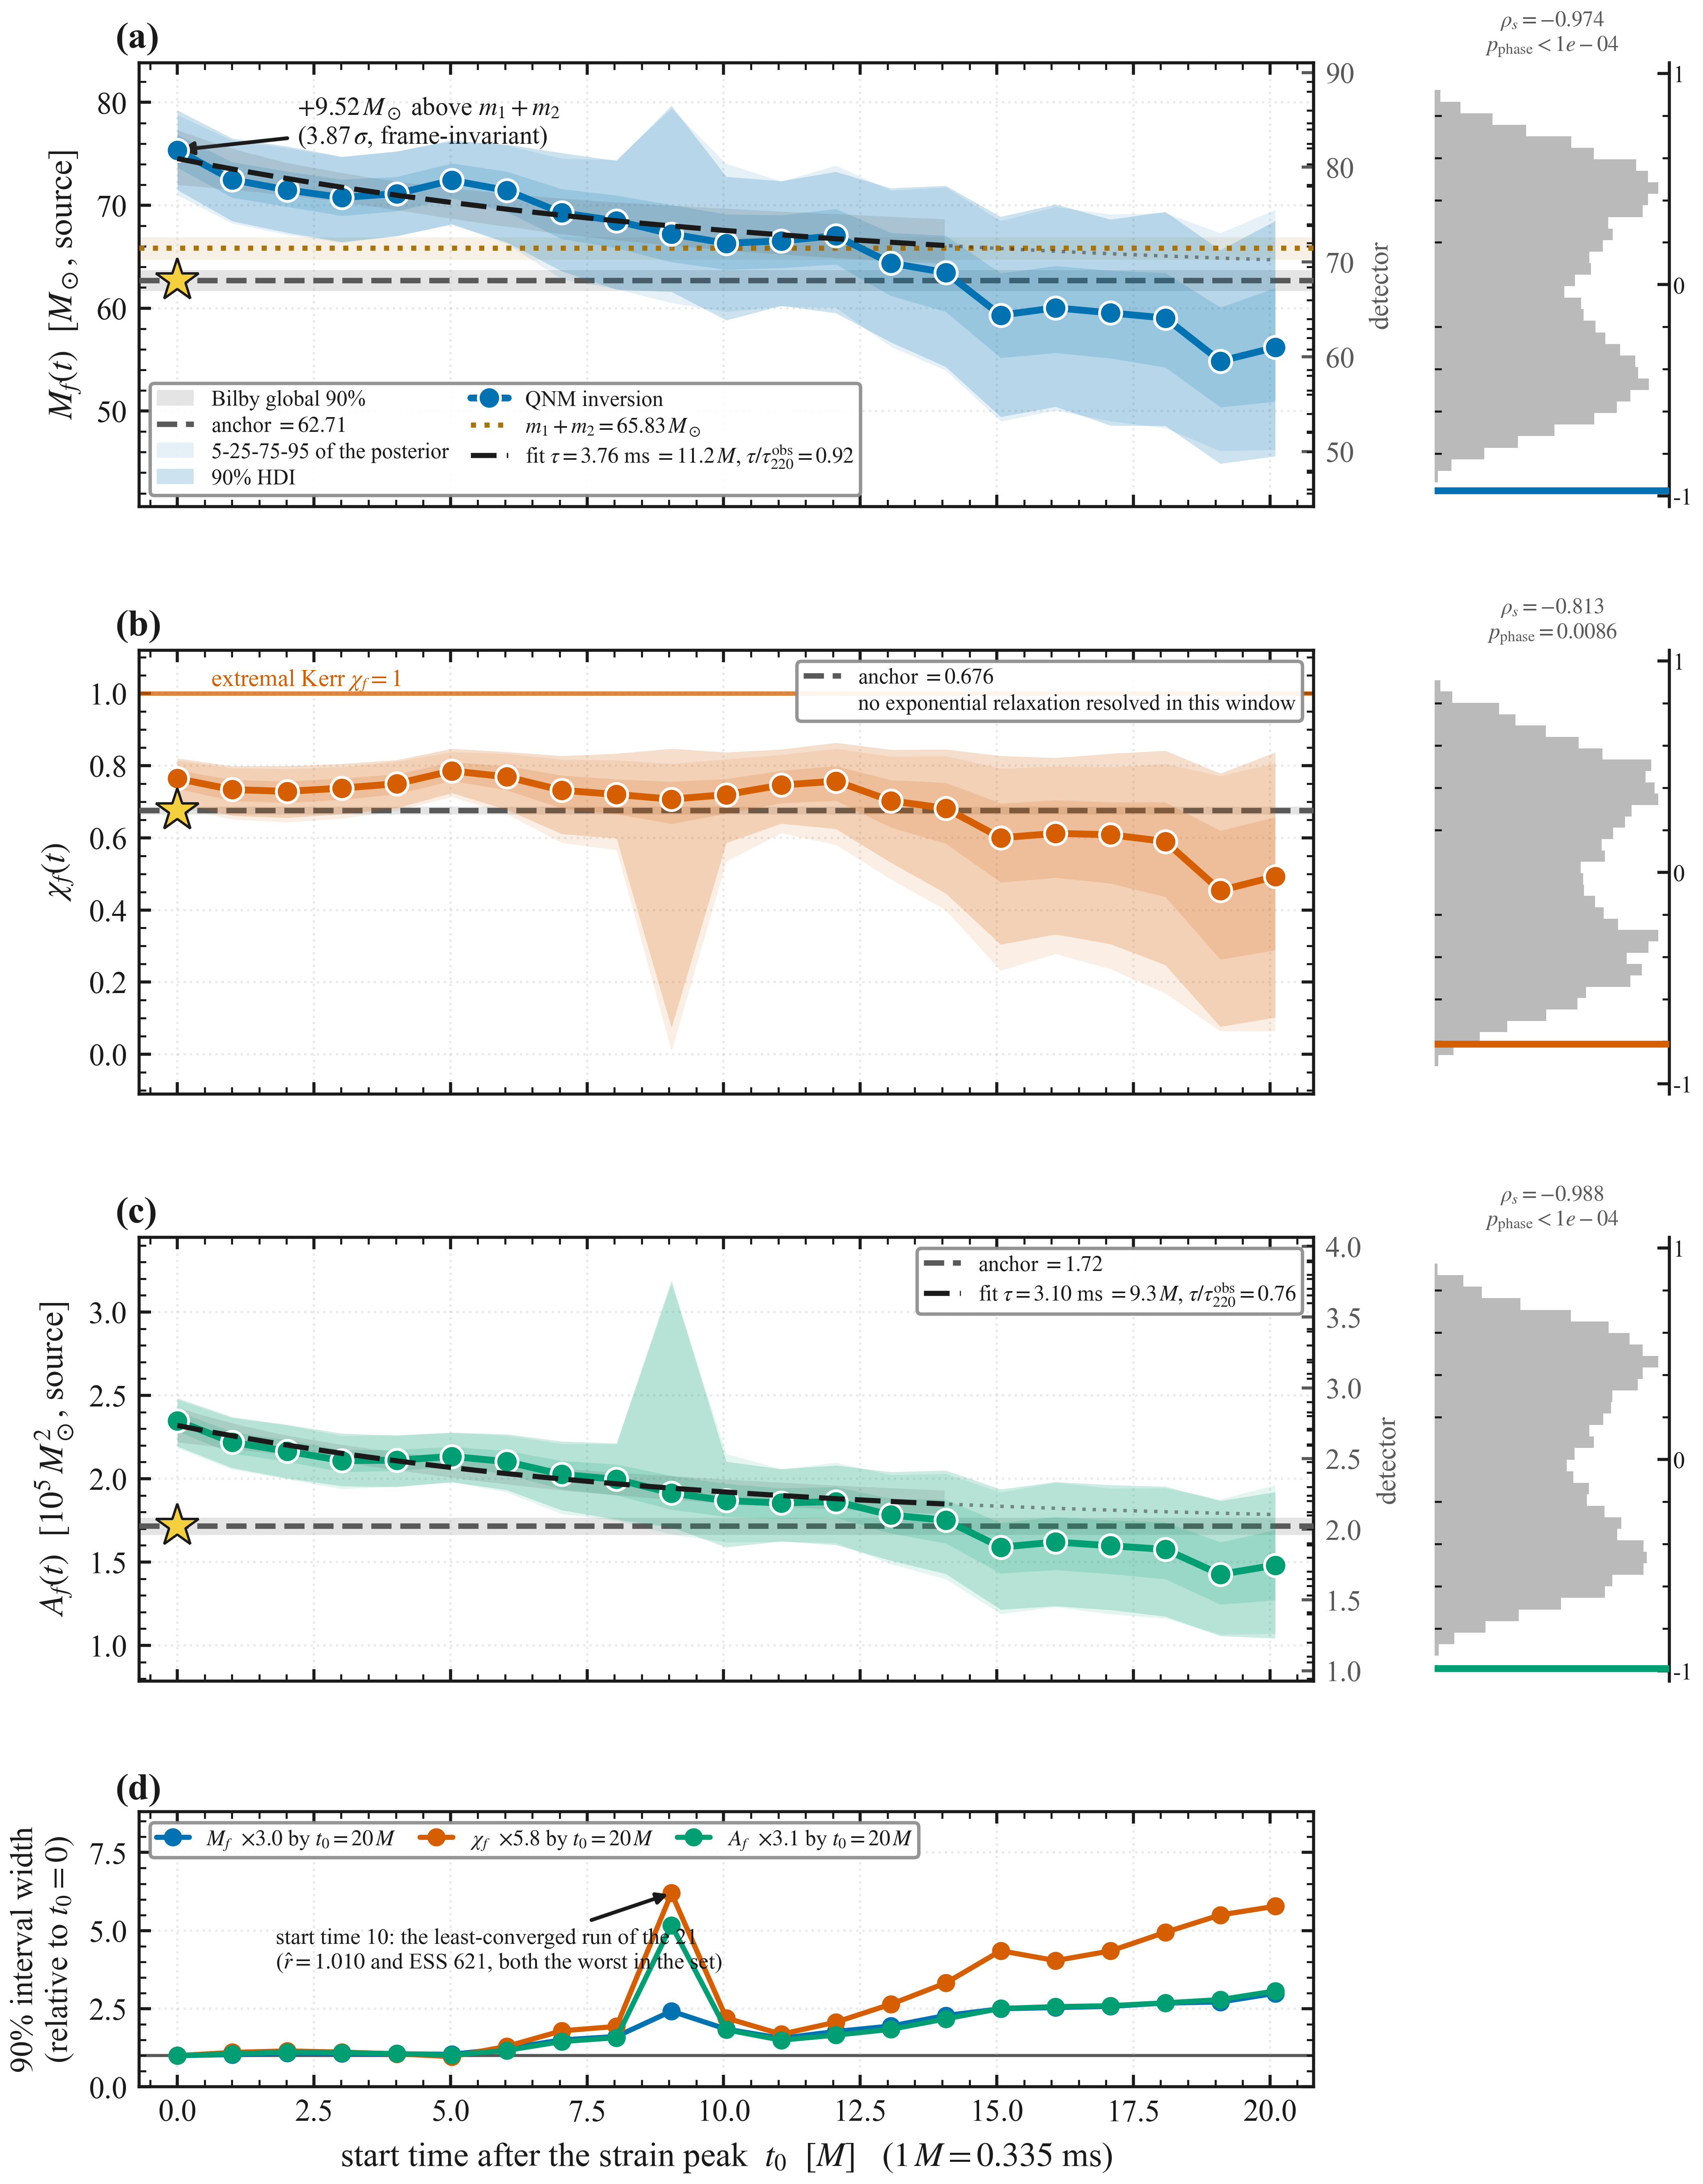
Figure 2: Time-resolved Kerr parameters across 21 ringdown start times. (a) the remnant mass Mf(t), (b) the dimensionless spin χf(t) and (c) the horizon area Af(t), each with the median QNM inversion, the 90% highest-density interval, the 5–25–75–95 quantile fan of the posterior itself, and the global Bilby posterior anchor with its 90% band. The mass panel carries the pre-merger budget m1+m2 = 65.83 M⊙, which the first start time exceeds by 9.52 M⊙ (3.87 σ with independent marginal posteriors; the excess is frame-invariant); the spin panel carries the extremal Kerr bound. A relaxation fit with a fixed asymptote is drawn wherever one is resolved: τ = 3.76 ms = 11.2 M for the mass and 3.10 ms = 9.3 M for the area, against an observed Kerr damping time τ220obs = 4.07 ms; none is resolved in the spin channel. The narrow panels at right give each channel's Spearman rank correlation against a phase-randomised surrogate null that preserves the autocorrelation of the start-time series. (d) the 5–95 percentile interval width of all three channels relative to the first start time, showing the progressive signal-to-noise degradation and the isolated excursion at start time 10, the least-converged run of the set (Fig. 1d). Mf and Af are source-frame; χf is frame-invariant.

Panel (b) of Figure 2 gives the corresponding time-resolved Kerr spin parameter $χ_{f}(t)$, decreasing from $χ_{f}≃0.76$ at the first start time to $χ_{f}≃0.49$ at the final start time and remaining sub-extremal throughout; the global posterior anchor $χ_{f}^{post}=0.676$ lies within the credible band of the intermediate start times.

Panels (a)–(c) of Figure 2 share a common time axis, and the relaxation of $M_{f}(t)$, $χ_{f}(t)$, and $A_{f}(t)$ toward their respective posterior anchors is simultaneous. The same evolution defines a direction in the joint (Mf, χf) plane: the start-time medians move along dχf/dMf = +0.0142, close to the local (2,2,0) template degeneracy measured at the first start time, dχf/dMf = +0.0159, a ratio of 0.89. The trajectory therefore moves along the direction in which the template is least constrained, which is where an absorbed bias is expected to appear; noise-driven shifts of the posterior favour the same direction, so this alignment is consistent with truncation bias but does not by itself distinguish it from noise.

Statistical Significance of the Relaxation
Convention for quoted significances. Posterior summaries in this work are 90% credible intervals. Where a significance is quoted in units of σ, that σ is the Gaussian-equivalent width of the 90% interval, σ = (P95 − P5) / (2 × 1.645), and a tension between two quantities is their difference divided by the quadrature sum of their individual σ. This treats the two marginal posteriors as independent: no joint posterior exists for quantities drawn from separate analyses, so their covariance is not included. All σ values below and in the figures are computed this way, including those against a fixed reference such as the global posterior anchor or the pre-merger mass budget. The mapping from a credible interval to a σ presumes the marginal posterior is approximately Gaussian. That is a good approximation for the early start times and a poor one for the widest late-time posteriors, where the interval is correspondingly asymmetric; wherever it fails materially we quote the credible interval itself rather than a σ, and say so at that point. Significances constructed this way are measures of separation, not of frequentist false-alarm probability, for which the permutation and phase-randomisation tests described below are used instead.
A monotonic decline of the magnitude seen in both channels is unlikely to arise from coloured noise with the observed spectrum. To test whether the monotonic decrease in $M_{f}(t)$ and $χ_{f}(t)$ could arise from random fluctuations, we compute the Spearman rank correlation coefficient $ρ_{s}$ between the start-time index and each observable. Unlike the Pearson correlation, it tests for any monotonic relationship without assuming a functional form, which suits decay profiles that are approximately but not exactly exponential.

Because adjacent start times overlap by $92.7\%$ of the informative interval, the 21 values are not statistically independent: the autocorrelation inflates the apparent sample size, and naive parametric $p$-values understate the Type I error rate. Three analyses that account for this correlation follow:
- Block Permutation Tests: To preserve short-range correlation while scrambling the long-term trend, we divide the 21 start times into contiguous blocks of size $B=5$, four of five start times and one of a single start time, and evaluate all 5! = 120 orderings of these blocks. The enumeration of this permutation space is exact; the null it represents is approximate, because block exchangeability neglects the correlation that remains across block boundaries and treats the shorter final block like the others.
- Phase-Randomization Surrogate Tests: We apply a Fourier transform to the time series of each observable, randomize the Fourier phases, and transform back to the time domain. This preserves the power spectrum and autocorrelation of the original series while destroying any coherent monotonic trend; the null hypothesis is a stationary linear Gaussian process with the observed power spectrum. The empirical $p$-values are computed from $10,000$ phase-randomized surrogates. The p-values drawn on the figures add one to both the count and the number of draws, a correction that cannot return exactly zero; where no surrogate reaches the observed statistic the value is therefore quoted as an upper bound set by the number of draws rather than by the data.
- Thinned-Data Analysis: To reduce the inter-window overlap, we thin the dataset by selecting every $5^{th}$ start time (start times 1, 6, 11, 16, 21), reducing the sample size to $N=5$ windows spaced 5 M apart. These are less correlated than the full set but not independent: measured against the informative duration of Sec. II they retain a 63.5% pairwise overlap. We compute the Spearman rank correlation on this thinned subset as a stability check, and rely on the surrogate tests for significance.

Table 2 summarizes the results of these significance tests. In both channels only the observed ordering of the blocks reaches the observed |ρ_{s}|, so p_{block} = 1/120 ≈ 0.008, the smallest value this construction can return; the block test is therefore limited by the size of its permutation space rather than by the data. The phase-randomization test yields $p<0.01$ for the spin channel, and no surrogate among 10,000 reaches the mass-channel statistic, so a monotonic trend of this magnitude is unlikely to arise from coloured noise with the observed spectrum.

Table 2: Spearman rank correlation and significance testing across 21 ringdown start times. Columns report the naive Spearman rank correlation coefficient $ρ_{s}$ and its $p$-value, the block permutation $p$-value ($p_{block}$ with block size $B=5$, from all 120 block orderings), the phase-randomization surrogate $p$-value ($p_{phase}$), and the thinned-data Spearman coefficient ($ρ_{s,\text{thin}}$) and $p$-value ($p_{\text{thin}}$) using every $5^{th}$ start time ($N=5$; these points remain 63.5% overlapped). The phase-randomised p-values in Table 2 and Fig. 2 come from independent surrogate realizations of the same procedure, reported as the plain exceedance fraction in the table and with the add-one correction in the figure, and differ within Monte-Carlo uncertainty.
Observable | Naive $ρ_{s}$ | Naive $p$-value | $$p_{block}$$ | $$p_{phase}$$ | $$ρ_{s,\text{thin}}$$ | $$p_{\text{thin}}$$
$$M_{f}(t)$$ | $$-0.974$$ | $$1.0×{10}^{-13}$$ | $$0.0083$$ | $$≲{10}^{-4}†$$ | $$-1.000$$ | $≤0.0167$*
$$χ_{f}(t)$$ | $$-0.813$$ | $$7.5×{10}^{-6}$$ | $$0.0083$$ | $$0.0090$$ | $$-0.900$$ | $$3.7×{10}^{-2}$$
* Note: Under the assumption of $N=5$ independent samples with perfect monotonic correlation ($|ρ_{s}|=1$), the exact two-sided non-parametric $p$-value is $p_{\text{exact}}=2/5!=0.0167$, corresponding to the two most extreme permutations out of $5!=120$ possible orderings. † No surrogate among 10,000 reached the observed statistic; the entry reflects the resolution of the surrogate draw rather than a measured probability.

The thinned-data analysis is consistent with this conclusion: with only $5$ points, which remain 63.5% overlapped, the mass channel is perfectly monotonic and the spin channel strongly correlated ($ρ_{s}=-0.900$, $p=0.037$), which would reject the null at the standard $95\%$ confidence level only under an independence the thinning does not achieve. For comparison with an analytical correction, we apply the Bayley-Hammersley (BH) formulation [23] for the effective number of independent degrees of freedom $N_{eff}$. For a time series with $N$ points and autocorrelation function $ρ(k)$, the effective sample size is:
$$N_{eff}=N{\left[1+2\sum_{k=1}^{N-1}{\left(1-\frac{k}{N}\right)}ρ(k)\right]}^{-1}.$$
Evaluated in its first-order autoregressive form, with the lag-1 autocorrelation of the ranked series, this yields $N_{eff}∼2.0$ and $3.4$ for the mass and spin parameters, respectively.

With these effective sample sizes the BH-corrected $p$-values are $0.145$ and $0.296$ for the Kerr mass and spin parameters, which would not reject the null at the $95\%$ confidence level. Because the lag-1 autocorrelation is taken on the ranks of the trending series, the trend under test is itself counted as correlation, which is what drives the effective sample sizes this low. The surrogate tests give p_{block} = 1/120 in both channels and p_{phase} ≤ 0.009 (Table 2).

Late-Time Behaviour of the Inferred Parameters
Having established the monotonic decline, we ask where the trajectory ends: whether the late-time values are consistent with the global posterior anchor once their precision is accounted for. Table 3 collects the mean of the last five start times in each channel against that anchor.

Table 3: Late-start time convergence: mean of the last 5 ringdown start times compared with the Bilby posterior anchor. Tension is defined as $T=|\overset{‾}{x}-x_{post}|/SEM$. The SEM quoted here is the scatter of the five start time medians; the inverse-variance-weighted estimate of Sec. III.C, which folds in the per-start-time posterior widths, reduces these tensions to 1.6 and 1.3 σ respectively.
Observable | Late-start time mean | SEM | Posterior anchor | Tension $T$
$$M_{f} [M_{⊙}]$$ | $$57.93$$ | $$1.02$$ | $$62.71$$ | $$4.69 σ$$
$$χ_{f}$$ | $$0.551$$ | $$0.033$$ | $$0.676$$ | $$3.82 σ$$

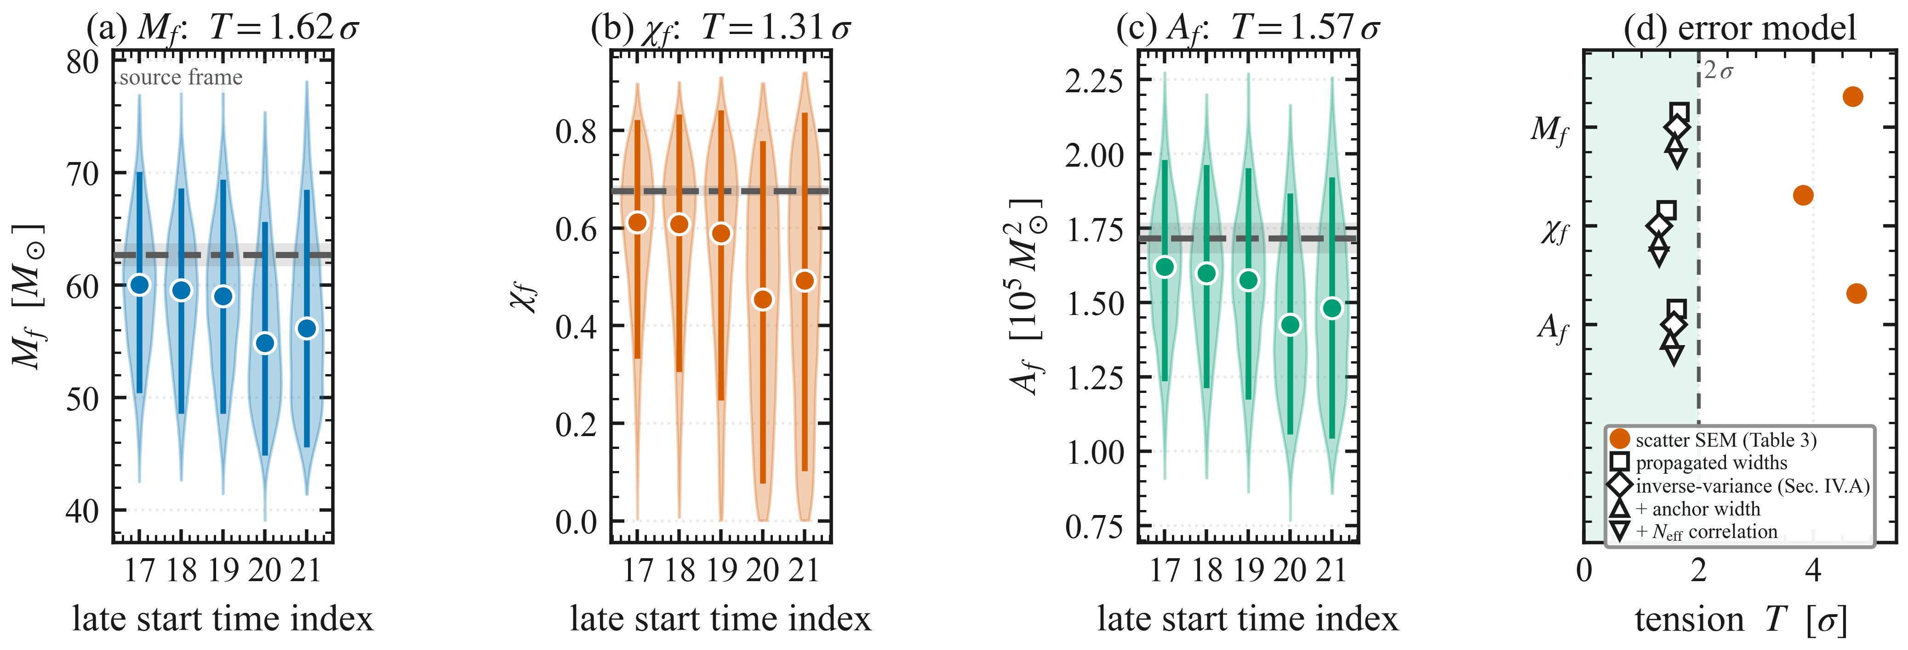
Figure 3: Late-start time behaviour of the inferred parameters. Panels (a), (b) and (c) display the last five ringdown start times of the Kerr parameters Mf(t), χf(t), and Af(t) respectively, with error bars derived from the per-start-time 90% credible intervals. The dashed line marks the Bilby posterior anchor. The tension T (in units of standard error) is annotated above each panel. In a frame-consistent analysis the mass channel crosses the anchor and undershoots by 1.62 σ, consistent with the spin and area channels, whose tensions reflect the signal-to-noise degradation shown in Fig. 1(b). Panel (d) compares the late-time tension under every error model used in this work: the scatter-based standard error of Table 3 is the outlier, while every model that propagates the per-start-time posterior widths places all three channels below 2 σ.

In the source frame the Kerr mass parameter crosses the anchor and undershoots at the latest start times, with a tension of $T=1.7 σ$ when the per-start-time posterior widths are propagated through the late-time mean; the spin channel undershoots similarly, with a tension of $1.4 σ$ on that same convention (Figure 3, whose panel (d) compares every error model used in this work). The inverse-variance weighting defined below returns a different pair of values, and the two conventions are not interchangeable. Three complementary diagnostics of $χ_{f}(t)$ follow.
- Quality-gated analysis. We classify each start time by the width of its 90% credible interval $Δχ_{90\%}$. The threshold for a precision-limited start time is $Δχ_{90\%}>0.5$, exceeded at six of the last seven (16–21), whose widths run from $0.52$ to $0.74$, compared to $0.13$–$0.17$ for the first seven, thus a degradation factor of $4.5×$. When only high-precision start times ($Δχ_{90\%}<0.3$) are retained, the latest reliable measurements (start times 8, 9, 11, 12, 13) yield ${\overset{‾}{χ}}_{f}=0.735±0.033$, above the posterior anchor.
- Start time 10 is absent from the high-precision set: its interval is Δχ90%=0.80 against 0.25 and 0.28 at the start times either side of it, a single-point excursion of 5.6× the median width of the first seven start times that recovers completely at the next start time and also appears in the mass intervals of the same run. We treat it as a property of the template rather than of the signal, which cannot change over one 0.335 ms step and back: at that start time 29% of the samples in this chain carry a spin below 0.01, against none in the (2,2,0)+(2,2,1) chain, the pure (2,2,0) chain, or a two-mode fit with free frequencies, all run on the same data under the same spin prior. The width gate removes it, and it is visible as the isolated spike in the credible bands of Figs. 2 and 8. No result in this paper depends on it: its median lies on the trend, and dropping it moves the Spearman coefficients by at most 0.004 (−0.974 to −0.970 for the mass). The spin trajectory is thus biased upward early by overtone content and downward late by noise, crossing the anchor only in between.
- Jackknife analysis. A leave-one-out jackknife over the last five start times leaves the tension in the range $2.9$–$3.8 σ$, so it reflects a systematic precision effect across the late-time ensemble, not a single outlier.
- Physical origin. The mass channel depends primarily on the frequency f220 and stays robust at low signal-to-noise; the spin is extracted through the quality factor Q = πf220τ220 and so inherits the uncertainty in the damping time, the less precisely determined observable at low amplitude [6, 20]. Early start times carry overtone content that raises Q and late ones carry noise that lowers it, so the spin is reliable over a narrower range of start times than the mass (Fig. 2d).

To account for the varying precision across start times we apply an inverse-variance weighting to the late-time convergence, defining the weighted mean of the last five start times as:
$${\overset{‾}{x}}_{wt}=\frac{\sum_{i=17}^{21}{x_{i}}/σ_{i}^{2}}{\sum_{i=17}^{21}{1}/σ_{i}^{2}},$$
where $x_{i}$ is the median parameter value at start time $i$, and the per-start-time uncertainty $σ_{i}=(x_{i,hi}-x_{i,lo})/3.29$ is estimated from the $90\%$ credible interval as a proxy for the standard error. The standard error of the weighted mean is:
$$σ_{wt}={\left(\sum_{i=17}^{21}{\frac{1}{σ_{i}^{2}}}\right)}^{-1/2}.$$
The tension between the weighted mean and the global posterior anchor is then evaluated as:
$$T=\frac{|{\overset{‾}{x}}_{wt}-x_{post}|}{σ_{wt}},$$
where $x_{post}$ is the median of the global posterior anchor.

Under this weighting the late-time spin is χf,wt = 0.567 ± 0.084, a tension of 1.31 σ against the anchor χf,post = 0.676 ± 0.007, inside the 2 σ consistency threshold, so the late-time tension is a precision limit of the low-amplitude regime rather than a bias in the inversion. The inter-window correlation of Sec. III.B does not apply to this mean: the lag-1 autocorrelation of the detrended last-five series is negative in both Kerr parameters (−0.51 to −0.57), so Neff ≈ 5 and the overlap does not tighten the estimate.

Physical Discussion and Implications

Relaxation Timescales of the Inferred Parameter Trajectory
To quantify the relaxation rate, we define the observable stress $ΔX(t)=X(t)-X^{post}$ for each Kerr parameter $X∈\{M_{f},χ_{f}\}$ and fit a single exponential decay $ΔX(t)=ΔX_{0} e^{-t/τ_{X}}$. For the Kerr parameter $M_{f}$, the fit yields
$$τ_{M}=3.76 (+1.90 / −1.04) ms,$$
with an initial amplitude $ΔM_{0}=11.83±1.61 M_{⊙}$. The theoretical Kerr $(2,2,0)$ damping time, evaluated with the fitting relations of Ref. [3] at the anchor mass of Table 1 and its remnant spin $χ_{f}=0.676$, is $τ_{220}=3.75$ ms in the source frame. The fitted times are detector-frame, so the like-for-like comparison is made in that frame, as set out below, where the ratio is $τ_{M}/τ_{220}=0.92$. The asymptote is held fixed because releasing it makes it exactly anti-correlated with the timescale, and over the interval fitted a straight line describes the trajectory equally well; both are set out in Supplementary S6. No theoretical value is available to compare the fitted timescale against: a linear-response argument would supply one, giving τeff = 1.88 ms, but it requires the overtone to be a weak perturbation, and the three-mode fit gives ε = 2.31 at the first start time. τ220 is therefore quoted throughout as a comparison, not as an expectation the measurement confirms.
Because the start times are detector-frame, the fitted timescale is an observed-frame duration; the like-for-like comparison is therefore with the observed damping time τ220^obs = (1+z) × 3.75 ms = 4.07 ms, which is what the ratio above uses. Equivalently, the measured timescale corresponds to 3.46 ms in the source frame. The measured value is consistent with τ220 at the 0.17 σ level, and its 68% interval is asymmetric, 3.76 (+1.90 / −1.04) ms. On the geometric axis the distinction does not arise: the Kerr damping time is τ220 = 12.1 M and the fitted timescale is 11.2 M in either frame, a ratio of 0.92. The fitted value varies between 2.9 and 5.5 ms with the analysis window and between 3.4 and 6.5 ms across four alternative error models, none of which goodness of fit prefers, so the timescale is determined only to about a factor of two (Supplementary S6).

The Kerr spin channel yields no resolved timescale: its exponential fit runs to the bound in both the full and the thinned samples, because the spin excess is only 2.25 σ above its own uncertainty at the first start time and decreases thereafter, so it is omitted from the fitted-timescale table. Table 4 gives the endpoints of the evolution; the fitted timescales are collected in Table S1 of Supplementary S6.

Table 4: Endpoints of the inferred Kerr parameter evolution, against the global posterior anchor. Endpoints are quoted in the source frame; the corresponding detector-frame value is Mf = 81.8 / 61.0 M⊙ (the spin χf is frame-invariant).
Quantity | t0 = 0 M | t0 = 20 M | Posterior Anchor
$$M_{f} [M_{⊙}]$$ | $$75.3$$ | $$56.2$$ | $$62.71$$
$$χ_{f}$$ | $$0.764$$ | $$0.493$$ | $$0.676$$

The low $χ^{2}/DoF=0.18$ for $M_{f}(t)$ is a statement about the error bars rather than about the fit. Residuals about the fitted trajectory scatter by 1.31 M⊙ while the per-start-time uncertainties average 3.55 M⊙, and 0.37² ≈ 0.14 accounts for the value directly. The marginal posterior width measures the absolute uncertainty on the mass at each start time, and nearly all of it is common to all 21 windows because they are very nearly the same data; the relative scatter between neighbouring start times, which is what constrains the shape of a decay, is smaller by a factor of 2.7. Unresolved overtone content deforms the trajectory at the early start times away from a pure $(2,2,0)$ decay profile, but that deformation is small compared with the per-start-time uncertainties over the fitted range, and an explicit double-exponential model is not preferred (Sec. IV.F). The single exponential is therefore retained as a benchmark summary of the dominant relaxation, and its consistency with $τ_{220}$ within $1σ$ is a property of the dominant mode in the signal decomposition, not a direct measurement of a single physical degree of freedom.

Physical Interpretation of the Early-Time Spin Bias
The elevated Kerr $M_{f}$ values at the earliest ringdown start times are consistent with unmodeled overtone content: the signal there contains the fundamental $(2,2,0)$ mode and higher overtones, and the localized QNM inversion attributes their combined spectral content to a single effective Kerr solution. As the overtones decay on timescales shorter than $τ_{220}$, the fundamental increasingly dominates and the inferred parameters relax toward the stationary Kerr values. On the like-for-like comparison of Sec. IV.A, 11.2 M against 12.1 M, the relaxation timescale of the single-mode projection is close to the fundamental damping time without being predicted by it.
The mechanism behind the bias is visible in the recovered parameters themselves. At the first start time the single-mode fit returns a frequency of 223.2 Hz, below both the fundamental (244.8 Hz) and the first overtone (240.4 Hz) that the three-mode fit reports there, together with a damping time of 5.16 ms; by 12–20 M the recovered frequency has risen to 247–250 Hz. Because the inferred mass varies inversely with the recovered frequency at fixed spin, this depressed frequency carries the larger part of the mass bias: at every start time the mass plotted is the one implied by that start time's own recovered frequency and spin, to within 1.5%, a difference between mapping the median parameters and taking the median of the mapped samples (the map's own accuracy budget is given in Sec. II.C; the same effect on the horizon area is audited in Sec. S4). Holding one of the two at its first-start-time value while the other varies separates the channels. Over the fitted range the frequency alone accounts for a −9.7% change in the inferred mass and the spin alone for −6.7%, against −15.8% when both vary, so the frequency carries about 60% of the decline. Over all 21 start times the balance reverses — −9.7% from the frequency against −17.7% from the spin, out of −25.6% in total — so the late-time undershoot is driven mainly by the recovered spin collapsing from 0.764 to 0.493, in the channel identified above as the first to degrade as the signal-to-noise ratio falls.

The initial positive bias in the Kerr spin parameter ($χ_{f}≃0.76$ at the first start time against the asymptotic $0.676$) follows from the same framework. With unmodeled $(2,2,1)$ overtone content present, the fitted $(2,2,0)$ quality factor $Q$ is elevated above its Kerr value at the earliest start times, and through the Berti relations an elevated $Q$ maps directly to a higher inferred spin.

Waveform Validation via Numerical Relativity Injection
Whether the early-time mass and spin elevations belong to the source or to the analysis is decided by a control whose truth is known. Overtone excitation near merger is established on numerical-relativity waveforms [10], and the QNM content this analysis resolves is linear; nothing here rests on the event-level detection of that overtone [5], whose significance has been disputed [11]. No quadratic or otherwise non-linear mode is fitted here, and none is required to account for the trajectory measured here. A separate analysis of this event reports Bayesian support for a quadratic (2,2,0)×(2,2,0) mode over the linear (4,4,0) [24]; that question is not settled by the templates used here, and nothing below depends on its answer. The temporal relaxation profiles measured here, specifically the $O(10 M_{⊙})$ dynamic range in the Kerr parameter $M_{f}(t)$, are what the controlled injection reported below reproduces from a remnant of known and constant mass, so the trajectory cannot be a property of the source. They are also what Sec. IV.D accounts for quantitatively: a linear three-mode template removes 62% of the first-start-time departure directly. What the injection excludes is the windowing pipeline as the origin of the trend; what it identifies as the origin is the single-mode template itself.

To test whether the sequential inversion itself produces the trend, we analyse a numerical-relativity (NR) injection whose remnant is known. The injection is the one prepared for the review of this event and released with it: the equal-mass, non-spinning simulation SXS:BBH:3617 [25], whose intrinsic parameters lie inside the 90% credible region of GW250114, injected into Gaussian noise generated from the power spectral density estimated for this event [9]. Because the simulation is equal-mass and non-spinning, its remnant spin is not a fitted quantity but a property of the simulation. The injected remnant has a true mass $M_{f}^{true}=68.41 M_{⊙}$, dimensionless spin $χ_{f}^{true}=0.6865$, and a corresponding theoretical fundamental QNM damping time $τ_{220}=4.11$ ms. These are detector-frame values, as the injection is defined, and every number in this section is quoted in that frame. The injected signal is analyzed with the same code, the same conditioning and the same sequential windowing as the event, though not with identical settings: the injection was run without downsampling, over a wider mass prior and 16 start times, against the event's ds = 4, [38.4, 88.4] M⊙ and 21. What the control tests is the windowing procedure, which is shared. It is analysed under two configurations: a single-mode template ($n0$, using the fundamental $(2,2,0)$ mode only) and a multi-mode template ($n2$, including $(2,2,0)$, $(2,2,1)$, and $(2,2,2)$ modes).

Figure 4 presents the side-by-side comparison of the NR injection recovery and the real event. As shown in Fig. 4(a), the single-mode recovery of the NR injection exhibits a prominent mass decay starting at $83.3 M_{⊙}$ and settling to $61.2 M_{⊙}$ at late times; these are detector-frame values, as the injection is defined. The event's own source-frame decay runs from $75.3 M_{⊙}$ to $56.2 M_{⊙}$, shown in Fig. 4(b). The two pairs are in different frames and are not compared directly; the comparison is made in ratios to each panel's own reference, which are dimensionless. The injection overshoots its known remnant mass by 21.8% at the first start time and ends 10.6% below it, against 20.2% and 10.4% for the event measured against the posterior anchor. A remnant whose mass is constant by construction is therefore misrecovered by this pipeline to within 1.7 percentage points of the misrecovery seen in GW250114, and relaxes to within 0.2 points of the same undershoot. An exponential fit to this single-mode trajectory, fixing the asymptote to the true injected mass, recovers a decay timescale of $τ_{M}=1.67±0.56$ ms (reduced $χ^{2}=0.484$).

In contrast, the multi-mode recovery ($n2$) accounts for the overtone content. In the earliest start times, the multi-mode template recovers the correct injected mass, in the same detector frame ($68.48±3.28 M_{⊙}$ at $t=0.0$ ms), which is consistent with the true value of $68.41 M_{⊙}$ within the 90% credible intervals. Although both single-mode and multi-mode recoveries exhibit late-time downward bias due to noise-induced signal-to-noise ratio degradation (with naive Spearman rank correlations of $ρ_{s}=-0.979$, $p=4.0×{10}^{-11}$ for $n0$ and $ρ_{s}=-0.962$, $p=2.9×{10}^{-9}$ for $n2$), the multi-mode template recovers the true parameters at early times, so the early mass excess of the single-mode analysis is removed once the overtones are modelled and is not an artifact of the windowing pipeline.

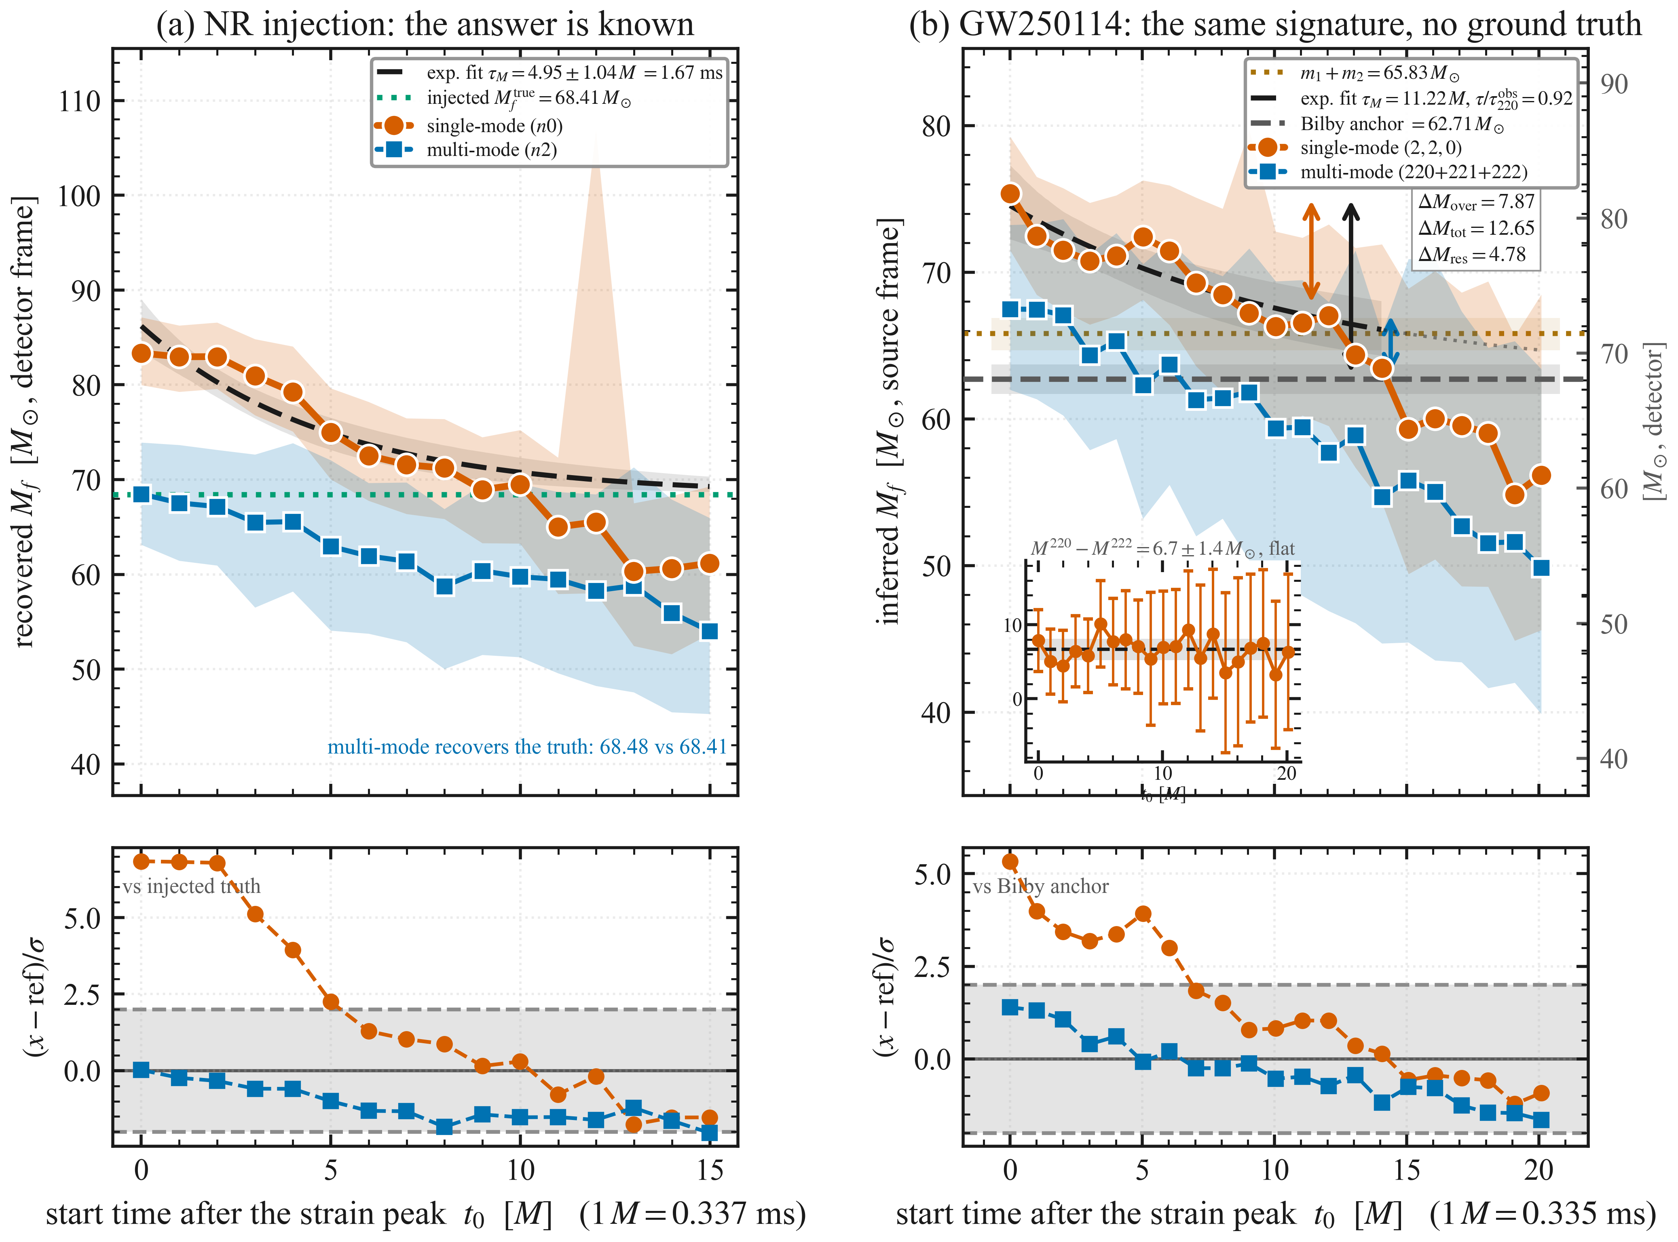
Figure 4: Numerical-relativity control against the event. (a) recovery of the injected NR remnant mass (Mftrue = 68.41 M⊙, dotted) with a single-mode template (n0, circles) and a multi-mode template (n2, squares): the single-mode recovery reproduces the spurious decay seen in the event, while the multi-mode template recovers the injected value at the first start time (68.48 against 68.41). (b) the same comparison for GW250114 against the global Bilby posterior anchor (62.71 M⊙) and the pre-merger budget, with the three-way decomposition of the first-start-time excess: ΔMtot = 12.65 M⊙ divides into ΔMover = 7.87 M⊙ attributable to overtone content and ΔMres = 4.78 M⊙ residual. The inset shows the single-minus-multi difference to be flat in time at 6.7 ± 1.4 M⊙, and the multi-mode trajectory stays within 1.65 σ of the posterior anchor at every start time. Exponential fits with fixed asymptotes give τM = 4.95 M = 1.67 ms for the injection and 11.2 M = 3.76 ms for the event, the latter a ratio τ/τ220obs = 0.92; the dotted continuation is extrapolation beyond the fitted range. The lower rows give the residual against each panel's reference in units of the per-start-time uncertainty. Panel (a) is detector-frame, as the injection is defined, and panel (b) source-frame; no quantity is compared across the two.

Quantitative Attribution of the Kerr Mass Parameter
This section reports three tests of that attribution; their convergence is difficult to produce by chance. The preceding analyses establish that the effective single-mode Kerr mass parameter $ΔM(t)=M_{f}^{(220)}(t)-M_{f}^{post}$ decays on a timescale comparable to τ₂₂₀ (Sec. IV.A) and is reproduced in a controlled NR injection (Sec. IV.C). The question here is whether $ΔM(t)$ can be quantitatively attributed to the spectral content of the unmodeled overtone modes. Throughout this section the quantity measured is the change in the inferred parameters when modes are added to the template, not the amplitude of any individual mode in the signal: the mode content inferred from a ringdown depends on the model used to infer it [26], whereas the displacement of the fitted Mf and χf between two stated templates does not. We address this through three data-driven tests.
- Test 1 — multi-mode overtone accounting. We apply a multi-mode fitting template incorporating the $(2,2,0)$, $(2,2,1)$, and $(2,2,2)$ QNMs simultaneously to the same data windows analyzed in the single-mode inversion. If the Kerr mass bias arises from overtone absorption, the multi-mode inferred mass $M_{f}^{(222)}(t)$ — the mass recovered by that three-mode fit, not by a single (2,2,2) mode — should be statistically consistent with the true remnant mass $M_{f}^{post}$ at every start time, since the template now explicitly accounts for the overtone content that would otherwise inflate the effective single-mode parameters (Figure 4). At the earliest start time ($t=0$), the effective Kerr mass is $M_{f}^{(220)}={75.34}_{-4.46}^{+3.64} M_{⊙}$ in the source frame (corresponding to $81.81 −4.74/+3.72 M_{⊙}$ in the detector frame; the single-mode mass exceeds the anchor by $+12.65 M_{⊙}$ in the source frame), while the multi-mode mass is $M_{f}^{(222)}={67.47}_{-5.48}^{+6.02} M_{⊙}$ in the source frame (corresponding to $73.26 −5.91/+6.35 M_{⊙}$ in the detector frame).
- The source-frame interval is relatively wider than the detector-frame one because the source mass is marginalised over the redshift posterior, which the detector measurement does not involve; the central values still satisfy the frame relation. The residual $R(t_{i})=M_{f}^{(222)}(t_{i})-M_{f}^{post}$, computed with the per-start-time posterior widths, quantifies any mass bias persisting after explicit overtone modeling. Across all 21 start times, the maximum residual significance is $|R|/σ=1.65$, below the $3σ$ threshold, and no start time exceeds this bound. The NR injection control confirms the methodology: at start time 0, the multi-mode template recovers the true injected mass ($68.48±3.28 M_{⊙}$ versus $M_{f}^{true}=68.41 M_{⊙}$), with a maximum residual of $2.03σ$ across all 16 NR start times. The decomposition in Figure 4(b) divides that +12.65 M⊙ bias into 7.87 M⊙ attributable to overtone content (the single- minus multi-mode difference) and 4.78 M⊙ of residual offset between the multi-mode fit and the anchor; the two components close on the total by construction.
- The source-frame residual between the multi-mode fit and the anchor is not a constant offset. It falls from +4.78 M⊙ at the first start time with a slope of −2.59 M⊙ ms⁻¹, changes sign between 4 and 6 M, and reaches −12.86 M⊙ at the last start time. Its weighted mean over all 21 start times is −0.34 ± 1.20 M⊙, consistent with zero, but that average sets a positive early residual against a larger negative late one rather than indicating an unbiased fit. The three-mode template therefore removes most of the early bias without converging on the anchor: it remains biased high while overtone content is present and biased low once the signal-to-noise ratio has fallen, in the same sense as the single-mode fit. The 62% quoted above is the fraction removed at the first start time, not a statement that the remainder is inert.
- Test 2 — Isaacson energy balance. If the Kerr mass bias represents absorbed overtone energy, its dissipation rate should track the instantaneous gravitational-wave luminosity. We fit the Kerr mass bias to $ΔM(t)=A_{0} e^{-t/τ}$ (Sec. IV.A: $A_{0}=11.83 M_{⊙}$, $τ=3.76$ ms) and compute the analytical derivative $-d(ΔM)/dt=(A_{0}/τ) e^{-t/τ}$. This smooth rate of change is compared with the Isaacson [27] GW luminosity $L_{GW}(t)∝\sum_{n}{A_{n}^{2}}[(2πf_{n})^{2}+γ_{n}^{2}]$, computed from the multi-mode posterior amplitudes, frequencies, and damping rates at each start time. The Isaacson expression is an incoherent sum, and rebuilding the waveform from the posterior phases shows the omitted interference to shift the decay timescale by less than 2 sigma, so the comparison that follows does not depend on the approximation (Supplementary S6).
- A second limitation belongs to the estimator rather than to this implementation. Isaacson's effective stress tensor is defined by averaging over a region containing many wavelengths, which presumes an oscillation fast compared with the scale on which the amplitude changes. A ringdown does not provide that separation: the quality factors Q = πfτ recovered here are 3.0, 1.0 and 0.5 for the (2,2,0), (2,2,1) and (2,2,2) modes as medians over the start times, and 3.5, 1.1 and 0.7 at the first start time, so the fundamental completes about one oscillation per damping time and each overtone less than one. LGW(t) is therefore used here as a relative indicator of how the radiated power falls with start time — which is all that the rank correlation and the timescale comparison require — and not as an absolute flux. The Spearman rank correlation between $-d(ΔM)/dt$ and $L_{GW}(t)$ is $ρ_{s}=0.79$, and the Pearson correlation $r=0.83$; the NR injection control yields $ρ_{s}=0.79$. The analytical derivative is used rather than the raw numerical gradient, because the point-to-point derivative amplifies the noise introduced by the $92.7\%$ overlap between adjacent analysis windows ($N_{eff}≈2$) and yields a negligible correlation ($ρ_{s}≈0$).
- Because the fitted rate is a strictly decreasing function of start time, this rank correlation is the statement that $L_{GW}(t)$ declines with start time, which it does despite 9 upward fluctuations across 20 inter-start time intervals; the surrogate value printed in Fig. 5(b) depends on how the surrogates are constructed and is not a test of an independent physical relationship. The Isaacson evidence lies instead in the decay timescales and in the amplitude scaling. Fitting an exponential to LGW(t0) gives τL = 2.25 ± 0.45 ms, against the τM/2 = 1.88 ms expected for an energy scaling as the squared amplitude of a perturbation decaying with τM; the two agree at 0.8 σ. Because this expectation is built from the fitted τM, it inherits that fit's factor-of-two systematic (Sec. IV.A), and the comparison is a consistency check rather than an independent determination.
- Test 3 — spectral energy correlation. We correlate $ΔM(t)$ from the single-mode posteriors with the overtone amplitude, the square root of $E_{overtone}(t)=A_{221}^{2}+A_{222}^{2}$ from the multi-mode posteriors, at all 21 start times the multi-mode chain provides (it reaches $20M$). The Spearman rank correlation is $ρ_{s}=0.80$, with a linear regression $R^{2}=0.57$. Calibrated against 10,000 phase-randomised surrogates of ΔM, which preserve its autocorrelation, it gives p_{phase} = 0.0055 (Fig. 5): a monotonic association that is unlikely under that surrogate null. Because both series decline with start time, the association is consistent with an overtone origin but does not establish it. The NR injection control yields $ρ_{s}=0.85$. The abscissa is the overtone amplitude rather than its energy because that is the scaling the data show: a log-log regression gives an exponent of 0.52 ± 0.12 for the bias against the overtone energy, and 0.51 ± 0.07 for the dissipation rate against the luminosity. Both are consistent with the value 1/2 expected when the bias is linear in the perturbation amplitude, and exclude the value 1 that a linear fit against an energy would assume, at 4.0 σ and 6.8 σ.
- An exponent of one half is the scaling of a displacement linear in the overtone amplitude; since ε = 2.31 at the first start time (Sec. IV.A), first-order perturbation theory is not strictly controlled here, and the scaling is empirical. Because a square root is monotonic, every rank correlation quoted here is unchanged by the choice of abscissa. Beyond about 10 M the overtone amplitudes are no longer measured — the ratio of the 90% credible interval to the median for a221 exceeds 3.5 — so the late start times limit what they contribute to this correlation rather than generating it; the correlation is stable across four choices of window (Supplementary S6).

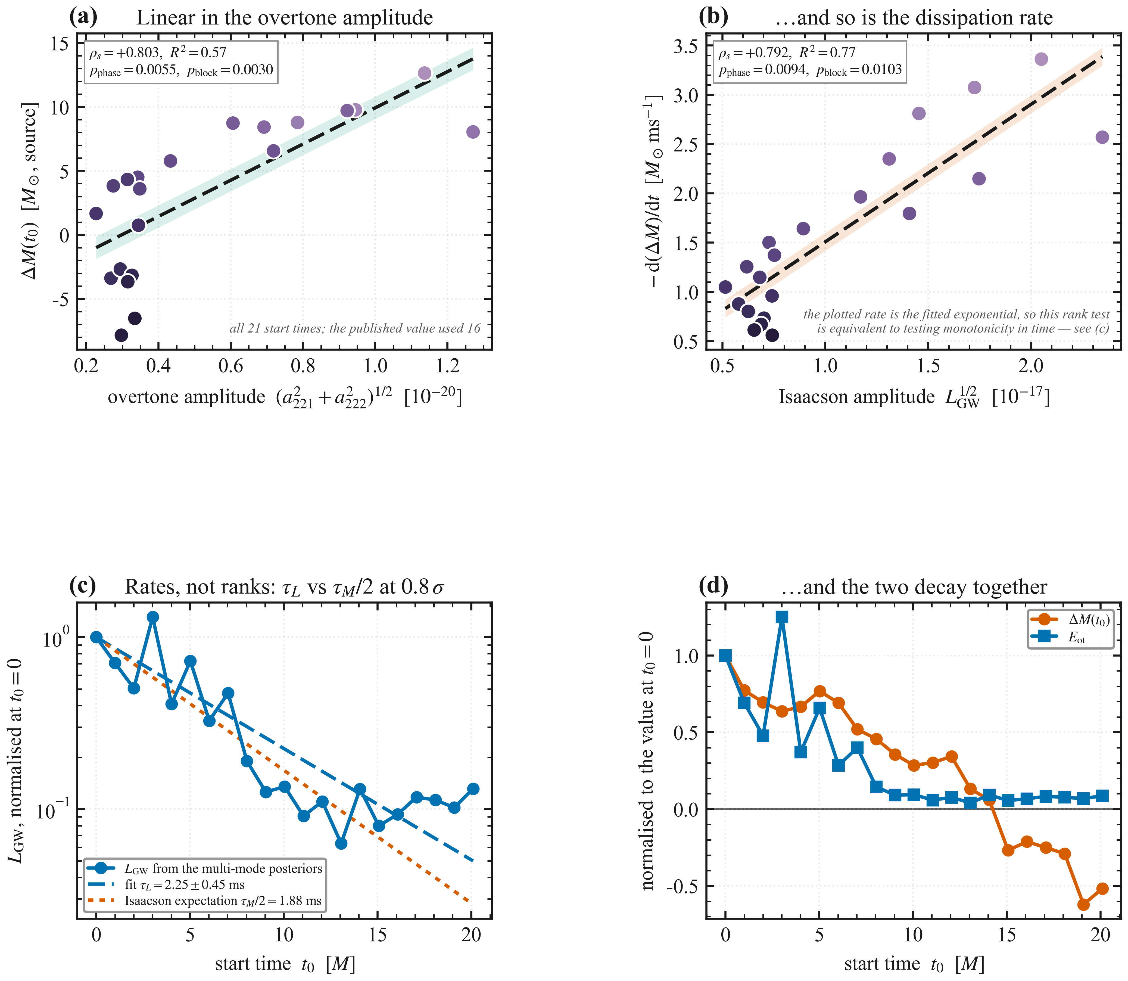
Figure 5: Correlation of the mass bias with overtone content. (a) the single-mode mass bias ΔM(t0) against the overtone amplitude (a2212 + a2222)1/2, and (b) the dissipation rate −d(ΔM)/dt against the Isaacson amplitude LGW1/2, where LGW ∝ Σn an2[(2πfn)2 + γn2], each with a linear fit and its uncertainty band. The abscissae are amplitudes because the bias and its rate scale as the square root of the corresponding energies (exponents 0.52 ± 0.12 and 0.51 ± 0.07), an empirical scaling (Sec. IV.D). Marker colour runs from the earliest to the latest start time. The naive Spearman p-value is not used, since the start times share 99.94% of their samples; each panel prints a phase-randomised surrogate value and a circular block-bootstrap value, with block lengths of 3 start times in (a) and 6 in (b). In (a), ρs = +0.80 with pphase = 0.0055 (pblock = 0.0030). In (b), ρs = +0.79 expresses the decline of LGW with start time, because the plotted rate is the fitted exponential, and the surrogate values printed there (pphase = 0.0094, pblock = 0.0103) depend on the surrogate construction and are not a test of an independent physical relationship. (c) the comparison that does not rest on monotonicity: the luminosity decays with τL = 2.25 ± 0.45 ms against the τM/2 = 1.88 ms that Isaacson balance predicts, an agreement at 0.8 σ (observed-frame durations, both curves normalised at t0 = 0 on a logarithmic axis). (d) the mass bias and the overtone energy in time, each normalised at the first start time.

Table 5: Summary of quantitative attribution tests for the Kerr mass bias $ΔM(t)$. All correlations use the Spearman rank coefficient $ρ_{s}$. The event's spectral p-value is calibrated against phase-randomised surrogates (Fig. 5); the Isaacson rank correlation expresses the decline of LGW with start time and is given without a p-value, and for the NR control only the rank coefficient is given.
Test | Metric | GW250114 | NR Control
Multi-mode accounting | max $|R|/σ$ | $1.65$ ($<3σ$) | $2.03$ ($<3σ$)
Isaacson energy balance | $$ρ_{s}(-dΔM/dt, L_{GW})$$ | $0.79$ | $0.79$
Spectral correlation | $$ρ_{s}(ΔM, E_{overtone})$$ | $0.80$ (p_{phase} = 0.0055) | $0.85$

Table 5 summarizes the three attribution tests. Their convergence — a multi-mode template that removes most of the departure, a radiated luminosity that decays on the timescale the mass bias implies, and a correlation with the overtone spectral energy — is difficult to produce by chance, and each is reproduced by the numerical-relativity control. All three, however, share our data products and our inversion. Three checks that do not are available for the same event, and are considered next; Figure 6 places the trajectory and the first of them on a common geometric time axis, with the inspiral-merger-ringdown posterior beneath.
Rational-filter mode detection. The QNMRF analysis released with the event applies a rational filter that removes a chosen quasi-normal-mode set from the strain and tests the filtered residual against noise; we quote those published results rather than re-running the pipeline. Its detection statistic for the first overtone is 15.84 at the merger and decays to 1.29 by t0 ≈ 15 M, while the statistic for the second overtone never exceeds 3.49. Overtone content is therefore supported over the early window and absent late, by a method sharing neither our template nor our inversion, and we claim no tighter correspondence than that. Repeating the comparison as a Bayesian model selection between the (2,2,0) and (2,2,0)+(2,2,1) templates on our own nested-sampling runs gives log10 B = 9.02 ± 0.30 at the merger — the same sign and decay — but the support crosses zero by t0 ≈ 5 M rather than persisting to ≈ 10 M. The two statistics are not constructed alike, a rational filter removing modes from the data where model selection fits them to it, and the model-selection runs use a shorter analysis segment and a different noise model from both the release and our trajectory fits. We therefore treat agreement in sign and trend as the robust content, and do not assert that the overtone support and the mass displacement decay on the same timescale; the attribution rests on the multi-mode measurement above.
Inspiral-merger-ringdown consistency. The inspiral-merger-ringdown consistency test of Ref. [28], applied to this event in the collaboration's released analysis [9], gives δMf/Mf = +0.023 (+0.068 / −0.063) and δχf/χf = −0.011 (+0.112 / −0.107), placing general relativity at the 49.5% credible level: the remnant is consistent with a standard Kerr black hole. These values are quoted as released; the collaboration's own note records that the inspiral-merger-ringdown consistency results are still to be recomputed with a corrected likelihood function [9]. A physical mass deviation of the size seen at the first start time, δMf/Mf ≈ 0.20, is excluded at 2.6 σ under the conservative reading of those bounds as one-sigma half-widths. On this test alone, a remnant property of that size is therefore disfavoured.
Direct comparison with the released posteriors. The collaboration's public data release for this event [8], [9] carries a start-time analysis of the same strain, and permits a like-for-like test of the trajectory reported here against the one its own pipeline returns. Its released inversion to remnant mass, spin and horizon area begins at 6 M, and its two reference analyses are quoted at single start times, 10.5 M for the single-mode template and 6 M for the two-mode; the released frequency scan itself runs from the strain peak to 30 M but is not inverted. Over the fifteen start times at which both exist, the two agree to a median of 0.67% in mass and 0.50% in horizon area, and the 90% intervals overlap at every one of them in both channels; the released pre-merger mass budget is the 65.83 M⊙ used throughout here. At the strain peak, where the release publishes a frequency but no inversion, its fundamental agrees with the value quoted in Sec. IV.E to 0.41%. The early window resolved here, from the peak to 5 M, has no released inversion to compare against, and it is where the departure is largest. Supplementary S8 tabulates the comparison.
Frame invariance. Under (M, t) → (1+z)(M, t) the horizon area scales as (1+z)2, so ratios, rank correlations, inequalities and the dimensionless spin are exactly invariant, while absolute masses, areas and timescales are not. The claims above that are frame-invariant — the pre-merger budget violation, the area-theorem inequality, the Spearman monotonicity, the overtone fraction, and the QNMRF and IMRCT statistics — are identified as such; the frame-dependent quantities are quoted in the source frame with their detector-frame values given alongside.
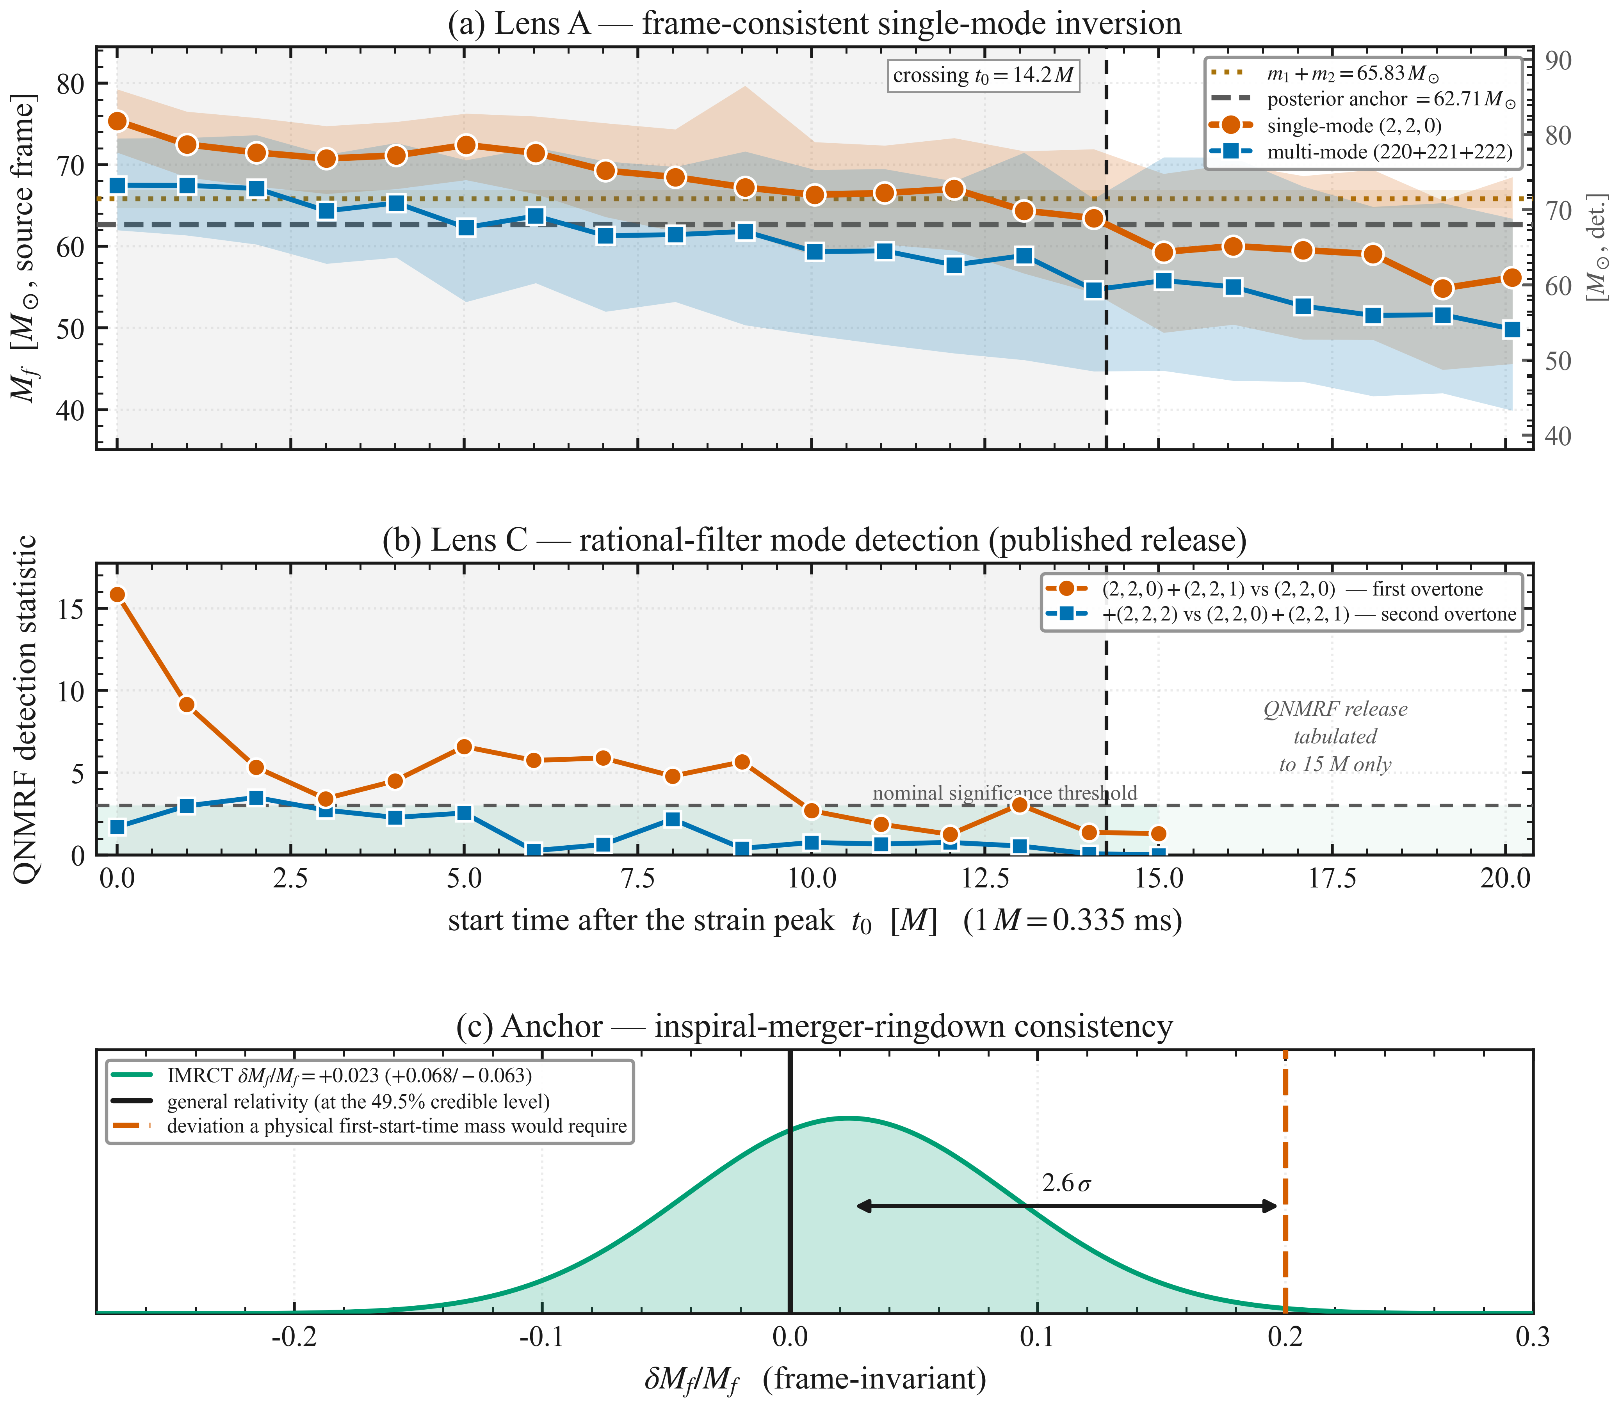
Figure 6: The attribution tests and the two external checks on one geometric time axis. (a) The frame-consistent single-mode inversion, shown with the pre-merger mass budget, the global posterior anchor, and the anchor crossing at t0 = 14.2 M. (b) The first- and second-overtone detection statistics of the released rational-filter (QNMRF) analysis; that release is tabulated to 15 M only, and the interval beyond it is marked as uncovered rather than left blank. (c) The inspiral-merger-ringdown consistency posterior for dMf/Mf, against the deviation a physical mass at the first start time would require. Panels (a) and (b) share the time axis and the marked crossing; the statistics in (b) are quoted from the release and are not re-derived here.

Constrained and Unconstrained Fits to the Same Data
- The preceding tests show that most of the departure is removed by adding modes to the template. A complementary question is whether the information needed to recover the remnant is present in the data at the earliest start time at all. The analysis the companion paper opens with answers it, repeated here on this work’s own configuration: the same strain, power spectral density and twenty-one start times, fitted with two damped sinusoids whose frequencies and damping rates are free and on which no Kerr relation is imposed, as in Ref. [9]. Its priors on mass, spin and amplitude scale are identical to those of the (2,2,0)+(2,2,1) run, so the only difference in the model is whether the frequencies and damping rates are free or fixed by Mf and χf. All frequencies and damping times quoted in this subsection are detector-frame, as recovered, and the Kerr values they are compared against are evaluated at the detector-frame remnant mass, so no redshift enters the comparison.
- At the first start time the unconstrained fit returns f = 249.9 (234.6, 262.1) Hz, against 249.3 ± 0.8 Hz predicted by the Kerr relations from the global posterior — a difference of 0.1 σ. The template used in this work returns 223.2 (219.3, 226.8) Hz at the same start time, 10.7 σ below the same prediction. The frequency of the fundamental is therefore present in the data from the strain peak onward, and the departure reported in Sec. III is not a loss of that information.
- The size of the departure orders with the spectral freedom of the template rather than with its mode count. Measured at the first start time against the same prediction: two free damped sinusoids, +0.1 σ; Kerr (2,2,0)+(2,2,1), −3.1 σ; Kerr (2,2,0)+(4,4,0), −10.7 σ; Kerr (2,2,0) alone, −10.8 σ. The (4,4,0) is tied to the same Mf and χf as the (2,2,0) and adds no free spectral parameter, and the template that carries it recovers the same frequency as the template that omits it. If the same Kerr relations are applied to the frequency and damping time recovered by each fit — which for the constrained templates simply returns their own parameters — the four give first-start-time masses 14.1%, 5.5%, 20.2% and 24.5% above the posterior anchor, each evaluated at that fit's median frequency and damping time. The ordering by frequency is not the ordering by mass, because the damping time enters the mass through the spin. Figure 7(a) places the four recoveries on the (f, τ) plane, together with the Kerr map that turns a point on it into a mass and a spin.
- The difference between the constrained and unconstrained fits closes with start time, and it closes where the published intervals open. Taking the first start time at which the constrained frequency crosses the prediction, the (2,2,0) template converges at 11 M and the (2,2,0)+(2,2,1) template at 5 to 6 M, against the 11 tMf and 6 tMf of [9], which were derived from amplitude stability on a noiseless simulation. The two criteria share neither the data — a noiseless simulation against the event itself — nor the statistic, and they place the boundary at the same start times. Figure 7(b) follows the constrained and unconstrained frequencies across all twenty-one start times, with both boundaries marked.
- Three limits bound this comparison. The unconstrained fit determines the frequency to ±5.5% at the first start time, so the agreement above is a consistency statement and not a precision measurement. Its damping time, 5.19 (3.91, 7.63) ms against the Kerr 4.073 (4.001, 4.139) ms, is long by 27%: residual content inflates the apparent decay whether or not the Kerr relation is imposed, which is why the mass ordering differs from the frequency ordering. And its second component sits at 202 (168, 231) Hz at the first start time, about 2 σ below the Kerr (2,2,1) frequency, with an interval spanning most of the prior beyond 8 M: the unconstrained fit does not resolve two quasi-normal modes. It provides somewhere for content the template does not carry to go, and that alone leaves the long-lived component unbiased. The inference of individual mode content from such fits is model-dependent [26]; no such inference is drawn here. An independent framework applies an agnostic two-damped-sinusoid model to this same event and likewise finds the remnant posterior consistent with the full-signal estimate despite the added freedom [29]; what is measured here is the contrast between the free and constrained fits at a single start time, in units of their own uncertainty. A separate line of work on model potentials reports that the number of modes included matters more than the fidelity of the model used for them [30]; that is not in tension with the ordering above, which compares templates of the same component count and varies only whether their frequencies are free.
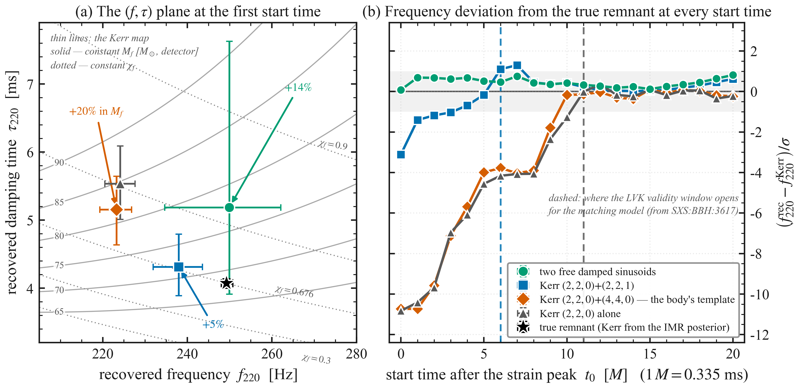
Figure 7: Constrained and unconstrained fits to the same data. (a) the (f, τ) plane at the first start time, with the Kerr map drawn as curves of constant Mf (solid) and constant χf (dotted). The star is the remnant's Kerr frequency and damping time evaluated sample by sample on the inspiral-merger-ringdown posterior — the best available estimate, not an injected truth as in Figure 4. The unconstrained two-mode fit (circle) sits directly above it: it matches the remnant's frequency and exceeds its damping time. The Kerr (2,2,0)+(4,4,0) template (diamond) and the pure (2,2,0) template (triangle) sit to the left, at lower frequency and longer damping time, and the Kerr (2,2,0)+(2,2,1) template (square) lies closest to the truth. Annotations give the first-start-time mass each recovery implies, as a percentage above the posterior anchor. (b) the frequency deviation from the true remnant at all 21 start times, in units of the combined uncertainty, with the ±1 σ band shaded; the dashed verticals mark where the companion analysis places the lower edge of each model's validity interval, 11 tMf for (2,2,0) and 6 tMf for (2,2,0)+(2,2,1) [9], where tMf is the remnant's geometric mass unit. The unconstrained fit stays inside 1 σ at every start time, and the constrained templates meet the prediction where those intervals open. All frequencies, damping times and Kerr values are detector-frame.

Robustness of the Decay-Timescale Fit and Explicit Two-Mode Comparison

Thinning the start times to five tests whether the relaxation timescale survives a less overlapped subset. The thinning reduces the overlap without removing it: 63.5% remains, and genuine independence would require spacings of ≳14 M. It therefore tests stability rather than independence, and within that scope the fits are stable and shift, if anything, closer to τ220 (Supplementary S6).

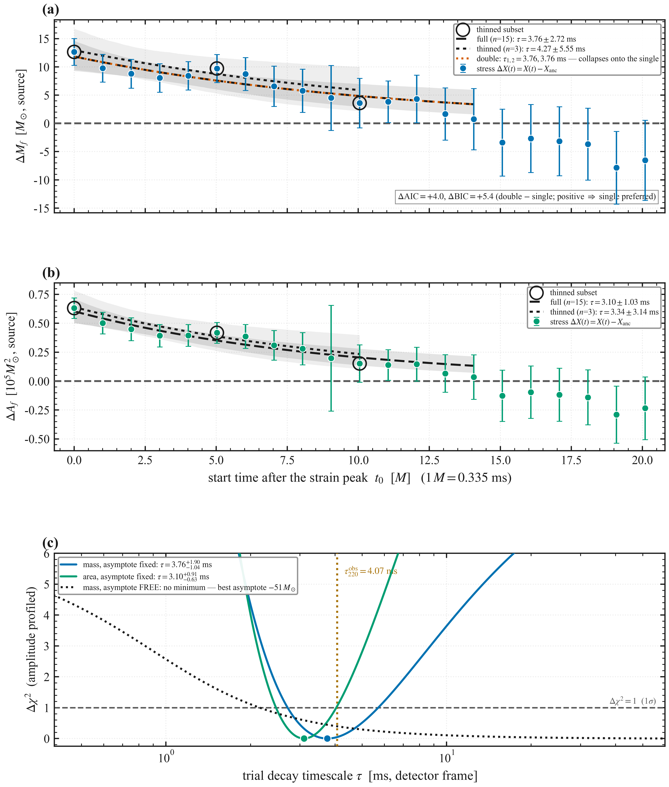
Figure 8: Identifiability of the relaxation timescale. (a) the mass stress $ΔM_{f}(t)=M_{f}(t)−M_{anc}$ with the full 15-point fit and the thinned three-point fit, each with its 90% bootstrap band, agreeing at 0.08 σ; the double-exponential model is overlaid and collapses onto the single exponential (τ1,2 = 3.76, 3.76 ms) and is not preferred (Sec. IV.F). (b) the same for the area channel, the two fits agreeing at 0.07 σ. The spin channel is omitted: no exponential relaxation is resolved in it under either fit. (c) the profile likelihood in the trial timescale, with the amplitude solved exactly at each τ. With the asymptote fixed to the physical reference, the mass profile has a clean minimum at 3.76 ms whose Δχ2 = 1 interval, [2.72, 5.66] ms, contains the observed Kerr damping time τ220obs = 4.07 ms; the shallow basin measures how weakly the timescale is constrained. With the asymptote released the profile has no interior minimum at all and the best-fitting asymptote is negative — which is why it is held fixed. Stresses are source-frame; the fits run on detector-frame start times.

To assess whether a second decay component is required, we refit the Kerr-mass-bias trajectory with an explicit double-exponential model, $D(t)=A_{f} exp(−t/τ_{fast})+A_{s} exp(−t/τ_{slow})$, admitting a fast overtone component and a slow fundamental component (Figure 8). The slow timescale (τ_{slow} = 3.762 ms) is not distinct from the fast one, τ_{fast} = 3.762 ms: the components collapse onto each other and the two models return the same χ2 to ten significant figures, so the double exponential is penalised for two parameters that add nothing. It therefore does not improve the fit under either the Akaike [31] or Bayesian information criterion [32] (ΔAIC = +4.0, ΔBIC = +5.4, double minus single, so positive values favour the single exponential), and the single exponential is preferred over the double exponential at the present cadence and signal-to-noise ratio. The two physical decay timescales obtained directly from the two-mode (220+221) posteriors, τ₂₂₀ ≈ 4.5 ms and τ₂₂₁ ≈ 1.5 ms, are therefore not separately resolvable in the single-mode mass trajectory. The single fitted timescale is an effective benchmark summary of the dominant relaxation of the inferred trajectory rather than a direct measurement of either individual QNM damping time; its proximity to τ₂₂₀ is consistent with the increasing dominance of the long-lived fundamental mode in the later, lower-overtone windows. A per-start-time Bayesian model comparison between the single-mode and two-mode templates, which favours the two-mode model exactly where the overtone is expected, is reported in Supplementary S7.

Scope and Limitations
The 21 ringdown start times overlap in time and are therefore not statistically independent. Choices that leave the model untouched can still move what a ringdown analysis reports: the resolution of the estimated noise spectrum, the digitisation of the start time and the sampling rate have each been shown to change the significance of an overtone in GW150914 [33]. The start times used here are those of the released configuration, and the conditioning is held fixed across all 21. The earliest windows are the most sensitive to overtone content and to any non-linear merger contribution, which is not modelled here. The pre-merger inspiral regime is not analyzed; the component masses $m_{1}$ and $m_{2}$ are taken from the global posterior as context for the energy budget, not as time-resolved observables. Four further limitations are established quantitatively in the body. The relaxation timescale is determined only to about a factor of two, its exponential form is a modelling choice rather than a preference of the data, and its asymptote must be held fixed because releasing it leaves it exactly anti-correlated with the timescale (Sec. IV.A). The spin channel is the weakest of the three, for reasons of signal-to-noise rather than of the inversion (Sec. III.C). Isaacson's effective stress tensor presumes a separation of scales that a ringdown with Q ≈ 0.5–3.5 does not provide, so LGW is used as a relative indicator rather than an absolute flux, and at the later start times the overtone amplitudes are bounded by their priors (Sec. IV.D). Finally, the present results pertain to a single event; establishing the generality of the inferred-parameter trajectory and its overtone origin will require applying this framework to a sample of high-signal-to-noise ringdowns analyzed under a common pipeline, which we leave to future work.

Conclusion
We have presented a time-resolved analysis of the Kerr parameters inferred from localized single-mode ringdown fits to GW250114 at 21 successive start times. Its purpose is not to improve the measurement of the physical remnant mass, which the inspiral-merger-ringdown posterior already provides and against which everything here is measured, but to understand why single-mode ringdown inference departs from that anchor at early times, by how much, and on what timescale the departure decays.
The inferred mass falls steadily from 75.3 M⊙ to 56.2 M⊙ in the source frame, crossing the global posterior anchor of 62.71 M⊙ at t0 = 14.2 M. At the earliest start time it exceeds not only the anchor but the entire pre-merger mass budget, by 3.87 σ with the two marginal posteriors treated as independent — an excess no choice of frame can remove, and the clearest evidence that the quantity being recovered there is an effective parameter and not a mass. The inferred horizon area exceeds the total pre-merger area at every start time, ending 36.5% above it — a property of the single-mode estimator, not a horizon measurement; its decline across the trajectory is driven by the mass channel, the spin contributing with the opposite sign (Sec. S2). The area theorem itself is tested in Sec. S5 of the Supplementary Material, where the global-posterior ratio A_f^post / A_pre = 1.582 ± 0.019 is shown to measure internal consistency, since both areas come from the same draws, and the late-time inferred area exceeds the pre-merger sum at 4.2 σ. Surrogates that preserve the correlation between overlapping analyses show that the monotonic decline is not a product of that overlap (Table 2). The conclusions that follow rest on the budget violation above, the numerical-relativity control, and the multi-mode and unconstrained fits, not on those significance levels.
The apparent excess is not a black hole losing mass. It is what results from projecting a multi-mode post-merger signal onto an incomplete single-mode Kerr model: while transient structure is present the recovered parameters absorb it, and as that structure decays they relax toward the physical remnant values. Repeating the fit with a (2,2,0)+(2,2,1)+(2,2,2) template removes 62% of the departure directly, and a controlled numerical-relativity injection reproduces the same trajectory from a remnant whose mass is known and constant. Those two results carry the attribution. A further run on the event's own data, with the frequencies and damping rates left free rather than fixed by a mass and a spin, recovers the remnant's fundamental frequency at the first start time: what the constrained fit loses is not the information but the freedom to express it. An independent rational-filter analysis of the same event finds overtone content present early and absent late, which agrees in sign and in trend; we do not claim more than that from it. The mechanism is not specific to black-hole spectroscopy: wherever a nonstationary signal is described by a model with a restricted set of degrees of freedom, the fitted parameters absorb what the model omits and can evolve while the system itself does not. The numerical-relativity control shows that directly, with a remnant mass that is constant by construction.
Fitting the departure with an exponential whose asymptote is fixed to the anchor gives τM = 3.76 (+1.90/−1.04) ms, or 11.2 M, against a Kerr (2,2,0) damping time of 12.1 M in either frame, a ratio of 0.92. This is a consistency rather than a measurement: the timescale is determined only to about a factor of two, its asymptote must be held fixed, and a straight line describes the fitted interval equally well (Sec. IV.G).
An independent prediction bears on where the trajectory should be trusted: a dynamical-excitation model of quasinormal mode amplitudes finds a stationary ringdown regime only from about 10–20 M after the peak [34], the same boundary the early-time bias measured here implies from the data side. Two limitations travel with these results: the spin channel is the weakest, its 3.82 σ nominal tension with the anchor under unweighted averaging falling to 1.31 σ under inverse-variance weighting, and every start time is analysed over the same stretch of data, so the trajectory is one correlated measurement of a trend rather than 21 independent measurements.
Applying the same sequential inversion to other high signal-to-noise events, and to subdominant spherical-harmonic modes, is the natural next step. With third-generation detectors the same method would follow the departure over a longer baseline than the present data allow, and could measure the relaxation timescale without fixing its asymptote by hand. Even those detectors would remain far from any semiclassical horizon-area quantization scale, as the order-of-magnitude estimate in Sec. S3 shows.

Acknowledgments
This research has made use of data, software, and/or web tools obtained from the Gravitational Wave Open Science Center (https://gwosc.org), a service of LIGO Laboratory, the LIGO Scientific Collaboration, the Virgo Collaboration, and KAGRA. We thank the developers of Bilby, pyRing, and QNMRF for their publicly available analysis tools.

Data Availability
The raw gravitational-wave strain data for the GW250114 event analyzed in this study are available from the Gravitational Wave Open Science Center (GWOSC). The global Bilby posterior samples, the time-resolved QNM inversion data sets, and the numerical data underlying all figures will be made publicly available in a Zenodo repository upon publication of this manuscript. The Python scripts and automated pipelines developed for this time-resolved analysis are available in a public GitHub repository. Every numerical value quoted in this work is re-derived from those posteriors by that pipeline rather than transcribed, and the derivations are included with it.

References
[1] The LIGO Scientific Collaboration et al., “GWTC-3: Compact Binary Coalescences Observed by LIGO and Virgo During the Second Part of the Third Observing Run,” Phys. Rev. X, vol. 13, no. 4, p. 041039, Oct. 2023, doi: 10.1103/PhysRevX.13.041039.
[2] G. Ashton et al., “Bilby: A user-friendly Bayesian inference library for gravitational-wave astronomy,” Astrophys. J. Suppl. Ser., vol. 241, no. 2, p. 27, Nov. 2018, doi: 10.3847/1538-4365/ab06fc.
[3] E. Berti, V. Cardoso, and C. M. Will, “On gravitational-wave spectroscopy of massive black holes with the space interferometer LISA,” Phys. Rev. D, vol. 73, no. 6, p. 064030, 2006, doi: 10.1103/PhysRevD.73.064030.
[4] K. Destounis and F. Duque, “Black-hole spectroscopy: quasinormal modes, ringdown stability and the pseudospectrum,” in Compact Objects in the Universe, E. Papantonopoulos and N. Mavromatos, Eds. Cham, Switzerland: Springer Nature, 2024, doi: 10.1007/978-3-031-55098-0_6.
[5] M. Isi, M. Giesler, W. M. Farr, M. A. Scheel, and S. A. Teukolsky, “Testing the no-hair theorem with GW150914,” Phys. Rev. Lett., vol. 123, no. 11, p. 111102, Aug. 2019, doi: 10.1103/PhysRevLett.123.111102.
[6] T. A. Clarke et al., “Striking the right tone: toward a self-consistent framework for measuring black hole ringdowns,” Phys. Rev. D, vol. 109, no. 12, p. 124030, Jun. 2024, doi: 10.1103/PhysRevD.109.124030.
[7] E. Finch and C. J. Moore, “Searching for a ringdown overtone in GW150914,” Phys. Rev. D, vol. 106, no. 4, p. 043005, Aug. 2022, doi: 10.1103/PhysRevD.106.043005.
[8] A. G. Abac et al., “GW250114: Testing Hawking’s Area Law and the Kerr Nature of Black Holes,” Phys. Rev. Lett., vol. 135, no. 11, p. 111403, Sep. 2025, doi: 10.1103/kw5g-d732.
[9] The LIGO Scientific Collaboration, the Virgo Collaboration, and the KAGRA Collaboration, “Black Hole Spectroscopy and Tests of General Relativity with GW250114,” arXiv:2509.08099 (2025); LIGO-P2500461.
[10] M. Giesler, M. Isi, M. A. Scheel, and S. A. Teukolsky, “Black Hole Ringdown: The Importance of Overtones,” Phys. Rev. X, vol. 9, no. 4, p. 041060, Dec. 2019, doi: 10.1103/PhysRevX.9.041060.
[11] R. Cotesta, G. Carullo, E. Berti, and V. Cardoso, “Analysis of Ringdown Overtones in GW150914,” Phys. Rev. Lett., vol. 129, no. 11, p. 111102, Sep. 2022, doi: 10.1103/PhysRevLett.129.111102.
[12] M. Suzuki, K. Kubota, S. Morisaki, H. Motohashi, and D. Watarai, “Ringdown Analysis of GW250114 with Orthonormal Modes,” arXiv:2605.03576 (2026).
[13] R. Li, “Deterministic Trust Regions for Finite-Window Black-Hole Spectroscopy in GW250114,” arXiv:2604.17558 (2026).
[14] S. H. Völkel and A. Dhani, “Quantifying Systematic Biases in Black Hole Spectroscopy,” Phys. Rev. D, vol. 112, no. 8, p. 084076, Oct. 2025, doi: 10.1103/g6sz-dw28.
[15] R. Dyer and C. J. Moore, “Quasinormal mode content of binary black hole ringdowns,” Phys. Rev. Lett., vol. 136, no. 19, p. 191403, May 2026, doi: 10.1103/ptmd-rz1t.
[16] L. Capuano et al., “Systematic bias in LISA ringdown analysis due to waveform inaccuracy,” Phys. Rev. D, vol. 112, no. 10, p. 104031, Nov. 2025, doi: 10.1103/86yd-x1sl.
[17] E. Coleman and E. Finch, “High-overtone ringdown fits: start time, no-hair tests, and correlations,” arXiv:2512.08098 (2025).
[18] H. Siegel, N. M. Khusid, M. Isi, and W. M. Farr, “GW231123 ringdown: interpretation as multimodal Kerr signal,” arXiv:2511.02691 (2025).
[19] V. Varma et al., “Surrogate models for precessing binary black hole simulations with unequal masses,” Phys. Rev. Res., vol. 1, no. 3, p. 033015, Oct. 2019, doi: 10.1103/PhysRevResearch.1.033015.
[20]M. Isi and W. M. Farr, “Analyzing black-hole ringdowns,” arXiv:2107.05609 (2021).
[21] G. Carullo, W. Del Pozzo, and J. Veitch, “Observational Black Hole Spectroscopy: A time-domain multimode analysis of GW150914,” Phys. Rev. D, vol. 99, no. 12, p. 123029, Jun. 2019, doi: 10.1103/PhysRevD.99.123029 [Erratum: Phys. Rev. D 100, 089903 (2019), doi: 10.1103/PhysRevD.100.089903].
[22] V. Baibhav, M. H.-Y. Cheung, E. Berti, V. Cardoso, G. Carullo, R. Cotesta, W. Del Pozzo, and F. Duque, “Agnostic black hole spectroscopy: Quasinormal mode content of numerical relativity waveforms and limits of validity of linear perturbation theory,” Phys. Rev. D, vol. 108, no. 10, p. 104020, Nov. 2023, doi: 10.1103/PhysRevD.108.104020.
[23] G. V. Bayley and J. M. Hammersley, “The “Effective” Number of Independent Observations in an Autocorrelated Time Series,” J. R. Stat. Soc. Ser. B, vol. 8, no. 2, pp. 184–197, 1946, doi: 10.2307/2983560.
[24] Y. Yang, C. Shi, and Y.-M. Hu, “Contribution from Nonlinear Quasi-normal Modes in GW250114,” arXiv:2510.16903 (2025).
[25] M. A. Scheel et al., “The SXS Collaboration’s third catalog of binary black hole simulations,” Class. Quantum Grav., vol. 42, no. 19, p. 195017, Oct. 2025, doi: 10.1088/1361-6382/adfd34.
[26] K. Chandra and J. Calderón Bustillo, “Black-hole ringdown analysis with inspiral-merger informed templates and limitations of classical spectroscopy,” arXiv:2509.17315 (2025).
[27] R. A. Isaacson, “Gravitational Radiation in the Limit of High Frequency. II. Nonlinear Terms and the Effective Stress Tensor,” Phys. Rev., vol. 166, no. 5, pp. 1272–1280, Feb. 1968, doi: 10.1103/PhysRev.166.1272.
[28] A. Ghosh et al., “Testing general relativity using golden black-hole binaries,” Phys. Rev. D, vol. 94, no. 2, p. 021101, Jul. 2016, doi: 10.1103/PhysRevD.94.021101.
[29] S. Guo and Y.-G. Miao, “A pre-merger-informed spectral-level ringdown inference framework for black-hole spectroscopy,” arXiv:2605.25623 (2026).
[30] P. J. Nee, S. H. Völkel, and H. P. Pfeiffer, “Role of black hole quasinormal mode overtones for ringdown analysis,” Phys. Rev. D, vol. 108, no. 4, p. 044032, Aug. 2023, doi: 10.1103/PhysRevD.108.044032.
[31] H. Akaike, “A new look at the statistical model identification,” IEEE Trans. Automat. Contr., vol. 19, no. 6, pp. 716–723, Dec. 1974, doi: 10.1109/TAC.1974.1100705.
[32] G. Schwarz, “Estimating the Dimension of a Model,” Ann. Statist., vol. 6, no. 2, pp. 461–464, 1978, doi: 10.1214/aos/1176344136.
[33] Y.-F. Wang et al., “A gating-and-inpainting perspective on GW150914 ringdown overtone: understanding the data analysis systematics,” Phys. Rev. D, vol. 112, no. 8, p. 083023, Oct. 2025, doi: 10.1103/3gqn-297f.
[34] M. De Amicis, E. Cannizzaro, G. Carullo, and L. Sberna, “Dynamical quasinormal mode excitation,” Phys. Rev. D, vol. 113, no. 2, p. 024048, Jan. 2026, doi: 10.1103/bgjv-lvyd.
[35] M. Isi, W. M. Farr, M. Giesler, M. A. Scheel, and S. A. Teukolsky, “Testing the black-hole area law with GW150914,” Phys. Rev. Lett., vol. 127, no. 1, p. 011103, Jun. 2021, doi: 10.1103/PhysRevLett.127.011103.
[36] A. Vehtari, A. Gelman, and J. Gabry, “Practical Bayesian model evaluation using leave-one-out cross-validation and WAIC,” Stat. Comput., vol. 27, no. 5, pp. 1413–1432, Sep. 2017, doi: 10.1007/s11222-016-9696-4.
[37] J. D. Bekenstein and V. F. Mukhanov, “Spectroscopy of the quantum black hole,” Phys. Lett. B, vol. 360, pp. 7–12, 1995, doi: 10.1016/0370-2693(95)01148-J.
[38] J. D. Bekenstein, “Generalized second law of thermodynamics in black-hole physics,” Phys. Rev. D, vol. 9, no. 12, pp. 3292–3300, Jun. 1974, doi: 10.1103/PhysRevD.9.3292.
[39] S. W. Hawking, “Gravitational Radiation from Colliding Black Holes,” Phys. Rev. Lett., vol. 26, no. 21, pp. 1344–1346, May 1971, doi: 10.1103/PhysRevLett.26.1344.
[40] D. Christodoulou, “Reversible and Irreversible Transformations in Black-Hole Physics,” Phys. Rev. Lett., vol. 25, no. 22, pp. 1596–1597, Nov. 1970, doi: 10.1103/PhysRevLett.25.1596.
[41] J. Mäkelä, “Black Hole Spectrum: Continuous or Discrete?,” Phys. Lett. B, vol. 390, pp. 115–118, 1997, doi: 10.1016/S0370-2693(96)01376-7.
[42] S. Watanabe, “Asymptotic Equivalence of Bayes Cross Validation and Widely Applicable Information Criterion in Singular Learning Theory,” J. Mach. Learn. Res., vol. 11, pp. 3571–3594, 2010.
[43]LIGO Scientific Collaboration, Virgo Collaboration, and KAGRA Collaboration, “GW250114 discovery paper figure scripts,” Zenodo, v1, Sep. 2025, doi: 10.5281/zenodo.16877102.

