Supplementary Material
Companion to "Single-Mode Kerr Inference Bias in the Early Ringdown of GW250114: Magnitude and Origin." This document preserves detailed analyses moved out of the main text during the revision that recast the paper around single-mode inference bias. Equations in Sections S1-S4 are rendered as plain text; Section S5 carries its own, moved intact from the main text.
Citations in this document follow the numbering of the main text's reference list; [6], [8], [9], [20] and [35]–[43] are resolved there.
S1. Detailed late-time spin/area convergence diagnostics
(Condensed in Sec. III.C of the main text.)
Quality-gated analysis. We classify each start time by the width of its 90% credible interval Δχ90%. Start times with Δχ90%>0.5 are flagged as precision-limited; six of the last seven start times (16–21) exceed this threshold, with CI widths ranging from 0.52 to 0.74, compared to 0.13–0.17 for the first seven start times, thus a degradation factor of 4.5×. When only high-precision start times (Δχ90%<0.3) are retained, the latest reliable measurements (start times 8, 9, 11, 12, 13) yield χf=0.735±0.033, which lies above the posterior anchor. This reveals a key feature: the spin trajectory transitions from being biased upward in early start times (due to overtone) to biased downward in late start times (due to noise), passing through the posterior anchor value only in an intermediate regime.
Jackknife analysis. A leave-one-out jackknife over the last five start times confirms that the tension is not driven by a single outlier: removing any individual start time leaves the tension in the range 2.9–3.8 σ. This is consistent with a systematic precision effect across the late-time ensemble rather than a pathological data point.
Physical origin. The spin extraction depends on the quality factor Q=πf220τ220, which amplifies the measurement uncertainty in τ220 due to the less precisely determined QNM observable at low amplitude [6, 20]. By contrast, the mass parameter depends primarily on f220 alone and remains robust in the low-SNR regime. Consequently, the spin parameter has a narrower effective dynamic range for reliable extraction than the mass parameter: early start times are affectedmore by overtone content that biases Q upward, while late start times suffer from noise that biases Q downward. The mass parameter, being insensitive to this Q-mediated amplification, converges cleanly across the full range of start times. Figure 2(d) visualizes this interval-width degradation across all 21 start times. In contrast to the mass channel, which depends primarily on frequency and remains robust at low SNR, the spin channel depends sensitively on the damping time and thus becomes unreliable in late-time regimes.
To account for the varying measurement precision across start times, we apply an inverse-variance weighted analysis to the late-time convergence. We define the weighted mean of the last five start times as:
xwt=i=1721xi/σi2i=17211/σi2,
where xi is the median parameter value at start time i, and the per-start-time uncertainty σi=(xi,hi-xi,lo)/3.29 is estimated from the 90% credible interval as a proxy for the standard error. The standard error of the weighted mean is:
σwt=i=17211σi2-1/2.
The tension between the weighted mean and the global posterior anchor is then evaluated as:
T=|xwt-xpost|σwt,
where xpost is the median of the global posterior anchor.
- Area channel. The Kerr horizon area parameter Af(t) is derived rather than measured: at each start time it is the Kerr area of the best-fit single-mode (2,2,0) parameters, not a direct measurement of the physical horizon area. Nor is it an independent channel: by the definition given in Sec. II.C of the main text it is fixed by Mf(t) and χf(t) alone, and across these start times its fractional deviation tracks the mass channel's with a coefficient of determination of 0.98, so the agreement between the two channels is largely a consequence of that definition rather than an independent corroboration. Its trajectory is shown in panel (c) of Figure 2 of the main text; its relaxation timescale is reported in Sec. S6 below.
- Trajectory and late-time convergence. Across the 21 start times it decreases from Af ≃ 2.34 × 10⁵ M⊙² at the earliest start time to Af ≃ 1.75 × 10⁵ M⊙² at late times, relaxing toward the global posterior anchor area Af,post ≃ 1.72 × 10⁵ M⊙²; the monotonic decrease reflects the convergence of the effective single-mode description toward the stationary Kerr geometry as the overtone content decays. Propagating the per-start-time posterior widths through the late-time mean gives a tension of 1.6 σ for the area, against 1.7 σ for the mass and 1.4 σ for the spin. Under the inverse-variance weighting defined above, Af,wt = (1.547 ± 0.108) × 10⁵ M⊙², a tension of 1.57 σ against the anchor Af,post = (1.716 ± 0.031) × 10⁵ M⊙², which falls inside the same 2 σ consistency threshold the spin does. The single-point excursion at start time 10 appears in the area intervals of that run as well as in the mass intervals, as is expected of a quantity derived from both.
S2. Shapley-value decomposition of the horizon-area change
Mass vs. Spin Decay Channels. The area's decline is driven entirely by the mass channel; the spin contributes with the opposite sign. The total median Kerr area change from the peak of the ringdown to the late-time stationary phase is ΔA=Af(t21)-Af(t1)=-8.61×10⁴ M⊙² (with 90% credible interval [-1.29×10⁵,-3.59×10⁴] M⊙²). To understand the parameter-driven channels behind this relaxation, we decompose this total change into the respective contributions of Kerr mass decay and Kerr spin relaxation. Because the Kerr area formula is non-linear and non-separable, a naive path-dependent decomposition depends on the order of parameter variations. To guarantee mathematical exactness and path independence, we apply a sample-by-sample game-theoretic Shapley value decomposition:
ΔAMj=12A(M2j,χ1j)-A(M1j,χ1j)+A(M2j,χ2j)-A(M1j,χ2j),
ΔAχj=12A(M2j,χ2j)-A(M2j,χ1j)+A(M1j,χ2j)-A(M1j,χ1j),
where the indices 1 and 2 denote start time 1 and start time 21, respectively, and ΔAMj+ΔAχj=A(M2j,χ2j)-A(M1j,χ1j) holds exactly for every sample j. The decomposition reveals that the Kerr area reduction is driven entirely by the mass decay channel, which contributes a median Kerr area decrease of ΔAM=-1.11×10⁵ M⊙² (90% CI: [-1.67×10⁵,-2.81×10⁴] M⊙², representing 128.92% of the total change). Conversely, the dimensionless Kerr spin relaxation (which decreases from χ≈0.76 to χ≈0.49) opposes this decay, contributing a positive area change of ΔAχ=+2.40×10⁴ M⊙² (90% CI: [-8.75×10³,+3.97×10⁴] M⊙², representing a -27.89% share; the two shares are medians of separate distributions and are not constrained to sum to 100%). This demonstrates that the macroscopic settling of the inferred Kerr area is driven by the radiation of mass-energy, while the simultaneous radiation of angular momentum actually halts further area reduction, satisfying the dynamical interplay of the Kerr geometry.
S3. Horizon-area quantization and third-generation resolution limits
Horizon Area Quantization & 3G Resolution Limits. As an order-of-magnitude estimate, we consider the detectability of horizon area quantization within semiclassical models; given the extremely large quantum numbers involved and the observational uncertainties derived here, such effects remain observationally inaccessible in the GW band. In semiclassical quantum gravity, the horizon area of a black hole is hypothesized to be quantized in discrete steps of the Planck area: $A_{N}=Nαl_{P}^{2}$, where $l_{P}=\sqrt{Gℏ/c^{3}}≈1.616×{10}^{-35}$ m is the Planck length and α is a dimensionless coefficient. The Bekenstein-Mukhanov spectrum [37] gives α=4ln(k), which is α≈4.39 at k=3; we evaluate below with α=8πln(3)≈27.61, larger by exactly 2π. Every quantum level below scales as 1/α, so the source's own normalisation would raise each of them by that factor and change nothing: the conclusion holds by more than seventy orders of magnitude either way. The alternative information-theoretic value α=4ln(2)≈2.77 [38] is considered as a check. Converting the physical areas using $1 M_{⊙}^{2}≈8.35×{10}^{75} l_{P}^{2}$, we calculate the posterior distribution of the quantum level N(t) at each start time. At the peak of the ringdown (start time 1), the black hole is in a highly classical state with a median quantum level NBM≈7.10×10⁷⁹. The statistical noise of the MCMC samples spreads the distribution over a range of σN≈2.69×10⁷⁸ (3.78% fractional uncertainty). At late times (start time 21), the level settles to NBM≈4.48×10⁷⁹ with σN≈8.32×10⁷⁸ (18.56% uncertainty). Resolving a single quantum transition (requiring the standard deviation to shrink to σN≤1) would require a detector with a physically impossible SNR of ≈4.03×10⁷⁹ at peak and ≈1.25×10⁸⁰ at late times. Under a projection for a third-generation (3G) detector like the Einstein Telescope or Cosmic Explorer (assuming a high-SNR regime of ∼10⁰⁰ for this event), the projected area precision is reduced to 0.28%, narrowing the quantum number uncertainty to σN≈1.25×10⁷⁷. While this represents a 67× improvement in area resolution, it remains far from the quantum regime. This demonstrates that classical and experimental noise completely wash out the discrete Planck-scale quantum gravity spectrum, leaving the classical continuous geometry as the only observable description in the gravitational-wave band.
S4. Jensen-inequality bias audit of the horizon area
Jensen-inequality bias audit. Median parameter values are adequate point estimates for the horizon area. Because the Kerr horizon area A(M, χ) is non-linear and coupled in both the mass and the dimensionless spin, evaluating it at the posterior medians rather than sample by sample can bias the result. Computing the area for all 4,000 samples at every start time and comparing the median of those areas with the area of the medians, the relative bias runs from −0.174% to +0.121% across the post-merger signal, with a mean of −0.028% and a standard deviation of 0.074%. Median parameter values are therefore adequate point estimates for the area, and the non-linear coupling introduces no significant distortion.
S5. Quantitative verification of the Bekenstein-Hawking area theorem
(The main text states the result and points here.)
The Bekenstein-Hawking area theorem [39], [40], [38] requires that the total horizon area cannot decrease in any classical process: $A_{final}≥A_{initial}$. An observational test of this theorem using GW150914 was presented in Ref. [35], and the collaboration has since applied it to this event itself [8], [9]. We verify this quantitatively for GW250114 using a rigorous Monte Carlo analysis over the full Bilby posterior distributions. The pre-merger horizon areas are computed from the individual component mass and spin posteriors ($m_{1}$, $m_{2}$, $a_{1}$, $a_{2}$), yielding
$$A_{pre}=A_{1}+A_{2}=8π\sum_{i=1}^{2}{m_{i}^{2}}\left[1+\sqrt{1-a_{i}^{2}}\right]=108,{517}_{-4,951}^{+3,705} M_{⊙}^{2} (90\% CI),$$
where the uncertainty is propagated from the full joint posterior of ($m_{1}$, $m_{2}$, $a_{1}$, $a_{2}$), using the measured individual spin magnitudes $a_{1}={0.092}_{-0.083}^{+0.208}$ and $a_{2}={0.100}_{-0.090}^{+0.236}$ rather than the $|χ_{eff}|/2$ approximation.

The final remnant area from the global posterior is $A_{f}^{post}=171,644±3,130 M_{⊙}^{2}$, yielding
$$\frac{A_{f}^{post}}{A_{pre}}=1.582±0.019,$$
corresponding to an irreversible area increase of $58.2\%$. The Monte Carlo analysis over 20,000 posterior samples confirms that $A_{f}>A_{pre}$ in $100\%$ of 20,000 realizations. By a Clopper-Pearson (rule-of-three) bound, this corresponds to p ≲ 1.5×10⁻⁴, i.e., a one-sided significance of $>3.6 σ$; that bound is set by the number of draws, not by the data. The ratio is measured far more sharply: A_f^post / A_pre = 1.582 ± 0.019 stands 31 posterior standard deviations above unity, the uncertainty being the standard deviation of the ratio on those same draws, so the correlation between the two areas is carried exactly rather than propagated. That is a statement of precision, not a Gaussian tail probability: both areas come from the same draws through NR-calibrated relations, so the ratio measures the internal consistency of the waveform model and cannot fall below unity. It is not, in the sense of Refs. [8] and [9], a test of the Bekenstein-Hawking area law against data; that test is made below. Figure S1(b) shows the joint posterior of (Apre, Afpost), the entire sample cloud lying above the Af = Apre boundary. All areas here are computed sample by sample rather than at the posterior medians, whose Jensen-inequality bias stays below 0.2% throughout. That audit, a Shapley-value decomposition of the area change into mass- and spin-driven channels, and an order-of-magnitude assessment of horizon-area quantization [37], [41] against third-generation detector resolution are reported in the Supplementary Information, since none bears on the measurements made in the main text.

The monotonic decrease of the Kerr model parameter $A_{f}(t)$ from early to late start times does not conflict with this result. As discussed in Sec. III.A, the early-time values represent the Kerr area of the best-fit single-mode solution, which overestimates the true remnant area due to unmodeled overtone content. Even so, $A_{f}(t)>A_{pre}$ at every start time (all 21 points), with a minimum ratio of $R=A_{f}/A_{pre}=1.31$ at start time t = 19 M. At early times, where the values are biased upward, that inequality only checks the estimator. At late times it does not: there the area is inferred from the ringdown alone while the pre-merger sum comes from the component masses and spins, so the two sides rest on different parts of the signal - the separation on which Refs. [8] and [9] build their own area-law test. The late-time area (weighted mean of the last five start times: $A_{f}^{late}=154,741±10,773 M_{⊙}^{2}$) undershoots $A_{f}^{post}$ at the $1.57 σ$ level. Against the pre-merger sum the same mean gives a ratio of 1.43, above unity at 4.2 σ when significance is measured as the difference in means divided by the root sum square of the two standard deviations. Ref. [9] divides instead by the standard deviation of the differences; the two coincide when the quantities are independent, and the late-time inferred area and the pre-merger sum rest on different parts of the signal. That reference obtains 3.7 σ for the fractional area difference on this same event, from an inspiral/post-inspiral split of the signal. The uncertainty used here is the inverse-variance combination of the per-start-time posterior widths; the scatter of the five means alone would place the ratio at 10 σ, and we quote the more conservative figure. Our pre-merger sum is drawn from the full-signal posterior rather than from the inspiral alone, so the separation is less clean than theirs; the component masses and spins are nonetheless inspiral-dominated, and no ringdown-inferred quantity enters it. Figure S1 presents the ratio trajectory $R(t)=A_{f}(t)/A_{pre}$, which stays above unity at every start time of the ringdown.
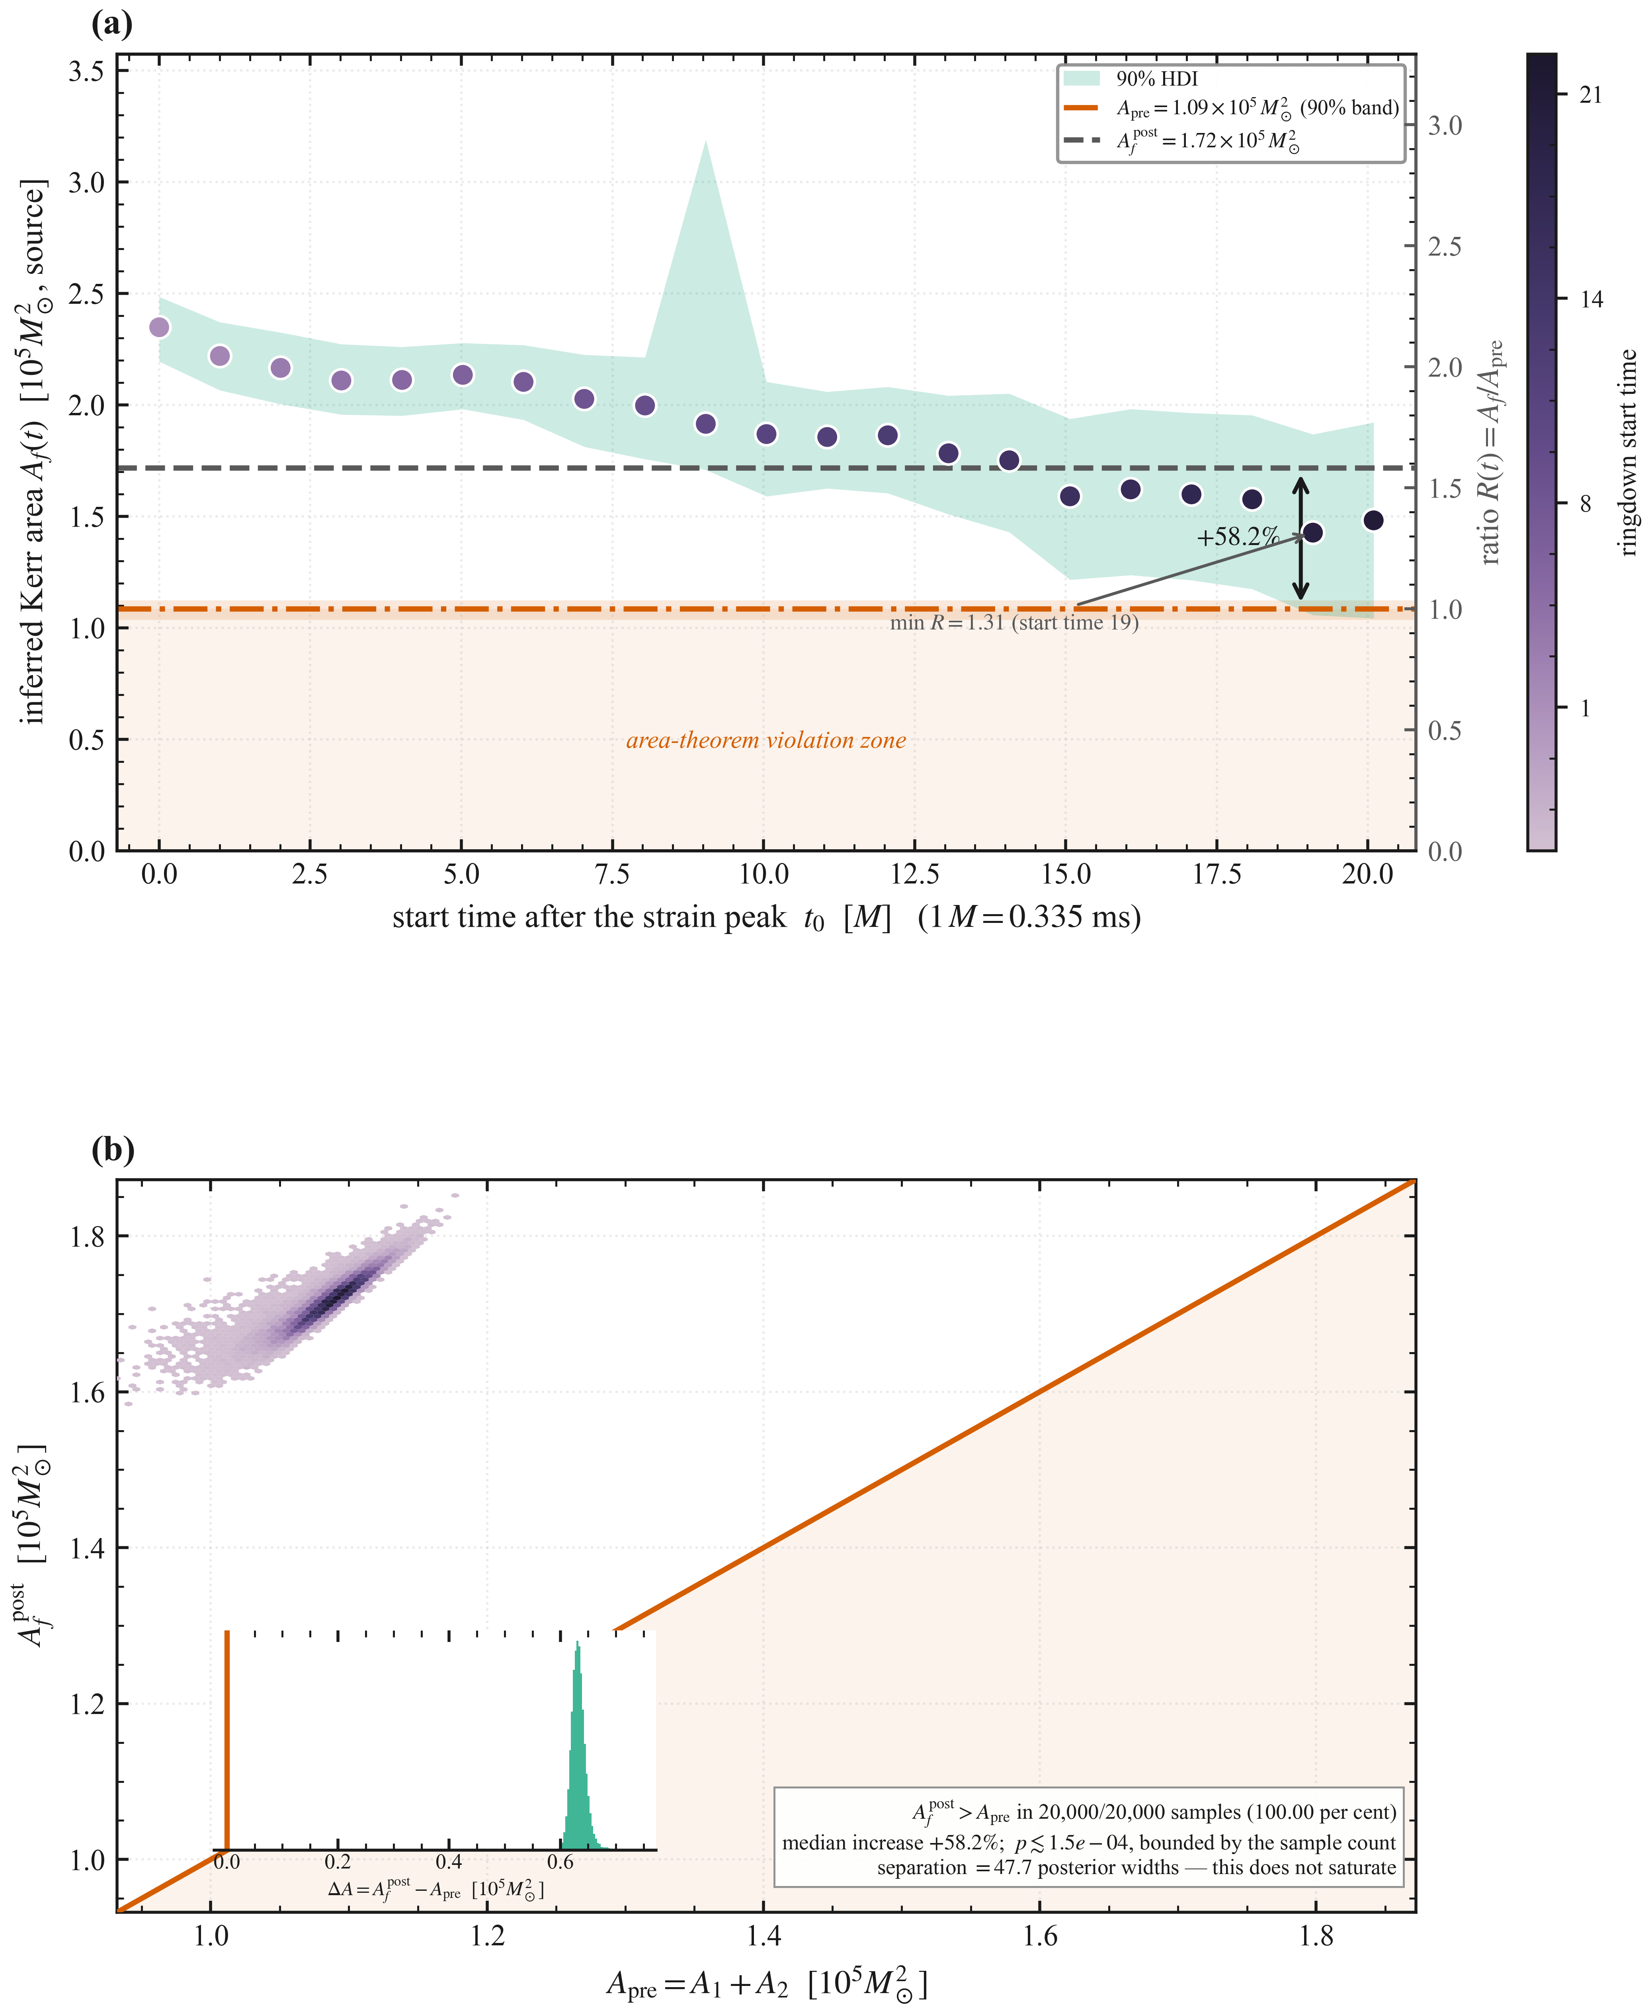
Figure S1: Quantitative verification of the Bekenstein-Hawking area theorem. (a) the inferred Kerr area Af(t) — the area implied by the best-fit single-mode parameters at each start time, not a direct measurement of the physical horizon — with its 90% credible band remains above the pre-merger area sum Apre = 1.09×10⁵ M⊙² (dash-dot, with its own 90% band) at every start time; marker colour runs from the earliest to the latest start time, and the right-hand axis carries the equivalent ratio R(t) = Af/Apre, whose minimum is 1.31 at start time t = 19 M. The double arrow marks the +58.2% median increase over the pre-merger sum. (b) the joint posterior of (Apre, Afpost): all 20,000 samples lie above the Af = Apre boundary. With every sample on one side, the p-value is bounded by the sample count, p ≲ 1.5×10⁻⁴, rather than by the data; the inset therefore shows the ΔA = Afpost − Apre posterior directly, which stands 47.7 of its own widths from zero. All areas are source-frame.

S6. Robustness of the relaxation-timescale fit
(The main text states the conclusion and points here.)
To probe the sensitivity of the fitted relaxation timescale to the ~92.7% inter-window overlap, which correlates adjacent start times and can artificially tighten a fit, we repeat the exponential decay fit on a thinned subset of start times. Thinning reduces the overlap without removing it: five windows spaced 5 M apart remain 63.5% overlapped, and genuine independence would require spacings of ≳14 M, of which the surveyed range admits at most two — the same N_eff ≈ 2 already quoted. The subset used is the one (1, 6, 11, 16, 21; three of them inside the positive-bias regime the exponential can describe) employed for the Spearman analysis in Sec. III.B. The thinned fits yield τ_{M} = 4.27 ± 5.59 ms (Kerr mass), τ_{A} = 3.34 ± 3.21 ms (Kerr area), and τ_{a} is unresolved (Kerr spin), as shown in Figure 8 of the main text. As expected for the reduced sample size, the fractional uncertainties widen relative to the full-window fits (15 positive-bias start times) (τ_{M} = 3.76 (+1.90/−1.04) ms, τ_{A} = 3.10 (+0.91/−0.63) ms, τ_{a} is likewise unresolved); however, the central values shift, if anything, closer to the theoretical τ₂₂₀ = 3.75 ms in the source frame (4.07 ms as observed, which is the frame of the fitted times), with the mass subset timescale, and the area's that follows from it, consistent with τ₂₂₀ to within 0.04–1.06 σ. Thinning therefore tests stability rather than independence, and within that scope the agreement is stable. The evidence that does not rest on correlated windows at all is of a different kind: the surrogate tests of Sec. III.B, which build the correlation into the null, and the numerical-relativity control of Sec. IV.C. The differences between the full-sample and thinned-subset central values, and relative to the single-exponential summary timescale, reflect the alternative fitting parameterizations and data subsets rather than any statistical inconsistency.
Two properties of this fit should be stated plainly rather than left implicit. First, the asymptote is fixed to the posterior anchor rather than fitted, and it has to be: releasing it leaves the asymptote and the timescale exactly anti-correlated (correlation -1.00), so the fit runs away to an arbitrarily long timescale about an arbitrarily low asymptote. That degeneracy is not an artefact of the baseline. It persists unchanged when the fit is extended over the range the single-mode run described in the Supplementary Information actually informs, to 25 M — beyond which its 90% interval exceeds a third of the prior range — against the 20 M covered here, so no data presently available can determine both.
The second of those two properties is that over the 15 start times the exponential is fitted to, a straight line of slope -2.02 M⊙ ms⁻¹ — a source-frame mass against an observed-frame time — describes the trajectory equally well (ΔAIC = -0.47, indistinguishable). The exponential is therefore adopted because a relaxing perturbation is expected to decay exponentially and because its recovered timescale can be compared with τ220, not because the data single it out; what the fit measures is a decay timescale under that model, and the correspondence with τ220 is the result, not the assumption. That correspondence is reported here as an empirical one, because no theoretical value is available to compare it against.
A linear-response argument would supply one: if the single-mode template were weakly perturbed by the overtone, the bias would track the amplitude ratio ε = a221/a220 and decay with 1/τeff = 1/τ221 − 1/τ220, giving τeff = 1.88 ms. That expansion requires ε ≪ 1. The three-mode fit instead gives ε = 2.31 at the first start time, rising to 2.70 at 3 M and falling below unity only at 11 M, so the overtone exceeds the fundamental at 13 of the 15 start times the exponential is fitted over. Linear response therefore supplies no prediction over the fitted range, and τ220 is quoted throughout as a comparison rather than as an expectation the measurement confirms.
The fitted value is sensitive to the window: extending the fit from the positive-bias regime (15 start times) to all 21 start times moves τM to 2.88 ms, while restricting it to the first eight moves it to 5.5 ms. We quote the fit over the regime the model can describe and note the 2.9–5.5 ms range spanned by reasonable alternatives.
A second, comparable systematic comes from the covariance rather than the window. The uncertainties used above are the marginal posterior widths at each start time, and the fit therefore treats the start times as independent; they are not. Repeating the fit under four alternative specifications — the measured point-to-point scatter alone, a triangular overlap kernel with the 4.59 ms informative duration of Sec. II of the main text, a nested form with ρ = SNRj/SNRi taken from the signal-to-noise curve of Fig. 1 of the main text, and a common-mode-plus-independent decomposition calibrated on the residuals — returns τM between 3.4 and 6.5 ms. Two of those reach χ2/DoF ≈ 1 while differing by a factor of 1.6, so goodness of fit does not identify a preferred specification and we adopt none. Taken with the window range above, the timescale is determined only to about a factor of two, and τ220obs = 4.07 ms lies inside every one of these intervals.
- The Isaacson expression is an incoherent sum: it omits the interference between modes, which is the phase-averaged result and is not exact here, because the mode frequencies differ by only a few hertz while the damping rates are of order 10² s⁻¹, so the relative phases barely advance before the signal has decayed. Rebuilding the waveform from the posterior phases and integrating the radiated energy directly shows the omitted terms to contribute 9% at the median and 25% at most, and to shift the decay timescale from 2.02 to 2.34 ms; both agree with τM/2 at 1.6 σ, so the comparison that follows does not depend on the approximation.
- Beyond about 10 M the overtone amplitudes are no longer measured. The ratio of the 90% credible interval to the median for a221 grows from 1.7 at the first start time to 2.3 at 6 M and 3.5–4.1 thereafter, and for a222 it exceeds 2.4 at every start time; a ratio above two means the interval spans essentially the whole positive range, so the posterior is bounded by the prior rather than informed by the data. Consistently, the overtone amplitude falls to 0.30 of its initial value by 11 M and then varies only between 0.20 and 0.30 across the last ten start times. Because a correlation computed over all 21 start times therefore includes points that carry little amplitude information, we repeated it over shrinking windows: ρs = +0.80 over all 21 start times, +0.86 over the 16 reaching 15 M, +0.82 over the 13 reaching 12 M and +0.75 over the 11 reaching 10 M, each of them significant. The luminosity decay timescale is equally stable, giving τL = 2.25 ± 0.45, 2.18 ± 0.54, 2.22 ± 0.68 and 2.37 ± 0.90 ms over the same four windows, every value within its own uncertainty of the others and of the τM/2 = 1.88 ms expectation. The amplitude floor therefore limits what the late start times contribute to the correlation; it does not generate it.
- The area channel's timescale. The area value quoted above, τA = 3.10 (+0.91/−0.63) ms, is a ratio τA/τ220 = 0.76 and is consistent with the mass timescale at the 0.47 σ level. That agreement is close to arithmetic rather than independent corroboration: since Af ∝ Mf2 (1 + √(1 − χf2)) is dominated by the mass term, the leading-order area perturbation δA ≈ 2 M∞ δM (1 + √(1 − χ∞2)) inherits the Mf decay timescale, and across the fitted start times the fractional deviations of the two channels track each other with a coefficient of determination of 0.98. The Spearman rank correlation of the area against the start-time index, ρs = −0.988 (p = 5.5×10⁻¹⁷, pblock = 1/120, pphase ≲ 10-4, ρs,thin = −1.000), is the strongest of the three channels for the same reason: the area compounds the mass and spin trends rather than adding to them. No surrogate among 10,000 reached the observed statistic in this channel, so the phase-randomization entry reflects the resolution of the surrogate draw rather than a measured probability. Table S1 collects both resolved timescales. The spin channel yields no resolved timescale, and is absent from that table: its exponential fit runs to the bound in both the full and the thinned samples, because the spin excess is only 2.25 σ above its own uncertainty at the first start time and decreases thereafter.
- Table S1: Exponential decay timescales by channel.
Channel | $τ$ [ms] | $$τ/τ_{220}$$ | $$χ^{2}/DoF$$ | Tension vs $τ_{M}$
Mass $M_{f}(t)$ | $$3.76 +1.90/−1.04$$ | $$0.92$$ | $$0.18$$ | —
Area $A_{f}(t)$ | $$3.10 +0.91/−0.63$$ | $$0.76$$ | * | $$0.47 σ$$
* Large absolute $χ^{2}$ from the area scale ($∼{10}^{5} M_{⊙}^{2}$); the fractional residual is $≲5\%$. All timescales are consistent with the observed-frame value of $τ_{220}=4.07$ ms within $2 σ$. The mass timescale's 68% interval is asymmetric, 3.76 (+1.90 / −1.04) ms. The spin channel is omitted: its exponential fit runs to the bound in both the full and thinned samples and yields no resolved timescale. Ratios use the observed-frame damping time τ220^obs = 4.07 ms (equivalently τ220 = 3.75 ms in the source frame).
S7. Per-start-time Bayesian model comparison
(Referred to from Sec. IV.F of the main text.)
- The second of the two tests of Sec. IV.F is a per-start-time Bayesian model comparison between the single-mode (220) and two-mode (220+221) templates using the per-detector expected log pointwise predictive density (WAIC) [36], [42], shown in Figure S2. The two-mode model is favored at the earliest start times (Δelpd = +22.2 at t = 0, with a mean Δelpd = +6.2 over the first 2 ms) and progressively disfavored at late times (mean Δelpd = −2.2 for t ≳ 4.7 ms), with the crossover occurring at t ≈ 3 ms ≈ τ220. This time-resolved preference, statistical support for a second mode precisely when and where the overtone is expected to be present, corroborates the overtone-attribution interpretation developed in Sec. IV.D.
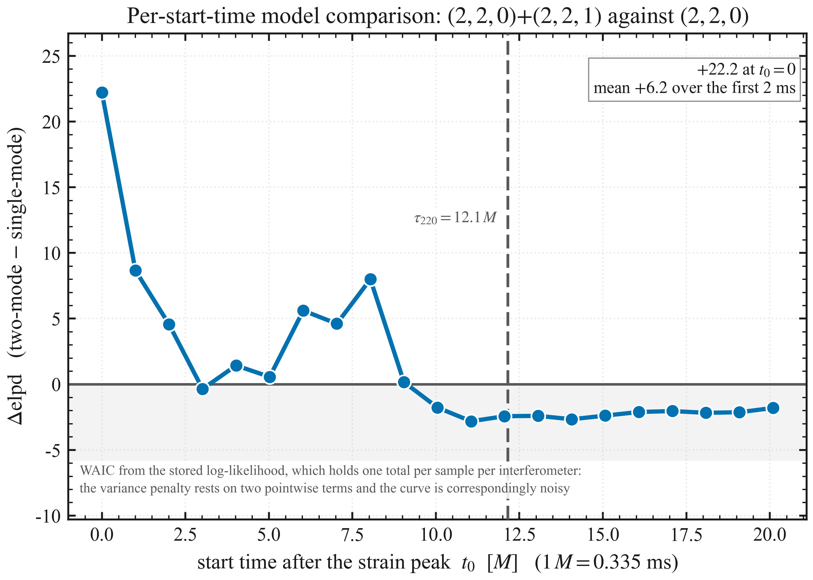
Figure S2: Per-start time Bayesian model comparison between the single-mode (220) and two-mode (220+221) templates. Positive Δelpd (two-mode minus single-mode WAIC) favors the two-mode model. It is +22.2 at t0 = 0 and averages +6.2 over the first 2 ms; it is negative beyond about 10 M, and in between it is not monotonic, crossing zero near 3 M and returning to +8 near 8 M. The stored log-likelihood holds one total per sample per interferometer, so the WAIC variance penalty rests on two pointwise terms and the curve is correspondingly noisy.
S8. Comparison with the collaboration's released posteriors
(Sec. IV.D of the main text states the result; the per-start-time values are here.)
The public data release for this event [43] publishes remnant mass, spin and horizon-area posteriors for the single-mode template at seventeen start times from 6 M, alongside a frequency and damping-rate scan running from the strain peak to 30 M. The released products are detector-frame. The conversion applied below is not fitted: the release publishes both total_mass and total_mass_source in the same posterior, and their median ratio, 1.0856, equals 1+z from its own redshift column to four decimal places. Masses are converted with the first power of that factor and areas with the second. The unit of the released area column is likewise derived rather than assumed, by rebuilding the Kerr area from the release's own mass and spin samples, which reproduces the published column exactly. The comparison is reproduced by code/figures_v2/verify_release_crosscheck.py.
- Table S2: The single-mode trajectory measured here against the collaboration's released posteriors, at the 15 start times both cover. Masses in M⊙, areas in 10^5 M⊙^2, both source-frame. Median absolute difference 0.67% in mass and 0.50% in area; the largest, 4.16% and 5.41%, fall at the start times carrying the widest intervals on both sides. The 90% intervals overlap at every start time in both channels.
t0 [M] | Mf here | Mf released | ΔM | Af here | Af released | ΔA
6 | 71.44 | 71.20 | +0.3% | 2.102 | 2.098 | +0.2%
7 | 69.27 | 71.31 | -2.9% | 2.026 | 2.103 | -3.7%
8 | 68.48 | 71.46 | -4.2% | 1.997 | 2.111 | -5.4%
9 | 67.21 | 67.96 | -1.1% | 1.914 | 1.945 | -1.6%
10 | 66.31 | 66.83 | -0.8% | 1.868 | 1.884 | -0.8%
11 | 66.54 | 66.92 | -0.6% | 1.855 | 1.863 | -0.4%
12 | 67.03 | 67.49 | -0.7% | 1.863 | 1.871 | -0.5%
13 | 64.37 | 64.64 | -0.4% | 1.782 | 1.782 | +0.0%
14 | 63.46 | 63.80 | -0.5% | 1.751 | 1.758 | -0.4%
15 | 59.31 | 59.26 | +0.1% | 1.589 | 1.581 | +0.5%
16 | 60.03 | 59.98 | +0.1% | 1.620 | 1.615 | +0.3%
17 | 59.54 | 59.77 | -0.4% | 1.598 | 1.601 | -0.2%
18 | 59.04 | 59.87 | -1.4% | 1.576 | 1.606 | -1.8%
19 | 54.85 | 56.19 | -2.4% | 1.426 | 1.481 | -3.7%
20 | 56.17 | 58.40 | -3.8% | 1.481 | 1.565 | -5.3%
S9. Analysis configuration
The ringdown signal is modeled as a damped sinusoid corresponding to QNM of a perturbed Kerr black hole. The Bayesian inference is performed using a time-domain Gaussian likelihood, conditioned on the BayesWave-derived PSD to account for the detector noise floor.
We adopt the Kerr QNM parameterization within pyRing, placing broad uniform priors on the model parameter $M_{f}∈[18.4,118.4] M_{⊙}$ and $χ_{f}∈[0,0.99]$. The QNM oscillation frequency $f_{220}$ and damping time $τ_{220}$ are computed from $M_{f}$ and $χ_{f}$ via the GR Kerr spectrum. These priors encompass the global NRSur7dq4 posterior support and are wide enough to capture early-time departures from the asymptotic Kerr values. The posterior exploration is performed using the cpnest nested sampling algorithm with $n_{live}=4,096$ live points, yielding $∼4,000$ independent posterior samples per start time that form the basis of the sequential Kerr QNM inversion.

