Progress Report

Modbus Master-Slave Relation

Modbus Master is usually a Windows XP/7 computer which sends commands to slaves (PLCs). But actually speaking of in client-server paradigm its a client, requesting information from PLCs.

Modbus Slave is a server type listener program running PLCs. It listens to requests from the Modbus master.

Relating or Conceiving Modbus in a honeypot environment

2 Possibilities:

1> Simulate a Windows machine with the modbus port open along with standard windows desktop ports. This gives the attacker a feeling of a Modbus master. Using this simulation, we could check for “STUXNET” type attacks.

2> Simulate a Modbus PLC, with just Modbus and HTTP (and SNMP if required)running on it, hereby giving the attacker a hint of series of PLCs present in the network. Further, we can test for Modbus vulnerabilities and exploits like buffer overflow, access control, input validation, authentication. In this case, for validation, a HMI interface running on the HTTP server makes it evident.

Attack Possibility 1 :



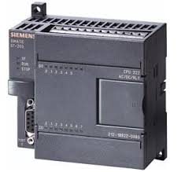
Attacker Modbus Master Modbus Slave PLC

All standard ports of Win 7 and 502 for Modbus

Attack Possibility 2:

Attacker Modbus Slave PLC

Open ports 502, or HTTP/HTTPS for HMI

Understanding Modbus TCP:

There is a variant of Modbus which runs on TCP and on Application Layer.

It contains function odes to specify set of operations that can be performed on a PLC

Operations include read register, write register, read coil, write coil, exceptions, error in R/W operations and so on...

Analysis of CONPOT ( A SCADA ICS Honeypot )

- Its a server side ICS honeypot. (No master profile)
- Ships with default profile that emulates Siemens 'S700' CPU.
- Default profile emulates MODBUS,HTTP, SNMP and s7comm protocols.
- Implemented in python.
- XML based configuration and data representation.

Installing PyCharm IDE to understand Conpot implementation and design:

- Uses many libraries like tk-modbus implemented in python.
- Conversion of many scripts not required for HosTage.
- Hard to implement somethings in Java. (inaccuracy)
- Understanding the reply and response mechanism.
- Not sure of how templates are implemeted.
- kamstrup protocol, specific to some PLCs is implemented.

Things done:

1. Able to successfully open Modbus port. (port 502)
2. Able to start MODBUS service from the services menu. (only opening of port lsitener)
3. Able to detect MODBUS port open through custom nmap modbus-dicovery script.
4. Scanning from this script detects port scan attack on the device. (have to change this attack name to modbus discovery script attack)

Things to do:

1. Study different modbus modes and requests received from a Modbus slave.
2. Understand Modbus reply sequence for request packets and implement the request codes.
3. Implement a response mechanism.
4. Try to simulate the template style which is done in conpot for modbus server by the use of templates for specifying the PLC Siemens S7000. (as much possible)
5. Try to setup a HMI in HTTP port 80.
6. Learn about various vulnerabilities and attack methods on SCADA ICS Modbus.
7. Simulate attacks on the Modbus service
8. Create alert mechanisms based on type of attacks.
9. Maintain log of attacks.

1. Study different modbus modes and requests received from a Modbus slave.

The modbus request modes are mainly classified into 4 commands:

1. Read Coil
2. Write Coil
3. Read Register
4. Write Register

The PLCs contain coils and registers which are memory units. These memory units store the values retrieved from sensors and also accept commands from the PLC master. The PLC relies on logical bridges and switches (0 & 1 switch) to perform its operations.

Wireshark Analysis:

To understand the packet structure of MODBUS TCP, I used Conpot, Nmap & Metasploit.

Conpot was installed and left running on one of the systems and the SIEMENS SIMATEC 7000 series template was simulated. Conpot has MODBUS and HTTP ports open as a service.
In other machine (VM) metasploit & Nmap was installed. The nmap-discovery script was used to detect if the Modbus service is running. Running the namp discovery showed the modbus service open and also the device information with some enabled function codes.

The wireshark trace captured TCP packets targeted towards conpot and port 502. Conpot on receiving a request on its binded port provides a device information as a response with enabled function codes.

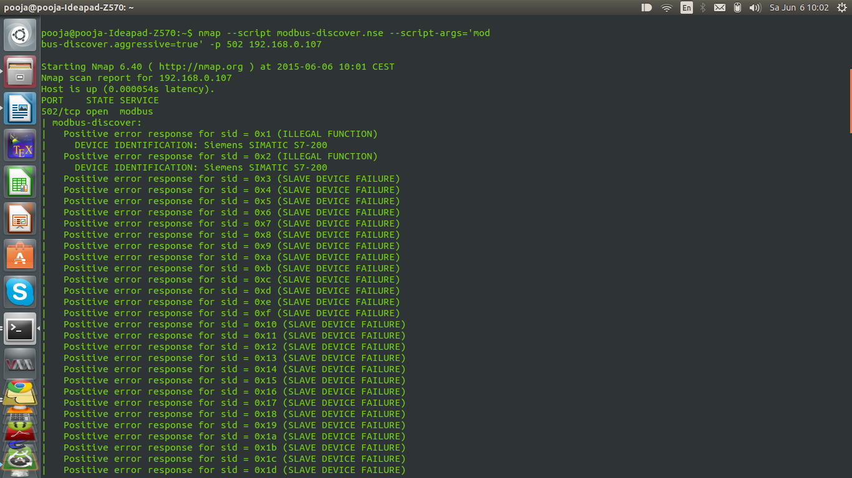
To simulate the read coil and write coil requests, Metasploit was used. The modules which were used are Metasploit Modbus Client Utility and Modbus Version Scanner.

1. Modbus Version Scanner

This module detects the Modbus service, tested on a SAIA PCD1.M2 system. But could be used to detect MODBUS services running on any device. Looking into the script (Ruby) of this module shows that it relies on the concept that when sending a Modbus request of some sort, the endpoint will return with at least the same transaction-id, and protocol-id. The module matches it with the request sent if they are equal. If so, then modbus service is running.

https://github.com/rapid7/metasploit-framework/blob/master/modules/auxiliary/scanner/scada/modbusdetect.rb

2. Modbus Client Utility

The modbus client utility module allows reading and writing data to a PLC using the Modbus protocol. Conpot maintains a array stack which resembles the coils and registers and maps the index positions to the coil & register address range. Any data to be written or read must be within the data range. The module was developed using Digital Bond's modbus attack and simulations.

The write coil command executes with setting of the data address. The packets were captured through wireshark to understand the request and reply structure.

Write coil Request:

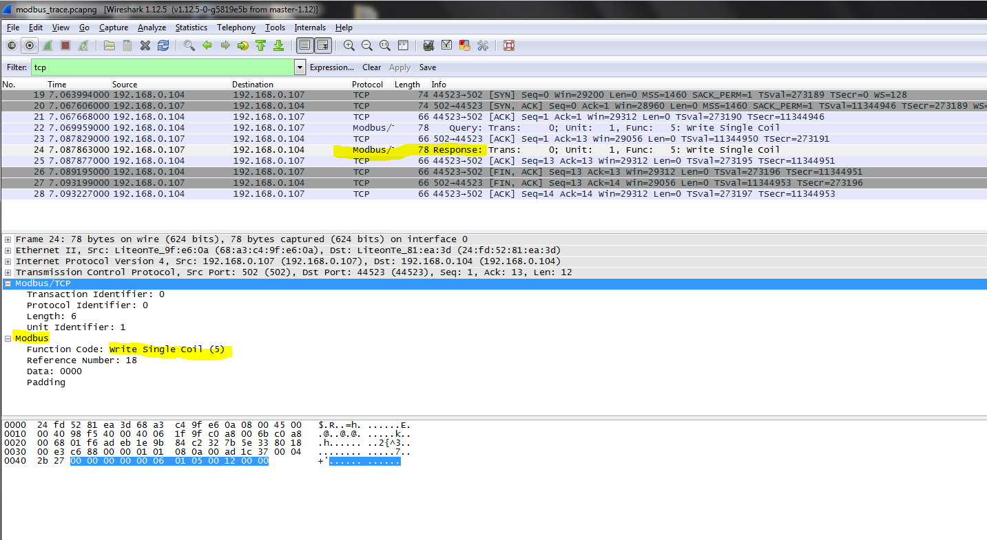

Write Coil Reply

The write coil request and reply are identical except for the source and destination (TCP header ).

However, this is not the same for the read request. The read request only specifies a data address from which the data has to be read . The response includes the data present in the respective coil.

The write register follows the same as in write coil, but the difference with the data addresses. It should match the register size and address of the PLC simulated.

Also, there are exceptions to be handled like illegal function, illegal data address, illegal data value, slave device failure, Response failure, ACK and NACK (for TCP)

The packet structure:

The packet structure :

implement 2 arrays of coil & register.

Try to extract these information from the packet:

1. Function Code
2. Reference Number
3. Data
4. Padding (Just to be sure of the packet, check if this is end of packet)

and also additionally in MODBUS TCP

Length (should be 6 )and Unit Identifier (must be 1)

The request packet is stored and retrieved in the form of a Byte array. The index positions 5,6,7,9 and 11 contain the ModbusTCP and Modbus packet data.

The data in these index locations is compared and based on the values present in these positions, the respective response packets are sent. The data at index position 7 provides the function code and based on this value, the respective response is generated.

Also, the data address value which is sent in index position 9 of the request packet is validated for allowed data address positions for coils and registers. If the data address violates the addresses present in the PLC, a exception has to be raised, and a response accordingly has to be sent.

To simulate the behavior of the coil and registers, 2 arrays have to be implemented which store arbitrary values. This is necessary to read and store the values the attacker sends through his packet.

The next task is to generate a response for the nmap modbus discover script as this is the basic script used to determine if a host is running the Modbus protocol.

The function code passed for Modbus Discover service is the value 17. If the value reads 17, then we send a discover template or device information to the device.

