Generate the following two result sets:

1. Query an *alphabetically ordered* list of all names in **OCCUPATIONS**, immediately followed by the first letter of each profession as a parenthetical (i.e.: enclosed in parentheses). For example: AnActorName(A), ADoctorName(D), AProfessorName(P), and ASingerName(S).
2. Query the number of ocurrences of each occupation in **OCCUPATIONS**. Sort the occurrences in *ascending order*, and output them in the following format:
3. There are a total of [occupation_count] [occupation]s.

where [occupation_count] is the number of occurrences of an occupation in **OCCUPATIONS** and [occupation] is the *lowercase* occupation name. If more than one *Occupation* has the same [occupation_count], they should be ordered alphabetically.

**Note:** There will be at least two entries in the table for each type of occupation.

**Input Format**

The **OCCUPATIONS** table is described as follows: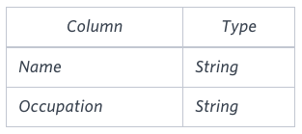*Occupation* will only contain one of the following values: **Doctor**, **Professor**, **Singer** or **Actor**.

**Sample Input**

An **OCCUPATIONS** table that contains the following records:

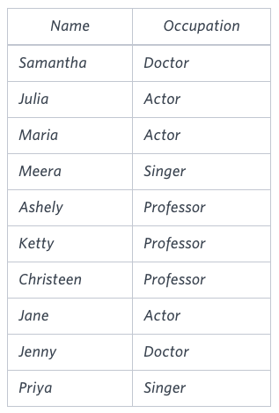

**Sample Output**

Ashely(P)

Christeen(P)

Jane(A)

Jenny(D)

Julia(A)

Ketty(P)

Maria(A)

Meera(S)

Priya(S)

Samantha(D)

There are a total of 2 doctors.

There are a total of 2 singers.

There are a total of 3 actors.

There are a total of 3 professors.

**Solution:**

(select concat(Name ,"(" , lefT(Occupation,1) , ")") as Nm from Occupations)

union

(SELECT CONCAT("There are a total of ", COUNT(Occupation),

concat(" ", lower(occupation), "s.")) as Nm

FROM OCCUPATIONS

GROUP BY Occupation ORDER BY count(OCCUPATION), occupation)

order by Nm;