BEDROOM

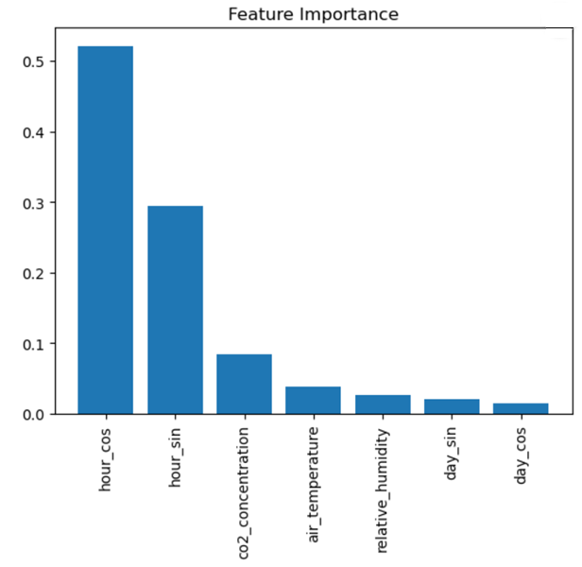

KITCHEN

LIVING ROOM

OFFICE

KITCHEN / LIVING ROOM

GENERELIZED MODEL

